Case study: HOnda Motor Company

ADM1300
GERARD BRAITHEWAITE STURGEON
BY: J
STUDENT #: *******

Table of Contents
Table of Contents 1
Company Overview 2
National comparative profile of Japan’s cultural dimensions 3
Masculinity-Femininity 3
Power Distance 4
Individualism-Collectivism 4
Uncertainty avoidance 5
Time Orientation 5
Managerial theories in Japan vs. Canada 6
How Planning Practises differ between Canada and Japan 9
Organizational differences between Honda and a Canadian Company 11
Leadership Styles 13
Analysing Control 14
Organizational Change 15
Effectiveness of teamwork 15
Works Cited ………………………………………………………………………………………………………………………………………….17
Appendices …………………………………………………………………………………………………………………………………………..18

Company Overview
Honda (HMC) is global car and vehicle manufacturing company with headquarters in Minato, Tokyo Japan. It was founded in 1946 by a Japanese scientist named Soichiro Honda and originally started off as a research institute. After WW2 Soichiro was tasked with coming up with a way to reuse or repurpose the excess small-engines and motors from the army surplus. He used these small-engines to make motorcycles which became very popular in Japan. Fast forward into modern time, the company has grown exponentially and has expanded into different industries; most evidently, the automotive industry.
Honda is now a global fortune 500 company with operations in many different countries and managed by their CEO, Takahiro Hachigō. According to FortuneGlobal500.com, Honda is ranked at 36th on the fortune 500 list and their revenues for the fiscal year exceeds 120 billion dollars. They are the owner of Acura motor company which is the luxury variant of Honda automobiles. Acura in particular has been doing very well in North America. The president of Honda operations in North America, Steve Mendel, says that Acura has increased its sales in every year for the past 3 years. The company also has a strong presence in India because of the sheer demand for motorcycles in that market. Honda is the number one motorcycling supplier in India.
Honda has developed a complex system of production and distribution which allows them to sell their cars in plenty of different markets. Their main markets to sell in, according to marketrealist.com, are North America, Japan, Europe and the rest of Asia. They have foreign subsidiaries in over 12 different countries but they are still a traditional corporation in that, their stocks can be bought and sold publicly.

National comparative profile of Japan’s cultural dimensions
This section will compare the cultural differences between Honda’s home country, Japan, with a company that is based in Canada. Japan and Canada are very different in terms of Geert Hofstede’s cultural tendencies analysis. Referring to appendix A, Japan has a much higher masculinity index, uncertainty avoidance, and long term orientation goals than Canada. However, japan is also described as being a collectivist society with a lower indulgence index than Canada. Here is a breakdown of the results of Geert-Hofstede’s 5 main cultural dimensions analysis according to their comparison analysis chart as seen in appendix A.

Masculinity-Femininity
Compared to Canada, Japan has a high masculinity index which indicates that Japanese culture values aggressiveness and assertiveness. Masculinity refers to the degree to which a culture favors masculine qualities over feminine qualities. For example, a culture that has a high masculinity index favors a ‘trial by fire’ mentality rather than a nurturing teaching mentality. In a heavily masculine work environment, success is an expectation and there is no concern for a manager to facilitate the success of the workers. This explains why work environments in a masculine society are highly competitive because their workers are always looking for ways to pull ahead and not fall behind. Canada scored a 52 in the masculinity index which means it is still a masculine culture but has a much lower degree of masculinity compared to Japan’s score of 95. Canada is a more balanced society when it comes to this cultural dimension meaning that they also share a sizable degree of feminine qualities. In terms of Geert Hofstede’s dimensions, feminine cultures value quality of life, cooperation, and caring. This type of cultural behavior is synonymous with one of Chris Argryis’ beliefs that a supervisor should adjust his role to do a better job of promoting human relationships with his/her workers which represents the “caring” and “nurturing” attitude that is associated with feminine qualities. Therefore, there is a high probability that a worker in a Canadian company could experience either of these management styles or even a combination of the 2 styles.

Power Distance
Japan has a higher power distance than Canada scoring 54 compared to Canada’s 39. Relatively speaking, japan isn’t even a high power distance culture. Power distance indicates the degree to which people in society accept that power is distributed unequally. In a high power distance culture there is complete respect for a boss or superior meaning that low level workers should not be able to challenge or question their superiors. Canada’s low power distance indicates that there is not much concern for a hierarchy and explains why we believe that you need to take the job of your superior in order to move up within the company. In low power distance cultures, stature and status are constantly being challenged because people in such a society demand that power is justified and deserved.

Individualism-Collectivism
Japan scored a 46 and Canada scored an 80 on the individualism-collectivism scale. This means that Japan is a much more collectivist society whereas Canada is a highly individualistic society. In order to be an individualistic society, the degree to which a society emphasises individual accomplishments and self interests must be greater than collective accomplishments and collective interests. The workplace in an individualistic society would be very segmented where every individual has their own tasks which allow them to succeed individually and to be rewarded individually. A worker is responsible for their own success which is why employees typically shift to different jobs in different companies throughout their working career in individualistic societies. Comparatively, workers in a collective society work together in tightly nit groups and achieve success as a group. Workers in a collectivist society are generally more loyal to their companies because the groups that they work in are very dependant on each other and they have a responsibility to each other to stay together.

Uncertainty avoidance
In this dimension Japan scored a 92 compared to Canada’s score of 48. Uncertainty avoidance is defined as being the degree to which a society tolerates risk or uncertainty. Since Japan scored a 92 on the uncertainty avoidance index, it means their culture has a preference for structure and order. Whereas Canada’s lower uncertainty avoidance indicates that they are much more open to new ideas and more accepting of ambiguous outcomes than Japan. However, their score is very close to being a high uncertainty avoidance culture. Therefore, they are a much more balanced society when it comes to uncertainty avoidance. This addresses the ecological fallacy that we assume Geert Hofstede’s dimensions apply equally to everyone in that culture because Canada’s uncertainty avoidance score is right at the border of being a high uncertainty avoidance and we cannot assume that the majority of people in Canada favor a low uncertainty avoidance attitude.

Time Orientation
Japan is a country that favors long term goals as shown from their high long term orientation score of 88. By contrast, Canada is a much more short-term oriented culture demonstrated by their low score of 36. Long term oriented countries emphasize patience, loyalty and preparation whereas short term oriented countries have an emphasis on getting immediate results. This explains the stigma that Japanese cars are better than American cars simply because the Japanese spend more time perfecting their products than Americans and thus, making better cars.

Managerial theories in Japan vs. Canada
The results from the Geert Hofstede analysis suggests that there is a significant difference between the behavior of people in Japan and people in Canada. These differences can lead to each culture embracing different management theories in the workplace.
The obvious answer is that the Japanese workplace would represent the Bureaucratic management theory because of their high power distance relates strongly with their respect for the hierarchy of workers however, it also encourages the separation of workers into different divisions which is contradictory to japans collectivism score. Based on the results from the national comparative profile, companies that operate within the Japanese culture will be using most of the principles outlined in Henri Fayol’s Administrative principles of management. In 1916 Henri published a list of 14 principles shown in appendix B for which he believed would be important for proper management of organizations and obviously, not all of his principles apply directly with Japan’s cultural profile. One of these principles that would dominate Japanese workplaces is principle #2 which outlines how managers and workers need to understand that managers have the right to give orders. This principle is in accordance with Japan’s higher power distance score because with high power distance countries, there is an unequal distribution of power. This causes a hierarchy wherein people are classified into their own status and they rarely ever shift to a higher level which is why workers always obey their manager’s orders. This is also relatable to principle #9 which states that Employees should be aware of where they stand in the organization's hierarchy, or chain of command. In a high power distance culture, workers have respect for the social hierarchy and work hierarchy. While analysing Fayol’s principles you may find that many of them relate very well with Japan’s power distance score but there are other principles that relate better with different Geert Hofstede dimensions.
One other principle from Henri’s list that you would expect to dominate their work culture would be that the interests of one employee (even managers) should not be allowed to become more important than those of the group. This can be proven by Japan’s collectivist rating because collectivist cultures are very group oriented especially in terms of responsibilities to the group. The interests of one person is almost never more valued than the interests of the group as a whole. The Japanese work environment consists of many people working in sync with each other, depending on each other and it simply does not tolerate anyone straying too far from the objectives of the group. Principle #5 is also a very good example because it deals with the unity of direction within the company and how teams with the same objectives should be working under the same director so that everything is coordinated better. Since japan is a collectivist culture, they believe that working in groups helps them coordinate better than people working separately and thusly, it also allows them to have one manager coordinate the jobs rather then multiple task managers. Comparatively, individualistic countries like Canada would operate in the opposite way in that, they would have many different managers many tasks even if they operate in the same sector.
Canada emulates a scientific management style more so than anything else however, Frederic Taylor’s Scientific management theory could also be considered as a dominant management theory in Japan. Scientific management theory practises two main ideas which are:
1. Managers should be motivated to bring prosperity to their employer and the workers
2. Production can be improved by reducing the physical tasks that employees go through to their most basic forms to allow for better production (motion study).
If you look at the Japanese collectivist worker system, there are many people working together splitting the workshare to accomplish a common goal which goes hand in hand with Taylor’s theory that reducing tasks increases productivity in the workplace because accomplishing a greater goal as a group is very much the same as the collectivist society. Also, Taylor’s proposition that managers should want to bring prosperity to their employer and workers demonstrates the loyalty that employees have to their firm which is seen in collectivist societies. Modern scientific management theory is better suited to a culture like Canada. Modern scientific management theory is an extension of Frederic Taylor’ s work with the addition of Lilith Gilbreth’s studies. Dr. Gilbreth’s work added human aspects of time management to Frederic Taylor’s archaic theory of management. Taylor believed that most workers were lazy people and only responded to wage changes in fact, while doing studies at the Bethlehem steel company, Taylor referred to it’s workers as sluggish and cow-like. According to Sherry E. Sullivan, a researcher of classical management, Taylor said that one of their employees was so stupid he resembled the mental state of an ox. Gilbreth’s approach puts emphasis on the worker as an individual and not a ‘cog in the wheel’ while still maintaining that incentives (such as money) can still help improve performance. This type of theory resembles Canada’s high individualistic tendencies. The whole idea behind motion studies and reducing job tasks to improve efficiency is to be able to produce more in the time it would usually take to do the same job. Using quality control is counter productive towards the production process. This is something that separates Japanese car manufacturers from car manufacturing in North America, the Japanese pride themselves in a rigorous quality control system which is something that would slow down production and thusly, making them less reliant on scientific management theory. Whereas Canadian manufacturing doesn’t focus nearly as much attention to quality control and focuses more on production levels. This coupled with Canada’s highly individualistic tendencies make it a society that favor the scientific management theory.
However, there are more principles within Henri Fayol’s list of management theories that connect better with Japan’s national profile than Henri Fayol’s Scientific management theory. Frederic Taylor thought that in order to achieve the optimal amount of production, managers need to spend most of their time training and teaching people how to properly do their job. Referring back to the results of japans national profile, we found that their high masculinity rating suggests that they would not emphasize a nurturing and teaching mentality in the workplace which disapproves scientific management theory for Japan. Since this was one of Taylor’s main assertions, and it doesn’t fit in with Japan’s national profile, it shouldn’t be considered the most important management theory. Therefore, Administrative management theory is better represented within the Japanese workplace.

How Planning Practises differ between Canada and Japan
There is much more that goes into the direction of a company than most people think. The planning process involves: Defining goals, Internal evaluation of strengths and weaknesses, anticipating future event, picking an strategy and then implementing it. In this section, we will see how Canadian companies and Honda might compare against each other in the planning process.
There are many different facets to planning such as long range and short range planning or strategic planning and tactical planning and Goal setting. Long and short range planning are pretty self explanatory however, strategic planning is how a company plans their long-term overarching direction. Tactical planning is how a company may respond or make adjustments when changes in the situation occur or when externalities occur. Typically, tactical planning involves functional planning which is basically determining how each operation within the company can adjust to the change.
Obviously, Japan scoring an 88 in long term orientation suggests that Honda motor company would probably want to plan much farther into the future than most Canadian companies. One major component of planning is forecasting which is when a company tries to predict future events and wants to adjust their company accordingly. Because Japan scored so high in uncertainty avoidance (92), you would expect that they would devote a lot of resources and time for preparing for the unknown outcomes in the future. This way, nothing will come as a surprise to Honda. A good example of this is how Honda was one of the only car manufacturers that didn’t suffer greatly during the 2008 financial crisis, unlike GM who had to be bailed out by the U.S. government. At the beginning of the finical crisis, Honda’s top managers forecasted how the market fallout would eventually reach the automotive industry so they began cutting costs and getting rid of some of their less important operations like when they pulled out of F1 racing and cut out their F1 researching teams. Since Honda is a very diversified company, losing significant sales in the U.S. market still hurt the company but didn’t put them in a rough financial situation. If we talk about some of the tactical changes that Honda had to make during the financial crisis we will see that they (along with many other foreign car companies in North America) lowered the prices of their cars to accommodate for the decreasing incomes and lower demand for vehicles. Canadian societies have an emphasis on short term orientation as demonstrated by their time orientation score (36) which means that a Canadian company may have be better at short range planning and tactical planning more than Honda. Since everything in Canada is so fast paced and expectations are to be fulfilled immediately, a Canadian company would likely make use of the operational planning model. This model is used to implement short term activities and fixes to larger, strategic plans. A Canadian car company would probably have better response times to changes in a situation than Honda would because they have a planning structure that is well suited for dealing with externalities and other unexpected scenarios. Even though north American car companies failed to survive the financial crisis of 2008 (except Ford) they would have a chance to practise contingency planning. Contingency planning is when a company must examine different alternatives or courses of action when forecasts are wrong. In GM’s case, their contingency plan would be asking the government to bail them out and Chrysler’s plan was to seek a buyout from a foreign automotive company like fiat.
The other main facet of planning is setting goals. Goals should be Specific, measurable, attainable, monitored and timely. The people who make goals for a company are usually the top mangers but the way that goal setting may differ between a Honda and a Canadian car company is that different personal from different sectors of the company may be able to jointly help set goals. Since Japanese companies follow the principle that workers that have the same broad task should be managed by one manager, it easier for manager to relay needs and goals better each other. However, because japan has a high power distance, they would not allow anyone but the top managers to help plan goals because it is not within their realm of status. The Canadian system would probably be open to have joint planning with lesser employees in the goal setting meetings because of their low power distance score.

Organizational differences between Honda and a Canadian Company
Organizational structure determines how employees interact with other employees and identifies the lines of communication between workers. There are many different structure types like functional and informal structures, Divisional structures, and matrix structures. This study will identify which of these structures Honda likely uses and which one is a suitable structure for a Canadian car company. Honda uses a Matrix structure of organization. According to a dissertation done by UK essays Honda mixes individuals and groups, both horizontal and vertical structures, formal and informal positions to the extent that it is quite impossible for anyone entering the firm from outside to understand precisely what Honda's organizational structure . So here we see that Honda does not use just one organizational structure but many which is why it should be classified as a complex structure but the closest thing we have to this is a matrix structure. From the outside, Honda’s organizational structure appears to be a functional structure wherein groups that have the same tasks are lumped together with people who have similar skills and tasks. But Honda differs from this concept because they have so many different product divisions that require different specialized skills and so these divisions simply cannot be lumped together because they are not compatible with each other as seen in Appendix C. This also shows why Honda cannot have a team structure because it would be too difficult to determine which divisions should work with each other and then groups can sometimes become confused as to which classification or ‘team’ they fall into. By having a Matrix structure, the goal is to have the benefits of both functional structures and divisional structures. Honda achieves this by not clearly defining specific responsibilities to their managers as well as not allowing their workers to become confused as to whose authority outranks another manager.
Canada’ s organizational structure resembles that of the divisional structure whether it be product, geographical or customer structure. Since they have a strong an individualistic rating it shows that a Canadian structure would favor a structure that separates groups into divisions that specialize in their specific sector. With a divisional structure, there is improved coordination among functional departments which. Canada’s Short term orientation score is suitable for this type of organization structure since directions and tasks can often change within functional groups and this way the organizational structure allows for quick changes to be made and implemented.

Leadership Styles
Leadership and power are 2 concepts that go together in tandem. Power is the ability to get your subordinates to do something you want done and leadership is how you use power to make things happen. There are different ways to lead for example; there is autocratic, human relations, laissez-faire and democratic leadership styles. Honda’s strong uncertainty avoidance score coupled with their high power distance and masculinity index shows that they prefer regimented, competitive and authoritative leadership styles. The best fit for a style of this nature would be the autocratic leadership style because it favors task over personal and the authority of higher ups to manage the lower level workers. As you know, Japan is a collectivist society which is why they would favor a task oriented leadership structure because their workers are organized in a way that optimizes production in by splitting the task between a group and not individuals. Canada’s prevailing leadership style should be the democratic style which is a balanced style between caring for people and tasks. Since Canada is relatively well balanced in individualism, masculinity, it means that they are relatively balanced when it comes to group task orientation and individual tasks and also whether they prefer a nurturing style of management or a masculine management style.
The way each company would use its power is slightly different. In a Canadian company, you would expect them to use reward power in order to get people to do what they want because they do not have a high power distance and people do not respect authority as much as they would in Japan. The only way to incentivise people into doing what you want is to provide a possible benefit or reward for doing work. In Canada companies use these incentives to get people to perform tasks for them: pension plans, travel vouchers, health care etc. Since Honda comes from a high power distance country and one with a higher masculinity index, they would incentivise workers with coercive power because managers are more respected there and have the authority to replace a bad worker if need be. So workers are constantly under pressure from competition and the coercive power of managers to perform well.
Manager in a high uncertainty avoidance country would prefer to use written communication as a way to inform their subordinates. In this case, Honda’s mangers may use this form of communication whereas a Canadian company has a low uncertainty avoidance index which means it would be acceptable to use non-verbal communication to inform an employee because they have an easier time accepting ambiguity.

Analysing Control
Controlling is the process of monitoring and measuring performance. There are many different types of control like, feedforward control, feedback control, concurrent control or the external bureaucratic control and market control.
Honda would control using form of bureaucratic control because it has emphasis on authority and the hierarchy controlling the behaviour of the workers. As we found earlier, workers at Honda respond better to negative incentives like being fired than they would with positive incentives because their masculine culture pushes the competition between workers in a way that does not accommodate for anyone that falls behind. They would also appreciate a feedforward control system because their uncertainty avoidance index is so high they would not tolerate waiting for an action to be completed to know if the action was good or bad like in feedback control. Therefore, Canadian companies would be more receptive to feedback control because they can tolerate the ambiguity of not knowing the results before hand. I also think that Canadian companies would use market control because the Canada is a capitalist society which promotes great completion between firms and usually allows the market direction to influence the behaviour on organizations.

Organizational Change
Organizational change is when a company undergoes major organizational remodeling. There are many ways in which this is done and there’s also many factors that resist change. However, change can sometimes be unplanned in some situations where an unanticipated event causes a reactionary response by managers to make changes within the company. Comparatively, planned change is when the company implements changes itself. Honda likely implements both planned and unplanned changes however they will probably use a force coercion strategy because they respond to coercion and have respect for the authority of the top managers. If Honda were to undergo organizational change, their biggest obstacle would be how to restructure the organization without having to retrain anyone or how to reassign tasks to the right functional groups. As we know, Honda’s organizational structure is very complicated but mimics the appearance of a functional structure which means that it may be difficult to break apart some of the working groups during the restructuring stage. Let’s say Honda needed to change a functional group’s tasks. They would need to either move employees who are better trained in the new task to the functional group (which makes complicates the organization structure even further) or train the existing employees how to perform the task. Since group work is heavily used within Honda it would take a long time to train all of the workers to perform the new task. However, bringing in employees from a different functional group would disrupt the established hierarchy or power relationships.

Effectiveness of teamwork
Earlier, we discussed why the use of teams or ‘teamwork’ is not the best way for Honda to operate. Using special task teams within a company disrupts the hierarchy of the company which is something that Honda wants to keep clear and in order. However, there are some unexpected externalities that may be so broad (like the financial crisis) that they affect multiple sectors of a company like Honda and the benefit of temporarily upsetting the hierarchical structure of the company may worth it. In these situations, it would be beneficial to establish a task force to handle such externalities. For example, in the 2008 financial crash, Honda would likely have assembled a team of their top analysts, marketing directors, product consultants and top managers to help determine a course of action to help respond to the crisis. Their combined expertise and knowledge would allow them to fix or make adjustments to the company quickly and implement them quicker because teamwork makes planning and coordination easier. They should set these teams up in case of the unlikely event of an economic externality so broad and all-encompassing it effects the company in so many different ways that that it would be difficult to coordinate a response. That being said, Honda does not need to use teams in everyday management and only in rare scenarios where many of their divisions can be affected by the same externality.

Works Cited
Crisis Affecting Automotive Industry Was Part Of Global Financial Downturn Business Essay. (2015, March 23). Retrieved November 29, 2016, from https://www.ukessays.com/essays/business/crisis-affecting-automotive-industry-was-part-of-global-financial-downturn-business-essay.php

Cultural Constraints in Management Theories (1st ed., Vol. 7). (1993). The Executive.

Hertwig, M. (2013, May 13). European Works Councils and the Crisis: Change and Resistance in Cross‐Border Employee Representation at Honda and Toyota. Retrieved November 29, 2016, from http://onlinelibrary.wiley.com/doi/10.1111/bjir.12027/abstract

Honda income-statement 2016. (n.d.). Retrieved November 29, 2016, from http://amigobulls.com/stocks/HMC/income-statement/annual

Schermerhorn, J. R., & Wright, B. (2014). Management.Toronto: J. Wiley.

Honda Worldwide | Honda R&D | Organizational functions. (n.d.). Retrieved November 29, 2016, from http://world.honda.com/RandD/fandf/

Ingram, D. (n.d.). Differences in Strategic Planning for Domestic & International Companies. Retrieved November 29, 2016, from http://smallbusiness.chron.com/differences-strategic-planning-domestic-international-companies-11594.html

Mito, S. (2012). The Honda book of management: A leadership philosophy for high industrial success. London: Bloomsbury.

Parker, John Jun 15, 2016 6:59 pm EST, J. (2016, July 15). Overview: The Beginning of Honda Motor Company. Retrieved November 29, 2016, from http://marketrealist.com/2016/06/overview-the-beginning-of-honda-motor-company/

Sullivan, S. E. (n.d.). Management's Unsung Theorist: An Examination of the Works of Lillian M. Gilbreth (1st ed., Vol. 18). Hawaii: University of Hawai'i.

Geert Hofstede. (n.d.). Retrieved November 29, 2016, from https://www.geert-hofstede.com/canada.html

Appendices

Appendix A
Geert Hofstede Comparison between Japan and Canada
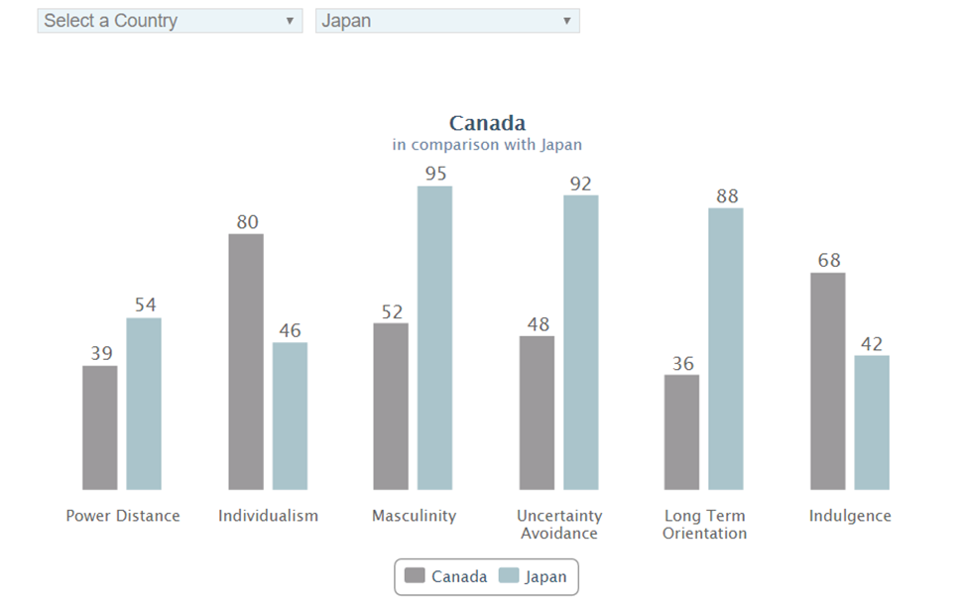

Appendix B
Henri Fayol’s 14 Principles of Management (Administrative management)
1. Division of Work – When employees are specialized, output can increase because they become increasingly skilled and efficient.
2. Authority – Managers must have the authority to give orders, but they must also keep in mind that with authority comes responsibility.
3. Discipline – Discipline must be upheld in organizations, but methods for doing so can vary.
4. Unity of Command – Employees should have only one direct supervisor.
5. Unity of Direction – Teams with the same objective should be working under the direction of one manager, using one plan. This will ensure that action is properly coordinated.
6. Subordination of Individual Interests to the General Interest – The interests of one employee should not be allowed to become more important than those of the group. This includes managers.
7. Remuneration – Employee satisfaction depends on fair remuneration for everyone. This includes financial and non-financial compensation.
8. Centralization – This principle refers to how close employees are to the decision-making process. It is important to aim for an appropriate balance.
9. Scalar Chain – Employees should be aware of where they stand in the organization's hierarchy, or chain of command.
10. Order – The workplace facilities must be clean, tidy and safe for employees. Everything should have its place.
11. Equity – Managers should be fair to staff at all times, both maintaining discipline as necessary and acting with kindness where appropriate.
12. Stability of Tenure of Personnel – Managers should strive to minimize employee turnover. Personnel planning should be a priority.
13. Initiative – Employees should be given the necessary level of freedom to create and carry out plans.
14. Esprit de Corps – Organizations should strive to promote team spirit and unity.

Appendix C
Honda’s Organizational Structure

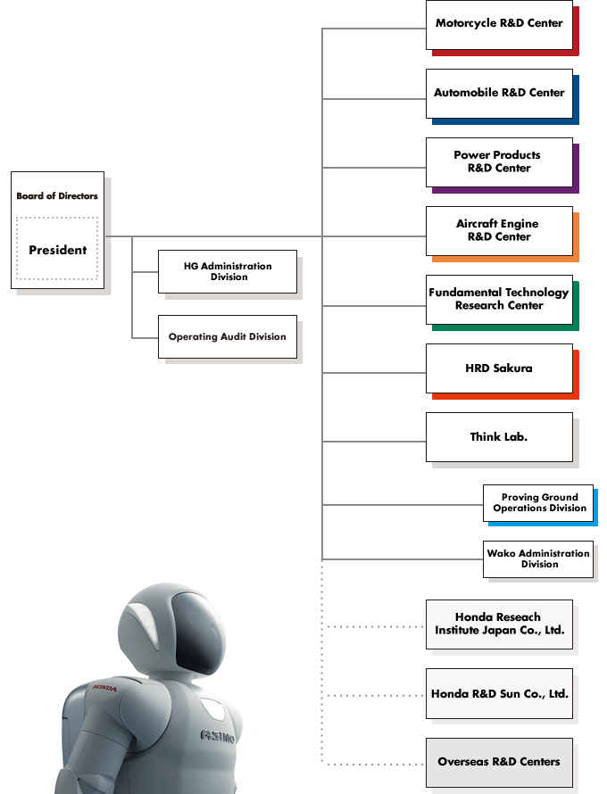

Honda Motor. (n.d.). Retrieved November 29, 2016, from http://beta.fortune.com/global500/honda-motor-36
Parker, John Jun 15, 2016 6:59 pm EST, J. (2016, July 15). Overview: The Beginning of Honda Motor Company. Retrieved November 29, 2016, from http://marketrealist.com/2016/06/overview-the-beginning-of-honda-motor-company/
Schermerhorn, J. R., & Wright, B. (2014). Management,P.93.Toronto: J. Wiley.
Schermerhorn, J. R., & Wright, B. (2014). Management,P.94.Toronto: J. Wiley.
Schermerhorn, J. R., & Wright, B. (2014). Management,P.47 Toronto: J. Wiley.
Schermerhorn, J. R., & Wright, B. (2014). Management,P.47 Toronto: J. Wiley.
Sullivan, S. E. (1995). Management's Unsung Theorist: An Examination of the Works of Lillian M. Gilbreth (1st ed., Vol. 18). Hawaii: Https://www.jstor.org/publisher/uhp.
Essays, UK. (November 2013). Crisis Affecting Automotive Industry Was Part Of Global Financial Downturn Business Essay. Retrieved from https://www.ukessays.com/essays/business/crisis-affecting-automotive-industry-was-part-of-global-financial-downturn-business-essay.php?cref=1

