SOURCES OF ORGANIZATIONAL THEORY
- historically, organizational theory originated from studies on how to improve the operations, management and performance of private organizations
  - as a result, organizational theory is often associated with schools of business management
- its of interest to us too because issues that concern how businesses organize themselves are also of major interest to public managers
  - theories from business have been adopted and adapted into the public sector, and
  - others have been derived from the social sciences (sociology and psychology)
- so, by organizational theory, we mean “the need to understand what people do, how things are done, and why we have organizations” both in public and private sectors

TYPES OF ORGANIZATIONAL THEORIES
- there are 3 main types of organizational theories:
- 1. The Classical Theories
- 2. Structuralist Theories
- 3. Humanist/Human Relations Theories

CLASSICAL THEORIES OF PUBLIC ORGANIZATIONS
- classical theories seek what effect the development of large-scale organizations will have or has on the power structure of society
- classical theories are therefore concerned with finding answers to questions such as:
  - ‘how does big government or big business influence a society’s political life?’
  - ‘is bureaucracy simply an administrative apparatus designed to meet societal goals or shape them?’
  - ‘how should such large-organizations be designed and what ought to be their role in society?’

KARL MARX (1818-1883)
- the best known of these theories is Marx’s manifesto of the communist party
  - it sees the policy process as a class struggle between workers and owners of capital
- in this class theory, Marx argues that the bureaucracy and public policies are a reflection of the interest of the capitalist class
- he sees bureaucracy as an instrument in the hands of capitalists to be used for the purposes of maintaining the capitalist system and the interest of the bourgeoisie
- with regard to public policy making and implementation in particular, Marx sees how particular policies serve the interest of capital, not ordinary citizens
  - for instance, the bailing out of Wall Street and not main street in the current financial crisis
  - tax cuts and loopholes for the wealth

THE GOSPEL ACCORDING TO MARX
- capitalist society is marked by class conflict in which the capitalist oppresses and exploits the working class in the pursuit of profits
- the state (bureaucracy) ultimately services the entrenched interest of the capitalist class over that of ordinary citizens
  - state tax policies always tend to benefit businesses
- bureaucracy also has its own vested interests to protect because at the core, the bureaucracy is a living organism
- it’s also focused on its own survival and the career building and advancement activities of its own employees
  - this explains why public unions fight against cutbacks and retrenchment in the public sector
A REVOLUTION? ITS ABOUT TIME
- “the universal spirit of bureaucracy is secrecy, the mystery, which it secures internally by hierarchy, and against external groups by its character as a closed corporation”
- bureaucracy is nothing more than a special interest that hides behind a more dignified picture of a faithful servant of the general will
- “the desire to claw one’s way up the bureaucratic career ladder in the quest for increased power, status and prestige is what motivates bureaucrats”
- finally, “class struggle will result in revolution, leading to a classless society in which the state (bureaucracy) will gradually whither away

REVOLUTION? WHAT REVOLUTION?
- the revolution has not yet occurred while at the same time, capitalist, the state, and bureaucracy is getting more powerful
- also, even if it is true that bureaucracy serve only the interest of capital, it can’t be concluded ipso facto that a policy was enacted at the behest of capital
  - you can’t prove that capitalist sent instructions to policymakers to draft a policy in their interest
- it also can’t explain why some policies are adopted and implemented by the state, despite open condemnation and opposition from capital
  - tax hikes in France, Healthcare reform in the USA
- elections, and not just capital, are more potent and have resulted in more voter friendly policies than capitalism
  - most social welfare programs in capitalist societies have become sacred policies

THE GOSPEL ACCORDING TO MAX WEBER (1864-1920)
- no other theorist has influenced the practice, research, and theory of public administration as much as Max Weber
- based on the accent studies of bureaucracies in Egypt, Rome, China, etc, he constructed what came to be known as the ‘ideal type’ or model of bureaucracy
- he argued that bureaucracy was essentially a “system of administration carried out on a continuous basis by trained professionals according to prescribed rules”
- Weber saw bureaucracy as a “rational, systemic, logical, and scientific approach to organization”
  - such an organization is not only limited to the public sector, but extends to the private sector as well

FEATURES OF THE IDEAL TYPE BUREAUCRACY
- hierarchy
  - people have clearly defined roles based on division of labour and is answerable to a superior
- continuity
  - people have full time salaries and tenure occupations and career structures for life
- impersonality
  - work is based on prescribed rules and written records, not on the whims and caprices of individuals
- expertise
  - personnel, selected based on the basis of merit, are trained and control access to knowledge and stored files
- political neutrality
  - people should serve any government that is in power at any particular time

BUREAUCRACY AND AUTHORITY
- Weber pioneered a path towards understanding how power and authority are legimated as a belief system based on 3 types of ‘authority’: traditional, charismatic and legal-rational

TRADITIONAL AUTHORITY
- legitimated by the sanction of tradition
- the ability and right to rule is passed down, often through heredity
- it doesn’t change over time, tends to be irrational and inconsistent and perpetuates the status quo
- example: the monarchy

CHARISMATIC AUTHORITY
- rather than focusing on history and continuity, charismatic authority is based on the power of ideas or the ‘gift of grace’
- its found in a leader whose charisma, mission, and vision inspire others and is based upon the perceived extraordinary characteristics of an individual
- such individuals posses a magnetism that binds who they are to what they say and when they say it
- example: Jesus, Prophet Mohammed, MLK, Nelson Mandela
- charismatic authority is not institutionalized, is very tenuous and usually dies with the individual

LEGAL-RATIONAL AUTHORITY
- its empowered by a formalistic belief in the content of the law (legal) or natural law (rationality)
- obedience is not given to a specific individual leader - whether traditional or charismatic - but a set of uniform principles
- Weber thought the best example of legal-rational authority was a bureaucracy (political or economic)
- respect and obedience is to the institution/office, not the individual
- for Weber, bureaucracy was a rational, systemic, logical, and scientific approach to managing any organization because its based on rational-legal authority

CRITICISMS OF THE WEBER’S IDEAL TYPE
- its an ideal type and may not work as planned in the real world
- it may lead to systemic discrimination against people who due to circumstances beyond their control do not have access to participate in the system
  - women, minorities, physically disabled
- “while impersonal rule may protect individuals from arbitrary treatment at the bands of officials, they may also be used to frustrate popular demands for social justice”

POLITICAL AND IDEOLOGICAL OPPOSITION FOR WEBER
- right-wing critics argue that regulation, control and intervention grows the government and hinders ‘the risk taking initiative and entrepreneurial spirit of capitalism’
- deregulation, de-centralization, privatization and neo-liberalism in particular are advanced by conservatives to limit the rise and growth of the state
- leftists also criticize the Weberian model because it assumes a view of human nature as constantly striving for power and self-gain and in need of disciple and control
- democratic governance scholars also stress that rigidity to rules, regulation and control leads to lack of transparency in the operations of government

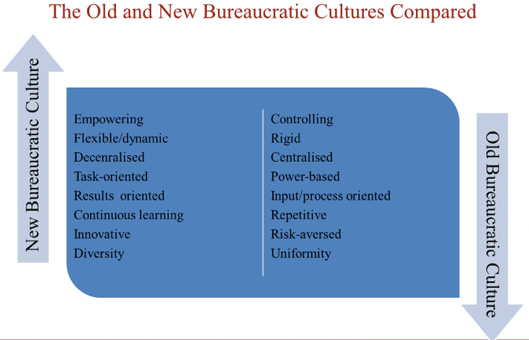
IS THE WEBERIAN GRAND BARGAIN IN PERIL?
- savoie (2005) has argued that the last 25 years have seen a breaking of the bargain between bureaucrats and their political masters
- in the 1970s-1980s, the traditional bargain guiding the relationship between politicians and career officials, which began to take shape in the early 1990s, was still in place
- if the policymaking and implementation process was a dance floor, ministers and bureaucrats completely dominated it in the 1980s
- ministers and bureaucrats were able to operate in isolation and prepare policy initiatives with limited public consultation and engagement in this closed and monopolized floor
- this was the era of the Weberian ideal bureaucracy - the good old days

IS THE GLUE COMING UNSTUCK?
- Savoies (2006) argues that today, the dance floor is over-crowded with new actors
  - lobbyists, interest and advocacy groups, think tanks, research institutes, policy consultants and the media
- they are “elbowing their way onto the dance floor” at the invitation of politicians
- it’s a very different time and dance, one in which public servants “no longer control their work environment to anything like the extend they did 25 years ago”
- in brief, government has become a proud operation, open to many policy actors
  - this new dance requires new tools, skills, and expertise that public servants might be lacking

THE DEATH OF NEUTRAL ADVICE
- for bureaucrats, their traditional world is collapsing because on policy matters, politicians no longer want neutral advice
  - they now insist on responsive competence if not partisan competence
- modern politicians come to office with a policy agency or at least a policy bias and look to career officials to embrace the bias and make it work
  - as such, the public service’s ability to speak truth to power is not appreciated as it was 25 or 50 years ago
- bureaucrats are now compelled to square this development with the basic values of their institutions
  - an anonymous, neutral and merit-based career service designed to promote detached, non-partisan and objective policy advice is dead
- public servants know that if they are not willing to offer the required responsive policy advice, politicians can now turn to many other sources to secure it

WEBER TODAY
- most public organizations are still structured, organized and managed based on the Weberian structure and hierarchy
- similarly, most private firms and corporations are also based on and structured around the Weberian structure
- most security agencies, police, intelligence, and especially the military is heavily based on and structured around the command control of the ideal bureaucracy
- whenever there is a scandal in the public sector (sponsorship scandal), the natural tendency of governments is to return to or attempt to return to the Weberian command and control, rules and regulations, accountability etc (FAA)

