Art of Africa in Modern Era
18th Century European Art

Present-Day Africa
- Work was stylized
- Artistic development within their community
Slave Ship
- On a massive scale people were being brought along the ocean
- The detailed plans and cross sectional drawing of the slave ship brookes was distributed by the abolitionist society in England as part of their campaign against the slave trade
- -
Julie Mehretu Dispersion 2002
Ink and acrylic on canvas
- Presenting the chaotic movement in the slave trade
- 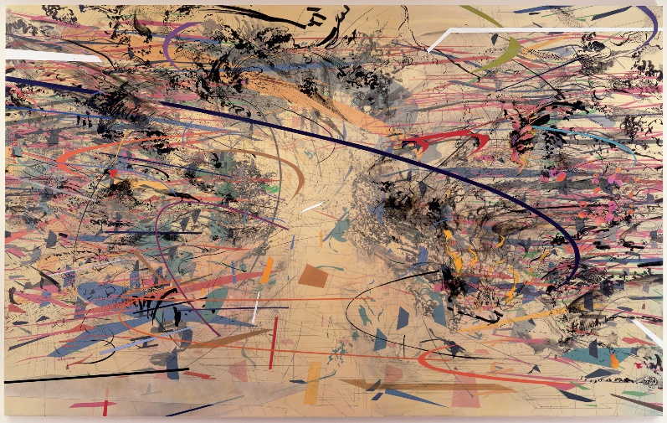

West African courts
Owo and ijebu: Composed primarily of Yoruba peoples
Benin: Composed primarily of edo people. Had the ijebu under their control
Title of oba: or king passed from generation to generation
Illefile: cradle of yuroba culture

Head of an oba, 16th century, Nigeria, court of benin
Brass
- Placed on alter of palace
- Oba king
- Wearing a cap of beads and extending over his ears
- And a single bead hanging over his forehead on his headdress
- Worn low on neck is someone of a benin ruler or of someone who has passed away at a young age
- These sculptures acted as vessels for transferring the kings power to the new king
- And can connect with the king daily
- The locus of the sculptures knowledge explains why the head was casted bronze
- Oba sculptures tend to be stylized
- Representing the king in the prime of his life: looking well

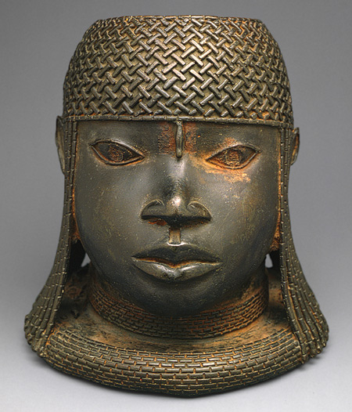
Head of an oba, 18th century
Nigeria, court of benin
Brass, iron
- 3 raised marks above his eyes were a characteristic during this period, representing ritual marks. Men usually had three above each eye, and women usually had four.
- 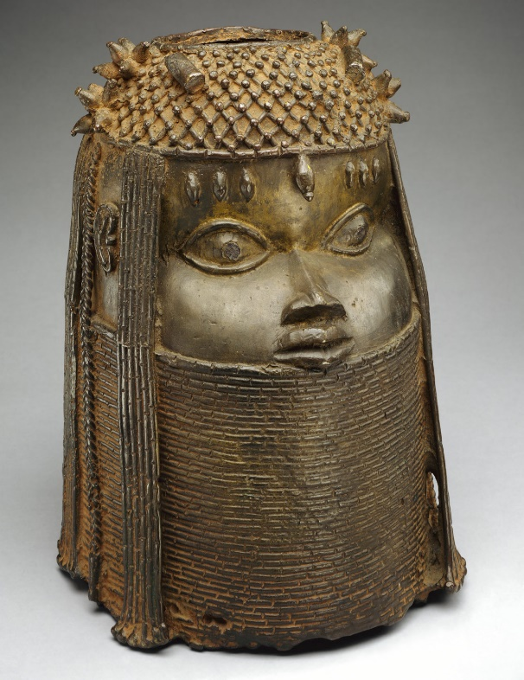
Empire Benin: oba people were separated from their people. And their villages were spoiled. British sold the benin art to get rid of the costs of the invasion and pay for the militaries damages. These artworks became very popular works. The new king used arts very strategically and made sure that they represented their culture. He also installed an alter for his father. The British returned pieces of the Oba artworks to the Benin empire. Upon receiving what the Oba would have owned, he was very happy. Solomon OSagie Alonge: young guy bringing back the Oba artwork.
The earl of Plymouth right, visiting the oba of benin, oba akenzu
Chief francis odo osagie, benin city Nigeria 1960
- Hand colored silver gelatin print
- Photograph of chief

Twin figures
Nigeria. Yoruba culture, 20th century. Wood
- The Yoruba people ate a lot of Yams, and they had the highest rates of twin births because they produce more estrogen – having more ovulations.
- The twin babies were cherished in the Yoruba people. They were faced a higher chance of loosing a child during birth.
- They produced sculptures of the twins to have one of the twins as the soul of the child with them
- The mother then cares for the child as if they were her actual child. They have the child in a case in the mother’s room and the mother cherishes it and rubs it to feed it
- If the statue is neglected than the soul ravishes on the mother and community causing illness and curses.
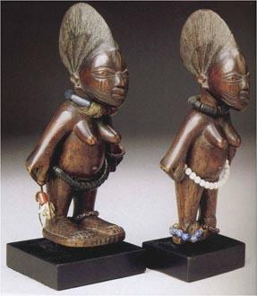
Mask, Burkina faso black volta river region, bwa peoples.
19th century, 20th century, wood pigment and fibre
- the bwa created masks with leaves and vines in ceremonies
- now they use wood masks
- the initiates for the ceremony is they are kidnapped by their older siblings and lay outside on the ground and are with nature learning how to connect with the spirits. Taught ceremonial songs
- interacting with the flying spirits
- even though the spirits are invisible they have associations with water, and can turn into large insects and swarm in circle after it rains
- they are originally embodied in the masks
- there are symbols on the masks that the older people teach the younger
- the black and white squares can represent the animal skins
- or represent the good and evil/light and dark. The initiate learning of the morals
- masks can use for burials, with the harvests and the planting
- the body of the dancer is concealed with a bushy fibre costume either dyed red or black: it is common in the ceremony for the dancer to twist back and forth and to raise the mask as if it is an embodied flying spirit.
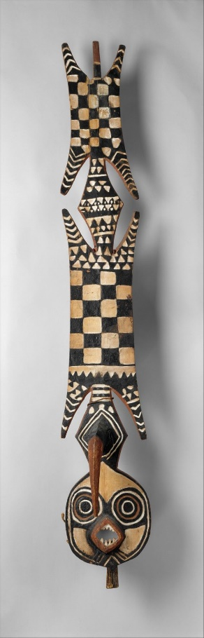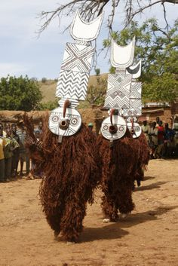

Sowei helmet mask, 1886
Raddia palm fibre and cotton wood
- women bondo
- older women
- the masks are carved as expressions of what the local ideals are of feminine beauty and serenity
- mask featured here was found by a british colonial
- there is a top hat
- Imported western clothing were signs of hpiaving an elite status: top hat showing elite status
- 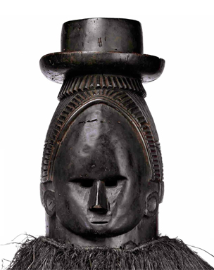
Picasso – owned a large collection of African masks: he develops these artworks in his artwork
Set of initiation wall panels showing a colonial administrator flanked by a Congolese soldiers, nikanu upeoples, democratic republic of the congo, early 20th century.
Wood, pigment.
- in these ingcanda celebration ceremonies they are celebrating the nikanu as a child and then they go back into the community as an adult
- who ever is in the ritual makes the wall panels that the masks go into
- the young men by observing learn about the meanings of the symbols within their community.
- This artwork was intended for display in the community
- the nikanu are on display here
- some of the initiates keep the masks on display to use in further ceremonies
- 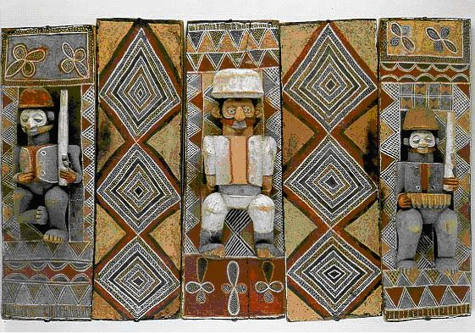
Nkanda: initiations. Work was attributed to their clans. Works that have been pillaged and taken from them and brought to western museums.
Kikaku: the structure
Wall panel showing a gaboon viper with an antelope in its mouth
20th century
- Antelopes represent the young initiates who are young and cheeky
- The initiates must rely on the protection of the chief and not outsmart their elders
- The initiates are often rereferred to as birds
- 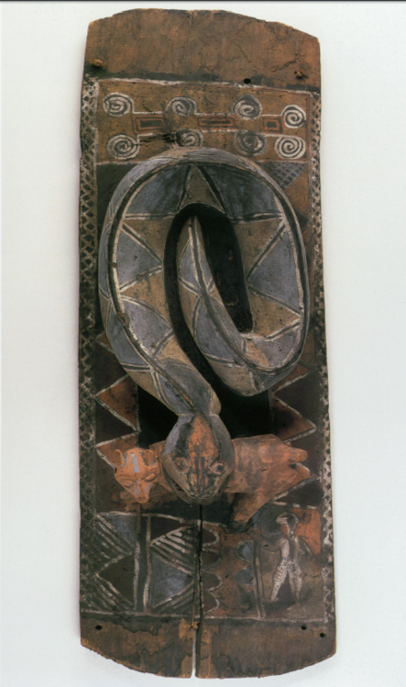
Floor sculpture portaying a snake flanked by a dog and civet or genet
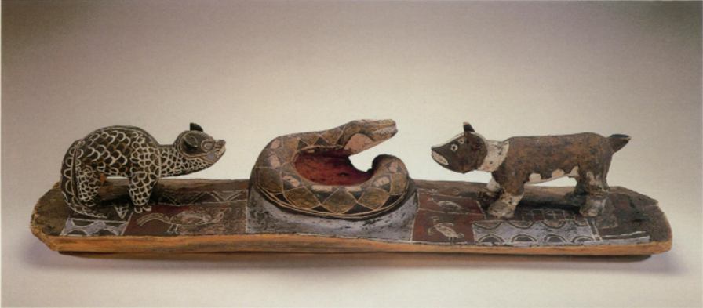
Wood, pigment
- The coiled snake is the male organ
- The dog is uncircumsized and the other one is circumsized
- Dick = snake
Wall panels with a female figure and a European.
Early 20th century.
Wood fibre, hair, pigment
Wall panels showing a woman giving birth and a European man.
Wood, fibre, pigment
- The men are in the middle of clapping hands
- European contact at this time

