Lecture 1
Principles of CPET 1

What is an integrative CPET?
- CPET permits simultaneous examination of the responses of the cardiovascular and ventilatory support systems to known exercise (metabolic) stress through the measurement of external respiration
- In the context of disease, CPET permits systematic examination into the pathophysiological mechanisms of exercise intolerance and exertional symptoms (ex: fatigue, dyspnea, chest pain/angina)
- It is integrative meaing it measures many physiological support systems
- Pathophysiological mechanisms of inability to exercise and symptoms in their daily life or in response to stress
- Need stress to provoke symptoms so people adapt physical activity levels to prevent the symptoms from occurring
- So we bring people into the lab to stop these symptoms instead of avoididng them

Questions addressed by CPET
1. Is exercise capacity reduced? Peak VO₂ and/or work rate that is >85% of the age, sex and height predicted normal value = no serious impairment in the function of physiological support system function.
2. Is the metabolic requirement for a given exercise stimulus increased?
3. Is exercise limited more by a patients ability to breath (ventilatory limitation) or by their ability to pump blood (cardiovascular limitation)? OR MUSCULAR?
4. Is there an abnormal degree of ventilation-perfusion mismatching? A lot of wasted ventilation? Oxygen desaturation? Not normal for healthy adults – desaturation bohr effect
5. Is there a deficit in muscle O₂ utilization or substrate utilization?
6. Is exercise limited by a psychogenic factors? Can be from panic and anxiety
7. Is peak power output abnormal because of poor effort? Can have reassurance that its not because of power output
8. Is the perceptual response to exercise abnormal? If yes, what’s the cause(s)? Do we have shortness of breath w low levels of ventilation? Severe leg fatigue? Low levels of metabolic demand?

- If one is not exercising to age height and sex predicted value then there is an abnormality
When should the patient undergo CPET?

- Differential diagnosis:
- When the cause of breathlessness (dyspnea), chest pain (angina) and/or exercise intolerance is uncertain, CPET can help identify the contributory factors
- Detection of a previously undiagnosed disorder
- Doctor isn’t sure of whats going on
- Ex: blood pressure and lipid levels normal but expericing functional impoment
- Measuring impairment for disability evaluation
- CPET provides objective assessment of exercise capacity and degree of functional impairment
- Impairment = any loss or abnormality in organ structure or function. Ex: failure of the heart
- Disability = any restriction or lack of ability (resulting from impairment) to perofrm an activity within the range considered normal for a human being results from impairment
- this identifies what the safe level of exercise to perform is and to identify the cause of impairment of disability
- ** disability is a consequence of impairment
- Cardiovascular, ventilatory and muscular systems have a large physiological reserve; thus, clinical manifestations (e.g., inability to perform daily activities) only occur when physiological capacity is greater reduced!
- Measurements made at rest inadequately reflect physiological capacity.
- CPET may reveal abnormalities at an earlier stage of the cardiopulmonary disease process.
Ability to perform Activities of Daily Living (%)
Physiological Capacity (%)
0
100
100
graph:
will be tested on!
Physiological capcity perfect cardio pulmonary uscular metabolic support funcgion
This graph shows that you to have lose a considerable amount of physiological capacity before you begin to see an impairment in daily living (left to right)
This is an indication of why for example a resting test don’t bring up stress so tey don’t show abnormalities in the early stages of disease – don’t stress system enough
Exercise testing allows physiological capacity beyond routine resting tests + can catch things early in the disease process
And due to physiological reserve resting tests are unsufficient

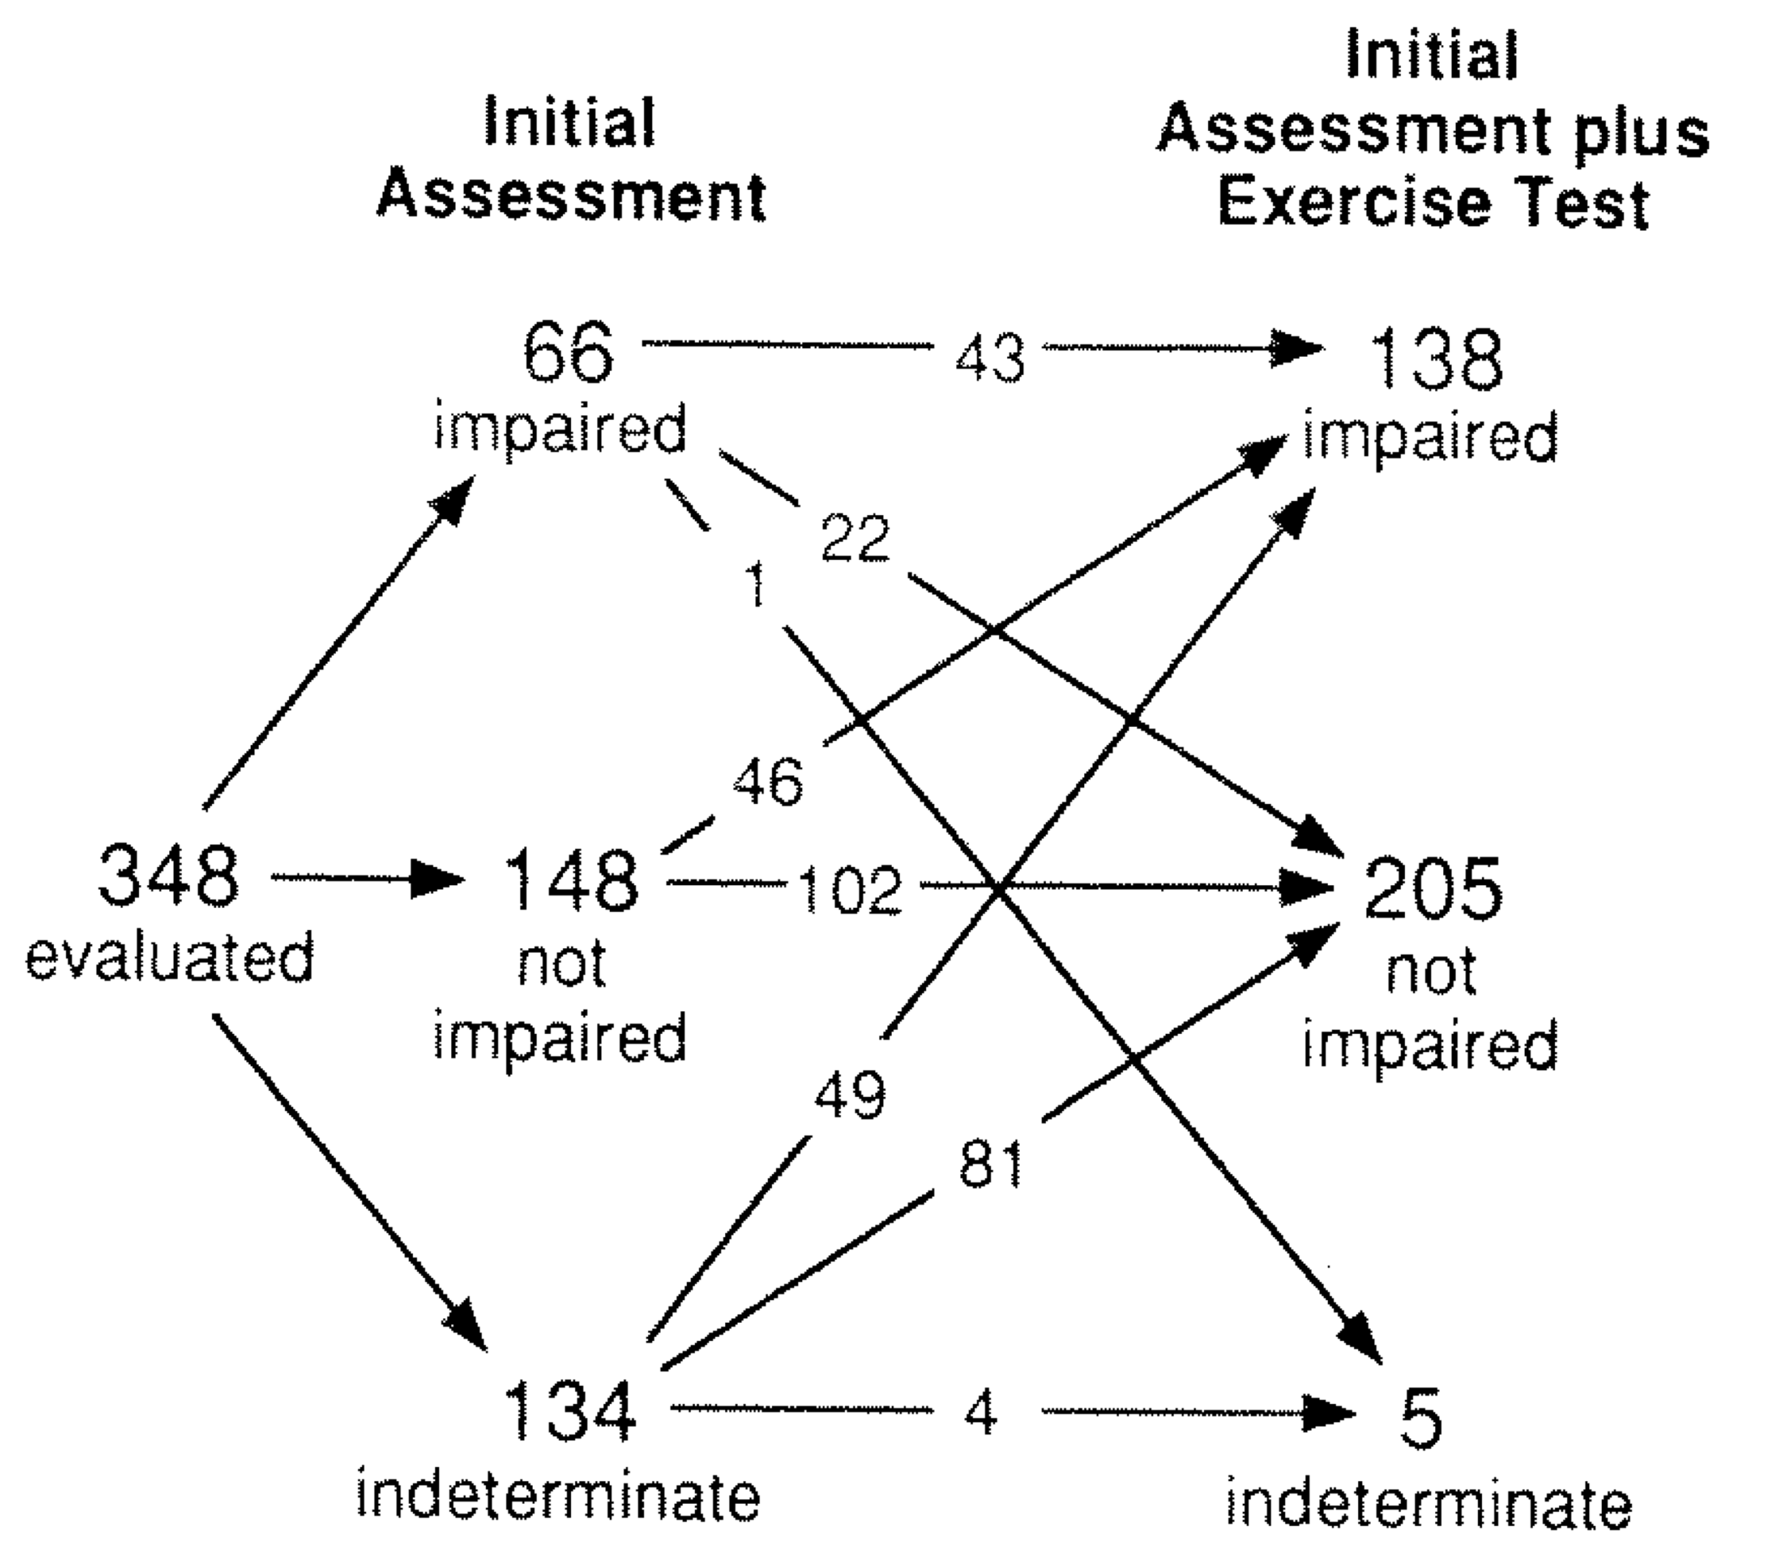
- 134 went to 5
- more indivudals were made as not impaired
- how do people go from impaied to indeterminate?
  - Ex: chest x ray was called a pneumonia but then it was clear that it was just scarring or something, doesn’t get worse in exercise
This shows before and after cpet

- Evaluation of occupational health

- Assessment of disability for indisutrial/work compensation and the ability of a wrker to carry on his or her job is an important application for cpet

Ex: oxygen cost of work assessment
- Perform cpet to determine peak vo2
- Examine peak vo2 in relation to known averages of the energy/oxygen cost of the job (1 met = 3.5 ml o2/kg/min)
- Work an be comfortable and safely performed at 40-50% of peak vo2
- Then there is a graph that shows how much o2 intake the job requires
- Ex: receptionist least metabolic cost vs a steel worker
- Rehabilitation:
- CPET helps to define the intensity of exercise that the patient can perform safely and without undue stess (ex: guides exercise prescription)
- CPET before and after rehabilitation permits quantification of the benefit of rehabilitation as well as the mechanism of improvement
- Can prescribe exercise based on known maximum capacity, this defines intensity tha a ptient can perform
- Before and after rehab allows to quantify the results
- Ex: reducing in blood lactate levels: evidence of mitochondrial and aerobic improvement

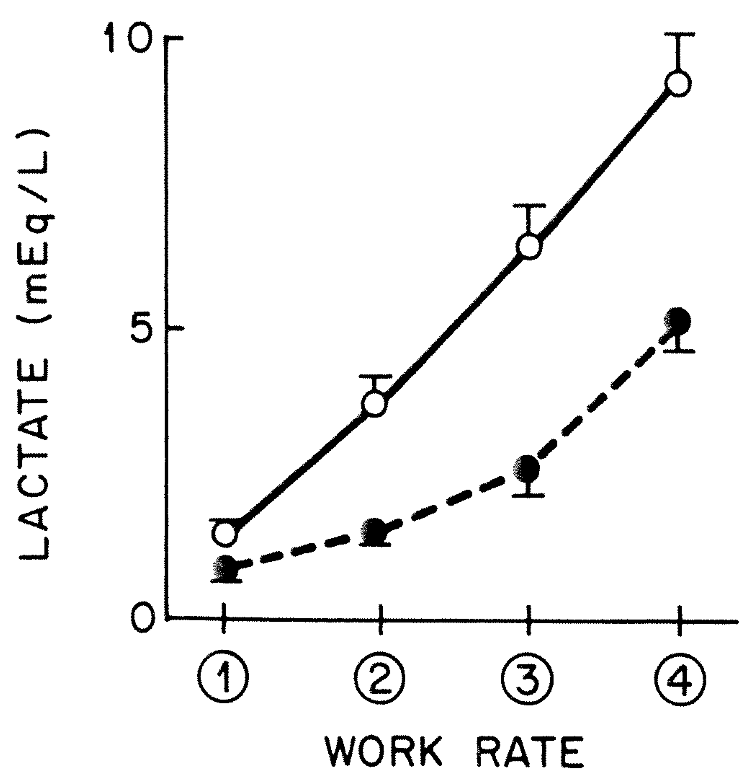

- Assessing preoperative risk:
- Physiological response to CPET provides an index of the bodies overall capacity to respond to stress, such as major surgery.
- Don’t want to put someone into surgery who cant handle th e stress
- Need to have physiological reserve capcity to tolerate the stress of surgery
Table: yes bad
2 or 3 are abnormal and then assess the risk
30 days or 90 days after surgery
Hartley et al. British Journal of Surgery. 99: 1539-1546, 2012.

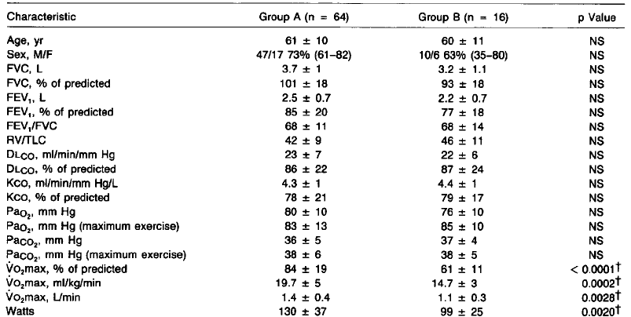
Left is patients without post op complicatiosna dn right is patients with
See how the patients with have lower vo2 max and lower than predicted

Grading severity of and prognosis in cardiopulmonary disease:
Ex: congestive heart failure
Group of 100 ind. With given level of severity of 30-35%
Within that 35% they have the same severity but a lot of variability exists
Looking at peak vo2, there is a lot of peak variability with exercise capacity
So even tho heart function is similar, can have different exercise capacity
VT = ventilatory (or anaerobic) threshold; VO₂ = metabolic rate of O₂ consumption in ml/kg/min
The worse class youre in for weber for heart failure (class d is the worst) the more likely you are to have an event
Event free survival decreases as weber class increases as vo2 peak dcrease

Evaluating effectiveness of therapy or progression of disease:
- Repeated CPET permits quantification and identification of mechanisms of improvement following various forms of medical therapy (ex: rehabilitation, pharmacotherapy) or worsening of disease severity

Graph review

And
Assessingfunctional capacitybefore hospital discharge; for example post myocardial infarction or surgery
Reassurance: exclusion ofpossiblity of serous diseae by cpet results within normal range baed on age, sex height and body mass

What limits exercise in health and disease?
Cardiovascular factors
Respiratory factors
Neuromuscular factors
Metabolic factors
- Most likely combination of all these things, yet one can be more contributing than others
- Most people come in with COPD with history of asthma, hypertension, heart issues, etc

Cigarette smoking is number one risk factor for COPD and cardiovascular disease, they occur in combination
Rare to really have one pure disease, often comorbid

Doctors manage the symptonms in many ways with palliative care

What limits exercise?
- Exercise is a voluntary activity and the majority of people stop when the intensity of a particular sensation (ex: breathlessness, leg fatigue, pain_ becomes intolerable, despite evidence of adequate cardiovascular and ventilatory reserve (ex: peak heart rate < age predicted maximum)
- Rather than dismissing symptos as subjective and by implication worthless it is better to quanitify them so that the factors contrivbuting to the symptom limiting exercise can be examined
- Breathless is the primary cause of activity limitation in patient swith COPD

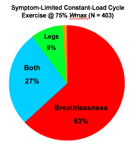
pie chart of why people with COPD stop

9/10 patients with copd are stopping prematurely due to intolerable symptoms of breathlessness alone or in combination of leg fatigue

Locus of symptom limitation predicts mortality among 1,923 healhty middle-aged men

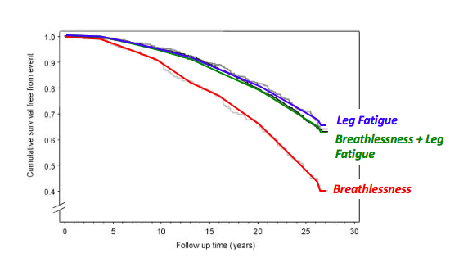
2,000 healthy middle aged men that were followed
26 year follow up study!!
At the beginning u stop because of breathlessness for ex
Those who stopped cuz of breathlessness have amuch lower value for event free survival
Just the reason for stopping exercise is predictive of whos gonna have health issues 26 years later!

Insert pic
Looking at mortality for patients that are referred for exercise stress testing
1 reference value
value to the right (squares) means in follow up after being referred to exercsiet esting youre more likely to die
to the left more likely to die than if you stop because of breathlessness
shows that patients that stopped due to breathless were 2.57 fold higher annual mortality rate than patients with chest pain
so breathless is WORSE
with chest pain still occurs as a risk but not as high as breathlessness
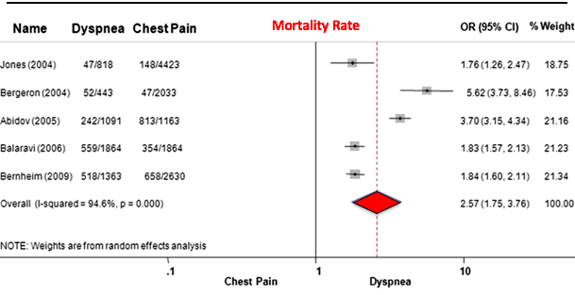

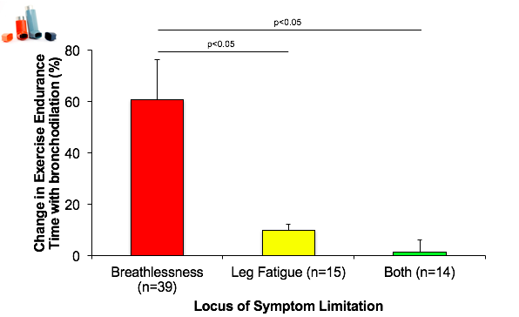
Change of exercise endurance time and sepearted them in patients with moderate to severe copd, based on stopping due to these three factors
Found that only patients with breathlessness stopping experienced bronchodilation improvement in exercise time
If breathlessness is your primary limitation then bronchodilation will obviously help that

From Dennis Jensen lab:
People that stop because of breathlessness they have more abnormal change in lung volume during exercise and lungs are much more inflamed, lungs are much more hyperinflated
Therefore, these people respond much better to bronchodilation
The higher the peak tidal volume, the more impaired your lung function is (peak inspiratory reserve volume)
Thelower your inspiratory reserve volume, the closer youre breathing to total lung capacity really hyperinflated

See slide
So peak tidal volume is highest for those with breathlessness, so obviously they have hyperinflation

People with leg discomfort can get more help from rehab rather than bronchodilators

