Respiratory Physiology
SF

- Breathing a mechanical process that depends on volume changes in the thoracic cavity
- Intrapulmonary pressure
  - Pressure in the alveoli, intra-alveolar
    - Fluctuates with breathing
    - Always eventually equalizes with P_{atm}
  - Pressure inside lung decreases as lung volume increases during inspiration; pressure increases during expiration
- Intrapleural pressure
  - Pressure in pleural cavity
    - Always NEGATIVE
    - Minimal fluid level
    - Fluctuates
  - Pressure becomes more negative as chest wall expands during inspiration; returns to initial value as chest wall recoils
- Transpulmonary pressure
  - Intrapulmonary pressure – intrapleural pressure
    - Keeps lung space open
    - GREATER transpulmonary pressure LARGER lung
- Atelectasis
  - Lung collapse (partially or fully)
    - Pneumothorax (air in pleural cavity)
      - Rupture of visceral pleura
      - Wound in parietal pleura
    - Plugged bronchioles collapse of alveoli
- Boyle’s Law
  - Relationship between gas pressure & volume
  - Inverse relationship
- Inspiration - ACTIVE
  - 1. Inspiratory muscles contract (diaphragm descends; rib cage rises)
  - 2. Thoracic cavity volume increases
  - 3. Lungs are stretched; intrapulmonary volume increases
  - 4. Intrapulmonary pressure drops (-1mmHg)
  - 5. Air flows into lungs down its pressure gradient until intrapulmonary pressure is 0 (equal to atmospheric pressure)
  - Diaphragm moves INFERIORLY
  - External intercostals CONTRACT
- Expiration – PASSIVE
  - 1. Inspiratory muscles relax (diaphragm rises; rib cage descends)
  - 2. Thoracic cavity volume decreases
  - 3. Elastic lungs recoil passively; intrapulmonary volume decreases
  - 4. Intrapulmonary pressure rises (+1mmHg)
  - 5. Air flows out of the lungs down its pressure gradient until intrapulmonary pressure is 0
  - Diaphragm moves SUPERIORLY
  - External intercostal RELAX

- Volume of breath
  - 500mL of air in and out of lungs
- Forced inspiration
  - Vigorous exercise
  - Chronic obstructive pulmonary disease
    - Accessory muscle further increase thoracic volume
      - Scalenes, sternocleidomastoid, pectoralis minor
      - Erector spinae muscles
- Forced expiration
  - Active process
    - Strenuous exercise
    - Stress response
    - Asthma attack
    - Emphysema
    - Accessory muscles help expel air (abdominal & internal intercostal muscles)
- Non-respiratory air movements
  - May modify normal respiratory rhythm
  - Some reflexive & some voluntary
    - Sneeze
    - Cough
    - Hiccup
    - Yawn
    - Cry
    - Laugh
- Influencing factors
  - Hinder air passage & pulmonary ventilation (energy required to overcome)
    - Airway resistance
    - Alveolar surface tension
    - Lung compliance
- Airway resistance
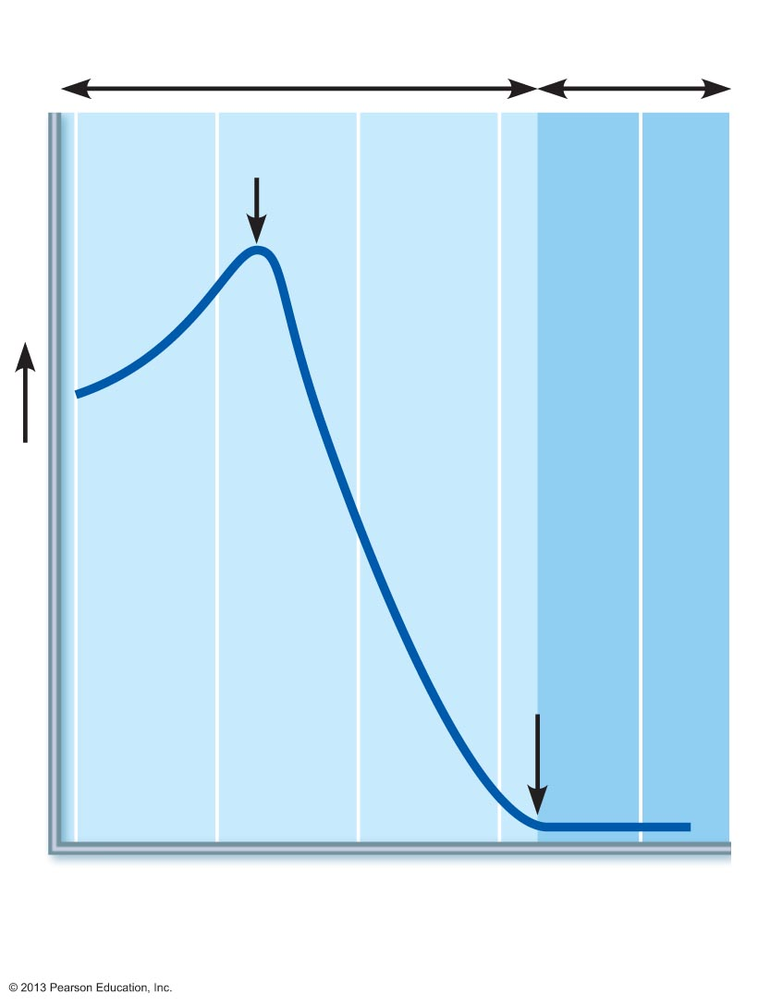
  - Relationship between flow (F), pressure (P) & resistance (R)
$$F=\frac{∆P}{R}$$
  - $∆P$, pressure gradient between atmosphere & alveoli (2mmHg or less during normal quiet breathing)
  - Gas flow changes inversely with resistance
  - What controls bronchial diameters?
    - Bronchoconstriction reduce air flow
    - Bronchodialation increase air flow
- Resistance in branching airways
  - When is airway resistance insignificant?
  - Why does airway resistance disappear at terminal bronchioles?
- Air resistance homeostatic imbalance
  - Inhaled irritants, asthma attack, mucus, tumor
    - Constriction or obstruction or bronchioles
      - Can prevent life-sustaining ventilation
      - Can stop ventilation
    - Epinephrine (sympathetic)
      - Dilates bronchioles, reduces air resistance
  - As air resistance rises, breathing movements become more strenuous
- Alveolar surface tension
  - Surface tension
    - Attract liquid molecules to one another at gas-liquid interface
    - Resists any force that tends to increase surface area of liquid
    - Surface tension of alveolar fluid tends to pull alveolar walls towards the center, or collapse them
  - Surfactant
    - Detergent-like lipoprotein produced by type II alveolar cells
    - Reduces surface tension of alveolar fluid
    - Prevents alveoli from collapsing
  - Infant Respiratory Distress Syndrome
    - Insufficient quantity of surfactant in premature infants
      - Alveoli collapse after each breath
  - Lung compliance
    - Measure of change in lung volume that occurs with given change in transpulmonary pressure
$$C_{L}=\frac{∆V_{L}}{∆\left(P_{pul}-P_{ip}\right)}$$
    - Higher compliance easier to expand lungs
    - Normally depending on
      - Distensibility (capability to be extended) of lung tissue
      - Alveolar surface tension
  - Lung compliance homeostatic imbalance
    - Diminished lung compliance
      - Nonelastic scar tissue (fibrosis)
      - Reduced production of surfactant
    - Decreased flexibility of thoracic cage
      - Paralysis of intercostal muscles
      - Ossification of costal cartilage
      - Deformities of thorax
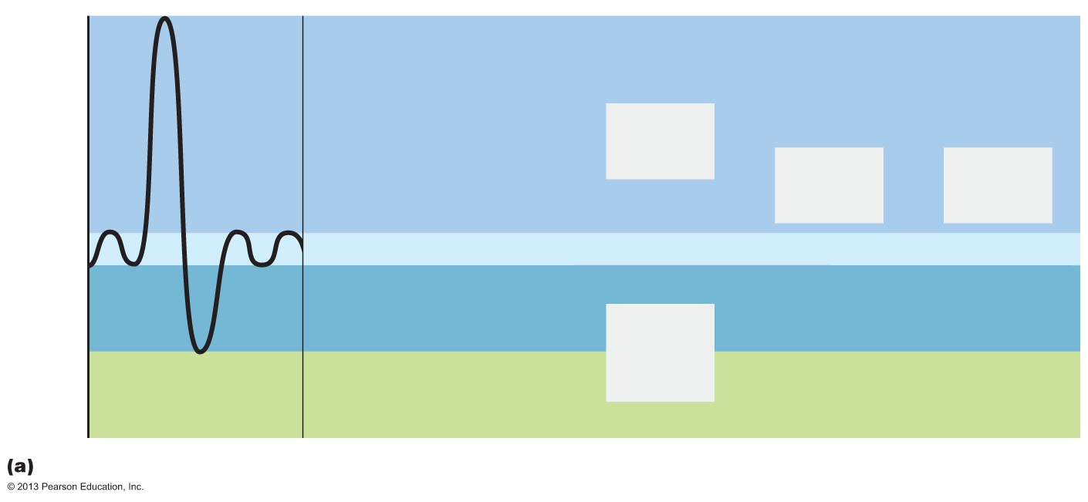
  - Assessment of ventilation
5000
4000
3000
2000
1000
0
6000
Inspiratory
reserve volume
3100 ml
Expiratory
reserve volume
1200 ml
Residual volume
1200 ml
Inspiratory
capacity
3600 ml
Functional
residual
capacity
2400 ml
Vital
capacity
4800 ml
Total lung
capacity
6000 ml
Tidal volume 500 ml
Milliliters (ml)

- Dead space
  - Anatomical dead space
    - No contribution to gas exchange
    - Air remaining in passageways (~150mL, 1mL/pound BW)
  - Alveolar dead space
    - Non-functional alveoli (collapse or obstruction)
  - Total dead space
    - Sum of anatomical & alveolar dead space
- Pulmonary Function Tests
  - Obstructive pulmonary diseases
    - Increase in airway resistance (bronchitis)
      - TLC, FRC, RV may increase (hyperinflation)
  - Restrictive disorders
    - Stiffen lungs due to disease or fibrosis
      - VC, TLC, FRC, RV decline (limited expansion)
- Vital capacity (VC) was measured using a spirometer. As he breathed into a handheld device, the speed and volume of air flow was calculated from the output of a pressure transducer.
- Spirometer – instrument for measuring respiratory volumes & capacities to gain information about a person’s respiratory status. Not specific diagnosis, only differential obstructive vs restrictive.
- Pulmonary function tests evaluate losses in respiratory function using a spirometer to distinguish between obstructive and restrictive pulmonary disorders
- Obstructive pulmonary diseases (DO NOT reduce respiratory volumes), narrow the airway & interfere with airflow, involve hyperinflation of the lungs and are characterized by increased TLC, FRC and RV
- Restrictive pulmonary disorders, in which expansion of the lungs is limited, display low VC, TLC, FRC, and RB.
  - Stiffen the lungs and thus reduce compliance & vital capacity.
- 1. Total lung capacity (TLC) is the sum of all lung volumes
- 2. Functional residual capacity (FRC) is the combined residual volume and expiratory reserve volume and represents the amount of air that remains in the lungs after a tidal expiration
- 3. Residual volume (RV) is the amount of air that remains in the lungs even after the most strenuous expiration
- 4. Vital capacity (VC) is the sum of tidal volume, inspiratory reserve, and expiratory reserve volumes and is the total amount of exchangeable air
- Tidal volume (TV) is the amount of air that moves into and out of the lungs with normal breathing. Inspiratory reserve volume (IRV) is the amount of air that can be forcible inhaled beyond the tidal volume. The expiratory reserve volume (ERV) is the amount of air that can be evacuated from the lungs over and above a tidal expiration. Residual volume (RV) is the amount of air that remains in the lungs even after the most strenuous expiration.
  - Vital capacity (VC) is the total amount of exchangeable air
- Rate of Pulmonary Ventilation
  - Forced vital capacity (FVC)
    - Gas forcibly expelled after a deep breath as rapidly as possible
  - Forced expiratory volume (FEV)
    - Gas expelled during specific time intervals of the FVC test
- Asthma – reversible OPD
  - Airway inflammation
  - Immune response caused by release of histamine and other inflammatory chemicals
  - Active airway inflammation bronchospasms
  - Coughing, dyspnea, wheezing, chest tightness
- Alveolar Ventilation
  - Total volume of gas flowing into or out of respiratory tract in 1 minute
    - Normal at rest = ~6L/min (500mL x 12 breath/min)
    - Normal with exercise = up to 200L/min (rough estimate of respiratory efficiency)
  - Alveolar ventilation rate (AVR)
    - Flor of fresh gases in and out of alveoli during a specific time interval
- Breathing Rate & Depth

- Gas Exchange
  - Occurs between lungs & blood as well as blood & tissues
  - Both processes are subject to:
    - Basic properties of gases
    - Composition of alveolar gas
- Dalton’s Law
  - Total pressure exerted by mixture of gases = sum of pressures exerted by each gas
  - Partial pressure exerted by each gas
    - Directly proportional to its percentage in the mixture

- Henry’s Law
  - Each gas dissolves in proportion to its partial pressure
  - At equilibrium, partial pressures in two phases will be equal
  - Amount of each gas that will dissolve depends on
    - Solubility
      - CO₂ 20x more soluble in water than O₂, little N₂ dissolves in water
    - Temperature
      - As temperature rises, solubility decreases
- Sites of Gas Exchanges
  - External respiration
    - Diffusion of gases in the lungs
  - Internal respiration
    - Diffusion of gases at body tissues
- External Respiration
  - Diffusion of O₂ & CO₂ across respiratory membrane
  - Influencing factors:
    - Surface area & structure of respiratory membrane
    - Partial pressure gradients & gas solubility
    - Ventilation – perfusion coupling
- Respiratory Membrane
  - Only 0.5 – 1 $μm$ thick
  - Large total surface area (~90 m² , 40x of skin)

- Partial pressures
  - Alveoli: more CO₂ & water vapor, less O₂
    - Gas exchanges in lungs (O₂ in & CO₂ out)
    - Humidification of air (CO₂ is 20x more soluble than O₂)
    - Mixing of alveolar gas (500 mL/tidal)
- O₂ Loading & CO₂ Unloading
- Ventilation – Perfusion Coupling
  - Perfusion
    - Blood flow in pulmonary capillaries
  - Ventilation
    - Amount of gas reaching alveoli
  - Closely matched for optimal gas exchange
    - Local autoregulation
    - Never balanced for all alveoli because of
      - Regional variations, effect of gravity on blood & air flow
      - Some alveolar ducts plugged with mucus

- Effects of local P_{O2} & P_{CO2}
  - Local P_{O2} controls perfusion by changing arteriolar diameter
    - Where alveolar O₂ is high, arterioles dilate
    - Where alveolar O₂ is low, arterioles constrict
      - Directs most blood to high alveolar oxygen to pick up more oxygen
  - Local P_{CO2} controls ventilation by changing bronchiolar diameter
    - Where alveolar CO₂ is high, bronchioles dilate
    - Where alveolar CO₂ is low, bronchioles constrict
      - Allows elimination of CO₂ more rapidly
- Alveoli Pathology
  - Thicken if lungs become waterlogged & edematous (pneumonia or heart failure)
    - Gas exchange inadequate
  - Reduced surface area in emphysema (walls of adjacent alveoli break down), tumors, inflammation, mucus
- Internal Respiration
  - Capillary gas exchange in body tissues
  - Partial pressures & diffusion gradients reversed compared to external respiration
    - Tissue P_{O2} always lower than in systemic arterial blood oxygen from blood to tissues
    - CO₂ from tissues to blood
- Gas Transport
  - Oxygen (O₂)
  - Carbon dioxide (CO₂)
- Oxygen Transport
  - Molecular O₂ carried in blood
    - 1.5% dissolved in plasma
    - 98.5% bound to Fe of hemoglobin in RBC
      - Oxyhemoglobin (HbO₂, hemoglobin-O₂ combination)
      - Deoxyhemoglobin (HHb, reduced hemoglobin)
- Hemoglobin Dissociation Curve
  - Sigmoidal nature
  - O₂ binding & release affected by P_{O2}
- Arterial P_{O2} & Hb saturation

- Venous P_{O2} & Hb Saturation

- Other Influencing Factors
  - Increases in temperature, P_{CO2}, H⁺ and BPG modify structure of hemoglobin decrease O₂ affinity
    - Occur in systemic capillaries
    - Shift O₂ hemoglobin dissociation curve to the right
    - Enhance O₂ unloading from blood
  - Decreases in any of these shift curve to left
    - Decreases O₂ unloading from blood
- Factors Increasing O₂ Release
  - As cells metabolize glucose & use O₂
    - Increases in P_{CO2} & H⁺ in capillary blood declining pH (acidosis) & increasing P_{CO2} Hb-O₂ bond weakens (Bohr effect) oxygen unloading where needed most
    - Heat production in active tissues directly & indirectly decreases Hb affinity for O₂ increased oxygen unloading
- Hypoxia
  - Poor O₂ delivery to tissues cyanosis
    - Anemic hypoxia
      - Too few RBCs; abnormal or two little Hb
    - Ischemic hypoxia
      - Impaired or blocked circulation
    - Histotoxic hypoxia
      - Cells unable to use O₂, as in metabolic poisons
    - Hypoxemic hypoxia
      - Abnormal ventilation, pulmonary diseases
    - Carbon monoxide poisoning
      - A leading cause of death from fire
- Oxygen Toxicity
  - P_{O2} > 2.5-3 atm free radical
    - CNS disturbance
    - Coma
    - Death
- CO₂ & Bicarbonate Ions
  - Body cells produce 200 mL of CO₂ per minute
  - CO₂ combines with H₂O to form carbonic acid (H₂CO₃) which quicly dissociates
  - H₂CO₃ formation occurs primarily in RBCs, where carbonic anhydrase reversibly & rapidly catalyzes this reaction
  - 70% CO₂ is transported via HCO₃⁻ in plasma
- CO₂ pickup at the tissues
  - Dissolved in plasma (7-10%)
  - Bicarbonate ions (HCO₃⁻) in plasma (70%)
  - Bound to Hb HbCO₂ (carbaminohemoglobin, 20%)
  - Oxygen releases and carbon dioxide pickup at the tissues
- CO₂ release in the lungs
  - Process is reversed in pulmonary capillaries
    - CO₂ dissolved in plasma simply diffuses into alveoli
    - HCO₃⁻ combines with H⁺ to form H₂CO₃ H₂O +CO₂
    - HCO₃⁻ back into RBCs H₂O + CO₂ (carbonic anhydrase)
    - HbCO₂ Hb + CO₂
    - Oxygen releases and carbon dioxide releases at the lungs
- Haldane Effect
  - Amount of CO₂ transported is affected by P_{O2}
    - The lower P_{O2} & hemoglobin saturation with O₂, the more CO₂ can be carried in blood
    - Reduced hemoglobin buffers H⁺ and forms carbaminohemoglobin more readily
  - Encourages CO₂ exchange in tissues & lungs
  - At tissues, as more CO₂ enters blood:
    - More O₂ dissociates from hemoglobin (Bohr effect)
    - Releases of O₂ from HbO₂ permits more CO₂ to form bond with Hb HbCO₂ (Haldane effect)
- Influence of CO₂ on Blood pH
  - Blood buffered by carbonic acid-bicarbonate system
    - If H⁺ concentration in blood rises, excess H⁺ is removed by combining with HCO₃– H₂CO₃ CO₂ and H₂O
    - If H⁺ concentration drops, H₂CO₃ H⁺ and HCO₃–
    - HCO₃– is considered the alkaline reserve of the buffer system
  - Effects of respiratory rate & depth on blood pH
    - Slow, shallow breathing CO₂ accumulates in blood pH drops
    - Rapid, deep breathing CO₂ decreases in blood pH rises
  - Respiratory ventilation is a fast-acting system to adjust blood pH & plays a major role in blood acid/base balance
- Control of Respiration
  - The brainstem
  - Chemoreceptors
  - Higher brain centers
  - Lung reflexes
- Respiratory Center in Brainstem
  - Reticular formation of medulla & pons
    - Ventral respiratory group (VRG)
      - Generates the basic respiratory rhythm
      - Sets eupnea (12–16 breaths/min, 2s in/3s out)
      - Inspiratory neurons excite diaphragm and external intercostals
      - Expiratory neurons inhibit inspiratory neurons
    - Dorsal respiratory group (DRG)
      - Integrates input from peripheral stretch and chemoreceptors, relays information VRG
    - Pontine respiratory centers
      - Influence & modify activity of VRG
      - Smooth out transition between inspiration and expiration, & vice versa
      - Lesions in this area of brain lead to apneustic breathing, prolonged inspirations
- Neural & Chemical Influences
- Influence of P_{CO2} H⁺
  - Most potent
  - Closely controlled (+/- 3mm Hg)
    - Blood P_{CO2} rise (hypercapnia)
      - CO₂ accumulates in brain
      - CO₂ + H₂O carbonic acid
      - H⁺ + HCO₃– pH drops
    - Increase in H⁺ excites central chemoreceptors of brain stem, which synapse with respiratory regulatory centers increase in depth & rate of breathing lower blood Pco₂ pH rises
- Influence of P_{O2}
  - Peripheral chemoreceptors in carotid & aortic bodies
    - Arterial O₂ level sensors
      - When excited, cause respiratory centers to increase ventilation
  - Po₂ effects on ventilation
    - Big O₂ reservoir bound to Hb
    - Drop in arterial Po₂ (to 60 mm Hg) a major stimulus to increase ventilation
- Influence of Arterial pH
  - pH can modify respiratory rate & rhythm even if CO₂ & O₂ levels normal
  - Only peripheral chemoreceptors (brain-blood barrier)
  - Decreased pH may reflect
    - CO₂ retention
    - Accumulation of lactic acid
    - Excess ketone bodies
  - Respiratory system controls attempt to raise pH by increasing respiratory rate & depth
- Summary of Chemical Factors
  - Rising CO₂ levels are most powerful respiratory stimulant
  - Normally, blood Po₂ affects breathing only indirectly by influencing peripheral chemoreceptor sensitivity to Pco₂ changes
  - When arterial Po₂ falls below 60 mm Hg, it becomes major stimulus for respiration (via peripheral chemoreceptors)
  - Changes in arterial pH resulting from CO₂ retention or metabolic factors act indirectly through peripheral chemoreceptors
- Pattern of Breathing
  - Hyperpnea
    - Increased ventilation in response to metabolic needs
  - Hyperventilation
    - Increased depth & rate of breathing that exceeds body's need to remove CO₂
      - decreased blood CO₂ level (hypocapnia)
        - tingling & involuntary muscle spasms
        - cerebral vasoconstriction & cerebral ischemia
        - dizziness, fainting periods of apnea
  - Apnea
    - temporary cessation of breathing (one or more skipped breaths)
- Exercise Adjustments
  - Adjustments geared to both intensity & duration of exercise
  - Hyperpnea (ventilation increases 10-20 fold)
  - Pco₂, Po₂, and pH remain constant during exercise
  - Three neural factors cause increase in ventilation as exercise begins
    - Psychological stimuli, anticipation of exercise
    - Simultaneous cortical motor activation of skeletal muscles & respiratory centers
    - Excitatory impulses to respiratory centers from proprioceptors in moving muscles, tendons, joints
  - Ventilation declines suddenly as exercise ends (the neural factors shut off)
  - Gradual decline to baseline as CO₂ flow declines after exercise ends
  - Exercise anaerobic respiration lactic acid
    - Not from poor respiratory function; from insufficient cardiac output or skeletal muscle inability to increase oxygen uptake
- Control of Breathing
  - Depth determined by how actively respiratory center stimulates respiratory muscles
  - Rate determined by how long inspiratory center active
  - Both modified in response to body demands
    - Most important are changing levels of CO₂, O₂, H⁺
    - Sensed by central & peripheral chemoreceptors
- High Altitude Adjustments
  - Quick travel to altitudes above 2400 meters symptoms of acute mountain sickness (AMS)
    - Atmospheric pressure and Po₂ levels lower
    - Headaches, shortness of breath, nausea, dizziness
    - In severe cases, lethal cerebral & pulmonary edema
- Acclimatization to High Altitude
  - Acclimatization
    - Respiratory & hematopoietic adjustments to long-term move to high altitude
      - Chemoreceptors become more responsive to Pco₂ when Po₂
      - Po₂ directly stimulates peripheral chemoreceptors
      - Minute ventilation increases and stabilizes in few days to 2-3 L/min higher than at sea level
    - Always lower-than-normal Hb saturation levels (less O₂ available)
    - Decline in blood O₂ stimulates kidneys to accelerate EPO production
    - RBC numbers increase slowly to provide long-term compensation
- Pathogenesis of COPD
- Embryonic Development
  - Upper respiratory structures develop first (cephalocaudal)
  - Olfactory placodes invaginate into nasal cavities by 4th week
  - Laryngotracheal bud present by 5th week
  - Mucosae of bronchi & lung alveoli present by 8th week
  - By 28th week, premature baby can breathe on its own
  - During fetal life, lungs filled with fluid & blood bypasses lungs
  - Gas exchange through placenta
- Development Aspects
  - At birth, respiratory centers activated, alveoli inflate, & lungs begin to function
  - Two weeks after birth, lungs fully inflated
  - Respiratory rate is highest in newborns & slows until adulthood
  - Lungs continue to mature & more alveoli formed until young adulthood
  - Respiratory efficiency decreases in old age

Reference: ANP1105 2017

