Drugs 101 Notes – Mental Illness
Introduction:
- The body is a chemical based machine – the brain, how we work is all dependent on chemicals. Humans are machines, robots and physical devices.
- Problems start to arise when the body stops working correctly - things can break down, and function in a way that’s not correct… when this happens we usually get illness’ in our body
  - This can be physical (for example in the heart maybe a valve doesn’t work properly)
  - The problems can be Chemical (ex. Diabetes and insulin deficiencies)
- Things can also happen to the brain that impair normal functioning - Ex. Concussion, epilepsy, = physical , damage to the brain that results in changes in personality
  - Chemical = too much or not enough of a material, or its manufacturing enough but not making it in the right way and it doesn’t’t see it
    - The brain is complex so there is a numerous amount of possibilities (physical, chemical – in multiple ways, either they aren’t making enough of a chemical or cannot recognize it)
- The brain controls behavior – if one has something wrong in their kidneys, most of the time only you can tell that something is wrong with you … but in the case of mental illness it effects your behavior and now not only you can understand that something is wrong but the people around you notice a change – you end up sharing the information that something is wrong because behavior everyone can see
- The fact that people assume “we can change our behavior” leads to a stigma, people start to believe that one can just change how they behave and therefore they can “change their behavior – that simple”
  - But not all behavior is easily controlled – mental illness is a chemical imbalance and therefor you cannot choose or change a behavior because it is something going on in your brain that you cannot control
- Genetic Basis for personality – example my dad and sister both have very type A personalities, Injury to brain can change personality, it is the genetic aspect that can be changed as well, and not only that the environment you are in (nature vs nurture – it is both, a combination)
  - Genes don’t necessarily mean your personality is going to be a certain way – type A and type B
- Mental illnesses have a genetic component (ex. Schizophrenia, depression etc. – sometimes it just runs in your genes, unlucky) – doesn’t mean that life experiences don’t play a role

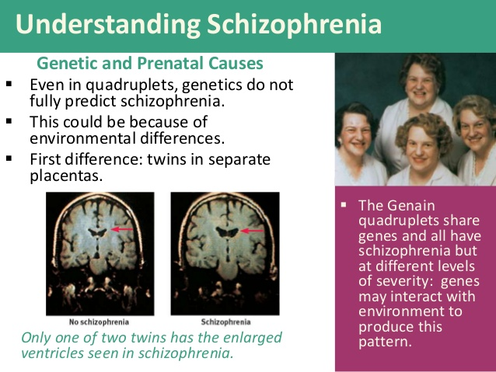
- Used to believe that if one had a mental illness it was caused by demons - But these changes in behavior didn’t always mean what they do now – they were thought as a demonic possession
  - Used to use trepanation as treatment (drilling the whole into a person’s head)
  - Mentally ill were often abused/tortured because they thought they could beat the illness out of you – or at least discipline/get rid of the bad behaviour
- If someone didn’t fit the average behaviour they used to throw them in prison – usually just to keep them away from the public (out of trouble/stop from bothering people)

Development:
- Freud developed psychotherapy 1896
- Lobotomy became popular 1940’s
  - Surgical procedure where you use a needle to make a lesion in a person’s brain – a cut in their brain, to change personality
  - Also used the lobotomy needle through the eye socket - they used a needle that was inserted in the eye socket – close to the part of the brain where they wanted to insert it, and where the bone is thinnest
    - You would but the needle in and wiggle it
  - Appeared to improve what was happening – so thousands were lobotomized
- Electric shock therapies were used as well – they wanted to reset the brain so applied a high voltage to get the muscles to contract and modify behaviour … brutal treatment but still use it today to treat epilepsy not exactly the same (we make sure they aren’t conscious)
- The rise of the lunatic asylum and its gradual transformation into, and eventual replacement by, the modern psychiatric hospital, explains the rise of organized, institutional psychiatry. While there were earlier institutions that housed the 'insane', the conclusion that institutionalisation was the correct solution to treating people considered to be "mad" was part of a social process in the nineteenth century that began to seek solutions outside families and local communities.
  - In England at the beginning of the nineteenth century, there were, perhaps, a few thousand "lunatics" housed in a variety of disparate institutions but by the beginning of the twentieth century, that figure had grown to about 100,000. This growth coincided with the development of alienism, now known as psychiatry, as a medical specialty
Drugs for Mental Problems:
- Hallucinogens: Magical – thoughts can influence the world or you’re the world has influenced your thoughts they get Auditory hallucinations, Confused thinking, Magical thinking, False beliefs, Anxiety disorders, Feelings of persecution and Lack emotion
- Antihistamines were used to calm patients during surgery - First effective treatment was discovered by accident in an effort to come up with better medical treatments
  - People had high anxiety going into surgery – so doctors tried experimenting with drugs to calm patients
  - Antihistamines were tried and promethazine was tried
  - And throaxine was also tried – similar properties
- Schizophrenia – loss of contact with reality: Brains are functioning in a way where they’re in a different world
  - First effective treatment for schizophrenia 1952 - Thorazine 25 % achieved remission
  - They could reduce the symptoms so dramatically that they were able to carry out normal lives
- Parkinson’s – Grimacing (a facial expression, often ugly or contorted, that indicates disapproval, pain, etc.) Dyskinesia (impairment of voluntary movement) and Lip smacking

Thorazine was a dopamine antagonist meaning it reduced the amount of dopamine that is released therefore it was used for schizophrenia because when you have it you produce too much dopamine – opposite for Parkinson’s they produce too little dopamine so amphetamine will raise the amounts of dopamine in the brain and therefore produce symptoms that are close to schizophrenia

Dopamine Antagonism:
- There are at least 5 receptor subtypes – The brain has 5 receptor molecules that are able to read dopamine – it allows them to use the same chemical to send different types of information to increase the number of signals in the brain
  - D₁ to D₅
  - Allow dopamine use in different parts of the brain
  - Create different pathways for dopamine to transfer information
- D₂ receptor most important
  - Early antipsychotics were all D₂ antagonists
- Early antipsychotics were not very “clean”
    - D₂ antagonists
    - D₁, D₃, D₄ antagonists
    - Serotonin antagonists
    - Adrenaline antagonists
    - Acetylcholine antagonists
    - Histamine antagonists
  - The inhibited a bunch of different neurotransmitters
  - Doing too much in the brain led to these side effects
Discovery of subsequent drugs:
- Take a baseline measurement, and then look for similar molecules that make the same outcome
  - Using existing drugs to find new drugs
- Identified using animal studies
- Researchers identify patterns of behaviour the drugs produce
- Each generation had small improvements over previous
  - Side effects
Atypical antipsychotics – 1972
- Clozapine
  - Breakthrough with treatment of schizophrenia
- Its pattern suggests that S is much more than a dopamine imbalance in the brain
  - So something more complicated about how schizophrenia is working
- Weak D₂ dopamine antagonist
- Strong serotonin agonist (5-HT)
- Less likely to cause motor-control (Parkinsonian-like) disabilities
- Produces reduction in symptoms but via a different mechanism

Loneliness and sadness in depression
- Depression = low mood
- Anhedonia – inability to experience pleasure
  - Unable to feel happy
  - We all go through periods where our mood is down, but comes back up
  - Some people can’t get out of it – involuntary
- Tricyclic antidepressants discovered by accident 1951
  - Imipramine
  - Not effective for schizophrenia
  - Elevated mood – didn’t do anything for S.

- Physical transfer of neurotransmitters send nerve signals - Controlled the amount of neurotransmitters

- Nerve cells must re-set after each transmission - They would get sucked back into the cell and re set it so it can release the chemical info all over again
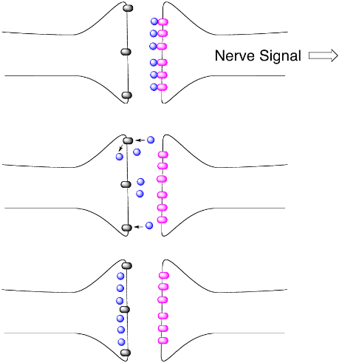

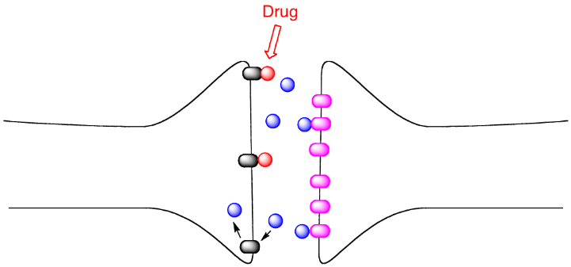
- Imipramine found to block serotonin reuptake - Blocked the reuptake for serotonin – It binds to receptors that re up take and by blocking them, so it slows down the rate in which it can get sucked back in

- Net effect is to amplify serotonin signals - This amplifies the signals of serotonin – and it traps some in the space between neurons – so there’s a larger quantity of serotonin = Called serotonin reuptake inhibitor

Imipramine effects lots of things in the brain (the drug that makes you feel better – increases your mood)
- Inhibits serotonin reuptake
- Inhibits norepinephrine reuptake
- Dopamine antagonist
- Acetylcholine antagonist
- Histamine antagonist
  - Side effects!
  - Design new drugs to be more selective
Accidental discovery of Ipronazid
- Proof that low serotonin was involved in depression
  - Tuberculosis drug
  - Antidepressant effects
  - Inhibits monoamine oxidase (MAO)
- Monoamine oxidase (MAO) helps regulate neurotransmitter amounts … Inhibiting MAO has the effect of increasing the amount of serotonin in the brain
  - Part of system that body uses to control the amount of neurotransmitters in the brain
  - When u give drug to a person, it artificially blocks the function of the enzyme that degrades serotonin = higher amount in brain
Drugs that raise serotonin amounts “elevate” mood
- Tricyclic drugs (Imipramine) prevent serotonin reuptake
- MAO inhibitors reduce serotonin destruction
- Both antidepressant drugs increase the effective amounts of serotonin
  - Basis of theory that depression arises from low serotonin amounts
- Tricyclic drugs – serotonin reuptake inhibitors
Prozac was the first SSRI
- SSRI = selective serotonin reuptake inhibitor
  - Selective Serotonin Reuptake Inhibitor
- Effectiveness similar to previous drugs
- Worked best for severe cases
- Much cleaner side effect profile
  - No effect on acetylcholine
  - They block the reabsorption of serotonin into the nerve cell but they have a cleaner side effect profile
  - When looking at the following there was almost no difference between placebo and Prozac: Anxiety, Sleep disturbances, Sexual dysfunction, Suicidal thoughts
- Produces an immediate effect on the brain, serotonin reuptake inhibitor, produces delayed symptoms like suicidal thoughts (3 week period) may feel hopeless, don’t see results right away
- Advanced tools are required to make changes so this doesn’t happen
OCD: Obsessive Compulsive Disorder
- Obsessive thoughts
- Rituals
- Magical thinking
  - Get an unwanted obsession
  - Some people develop rituals – like washing hands, or shutting off the light numerous times
- Basis of theory that low serotonin function produces OCD
- In one person lowering serotonin = OCD, in another = depression
- Serotonin is defiantly involved, but something else has to be involved = why it’s so hard to treat
Bipolar Disorder
- Alternate between high energy happy periods
- Depressed isolated periods
  - Manic = really happy, invincible – someone with bipolar will have “manic episodes”
  - Alternated to depression = extreme
- John Cade thought manic depression was caused by toxins – he injected urine of manic’s into Guinea pigs: he wanted to reproduce these bipolar episodes into guinea pigs
  - Adding Li2CO3 produced calming effect on guinea pigs – 1949
  - Used this to calm inmates
  - Original ingredient in 7-up: used to make a calming effect
- Lithium has narrow therapeutic window - Difference between effective dose and dangerous dose is very small
  - Hard to design new drugs based on lithium structure – drug is composed of one atom … nothing to play
- Lithium mechanism of action not precisely known:
  - No known lithium receptor
  - Increases secretions of glutamate (neurotransmitter)
  - Reduces dopaminergic activity
    - Nerve signals associated with dopamine
  - Enhances cholinergic activity
    - Nerve signals associated with acetylcholine
  - Inhibits GABAergic activity
  - Inhibits certain phosphatases
    - Involved in protein modifications
    - Interferes with inositol synthesis
      - Sugar involved in nerve cell activity
  - Inhibits phospholipase related signal pathways

Valproic acid is sometimes used
- Used to be an anticholinergic drug – meaning it is a substance that blocks the neurotransmitter acetylcholine in the central and the peripheral nervous system.
  - Used to calm manic depressive patients
  - Cleaner than lithium
- Many patients enjoy the mania – bipolar people enjoy these episodes
  - Patients don’t want drugs/treatment
  - side effects are unwanted
    - They want to be manic and they want to be creative
    - Many artists are thought to get their inspiration from this - supercharged creativity
    - Von Gogh’s Bipolar, depression etc. he committed suicide

Anxiety Disorders are Common: Fear without reason
- Barbiturates discovered by accident 1864
  - Have a calming effect on brain but lots of side effects and addictive material
  - Barbiturates are GABA agonists - GABA is a neurotransmitter that inhibits neural function
    - Agonists reduce neural activity
    - Many side effects
- Milltown was the first big seller 1967
  - Cleaner versions of these drugs came out in 1960s
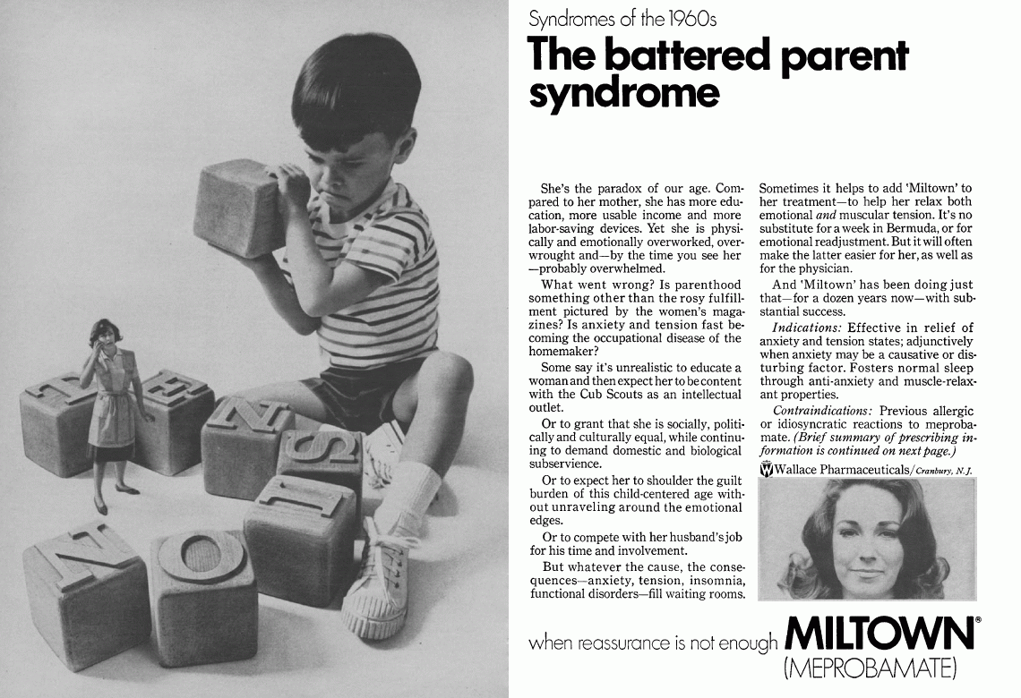
  - But controversial because people questioned if they were being over prescribed
- Benzodiazepines had cleaner profiles
  - Targeted towards women to help with anxiety
  - Amplified the GABA - Increases the sensitivity of GABA receptors and binds to a different location on GABA receptors … Agonist but not really
- GABA activates a special receptor called an ion channel
  - GABA acts on a receptor called an ion channel
    - The receptor will change shape
    - It now opens up a pore that allows ions to move from one side to the other
    - Leads to a biological response - calming down the brain
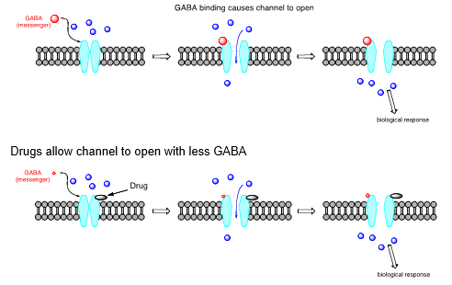
  - Now – GABA can come in a smaller amount and still opens up

Valium became Mother`s Little Helper
- Associated with housewives being home all day so they had a lot of anxiety
- Psychiatric drugs often criticized
  - Claim that there is an addictive component and just want to make money
  - “Alter brain chemistry” - But that’s what you’re trying to do … There’s an alteration in a person’s brain chemistry so its altering their behavior – it is the very reason of why you take the drugs
  - “Similar to placebo”
  - Limited effectiveness
  - Side effects that are unpleasant, frequent and permanent
- 30 % improvement for placebos
- 30 % improvement for drugs
  - NOT THE SAME!!!
  - With a background with people who would respond on their own – (placebo)
  - In drug group – difference in drug group and placebo group – they report the difference between drug group and placebo group – drug itself
  - But the drug group will give you a better of chance of getting better
  - You can’t tell which one is responding to placebo or drugs or by themselves
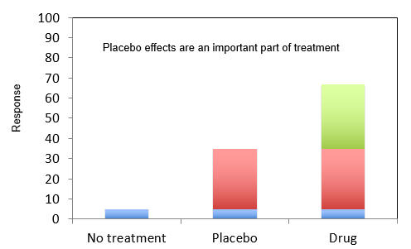

- Drugs in 2016 no more effective than drugs in 1950’s?
  - Technology is advancing but drugs aren’t
  - Response rate from old drugs aren’t much different than today
- There are improvements in drugs - Each new drug provides more information
  - Each drug produces slightly different molecular interactions
  - Side effect profiles tell you what to look for
    - Once side effects are known, drugs can be engineered to avoid or minimize them
  - Each new drug is a little better than the older ones
- Modern drugs show fewer side effects – not a night and day kind of thing but due to incremental (an in addition kind of thing) improvements

Why don’t these Drugs work Better?
- Brain is a black box – each cells has multiple connections to another – there are thousands of chained events that occur and therefore it is hard to come up with a drug that will target all these chains of reactions
  - You have to figure out how to fix it without taking it apart

The entire nervous system has been mapped - All of the connections have been mapped … Affinity view – precise strength of synapses
Reflex behavior has been mapped as well – we know how functions happen, ex. Reflexes
The human brain is way more complex – we need to take this all in where there are more neurons and more connections: to cut things out and put things in you have to know the big picture and how the “engine” works
Experiments with Animals: allows for full control, but is limited to what we can do/find out … need to look at living things … We cannot fully control humans (ex. If in a clinical trial they can drop out if they please) – have them for an hour but not before or after it’s on their terms – Can’t do the same thing to a human that you can to an animal… they only wat to find out how the brain works is to go in but we cannot just pick someone to open up their head and do tests
The Human brain is not the same as a mouse brain:
- Basic functions similar
  - Neurotransmitter-receptor interaction
- Human brains more complex
  - Additional structures
- We have to experiment on animals but it is not the same because their brains are not the same – same messenger receptor interactions but the structures are not the same – this will cause challenges and limitations
  - Do mice really get depressed? Or Mental Illnesses?
  - How relevant is it? What is toxic what isn’t, how do we translate mouse brain to human
Drugs are used to Develop Pattern of Behavior
Measure normal behavior using tests, look for same pattern of behavior with candidate drugs – look how mice act with no drug, then look at how they act with the drug, from there we measure the change and look for the same compound of change with other drugs

Swim Despair Test in Mice:
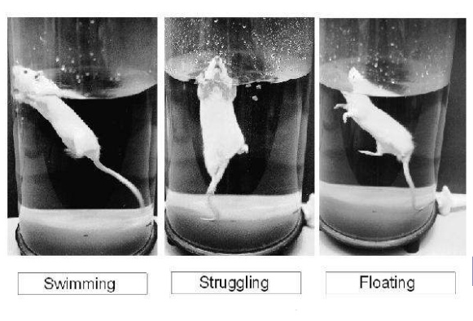
- Time the amount of time it takes to start floating
- When you give a drug you time the amount it takes for them to float
- Ex. Antidepressant drug will make them swim for a longer period of time

Hotplate Pain Test:
- Gradually head the plate and it will lift its feet, certain drugs will alter the timing of this – because the drug numbs its feet it doesn’t care
We get the animal to mimic the symptoms in a human (by altering brain, surgical actions etc.) – have to take a normal mouse and alter these … some will take monkeys and feed them a high salt diet to make changes in blood pressure, and lesions in mice brains to create schizophrenia

Me too Drugs
- A Me-too is a generic drug with an identical formulation and indications as a pharmaceutical drug previously approved for medical use – a new drug that is structurally similar to other already known drugs but we make minor changes to them
  - Use the old drugs as starting points (chosen to reduce side effects)
- Have to investigate the way a drug works without killing the patient/specimen
- Common in other cases like going from changes in technology – from the telephones you have used with the spiral chords in the old ages to the new iPhone – each generation adds small improvements (large changes are rare)
Theories are Based on Drug Effects:
- Observe changes induced by drugs
- Drug Theory New Drug New Theory
- Some drug effects unexplained

Take Home Message: Drugs for Mental Health DO work
- Efficacy rate is lower than for other diseases
- Have been improvements
  - Side effects
- The nature of some illnesses means they can only be managed
- “breakthrough” drugs require
  - Luck
  - Breakthroughs in understanding of the biochemistry of the disease

