COMM 223- Midterm
LECTURE 1
Marketing concept: the key to achieving organizational goals consists of determining the needs/wants of target markets + delivering the desired satisfactions more effectively/efficiently than competitors
Concentrate → needs of buyer, NOT needs of seller
Marketing: the process of maximizing company profits (short/long-term) through creation of superior value for customers relative to competition
The Core Marketing Concept:
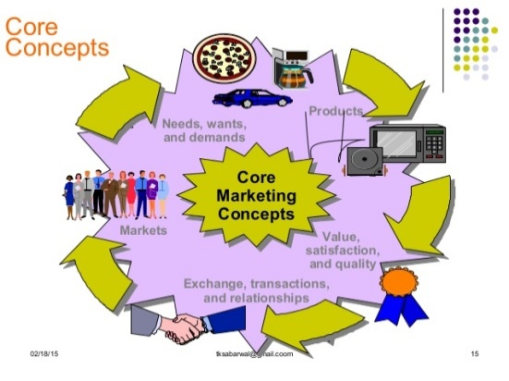
Needs: state of feeling deprivation (e.g.: hunger)
Wants: needs shaped by culture/individual personality (e.g.: “I want a hamburger and fries”)
Demands: wants backed by buying power (e.g.: I have money to buy this meal → I’m buying it)
Meeting customer needs and wants:
Products: anything that can be offered to a market for attention, acquisition, use or consumption and that might satisfy a need/want.
Customer’s Decision Criterion:
Customer value: benefits customer gains from using product compared to cost of getting product
Customer satisfaction: depends if product’s perceived performance in delivering value can meet buyer’s expectations

How Consumers Meet Needs and Wants:
Exchanges: obtaining a desired object from someone, offering something in return
Relationships: process of creating, maintaining and enhancing ongoing exchanges/transactions
The Market: the set of all actual/potential buyers of a product/service
LECTURE 2
Marketing Management Orientations:
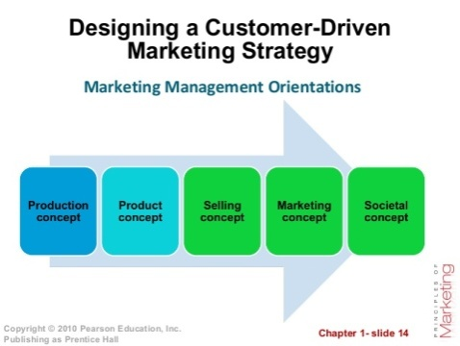
Marketing Approaches
Classic Marketing Approach (stick to basics) | Alternative Marketing Approach (innovation)
- Market-driven  - “Give customer what they want.”  - Matches well with markets containing products with high buyer familiarity  - Assumes buyers evaluate choices based on fixed value concepts | - Market-driven  - “Help customers learn what they want”  - Matches well with rapidly evolving markets with growing number of original products  - Assumes buyers can learn/evolve with new value concepts

Customer Relationship Management (CRM):
- General process of building/maintaining profitable customer relationships by delivering superior customer value/satisfaction.
- It costs 5-10x more to attract a new customer than it does to keep current one satisfied
- Marketers → concerned with lifetime value of the customer
- Customer equity: total customer values of all of the company’s current/potential customers
- Ideal relationships with customers → treating customers as assets that need to be managed/maximized
- Different customers = different CRM strategies
Customer Lifetime Value (CLV):
- The value of the entire stream of purchases that ONE customer would make over a lifetime of sponsorship
- E.g.: Lexus estimates one customer = $1,170,000 in lifetime sales
- CLV can end up negative→ e.g.: customer buys but does not pay
Strategic Planning: managerial process of developing/maintaining a strategic fit between organization’s goals and resources in its changing market environment
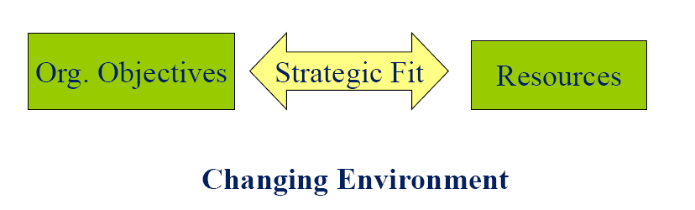
Steps in Strategic Planning:
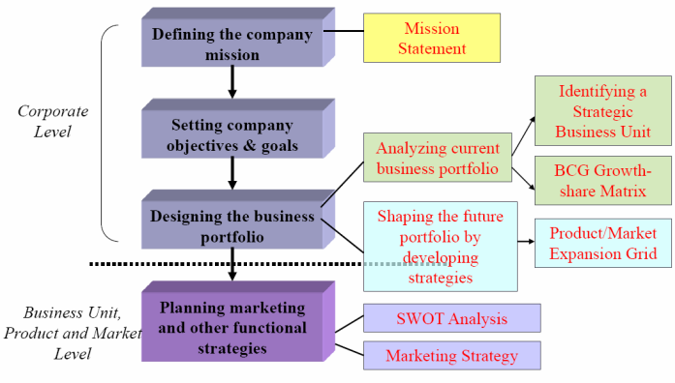
- Mission statement:
- statement of organization’s broad purpose; what it wants to accomplish in the big picture
- statement of the organization’s scope, often identifying its customers, markets, products, technology and values
Evaluating a Mission Statement:
- Market oriented: focus on meeting consumer needs
- Realistic: don’t be delusional
- Motivational: inspire employees
- Consistent with the market environment: be up to date

- Corporate goals:
- Convert the mission into targeted levels of performance
- Measurable, achievable, unequivocal

- Business Portfolio: P&G example
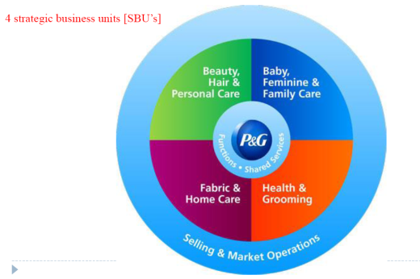
- BCG Growth Share Matrix
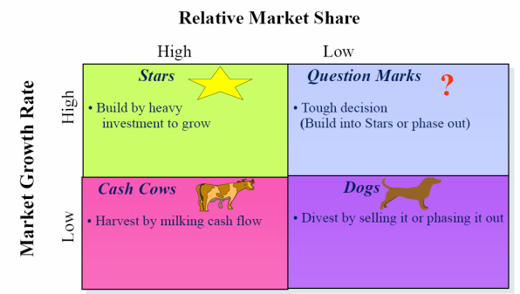
Limitations of BCG analysis:
- Independence assumption
-does not account for synergies
-cannot explain cannibalization
- Not powerful for future planning
- Limited information used
-market attractiveness= growth?
-competitive position = market share?

Product/Market Expansion Grid:

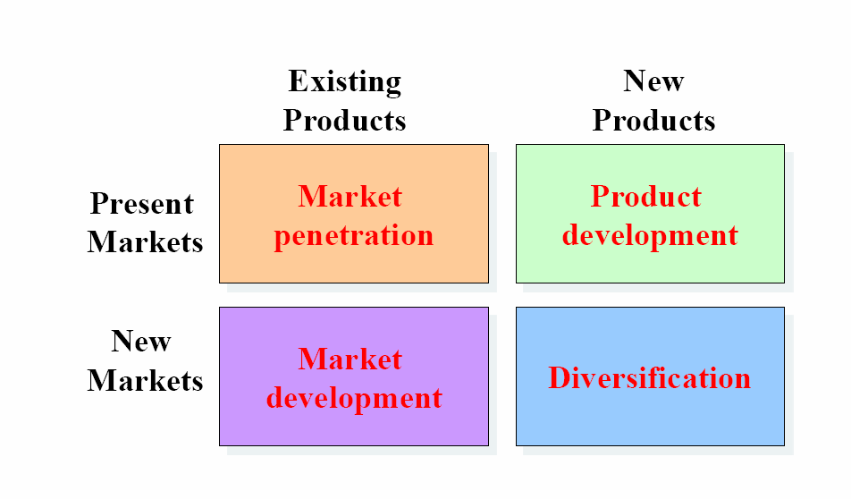

Market Penetration:
- Making more sales to current customers without changing its products
- How? →Add new stores in current market areas, improve ads, prices, service/store design, suggest a new usage
Market Development:
- Develop new markets for its current products
- How? → Identify new demographic/geographic markets
Product Development:
- Offering new products to current markets
- How? → new styles, flavors, colors, modified products
Diversification:
- New products for new markets
- How? → Start up/buy new businesses
Planning Phase:
- Situation analysis (SWOT): complete analysis of company’s situation
- Customer-focused Marketing strategy (STP): targeting/positioning + managing marketing mix (4 P’s)
SWOT analysis: formal framework for identifying/framing organizational growth opportunities
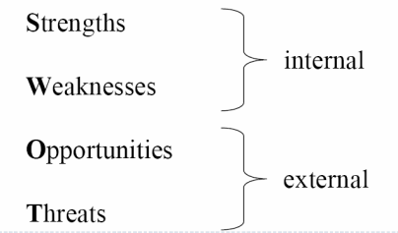
Marketing Environment:
- Company’s Microenvironment:
- Consists of the actors close to the company which affect its ability to serve customers
- The company, customers, competitors, suppliers, marketing intermediaries, publics
- Company’s Macroenvironment:
- Consists of the larger societal forces that affect the microenvironment
- Demographic, economic, natural, technological, political, cultural-environment.
- E.g.: more people are divorcing and separating
Age groups:
- Children: (generally speaking)
- Increasing in developing countries
- Decreasing in developed countries → does NOT imply ↓ spending
- Expenditure on baby/kids products depends on culture
- Teenagers
- Easily switch brand preferences
- Easily liable to peer influences
- Young adults
- 18-25 have ↑ (gen Z)
- 26-36 have ↓ (gen Y)
- Middle-aged segment
- Baby-boomers
- Elderly
- Proportion growing strongly in industrialized nations
- Cognitive/perceived age often different from actual age
- Want ads to appeal to them, but not too obvious
- Have a lot of discretionary income, but:
- often don’t need to spend
- are often careful spenders
- have more time (use coupons, buy during off-peak hours)
- Newspapers and AM radio
- Shop earlier
- Declining sensory abilities
Attractive Age groups:
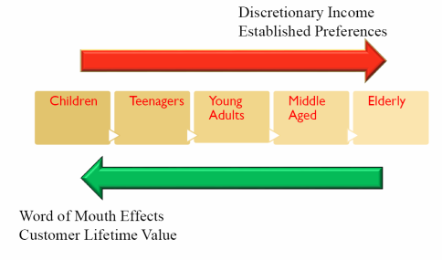
Technological environment: includes forces that create new technologies creating new product/market opportunities
Political environment: increase legislation and social responsibility emphasis

LECTURE 3
Marketing Research: the process of acquiring market information to improve marketing decisions
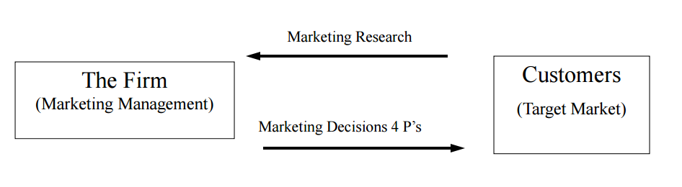
*4 P’s = Product, pricing, placement, promotion
Marketing Information System: information needed by managers can be obtained from…
- Internal data
- Computerized collection of consumer and market info from data sources (i.e.: accounting) within the company network
- Gathered via customer databases, financial records and operations reports
- PROS: quick, easy access to info
- CONS: incompleteness, inappropriateness to a particular situation
- Marketing Intelligence
- Collection/analysis of publicly available information about competitors/developments in the marketing environment (i.e.: technological)
- Competitive intelligence gathering activities have grown
- Many sources of competitive info exists
Procedure for Marketing Research:
- Define purpose of the research
- Why should we do the research?
- What should the research tell us?
- Plan the research
- How should the research be carried out?
- Perform the research
- Collecting/analyzing data
- What should we do with the data?
- Interpret and report the findings
- What do we do with the results?
Research plan: classification of research types
- Exploratory:
- Gives insights into the general nature of a problem, possible decision alternatives, and the relevant variables to consider
- Used when little is known about the problem/situation → to develop initial hunches/insights and to provide direction for any further research needed
- Used to gain ideas and insight into the research problem
- Used to determine what factors/variables/constructs may potentially be influential
- Research outcome: a list of potentially influential factors/variables
- Descriptive:
- Provides an accurate snapshot of some aspect of the market environment
- Used when the research objectives/questions are clearly defined and summary measures are needed to address the research questions
- Used to describe the characteristics/composition of relevant groups or units
- Research outcome: summary measures (of characteristics)
- Causal/Confirmatory/Experimental:
- Shows whether one variable causes or determines the values of other variables
- Used to identify/establish cause-and-effect among variables
- Used to understand tight connections between management actions and observed outcomes
- Research outcome: and X & Y relationship → if X occurs, Y happens
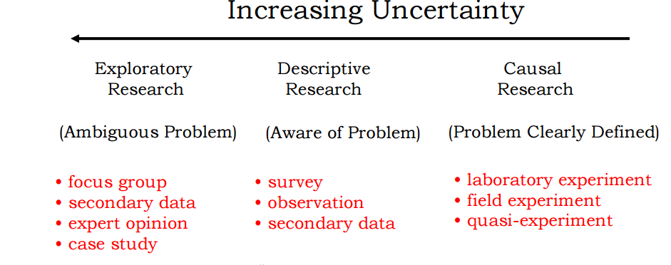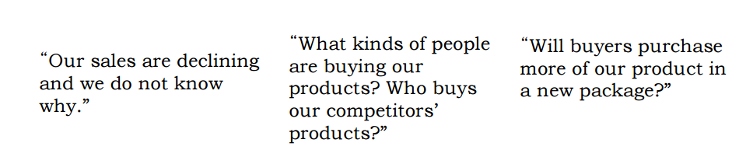
Descriptive vs. Causal Studies: Correlation and Causality
- Correlation DOES NOT = Causality
- Reverse causation: the more firemen fighting a fire, the bigger the fire is going to be. Therefore, firemen cause fire
- A third common causal factor: does wearing a seatbelt reduce death risk in a car accident?
- Coincidence: since the 1950’s, both the atmospheric CO2 level and crime level have increased sharply. Hence CO2 = crime
Experiments for Causal Relationship:
- Goal: to determine causality
- Conditions necessary to establish causality
- The cause must precede the effect (A before B)
- No plausible explanation for B other than A
- Ceteris Paribus (all things being equal)
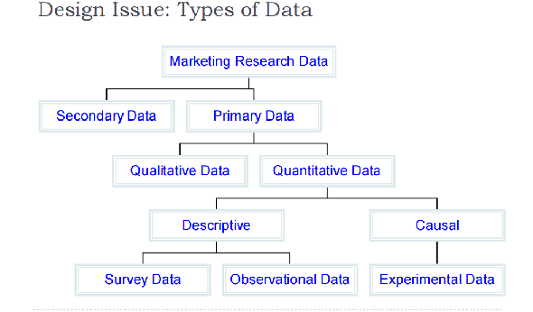
Primary vs. Secondary Sources
Primary
- Collected by researcher
- Addresses a specific research objective (survey data, questionnaire, etc)
PROS of Primary:
- More reliable
- Better suited to specific research goals
- Used in exploratory, descriptive, and causal research designs
Secondary
- Typically collected by a 3rd party (not the researcher)
- Collected without specific research objective (census, store audits)
PROS of Secondary:
- Cheaper than primary data
- Easy to obtain
- Best for exploratory research
Qualitative Research:
- Involves: small samples + non-structured data collection procedures
- Provides: initial insights, ideas of understanding of the problem
- Should NOT be used to recommend final course of action
- Main methods
- focus group: a group discussion, best for preliminary research
- in-depth interviews: one respondent, one researcher leads discussion, encourages uninhibited responses, laddering (follow-up question based on respondent’s answer) as a technique
- observation: involves recording the behavioral patterns of people, objects and events in a systematic manner
Projective Techniques:
- unstructured/indirect form of questioning which encourages the respondents to project their underlying motivations, beliefs, attitudes or feelings regarding the issues of concern
- Examples:
- word association: respondent responds to a list of words, reacting to them with the 1st word that comes to mind
-Measures: frequency, time limit, # of respondents who don’t respond at all
- sentence completion
- picture response and drawings
- ZMET: Zaltman Metaphor Elicitation Technique
-elicitation of respondent’s unconscious thoughts via non-literal or metaphoric expression
-respondents are asked to collect a set of pictures that represent their thoughts and feelings about the topic of interest
Survey Data:
- Useful for descriptive research
- PROS:
- Standardization/completeness
- Ease of administration
- Access to unobservable perceptions
- Suitable for statistical analysis
- CONS:
- “I don’t care”
- Easy to do wrong
Types of Sampling Methods:
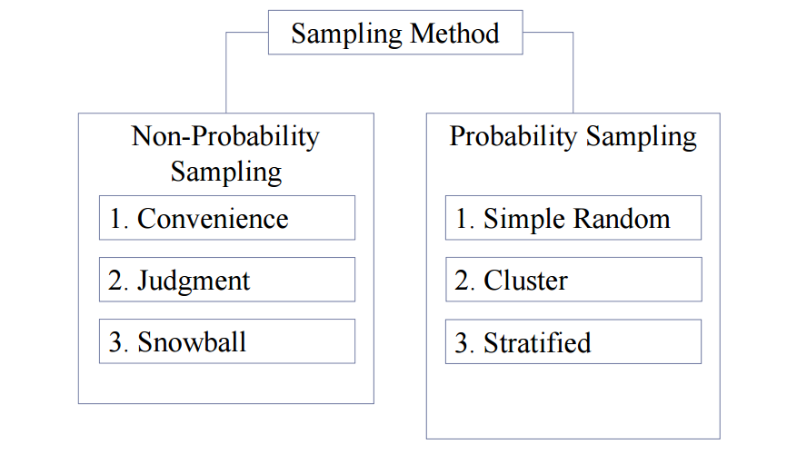
Probability vs. Non-Probability Sampling
- Probability sampling: every element of the population has a known probability of inclusion in the sample
- PRO: one can quantify the amount of error that is introduced because a sample is used instead of a census
- Simple random sample: computer generated random numbers
- Stratified sample:
- Use it to increase precision and ensure different subgroups are represented
- To use this method researchers must have knowledge on the size of each stratum in population
- Two step procedure:
- The target population is divided into subsets or strata
- Mutually exclusive/exhaustive
- Strata are based on one of more characteristics (e.g.: age, gender, state, store size)
- A simple random sample is chosen from each subset
- Cluster sample:
- cost friendly
- require homogeneity across cluster and heterogeneity within cluster
- Two step procedure:
- Population is divided into mutually exclusive/collectively exhaustive subsets
- Random sample of subsets is selected
- Non-probability sampling: some elements have zero chance of being selected
- Convenience sample: “person on the street” survey, popup window on website, mall intercept
-cheap, convenient, but often opinionated
- Judgement sample: expert opinion, “techy” consumers
- Snowball sample
- CONS of non-probability sampling:
- sample may not be representative of target population
-difficult to project sample results to target population
- Circumstances under which a non-probability sample may be used:
- Exploratory research, e.g.: focus groups
- When probability samples are too costly
Why don’t we just ask consumers what they want?
- People don’t know what they want
- People don’t always know their needs
- People don’t want to tell you why they do what they do
- People don’t know why they do what they do
- Sometimes asking them changes their behavior
LECTURE 4
Consumer behavior: the activities of consumers in obtaining, using and disposing of goods/services, including the decision process that precede and follows these actions
Consumer behavior model:
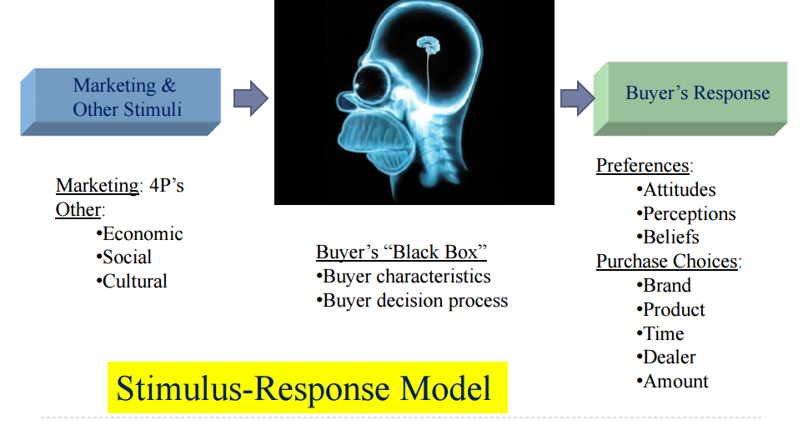
Factors affecting consumer behavior:
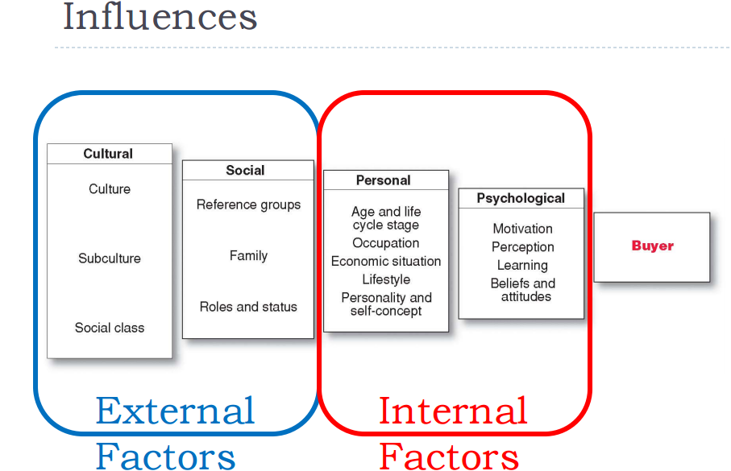

Internal factors:
Personal factors
- Age and life cycle stage
- Occupation
- Economic situation
- Personality
- Refers to the unique psychological characteristics that lead to consistent and lasting responses to the consumer’s environment
- Brands also have personalities →consumers are likely to choose brands with personalities that match their own
- Lifestyle
- person’s pattern of living as expressed in his/her psychographics
- measures consumer’s AIOs (activities, interests, opinions) → capture person’s pattern of acting/interacting in the environment
Psychological Factors:
- Motivation: drives person to seek satisfaction of need
- Perception: process by which people select, organize and interpret info
- Learning: changes in individual’s behavior arising from experience
- Belief: descriptive though that a person holds about something
- Attitude: person’s consistently favorable or unfavorable evaluations, feelings and tendencies toward an object/idea
Psychological Influences Motivation
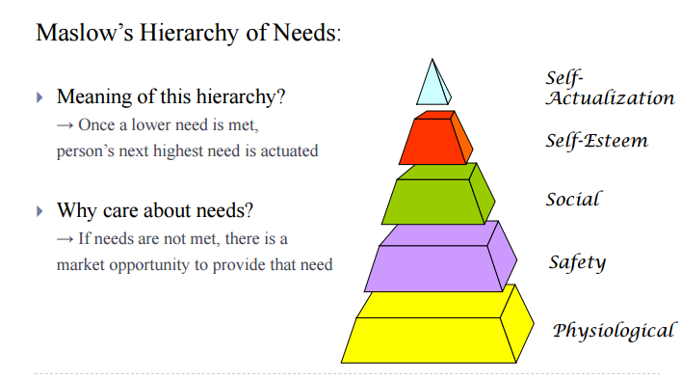
- Physiological needs: generic foods, medication, special drinks, supplements for athletes
- Safety needs: smoke detectors, preventative medicines, insurance, social insurance, retirement investments, seat belts, burglar alarms
- Social needs: cosmetics, clothing, entertainment, house
- Esteem needs: clothing, furniture, hobbies, automobiles, watches
- Self-actualization: education, hobbies, sports, adventure, vacations, books, gourmet foods, museums

Psychological Influences: Perception and How to reach consumers
- Exposure: e.g.: consumer must SEE your billboard
- Attention: e.g.: consumer must LOOK at Ad message
- Selective attention: people screen out most of info to which they’re exposed to
- Selective distortion: people interpret info in a way that will support their beliefs
- Selective retention: people will remember good points made about a brand they favor and forget good points about competing brands
- Perception: e.g.: consumer must TAKE IN message
Perception = Constructed Reality:
- Reality = perception
Perception is Crucial in Consumer Behavior:
- What is perceived is not necessarily what is true
- What consumers perceive is what is reality for them; it affects their actions

Psychological Influences: Classical Conditioning
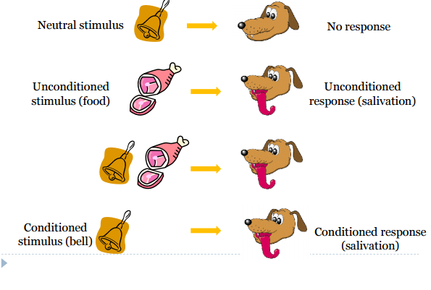
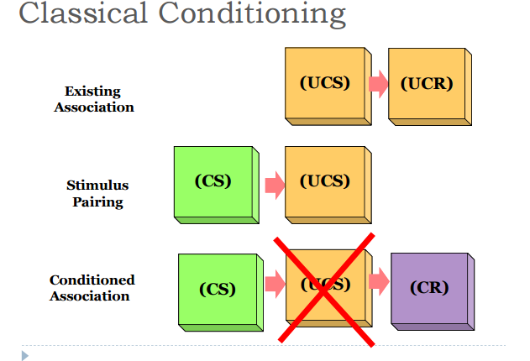
Types of Buying Behavior
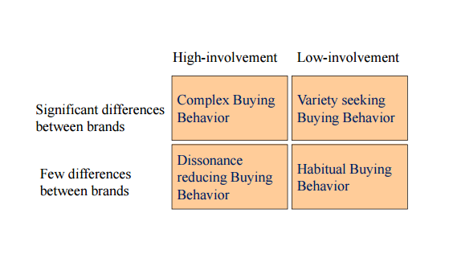
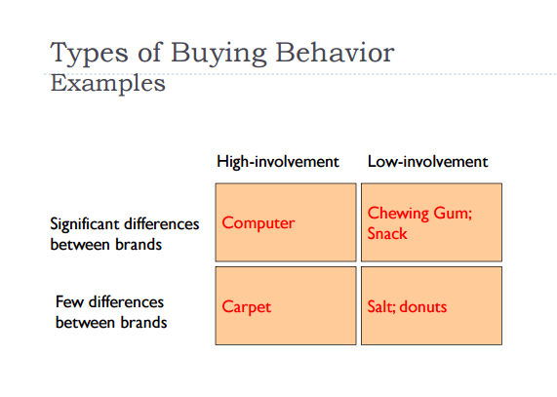
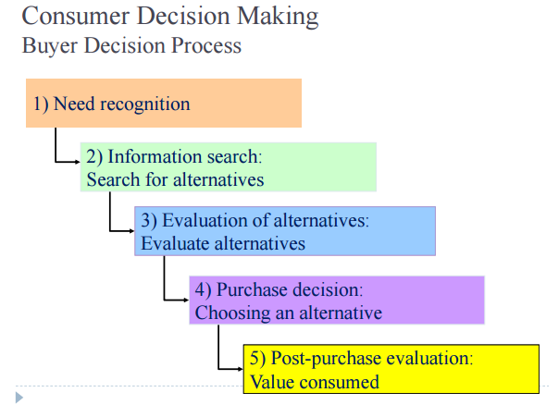

- Need recognition
- Stimuli
-internal: hunger, thirst
-external: rain
- Need recognition does NOT equal need
- Consumers may not always identify their needs, marketers should help them recognize them
- Marketers must know why consumers need something, while consumer do not need to
- Information search
- Personal sources: family + friends
- Commercial sources: ads, internet
- Public sources: mass media, consumer org.
- Experiential sources: handling, examining, using the product
- Evaluation
- Most buyers evaluate multiple attributes (i.e.: product characteristics), each of which is weighted differently
- Marketer’s perspective → highlight products strengths in info stage. If features = benefits consumer, product will stand out
- Purchase decision
- Consumer chooses the alternative the “best” solves the problem based on…
-attributes of the alternative
-other consumers’ attitudes
-value net of cost to acquire (e.g.: proximity to store)
- Post-purchase evaluation
- Discrepancy between: consumer expectations vs. perceived performance
- Cognitive dissonance: buyer discomfort cause by post-purchase conflict
External Factors:
Cultural Influence
- Culture: learned values, perceptions, wants and behavior from family and other important institutions
- Cultural shifts can be good market opportunities
- Subculture
- Smaller groups with shared value systems
- E.g.: francophones vs. Anglophones
- Social class
- Divisions based on social/economic status
- Distinctions can be unclear in some cultures like Canada
Social Influence
- Family
- Wife/husband, parents/children
- Groups
- Membership
- Reference groups
- Opinion leaders
- Online social network
Sources of Socio-Cultural Influences
- Opinion leaders
- More likely to create WOM than others
- Characteristics of opinion leaders
- Similar to receiver
- Greater status
- Involved with the product
- Outgoing
- Seek others’ opinions themselves
- Market mavens
- Have a lot of info about the marketplace in general
- Initiate discussions with consumers and respond to requests from consumers for market info
Types of Reference Groups: person/group that influences your behavior
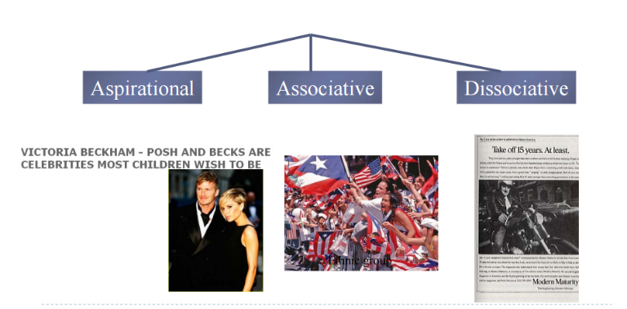
Compliance
- Tendency to be influenced
- More likely to occur publicly than privately
- Can also occur in response to some trigger
- Automatic
- Efficient
- Compliance tactics
- Authority
- People defer to experts
- Experts provide shortcuts to decisions requiring specialized info
- Social Proof
- We determine what is correct partially because of what others think is correct
- E.g.: “most popular”, “best selling”
- Laugh tracks for TV comedy (makes you want to laugh)
Socio-Cultural Influences: Reference group – Influence on Product/Brand choice
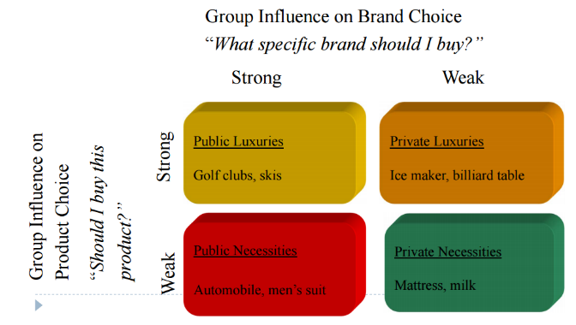
LECTURE 5
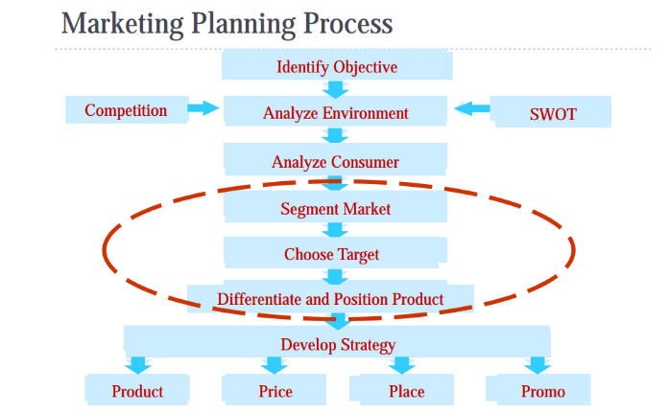
Market segmentation:
- Dividing the market into smaller groups with distinct needs, characteristics, or behaviors that might require separate marketing strategies/mixes.
- Bottom line: not everyone likes the same things and preferences variate
Targeting: evaluating each market segment’s attractiveness + choosing one or more segments to enter
Differentiation: differentiating the market offering to create superior customer value
Positioning (Value proposition): arranging for a market offering to occupy a clear, distinctive, and desirable place in the minds of target consumers
Market Segmentation Benefits:
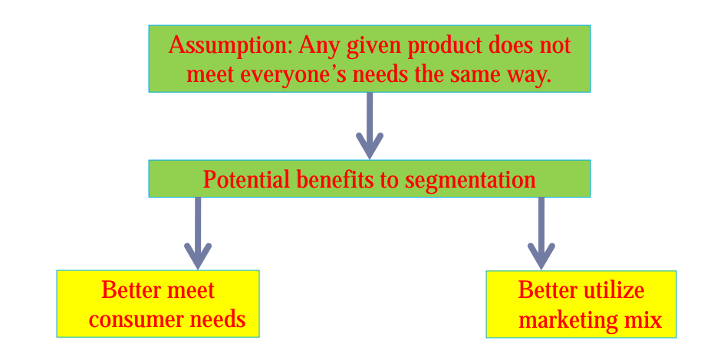
Bases of Segmentation:
- Geographic Segmentation
- By region
- Urban vs. rural
- City size
- Climate
- Demographic Segmentation:
- Age
- Income
- Gender
- Family size
- Life cycle: The traditional family life cycle
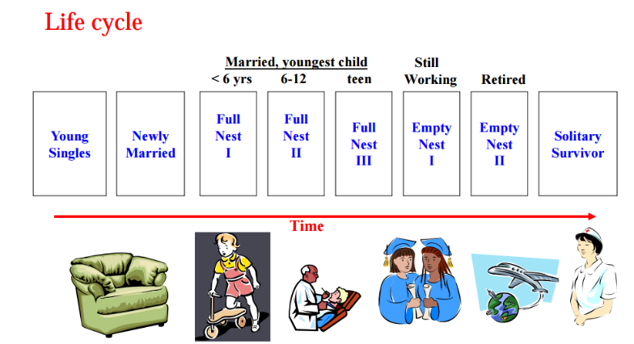
- Different stages of life cycle: why are they important?
- “Sharpened” memory, loyalty (e.g.: newlyweds)
- Open to changes (e.g.: Ford Freestyle)
- Education
- Religion
- Nationality
- Demographic segmentation doesn’t always work!
- People from same demographic segment may exhibit very different preferences
- People from different demographic segment may exhibit very similar preferences
- Solution: add Psychographics Segmentation
- Psychographic Segmentation:
- Social class
- Lifestyle
- Personality
- Values
- Compared to geographic/demographic:
- Usually difficult to identify
- Often closer to “real” segmentation
- Consumer characteristics that are not evident:
- Not overt (obvious), but covert (discrete) characteristics
- Tells you why people consume, not just who consumers
- Psychological and sociological variables. E.g.: consumer personalities, values and lifestyles
- More determinant of consumer behavior, but harder to measure than demographics
- Example:
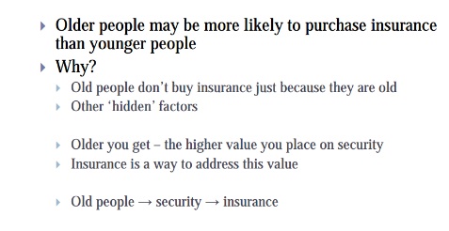
- Behavioral Segmentation:
- Usage occasion (typecasting)
- Particular holiday-specific product
- “XXX chocolate for snowy winter”
- Usage experience
- “I haven’t bought it”
- “I had bought one”
- “I currently own it”
- Usage frequency
- Loyalty
- Benefit
- International Market Segmentation:
- Political factors
- Legal factors
- Religions
- Culture
- Economic factors
Necessary conditions for good segments:
- Homogenous (consistent) within
- Heterogeneous (diverse) between
- Targetable
- Measurable (identifiable based on observables)
- Accessible (for marketing activity)
- Substantial (large enough to make business sense)
- Actionable (resources should be available)
- Differentiable (distinctive behavior)
- Stable (across time)
Targeting: Levels of Targeting
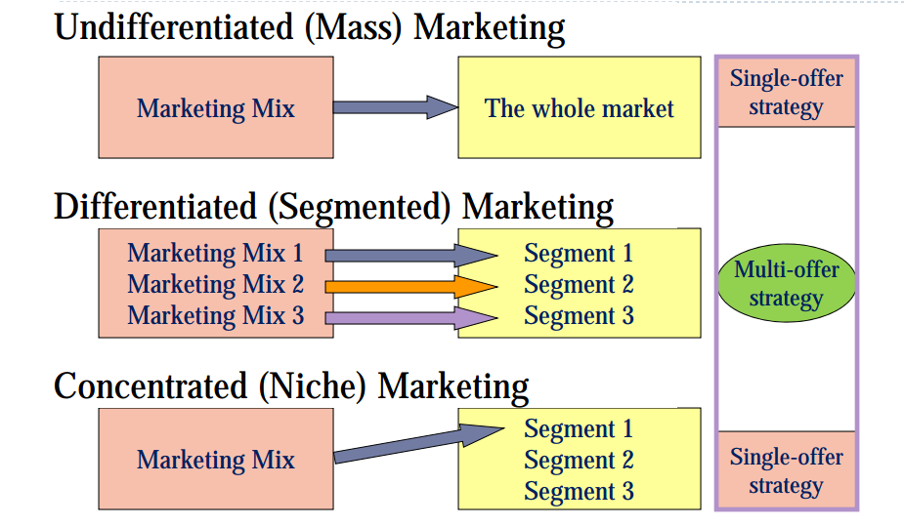
Target Marketing Strategies:
- Undifferentiated Marketing (Mass-marketing)
- Economies of scale (produce large quantities and benefit from lower average costs)
- Less investment
- Vulnerable to competition focusing on segments
- Differentiated Marketing (Segmented)
- Higher combined sales
- Better/ stronger position
- Potential problem with economies of scale
- Cannibalization (a reduction in sales volume, sales revenue, or market share of one product as a result of the introduction of a new product by the same producer.)

Target Marketing Strategy
- Niche marketing
- Narrowly defined group, typically a small market whose needs are not being well served
- Good when company resources are limited
- Achieve a strong position
- Large market share of a small market
Selecting Segments to Target:
- Segment size + growth
- Market + sales potential
- Project growth rate
- Segment structural attractiveness
- Competitors
- Manufacturer-retailer relationship (bargaining power)
- Company objectives + resources
- Consistent with the long-term objective
- Feasible
Positioning (Value Proposition)
- Define the product/firm/brand’s place relative to the market’s
- Needs
- Consumer perceptions, beliefs and attitudes
- Competitive offerings
- Segmentation + positioning
- Segmentation: the market’s view of the consumer
- Position: the consumer’s view of the firm
- Positioning: using the 4P’s to affect the firm’s position
Choosing a Positioning Strategy
- Choosing the right competitive advantages
- How many differences to promote?
- Unique selling proposition
- Several benefits
- Which differences to promote?
- Important: does it matter to consumers?
- Distinctive: is it different?
- Superior: is it better?
- Communicable: can you explain?
- Pre-emptive: can you competitors catch up?
- Affordable: does consumer benefit exceed cost?
- Profitable: does additional profit exceed additional cost?
Positioning Statement
- Components
- Target segment and need
- Brand
- Concept
- Point of difference
- Example
- Too busy, mobile professionals who need to always be in the loop, Blackberry is a wireless connectivity solution that gives you an easier, more reliable way to stay connected to data, people, and resources while on the go.
Perceptions and Positioning
- Perceptual map
- Spatial representation of several competing products/services
- Conveys perceptual info in 2-3 key dimensions
- Represents the position of the product…from consumer perspective
- Example:
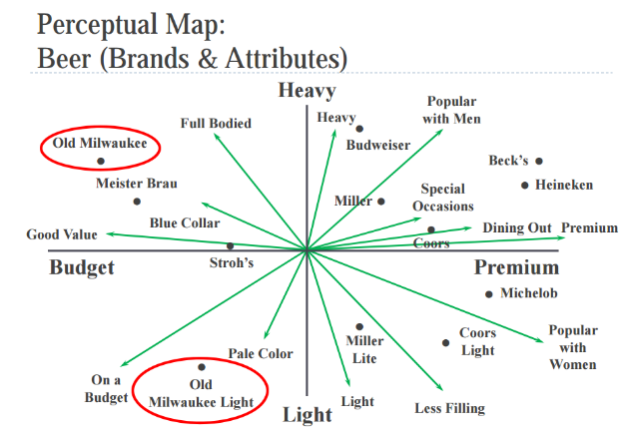

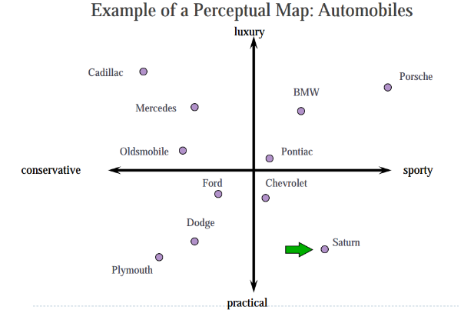
Integrating Perceptions/Preferences
- The consumer’s ideal point represents the trade-offs being made among key attributes
- Brand closest to the ideal point = highest consumer preference
- Consumers are most likely to choose the product for which they have the highest preferences
Perceptual maps help managers to:
- Investigate where unmet customer needs potentially exist
- Identify where competitors might be vulnerable
- Gain insights into how an under-performing product might be repositioned
Positioning: techniques
- The product/service can be positioned in many ways:
- Product attribute(s)
- Benefits sought by consumers
- Competitors (towards or away)
- Example: BMW, Avis

LECTURE 7
Why introduce new products?
- Market needs change
- If you don’t someone else will
- Products under 5 years old contribute to 30% profit
- If you introduce a new product…98% fail
- If you don’t introduce a new product… 100% fail
The NPD process: 8 steps
- Idea generation
- Internal sources:
- Engineering and marketing
- Other employees
- Formal research and development
- External sources:
- Consultancy
- Competitors
- Customers
- Idea screening
- Screen unrealistic ideas
- Write down your success criteria
- Separate tasks of sponsoring and evaluating the idea
- Concept development and testing
- Marketing strategy development
- Business analysis
- A review of the sales, costs, and profit projections for a new product to determine whether these factors satisfy the company’s objectives
- Product development
- Test Marketing
- Important when:
- It is a very innovative product such that you cannot anticipate sales based on existing competitors’ products
- Cost of failure = HIGH because of high R&D cost
- Competitors can hardly benefit from your test marketing
- Different types:
- Standard test markets
-e.g.: The New York Times using Canada as a giant guinea pig to test market its new pay wall
- Controlled test markets
-e.g.:
- Simulated test markets
-Decision insights –a product testing firm
-Applications: convenience store, restaurants
- Commercialization
Six examples of new product failure
- Impractical convenience
- Example: microwavable, instant coffee → packaging was not microwavable
- What do we learn from this mistake?
- Deliver the goods as you said they would be delivered (“convenience”)
- Know the market
- Create the new trends
- Inconsistent brand extensions
- Example: Colgate (toothpaste company making meals)
- Alienating loyal consumers
- Example: “New” coke
- Faulty packaging
- Example: All-in-one cereal and milk → consumers didn’t like the idea of warm milk and packaging wasn’t kid-friendly
- Network incompatibility and externality
- Example: Sony Betamax → incompatible with VHS and VHS licenses its technology
- Breaking regulations
- Example: Cocaine energy drink → banned by the FDA for illegal marketing as a substitute for street drugs
CONSUMER ADOPTION
Visionaries
Innovators:
- First to adopt an innovation
- Venturesome, less risk averse
- Often younger, higher incomes, better educated
- Change enthusiasts
- Willing to tolerate glitches/problems
- Respond to straight information\
- Sometimes buy the product just because it’s new
Early Adopters:
- Respected, opinion leaders
- Interested in “newness”, yet prudent
Pragmatists
Early majority:
- More deliberative decision makers
- Seldom stand out
- Prefer incremental, measurable and predictable progree
- Risk is a negative word
Late Majority:
- Skeptical, doubtful of the benefits of adoption
- Conservative and generally anti-innovation
- Believe more in tradition than progress
Laggards:
- Traditionalists, locally oriented in terms of social horizons
- Relatively strict in beliefs/values
Non-Adopters:
- Rejected in the first place
- Tried and rejected
- Resistant: preference for existing, familiar products and behaviors over new pones
- Hesitant to disrupt psychological equilibrium
- Rejectionists: those who actively/publicly oppose an innovation
Differences in Adoption: The Chasm Model
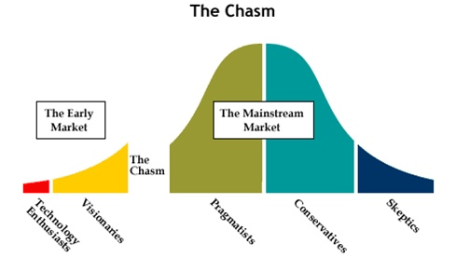
Drivers of adoption:
- Relative advantage: how much better is it than the existing product?
- Compatibility: how compatible is it with the consumer’s values/lifestyle?
- Easiness: how easy is it to learn how to use it?
- Triability: can this new product be tried on a limited basis?
- Communicability: can the benefits of it be easily explained/demonstrated?
The buyer decision process for new products:
- Adoption process: mental process an individual goes through from first learning about an innovation to final regular use
Stages:
Awareness → Interest → Evaluation → Trial → Adoption

PRODUCT LIFE CYCLE
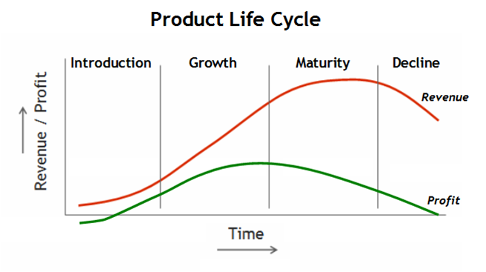
- Development
- High failure rates
- High development costs
- Growing emphasis on speed to market
- Introduction
- Characteristics:
- Sales = low
- Costs = high
- Profits = negligible/negative due to high production/marketing costs
- Customers = visionaries (innovators/early adoptors)
- Competitors = few
- Follow the leader companies
- Me-too companies
- Pioneers
- Advantages of being a pioneer:
- Get to choose best target market
- Product becomes prototype against which all others judged
- Lock up necessary resources, distribution
- Experience curve effects
- Advantages of being a second mover:
- Learn from pioneer actions
- Benefit from pioneer marketing efforts
- Customer preferences can evolve faster than pioneer
- Different customer segments have different preferences
- Growth
- Characteristics:
- Sales = fast growth
- Cost = moderate
- Profits = grow as a result of high prices and growing demand
- Customers = early adopters
- Competitors = growing number
- Maturity
- Characteristics:
- Sales = peak
- Costs = low
- Profits = high and flat
- Customers = middle majorities
- Competitors = many but stable number of rivals
- Decline
- Characteristics:
- Sales = declining
- Costs = low
- Profits = declining
- Customers = laggards
- Competitors = competitors exit the market
LECTURE 8
Marketing Planning Process
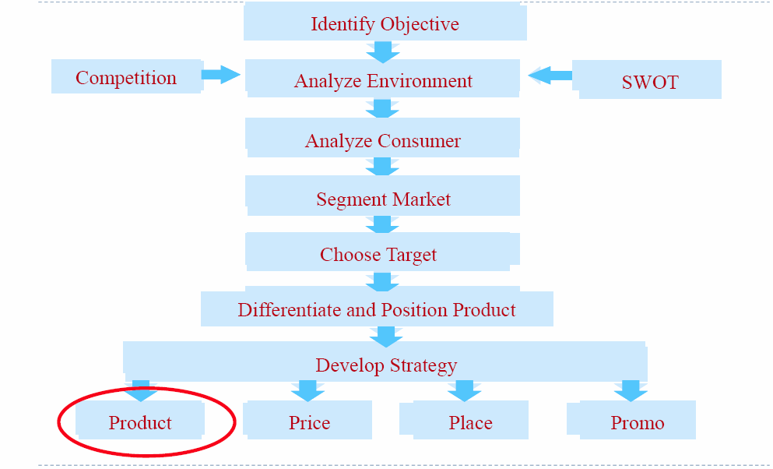

DEFINITION AND CLASSIFICATION OF CONSUMER PRODUCTS

- A product is anything that can be offered to a market for attention, acquisition, use or consumption and that might satisfy want/need\
What is a product?
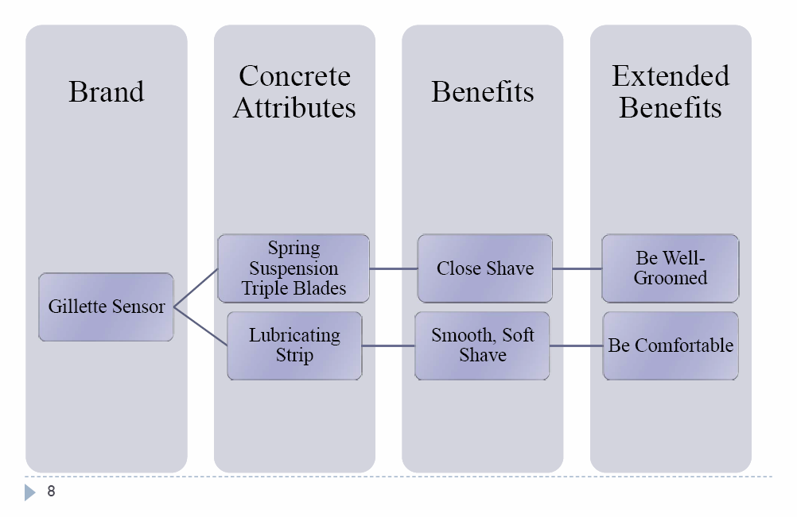
The total product concept
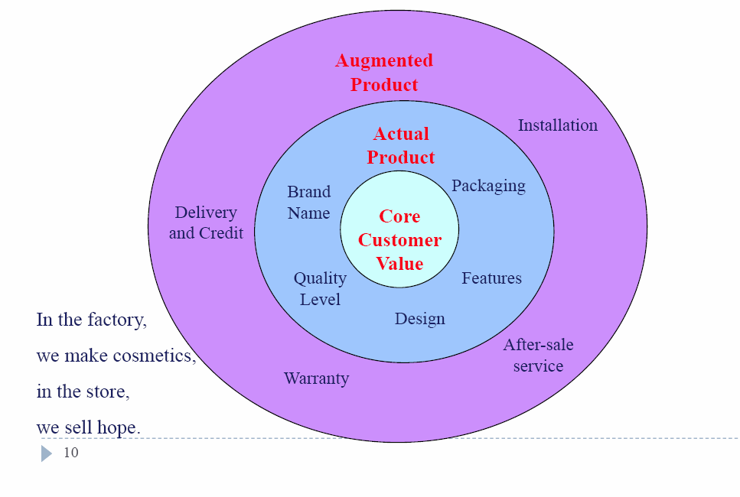

Classifying products
- How many times it can be used? (durable, nondurable)
- Who can use it? (consumer or industrial product)
Consumer Products
- Convenience
- Frequent purchases bough with minimal buying effort and little comparison shopping
- Low price
- Widespread distribution
- Mass promotion by producer
- Example: candy, toothpaste, laundry detergent
- Shopping
- Less frequent purchases
- More shopping effort for comparisons
- Higher than convenience good pricing
- Selective distribution in fewer outlets
- Automobiles, furniture, clothing
- Specialty
- Strong brand preference/loyalty/special purchase effort
- Little brand comparisons and low price sensitivity
- High price
- Exclusive distribution
- Carefully targeted promotions
- Example: Mercedes car, Patec watch
- Unsought
- Little product awareness and knowledge; sometimes aware but negative interest
- Pricing varies
- Distribution varies
- Aggressive ads and personal selling by producers/sellers
- Example: life insurance, blood donation

MAJOR PRODUCT DECISIONS
Individual product decisions:
- Product attributes
- Features
- Product quality
- Style and design
- Branding
- Brand: a name, term, sign, symbol or design or combination of them, intended to identify goods/services of one seller or group of sellers and to differentiate them to competitors
- Helps buyers: quality assurance, easier to evaluate new products
- Helps sellers: reduce selling effort, facilitate repeat purchase, assist market segmentation
- Brand equity:
- Added value that a given brand gives to a product beyond the functional benefits provided
- Provides a competitive advantage
- Higher willingness to pay
- Relationship between customer and brand:
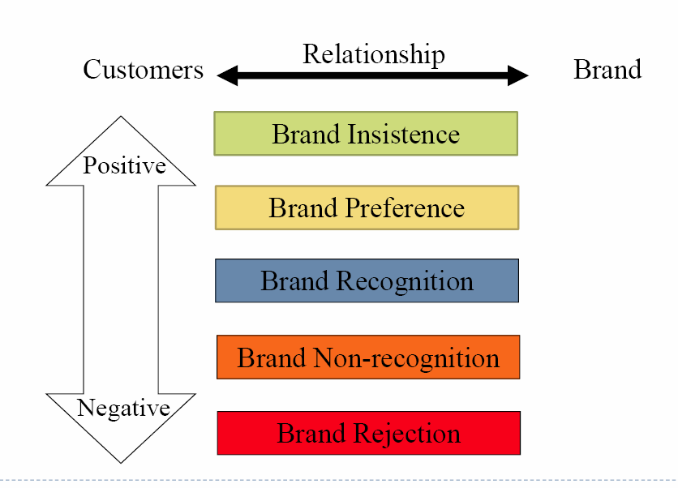
- Building a strong strategy:
- Brand positioning (product attributes, benefits, beliefs and values)
- Brand name selection
- good brand names suggest something about the product and its benefits
- are easy to say, recognize and remember
- are distinctive
- are extendable
- translate well into other languages
- can be registered and legally protected
- Brand sponsorship
- Manufacturer brands
- Private (store) brands → costly to establish and promote and higher profit margins
- Licensed brands → name and character licensing has grown
- Co-branding → pros and cons
- Brand development
- line extensions → minor changes to existing products
- brand extensions → successful brand names help introduce new products
- multi-brands → multiple products entries in a product category
- new brands → new product category
- Brand strategy decision:
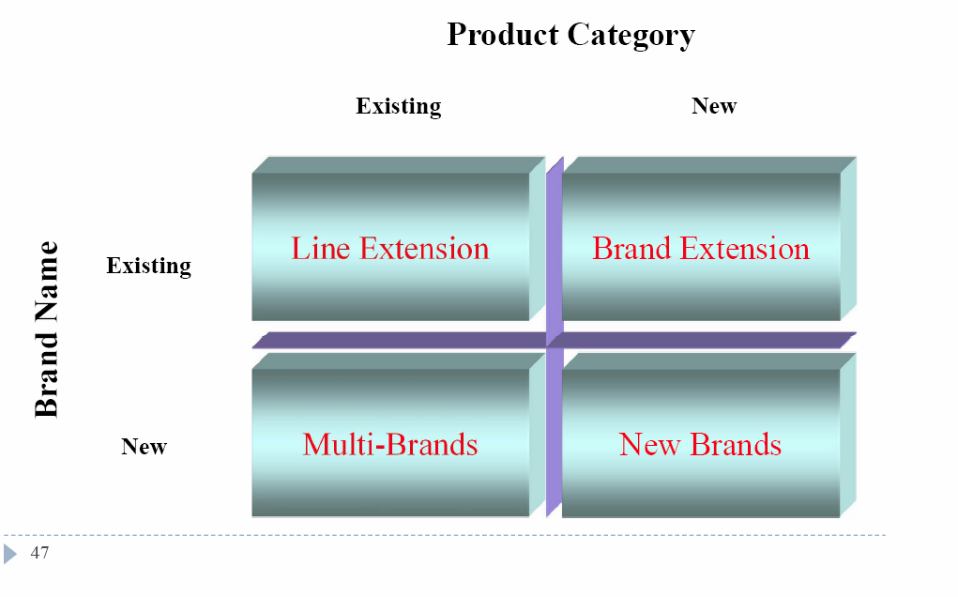
- Line extensions:
- Pros:
- Low cost/low risk to address different consumer segments
- Offer more variety to customers and thus increase brand loyalty
- Expand company shelf space presence
- Opportunity to offer a broader range of price points
- Retailers want it
- Cons:
- Confuses customers
- It may dilute the brand name
- Cannibalization if not enough differentiation
- Stagnant category demand (people don’t eat more, drink more, brush their teeth more because they have more products to choose from)
- How to extend a brand:
- Transferability of skills/assets
- Complementarily of use
- Functional attributes
- Emotional attributes
- Same users
- Brand personalities:
- Products have “personalities” like consumers do.
- Consumers are more likely to purchase a product whose brand personality matches their own
- Marketers develop brand personalities that match with their target market and vice versa
- Personified characteristics of brand
- Human characteristics or traits are often associated with a specific brand
- Packaging
- Labeling
- Product-support services
- To ensure satisfaction post purchase, firms use product support
- Pros:
- Repeat purchase
- Word-of-mouth
- Reputation
- Quality signal
- Cons:
- Employ staff
- Set up costs
Product line vs. Product length/width
- Product line: a group of closely related products
- Product length: the number of product items in a product line
- Product width: the major product line categories

Service marketing: what is service?
- Service: a form of product that consist of activities, benefit or satisfactions offered for sale that are essentially intangible and don’t result in the ownership of anything.
Four Service Characteristics:
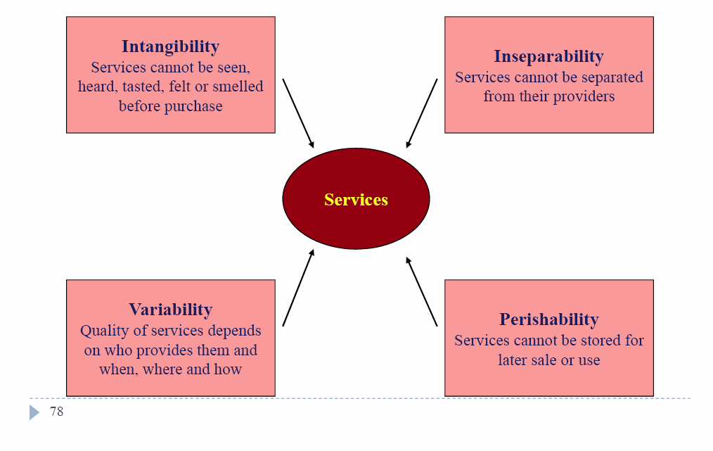
LECTURE 9
Marketing Channels: Value Added
- Reduce transaction costs
- Transactional functions: buying/selling/risk taking
- Logistical functions: assortments/ warehousing/ transporting
- Facilitating functions: financing/ market information
Channel Design:
- Analyze consumer needs
- Do customers highly value location? (convenience factor)
- What kind of transaction do customers prefer? (in person, phone, e-mail, online)
- Do customers value assortment breadth? (Wal-mart, sears vs. Apple store)
- How much add-on service do customers require? (instructions, professional assembly)
- Setting channel objectives
- Targeted levels of customer service
- What segments to serve
- Best channels to use
- Minimizing the cost of meeting customer service requirements
- Channel structure
- Types of channel structures
- Direct (without intermediaries)
- Pros:
- Greater control
- Lower cost
- Internet makes direct distribution easier
- Direct contact with customer needs

- Indirect (with intermediaries)
- Hybrid/mixed
- Degree of control/specialization
- Direct channel gives more control
- Indirect channel allows for better specialization of functions
- Role of segmentation
- Hybrid channel structure may be used for segmentation
Channel Design:
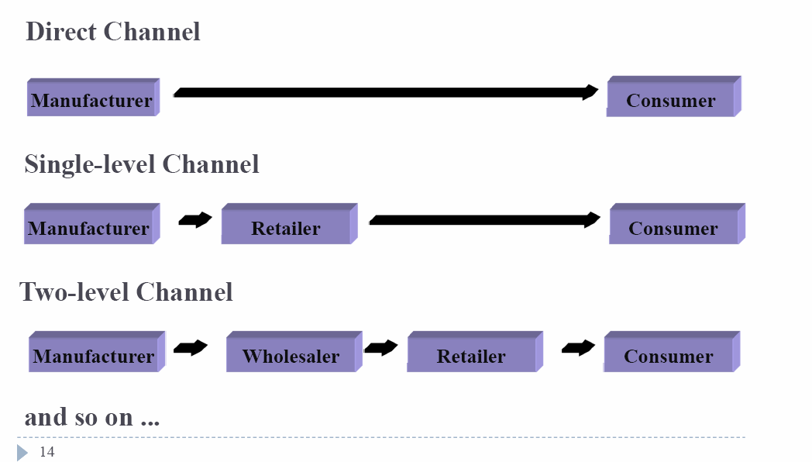

Multichannel Distribution System:
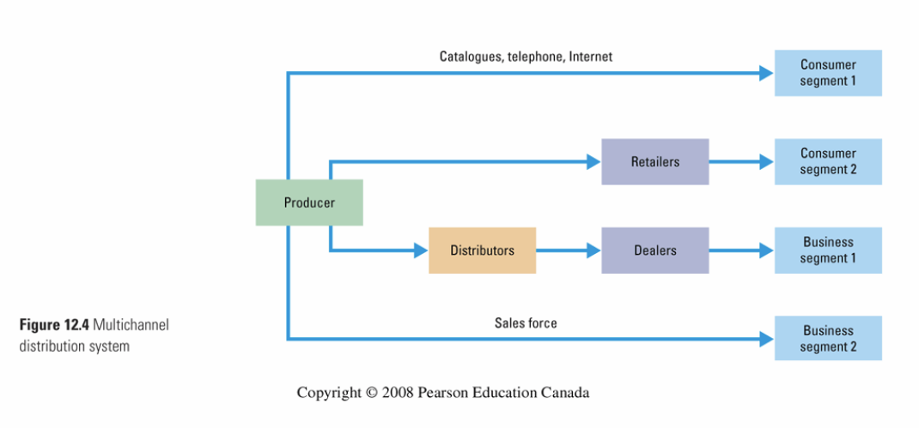
- Advantages:
- Gain opportunities to tailor its products/services to specific needs of diverse customer segments
- Expanded sales/marketing coverage
- Disadvantages:
- (more) difficult to control
- Generate more conflict as more channels compete for customers and sales
- E.g. Manufacturer could see a product at a lower price online (direct channel) than retail price, due to the channel cost savings.
Channel intensity:
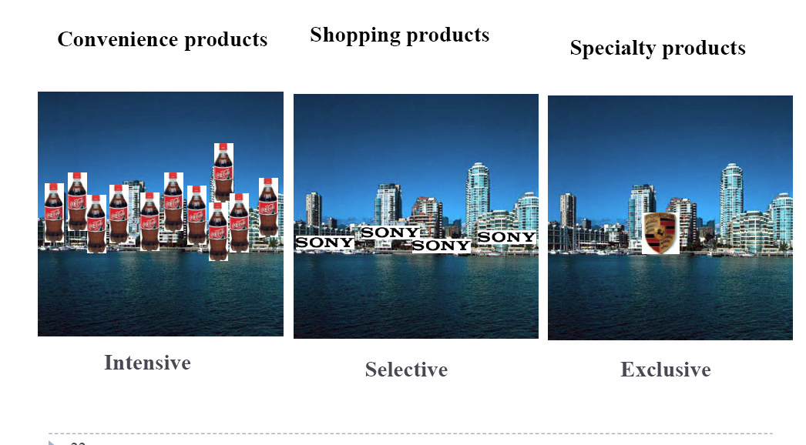
Channel Management:
- Independence of intermediaries?
- Inevitable problems:
- Coordination: decisions are mutually dependent
- Incentive conflicts: goals are not aligned
- Role of channel management
Channel Partner Selection:
- Deciding what role your partners play
- What margins to give
- How much experiences do they have in carrying similar products and their reputation
- If they carry competing or complementary products
- Controlling cannibalization with other channel members or channels
Motivating channel members:
- Channel conflict: occurs when channel members disagree
- Types of conflict:
- Horizontal: occurs among firms at the same channel level
- Certain distributors offer pre-sale services → however, some other distributors who carry the same manufacturer’s product don’t provide pre-sale services → they often “free ride” on the services provided by other distributors + attract consumers by offering lower prices
- Ensure fairness → cooperative promotion
- Reduce competition → different models in different retailers, exclusive (geographic) territories
- Vertical: occurs among firms at different channel levels
- Quantity discount: the more the retailers sell → higher margins on all products
- Two-part pricing
- Increased competition among distributors
- Vertical integration
- Build relationship with distributors
- Manufacturer’s suggested retail price (MSRP)
- Example:
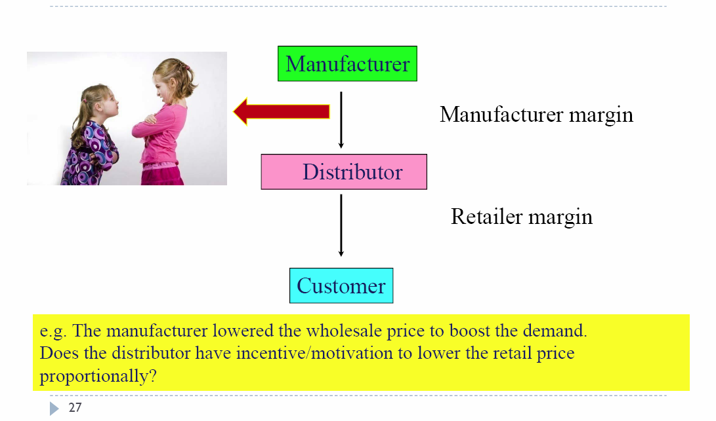

Vertical Marketing System: distribution channel in which the manufacturer, wholesaler and retailer act as one.
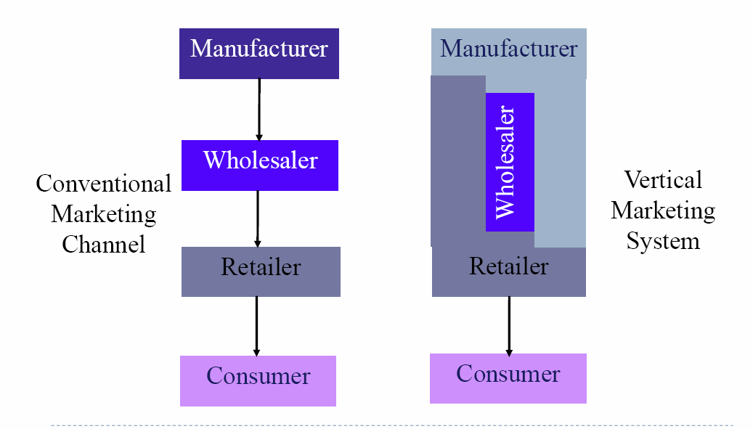
Different types of Vertical Marketing Systems (VMS):
- Corporate:
- Combines successive stages of production/distribution under single ownership
- Control over almost every aspect of supply chain
- Forward or backward integration
- Contractual:
- Independent firms at different levels of production/distribution, join together through contracts + obtain more economies or sales impact than they can achieve alone
Pricing Strategy:
- Price: the value that a buyer exchanges for a good/service
Factors affecting pricing decisions:
- Internal:
- Marketing objective
- Marketing mix strategy
- Costs
- Organizational considerations
- External:
- Nature of the market and demand
- Competition
- Other environmental factors (economy, resellers, government)
General Pricing Approaches:
- Asses what value your consumers place on the product/service
- What should the appropriate process be?
- From company → to market place
- From marketplace → to company
- Looking at competitors
Types of pricing
Cost-based pricing:
- Let’s recover our costs and make a profit
- What it’s called: cost-based, markup, cost plus, target profit, ROI…
- Adding a standard → MARKUP cost or sales → Break-even pricing
Pros:
- Simple → easy to use, manage and implement
- Easily justifiable to buyers/ sellers

Cons:

- Unit or average cost varies with price → price affects volume and volume changes average cost; model is “circular”
- Market/demand conditions never enter the model → what is your competitor’s price? Are you customers willing to the pay the amount?
Value-based pricing
- Price is based on buyer’s perceptions of value
- Quantify consumer benefits relative to existing products
Cost-based vs. Value-based
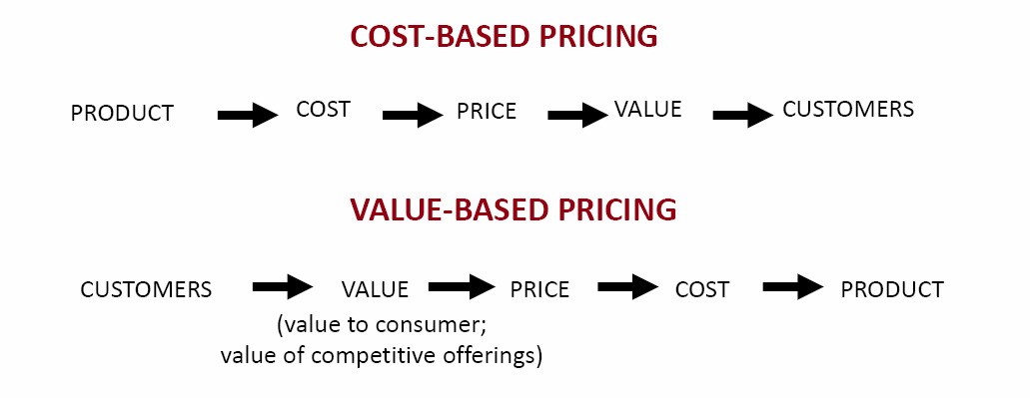
Market-based
- Make price at the same level, above or below competition
- When demand elasticity is difficult to measure

Cost-based vs. Value-based vs. Market-based
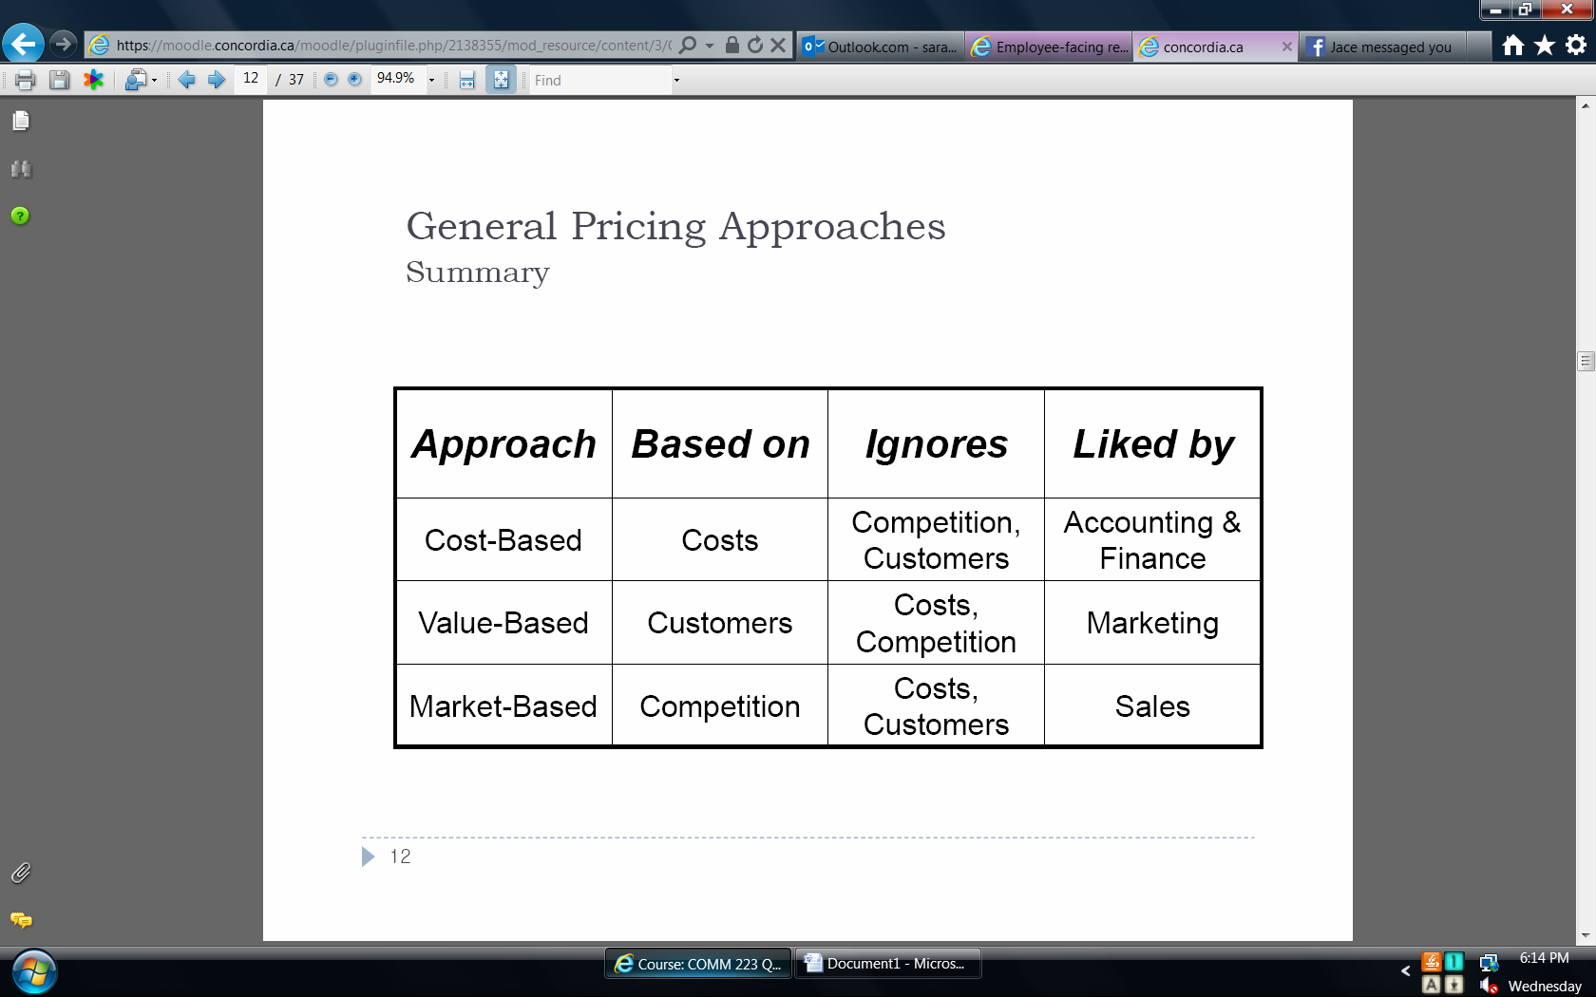
Price adjustment strategies:
- Discounts and allowances
- Price segmentation
- Geographic pricing
- International pricing
- Psychological pricing
- Promotional pricing

Price segmentation:
- Two or more prices for the same product
- Also known as: price customization, price discrimination, segmented pricing
- Forget the following idea: “all customers are charged the same price”
Basis for segmentation:
- Customer, location , product form, time
- To be effective:
- Market must be segment-able
- Fences that ensure “high” types pay higher price
- Imposed fences: divide and identify customer type
- Induced fences: self-selection mechanism
- No arbitrage
- Incremental revenue is bigger than cost of segmentation
- Must be legal
- No customer resentment/antagonism
Price segmentation:
Group Pricing
- “Low” types identifiable
- Some examples:
- Senior discounts
- Student discounts
Location
- WTP depends on location
- Examples:
- Income differences → gas price in high income area vs. low income area
- Competitive differences → Starbucks at airport vs. non-airport
Transaction cost
- “Low” type has lower transaction (opp.) cost
- Examples:
- Coupons
- Haggling

Time Purchased
- Valuation relates to patience
- Examples:
- Books
- First runs
- Fashion sales
Optimal pricing strategies:
- Option pricing: pricing optional or accessory products sold with the main product
- Product line pricing: different models have different prices
- Reference price
- Order effect: For a given product, different sets of subjects were shown reference prices in varying order
- The Attraction effect: given alternatives A and B, B dominates → add alternative C which A dominates
- Captive pricing: pricing captive products that are useless without their core product (e.g.: printer and ink)
- Bundle pricing: (e.g.: vacations –all inclusive)
Price Elasticity of Demand:
- Price elasticity: the extent to which the percentage change in quantity demanded (q) is affected by a percentage change in price (p)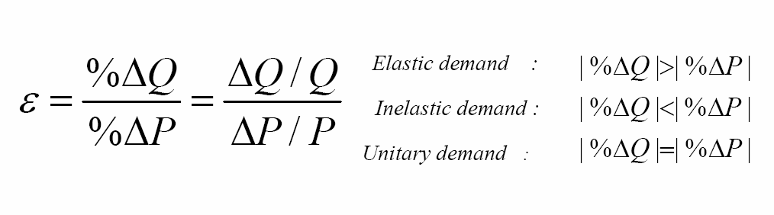
- Characteristics
- It does not depend on the unit quantity → the ratio of “percentage” change
- The sign matters → + elasticity = ↑ in one variable leads to ↑ in another ;(-) → an ↑ in one variable leads to a ↓ in another
- The magnitude matters: elastic → if it is greater than 1 in absolute value; inelastic if it is smaller than 1 in absolute value

Inelastic vs. Elastic Demand
Less elastic if:
- Fewer substitutes
- Fewer competitors
- Difficult to compare prices
- Slow to change consumption rate/switch brand
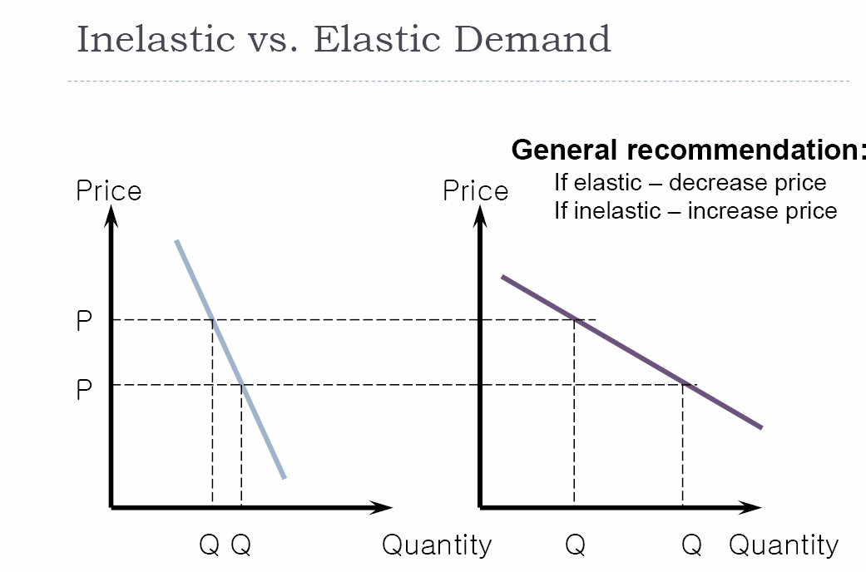
New Product Pricing:
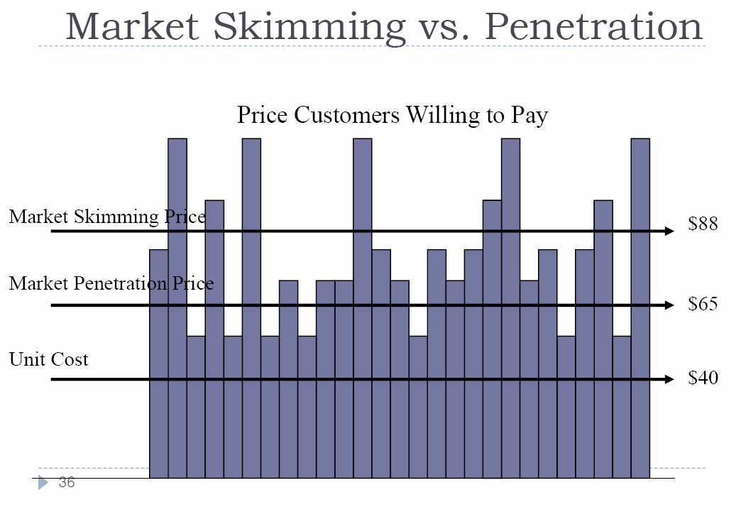

Skimming vs. Penetration Pricing:
Skimming:
- Enough early-adopters willing to buy at high price
- High price will not attract competition
- High price is a heuristic for high quality
- Lowering the price has only a minor effect on ↑ the sales volume (inelastic) and ↓ the unit cost
Penetration:
- Customers are high price sensitive
- Low price = lower competition
- Products costs ↓ when more volume
LECTURE 10
Marketing Communication Model
The Integrated Marketing Communications Mix
Integrate:
- Advertising: any paid form of non-personal presentation and promotion of ideas, goods, or services by an identified sponsor
- Sales promotion: short-term incentives to encourage purchase or sale of a product/service
- Public relations: building good relations + corporate image with the company’s publics using publicity/handling unfavorable events
- Personal selling: personal presentation by the firm’s sales force for the purpose of making sales and building customer relationships
- Direct marketing: direct communications with targeted individuals to obtain an immediate response and lasting customer relationships
Integrated Marketing Communication:
- Integration/coordination of the firm’s various communication channels or promotion mix elements
- Three points in integration/coordination
- Clarity
- Consistency
- Positive synergy

Developing Effective Communication
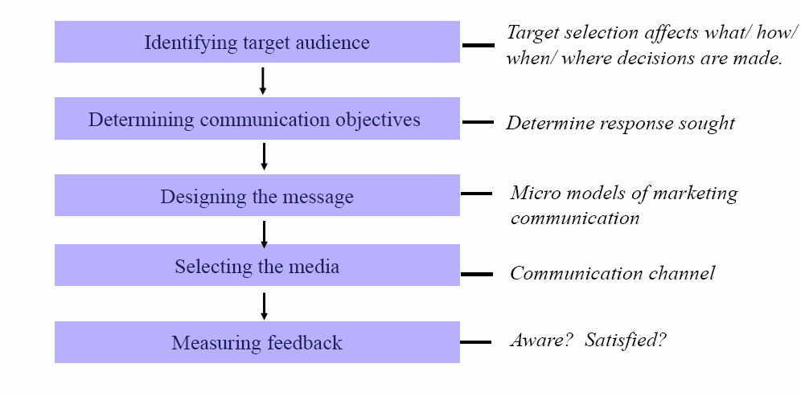
- Identify target audience:
- Who are you targeting?
- Target selection effects → what, how, when and where message is communicated
- Target selection may include:
- Potential buyers/current users
- Deciders/influencers
- Individuals/groups
- Particular publics/general publics
- Determining communication objectives:
- What do you want to get from communication?
- Consumer readiness stages model
- Awareness → knowledge → liking → preference → conviction → buy
- Four possible objectives
- Category need
- Brand awareness
- Brand attitude
- Brand purchase intention
- Designing the message:
- Message content contains appeals or themes designed to produce desired results
- Types of appeals:
- Rational: relate to the audience’s self-interest
- Emotional: stir up negative/positive feelings using humor, fear, pride, joy or even disgust
- Moral: relate the audience’s sense of right vs. wrong
- Selecting the media:
- Non-personal communication channel
- Media
- Sales promotion
- Events/experiences
- Public relations
- Person communication channel
- Face-to-face, phone, mail, internet
- Woud-of-mouth influence = critical
- Buzz marketing leads to opinion leaders
- Who should say it?
- Expert for credibility
- Testimonials for trust
- Celebrities for likability
- Measuring feedback:
- ROPI (return on promotion investment)
- Sales, profit, financial gains, brand images
- Difficult task
- On average, negative return on advertising
Does advertising work?
- Many executives believe ads = only successful if produce sales
- Others believe ads should emphasize long-term brand building
Promotion Mix:
- Push strategy:
- Marketing activities toward channel members
- The channel members promote the product to final consumers
- Personal selling, trade promotion
- Good when → consumers will not deliberately seek your product (low brand loyalty, impulse item)
- Pull strategy:
- Marketing activities toward end users
- The end users demand the product from channel members
- Advertising, consumer promotion
- Good when → consumers will seek out your product (high brand loyalty, significant differentiation among brands)
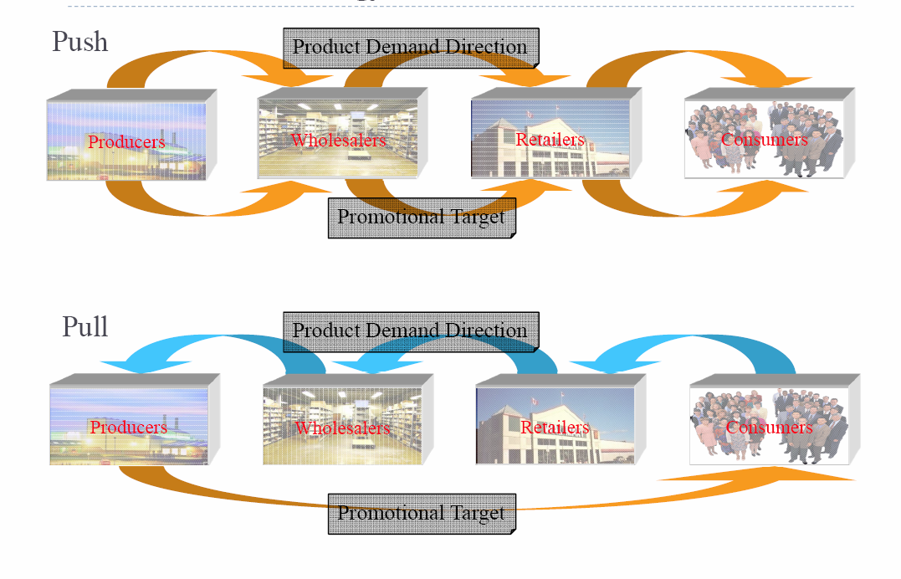
Push vs. Pull strategy: Marketing trend
- Pull → push → pull
- Why “push” again?
- Mass media = less effective due to ↑ amount of info and ↑ diversity in consumer preferences
- Little meaning in product differences due to ↑ competition
- Growing strength of mega-retailers
Promotion Mix: Tools of Promotion
- Advertising
- Objectives:
- Inform
- Persuade → comparative ads “us vs. them”
- Remind
- Message:
- Meaningful yet simple → clear about benefits offered
- Believable → customer convincement
- Distinctive → be different
- Strategy (media):
- Selection criteria
- Reach
- Frequency
- Impact
- Modern media concerns
- Clutter
- Resistance
- New media forms
- Product placement
- Buzz marketing
- Word-of-mouth
- Timing:
- Frequency
- Continuity:
- Scheduling ads evenly within a given period
- Once a week for one year (52 times)
- Pulsing:
- Scheduling ads unevenly over a given period
- Intense ads during the holidays within a year
- Some patterns:
- Continuous (steady) schedule
- Flighting (intermittent) schedule
- Pulse (burst) schedule
- Sales promotion
- Personal selling
- Public relations
- Direct marketing
Public Relations
- Public relations → focuses on all the relationships organization has with various publics
- Publics → all the groups of people with which an organization interacts (employees, members, local communities, shareholders, etc.)
- Stakeholders → people who have a stake in a company/org.
PR vs. Ads
Control:
- With new stores, PR strategists are at mercy of media gatekeeper
- There is no guarantee your story will run → story may be rewritten/reorganized
- In contract → ads run exactly as the client who paid for it has approved and as scheduled
Credibility:
- The public tends to trust the media more than they do advertisers
- Consumers assume a story is legit if it appears in the media

LECTURE 11
Advertising: any paid form of non-personal presentation of ideas, goods or services
Advertising objectives:
- Inform
- New products
- New uses
- Company image
- How “it” works
- Reduce risk/fears
- Persuade (comparative advertising)
- Growth products
- Brand preference
- Perception of features
- Change attitude
- Buy NOW
- Brand switching
- Reminder
- Mature products
- Top of mind
- Brand equity
Comparative Advertising: competitors are directly/indirectly referred to in an ad, either on an attribute or an “overall” basis
Timing:
- Continuity
- Scheduling ads evenly within a given period
- Once a week for one year (52 times)
- Pulsing
- Scheduling ads unevenly over a given period
- Intense ads during the holidays within a year
Public relations: focuses on all relationships an organization has with various publics
Publics: groups of people with which org. interacts: employees, members, local communities, shareholders, customers, other institutions, etc.
Stakeholders: people who have stake in a company/organization
Sales Promotion: a varied collection of activities –other than personal selling, advertising and publicity –that stimulate interest, trial or purchase
Major Promotion tools:
- Consumer promotion
- Contests, sweeps, games
- Price packs
- Premiums
- Samples
- Coupons
- Trade promotion
- Co-operative advertising
- Merchandising allowances
- Free goods or discounts
Managing the Sales Force
- Designing sales force strategy and structure
- Territorial sales force structure (e.g. Montreal, Toronto…)
- Product sales force structure (e.g. car insurance, home insurance…)
- Customer sales force structure (e.g. new customers, existing customers…)
- Complex sales force structure (cumulative)
- Recruiting and selecting sales people
- Increase overall sales force performance
- Reduce turnover
- Reduce recruiting and training costs
- Training programs
- Identify with the company and its products
- Know about customers and competitors
- The basics of the selling process
- Compensating salespeople
- Compensation elements: salary, bonuses, commissions, expenses and fringe benefits
- Basic compensation plans: straight salary, straight commission, salary + commission
- Supervising salespeople
- Sales quota
- Sales meetings
- Positive incentives
- Evaluating salespeople
- Sales reports
- Call reports
- Expense reports
Forms of Direct Marketing
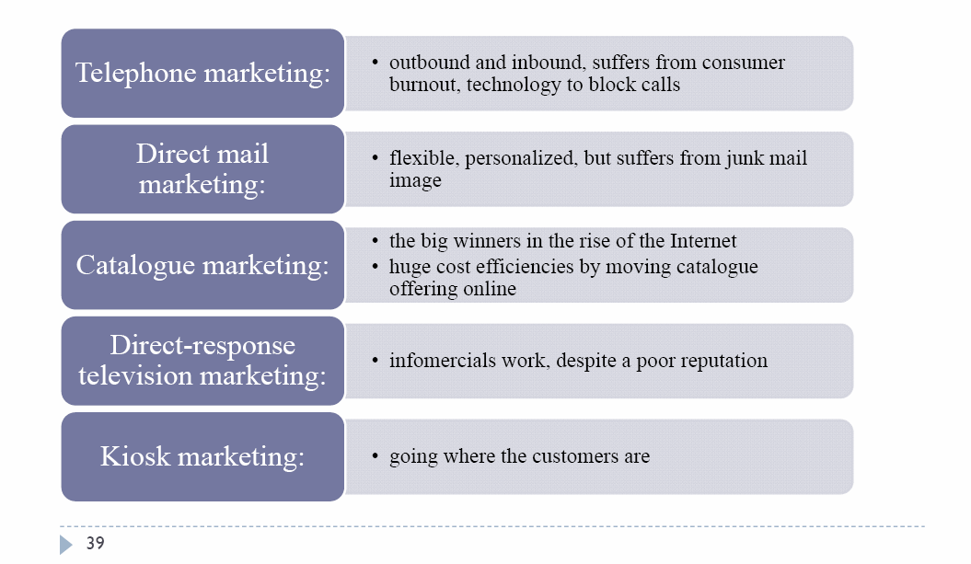
Benefits of direct marketing to buyers:
- Convenience
- Ready access to many products
- Access to comparative information about companies, products, and competitors
- Interactive and immediate
Benefits of direct marketing to sellers:
- Tool to build customer relationships
- Low-cost, efficient, fast alternative to reach markets
- Flexible
- Access to buyers not reachable through other channels (e.g. small firms going global)

Promotion Mix: PROS and CONS
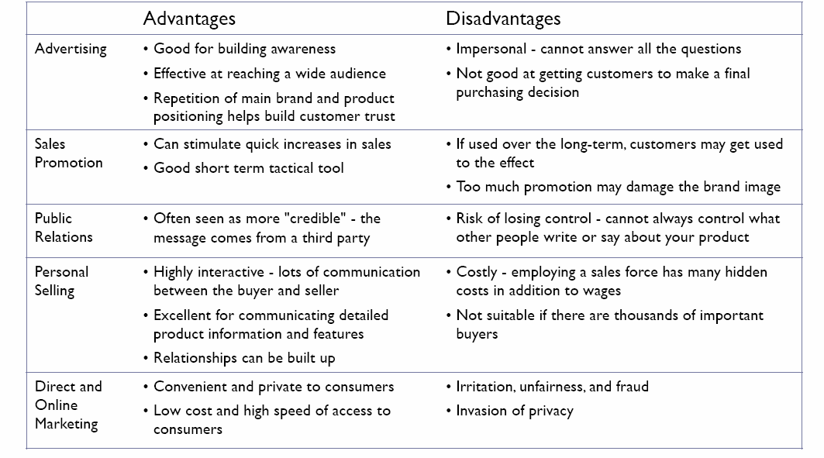
Promotion Mix: stages in consumer decision process and promotion mix elements
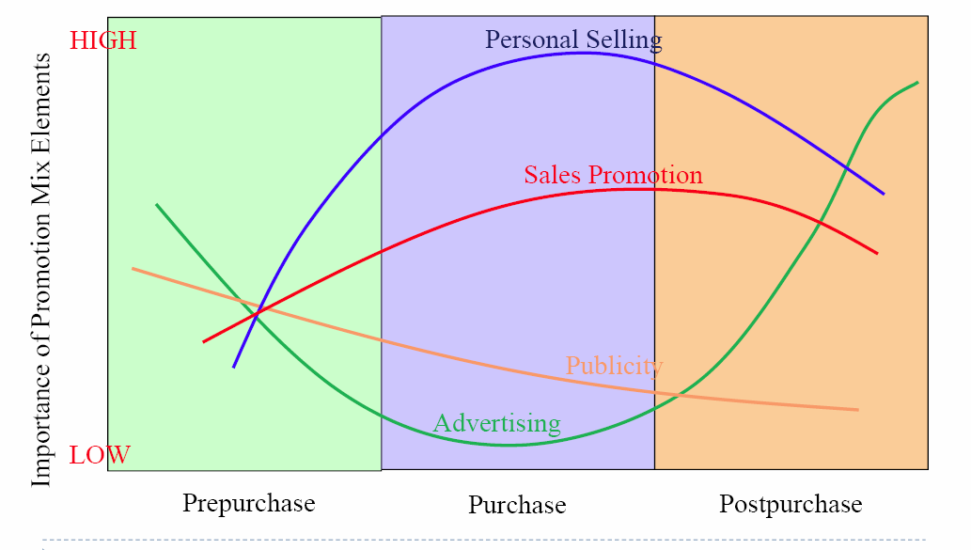

Social and ethical criticisms of marketing:
The impact on individual consumers:
- Deceptive practices
- Pricing
- Promotion
- Packaging
- High-pressure selling
The impact on society as a whole:
- False wants and too much materialism
- “Greed is good”, “Shop till you drop”
- Cultural pollution
- Ads obscure magazine
- Billboards mar beautiful scenery
Miscomprehension: misleading advertising → lead consumers to make incorrect inferences
- Literal vs. Figurative meanings
- Brand X “may” relieve your pain
- Comparison omission
- Brand X relieves pain better
- 500 doctors recommend brand X
Examples of Miscomprehension
- Piecemeal comparisons → Brand X works faster than Y and longer than Z
- Wrongfully inferring causality → active people take Brand X
- Misleading visuals
- Unclear definitions → Ocean spray, more “food energy” than juice (instead of calories)
LECTURE 12
Global marketing
Major decisions
- Whether to go international or not
- Which market to enter
- How to enter the market
- Deciding the global marketing program and organization

Why internationalize?
- Resource seeking
- Secure key supplies
- Access low cost factors of production
- Market seeking
- Competitive advantages over local players
- Small domestic markets
- Saturated domestic markets
- Industry economies changing
- Increasing economies of scale
- Ballooning R&D investments
- Shortening product life cycle
- Learning capabilities
- Exposure to (better) alternative sources of supply
- Exposure to new technologies or market needs
- Competitive positioning
- Cross-subsidization of markets for risk-pooling
- Attack domestic markets’ competitors
Standardization vs. Adaptation
Globalization (Standardization)
- Developing standardized products marketed worldwide with a standardized marketing mix
- Essence of mass marketing
Global localization (Adaptation)
- Mixing standardization and customization in a way that minimizes costs while maximizing satisfaction
- Essence of segmentation
- Think globally, act locally
Key questions to ask:
- Where to standardize/localize (segmentation, targeting, positioning)
- What to standardize/localize (marketing mix, 4 P’s)
- How much to standardize/localize

Political and Regulatory Environment
- Role of government in economy
- Market vs. command economy
- Taxation policy
- Corruption
- Foreign investment limitation
- International trade system
- Tariffs
- Quotas
- Exchange controls
Economic environment
- Size and distribution of economy
- Income level, region, urban vs. rural, age, gender
- Financial situation
- Inflation, interest rates
- Private consumption by category
- Food, clothing, transportation, housing, health care, education, leisure…
Marketing implication of income level:
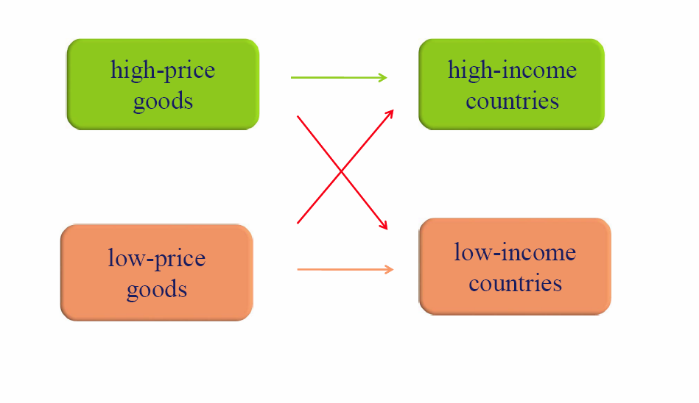
Total number of consumers:
Not only is the number of people important, but also:
- Need to buy
- Ability to buy
- Willingness to buy
Evolution of total population depends on:
- Births
- Deaths
- Net migration
International Market Entry strategy
- Exporting → product
- Joint venture → licensing, contract manufacturing/management contracting, joint ownership
- Full ownership direct investment
Deciding on the Global Marketing Program
- Standardized marketing mix
- Same basic product, advertising, distribution, and other elements of the marketing mix are used in all international markets
- Adapted marketing mix
- The marketing mix elements are adjusted for each international target market
Five International Product and Promotion Strategies:
Strategies | Product | Promotion
- Straight extension | Don’t change | Don’t change
- Communication adaptation | Don’t change | Adapt promotion
- Product adaptation | Adapt product | Don’t change
- Dual adaptation | Adapt product | Adapt promotion
- Product invention | Develop new product | Adapt promotion

