ENGR 392 QUIZ #2

10 questions.

- Code is Law – Article by Lawrence Lessig: article about how coders and people who make the infrastructures are deciding the internet laws. It affects privacy and security. One of the main point of this article is that those who say that we should naively not regulate the internet need to be careful about what they are asking for. The author point here is that the internet is being regulated, but not by the government… by the coders. Your activity online is being regulated, the coders are not working for the government or huge telecom. There is none representative or democratic system. It is being regulated in the interest of very few. The counter intuitive problem here is that if we want a none regulated internet, we should be careful because if the government do not regulated it, other people who do not represent us (like coders) will, and it could be not in our best interest. Code is technology. People who are coding are bringing with them a set of values (and all technologies do). Those values are not values that many of us like.
  - How Lessig’s point about people that are bringing particular values with them as they code the internet, how that can relate to other subjects that were mentioned in this course :
    - Social-Constructivism: S ↔ T society and technology co-construct each other. Internet shape the society with the values implemented by the Coders.
    - Reification(process of making something real):
Pre-Existing values Technology Reinforced values
    - The very definition of technology of NYE in chapter 1: Coding is more than an artifact, it can have politics. Therefore has values and effects (See notes from QUIZ 1 review).
- “Do we need a technology Policy?” – S.Kline & D. Kash & “Technology Assessment: Product or Process ” – Josee Van:
Four function of technology policy:

- Coordinating : common sense. In order to come up with transport system in Canada, requires coordination at gov level across many indsutries in society, who have no incentives to work with each other. All business, in order for business to exist, requires a national transport system but none of them could afford to implement them themselves. So the government is laying the preconditions industries to exist at all and they are incentivizing this.
  - Surveying: Collecting data that industries cannot and for the benefit for everyone. / a tech policy in place to survey technical trends so that our own technology can remain competitive on the global scale. All businesses benefit from having the data that Statscan gets. The government’s responsibility to gather this data, because it’s too expensive for any single person to do. Statscan has a lot of data.

  - Gap Filling: On under a specific set of circumstances, it is beneficial for the government to step in. Orphan drug, drug that people need that are suffering from a rare condition. / Direct government intervention might be required in the tech sector to the benefit of everyone. None of the functions so far have governments working directly on it. Ex. Orphan drugs, designed to cure disease that few people suffer from. Medicine and drugs are a private industry run by capitalism. If only 1% is suffering from something, then you’re not gonna invest lots of money to cure it. So government step in and fund, subsidize, wtv to help out. Government steps in and helps to the benefit of everyone. ALSO research with no direct goal. DARWA? Gives unlimited budget to a bunch of smart people to develop high tech.
  - Climate Setting: Well functioning policy for a well thriving technology sector is to provide a good service for any private actor to bear. Transportation infrastructure: Roads, railways, airlines. / : Government policy must make it attractive to get into the technology sector: incentives (subsidizing particular areas, cash to incubators, cash to startups, etc) and education (making sure that we have a workforce of people heading into the technology sector). Basic foundation of all government: role of the gov to provide things that benefit everyone but the cost is too high for any single person to bear alone. So it’s society’s job that the basic preconditions that are necessary are fulfilled so that companies can pull from an educated pool. It’s to Microsoft’s benefit that they hire an educated workforce. But Microsoft can’t pay for everyone to be educated for example. Government’s job.

Two main point in this article:
Why don’t we have a more conscious, reflective, formal technology assessment mechanism in Canada or in the USA? Why do we have a Ad Hoc Paradigm instead?
In North America, we are neo-liberals, so the government should be hands off when it comes to the technology sector of the market, it’s falsely thought that the government has no role plan in technology policy in a free market society. In fact, one could not have a technology policy without the government involved in it. The government is needed when it benefits all but the cost is too big for any individual actor to bear.

Five technology assessment paradigms: (p. 276)16:00
- Ad Hoc paradigm: Non-systematized and informal. / First attempt Americans made to assess tech. Classical tech assessment paradigm (p276 block quote). Systematic evaluation of secondary consequences of tech on social, economical systems. Has self-contradictions. Technological determinism is not an accurate theory, but social constructivism is. Which says that tech is normative depending on elements. They come with human intentions and desired outcomes, which means that if you’re giving a description of a tech, it’s not possible to give one that is neutral. They are inherently normative and inherently political. Giving a factual, neutral assessment will be by definition impossible. They move to another model called the OTA paradigm.
- Classic technology assessment paradigm: Which assessments are good for us and which is bad for us. Does not work. Predictive/bias issues. Democratic assessment and normative are related since technology is normative. In normativity, people have differing views which is why democracy exists. It’s an impossible thing. Recognized early on. / Around the counter-enlightenment – very well publicised disasters that took place, Technology assessment is the systematic identification, analysis and evaluation of the potential secondary consequences (whether beneficial or detrimental) of technology in terms of its impacts on social, cultural, political and environmental systems and processes. Technology assessment is intended to provide a neutral, factual input to decision making. It is possible for a single individual to arrive at a factual, neutral, normative assessment of technology.

- Office of technology assessment paradigm: The Collingridge dilemma: Bull and horns analogy. The knowledge horn: We cannot know what the tech will do until we witness it in society. The power horn: / independent body of experts that studied science and technology arrive at facts about the technology include stakeholders, non-experts, people that have Alongside their facts, present stakeholders view. In 1995, the OTA died / 1975. It is a number of scientists employed by public funds to assess tech and run analysis on tech. In addition to scientific technological research, they also bring in non-experts into the process. Non-expert perceptions of the technology which is also gathered as statistically relevant data. Inclusion in the OTA paradigm of non-expert opinions which gives us idea of what direction technology needs to go in. Still exists in Western world. By the mid80s, all the EU countries start employing this because they realize that the policy will be accepted overall because the public participates in it. But they call it their own thing, public TA.

- Public technology assessment paradigm: results in neo-colonization and claiming of other cultures through economic measures. Some companies just do things just to get support from donors regardless of the actual social impacts and circumstances. It is completely skipping over adequate incentive progress. They do it because they need to say “the number of wells they dug” to get continuous funding. / direct participation by non-experts in policy crafting process. Consensus Committee, or citizen’s jury. This is not a theory. This is a description of actual practices that actually happen. Consensus committee look like our criminal charges look like. Jury sits and listen to expert testimony. You must take expert testimony as evidence. Discuss issues like releasing GMO salmon's into the rivers. Bring in experts and their testimony is privileged but the overall decision is in the hands of the jury or the representative body of the public.

- Constructive technology assessment paradigm: Putting the people in the actual creation and production process. People with different perspective. Why? Because technology is normative. Let’s have a conscious, purposeful, systemized, infrastructure. Focus groups will include users to positively affect them. The right and let will join. / Better if take representatives of the public and include them in the development process of technologies rather than waiting until after it’s developed and released. Not used very often. Used when a very very controversial issue comes up or something that doesn’t have clear implication yet.
Two justifications to include non-expert in technology assessment (TA):
- Democracy (17:50)
- Epistemic argument : as we democratize policy, we are increasing the number and diversity of decision makers and thus perspectives, and we don’t arrive at a weaker claim of technocracy. There is a stronger claim to better policies because of more views. Strong objectivity. More perspectivies we can assess the technology from, the stronger we can claim objectivity. So laws are more rational and more objective than those only from those made only by experts.

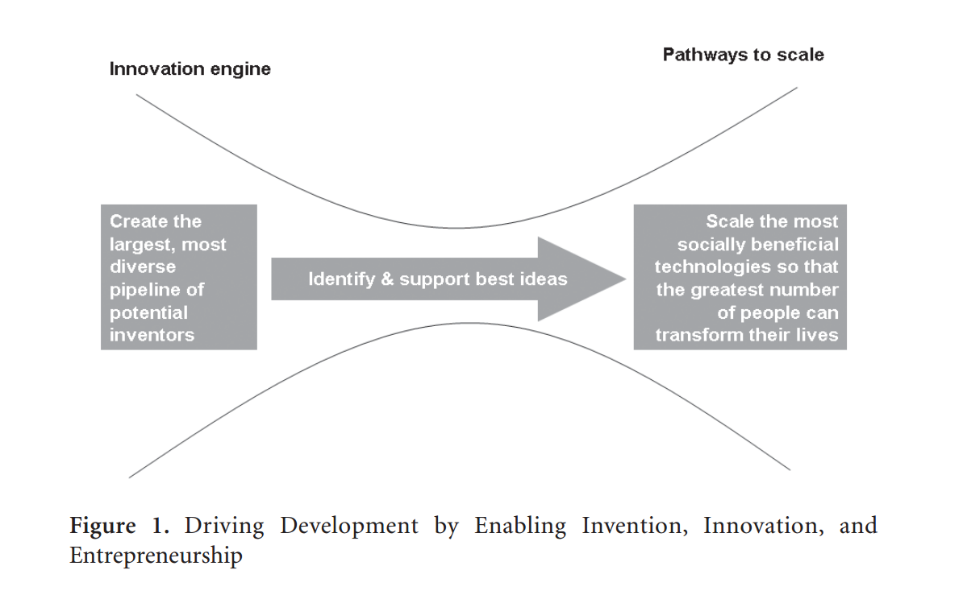
- “By the Grace of Invention” – J Novy Hidesley & Tapping ICT to Reduce Poverty in Rural India:
The trajectory of the development world and how it’s rate at which they are developing. They develop more rapidly than us. And the technological pathways they are taking to increase to develop, which is highly problematic because if the trend continues we’re all going to die.(greenhouse gases)

Leapfrog energy technologies (Leapfrogging) Relate with the pathways to scale.
Important to introduce new clean technologies in developing countries,

Who will introduce these leapfrog technologies to the new world.

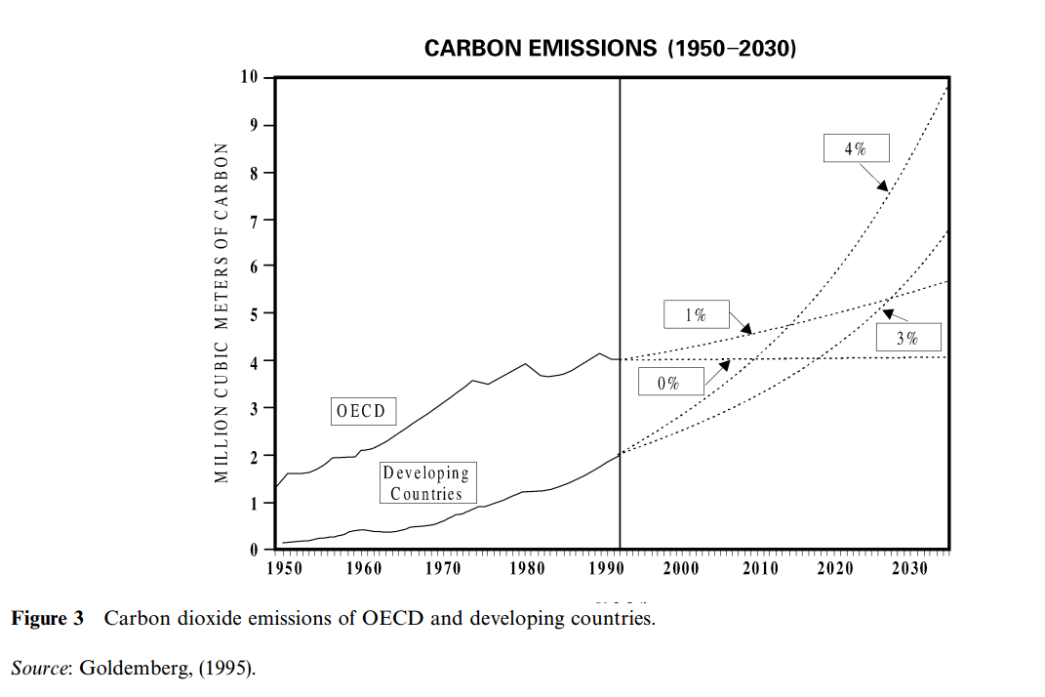

- PPP: Polluter Pay Principle = you break it you fix it (not a good solution because older generations are no longer here).

- BPP: Beneficiary Pay Principle = if you are benefitting off of pollution then you are responsible for that pollution corresponding with your benefit. The problem is you didn’t decide to be a beneficiary, we did not decide to be born into a world that is as polluted.
Holds people that are polluting now responsible more than people in past generations.
(Vinny and the stolen DVD player) Having a stolen good and stealing it is not morally the same thing.

- Egalitarianism Cap and TRADE: each individual is responsible for their equal and acceptable share of cleanliness. Emission CAP, because they have more people, they are allowed to pollute more, because they. Every country is allowed to pollute at a certain extent that is.

Each of these principles are meant to correct for the problems of global warming. As soon as it fails to differentiate responsibility in such a way that the problms of global warming are avoided then the principle fails.

Reading: Design on Development:

    - Nicaragua Case Study: even engineers focus too much of product rather than process. Process is important when taking tech movement seriously. You must take into account the idiosyncracys of the new context of which you’re working. Have people from there actually a part of the project. Actual end users to help be part of the design process. Too much attention being paid to the technology itself.

3 barriers to successful development initiatives: page 31 and 51
- over attention to technology/product (pages 34 and 51 descriptions of three barriers) the success of a particular initiative is judged by a product/thing that’s there (number of wells that have been done)
when you focus on the product as opposed to the process, you often fail to do the good you set out to do.
Example of the woman walking around the carousel, had they gone through the process instead of focusing on the product, the amount of time-intensive labour and physical to extract water? Process training the woman how to fix the more traditional pumps, having better understanding of the social context in which they were working in and the process by which they can arrive at their goal which is presumably was providing them with water that’s more readily and easily available without as much time and physical labour. We can understand that more attention to the process might have helped avoid the silly problems that they ran into.
- Inattention to power and balances: the well-trained engineering professionals from western countries are perceived as experts in their field. The people give too much power/authority to the westerns, they are perceived as experts, however, the engineers from MIT might know more in his field, but lets keep in mind, we’re talking about appropriate technology, making sure that the technology is going to make sense in the new social context, so how do we know if it’s appropriate technology, how do we know how the social context differs from the place we’re taking it from we know that from working with people that live there so they do have a type of expertise that is absolutely necessary to make sure that your technology is an appropriate fix, which means if there is power imbalance between the experts coming in from advanced countries and the people there, you are not going to arrive to an appropriate solution, because you will not be properly incorporating local concerns and values into decision making processes. There’s the idea of pre-existing power imbalance (especially in the Sri Lankan case where Dean was telling them to have an input and the locals were telling him that he’s the expert, he should make the decisions) that beings to talk about larger relationship between first world and second, third world countries.
Why it’s a problem? In order to make sense whether a technology is an appropriate technology, we need an understanding/ participation of people in the social context where the solution is being applied to know that we’re doing it properly.
- Uncritical use of problematic models of development: basic assumption about socioeconomic structure (it captures both the social and economic structure of a particular society) the students involved in the Nicaraguan case study, they almost set up businesses that would compete with other businesses, they weren’t just going to come up with a product out of nowhere, they were going to learn about the local community and its needs and develop a product based on these needs, develop the product and then sell it, tries to adheres to appropriate technology movement because the product they were going to sell was going to be based on research, but there’s a whole other problem, without realising it, they were transferring a particular understanding of the socioeconomic to do so through a capitalist, private is not obviously the right way to do it
many of them are communists and socialists, the point here is without knowing, they have brought here how technologies , assumptions that come from , the collective good driven by individual process, trying to take capitalist business, communism isn’t most of communists are very appy and proud to be communists, systems don’t just come as set of rules and need more than rule, they need people to think that those rules are good , they think they’re part of a larger system that they think is a good system. Having the values of capitalism
capitalism is one form of economic structure which is that embodiment of those values held by the people
often times people employing socioeconomic in addition to the artifact, without realising it, you’re transferring the social part where
when it comes to socioeconomic , there are blind spots other people live and think about the world the same way we do, check your privilege , be a little more attentive to the other differences, on a conceptual level, the idea is that something

=> first barrier:
talk about technology transfer, know what the problem with it are and relate them to previous course material
not transferring a technology but only transferring an artifact from one place to another (theres two technologies here). Helps us understand why tech transfer is a bad thing.
Next 2 barriers:
Talk about neo liberalism (know everything about it) defend it (why do they think neo liberalism is a good thing?) and to critic it
Neo is the General idea that the privatization and the opening up of markets often times through cohesion and manipulation (forcing countries to open their market) will result in a one world market where everyone rise. Through their participation in an open market their standards of living will increase.
Critic: because we force countries to relinquish sovereignty no one is allowed to have protectionist taxes of any sorts. Also with this open market that is dominated by some countries it comes with some cultural changes that some people don’t like (it basically forces everyone to become American)

Nicaraga:
When well intentioned engineers go to developing countries
It didn’t occur as first to Nicaragua people spreading capitalism for developpement and working with a open market like it works in America can be a bad idea. Working neo liberaliasm models dont make sense in a socialist or collective-oriented country.

READING: IT’S A FLAT WORLD AFTER ALL:

4 world flatteners memorized and intelligently discuss them
Descriptive vs normative account of globalization

10 World Flatteners:

- 1989 taking down the berlin wall and the collapse of USSR
- Netscape, making the internet surf-able.
- Work flow-> app-app communications through the internet.
- Outsourcing
- Offshoring
- Open sourcing
- Insourcing: allowing companies to come in and do stuff in ur company, inventory, optimizing … ex. UPS
- Supply chaining: offer a far greater variety of goods with a way lesser price, u link ur point of sales with manufacturing and inventory. So u never hold more product than u need. Avoids the problem of having all ur capital wrapped up
- Informing: it becomes possible for anyone to get info and info is power. Ppl come her get an awesome education and then end up staying. Brain drain.
- Steroids: the 9 previous ones getting more extreme and making them easier to implement.

Be able to talk about the kinds of choices the Canadian eng profession and the CEAB and how they view the 2 views it is not the main purpose in Canada for eng to be successful in the global order but to also be able to be critical.

Instrumental notion of Engineering education VS. Normative notion

2 ways to look at Engineering education:
- Instrumental: sees how to educate in order to produce eng who r capable to successfully live in the industry. If we find imperfections in the system yet educate around that same system we can never fix things. Meet with industry, find what the demand is. Valued soally as a means to get a job.
- Normative: in addition to the first part, eng should graduate with the ability to critique and be able to change things for the better.
As mandated by the (CEAB) accreditation board, eng education should be looked at normatively, to be able to critique and reform.

When we talk about the neoliberal policies, we r talking about a normative account of globalization. Some people think that neoliberal policies open up possibilities for free trade and eventually the standard of living of all those people will be lifting up. Others see it as a continuation of liberalism and trample on the basic rights of people in developing countries.
Is this how we want our world to become one world: be able to supply the arg for: if we force ppl to engage with the global market then we force everyone to become economicly interdependence thus reducing war also a common tide raises all boats.
At the same time: ull hv to be ‘forced‘ to do so: that’s bad enough, ull also be letting in a particular lifestyle: it transforms countries into the us. Neoliberalism: tries to fight for the same thing liberalism faught for but nstead of using wars it uses economic means
basic point: a while ago it was decided that it’s the normative model in which you are prepare to participate in the globalize model and are equipped by the conceptual capabilities to critic and change those practices when necessary.

READING: WW3.0
discuss the 2 sides of each of the 4 fronts

Forces of order VS. Forces of disorder

- Sovereignty: the right of a nation to be able to control their own affairs. Individuals now also have sovereignty. U hv as much liberty as possible for everyone to hv the same amount.
The forces of order want to take our existing form of sovereignty and map it onto the architecture of the internet. They want to shape the internet to hv the same structure.
The forces of disorder are against that. The internet was made for ppl to communicate without a third party knowing where they r. it undercuts the idea of limiting ppl to communicate according to national boundaries. Look at north korea and china they both limit what ppl can access on the internet. The forces of disorder want to change that. And make sure that everyone has the same access to that type of information regardless of their location. They r for the free use and exchange of ideas.

- Piracy: software piracy. The forces of disorder thinks that there is a difference btwn intellectual property and actual property. When u take intellectual property u r not depriving anyone of intellectual property u r spreading property to more ppl. The forces of order want to enshrine the same rules as individual sovereignty

- Privacy: the forces of order think that there is no right to privacy online this is so that they can map things like geophysical locations… they don’t only want to attach ur identity online but they want government to access what u look at and do on the internet
The forces of disorder are against it since we all hv a right to privacy.
Argument against that: Even in the real world u right to privacy does not extend if u r doing something that is iffy when it comes to legality, reasonably suspicious something, u do not hv a right to privacy. The internet is not a private space it is a public space, thus ur normal right of privacy does not apply so surveillance is legally permissible.
Having the ability to freely express urself anonymously is still vry important. Same as the anonymous panflit in the American revolution

- Security: order: the only way to hv security is to not have anonymity and privacy online
If we take a stand that my right to privacy is more important that the government providing security. So its one or another.deep dark web or ur anonymity + privacy

Nuclear Waste Reading:
Discuss what is wrong with the nuclear waste program of Canada:
Discuss the problems with Guidelines:
NWMO in Canada: In charge of ethical environmental risks of storing nuclear waste in a big hole. We need to stop producing GHG asap so we need to use an alternative. Other options were shooting it outer space and or dropping it in a volcano. Tasked on coming up with an ethical guideline.

- They came up with ethical guidelines: looked at by parliament: the plan is to bury the tank under the Canadian shield. Several concerns exist. One of which is how it can impact local people.

- Problems:
- Guidelines were a list of questions. Because they are supposed to be guidelines, if something goes wrong there is nothing that can hold u accountable. There is no clear indication if something is right or wrong. Since they r questions, they r not legally binding. The answer can be yes or no. this is a huge problem.
- The author tries to argue that even if we read these questions as principles, they still fail to give ethical guidelines.
- Inability to give informed consent for future generation.
- Uncertainty with what makes nuclear waste unhealthy. Human uncertainty when it comes to how much harm small amounts can cause. The science is unclear so decisions cannot be informed. So ppl cannot make informed consent. We cannot consent on our own behalf therefore we cannot give proxy consent.
The current guidelines are utterly useless: they are not guidelines they r questions. Even if we read them as guidelines they do not stand due to how they imagine informed consent. There is an uncertainty about the repercussions. The proxy consent issue (John Rawls).
John Rawls’ Theory of consent (1970s): Foundation of democracy theory today. Justice as fairness.
The original position: Standing outside of society, in an original position, and coming together to agree upon a set of rules to apply in that society. The veil of ignorance, without any of the morally arbitrary characteristics of ourselves (skin color, sex, gender). Policies that are fair that do not discriminate one of these positions, because there is a rational interest to agree on fair policies. We can explain with this theory why certain laws or policies was not appropriate. Laws to abolish hijabs are unjust and unfair. Future generations as well as present ones are projected. Would you apply these laws and policies to nuclear waste management? We cannot ask future generations because there’s still many uncertainties. We very well may find low exposures of radiation in the future. Due to the great ideal of uncertainty, the idea of consent collapse because we do not have the information. We do not have clear ethical guidelines. The least bad guideline is the best solution because they can’t get informed consent (the least unfair). This shows how the NWMO’s guidelines collapse.

- PUST: Public Understanding of Science and Technology
- PEST: Public Engagement of Science and Technology = empowerment
THE PUBLIC SHOULD LEARN MORE ABOUT SCIENCE BUT EXPERTS NEED TO LEARN MORE ABOUT THE LEGITIMATE NON-TECHNICAL CRITIQUES OF TECHNOLOGY.

Science and its Public
Be familiar with the 3 examples: how they provide evidence that if we only see lack of trust as a cause of people’s ignorance then we overlook the legitimate non-technical critiques.

- Mad cow disease: Scientists produced data that suggested it was safe to eat meat in the 80s, the people didn’t believe them, the government said that the people didn’t know the processes of science and that is the reason it why they don’t trust the science and so we need to educate them. The author disagrees he says that it was due to an observation that the science was being produced by an agency that was too closely linked to the farming industry

- GMOs: People believe that GMOs are harmful to people. Crossbreeding species. Legitimate non-technical complaint is from the monopolization (Monsanto) of the food industry. The high yields of crops came from seeds that will only respond positively to a massive amount to pesticides which are also owned by Monsanto. Distrustful to GMOs because of unfairness to farmers.

- HIV/AIDs: Does HIV cause AIDS? People in this part of Africa people actually think they’re not related. General idea is that their critique relies on international pharmaceutical companies. Charging too much on life saving drugs for people in Africa. Solution is more involvement of policy making people. Empower people/non-experts to be part of the decision making and policy making.
The legitimate non-technical critique is that: the control is by big pharmaceutical monopoly companies that own the cure to AIDS. The critique of how HIV and AIDS are dealt with by big pharma, it is a legitimate non-technical critique.

Because there exists legitimate non-technical critiques of science and tech, the public should be engaged in science and tech policy .it is not enough to educate. Empower people/non-experts to be part of the decision making and policy making.

Ethics of Synthetic Biology

See how synthetic biology is similar to the 3 cases (Mad cow, GMO’s, HIV)
How the lessons learned from these cases apply to S.B

No regulatory framework in place. It is brand new. What do you do with this uncertainty? Ex. Ethical and social implications of nanotechnology. How should we start thinking about the social, ethical, and political implications of synthetic biology?
Legitimate non-technical critique of science and technology:

