Module 1.1: of the Solar System and the Earth

Solar System Formation and General Properties of Planets, Asteroids and Comets
-Describe the scientific method and evaluate whether decision-making processes are consistent with the scientific method.
You have initial observation or experiment, then theory [well-tested or widely accepted hypothesis, the new prediction, then further experiment or observation. In the scientific method you gather information through observation to formulate hypothesis or theory. 4 steps: collect facts, develop hypothesis, test hypothesis, then accept/modify/reject.
-Describe the relative proportions of elements that make up everything (including us) in our solar system and explain where those elements originated.
Hydrogen and Helium, which were formed during the big bang. The heavier elements in our bodies were formed in stars. The death of stars [supernova] creates these heavier elements.
-Identify the major characteristics (physical, chemical, dynamical) of our solar system that must be accounted for by any theory that explains how the solar system was formed.
It was formed initially by dust and gas. The sun began to form in a nebular thus our solar system began. The solar nebula was made of 70% hydrogen 27% helium, and 3% other heavier elements.
Dynamic: Planets orbits are nearly circular, suns rotation and planets revolution around sun is in same direction. Each planet goes around the sun in similar fashion and moons follow planet like planet follows sun.
Chemical: Progressive change in planetary composition with distance from sun. Closer to sun then higher rocky/metals. Lower Volatiles (methane, ammonia,[gas] water). Thus the larger gas planets have higher proportion of volatiles as well as hydrogen and helium.
The sun is mostly gas 90% hydrogen and 9% helium. Jovian planets have less H and He than the sun, and the terrestrial planets have far less H, He, and Volatiles than the huge planets.
-Explain the processes that likely led to our solar system's compositional gradient and the dramatic size differences between the terrestrial planets, gas giants, and outer planets/comets.
Condensation and Accretion led to the creation of solar system composition.
1) Gravitationally the cloud collapses and flattens into spinning disk.
2) Condensation of gasses and dust grain accelerates
3) Planetesimals form and get bigger
4) New sun generates solar winds
5) Planetesimals continue to collide and get grow
6) Relatively stable system is formed
Temperature decreases away from the sun, so each formed in different thermal environment. Different gasses condense to solids at different temperatures. (Metals condense at higher temps, rocky materials at lower, and volatiles at much lower)
-List and explain observations that provide evidence for the nebular hypothesis of solar system formation.
Young stars all born in nebulas with regions of dense gas/dust
Gas/dust disks observed around young stars
Planets have been found orbiting other stars
-Contrast the size, structure, and compositions of the terrestrial and the jovian planets. Relate the differences in composition to predicted condensation temperatures.
The jovian planets are larger than the terrestrial planets. The are mostly composed of volitiles, gases like He and H which they have a larger composition of than the terrestrial planets because of gravitational attraction they were able to pull them in, when the sun was growing it pulled in all the He and H from the solar system. Different minerals condense [turn into solid] at different temperatures. Starts with metallic at highest temperature, then rocky materials, then volitiles then gases. All terrestrial planets have metallic inner cores, and Jupiter and Saturn also do but are very small.
-Distinguish between asteroids and comets (locations, compositions) and explain how they formed and how that relates to where they are normally found.
Asteroids: rocky metallic. Found within the asteroid belt between orbits of Jupiter and mars. Formed in the inner solar system. Development by condensation, accretion, fragmentation.
Comets: dusty ice balls. Made of water ice + methane ice + dust. Has a dust tail, which is dust particles, and ion tail which has charged gas particles. These formed in outer solar system. Most found in Oort cloud some in Kupier belt. Development is same as asteroids, but including sublimation.
-Explain the process of accretion and the role it has played in solar system development. List several observations that provide evidence for intense accretion occurring during the formation of the planets.
Condensation and accretion theories suggest that planets including earth were formed from the accretion of smaller bodies like asteroids and comets.
-Describe how planetary systems around other stars have been discovered and explain the factors that may influence whether or not life develops or has developed in those solar systems
Primary detection method stellar “wobble” of a star caused by the mass of an orbiting planet. The stellar wobble is detected by observing the oscillating Doppler shift of the light of the star emits. Although the mass of the star is greater than the planets orbiting it, the still exert a gravitational pull on each other. The bigger the outer mass, the bigger the wobble of the inner mass.
In order to have planets in the “life zone” where liquid water can exist on the surface you need giant planets in stable, near circular orbits well away from the sun. This permits small terrestrial planets to form in the life zone. Having stable and near circular rotation means there are more stable climate (weather) conditions for life to develop.
In order for large planets to not grow beyond life zone, the sun needs to blow the H and He gas from the nebula (T-tauri phase) this is because these large planets grow by sweeping in the gasses with their gravitational fields, which spirals them towards the sun.
-Define "planet".
A celestial body moving in an elliptical orbit around a star

Structure and Properties of Planetary Interiors

Formation and Structure of the Earth and Moon
-Describe how the iron catastrophe resulted in the chemical zonation or layering of the Earth and all other large bodies in the solar system.
Accretion, compression, and radioactive decay led to the iron catastrophe.
Accretion: growth of the proto-planet by collision. Kinetic energy converted to heat. Condensation lead to accretion and then more ACCRETION with gravity increasing.
Compression: Gravitational compression increased with more and more accretion, pressure within increases and heat further increases.
Radioactive Decay/ Disintegration: decay of unstable elements
With the Iron Catastrophe, temperatures increased above melting point. Dense and heavy compounds like iron, nickel went down and light compounds like silicon, magnesium went up. Which caused more heating, thus a total meltdown resulted in layering of the earth by the compound density.
-Explain how the differentiation or layering was controlled by compound density rather than simply element density.
Differentiation is process by which the material of a planetary body is separated according to density and chemical affinity into a layered body with a core, mantle, and crust. During differentiation, dense iron sank to the core, silicon floated upward to form the crust leaving a magnesium rich residue between them (the mantle). Furthermore, light elements escaped to form a gaseous atmosphere.
Secondary effects: Radioactive elements floated upward, got out of core and mantle, which slowed heating, the atmosphere was created, then plate tectonics were possible.
-The Earth's interior is layered both compositionally and rheologically(strength). Sketch a cross-section of the Earth and label and describe the compositions and properties of these layers.
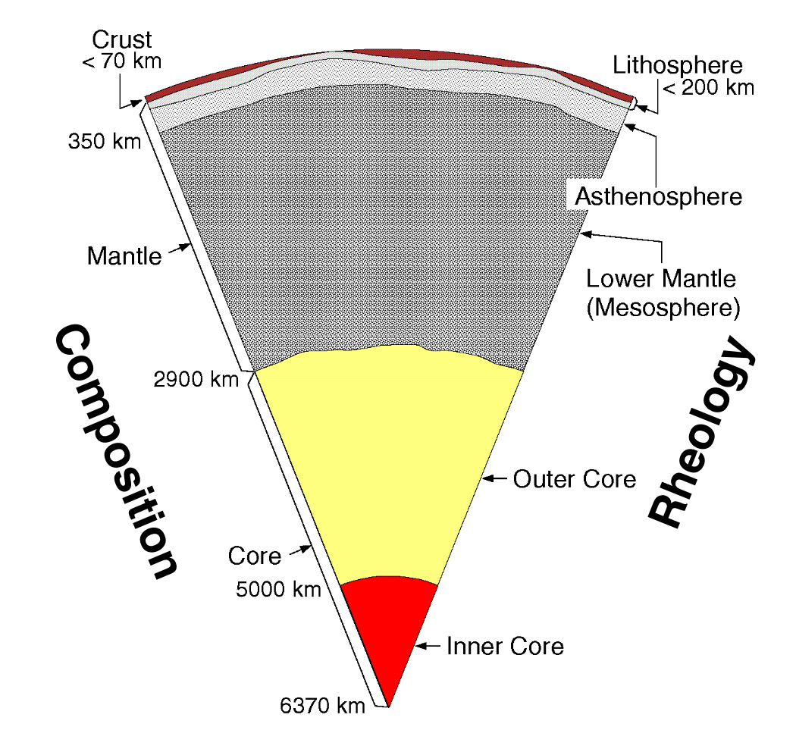

Crust: Made up of continental 35km thick (Felsic [granite], low density and low melting point) and oceanic layers 5 km thick (Mafic and Ultra Mafic [basalt], high density and higher melting point).
Mantle: 2800 km thick. Ultramafic. The crystal structure changes with depth (pressure).
Core: 3500 km thick. Metallic (not rock). Mostly iron and nickel. Much more dense than mantle and crust rocks.
Lithosphere: rigid, stiff, outer layer of earth. Includes crust and upper mantle.
Asthenosphere: weak, ductile, plastic zone. Solid but some partial melt.
Lower mantle: solid with no partial melt but still ductile.
Outer core: fluid
Inner core: solid

-Rock is a good insulator; explain why this property is important in terms of the iron catastrophe.
Rock traps heat longer than the earth gives it off. This allowed the earths temperatures to rise above the melting point of iron compounds, which enabled them to rise and sink to form the layers of the earth.
-Describe or predict what a cross-section through another planet or other body in our solar system would reveal in terms of composition and rheology. Justify your description/prediction on the basis of theories of solar system formation and observations.
For example Mars. Mars would have a composition including a crust, mantle, and core just like earth. Then the rheology would be lithosphere which is strong rock, then the asthenosphere which has partial melt, then well have the lower mantle witch doesn’t have partial melt but is ductile. Then we assume mars to have a mostly solid outer core unlike earth, but a metallic inner core like earth.
Distinguish the differences between the crust, mantle, lithosphere, and asthenosphere and explain the factors that cause these differences.
Crust: continental is felsic, oceanic is mafic [basalt] rock. Mantle is ultramafic, and the core is metallic (not rock). The lithosphere is the crust and upper mantle. The asthenosphere is the weak partial melt, ductile zone. Lower mantle is solid with no partial melt but ductile. The factors that causes these differences is density of compounds. It is called isostasy. Just like an iceberg reaches a balance to float in the water, rocks reach a balance to sink or rise due to density.
- The layered earth structure can be divided into compositional layers. Draw a cross-section of the Earth and label the crust, mantle and core. Describe the thicknesses, and general compositions of the layers. See above diagram
- The layered earth structure can be divided into rheological (strength) layers. Draw a cross-section of the Earth and label the lithosphere, asthenosphere, lower mantle, outer core and inner core. Describe the thicknesses and rheological properties (solid/fluid, rigid/weak). Relate the rheological layers to the compositional layers. See above diagram
-Explain the fundamental differences between continental crust and oceanic crust and relate the compositional difference to the Earth's bimodal topography.
Made up of continental 35km thick (Felsic [granite], low density and low melting point) and oceanic layers 5 km thick (Mafic and Ultra Mafic [basalt], high density and higher melting point).

Explain how the mantle differs from oceanic crust.
Because crystal structure changes with depth, the mantle is much more thicker than oceanic crust and there fore rocks are ultramafic.
Describe the differences between the lithosphere and the asthenosphere.
Lithosphere is the rigid outer shell, the asthenosphere is the weak ductile area.
Contrast the internal structure (composition/rheology) of the Moon with that of the Earth and other terrestrial planets.
The moon has a lithosphere (crust and upper mantle).
Lower Mantle. No partial melt, and is solid
Core: is solid. No fluid outer core.
In comparison to earth, it has a much thicker litho, tiny metallic core, no melt, and few volatiles.

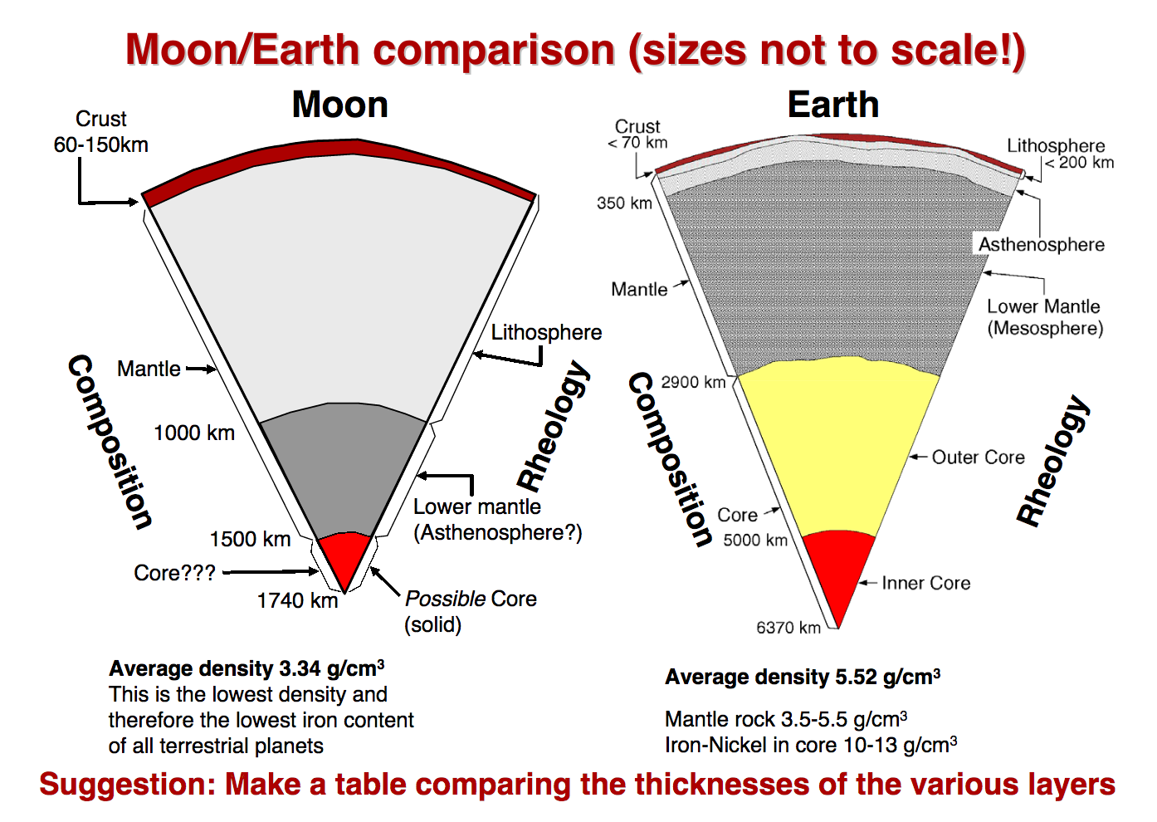

Explain the current theory for our Moon's formation using the observational evidence.
A large mars sized impactor hit proto earth, while it was still likely molten. This explains the similarity to earths mantle, undersized metallic core and fewer volatiles (lost in collision)

Imaging Earth's Interior
Describe several methods of determining the internal structure and physical properties (composition, rheology, temperature) of the Earth's interior.
Seismology: study of how vibrations travel through earth. Learn about earth structure and properties as well as earthquakes. If we study the speed, learn about the composition. If we study the path, learn about structure.
Geochemistry: learn about exposed rock samples.
Theoretical/lab work: modeling, high pressure anvil tests

Describe the motion and speed that different types of elastic waves (P waves, S waves and surface waves) travel through the Earth or over its surface.
Different types of waves tell us about the earths structure. Pulses of energy (waves) arrive at different times from the same earthquake. Earthquake equals vibrations or waves travelling through earth. Fastest to slowest, P, S, Surface.
P Waves: Change in volume of material. Particle motions are parallel to the direction the waves travel (refraction).
S Waves: change in shape (bending) of the material. Particle motions are perpendicular to the direction the waves travel (reflection).
Surface Waves (Love, Rayleigh waves): interface waves travelling along a surface. Wave size decreases away from surface.

-Explain why shear (S) waves cannot propagate through fluids while compressional (P) waves can.
A liquid or gas cannot be “bent”, It has no rigidity, therefore s waves can not travel in liquids or gasses
-List several factors that control the speed of waves travelling through the Earth and use them to explain the distinctions between the crust/mantle, lithosphere/asthenosphere, transition zones, lower mantle, and inner/outer core.
- Speed = frequency x wavelength. Speed controlled by rock properties.
- Waves travel at different speeds because of 1) Compressibility (Volume change) 2) rigidity (bending) 3) Density (related to temperature and pressure).
When there is a gradual change in speed, composition is same, but changes in pressure or temp. Where there is an abrupt change in speed, change in composition, or mineral phase change.
-Articulate the difference between reflection and refraction and explain why they are relevant to imaging Earth's interior structure.
To image the interior structure, you need to examine waves and see the path they take to learn about the composition and material make up. A waves path changes as material properties change. Refracted waves go through at different speed. Reflected waves bounce off. Refraction is outlined by curvature of energy. Picture of wave curving out of center. Hence, if if the earth was all one material, then the waves would just come out in a perfect sphere.
-Describe how and explain why temperature increases with depth in the Earth.
The earth can only cool from the outside, therefore temperature increases away from the surface. Abrupt changes in temp with depth are by compositional changes.
The only way for the earth to cool is to loose heat to oceans and atmosphere. This occurs slowly because rock is a good insulator. Heat can be transferred: Radiation, Conduction, Convection, and Advection. Heat transfer is dominated by convection, this drives plate tectonics and geomagnetism.

Minerals and Rocks

Basic Rocks and Minerals
-Mantle and crustal rocks can be described as being felsic, intermediate, mafic and ultramafic. Explain the differences between mafic and felsic rocks and suggest locations where you would go to find rock samples of the two types. What about ultramafic rocks?
Felsic: Low melting temperature, low density ex granite. Find on the continental crust like the chief
Mafic: higher melting temperature, higher density ex basalt. Find these at oceanic crust, mostly near volcanoes.
Distinguish a mineral from a rock.
A mineral is a naturally occurring, inorganic solid with a definite chemical composition and a crystalline structure formed by geological processes. A rock is an aggregate of one or more minerals whereas a rock may also include organic remains and mineraloids
Rock: A rock is a naturally occurring solid aggregate of minerals or, in some cases, nonmineral solid matter.
-Describe how the three basic types of crustal rocks (igneous, sedimentary, and metamorphic) form. Justify where you would suggest going to find examples of these rock types.
Igneous: formed by solidification of magma. The cooling environment can be intrusive (molten rock that rises into existing rock and solidifies there slowly) or extrusive (molten rock that rises to the surface, exposed to air, in the ocean where it solidifies quickly). Can be found at lighthouse park or mt garibaldi.
Sedimentary: the accumulation and cementation of mineral grains transported by water, wind, ice. Or chemical precipitation at the deposition site. Can be found at sandstone in Utah.
Metamorphic: these are igneous and sedimentary rocks that have been altered by changed to pressure and temperature. Changes occur at solid state. Example limestone, increase pressure and temperature turns to marble.
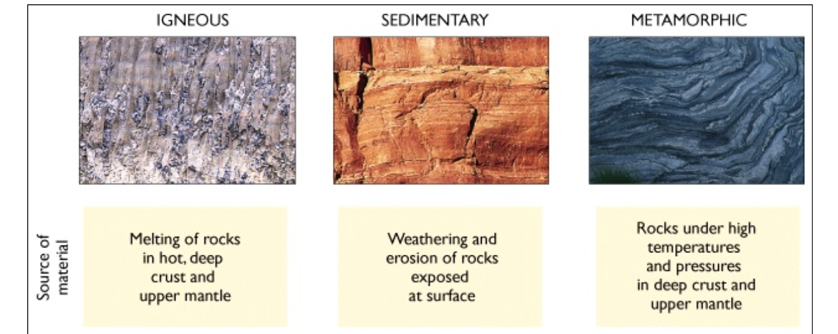
Explain the difference between intrusive and extrusive igneous rocks.
Igneous: formed by solidification of magma. The cooling environment can be intrusive (molten rock that rises into existing rock and solidifies there slowly) or extrusive (molten rock that rises to the surface, exposed to air, in the ocean where it solidifies quickly
-Describe the two primary factors that cause rock metamorphism and suggest earth processes that could result in metamorphism.
Regional metamorphism occurs where high pressures and temperatures extend over large regions, as happens where plates collide.
Where high temperatures are restricted to smaller areas, as in the rocks near and in con- tact with a magmatic intrusion, rocks are transformed by contact metamorphism.
Using the area around Vancouver, describe how the rock cycle operates and the rates of how quickly the materials move through it.
The rock cycle: Magma – igneous rock- sedimentary rock- metamorphic rock- then back around

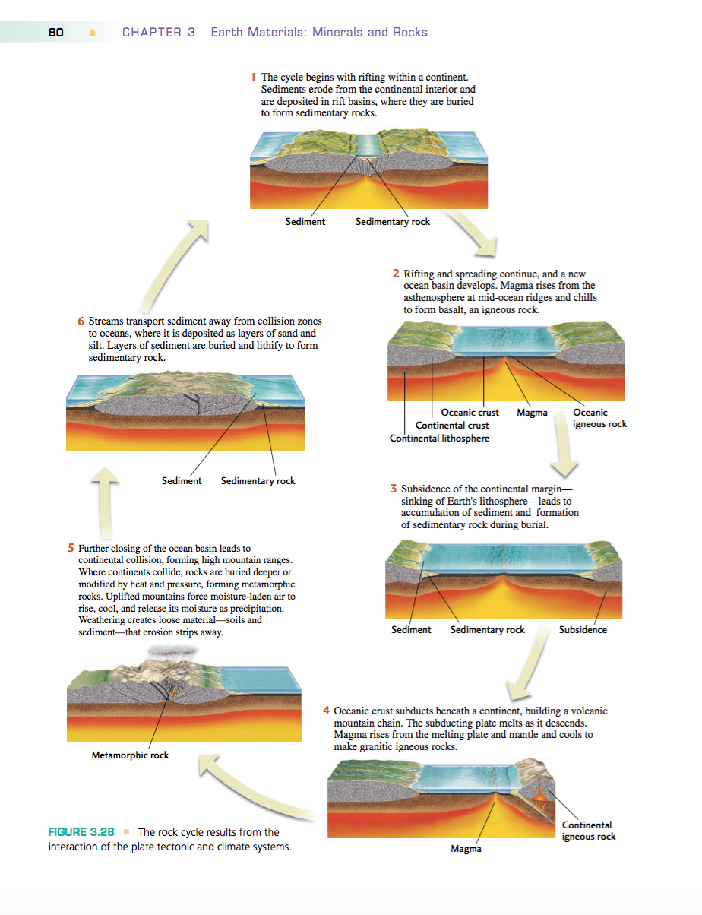

Numbers to Know
I don't expect you know too many numbers. It's the concepts that are really key. However, there are a few numbers that are useful to illuminate the concepts.

Thicknesses and Depths:
- oceanic crust: 5-7 km (except right at the ridgecrest where it is being formed)
- continental crust: variable, but approximately 35 km.
Up to about 70 km (double normal thickness) in areas of continental-continental collision
- Those major differences in thickness are related to compositional differences - Make the connection all the way back to the iron catastrophe and consider how plate tectonic processes sustain the "bimodal" structure.
- You won't need to know exact depths or thicknesses of the asthenosphere, lower mantle, outer core, inner core, earth radius etc.
But you should know the general "solid" Earth layers and their properties.
- Transition zones: 400, 670 km depth (mineral transformations due to increasing pressure (and temperature) conditions).
- Planetary information: I will only expect you to know comparative/proportional information. (e.g., You won't need to know the Moon's radius, or the radius of its core. But you should know that the Moon's metallic core is much smaller in proportion to its mantle than the core:mantle proportions of the other terrestrial planets)

Velocities of seismic waves:
- P-waves are about twice as fast as S-waves (approximately 6 vs. 3.5 km/s in the upper crust)

Geologic dates:
- Estimated speed of solar system formation
- Estimated age of Earth formation: ~4.55-4.6 Ga (billion years ago).
- Age of the oldest known rocks on Earth: 4.0 Gy (billion years)
- Age of the youngest known rocks on Earth: 0 years ago (the Earth is still active!).
- Age range of the Earth's continental crust: 0 to >4.0 Gy
- Age range of the Earth's oceanic crust: 0 to 0.2 Gy (or 200 million years) (much younger than most continental crust)
- Age that Pangaea began to break up: ~200 Ma (last supercontinent)
- Accretion of the Intermontane superterrane began: ~180 Ma (million years ago)
- Accretion of the Insular superterrane began: ~110 Ma
- Western margin of North America pretty similary to today by: ~40 Ma. (Juan de Fuca ridge and plate system gradually being overridden by the North American plate - will eventually be gone).
- Last Glacial Maximum: 18,000 years ago (ya)

Temperatures:
- mafic, low silica rock requires hotter temperatures to melt: ~1200C
- felsic, high silica content rock can melt at lower temperatures: ~800C
- most minerals that can be magnetized lose their thermoremnant magnetism at temperatures about 500C. Therefore some igneous rocks, as they solidify and cool, have the fields of minerals within orient and lock in the earth's field orientation.

