- DEFINING CULTURE
  - “We don’t know who discovered water, but it wasn’t the fish”
- source? No one knows: http://quoteinvestigator.com/2013/12/23/water-fish
  - “Culture is an implicit agreement among a group of people concerning what people’s actions mean” (Lane)
  - “Culture can be seen as a set of relatively stable, basic, and shared practices and values that help human social groups or societies find solutions to fundamental problems” (Hartog & Dickson)

- 1450: “The action or practice of cultivating the soil”
- 1580: “The cultivating or rearing of a plant or crop”
- 1510: “The cultivation or development of the mind, faculties, manners, etc.; improvement by education and training.”
- “The education of Children [is called] a Culture of their mindes.” Hobbes, Leviathan 1651
- 1677: “Refinement of mind, taste, and manners; artistic and intellectual development.”
- “Men of any tolerable Culture and Civility must needs abhor the entring into any such Compact”
- 1860: “The distinctive ideas, customs, social behaviour, products, or way of life of a particular nation, society, people, or period.”
- 1940: “The philosophy, practices, and attitudes of an institution, business, or other organization.”

  - Culture is the collective programming of the mind which distinguishes the members of one category of people from another. (Hofstede)
  - “The software of the mind”
- Structure vs. agency
  - Culture is tool kit of strategies, actions, symbols, etc that individuals can draw upon to solve different problems. The individual is not an automaton, a person has a choice in how they want to act by considering the different options in his or her toolkit. But culture limits the range of possibilities that are in that toolkit, the types of strategies, actions, and symbols that are viewed as options by the individual. (A rough summary of Swidler)

- CULTURE OF POVERTY
- Oscar Lewis, La Vida; A Puerto Rican Family in the Culture of Poverty. 1966
- Both an adaptation & reaction to position in a “class-stratified, highly individuated, capitalistic society”
  - Dominant belief that individuals can succeed, and yet conditions make it impossible to succeed
  - Coping with the hopelessness which comes from the improbably of succeeding according to mainstream values
  - Gregariousness, abandonment of wives and children, disposition towards authoritarianism, weak ego structure, lack of impulse control, strong present-time orientation, belief in male superiority, fatalism

- “Once it comes into existence, it tends to perpetuate itself from generation to generation because of its effect on the children. By the time slum children are age six or seven, they have usually absorbed the basic values and attitudes of their subculture and are not psychologically geared to take full advantage of the changing conditions or increased opportunities that may occur in their lifetime.” p. 188
- Moynihan Report in the United States: “The Negro Family: A Case for National Action”
- → how you define poverty matters

- ELEMENTS OF CULTURE: Hofstede’s onion

- 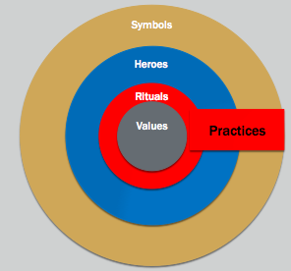

- CULTURE AS AN ONION 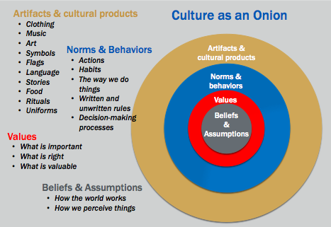

- VALUES/PERCEPTIONS/ASSUMPTIONS:

- THE PRODIGAL SON
- The parable begins with a young man, the younger of two sons, who asks his father to give him his share of the estate. The implication is the son couldn't wait for his father's death for his inheritance, he wanted it immediately. The father agrees and divides his estate between both sons. Both the son's asking and the father's granting of this request would have been shocking to Jesus' Jewish audience.
- Upon receiving his portion of the inheritance, the younger son travels to a distant country and wastes all his money in extravagant living. Immediately thereafter, a famine strikes the land; he becomes desperately poor and is forced to take work as a swineherd. (This, too, would have been abhorrent to Jesus' Jewish audience, who considered swine unclean animals.) When he reaches the point of envying the food of the pigs he is watching, he finally comes to his senses

- ELEMENTS OF CULTURE:
  - THOMPSON: Culture is systematic and organized
  - Culture is not random

- Causes: Where does culture come from?

- Causes: where does culture come from?
  - Location
    - Assigned Chinese negotiation article as an example of trying to dig into the sources of a culture.
    - People with experience in China? (from China or spent time in China) Accurate
    - What are they implying are the sources?
    - “Cultural Ecology”- argument that culture is strongly influence by the natural environment. Warm countries with abundant food less concern about time and efficiency
  - Shared experiences/history
  - Religion – protestant ethic
  - Parasites?

- Transmission: how is it perpetuated?
  - Thompson “the mental programming of a group is learned by its members over long periods as they interact with their environment and with each other”
  - Upbringing: socialization
    - Eye contact
  - Homeostatic: self-reinforcing
    - Norms and sanctioning – Invisibilia - BATMAN
  - Not just because there are all of these elements teaching everyone, but also because it permeates everything.
  - Not just due to socialization but also affects outcomes
  - IT DETERMINES CAUSE AND EFFECT

- CHANGE
- 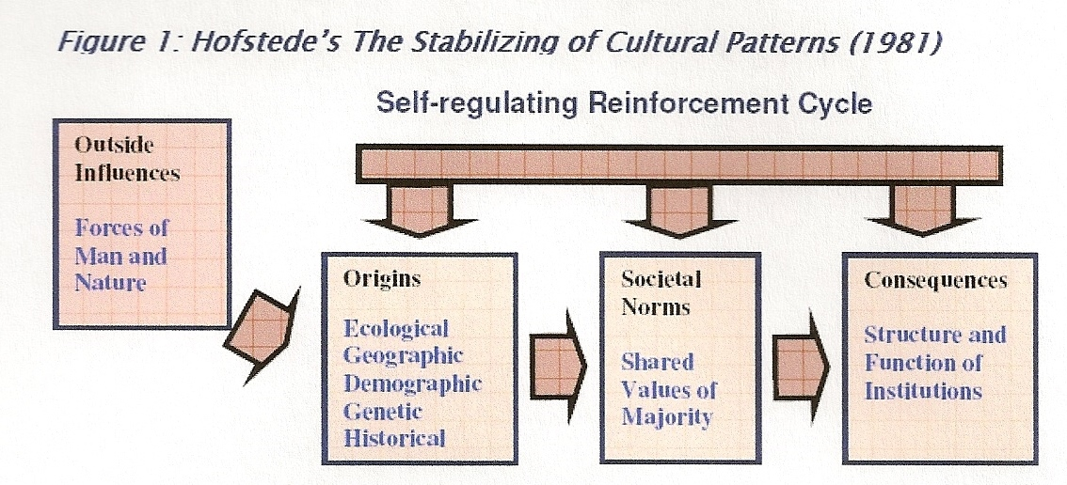

- Shocks from the outside
- -Agency
  - Social construction
    - “Culture defines its constituents, but is also constantly being shaped by them”
- -Toolkit

- Reading#1: Chinese Negotiation
  - Superficial obedience to the rules of etiquette gets you only so far
  - Root cause: a failure on the American side to understand the much broader context of Chinese culture and values, a problem that too often leaves western negotiators both flummoxed(confused) and flailing (waving)
  - Challenge: American and Chinese approaches often appear incompatible.
  - Americans see Chinese as: inefficient, indirect, dishonest
  - Chinese see Americans as: Aggressive, impersonal, excitable
    - Differences have deep cultural origins
- The Roots of Chinese Culture:
- Agrarianism: 2/3 still live in rural areas, labouring rice or wheat
  - Communal
  - Survival depends on group cooperation and harmony
  - Loyalty and obedience to familial hierarchy binds labouring groups together

2) Morality: writings of Confucius served as the foundation of Chinese education
  - Society organized under a benevolent moral code would be prosperous and politically stable and therefore safe from attack
  - Five cardinal relationships:
    - Between ruler and ruled
    - Husband and wife
    - Parents and children
    - Older and younger brothers
    - Friend and friend
      - Strictly hierarchical
    - The ruled: wife, children, younger brothers were counselled to trade obedience and loyalty for the benevolence of their rulers (husbands, parents, older brothers)
      - Social harmony: the antidote for the violence and civil war of Confucius’ time
  - Lao Tsu: relationship of yin (feminine, dark, passive force) to yang (masculine, light, active force)
    - Two forces oppose and complement one another
    - Cannot be separated, must be considered as a whole
    - Tao: key to finding the way between the two forces, the middle ground, a compromise
  - Chinese negotiators are more concerned with the means than the end, with the progress more than the goal
  - Americans: the truth is worth arguing over and even getting angry about
- 3) Pictographic language: memorize thousands of pictorial characters
  - words are pictures
  - holistic processing of information

- Michael Harris Bond: Chinese children are better at seeing the big picture, while American children have an easier time focusing on the details

- 4) Chinese people’s wariness of foreigners, which has been learned the hard way – from the country’s long and violent history of attacks
- 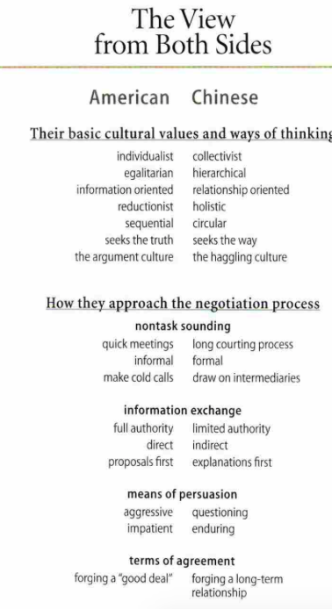

- The Eight Elements

- 1) Personal Connections: place a premium on individuals’ social capital within their group of friends, relatives and close associates
  - favours

- 2) The intermediary: suspicion and distrust characterize all meetings with strangers
  - finding personal links to your target organization or executive

- 3) Social Status: who the company sends to China/ ranked equalled to theirs
  - evaluate the relationship during a show of sincerity by their western counterparts

- 4) Interpersonal Harmony: Any attempt to do business without having established enough interpersonal harmony is rude
  - importance of harmonious relations between business partners

- 5) Holistic Thinking
  - Chinese think in terms of the whole
  - Americans think sequentially and individualistically

- 6) Thrift
  - save their money
  - silence as negotiating tactics

- 7) Face or Social capital
  - in business culture, a person’s reputation and social standing rest on saving face
    - important to measure social worth
- 8) Endurance, relentlessness, eating bitterness and enduring labour
  - more important and honourable
  - hard work is ideal
  - ask questions
  - great lengths to do your research and then educate your Chinese counterparts
  - Showing patience

- Reading #2: Cultural Knowledge

- Cultural Knowledge

- Chinese culture:
  - Chinese custom is to show respect for a guest by disparaging one’s own accomplishments, even the selection of a restaurant
  - The expectation is that the guest will return this respect with a compliment

- Components of cultural intelligence:
  - Lacks detailed knowledge: crude stereotypes that leave open multiple interpretations and are of little help in enabling him to understand the situation
  - Lacks mindfulness: lack the ability to observe and interpret the remark in the context of other cues – unable to read the situation as it develops
  - Mindfulness: means of continually observing and understanding cultural meanings and using that understanding as a basis for immediate action and long-term learning
  - Lacks the skill to adapt to his behaviour: need to develop a repertoire of behaviours that will enable him to act appropriately and successfully in any cross-cultural situation

- The 3 components combined provide a template for intercultural flexibility and competence
  - Culturally intelligent people have:
- The knowledge to understand cross-cultural phenomena
- The mindfulness to observe and interpret particular situations
- The skills required to adapt behaviour to act appropriately and successfully in a range of situations

- Culture: Consist of shared mental programs that condition individual’s responses to their environment
  - it is deeply embedded in each of us
  - Mannerisms, way of speaking, the way we dress are manifestations of deep culturally based values and principles

- Key feature of culture is that these mental programs are shared:
  - Deepest level – human nature
    - Based on common biological reactions (hunger, sex drive, territoriality, nurturing the young)
  - Shallowest level – personality
    - Specific genetic makeup and personal experiences that make each of us a unique individual
    - Because of personality, each of us has many behaviors and understandings that are quite different from those of others even though they come from the same culture
  - Middle level – culture
    - Based on common experiences that we share with a particular group of our fellow human beings
    - Cultural values, attitudes, and assumptions about proper behaviour gives us something in common with a definable group of others, but not with all of them

- Characteristics of culture
  - Culture is shared:
    - Something that a group has in common that is not normally available to people outside the group
      - Mental programming held in common that enables insiders to interact with each other with a special intimacy denied to outsiders
  - Culture is learned and is enduring
    - Builds up systematically over time based on sequences of historical events
      - Mental programming of a group is learned by its members over long periods as they interact with their environment and with each other
    - Built into institutions: religious beliefs, systems of land ownership, forms of marriage
    - Parental role modeling and advice to the young ones
  - Culture is a powerful influence on behaviour
    - Hard escaping our culture
      - Mental programming is strong
      - Acculturation: being embedded in an unfamiliar setting causes some to learn actively about the new culture while others attempt to avoid it, often by trying to re-create their old culture in the new situation
      - Adaptation: learn the new culture while still retaining valuable elements of their original culture – cultivate cultural intelligence
  - Culture is systematic and organized
    - Not random
    - Organized system of values, attitudes, beliefs and meanings that are related to each other and to the context
      - Mental programming imposed by our own culture, the cultures of other people often seem strange and illogical
  - Culture is largely invisible
    - Expressed in living artifacts
      - Communicated messages
      - Human activities
      - Language, customs, dress
      - Architecture, art, decoration
    - Iceberg: culture is not the obvious physical symbols that are above the surface but the deep underlying values and assumptions that they express
  - Culture may be tight or loose
    - Culture differ from each other not just in their details but also in their pervasiveness
      - Some societies are characterized by 100% agreement as to the form of correct behaviour
    - Tight: uniformity and agreement – homogeneous populations japan
    - Loose: diverse population Canada

- National and Global Culture
  - Nations formed because of cultural similarities among different population groups and they reinforce their adherence to a national culture by means of shared institutions, legal and educational systems, mass media
    - Important in international business

- Argument: Global culture: all countries converge toward a single culture

- Against:
  - modern but they are doing so in different ways
  - the change is often recontextualized to fit pre-existing cultural patterns
  - pace is very slow
  - recognizing diversity in human affairs

- How Culture Works: Part 1

Schemas and mindfulness:
- Schema
- a mental codification of experience that includes a particular organized way of perceiving cognitively and responding to a complex situation or set of stimuli (Merriam-Webster)
- “In more simple terms Piaget called the schema the basic building block of intelligent behavior – a way of organizing knowledge. Indeed, it is useful to think of schemas as “units” of knowledge, each relating to one aspect of the world, including objects, actions and abstract (i.e. theoretical) concepts.” http://www.simplypsychology.org/piaget.html
- Our first step is to choose the most appropriate schema

Schema examples. Without schemas it’s hard to process and remember things.
- Laundry paragraph: The procedure is actually quite simple. First you arrange things into different groups. Of course, one pile may be sufficient depending on how much there is to do. If you have to go somewhere else due to lack of facilities that is the next step, otherwise you are pretty well set. It is important not to overdo things. That is, it is better to do too few things at once than too many. In the short run this may not seem important bu complications can easily arise. A mistake can be expensive as well. At first the whole procedure will seem complicated. Soon, however, it will become just another facet of life. It is difficult to foresee any end to the necessity for this task in the immediate future, but then one never can tell, After the procedure is completed one arranges the materials into different groups again. Then they can be put into their appropriate places. Eventually they will be used once more and the whole cycle will then have to be repeated. However, that is part of life.

- Schema

Useful but problems:
- Miscategorization
- Judgment
- Resistant to change
- Exception proves the rule: Obama is so articulate
- Self-fulfilling prophecy



