MOS 1023 Notes

Lecture 1 — Introduction to Accounting Pg 1-27
Why Study Accounting?
- language of business
- global economic systems rely on it

Accounting: information system that identifies and records the economic events of an organization, and then communicates them to a wide variety of interested users.
Accounting:
- Measures business activities
- Processes data into reports (financial statements.)
- Communicates data to decision makers.

Accounting identifies and records economic events of ORGANIZATION and communicates it to interested USERS.

Two Broad Categories of Users:
INTERNAL USERS (work for the company)
- Managers plan, organize, and run a business.
  - pricing
  - strategy
  - marketing
  - employee compensation
  - capital budgeting
  - resource allocation
EXTERNAL USERS
- Investors (Shareholders) (Primary User)
- Creditors (Lenders) (Primary User)
- Others
  - Tax authorities
  - Regulatory agencies
  - Customers
  - Labour unions
  - Economic Planners.

Ethical Behaviour
Side note:
Accounting and economic entity is the same thing
Legal and taxable entity are the same things
- Accountants must have high ethical standards for accounting information to be valuable
- Actions are legal and responsible
- Consider organization’s interests
- Rules of conduct to guide ethical behaviour exist.

FORMS OF BUSINESS ORGANIZATIONS
- Proprietorship
  - owned by one person
  - simple to set up
  - owner has control
  - unlimited liability
- Partnership
  - Similar to proprietorship except owned by more than one person
  - formalized in written agreement
  - Each partner has unlimited liability
- Corporation
  - Separate legal entity owned by shareholders (owners of shares)
  - Indefinite life
  - Owners enjoy limited liability
  - May be public or private
    - Depends on whether shares are publicly traded
  - Consolidated statement: includes all subsidiaries financial results.

TYPES OF BUSINESSES
Manufacturing: heavy investment in factories, product development, investment in inventory, hardest to do accounting for
- GM
- Intel
- Boeing
- Nike
- Coca-Cola
- Sony
Merchandising: many levels of costs and investment in fixed assets
- Walmart
- Toys R Us
- Best Buy
- Amazon
Service: doesn’t deal with inventory
- Disney
- Air Canada
- Marriott Hotels
- Merrill Lynch
- Rogers

3 Types of Business Activities
Financing
- Obtaining and repaying funds to finance operations of the business
  - debt financing (borrowing money)
  - equity financing (selling shares)
Investing
- Obtaining resources or assets needed to operate business for the long term.
- can be short-term investments (used for operating the company) or long term investments on which to earn a return.
Operating
- Main day-to-day activities of the business
- Revenues (fees, sales), expenses, related accounts (accounts payable, receivable, inventory)

Financial Statements are the business documents that companies use to report the results of their activities to various user groups. System of accounting produces 4 statements.
- Income statement / Statement of Earnings
- Statement of changes in Equity
- Statement of Financial position / Balance Sheet
- Statement of cash flow.

Income Statement
- reports results of operations for specific period of time.
- Revenues arise from sale of a product or service, result in inflow of assets.
- Expenses are costs of assets consumed or services used to generate revenues.
- Net Revenue (Loss) = revenues - expenses.
- (NO COGS = NOT A MANUFACTURING or MERCHANDISING COMPANY).

Statement of Changes in Equity (Statement of Retained Earnings)
- Shows the changes in each component of shareholder’s equity for the period
- SHAREHOLDER’S EQUITY (2 PARTS)
  - Share capital:
    - Amounts contributed by shareholders
    - May have common and preferred classes.
  - Retained earnings / deficit:
    - Cumulative profit retained in the company
    - Less dividends paid to shareholders

Statement of Financial Position / Balance Sheet
- Assets: resources owned by business
- Liabilities: obligations of business
- Shareholder’s Equity: share capital and retained earnings.
- Assets = Liabilities + Shareholder’s Equity

Statement of Cash Flows:
- Reports cash receipts and payments for a specific period of time
- Changes in cash should be categorized as one of the following activities:
  - Operating
  - Investing
  - Financing
- Reconcile the change in cash to the beginning and ending cash balances.

ASSETS are the economic resources of a business that are expected to produce a benefit in the future.
LIABILITIES are “outsider claims” or economic obligations payable to outsiders.
SHAREHOLDER’s EQUITY represent “insider claims” of a business. (Owner’s Equity if the company is a sole proprietorship.)

Shareholder’s Equity is divided into two main categories:
- Share Capital: amount invested into corporation by its owners
  - Basic component of contributed capital is common shares.
- Retained Earnings: amount earned by income producing activities and kept for use in the business.

Net Income
- Revenues are increases in retained earnings from delivering goods/services to customers.
- Expenses are decreases in retained earnings that result from operations.

Components of Retained Earnings:
Beginning Balance of Retained Earnings + Net Income - Dividends = Ending Balance of Retained Earnings.
Relationships among Financial Statements:
- Income Statement (Net Income)
- Statement of Changes in Equity (Add Net Income)
- Statement of Financial Position (Equity)
- Cash Flow Statement (Cash Balance from Balance Sheet)

Annual Report
- Publicly traded companies must prepare an annual report each year.
- Includes financial and non financial information about the company
  - Financial: management discussion and analysis (MD&A), statement of management responsibility, auditors’ report, financial statements and notes
  - Non-financial: company’s mission and goals, products, people

GAAP (Generally Accepted Accounting Principles)
- Rules and practices for the preparation of financial statements.
- Different for publicly traded and public corporations
  - Public corporations use International Financial Reporting Standards (IFRS)
    - “Statement of Financial Position”
    - “Profit”
  - Private corporations use IFRS or Accounting Standards for Private Enterprises (ASPE)
    - “Balance sheet”
    - “Net Income”
- Proprietorships and partnerships do not have to use IFRS or ASPE as statements are prepared for internal users only.

Reporting Entity Concept: concept that economic activity that can be identified with a particular company must be kept separate and distinct from activities of owners and of all other economic entities.

Lecture 2 — Financial Statements — Framework, Presentation, Usage Pg 28-53, Pg 54-74
Usefulness of a Conceptual Framework: coherent system of interrelated objectives.
- Aids in creation of standards for accounting profession
- Increases users’ understanding and confidence in reporting.
- Enhances comparability

Objectives of this Conceptual Framework
- Foundation for building a set of accounting concepts and objectives.
- Framework is a reference of basic accounting theory for solving new and emerging practical problems of reporting.
- (E.g. How do we present something? When do we record an economic event? Guideline!)

Conceptual Framework for Financial Reporting
OBJECTIVE: Why are we doing this?
- Objectives of financial reporting
MIDDLE: bridges levels 1 and 3.
- Qualitative Characteristics of Accounting Info
- Elements of Financial Statements
BOTTOM: How do we do it? Implementation
- Foundational Principles and Conventions

*Sole Proprietorships / Partnerships don’t need to follow these rules (no external users).
Moral hazard arises due to information asymmetry in accounting:
- Moral hazard, manager paid on performance basis, needs observer.

Objective of Financial Reporting (Trueblood Committee 1970’s)
- To provide information that is:
  - Useful to users (investors, creditors)
  - Decision relevant (resource allocation)
  - Resource Allocation decisions are assumed to include assessment of management stewardship (management role in maximizing shareholder value.)
Shareholders invest in companies debt (interest / payback)

Fundamental Qualitative Characteristics are:
- Relevant
  - Makes a difference in decisions
  - Has predictive and feedback/confirmatory value.
  - Includes all material information (information that makes a difference in decision)
- Representational Faithfulness (Reliability)
  - Complete: ALL activity summarized in statements
  - Neutral: NO BIAS towards results
  - Free from material error: NUMBERS aren’t wrong.
  - Substance over form

4 Ways to Enhance Qualitative Characteristics:
- Comparability
  - Year to year, company to company, information is measured and reported similarly.
- Verifiability
  - Enhances reliability, same results achieved if same methods are used (consensus)
- Timeliness
  - The faster they are produced, the more relevant they are, but may cost reliability
- Understandability
  - Allows reasonably informed users to see significance of information
  - Provides ENOUGH information to be clear

Tradeoffs
- It is not always possible to have all fundamental and enhancing qualitative characteristics
- Tradeoffs happen when one qualitative characteristic is sacrificed for another
Constraints
- Materiality
  - If including information would influence judgement of a reasonable reader, the information is considered material.
- Cost vs Benefits
  - Benefits of using information should outweigh costs of providing that info

7 ELEMENTS OF FINANCIAL STATEMENTS:
- Assets (3 key characteristics)
  - involve some economic benefit to the entity
  - entity has control over that benefit
  - benefit results from a past transaction or event
- Liabilities (3 key characteristics)
  - represent a present duty or responsibility
  - Entity is obligated and has little or no discretion to avoid duty or responsibility
  - obligation results from a past transaction or event
    - Can result from (other): constructive obligation, equitable obligation.
- Equity (Net Assets)
  - represents residual interest in assets, after all liabilities are deducted
  - Shareholders and investors come last.
- Revenue: increases in economic resources resulting from ordinary activities
- Expenses: decreases in economic resources resulting from ordinary revenue-generating activities
- Gains: increases in equity from peripheral or incidental transactions
- Losses: decreases in equity from peripheral or incidental transactions

Ordinary: day to day activities
Incidental: one-offs

FOUNDATIONAL PRINCIPLES: foundational concepts and constraints help explain which, when, and how financial elements and events should be recognized/derecognized, measured, presented/disclosed. Principles act as guidelines for developing rational responses to controversial financial reporting issues.

RECOGNITION
- Process of including an item on entity’s balance sheet or income statement
- Elements of financial statements have historically been recognized when:
  - meet the definition of an element (e.g. asset)
  - they are probable, and
  - they are reliably measurable
DERECOGNITION
- Process of removing something from balance sheet or income statement

Economic Entity Assumption (ENTITY CONCEPT):
- Allows us to identify an economic activity with a particular unit of accountability
- Business activity is separate and distinct from its owners
- Does not necessarily refer to a legal entity
- Legal entity concept is used for tax and legal purposes
- Economic and accounting entity = same thing
- Legal entity and taxable entity = same thing
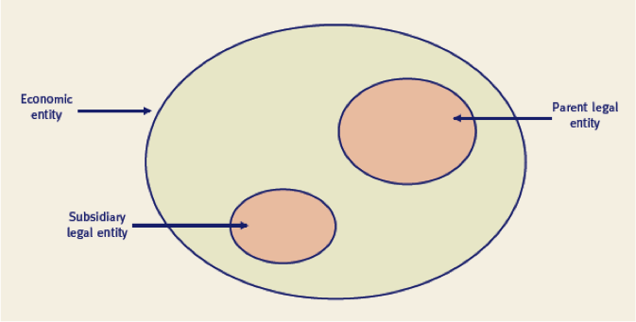
- Corporations set up many legal entities as a tax strategy to have preferential tax treatment
In financial reporting, WE DON’T CARE WHAT THE LEGAL ENTITIES ARE, JUST ECONOMIC ENTITIES.

Special Purpose entities have their own individual tax returns.

Control
- Important factor in determining entities to be consolidated and included in economic entity
- Some concepts of control include: investor has control over investee when it has:
  - Under IFRS
    - Investor has power over investee
    - Investor has exposure, or rights to variable returns from involvement with investee and
    - Ability to use power over investee to affect amount of investor’s returns
  - Under ASPE:
    - control: continuing power to determine strategic decisions without the cooperation of others.
Revenue Recognition Principle:
- Revenue is recognized under 3 conditions:
  - Risks and rewards have passed or the earnings process is substantially complete.
  - Revenue is measurable and
  - Revenue is collectible (realized or realizable)
- Revenues are realized when products, merchandise or assets are exchanged for cash

Matching Principle
- Expenses are matched with revenues that they produce
- Illustrates a cause and effect relationship between money spent to earn revenues (expenses) and revenues themselves.
  - Expenditure:
    - Product costs
      - material, labour, overhead, ATTACHED TO THE PRODUCT, part of inventory production process
    - Period costs
      - salaries, administrative expenses, cost is recognized immediately, though benefits occur in the future.
- If the expense benefits the future periods and meets the definition of asset, it is recorded as ASSET.
- This asset’s costs is then systematically and rationally matched to future revenues.
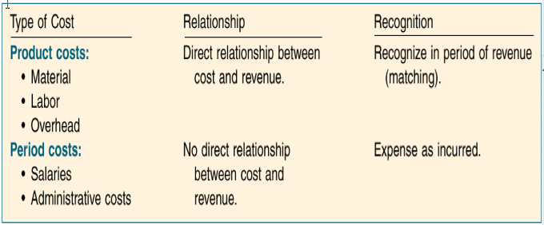
- Examples of matching: depreciation, bad debt expense, warranty expense, salary expense

Accrual Accounting (summing benefits or payments over time)
- records cash transaction + non cash transactions
- Examples of non cash transactions:
  - Purchase of inventory on account
  - Sales on account
  - Expenses used but not yet paid
  - Revenue earned but not yet received
  - Deprecation expense
  - Usage of prepaid rent, insurance and supplies

Measurement
- All elements must be measurable to be recognized.
- Because of accrual accounting, many elements of financial statements require use of estimates.
- We must
  - Determine level of uncertainty that is acceptable for recognition
  - Use appropriate measurement tools and
  - Disclose sufficient information to indicate and describe uncertainty.
- Periodicity Assumption
  - economic activity of an entity can be divided into artificial time periods for reporting purposes
    - month, quarter, year
- Monetary Unit Assumption
  - Money is the common unit of measure of economic transactions
  - Use of a monetary unit is relevant, simple, understandable, available, and useful
  - In Canada/USA, we use the DOLLAR (stable in value).
- Going Concern Assumption
  - Assumption that a business enterprise will continue to operate in the foreseeable future
  - Expectation of continuing long enough to meet objectives and commitments
  - Management must look out at least 12 months from balance sheet date
  - If liquidation is assumed to be likely, USE LIQUIDATION ACCOUNTING, not going concern
- Historical Cost Principle
  - Three basic assumptions of historical cost:
    - Represents a value at a point in time
    - Results from a reciprocal exchange (two way exchange)
    - Exchange includes an outside arm’s length party
- Fair Value Principle
  - Defined under IFRS as
    - “Price that would be received to sell an asset or paid to transfer a liability in an orderly transaction between market participants at measurement date”.
    - Subsequent to initial recognition, historical cost and fair value often differ
    - Often more relevant for certain assets/liabilities and as time goes on.
    - CAN BE ADJUSTED TO WHAT CURRENT MARKET PRICE IS.
- Full Disclosure Principle
  - Anything that is relevant to user’s decisions
  - Disclosure may be made:
    - within main body of financial statements
    - as notes to financial statements
    - as supplementary information, including Management Discussion & Analysis MD&A

Management Discussion and Analysis
- Management’s explanation of financial information and the significance of the information
- Five key elements should be included:
  - Company’s vision, core businesses and strategy
  - Key performance drivers
  - Capital and other resources
  - Historical and prospective results
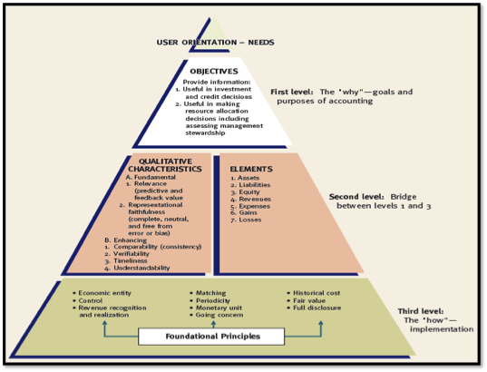
  - Risks
Financial Reporting Issues:
- IFRS and ASPE are principles based
- Selecting and interpretation these principles relies on professional judgement
- Legally structuring transactions so they meet company’s reporting objectives is known as financial engineering
- When pressures for reaching specific financial reporting objectives are high, risk of fraudulent financial reporting increases.

DEBATE: Rules Based vs Principle Based
Principle based:
- Key objectives of good reporting
- Subject area requires guidance
- Explains the objectives
- Relates to common examples
- Some rules exist, how ever intent is to not have a rule for every situation
- When in doubt, go back to principles (120 countries use IFRS)
- RELIES ON PROFESSIONAL JUDGEMENT IS THE KEY POINT.

CLASSIFIED BALANCE SHEET
- Generally contains following standard classifications
  - Assets
    - current assets (expected to be converted to cash within a year)
      - cash, A/R, prepaid expenses, inventory
    - long term investments
      - debt or equity of other corporations, not sold within a year
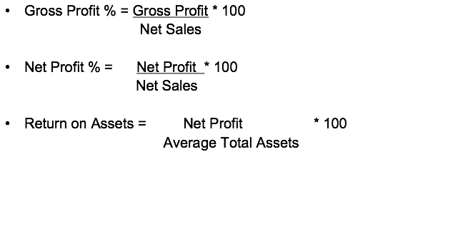
    - property, plant, equipment: tangibles with long useful lives, used in operating business
      - depreciate over time
    - intangibles: represent privilege or right
      - goodwill, patents, copyrights, licenses, trademarks
  - Liabilities
    - current: paid within 1 year
      - A/P, notes payable, interest payable, salaries payable, accrued liabilities, deferred revenue (unearned revenue, advanced deposit)
    - long term: paid after 1 year, bonds payable, notes payable, mortgage, lease
  - Shareholder’s Equity
    - share capital: investment of cash or other assets by shareholders in exchange for shares
    - retained earnings: earnings kept for use in business

Depreciation: allocation of assets full purchase price to match cost over entire useful life
Accumulated Depreciation: shows total amount of depreciation taken to date — this account is a contra asset account (shows credit value, subtracts from assets)
Difference between cost of asset and accumulated depreciation is carrying amount or book value.

FINANCIAL STATEMENT ANALYSIS:
Purpose:
- To use statements to evaluate an organization’s performance and financial position
- To have means of comparative analysis across time in terms of:
  - Intracompany basis
  - Intercompany basis
  - Industry Averages
- Financial Ratio analysis involves calculating and analyzing ratios from statements

PROFITABILITY RATIOS:
- analyzing on sales and cost of goods sold (gross profit)
- analyzing control of expenses (net profit)
- analyzing return on assets and return on equity.

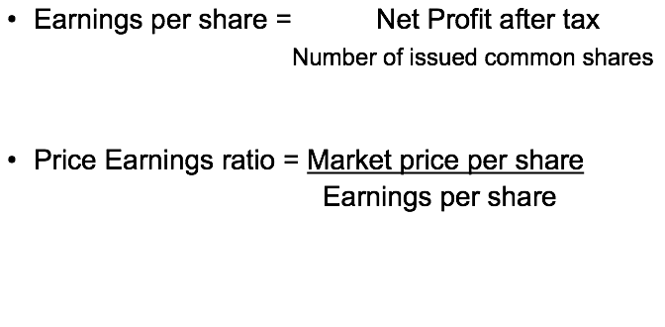

Confidence = high PE ratio
Overvalued stock = overtly high PE ratio (e.g. Krispy Kreme)

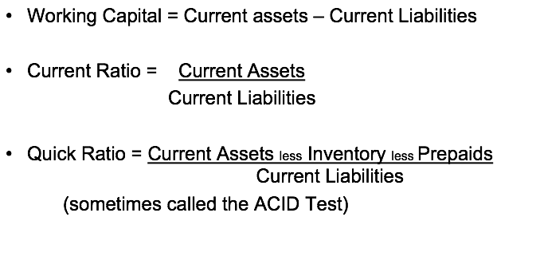
Liquidity: measures short-term ability of company to pay its maturing obligations and meet unexpected needs for cash.

Solvency: ability of an organization to pay interest on their obligations and repay debt upon maturity. Measures ability for a company to survive over a long period of time.

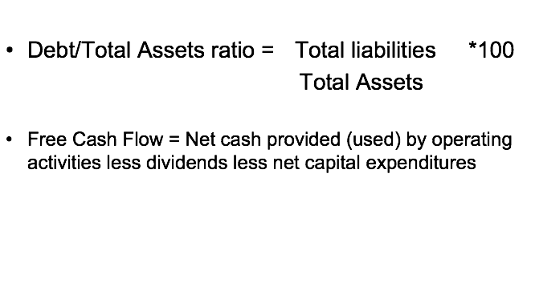

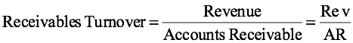
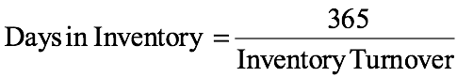
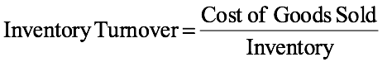
EFFICIENCY RATIOS

Earnings per share: net earnings / # of shares
Price - Earnings Ratio: ratio of stock market price to its earnings per share

Lecture 3 — Accounting Information System Pg 75 - 101

Accounting Information System:
- The system of collecting and processing transaction data and communicating financial information.
- 4 Parts:
  - Accounting Transactions
  - The Account
  - Steps in the Recording Process
  - Trial Balance
- Varies based on factors such as:
  - Types of business (manufacturing, retail)
  - Size of company
  - Amount of data (Walmart)
  - Information requirements

Transactions: economic events that change the value of the company (assets, liabilities, equity) that must be recorded in the financial statements.

Debit Balance — more debit amount than credit amount
Credit Balance — more credit balance than debit amount.

Account: an individual accounting record of increases and decreases in a specific asset, liability, or shareholder’s equity. 3 PARTS:
- Title of account
- Left or debit side
- Right or credit side

ASSETS:
- go up with debit
- go down with credit
LIABILITIES & SHAREHOLDER’S EQUITY
- go down with debit
- go up with credit

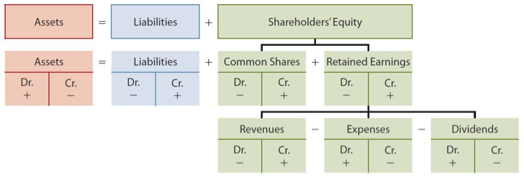
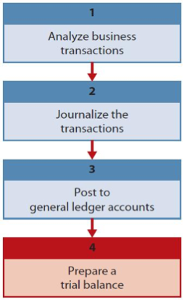
Normal Balance: assets NORMALLY are a debit balance, liabilities/equity normally credit balance.
Debit (Increases):
Dividends
Expenses
Assets
Losses

Credit (Increases)
Gains
Revenues
Liabilities
Shareholder’s equity

Source Document: evidence of transaction, such as sales slip, cheque, bill, cash reg. tape.

STEPS IN THE RECORDING PROCESS:
- Analyze each transaction to determine effect on account (comes from source document)
- Record transaction as a journal entry in the general journal (most common)
  - Chronological order
  - Double entry (affects both debit and credit account)
  - This process is called journalizing
- Transfer information to appropriate accounts in the general ledger (entire group of accounts).
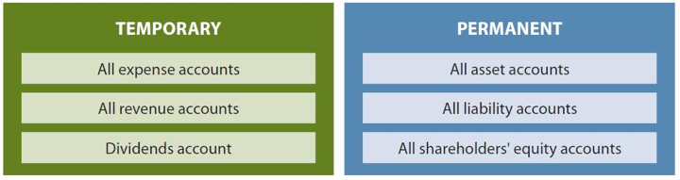
  - Posting is the process of transferring info from general journal to general ledger accounts (assets, liabilities, equity, etc.)
  - List of Accounts is called chart of accounts (framework for accounting database, account numbers used to identify)
- Prepare trial balance
  - Lists all accounts and balances, to prove equality of total DR = total DR

ADJUSTING ENTRIES:
- made to adjust or update accounts at the end of the accounting period
- required because trial balance may not contain complete and up-to-date data
- Prepayments
  - prepaid expenses: costs paid for in cash before they are used
  - unearned revenues: cash has been received before revenue is earned
- Accruals
  - accrued revenues: revenue that has been earned, but not received in cash
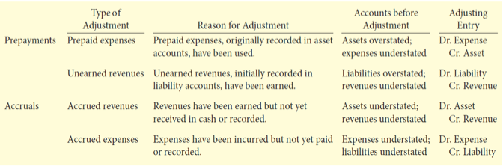
  - accrued expenses: expenses that have been incurred, but not yet paid

CLOSING THE BOOKS
- revenue and expense accounts are temporary accounts (start at 0 on January 1st)
- Balance sheet account is permanent account (carry forward into next year)
- Closing entries:
  - temporary account balances are transferred to retained earnings
  - produce a zero balance in the temporary accounts to prepare them for next periods activity

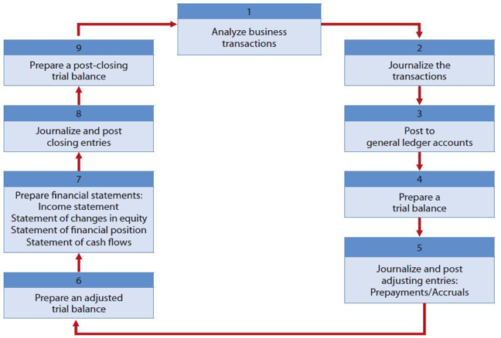
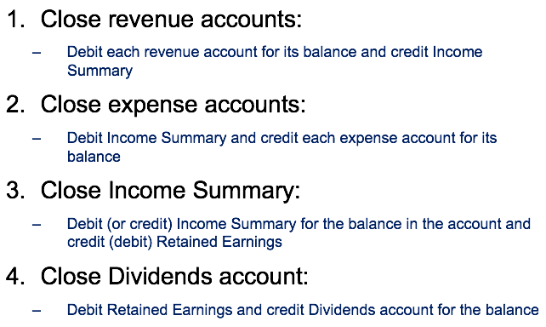

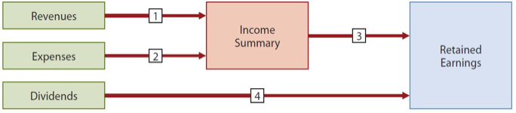

Lecture 1 — Managerial Accounting
Role for accounting:
- helps decide cost/benefit of options
- Two classes of decision makers
  - Outside the firm
  - Inside the firm

EXTERNAL
Types of decisions: investing, loans, taxation
Information needs: different across users, expensive for specificity, confidentiality
Solution: financial reports (comprehensive statements), GAAP, regular statements

INTERNAL
Types of decisions: run promotion, what to purchase, who to hire?
Information needs: differ across users, need specific data for the smaller decisions, might need both financial and non-financial data
Solution: decision specific data produced no preset rules for how to process
produced as needed

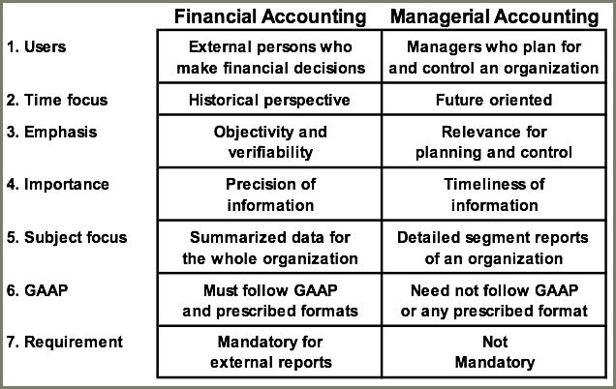
5 Functions of the Process of Management:
- Strategy formulation
- Planning
- Control
- Decision making
- Directing and motivating

Company Vision
- Set vision statement
- Build objectives from this vision.

Strategic Management
- enable an organization to achieve its objectives
- results from managerial choices among numerous good alternatives, signals commitment to specific markets policies procedures and operations
- game plan

Planning
- Identify alternatives
- Select best
- Develop budgets

Directing and Motivating: managing day to day activities to keep organization running smoothly. Work assignments, problem solving, conflict resolution, effective communication.

Control: ensures plans are being followed. Feedback in form of performance reports that compare actual results with budget are an essential part of control function.

Variance: difference between actual cost and budgeted cost
- favourable if actual cost less than budgeted cost
- unfavourable if actual cost greater than budgeted cost

Budgets: detailed plan that sets out in monetary terms, plans for income and expenditure in a future period. Prepared in advance based on objectives and strategy. First sales budget, then master budget.

Forecasts: making predictions. Forecast —> Planning —> Budget Preparation

Budget Committee: senior managers who are responsible for designing strategy. Receives initial budgets from functional managers. Suggest changes if needed to meet strategy.

Accounting Department: works with operations managers to begin budget preparation. Advise and assist in budget preparation, accounting staff must understand business operation

Sequence of Budgetary Process:
- communicate objectives and strategy
- communicate procedures
- prepare an initial set of budgets
- negotiate budgets with line managers
- coordinate and review bud
Negotiation: bottom-up budget is started by inviting those who will implement the budget to be involved in setting the budget. Top down is set by management and imposed on those who will implement the budget.

Benefits of Budgeting:
- Planning
- Control
- Communication and coordination
- Basis for performance evaluation

4 STEP FRAMEWORK FOR DECISIONS
- decision problem, goals
- Identify options
- benefits- costs = value
- Make decision, choosing option with highest value

Specify Problem & Goals
- vary across individuals, depends on the importance placed on money, fame, leisure
Effective decisions require that we
- identify goals clearly
- understand factors that influence goals and their relative importance

Organization: collection of individuals engaged in a collectively beneficial mission
Goals may vary (profit, not for profit, government)

Conflict in goals: divergence between organizational and individual goals. Need to align incentives to create goal congruence

Three Broad methods to reduce loss due to conflict:
- Policies and procedures
- Monitoring
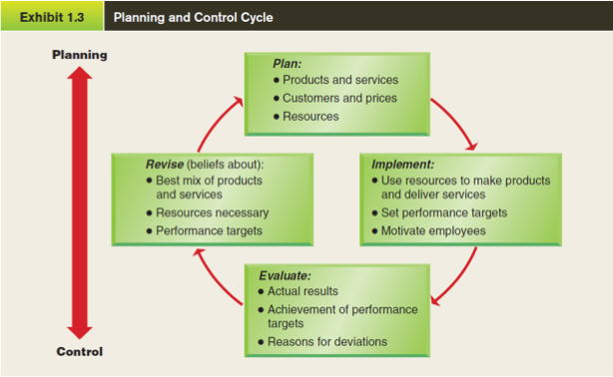
- Incentive schemes and performance evaluation
Ethics & Decision Making
- How we define goals
- What options to consider
- Unethical choices have high costs
- Quit before making an unethical decision

Key Players in Organizations
- Board of Directors
- In the corporate offices
  - CEO
  - CFO
  - Chief internal auditor
- Other accounting functions
  - Controller
  - Treasurer
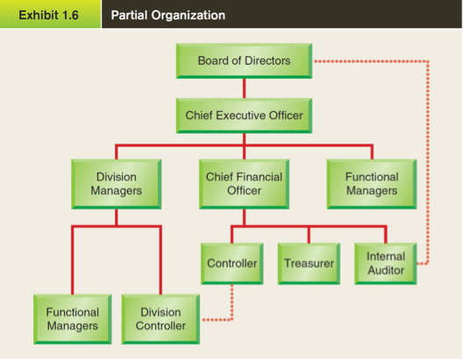
COST CONCEPTS AND TERMINOLOGY (FBCRT)
- Function
  - period vs product
- Behaviour
  - variable, fixed
- Traceability
  - direct, indirect
- Controllability
  - controllable, incontrollable
- Relevance
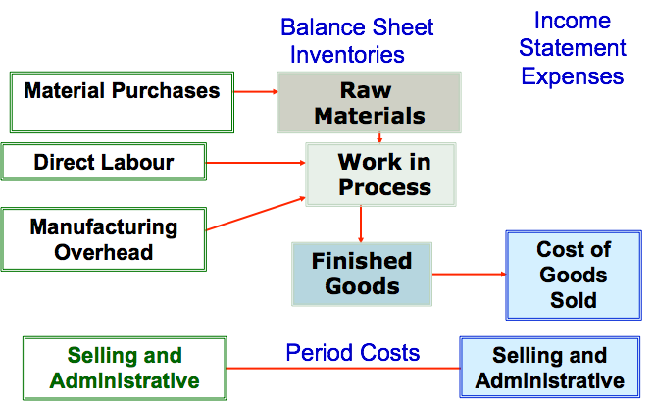
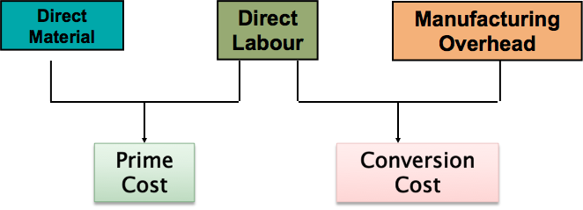
  - OOP, Sunk, OC

Classification by Behaviour
- cost behaviour means how a cost will react to changes in level of business activity
  - fixed
  - variable

Types of Fixed Costs:
- Committed (Long-term): depreciation on buildings, equipment, real estate tax
- Discretionary (may be altered in short-term by management): advertising, R&D

VARIABLE COST PER UNIT REMAINS SAME OVER DIFFERENT LEVELS OF ACTIVITY.
FIXED COST GOES DOWN AS ACTIVITY LEVEL GOES UP.

Classification by Traceability:
- Direct costs:
  - costs traceable to single cost object
  - material & labour
- Indirect costs:
  - costs cannot be traced to a single cost object
  - Maintenance expenditures benefiting two or more departments.

Classification by controllability
- Controllable cost is a cost which is capable of being regulated by a manager
- Non-controllable cost is one which is not capable of being regulated by a manager

RELEVANT OR NON-RELEVANT (TWO NECESSARY CONDITIONS):
- future cost or benefit
- future cast flow change because of the decision

Classification by Relevance
- Sunk Costs: All costs incurred in the past that cannot be avoided or changed
  - dont consider
- Out of Pocket costs: a cost that requires a future outlay of cash. SHOULD BE CONSIDERED IN DECISIONS.

- Opportunity Cost: potential benefit that is given up when one alternative is selected over another.

Function
Product cost/ inventoriable: all costs associated with product
Period costs: all other costs
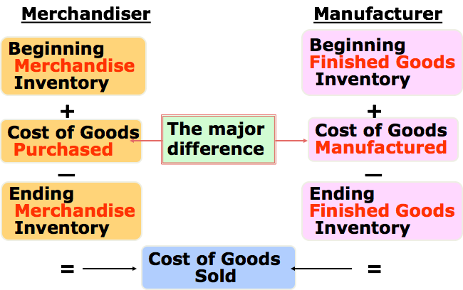
Cost Classifications on Financial Statements — Balance Sheet
Merchandiser: merchandise inventory
Manufacturer: inventories (raw materials, work in process, finished goods)

Income Statement
Merchandiser: purchases
Manufacturer: Cost of Goods manufactured

Manufacturing costs:
- Direct labour
- Direct material
- Manufacturing overhead (all other manufacturing costs)
  - Indirect material: lubricant, cleaning supplies
  - Indirect labour: cost of personnel who don’t work on product, security guard, maintenance)
  - Other costs: amortization, plant and equipment, property taxes, insurance, utilities

non-manufacturing costs
- marketing or selling costs
- administrative costs

prime cost: DM, DL
Conversion cost: DL + FOH

Cost Allocations & Cost Flows:
- overhead costs are not traceable to specific products
  - part of product cost for individual products
- Problem: how to divide total overhead to pieces that belong to individual products
- Solution: cost allocation

- Cost Pool
- Cost Objects (items or entities to which we allocate the costs)
- Cost driver (attributes that we can measure for each cost object, e.g. quantity)
- Allocation volume (sum of the cost driver amounts across all cost objects)

Decentralization: delegation of freedom to make decisions. The lower in the organization that this freedom exists, the greater the decentralization.

Centralization vs Decentralization: tradeoff between constraints & freedom.

Benefits of decentralization:
- lower level managers gain experience in decision making
- top management freed to concentrate on strategy
- decision making authority leads to job satisfaction
- lower level decision based on better information
- lower level managers can quickly respond to customers

Disadvantages of Decentralization
- Duplication of costs and efforts
- Lower-level managers may make decisions without seeing the big picture
- Lower-level manager’s objectives may not be those of the organization
- May be a lack of coordination among autonomous managers
- May be deficit to spread innovative ideas in the organization

Discretionary Cost Centre: output is difficult to measure
Engineered Cost Centre: clear input and output

Responsibility Accounting:
- Accounting information structured by responsibility centre
- measure performance and provide info for decision making by responsibility centre manager
- Developed to motivate evaluate and reward only on what we can control
Responsibility Centres: CRIP
- Cost centre
- Revenue centre
- Profit centre
- Investment Centre

ROI Formula:
Margin = Operating Income / Sales
Turnover = Sales / (Average operating Assets)

ROI= Operating Income (Income before Interest and Taxes EBIT) / Average Operating Assets (Cash, AR, Inventory, Plant and Equipment)

Increasing ROI (three ways)
- Reduce expenses
- Increase Sales
- Reduce Assets

Advantages of ROI (3 Advantages):
- Most widely used measure of divisional performance
- Easily understood
- Encourages managers to concentrate on projects which make best use of resources.
Disadvantages of ROI (3 disadvantages):
- Problems defining the amount of investment funding
- Problems of defining the profit controllable by the division.
- Manager of one division may avoid a project which lowers the average ROI for that division but would be of benefit to the organization a whole.

Lecture 2 — Audits & Fraud

Predication: totality of circumstances that would lead a reasonable, professionally trained individual to believe that a fraud has occurred, is occurring, or will occur.

Types of Audits:
- Tax
- Operational
- Compliance
- Financial Statement
- Fraud

Tax Auditing:
- Sales Tax
  - Harmonized sales tax
- Payroll tax
- Income Tax
  - Permanent differences
  - Temporary (timing) differences

Internal Auditing: Internal Auditing is an independent, objective assurance and consulting activity designed to add value and improve an organization's operations. It helps an organization accomplish its objectives by bringing a systematic, disciplined approach to evaluate and improve the effectiveness of risk management, control, and governance processes
- Effectiveness and efficiency of operations
- Reliability and integrity of financial and operational information
- Safeguarding of assets
- Compliance with laws, regulations, and contracts

External Auditing:
- Companies prepare information to be used by financial decision makers
- These companies do so to obtain loans or sell stock
- This is a potential conflict of interest
- Users are a naturally skeptical of the financial information
- External professional auditors lend credibility to the financial information
- Verification reduces the risk the information is misleading
- Without effective audits, capital resources cannot efficiently be allocated to economic entities.

Auditor’s Role:
- Auditing does not include financial report production
- Auditor’s role is to determine whether the information in the financial statements is reliable, communicate this to users
- Auditing reduces information risk
  - verify, framework, opinion, audit report

Business Risk: risk that a company may fail to achieve its objectives due to:
- economic changes
- technology changes
- poor management decisions
- bad luck
Information Risk: unreliable
- Audit risk: risk of insufficient evidence -> wrong audit opinion
  - Inherent risk: probability material misstatement will occur in financial statements
  - Control risk: material misstatements will be not prevented or detected by internal controls
  - Detection risk: material misstatements will not be detected by auditor
  - AR = IR x CR x DR
- Accounting risk: risk that errors associated with estimates used in GAAP are not properly disclosed

CANADIAN AUDIT STANDARDS (CAS):
- practice standards are general guides for the quality of professional work
- General standard refers to: OCDC
  - objectivity
  - competence
  - due care
- Key supporting rules of professional conduct

Examination Standards:
- Planning and supervision
- understand system of internal controls
- Auditor is explicitly required to design procedures to detect fraud

Objective: an audit fails if there is not sufficient appropriate audit evidence to support the report opinion, compliance with GAAP.

4 audit opinions
- unmodified/clean
- qualified
  - not complete/follow GAAP
  - useable
- adverse
  - bad, wrong doing
- disclaimer of opinion
  - no opinion

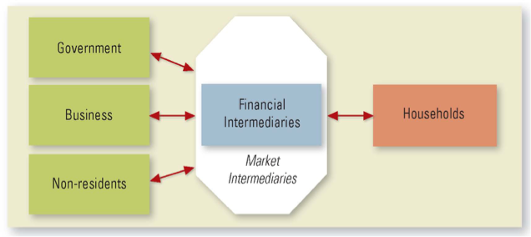
Fraud: deliberate deception practiced so as to secure unfair or unlawful gain
- Occupational fraud: personal enrichment through deliberate misuse of employing organization’s resources or assets
Elements of Fraud 4 elements:
- Material false statement
- Knowledge that the statement was false
- Reliance by victim
- risk for victim

fraud crimes
- larceny (stealing)
- Conversion (voluntary action inconsistent with ownership rights of the owner, alteration of its condition)
- Embezzlement (stealing but you have right to access the property)
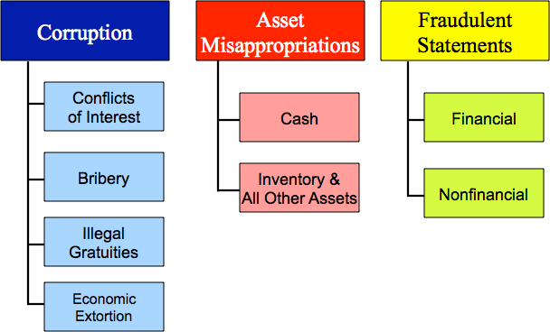
- Breach of fiduciary duty (failure to protect shareholder’s board of directors)

Discipline of Fraud Examination:
- Resolving allegations of fraud from tips. complaints, or accounting clues
  - Document evidence
  - Interviewing witnesses
  - Writing investigative reports
  - Testifying
  - Assisting in the detection and prevention of fraud
- Forensic accounting vs fraud examination

Fraud Theory Approach:
- Analyze available data
- Create hypothesis
- Test hypothesis
- Refine and amend hypothesis

observation
document analysis
3rd party witness
corroborative witness
coconspirators
target

Predication: totality of circumstances that would lead a reasonable professionally trained, prudent individual to believe a fraud has occurred, is occurring, or will occur. Fraud examination must be based on predication.

Edwin H. Sutherland: 1939
- defined white-collar crime
- criminal acts of corporations
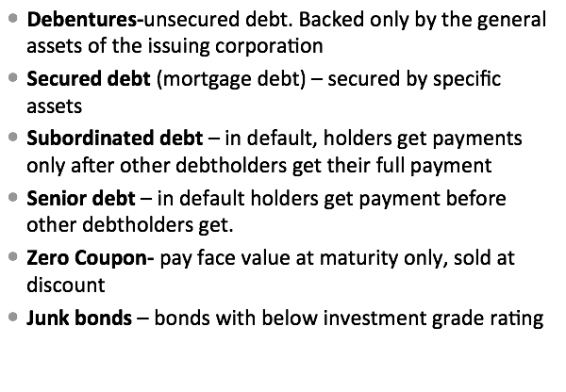
- individuals in corporate capacity
- Theory of differential association:
  - crime is learned
  - not genetic
  - learned from intimate personal groups

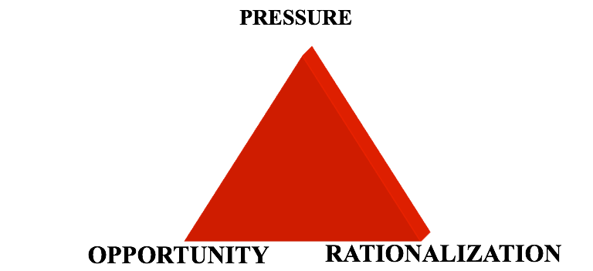
Donald Cressey:
Pressure:
- violation of ascribed obligations
- Personal failures
- business reversals
- Physical isolation
- status gaining
- employer-employer relations

Perceived Opportunity
- General information
  - Knowledge that the employee’s position of trust could be violated
- Technical skill
  - Ability to commit violation
  - Usually same ability that employee needs to obtain job in the first place

Rationalization:
- They owe me
- Borrowing
- Nobody will get hurt
- I deserve more
- It’s for a good purpose

Cressey’s Offender Types (3 Types)
- Independent Businessmen
  - Borrowing
  - Funds really theirs
- Long Term violators
  - “Borrowing”
  - Protect family
  - Company cheated them
  - Company generally dishonest
- Absconders
  - Take the money and run
  - Usually unmarried
  - Blame outside influences or persona defects

Steve Albrecht (FRAUD SCALE)
- Assembled a complete list of pressure, opportunity and integrity variables
- Created a list of 50 possible indicators of occupational fraud and abuse
- Variables fell into 2 principle categories
  - Perpetrator characteristics
  - Organizational environment
- Developed the fraud scale

FRAUD SCALE:
- Situational pressures
  - high
- Perceived opportunities
  - high
- Personal integrity
  - low

Hollinger Clark Study
- surveyed 10000 workers
- theft caused by job dissatisfaction
- true costs vastly understated
- Conclusions:
  - Employee perception of controls is critical
  - Increased security may hurt, not help
  - Employee thieves exhibit other deviance (sloppy work, sick leave abuses)
  - Management should be sensitive to employees
  - Pay special attention to young employees

Lecture 3 — Introduction to Finance

Finance: study of the management of funds

Goal of the firm:
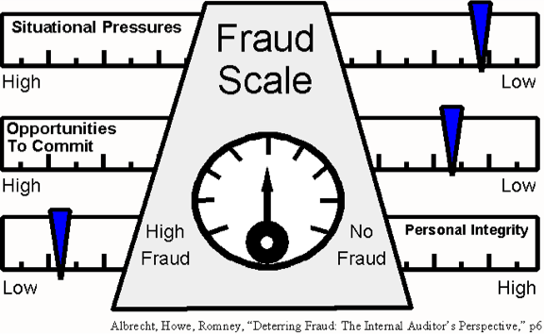
- create value for firm’s shareholders
- by: maximizing price of existing common stock

Stakeholder: any group interested in the financials (managers, etc.)

Role of Management: an arbitrator and moderator between conflicting interest groups or stakeholders and objectives.

Creditors, managers, employees and customers hold contractual claims against the company.

Shareholders have residual claims against the company.

Basic Role of Finance in Business (3 Basic Issues):
- What long term investments should the firm undertake (capital budgeting)?
  - How should the firm raise money to fund these investments (capital structure decision)?
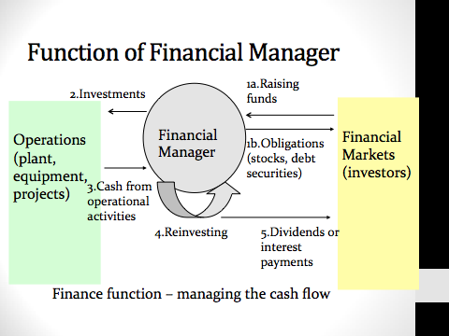
- How to manage cash flows arising from day-to-day operations (operating decision)?
Principles of Finance:
- Cash flow is what matters
  - Accounting profits are not equal to cash flows
  - It is possible for a firm to generate accounting profits but not have cash or to generate cash flows but not report accounting profits in the books
  - Cash flow, not profits, drive the value of a business
  - We must determine additional cash flows when making financial decisions.
- Money has a time value
  - Dollar received today is worth more than a dollar receive in the future
  - Discounting: taking future value and bringing it back to today.
  - Net Present Value:
    - Calculate present value of cash inflows
    - Calculate present value of cash outflows
    - Subtract present value of outflows from present value of inflows
  - Risk Requires a Reward
    - Risk is uncertainty
    - Rational investors (risk averse) choose investment only if return > justify greater risk
    - removed or diversified
    - Firm specific (unsystematic) (eliminated by diversification)
    - Market (systematic) (unavoidable)
  - Market Prices are Generally Right
    - Financial market is “information efficient” prices of securities reflect all information available to public
    - When new information becomes available, prices quickly change to reflect that information.
    - Information efficient markets provide liquidity and fair markets
    - Inefficiencies may distort market prices from value of assets.
  - Conflicts of Interest cause Agency Problems
    - Separation of management (agents) and the ownership of the firm creates an agency problem.
    - Owners or equity investors are called principals. Want to maximize their return on their investments.
    - Dispersed ownership: no one person can sway the managers.
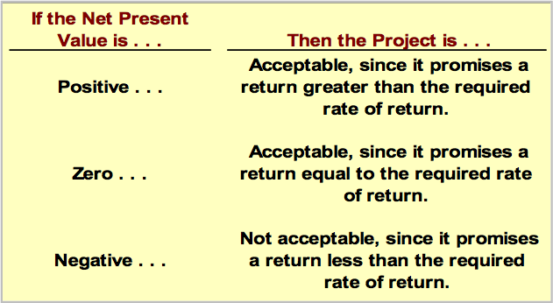
  - Principle 6: Ethics & Trust in Business
Cost of Capital (Discount Rate): minimum required rate of return. Cost of capital is the average rate of return the company must pay to its long-term creditors and stockholders for the use of their funds.

Corporate Governance Functions: (How the company is controlled)
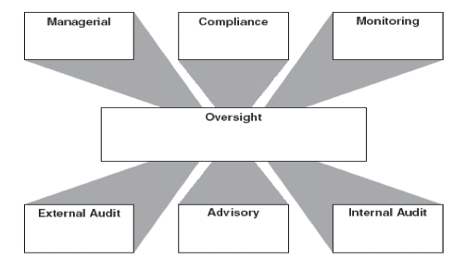
Oversight: board of directions
Managerial: run company
Compliance: laws regulations standards
Internal Audit: assurance and consulting activity
Legal and advisory: advice
External audit: lend credibility
Monitoring: elect or remove directors and management

Real Versus Financial Assets
- Real assets are tangible things owned by persons and businesses
  - Residential structures and property
  - Major appliances and automobiles
  - Office towers, factories, mines,
  - Machinery and equipment
- Financial assets are what one individual has lent to another
  - consumer credit
  - loans
  - mortgages

Functions of money:
- Medium of exchange
- Standard of value
- Store of value

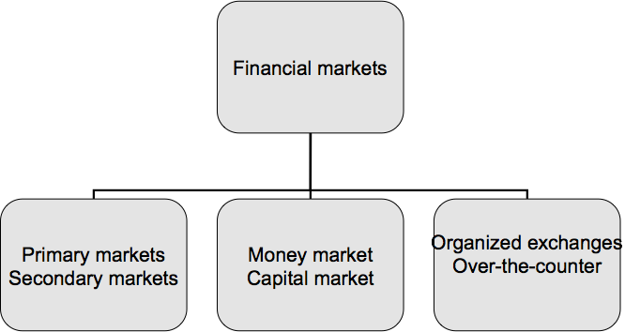
Financial intermediaries (change the nature of the security)
- banks and other deposit-taking institutions
- insurance companies
- pension funds
- mutual funds

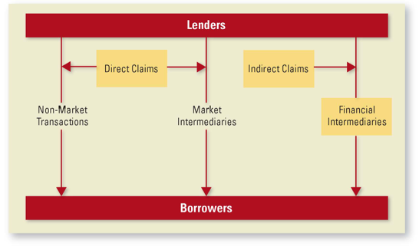
Channels of Intermediation:
Financial Market:
Primary Market transaction: first time that it happens (ISSUING of IPO or BONDS etc.)
Secondary Market transaction: company is NOT involved, stock is already issues, you buy or sell it to a third party.
Third market: through large institutions (between banks)
Fourth market: not involved in the market at all.

Money Markets:
- Short term debts
- OTC

Capital Market:
- Long term debt
- Shares (5 years and up)

Organized Exchanges: TSX, NYSE
Over the Counter: OTC

Debt Instruments:
- Commercial Paper: unsecured, no collateral (1-270 days), working capital financing, only solid companies
- Bankers Acceptance: bank guarantees the investment
- Corporate Bonds

Bond Features
Retractable: allows the holder to force issuer to pay back bond early (interest rates are higher)
Convertible: allows the holder to have the option to convert to shares or other security
Extendable: allows the holder/issuer to extend the length of the bond
Callable (Redeemable):

Common Stock:
- owners of corporate equity
- voting rights
- returns come from dividends and capital gains

Preferred stock:
- have face value predetermined periodical dividend payments.
- no voting rights
- paid preferred dividends before common dividends
- non-cumulative (won’t add up if it can’t be paid) or cumulative
- participating or non-participating (gets double dividends in common stock dividends)

Derivatives
- securities whose value is derived from the value of some underlying asset
- most important ones are options and futures

Stock options: method of compensation.

Lecture 7 — Financing and Distribution

Bootstrapping:
- Initial funding of firm
  - Process of raising seed money and other resources
  - Seed money usually comes from founders
  - Personal savings, sale of personal assets,
  - Usually spent on developing prototype of product or service and business plan.

Venture Capital
- Individuals or firms that help new businesses get started and provide early-stage financing
- Typically wealthy individuals who invest their own money in emerging businesses.
- 3 Reasons why emerging businesses do not get traditional sources of funding:
  - High risk
  - Types of productive assets
  - Informational asymmetry problems
- Investment gives equity interest in company
  - Usually in form of preferred stock convertible to common stock at investor’s discretion
- Also provide advice
- Reduce their risk by:
  - Funding ventures in stages
  - Requiring entrepreneurs to make personal investments
  - Syndicating investments
    - Originating venture capitalist sells a percentage of a deal to other venture capitalists
    - 1. Diversifies portfolio
    - 2. Willingness of other venture capitalists to share in investment provides independent corroboration.
  - In-depth knowledge about industry
- Exit Strategy:
  - Timing
  - Method
  - Price
  - 3 Principle ways:
    - Sell to a strategic buyer in private market.
    - Sell to a financial buyer in private market
    - Selling common stock in IPO.
      - Easier to attract top management talent if firm’s stock is publicly traded.
      - High cost of IPO
      - Costs of complying with SEC disclosure requirements
      - Transparency is expensive.

IPO
Investment Banking services
- Origination
  - Giving firm advice and getting issue ready to sell
  - File registration statement with SEC
- Underwriting
  - The risk-bearing part of IB.
  - Two ways:
    - Firm-commitment basis
    - Best-efforts basis.
  - Syndicate shares risk and sells more efficiently, receive portion of underwriting fee and allocation of securities to sell to its own customers.
  - Determining offer price.
  - Due diligence meeting:
    - Representatives from syndicate with reps from issuer
    - Protect reputation and to reduce risk of investor lawsuits in case it goes sour.
- Distribution
  - Pricing call takes place after market has closed.
  - Management accepts or rejects IB’s price recommendation

IPO Pricing and Cost
- 3 Basic costs with issuing IPO:
  - Underwriting spread: difference between proceeds the issuer receives and total amount raised in offering.
  - Out of pocket expenses: legal, banking, accounting, printing, travel, consulting expenses.
  - Underpricing: difference between offering price and closing price at end of first day of IPO
Private vs Public Markets
- Smaller firms have to go to private market for funding
- includes bootstrapping and venture capital financing
- many private companies owned by entrepreneurs, families, or family foundations still sell through private markets.
- Private replacement occurs when a firm sells unregistered securities directly to investors such as insurance companies, banks, or wealthy individuals.
  - Private lenders more willing to negotiate changes to bond contract
  - Problems more likely to be resolves without going to bankruptcy court
  - Speed and flexibility
  - Drawback: restrictions on resale of securities.

Private Equity Firms:
- Pool money from wealthy investors, pension funds, insurance companies, and other sources to make investments.
- Invest in more mature companies, and often purchase 100% of company.
- Closely monitor firms and provide better management
- Sell firms for profit, generally hold for 3-5 years

Dividends
- distributed on pro-rata basis (per share)
- can involve cash, assets, discounts on products, etc.
- Reduces the value of stockholders’ claims against firm
- Reduces stockholders’ investment in a firm by returning some of that investment to them.
  - Regular Cash dividend:
    - most common
    - quarterly basis
    - typically set at level that mgmt expects it can maintain in long run.
  - Extra Dividends
    - has option of paying extra if earnings higher than expected
    - paid at same time as regular
  - Special Dividend
    - one time payment, larger than extra dividends and less frequent
  - Liquidating Dividend
    - paid to stockholders when firm is liquidated

Stock Repurchases
- Open Market repurchase
- Tender Offer
  - Fixed Price
  - Dutch auction —- demand curve
- Targeted Stock Repurchase
  - used to thwart hostile takeover

Stock Dividend
- distributes NEW SHARES OF STOCK to existing shareholders
- Value of company DOES NOT CHANGE.
- Stockholder is left with exactly the same value as before

Stock Splits
- quite similar to stock dividend, involves distribution of larger multiple of outstanding shares
- division of each share into more shares.
- Send positive signal to investors.

Management considerations:
- how much does earnings exceed investment requirements
- does company have enough financial reserves to maintain dividend payout in times of low earnings or high investment needs.
- does firm have sufficient financial flexbility to maintain dividends if unforeseen circumstances wipe out financial reservcs
- can firm quickly raise equity capital
- if finance through selling equity, does less control of company matter

Lecture 8 — Merg & Acquisitions, Intl Finance

Acquisition: purchase of one firm by another
Merger: combination of two firms into new entity
Amalgamation: genuine merger in which both sets of shareholders must approve transaction.

Pros:
Related businesses (horizontal relationships)
Transferring competitively valuable expertise
Combining related activities into single operation to lower costs
Exploting common use of a well known brand name.

Vertical Integration Strategies
- Extends competitive scope in same industry
- backward —> supply
- forward —> end users

Unrelated Diversification
- favors capitalizing on a portfolio of businesses that are capable of delivering good performance
- Undervalued assets
- Financially distressed
- High growth potential but short on investment capital

Motivation for M&A:
1. synergy 1+1 =3
- Economies of Scale
- Economies of Scope — variety
- Complementary Strengths
- Efficiency increasae: unused production, sales, marketing channels can be utilized
- Financing synergy: reduced cash flow variability, increase in debt capacity, reduction in average issuing costs, tax benefits
- strategic realignment
- Managers:
  - Increased firm size, more rewarding financially, power and prestiage
  - Less risk through diversification

How its financed
- Cash transaction
- Share transaction
- Going Private Transaction (Issuer Bid)

General intent of legislation
- Transparency
- Fair Treatment
  - avoid oppression of minority shareholders
  - permit competing bids during process and not have first bidder have special rights
  - limit ability of minority to frustrate will of majoritty.

Exempt Takeovers
- Private companies are generally exempty from proinvicial securities legislation.
- Public companies may be subject to takeover laws from another province where majority of shareholders reside.
- Purchase of shares from fewer than 5 shareholders

Creeping Takeovers
- 5% rule, allows company acquiring target over long period of time. 1 year

Securities Legislation
- 10% Early warning, report sent to OSC, alerts other shareholders
- 20% takeover bid
  - not allowed further open market purchases but must make takeover bid
  - allows all shareholders an equal opportunity to tender shares and forces equal treatment of all at same price
  - forces acquisitor into disclosing intentions publicly before moving to full voting control of firm.
  - 50.1% control: controls voting decisions under normal voting. can replace board and control management
  - n66.7%, amalgamation: can approve amalgamation proposals
  - 90%: minority squeeze out: minority shareholders can be forced to tender their shares

Takeover Bid Process
- Takeover circular sent to all shareholders
- Target has 15 days to circulate letter to shareholders with recommendation of BoD
- Bid must be open for 35 days following announcement
- Shareholders tender to offer by signing authorizations
- Competing bid automatically increases takeover window by 10 days and shareholders during this time can with draw authorization and accept competing offer
- does not have to be for 100% of shares
- tender offer price must not be less than average price of last 90 days shares purchased

Friendly Acquisition
- Target will accomodate overtures and provide access to confidential information to facilitate scoping and due diligence processes
- Normally starts when target voluntarily puts itself into play
  - Uses an investment bank to prepare offering memorandum
    - May set up data room and use confidentiality agreements
    - Signed letter of intent
    - Legal team
- Initiated by friendly overture by an acquisitor seeking information that will assist in the ,,,.valuation process

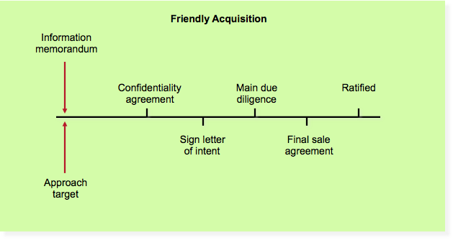
Allows both parties to:
- structure deal to mutual satisfaction of tax issues
- asset purchases rather than share purchases
- earn outs: initial purchase price with conditional later payments depending on performance of target after acquisition

Hostile Takeover- target has no desire to be acquired and actively rebuffs acquirer. Acquirer usually ahs already acumulated an interest in target (20%)
Process:
- Slowly acquire toehold by open market purchase without attracting attention
- File statement with OSC at 10% early stage.
- Accumulate 20% of shares through open market purchases.
- Make tender offer to bring ownership percentage to desired level (control or amalgamation)

Market clues to potential outcome:
- Market price jumps above offer price:
  - competing offer is likely OR
  - bid price too low
- Market price stays close to offer price
  - Deal will likely go through
- Little trading in shares
  - Bad sign for acquirer because shareholders are reluctant to sell
- Great deal of trading in shares
  - arbitrageurs coordinating a response to tender offer in seek of premium

Hostile Takeover Defensive Tactics
- Shareholder Rights Plan
  - Known as poison pill or deal killer
    - Gives non-acquiring shareholders the right to buy 50% or more of shares at discount price.
- Selling Crown Jewels
  - selling of target company’s key assets that the acquirer is most interested in
  - can involve large dividend to remove excess cash from target’s balance sheet
- White knight
  - target seeks another acquirer that is more friendly and can make a counter offer .

INTERNATIONAL FINANCE

SIX FACTORS AFFECTING INTL FINANCIAL MANAGEMENT:
- UNCERTAINTY in future exchange rates
- different legal systems and tax codes
- english not world’s social language
- cultural views are different
- economic system
- Country risk: politics, changes in tax law, tariffs, quotas

Goals of Intl Finance Mgmt.
- Stockholder value maximization (CA, UK, US)
- Maximize corporate wealth: Europe

Country Differences:
- japan, companies form tightly knit, interlocking business groups, focused on increasing wealth and growth of this group, and focus on market share rather than stockholder wealth.
- china, differences between stationed and emerging privates sector firms. state-owned goal of maintaining full employment while private sector holds goal of stockholder value maximization

Basic Principles
- same basic principles of managerial finance
- time value of money not affective by domestic or int’l
- same models are used for valuing capital assets, bonds, stocks

FX Markets: group of international markets connected electronically where currencies bought and sold in wholesale amounts

Factors affecting currency rates:
- supply demand relationships
- inflation rates
- relative interest rates
- other factors (political, economic risk)

Market Structure and Major Participants (FX MarketS)
- multinational commercial banks
- large IB firms
- small currency boutiques
- central banks also intervene to smooth out fluctuations in exchange rates

Foreign Currency Quotations
- SPOT RATE rate at which one agrees to buy or sell currency
- FORWARD RATE for future buy or sell
- forward transactions to lock in cost of FX, HEDGE risk.

currency exchange rate: value of one currency relative to another
direct quotation method: indicates amount of a homecountry’s currency needed to purchase one unit of foreign currency
indirect: indicates amount of foreign currency needed to purchase one unit of home country’s currency

INT’L Capital budgeting
- multinational firm wants to consider overseas capital projects, manager faces decision which should be accepted on a company wide basis.
- Decision to accept projects with positive Net present value increases value of firm.

DETERMINING CASH FLOWS
- harder to estimate incremental cash flows for foreign projects
- problems with cash flows arise when foreign gov’s restrict amount of cash that can be repatriated, or returned to parent company

Exchange Rate risk
- have to deal with this risk on int’l capital investments
- to convert future cash flows into another currency, need to come up with projected rates
- problem is many projects have lives of 20 years or more, makes difficult

Derivatives: derive all or part of their value from another underlying security:
- expands investment opportnities
- lower cost
- increase leverage

Options: created by investors, sold to other investors
Call option: buyer has right, not obligation, to purchase fixed quantity from seller at a fixed price up to a certain date.
Put option: buyer has right, to sell to seller at fixed price to certain date.

Exercise Strike Price: per-share price at which common stock may be purchased or sold

Expiration date: last date which an option can be exercised.

TYPES OF OPTION EXPIRATION DATE:
- AMERICAN
- EUROPEAN
- BERMUDAN

Option Premium: price paid by option buyer to the writer of the option

Options Exchange: Montreal Exchange, Chicago Board Options Exchange CBOE

Standardized exercise dates, exercise prices, and quantities
- facilitate offsetting positions through clearing corporation
- CLEARIGN CORPORATION IS A GUARANTOR, HANDLES DELIVERIES

In the money: positive cash flow if exercised immediately
Out of money: should not be exercised immediately
IF S = E, option is AT THE MONEY

Factors affecting prices:
- stock price
- exercise price
- time to maturity
- stock volatility
- interest rates
- cash dividend

Right: to purchase a stated number of common shares at specified price within a specific time
- issued by corporation
- transferable
- option to purchase shares often lower price than the market price
- certificates mailed to current shareholders on pro rata basis

Warrant: to purchased a stated number of common shares at a specified price within specified time, attached to debt or preferred shares as sweetener, detachable.

FUTURES MARKETS
Spot or Cash Market: price refers to item available for immediate delivery
Forward Market: price refers to item available for delayed delivery
Futures Market: sets features (contract size, delivery date, and conditions), for delivery
- AN OBLIGATION TO BUY OR SELL A FIXED AMOUNT ON A SPECIFIED FUTURE DATE FOR A PRICE SET TODAY *
Performance guaranteed by a clearing house (centralized market)
- Commodities
- Financials foreign currencies as well as debt and equity instruments

Futures Exchanges:
- voluntary non profit associations typically unincorporated
- financed by membership dues and fees
- members trade for self or for others

Clearing Corporation:
- corporation separate from, but associated with each exchange
- exchange members must be members or pay a member for these services
- BUYERS AND SELLERS settle with clearing corporation, not with each other
- Helps facilitate orderly market
- Keeps track of obligations

Through open out-cry, short position (seller) commits a trader to deliver an item at contract maturity
Long position (buyer): commits a trader to purchase an item at contract maturity.

Futures Margin
Good faith deposit made by both to ensure completion of contract
Each clearing house has own requirements
Initial margin usually less than 10% of contract value
Margin calls occur when price goes against investor
- must deposit more cash or close account
- position marked to market daily
- profit can be withdrawn
each contract has maintenance or variation margin level below which the investor’s net equity cannot drop

WHO USES FUTURES

Hedgers
- at risk with a spot market asset and exposed to unexpected price changers
- buy or sell futures to offset risk
- Used as for mof insurance
- willing to forgo profit in order to reduce risk

Speculators:
- buy or sell contracts in attempt to earn return
- absorb excess demand or supply generated by hedgers
- assumes risk of price fluctuations that hedgers wish to avoid
- speculation encouraged by leverage, ease of transaction, low cos

There is direct relationship between the price of a call option and the volatility of the underlying common stock

