Chapter 1-3 – Introduction
Investment: Commitment of current money/resources for future benefits/income
Two types of assets
- Real Assets: Used to produce a good/services (Property, Plant/Equipment)
- Financial Assets: Claims on real assets or claim on asset income (Stocks, Bonds, Derivatives)

Three types of Financial assets
- Debt (Fixed Income):
  - Money Market: Short-term, low-risk (CD’s, Treasury bills)
  - Bond Market: Municipal, Corporate or Government Bonds
- Equity (Common Stocks): Ownership stake in a company
- Derivatives: Contract whose value comes from value of underlying assets, used to hedge risk and speculate (Options, Futures, Swaps)

- The asset allocation decision is the primary determinant of a portfolio’s return

Players in Financial Markets
- Firm: Net Borrowers
- Household (Individuals): Net Lenders
- Government: Borrowers or Lenders
- Financial Intermediaries: Bring lenders and bowers together.

American Depository Receipts (ADRs): Denominated in dollars, trade in U.S., claim on a foreign stock.
Pass-through securities: Pool of fixed income securities, baked by package of assets
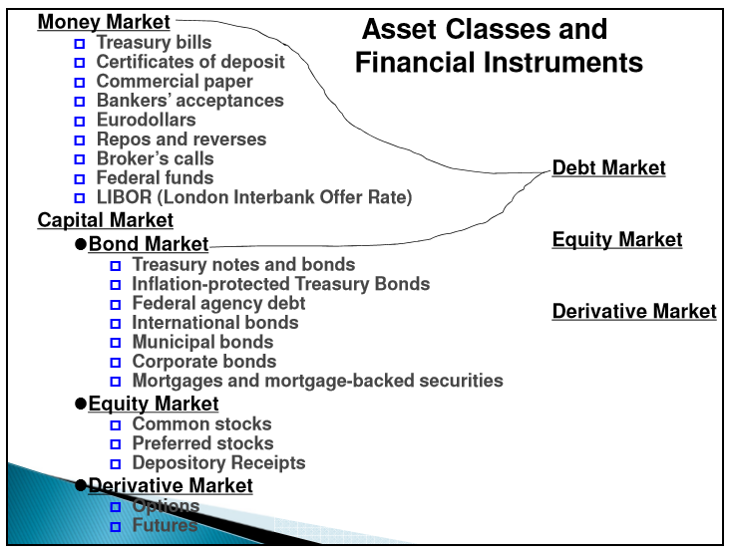
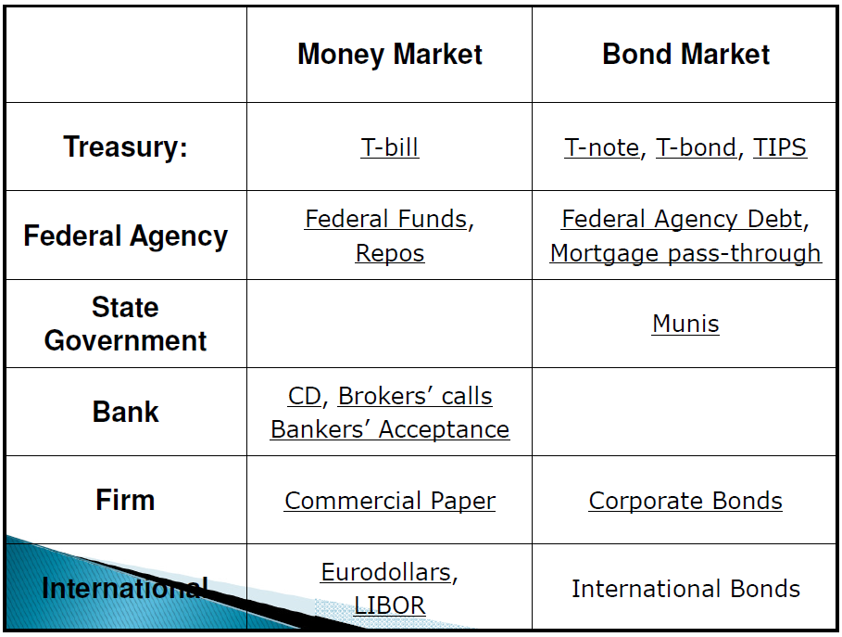
Treasury Debt
- Money Market:
  - Treasury Bills: 1 year or less, Zero coupon
- Capital Market:
  - Treasury Notes: 1-10 years, Semi-annual coupon
  - Treasury Bonds: 10-30 years, Semi-annual coupon
  - Treasury Inflation Protected Securities: 5, 10, 20, 30 years, Semi-annual coupon

Non-Treasury Debt
- Money Market:
  - Commercial Paper: Short-term, unsecured debt issued by corporations
  - Eurodollars: dollar-denominated deposits in foreign banks
  - LIBOR: London Interbank Offer Rate
- Capital Market:
  - International bonds: Eurobonds
  - Corporate bonds: Default risk, higher yield
  - Municipal bonds: tax-exempt
  - Mortgage Pass-through

Bid-Ask Spread
- Bid: Buyer Price, Ask: Seller Price (dealer point of view)
- Bid-ask spread: Ask – Bid
- ** Buyer pays the Ask price, but seller only keeps bid price, Dealer makes the spread.
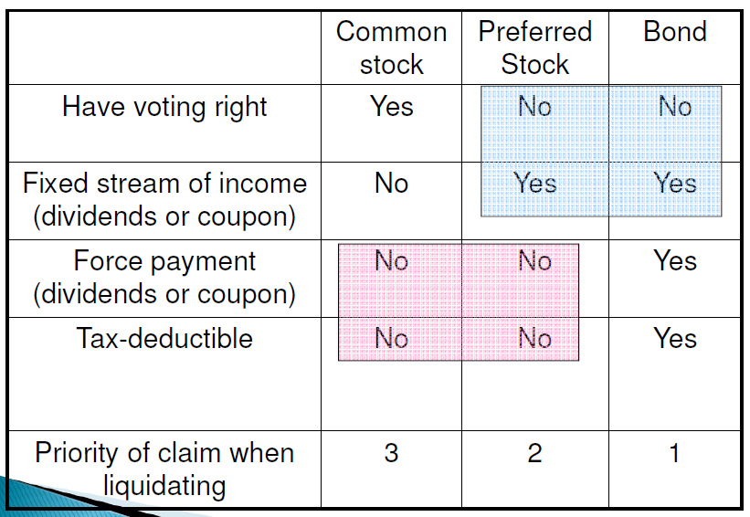

Stock Market Indices
Price Weighted: Invest once in each stock (DJIA), then divide by number of stocks
Market Value Weighted: Weight depends on MV of each stock (S&P, Nasdaq)
Equally Weighted (Value line index): Invest $1 (equal amount in each)

Options
Call Option: Right to buy an asset at strike price (X)
Put Option: Right to sell an asset at strike price (X)
European option: Must exercise option on expiration date
American option: Can exercise any time before or on expiration date
Futures
Futures Contract: The obligation to deliver an asset (or its cash value) for an agreed-upon price (futures price) at the maturity date (T)
- Futures contract is free to enter.
Securities Markets
Primary Market: Market for new issues of securities
Secondary Market: Market for already-issued securities
Public offering: Sell to the public, registered with SEC
- SEO: Seasoned Equity Offering
Private Placement: Sell to 1 or a few institutional investors
- Not registered with SEC (less costs)
- Not on secondary market (less liquid)
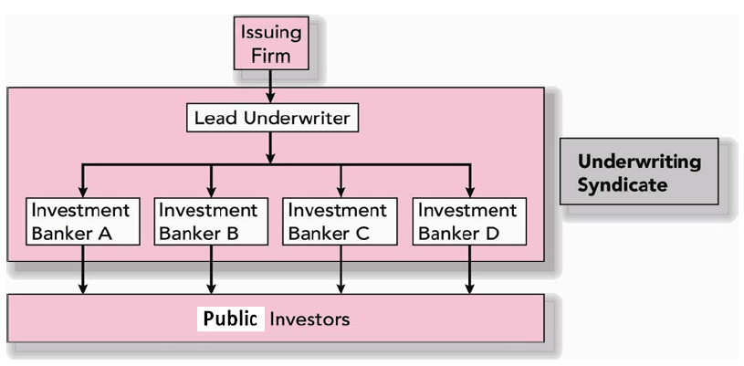
Preliminary Prospectus: registered with SEC
Road shows (book building): done to generate interest in IPO and get price information
IPO’s are usually underpriced!

Types of Markets:
- Direct Search Market: Buyer/Seller each find each other (craigslist)
- Brokered Markets: 3rd party helps locate buyer/seller (Primary market, IPO)
- Dealer Markets: 3rd party buys and sells on his own account; bid-ask spread (Secondary Market, Nasdaq)
  - NASDAQ: Computer linked price-quotation system for OTC Market.
  - Electronic Communication Network: Computer networks that allow direct trading without market makers.
- Auction Markets: All buyers and sellers converge at one place (NYSE)
Types of Orders
- Market Order: Execute immediately at market price
- Price-contingent orders:
  - Limit buy order: Buy if below limit
  - Limit sell order: Sell if above limit
  - Stop loss order: Sell if below limit
  - Stop buy order: Buy if above limit
Margin Trading: Way of leverage (Magnifies gains/losses)
- Initial Margin: Minimum acceptance level of owners’ equity when stocks are 1st purchased (FED: 50%, usually 60%)
- Maintenance Margin: Minimum acceptance level of owners’ equity throughout the life of the loan (FED: 25%, usually 30%)
  - If Margin goes below this level, investor gets a Margin Call and needs to either deposit more cash or liquidate
Short Sales: Profit from betting against the stock and hoping the price declines
- Borrow Stock from broker (stock is your liability)
- Sell the Stock and put proceeds and margin in a brokerage account
- Closing out your position: Buy the stock with funds and give back borrowed stock
Short sellers are required to post margin to cover losses, incase stock price goes up during the period.

Chapter 4-9 – Portfolio Theory

Arithmetic Average: Total returns/# of returns
Geometric Average: Single per period return that gives the same cumulative performance of sequence of returns.
Risk aversion coefficient (A): reluctance to accept risk (higher means more risk averse)

Risk and CAL:
- Risk-averse: Closer to Risk-free (y<1)
- Risk-neutral: Closer to Risky-portfolio (y<1)
- Risk-loving: Past Risky-portfolio, levered position (y>1)
CAL: uses Risky Portfolio
CML: uses Market Risky Portfolio (Index)
Portfolio Selection: Efficient Frontier > Optimal Risky Portfolio > Complete portfolio

CAPM
- All investors reach same Optimal Risky Portfolio (Homogenous expectations)
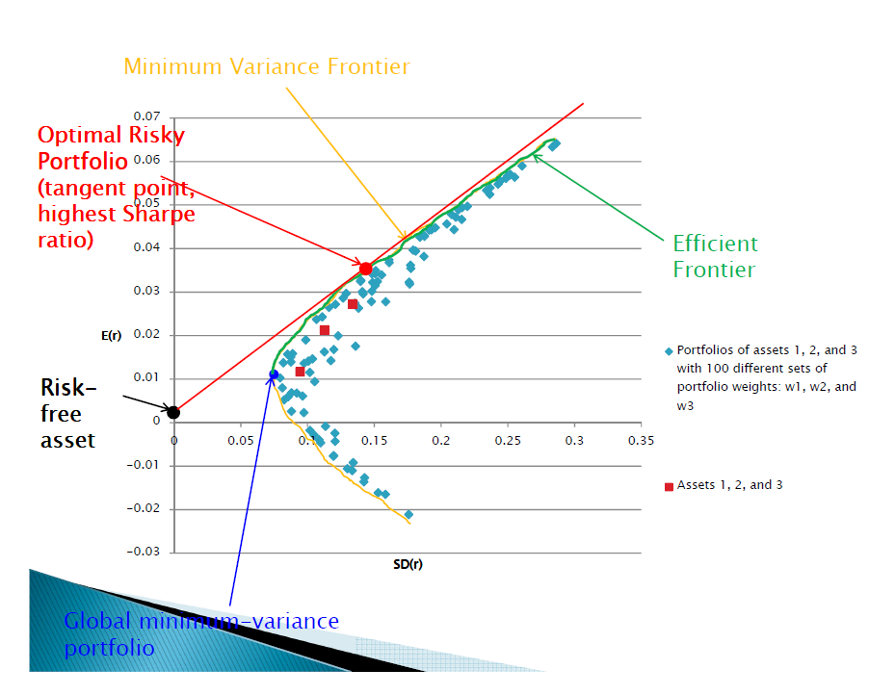

Efficient Frontier: Top half of Minimum Variance Frontier
Global Minimum Variance Portfolio (G): Portfolio with lowest variance
Optimal Risky Portfolio (P): Tagency point between CAL and Efficient Frontier

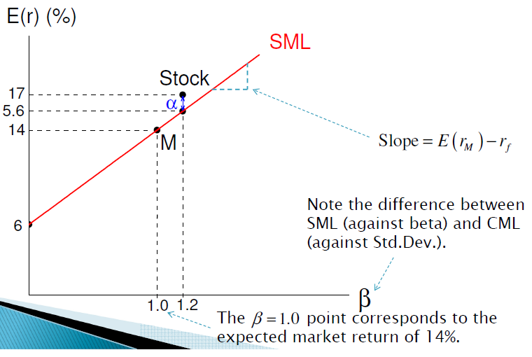

-Use Alpha to compare between 2 stocks

Arbitrage: Exploiting mispricing to earn a risk-free profit
Steps to construct a zero-beta portfolio and earn alpha
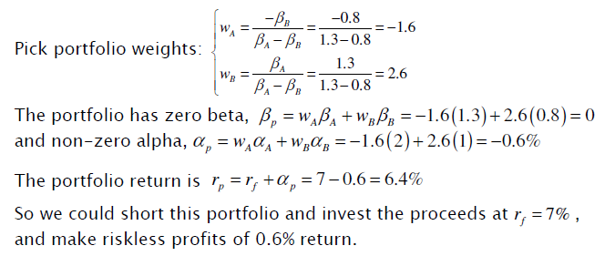
*Short portfolio and invest in Rf if Rf>
*Borrow Rf and invest in portfolio if Rf<

Efficient Market Hypothesis: The hypothesis that states that stock prices already reflect all available information about securities.
- Markets and efficient and well-functioning
- Old and predictable information is built-in current stock price
- Stock price only changes to new (unpredictable information), therefore stock movement is random
- Under EMH: Passive Portfolio Management (Diversification)

- Strong Form Set: All information (not beatable)
- Semi-strong Form Set: All public information (insider trading can beat it)
- Weak-form Set: All past trading information (Fundamental analysis can beat it, technical can’t)
Technical Analysis: Trend Analysis
- Resistance levels: Price which it’s hard to go over
- Support levels: Price which it’s hard to go under
- Relative Strength: Ratio of stock price to market index
Fundamental Analysis: Identifying underpriced firm, research on stock value

Issues that Make EMH Tests Difficult:
Magnitude Issue: Abnormal returns while managing a large portfolio implies huge profit/loss, but less variance than the market.
Selection bias: Investors want to keep their winning strategy
Luck Issue: There will always be one investor that will constantly do well against the market.

Weak form tests (Technical analysis): Short-run momentum and long run reversal
Semi Strong Tests: Anomalies: Patters of returns that contradict EMH
- Small firm effect
- Liquidity effect
- Book to market ratio
Strong Form Tests: Not strong form efficient due to Insider Trading (Superior profits)

Chapter 12-14 – Bonds

Face Value, Par Value: Final payment to the bondholder at maturity
Coupon Rate: Bond’s annual interest payment (divide by 2 for semi-annual payment)
TBonds and TNotes:
- Typically sold in denominations of $1000 par value
- Price quoted as percentage of par value (100:10, 100+10/32 = 100.313% of par)
- Ask Yield: YTM based on Ask Price
- Invoice Price = Quoted Price + Accrued Interest
- Bond prices fall when market interest rates rise
Corporate bonds
- Callable Bonds: firm has right to call back the bond
  - Higher coupon rate than non-callable bonds
  - Call back when interest rates go down
- Convertible Bonds: holder has right to convert to stocks
  - Lower coupon than non-convertible
- Puttable Bonds: holder has right to retire bond earlier
Retire the bond when interest rates go up
- Floating-rate bonds: Coupon rates change periodically based on market rates

International Bonds
Foreign Bonds
- Yankee bonds: Dollar-denominated bonds sold in US by non-US issuers
- Samurai Bonds: Yen-denominated bonds sold in Japan by non-Japanese issuers
- Bulldog Bonds: Pound-denominated bonds sold in UK by non-UK issuers
Eurobonds
- Euroyen: Yen-denominated bonds selling outside Japan
- Eurosterling: Pound-denominated bonds selling outside the UK

Premium Bonds: CR > YTM, Current yield decreasing
Discount Bonds: CR < YTM, Current yield increasing
- Bond Prices vary, unless sold at par
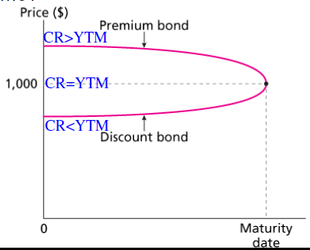

Default Premium: Yield spread between corporate bonds and comparable T-bonds
Credit Default Swap (CDS): Insurance for the default of a corporate bond. In a default, buyer gives seller the defaulted bond in return for the Par Value

Expectations Theory: YTM is determined by expectations of future short-term interest rates
- Upward sloping: Expect future interest rates to go up
- Downward sloping: Expect future interest rates to go down
Liquidity Preference Theory: Investors of long-term bonds demand a risk premium (Yield curve always increasing)

Duration: 1ST order Bond Price Sensitivity to interest Rate Changes
Convexity: 2nd Order Bond Price sensitivity to Interest Rate Changes
- Increase in YTM results in smaller Price change than decrease in YTM (of equal magnitude)
Immunization: Duration matching

Bonds are more sensitive when they have:
- Longer maturity
- Lower coupon rate

Duration: PV-weighted average of time to each payment (measure of effective maturity)
- Duration of a zero-coupon bond equals its TTM
- Duration is higher when coupon rate is lower
- Duration increases with maturity
- Duration is higher when YTM is lower

Rebalancing: Realigning the proportions of assets in a portfolio to match duration of assets and liabilities.

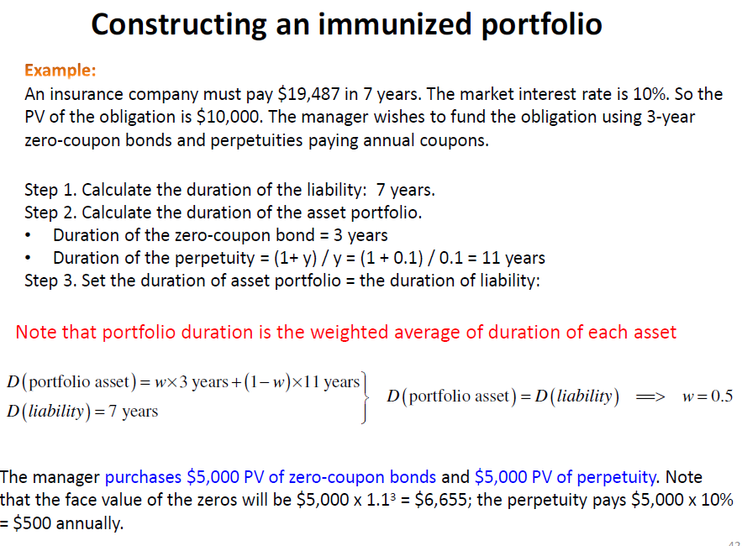
Cash Flow Matching: Buying zero-coupons equal to liabilities (Dedication strategy). No need for re-balancing
Convexity: Curvature of the Price-Yield relationship of a bond. (used for large changes in bond yield)
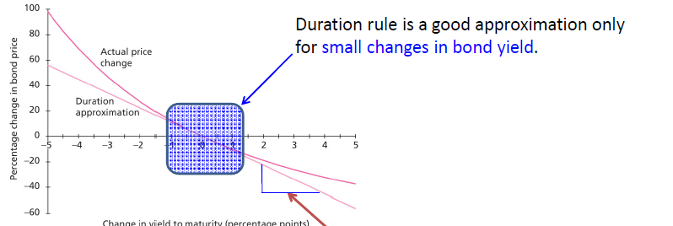
- CHANGE IN YTM IS SMALL > DURATION
- CHANGE IN YTM IS LARGE > CONVEXITY
- Convexity is Good, A Convexity bond performs better no matter which way interest rates move

