Barney

The word that we should remember is competitive advantage.
- Claim: its not enough to consider the competitive environment in which the company operates to understand why a firm is successful, you also need to give a close look to the organizations.
His own theory is not the SWOT analysis, but he does talk about it. He focusses on the S and W of the SWOT analysis.

Each organization is a collection of unique resources. He classifies the resources into tangible (financial, physical, equipment, technological, and organizational) and intangible (human, innovation/creativity, reputation).

Four important questions that need to be asked about resources and capabilities.
- The question of value: are we able to produce to offer something that is valuable on the market
- The question of rareness: are we the only ones with these resources
- The question of unique ability: can other firms copy me and how expensive is it
- The question of organization: extent to which my company is well organized to exploit these capabilities.
The most important criteria’s is the notion of imitability, the extent to which another firm will be able to copy what you do. Resources that are intangible are often the ones harder to imitate.

- The importance of history: each organization has its own history, and this cannot be copied.
- The numerous small decisions: small decisions (hiring, allowing, deciding, etc.) can explain why the way we do things is so unique
- Socially complex resources: explain why they are so difficult to imitate.

VRIO (value, rareness, imitate, organization). A sustainable competitive advantage is long term.

Chandler

The key word for Chandler is industrial success. Chandler developed a theory that explains how companies can understand industrial success.

*a concept map is a pictorial representations of various concepts and the relationship between these concepts*

The smaller organizations will disappear or be swallowed by larger organizations. The importance of the word “related diversification”.

- Economies of scale: large companies can produce at a much lower cost than smaller ones because the cost per unit drops as the volume of output rises.
- Economies of scope: organizations can use same raw-data/semi finished material in order to produce other products than the original

You need three conditions for these economies to happen:
- Flow of materials must be kept constant
- National (international) marketing and distribution functions must be created
- You need to create large organizations that will have the hierarchy of lower and middle managers.

Collins and Porras

Their theory is about a well conceived vision. The Ying yang summarize their message, its about stability and change.

The first element that needs to be considered is:

- Core ideology: something that will endure, it’s something that will last forever. You need to formulate it so it stays.
- Core values: essential principles, formulated using (ex: high quality, customer service, passion, etc.)
- Core purpose: Organisation’s raison d’être. The core purpose needs to be formulated in a way that will last.
You cannot invent your core ideology; it’s really made for managers to discover it. It’s not what you wish it’s something that actually exists.

- Envisioned future (things that will change)
- BHAG (big hair audacious goals): 10-30 years that is self explainable, you might not achieve them but at least formulating them motivates people
- Vivid description: explanation in a few words of what it will be like to achieve these BHAG.

Recap:
- Core ideology (stays)
  - Core value (not more than 3-5)
  - Core purpose – does not refer to the product, something that will last, you can 5 times the question why. Our company makes excellent market research (why five times, each time getting a different answer)

- Envisioned future (changes)
  - BHAGs
  - Vivid description

French and Raven

Summarized with five basis of power. We need to remember that power is not an attribute, we cannot say this person has power. Power is not a quality it’s a relationship. To exert power, you need to have access to five power basis (let’s imagine that Mary exerts power over Paul, and he is conscious that she has Power over him):
- Reward power: Mary can have reward power if Paul knows she can reward him
- Coercive power: If Paul knows Mary can punish him, she can have Coercive power
- Expert power: Mary can exert expert power on Paul if Paul recognizes her expertise (she’s been in the company for a long time, she has a degree, etc.)
- Legitimate power: this one takes time to develop. Mary is able to exert power on Paul if he recognizes that through time she has acquired such an experience. It doesn’t have to do with authority
- Referent power: Mary will be able to exert referent Power over Paul if he admires her a lot and he wants to be like her (think about a CEO who has leadership and has been so successful)

Greiner

Claim: growth does not happen smoothly, its characterized by phases of evolution and revolution. Management practices that work well in one phase are very likely to bring a crisis and a change of management will be required.

He considered various concepts:
- Age of organization
- Size of organization
- Stages of evolution
- Stages of revolution
- Growth rate of the organization
- Management style
- Organisational style

Concept map it’s not enough to know the name of each phase, we need to know what happens in each phase.
- Phase of creativity
  - Crisis of leadership
- Phase of direction
  - Crisis of autonomy
- Phase of delegation
  - Crisis of control
- Phase of coordination
  - Red tape
- Collaboration
  - ?
Remember that what worked well in one phase creates problem in the next.
Handy

His theory is about change. He proposes his own theory of change and he does that with the Sigmoid curve. When applying this theory, we need to understand what’s the first curve, the second curve, and what can they represent us?

When you start something new, it’s always difficult. Things then pick up (growth), this will last and eventually things will mature and go down.

Handy’s idea says that it is best to start a second when you are only at point a on the first one (don’t wait for failure) while you’re still successful with one project, start another one. It’s going to be way more difficult to start something new when your first curve is already doing bad. The middle of curve (grey area) is when people are not happy and wonder why they are doing this if their business is going well.

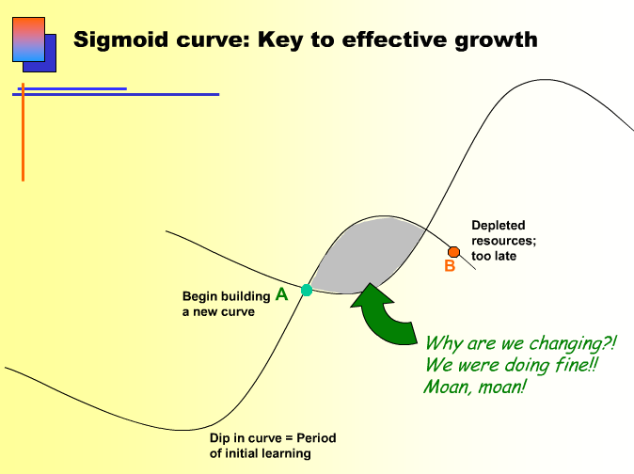

Everything in life can be modeled using that curve (marriage, organization, etc.)

Herzberg

The key word that should come to mind when thinking of Herzberg is motivation. The key contribution is the two factor theory that we absolutely need to understand. Factors that causes dissatisfaction are not the same that cause satisfaction and motivation.

For example, you start with employees that are dissatisfied, so you give them hygiene factors.
- Start with their motivation (larger paychecks, good physical environment). They will stop being dissatisfied, however they will not be more motivated. You need to add something else to be motivated.

Hygiene factors do not motivate employees, what you need is motivators
- The best one could be the sense of achievement

Hygiene factors make sure the employee is satisfied, however they cannot motivate. You need motivators to do this.

Herzberg also talks about positive and negative KITA (kick in the ass), which looks a lot like reward and coercive power. It is false to think that employees will be motivated with punishment or rewards. The absence of hygiene factors causes dissatisfaction, whereas the presence of motivators results in satisfaction.

An example of positive KITA can be a reward (giving a bonus to someone, giving a gift, etc.). According to Herzberg these will serve to be satisfied but not more motivated.

Kaplan and Norton

The key word to remember is that this is a theory for performance evaluation. They say that if you really want your employees to achieve the results you want, make sure that these are translated into performance indicator and that they are concrete.

Claim: what you measure is what you get. They also say that the bottom line (sales minus expenses) is not enough, you also need to consider other aspects of performance (not just financial).

(example: telling your employees you want to produce the best quality possible doesn’t tell much about how this will happen. Instead, you need to transform your objective in a measurable way. You could say we want to keep a certain maximum % of defective products per assembly line. If percentage is not what we want, we will take action to improve the quality.)

They look at four perspectives for a balanced scorecard (vision strategy):
- Financial perspective how can we ensure profitability for shareholders?
- Customer perspective: what do customers want?
- Internal business: how can we produce to meet customer expectations?
- Innovative and learning perspective: how can we make continual improvements?

Mintzberg

Mintzberg talks about the manager’s role. Up until now, the theory was that managers had to plan, organize, coordinate and control. Mintzberg knew that this was not true and there was more to this. He put a series of 10 managerial roles (we need to understand the three categories of roles and know what goes in each of them – provide examples as well):

- Interpersonal roles (interacting with people)
  - Figurehead: you’re the figure the public sees.
  - Leader role
  - Liaison: has contact outside the unit outside the organization
- Informational roles
  - Monitor: make sure nothing bad is going to happen, gather the information
  - Disseminator: decide to whom this information will be shared
  - Spokesperson: example is presenting results to the shareholders
- Decisional roles
  - Entrepreneur: they look out for new opportunities
  - Disturbance handler: they will handle conflicts and solve problems between people
  - Resource allocator: the manager decides whether or not some money will be distributed in a certain resource
  - Negotiator: either with employees, unions, clients, etc.

Be able to recognize these roles, classify them in each of their category. To get good examples, imagine yourself doing these.

Tannenbaum and Schmidt

This is a theory of leadership. These theorists offer seven different leadership style, and they basically say that different leadership style will be relevant and adapted to different situations.

They start from boss-centered leadership to subordinate-centered leadership.
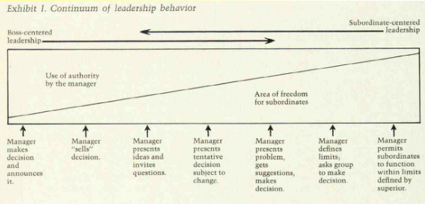

They also talk about manager and non-manager leadership.

T&S explain that you need to take into considerations three different forces, which will determine the leadership style should be adapted.

- Forces in the manager: himself/herself, his feeling of security (this will influence delegation)
- Forces in the subordinate: who are we supervising, and these people have forces as well. If these people have a high tolerance of ambiguity and independent, adapt a democratic leadership style.
- Forces in the situation: same as subordinate. For example, the nature of the problem (money), types of organization, time pressures, etc. will determine your leadership style.

Popular business expression

- Bottom-line: financial result of the organization (we need to consider more than that)
- CEO: Chief executive of organization
- Emotional intelligence: rational readers
- Globalization: buy components elsewhere or sell everywhere in the world
- Knowledge workers: people who come to work have skills, knowledge
- Outsourcing: having other supplies conducting other activities that you could be doing in the organization (paying another firm)
- R&D: research and development
- Shareholders: hold various shares of the organization

Recap of our critical thinking model – will be in final exam

Don’t believe everything someone tells you, make sure to have evidence.
- Identify author’s major conclusion: this is claims
  - A claim is a key idea that another wants you to believe (you can draw a concept map)
  - Claims are not always explicit (can’t always use one sentence and say this is the claim, we will often have to make it with our own words what it is that the author is saying)
- Two types of claims
  - Uncontestable claims: example the sky is blue
  - Contestable claims: as a critical thinker, we like to study these. We need to ask for evidence. A claim that is contestable cannot stand o
- We need to use 6 criteria to evaluate the quality of evidence:
  - Accuracy: the most important one, you want the evidence to be true (you can do your own research)
  - Precision: you want precise numbers and quotes (don’t use almost, use a number or actual fact)
  - Sufficiency: the amount of evidence we need to support our claim
  - Representativeness: sources of evidence represent the population as a whole.
  - Authority: I use information coming from people who have expertise
  - Clarity of expression: the evidence is clear, we want it to be clearly formulated
- Question ourselves, explore underlying assumptions. As critical thinkers we need to challenge these assumptions, there are two types:
  - Reality assumptions: my belief about how the world operates (ex: theory X is that you believe people are lazy, or theory Y is that you believe people need to have a sense of achievement)
  - Value assumptions: these are trickier, it’s more about what we think is right and wrong. This is our belief on how things should be.

- Causal claim (important to understand): cause and effect relationship. Trying to explain something. Sometimes we have claims that put variables in relations (cause and effect), understand why a certain phenomenon occurs. When two variables are put together, we have to explain why it is like that.
  - Example: A claim that says having a strong vision causes success. You could say that having a strong vision means that employees have a clear sense of what they need to accomplish, they will be motivated, work well and therefore the company will work well.

- Rival causes: the same evidence can be consistent with different interpretations

- Examine critically causal explanation of:
  - Differences between groups
  - Association of characteristics (is there a 3rd variable that can explain the claim)
  - Claims of post hoc (false claim)

- Techniques of persuasion (to keep in mind for exam)
  - You need to write in a way that will persuade reader
  - Anticipate objections
  - It’s good to counter argue your arguments before the reader can do it.
  - Rhetoric: use language and proper words to persuade

- Persuasive essay (there will be this in final exam)
  - Before writing have an idea of what you’re going to write about
  - Think of the evidence you will use and arrange it
  - Use persuasive writing (clear claim, good evidence, challenging underlying assumptions, countering any objections)
  - Use references if necessary

