Chapter 1: Integrative Model of Organizational Behaviour
Organizational Mechanisms
Organizational Commitment
Job Performance
Individual Mechanisms
Learning and Decision Making
Trust, Justice, and Ethics
Motivation
Stress
Job Satisfaction
Organizational Mechanisms
Individual Characteristics and Group Mechanisms
Organizational Structure
Organizational Culture and Change
Personality, Cultural Values, and Ability
Teams, Diversity, and Communication
Power, Influence, and Negotiation
Leadership Styles and Behaviours

1.Personality, Cultural Values, and Ability:
2.Teams, Diversity, and Communication:
3.Power, Influence, and Negotiation:
4.Leadership Styles and Behaviour:
5.Dictates how the units within the firm link to (and communicate with) other units
6.In the organization—shared knowledge about he values and beliefs that shape employee attitudes and behaviours
7.What employees feel when thinking about their jobs and doing their day-to-day work
8.Employees’ psychological responses to job demands that tax or exceed their capacities
9.Energetic forces that drive employees’ work effort
10.The degree to which employees feel that their company does business with fairness, honesty, and integrity
11.How employees gain job knowledge and how they use that knowledge to make accurate judgments on the job
12.The set of employee behaviors that contribute, either positively or negatively to organizational goal accomplishment
13.Desire to remain a member of the organization

Chapter 2: What Does it Mean to be a Good Performer?
Job Performance
Citizenship Behaviour
Counter Productive Behaviour
Task Performance
Personal Aggression
-Harassment
-Abuse
Political Deviance
-Gossiping
-Incivility
Production Deviance
-Wasting Resource
-Substance abuse
Property Deviance
-Theft
-Sabotage
Organizational
-Voice
-Civic Virtue
-Boosterism
Interpersonal
-Helping
-Courtesy
-Sportsmanship
Creative
Adaptive
Routine

1.Task Demands are predictable
2.Task Demands are novel and unpredictable
3.Ideas/ Outcomes are both novel and useful
4.Interpersonal Citizenship Behaviour:
5.Organizaitonal Citizenship Behaviour:
6.Undesired behaviours towards resources
7.Undesired behaviours towards the company
8.Undesired behaviours in a social scene (more verbal)
9.Undesired behaviours that are (more physical)
10.Employee Behaviours that are directly involved in the transformation of organizational resources into the goods or services that the organization produces
11.Voluntary employee activates that may or may not be rewarded but that contribute to the organization by improving the overall quality of the setting in which work takes place
12.Employee behaviours that intentionally hinder organizational goal accomplishment
13.The set of employee behaviors that contribute, either positively or negatively to organizational goal accomplishment

Chapter 3: Overall Drivers of Organizational Commitment
Overall Organizational Commitment
Felts in Reference to Ones:
-Company
-Top Management
-Department
-Manager
-Work Team
-Specific Co-workers
Normative Commitment
Continuance Commitment
Affective Commitment

1.A desire to remain a member of an organization due to an emotional attachment
2.A desire to remain a member of an organization because of an awareness of the costs associated with leaving it
3.A desire to remain a member of an organization due to a feeling of obligation
4.Desire to remain a member of the organization

Chapter 3: Responses to Negative Events
Chapter 3: Embeddedness and Continuance Commitment

Facet
For the Organization
For the Community

Links
-I’ve worked here for such a long time
-I’m serving on so many teams and committees
-Several close friends and family live nearby
-My family roots are in this community

Fit
-The weather where I live is suitable for me
-I think of the community where I live as home
-My job utilizes my skills and talents well
-I like the authority and responsibly I have here

Sacrifice
-People respect me a lot in my community
-Leaving this community would be very hard
-The retirement benefits provided by the organization are excellent
-If I leave I sacrifice a lot

Active
Passive

Exit
Neglect
Destructive

Loyalty
Voice
Constructive

1.Ends or restricts organizational membership
2.attempts to improve the situation
3.“Grin and bear it”
4.Interest and effort in the job declines

Chapter 3: Psychological and Physical Withdrawal
Quitting
Absenteeism
Missing Meetings
Long Breaks
Tardiness
Cyber loafing
Moonlighting
Socializing
Looking busy
Daydreaming
Physical Withdrawal
(Exit)
Psychological Withdrawal (Neglect)
Withdrawal Behaviour

1.A behaviour that is counter-productive to work activities
2.Actions that provide a mental escape from work
3.Actions that provide a physical escape from work
4.A form of psychological withdrawal in which one’s work is interrupted by random thoughts or concerns
5.A form of psychological withdrawal in which one attempts to appear consumed with work when not performing actual work tasks
6.A form of psychological withdrawal in which employees surf the internet, e-mail, and instant message to avoid doing work-related activities
7.A form of psychological withdrawal in which one verbally chats with co-workers about non-work topics
8.A form of psychological withdrawal in which employees use work time and resources to do non-work-related activities
9.A form of physical withdrawal in which employees arrive late to work or leave work early
10.A form of physical withdrawal in which employees neglect important work functions while away from the office
11.A form of physical withdrawal in which employees voluntarily leave the organization
12.A form of physical withdrawal in which employees take longer-than-normal lunches or breaks to spend less time at work
13.A form of physical withdrawal in which employees do not show up for an entire day of work

Chapter 4: Value Precept Theory of Job Satisfaction

Overall Job Satisfaction
Work Satisfaction
Co-worker Satisfaction
Supervision Satisfaction
Pay Satisfaction
Promotion Satisfaction
(Work_{want}-Work_{have)} *Work_{importance}
(Co-worker_{want}-Co-worker_{have)} *Co-worker_{importance}
(Supervision_{want}-Supervision_{have)} *Supervision_{importance}
(Promotion_{want}-Promotion_{have)} *Promotion_{importance}
(Pay_{want}-Pay_{have)}
*Pay_{importance}
(D_{want}-D_{have)} *D_{importance}

Chapter 4: Job Characteristics Theory
Satisfaction with the Work Itself
Knowledge of Results
Responsibility for Outcomes
Variety
Feedback
Autonomy
Significance
Identity

Meaningfulness of Work

1.The degree to which a job requires different activities and skills
2.The degree to which a job offers competition of a whole identifiable piece of work
3.The degree to which a job really matters and impacts society as a whole
4.The degree to which a job allows individual freedom and discretion regarding how the work is to be done
5.In Job characteristics theory, the degree to which the job itself provides information about how well the job holder is doing

-Role Conflict
-Role ambiguity
-Role overload
-Daily hassles
-Family time demands
-Personal dev.
-Positive life event
-Time pressure
-Work complexity
-Work responsibility
-Work-family conflict
-Neg. life events
-Financial uncert.
Hindrance
Challenge
Non-Work
Work

Chapter 5: Transactional Theory of Stress

1.Conflicting expectations that other people may have of us
2. Lack of information regarding what needs to be done in a role
3. Number of demanding roles is so high that one cannot perform some or all very effectively
4. Minor day-to-day demands that get in the way
5. Perception that the amount of time you have is just not quite enough
6. The degree to which the requirements of the work exceed one’s capabilities
7. The obligations that a person has to others
8. A type of role conflict where the demands of a work role hinder the demands in a family role (or vice versa)
9. E.g., divorce, death of a family member
10.Uncertainties with regard to the loss of livelihood
11.Time that a person commits to participate in an array of family activities and responsibilities
12.E.g., formal education programs
13.E.g., Marriage, pregnancy

Chapter 5: Examples of Coping Strategies
-Avoiding, distancing, and ignoring
-Looking for the positive in the negative
Reappraising
Problem-Focused
Emotion- Focused
Behavioural Methods
Cognitive Methods
-Working Harding
-Seeking assistance
-Acquiring additional resources
-Engaging in alternative actions
-Seeking support
-Venting anger
-Strategizing
-Self-motivation
-Changing priorities

Chapter 5: Examples of Strain

Physiological Strains
(Illness, high blood pressure, coronary artery disease, headaches, back pain)

Psychological Strains
(Depression, anxiety, irritability, forgetfulness, inability to think clearly, burnout, low confidence)
Behavioural Strains
(Alcohol and drug use, teeth grinding, compulsive behaviours, overeating)

Stress

Strains related to physical pain
Strains related to psychological problems
Strains related to compensating

Chapter 6: Some Graph

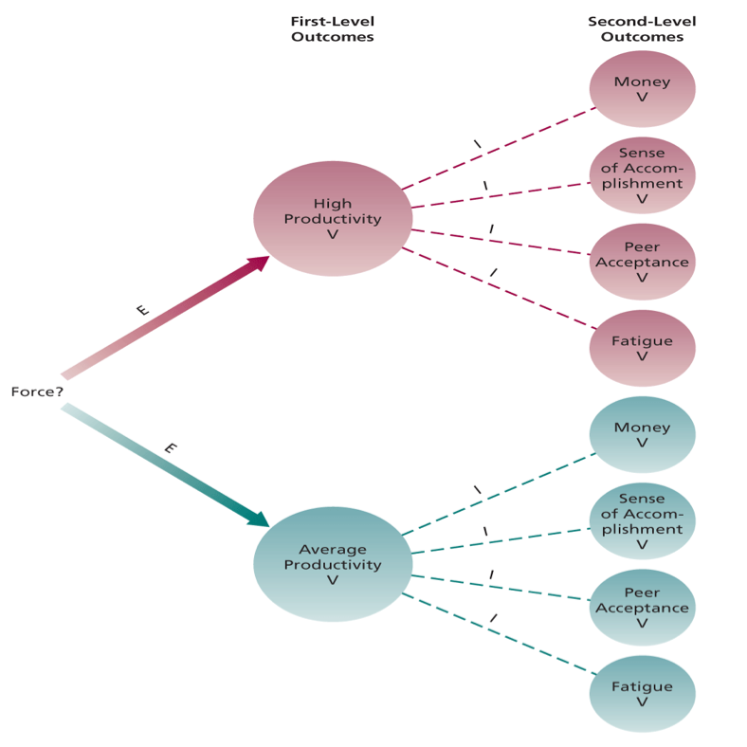

Chapter 6: Commonly Studied Needs in OB

Need Label | Alternative Labels | Description
Existence | Physiological, Safety | The need for the food, shelter, safety, and protection required for human existence
Relatedness | Love, Belongingness | The need to create and maintain lasting, positive, interpersonal relationships
Control | Autonomy, Responsibility | The need to be able to predict and control one’s future
Esteem | Self-regard, Growth | The need to hold a high evaluation of ones
Meaning | Self-actualization | The need to perform tasks that one cares about and that appeal to ones ideals and sense of purpose

Chapter 6: Equity Theory Comparisons

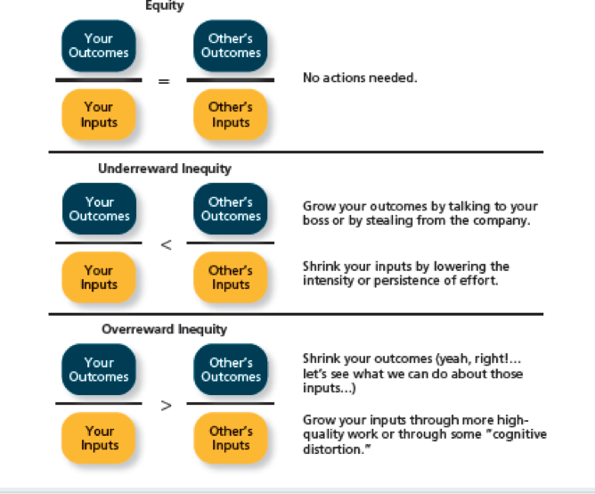

Chapter 7: Factors that influence trust levels

Trust Propensity
Disposition- Based Trust

Ability

Cognition-Based Trust
Trust
Benevolence

Integrity

Affect Based Trust
Feelings towards trustee

1. Trust that is rooted in one’s own personality, as opposed to a careful assessment of the trustee’s trustworthiness
2. Trust that is rooted in a rational assessment of the authority’s trustworthiness
3. Trust that depends on feelings toward the authority that go beyond any rational assessment of trustworthiness: Trust that depends on feelings toward the authority that go beyond any rational assessment of trustworthiness
4. A general expectation that the words, promises, and statements of individuals can be relied upon
5. The skills, competencies, and areas of expertise that enable an authority to be successful in some specific area
6. The belief that an authority wants to do good for a trustor, apart from any selfish or profit-centered motives
7.The perception that an authority adheres to a set of values and principles that the trustor finds acceptable

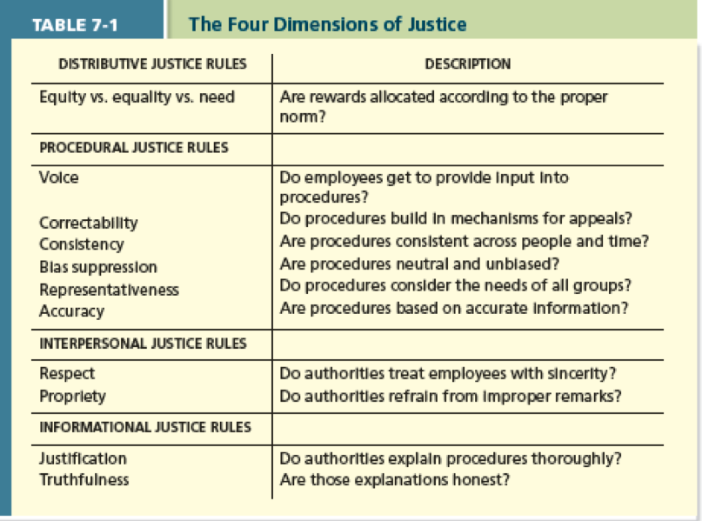

1.The perceived fairness of decision-making outcomes
2.The perceived fairness of decision-making processes
3.The perceived fairness of the interpersonal treatment received by employees from authorities
4.The perceived fairness of the communications provided to the employees from authorities

