BTM notes
COMM 226
Kiefer Schoelch

Chapter 1

Business Technology Management Program: Combines in-demand technical computer skills with practical business knowledge to solve unique business issues
Addresses business needs or opportunities using information technology
Supports and improves business processes
Gathers, processes, stores and presents vital information to the right people at the right time

CCICT
The Canadian Coalition for tomorrows ICT skills is an industry-led association of employers, universities and organizations founded by bell (2007)
Aim is to ensure that Canadian organizations can hire the Information and communications technology professionals they need to meet their workforce changing needs
Members: Bell, Canadian tire, Scotia bank, McCain, Bombardier, Microsoft

BTM Knowledge Areas
Projects, processes and change
Technology in Business
Business
Technology
Personal and interpersonal
Integrative learning outcomes

BTM is not extensive programming, hardware and electronics or complex networking

Jobs
Chief information officer
Project manager
Webmaster
Data security manager

CHAPTER 3

Computer Hardware Components
CPU: Central Processing Unit (the brain of computer, 2 CPUS = dual processor)
RAM: Random Access memory (main memory of the computer)
Storage Hardware (magnetic disks, CD’s, Thumb drives)

Hardware types
Personal Computer (Desktop and Laptops)
Tablet (Ipad, Kindel, Nexus)
Smartphone (Motorola, droid)
Server (dell PowerEdge server)
Server Farm (Racks of servers)

Computer Data Sizes
- Byte = 8 bits
- Kilobyte = 1024 bytes K
- Megabyte= 1024K MB
- Gigabyte= 1024MB GB
- Terabyte = 1024GB TB
- Petabyte= 1024 TB PB
- Exabyte= 1024PB EB

Computer Data
Hertz (CPU speed)
32-bit/64-bit

Memory
Volatile memory: memory is temporary and erased when turned off. (Cache and main memory)

Non-volatile memory: memory that remains when computer is turned off (Optical and magnetic disks, flash drives)

Operating systems OS: program that controls the computers resources
Non-Mobile client operating systems(Windows and Mac)
Mobile client operating systems (IOS, Blackberry OS, Android)
Server operating systems (Windows server, Unix, Linux)

Virtualization: The process where one computer hosts the appearance of many computers. The Host operating system runs one or more operating systems as applications. The hosted OS are called Virtual Machines.

Three types of virtualization
PC virtualization: where a personal computer hosts several OS so the user can have different systems on the same hardware
Server Virtualization: server computer hosting other server computers
Desktop Virtualization: Involves a server that hosts many versions of desktop operating systems

Own vs. License
When we buy Microsoft windows, we don’t own it we own a license to use it

Types of Applications
Horizontal application software: can be used across various industries (Excel and Word.)
Vertical market application software: More specific to an industry, cannot be used in others
One-of-a-kind application software: made for a specific need, Example the IRS. 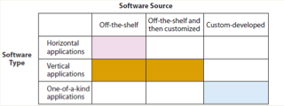

Firmware: computer software installed into devices like printers, print servers and communication devices.

Open Source: The source code is freely available to the public. Source code is a computer code written by humans. Microsoft office is a closed source because the source code is protected and not public
Becoming a more viable option today.

Native Applications: Run on one operating system
Thin-Client applications: Run in browsers on many different operating systems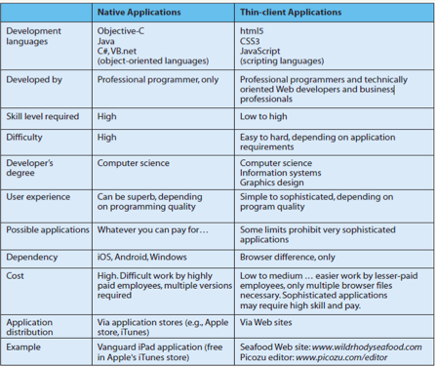
Mobile User Experience
User interface (UI): presentation format of an application (windows, menus, icons, dialog boxes, toolbars, content.)
User Experience (UX): The way a user responds to the application

Characteristics of Quality Mobile UX
Feature content and support direct interaction
Use context sensitive chrome when needed (visual overhead, windows, menus etc.)
Provide animation and lively behavior
Design to scale and share (should scale up and down and not be intrusive)
Use the cloud

Components of a LAN
LAN: connecting computers at a single location
Small office/Home office (SOHO LAN)
Wired Connectivity: computers use a network interface card NIC, one of the devices on the network acts as a switch that is used to receive and transmit traffic on the network. The wire used is unshielded twisted paired cable (UTP). Other cables used to make this connection are fiber optics or coaxial cable.
Wireless connections: Use a wireless network interface card (WNIC) they connect to an access point that receives the traffic and communications with the wired switch

Lan Protocols: provide rules by which communication can take place. Aka protocols make two computers speak the same language when communicating
Institute for Electronic and Electrical Engineers (IEEE 802) sponsors committees that create and publish these protocols
IEEE 802.3 (wired Ethernet)
IEEE 802.11 (Wireless)
Bluetooth

How to connect your LAN to the Internet: Your connecting to a WAN
Internet service provider (ISP): Provide users with access to internet and act as a gateway. ISPs pay for this access and charge their customers fees to access the internet through them.
Digital Subscriber Line (DSL): converts digital data from the computer to analog data for so/ho Lans to connect to ISPs. It operates over a telephone wire
Cable: cable modems transmit over a television cable
Wireless: involve mobile devices that access the wan via a wireless LAN or WAN, protocols are required

Summary of LAN bullshit

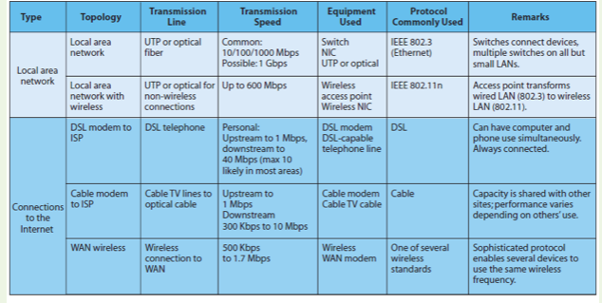

The Internet is a network of networks that consists of tens of thousands of LANS and WANS

Communication over the Internet
TCP/IP architecture
A scheme of 5 protocol types arranged in layers.
Hypertext Transport Protocol (Http)
Protocol used by browsers to request and send information over the Internet. HTTPS is more secure
Simple Main transfer protocol (Smtp)
Used for email transmission
File Transfer protocol (FTP)
Used to move files over the Internet
Uniform resource locator (URL)
An address on the Internet, consists of protocol and domain name

What happens on a typical Web Server

Web storefront
Server on the web from which you can buy/sell products

Three-Tiered Architecture
User tier: Consists of computers, phones and other devices with browsers that access web pages.
Server tier
Web page:
Web Servers: programs run on server tier, manage traffic and send and receive web pages to and from clients
Web Farm: using multiple web servers for a single site to ensure performance.
Database tier: consists of computers that run a database management system, which processes requests to retrieve and store data

Hyper Text Markup Language (HTML): the most common language for the structure and layout of Web pages.
HTML tags, a tag is a notation used to define a data element for display or other purposes, and is indicated using < and > brackets.
Hyperlinks: A hyperlink is a pointer to another Web page. And HTML tag is used for creating a hyperlink and is followed by the attribute for that tag which is “Href”. The value following this attribute will define the web page that the hyperlink will display when selected.

The Cloud: The cloud is the elastic leasing of pooled computer resources over the Internet. The Internet is represented as a cloud symbol.
Elastic: The amount of resources used can be increased or decreased dynamically, programmatically and in a short period of time. This allows organizations to pay for just the resources they need.
Pooled: when many different organizations use the same physical hardware. That hardware is shared through virtualization.
The resources are accessed via internet protocols, additions to TCP/IP that enable cloud-hosting vendors to provide processing capabilities in flexible yet standardized ways.

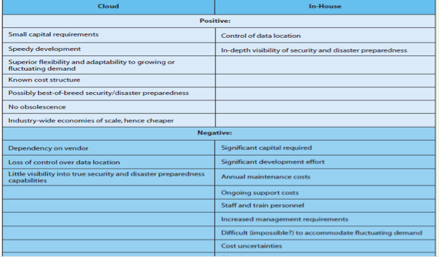

The cloud has become so popular today is the cost of processors, data communication, and data storage are low. Virtualization technology has enabled remote use of the cloud.
Using a design philosophy called service-oriented architecture (SOA) applications use standard protocols to publish a menu of services that the application provides, the structure of the data that it expects to receive, the structure of the data it will produce and the way it can be requested.

Three types of Clouds
- Software as a service (SaaS) organizations can gain access to not only hardware infrastructure but also an operating system and application programs.
Example “Icloud, Office 365”
- Platform as a service (PaaS): Where vendors provide hosted computers, an operating system and possibly a DBMS to the consumer
Oracles website, Microsoft Azure
- Infrastructure as a service(Iaas): which is the cloud hosting only a bare server computer or disk drive
Amazon S3, Amazon Ec2 (elastic cloud 2)

MODULE 3

Business Process: A sequence of activities for accomplishing a function
Activities are the tasks within the business process
Example: Processs = Booking a flight online
Activities = enter dates, times, and number of passengers to find flights
Select from the alternatives, choose seats, baggage
Documenting Business processes
Business process model and notation (BPMN): global standard for documentation that consists of roles, actors, swimlanes
Roles: Business activities performed by actor
Actors: a person
Swim lanes: Separate the various roles in the process model.
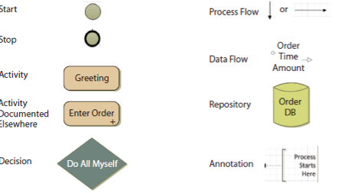
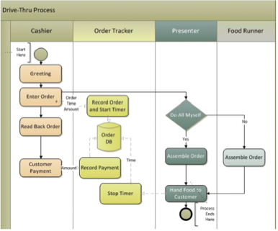
How much detail to put in?
Enough to avoid ambiguity

Benefits of standardizing business processes
Enforce policies
Produce consistent results
Scalable
Reduce risk

System: Group of components interacting to achieve some purpose
Information System: Group of components to produce information
5 Components
- Computer hardware: does things
- Software: tells hardware what to do
- Data
- Procedures: tell people what to do
- People: does things

How to use the five-component model
Recognize that you are the key
Make each component work
Estimate the scope of new information systems
Order components by difficulty and disruption

An information system is kind of like a Business process
It can support several processes. 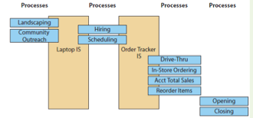
The Role of Procedures
Set of instructions for a person to follow when operating an IS
Different procedure for different processes
Multiple procedures for one IS because of multiple processes

Structured Vs. Dynamic Processes
Structured
Formally defined, activity flow fixed
Process change slow and difficult
Control is critical
Innovation not expected
Efficiency and effectiveness are important
Procedures are prescriptive
Example: Fast food restaurant : drive thru, in store ordering, revenue totaling, reordering, opening, closing

Dynamic Processes
Informal process
Process change rapid and expected
Adaptation is critical
Innovation required
Effectiveness typically more important
Procedures are supportive
Example: Fast food: Landscaping, community outreach, hiring

Information
Knowledge derived from data
Data presented in a meaningful context
Processed data
A difference that makes a difference

Information is not just data, it is more it has meaning, it varies from person to person and is located inside of you

How to USE information
Hard to communicate, everyone interprets it differently
All new information systems are frustrating at first
Understand how to be effective on a team
Stay curious

Necessary Data characteristics to turn into information
Accurate (correct and complete)
Timely (available in time for use)
Relevant: To context, to subject
Just sufficient (enough to be relevant but not too much)
Worth its cost

MODULE 4 Chapter 5: Using IS to Improve Processes

Important characteristics of processes in Organizations
Business process: sequence of activities for accomplishing a function
Activities: Tasks within a business process
Resources: items to accomplish an activity
Actors: Resources that are either human or computers
Role: Subset of activities, in a business process performed by a particular actor

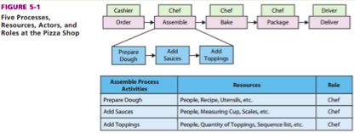

The 4 characteristics of processes
- Stability of flow
Structured or Dynamic
- Scope
Operational, managerial, strategic
- Objectives
Effectiveness, Efficiency
- Location in value chain
Inbound logistics, operations, outbound logistics, sales and marketing, service, technology development, infrastructure

Scope of processes 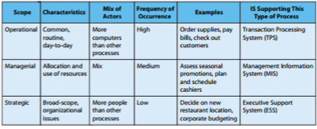
Objectives of Processes:
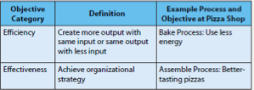

The Value Chain
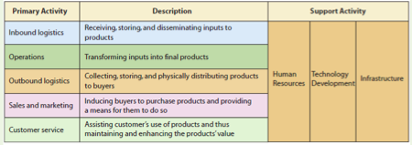

Processes in different activities

Inbound logistics
Procurement
Managing inventory
Evaluating potential suppliers

Operations
Schedule the equipment, people and facilities to build product

Outbound logistics
Collect, store, distribute products to buyers
Especially prominent for non manufacturers (distributors, wholesalers, retailers)
Example: sales process that records sale order, ships and bills customer

Sales and Marketing Processes
find prospects and transform them into customers by selling

Service processes
Tracking orders, customer support, customer support training

Supporting Activities
Human Resources
Assess the motivation and skill of employees
Create job positions
Investigate complaints
Staff, train evaluate personnel

Technology Development Processes
Designing, developing and testing technology in support of primary activities

Infrastructure: essential in the organization of day to day activities
Accounting
Administration
Quality assurance
Legal and financial areas

Applying Process Characteristics
Ask good questions about objectives
Standardize structured processes, keep dynamic processes fluid
Don’t confuse process and IS
Ensure processes work together

How can Management improve processes?
Process Improvement: a process better achieves its objectives based on its measures
Process objectives (efficient, effective)
Process measures (metrics, quantities assigned to attributes AKA KPI key performance indicators)

To improve processes managers must specify and communicate appropriate objectives in 3 ways
- Classify objectives as effective or efficient to avoid ambiguity
- Make unstated objectives explicit
- Ensure objectives are appropriate for strategy
For measures
Managers must specify and communicate measures for each objective

Using INFORMATION SYSTEMS to improve PROCESSES
Improve an activity
Improve data flow among activities
Improve control of activities
Use Automation
Improve procedures

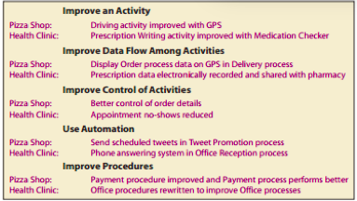

Process Management PRINCIPLES to improve processes
Examples of process management principles
Systems engineering: (Workflow/WfMC)
Business process modeling, Six Sigma and others

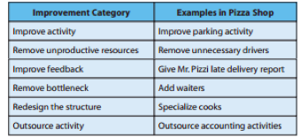

Six Sigma
Removing causes of defects
Minimizing variability in the process
99.99966% of output free of defects

How do process teams diagram process improvement

Diagrams can be beneficial in understanding the process changes that would occur as a result of process improvements

Diagrams in process Improvement
BPMN diagramming (tool we will use to address diagraming)
As-is BPMN Diagrams ( how its currently run)
Ought-to-be BPMN diagrams (should depict process improvements, which means they should satisfy the objectives seen in this table) 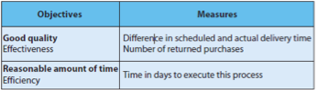

How can an IS hinder a process
Information silos: exist when data exists in isolated IS. These systems were designed for a functional purpose; as a result you have data that is duplicated in various files and databases. Results in inconsistent data
Why do they exist? Users from many different areas may request the same data but use it for different purposes.
They also exist because many departments fin it more cost effective to have their own IS. Only when many processes rely on the same IS will a savings be made.

Ethics guide

CHAPTER 6 Supporting Processes with ERP systems

What problem does an ERP system solves?
Information Silo problem: data is isolated in separate information systems leading to inconsistent data or other issues
Solutions: Enterprise application integration (EAI)
Enterprise Resource Planning (ERP)

EAI
Connects information silos via a new layer of software
Enables existing applications to communicate and share data
Provides integrated data
Leverages existing systems, leaving departmental IS alone but providing an integrative layer over the top
Enables a gradual move to ERP
EAI is beneficial because it allows organizations to continue to take advantage of current IT investments and causes less disruption than an ERP implementation.

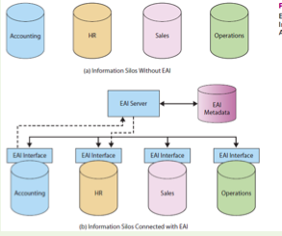

What problem does an ERP solve?

ERP characteristics
Consolidation of data for real-time sharing of data
Integrated processes

ERP moves all of your processes previously supported by separate information systems into a single information system. In this way, data is stored in a single database and can be shared across processes in various departmental areas. As a result of the single database, the processes can be integrated with one another.

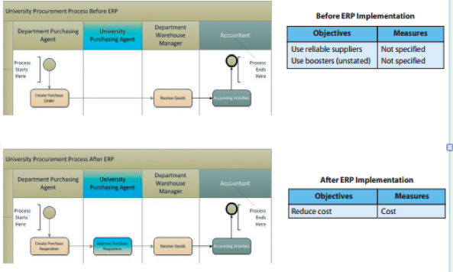

In these two diagrams, we see the differences for a purchasing process before and after an ERP.
Before implementation, each department’s procurement process had three main activities—Create Purchase Order, Receive Goods, and Accounting Activities. The process was initiated by an actor in the Department Purchasing Agent role. Every department at the university had a purchasing agent. The objective was to use reliable suppliers and, in the case of the athletic department, use boosters. No measures for evaluating the process existed.

After implementing the ERP system, a new procurement process provided by the ERP vendor is used by every department. A purchase requisition is a PO awaiting approval. The purchase requisition is approved by a University Purchasing Agent as the second activity. The rest of the activities in this process remain the same. Rather than storing data in department information silos, the new ERP process consolidates all the procurement data for the different departments in a central database. With the university purchasing office now orchestrating the process, specific and clear objectives and measures have been developed for the process and shared with all purchasing agents.

Manufacturing Software
These are some older software that were available to manufacturing organizations
MRP( Materials Requirements Planning) : This software was designed to manage inventory, production and labor.
MRPII (next gen MRP) included financial tracking of manufacturing processes and to schedule capacities

ERP includes applications that integrate the processes for the following functions
Supply chain management
Manufacturing
Customer relationship management
Human Resources
Accounting

5 components of an ERP system
- Software
- Hardware
- Data
- Procedures
- People

ERP Software
Configuration: each organization customizes its ERP software to meet its needs

ERP Data
Transactional Data :related to events such as a purchase or a student enrollment
Master Data : also called reference data, data that don’t change with a transaction
Organizational Data: data about the university such as the location of its warehouses, mailing addresses and names of financial accounts

ERP Hardware
Includes Storage devices
Clients
Printers
Servers
Organizations now face an ERP hardware dilemma. Smartphones are now being used for business activity, The cloud has also become a player in ERP, businesses may rent ERP systems with lower up-front and hardware costs.

ERP procedures
Can be very strict and require training
Organizations schedule trainer sessions where the third party vendor would train individuals to use it

Elements of an ERP system
Inherent business processes: predefined processes based on best practices for ease of implementation and use
if you don’t adapt you have to customize your erp which is costly

Benefits of an ERP system
Data sharing in real time
Implements integrated processes that are industry best practices
More managers see more data, better foresight
Information silo problem solved
Better integration with supply chain partners

Challenges of implementing an ERP system
Decision-making challenges
People Challenges
ERP upgrades

Decision-Making challenges
ERP vendor selection
GAP analysis, how to handle gaps in what the system should do for them
Configuration- identifiers, order sizes, BOM
Data issues- what format to use
Cutover pressure- decision made regarding transition from current system to ERP

People Challenges
Management
Moves on prematurely
Oversells
Fails to anticipate cultural resistance
Team
Collaboration breaks down
Individual
Users feel pain of change but no gain as their work does not change

ERP upgrade challenges
Surprise and resistance
Justification
Version lock from customization
No long term upgrade strategy

Types of organizations that use ERP

Industry type
Manufacturing
Distribution
Mining, materials extraction, petroleum
Medical care
Gov. and public service
Utilities
Retail
Education
ERP Products
Other 53%
SAP 22%
Oracle 15%
Microsoft 10%

Why is SAP different from other ERP products?
SAP Modules (product made up of a collection of interdependent and interconnected modules, modules are a distinct and logical set of processes)
SAP Inputs and Outputs (usability features, all data in one system and when users enter info for a transaction is pulls up additional relevant info)
SAP Software (Sap business suite)

SAP MODULES

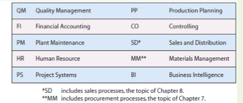

SAP inputs and outputs
You input information into various fields
Click enter to receive outputs
Allows users to validate their entries with information

SAP BUSINESS SUITE
-SAP ERP
-SAP CRM: customer relationship management
-SAP SRM: Supply relationship management
-SAP SCM: Supply Chain management
-SAP Net Weaver: platform that all these things run, allows applications to integrate with non sap applications

Chapter 7

Fundamentals of a procurement process
Order Purchasing manager
Receive Warehouse manager
Pay Accounting

Supporting the inbound logistics process within the value chain
Procurement of raw materials needed for production

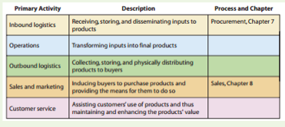

How did the procurement process at CBI work before SAP
Six roles
Two roles performed by people
- Warehouse manager
- Accountant
4 roles performed by separate computer applications with separate databases
- Sales DB
- Purchase Order DB
- Warehouse DB
- Accounting DB

Before SAP Procurement process
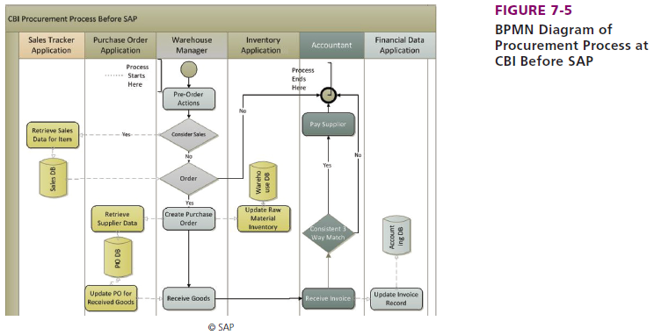
Information Systems Silos
Sales DB: Monitor demand for materials
Purchase order DB: Manage inventory levels
Warehouse DB: Manage Inventory levels
Accounting DB: Manage Payables

4 databases are used before the introduction of SAP

CBIs Procurement Process before SAP
Involved several roles
Resulted in information silos
Inefficiencies

Problems before SAP
Warehouse Problems: Manager lacked sales data, he didn’t know if sales were due to a discount or being bundled and so he didn’t order enough materials to meet demand
Accounting Problems:
Three-way match for payment was a challenge, correcting the discrepancies involved communication with several individuals. Data wasn’t in real time
Purchasing Problems
Purchasing wasn’t centralized: prices weren’t shared and couldn’t take advantage of volume pricing
Inexperienced users: errors in data entry
Errors in data entry
Pressure for greater financial controls

ERP can provide a soloution to CBIs problems and they chose SAP

As a result they had to change their strategy
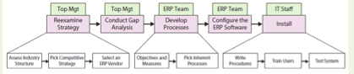

How to implement
Determine industry structure using porters five forces model and found it had a strong rivalry with low switching costs to other people

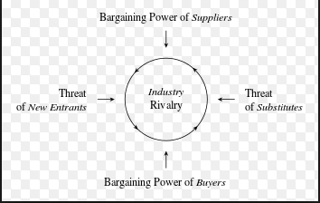
FIVE FORCES MODEL: Framework for analyzing the competition within an industry using 5 forces

Commit to a specific Competitive strategy
Differentiation strategy of responsiveness
Focus on high-end bikes 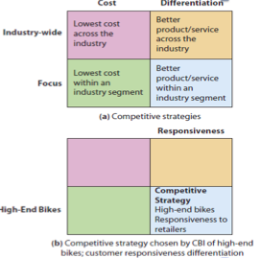

Develop objectives and measures for processes – ERP team 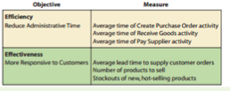
Clear Approach to implementing SAP
Found their position in their industry
Defined a competitive strategy
Created objectives and measures for their processes
Maintained the same major activities (order, receive, pay)

Soloutions provided
Single database

New purchase process after SAP 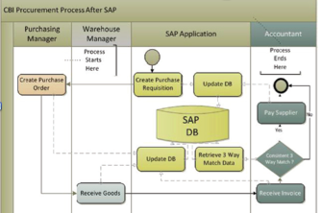

Warehouse
- Goods receipts entered into same database as PO’s
- SAP verifies the goods received against the PO
- Immediate update to inventory
- SAP documents this in the database

Accounting
- Three way check completed by SAP
- Incoming invoices are compared to PO and Goods Receipt for verification
- Payment simplified
- Accounting updated automatically in SAP
- SAP documents these steps in the database

BENEFITS OF SAP IMPLEMENTATION

HOW can SAP improve Supply Chain Processes at CBI

Supply Chain Processes
Supply relationship management SRM
Returns management
Supplier Evaluation
Supply Chain Management (SCM) 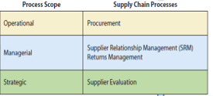

Improving Supply Chain Processes by Sharing Data
Process integration improves with sharing data

Here we can see that information from returns can help the supplier evaluation process.
Sharing data can also help suppliers respond to the needs of our inventory faster eliminating the bullwhip effect

Bullwhip effect is a distribution channel phenomenon in which forecasts yield supply chain inefficiencies. It refers to increasing swings in inventory in response to shifts in customer demand as one move further up the supply chain.

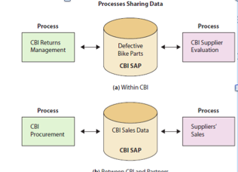

Improving Supply chain processes by sharing data continued
Process integration improves with sharing data
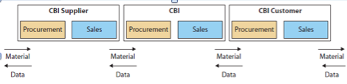
CBI shares their customer data to suppliers and they share theirs making the ERP systems communicate makes the process more efficient

Improving Supply Chain Processes with Integration
Process synergy occurs when processes are mutually supportive. When one process is done well, it supports the objectives of another process.
Also true for companies outside CBI
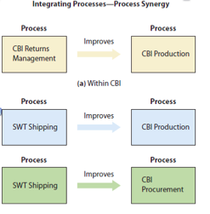
Improving processes beyond the Supply Chain
Using enterprise wide approach for SAP in
Accounting
Procurement
Production
AND SALES

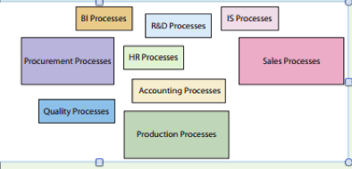

Overall how can SAP improve supply chain Processes at CBI
Supply chain processes
Improving Supply chain processes by sharing data
Improving supply chain processes with integration
Improving CBI processes beyond the supply chain

How does SAP change the company?
New skills are needed
Process Focus and less on individual activities
More data sharing
Outsourcing

Additive manufacturing: 3D printing, objects manufactured through the deposition of layers of material 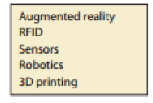
NEW IS IN 2014

Augmented reality: computer data and graphics overlaid into reality
RFID (radio frequency identification): used to identify and track items in supply chain
Sensors: make make transportation process more efficient
Robotics: Reduce inventory costs

MODULE 6 CHAPTER 5
Content: is something of value that can be considered an asset just like other items of property. Closely related to Intellectual property

Intellectual property: A form of creative endeavor that can be protected though a trademark, patent, copyright, Industrial design, or integrated circuit topography

Content varies by industry

Organizations may store; data, documents, spreadsheets, presentations, webpages, text from blogs, twitter, or discussion boards, graphics, video files and video logs, audio files etc..

Q2 How can Content be organized?

Content Management
- Management of Content
Efficient and effective storage and processing of bytes
Handled by database management systems (DBMS)
- Presentation of content
Present data to the person using the system
Handled by content management system (CMS)
- Content management challenge
Processing and storing the right content
Getting the right content to the right person in the right format at the right time.

Q3 What is the purpose of a database?

Database keeps track of things
Many professionals keep track of things using spreadsheets

Spreadsheets: keep lists that involve a single theme
Databases: Keep lists that involve multiple themes

Q4 what does a database contain?

Database: is a collection of tables plus relationships among the rows in those tables, plus special data called metadata that describe the structure of the database.

Hierarchy of data elements
Byte is a character of data
Bytes are grouped into columns/fields
Columns grouped into rows/records
rows grouped into tables/files

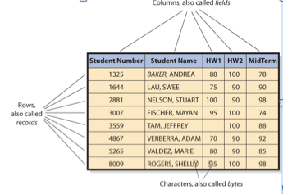
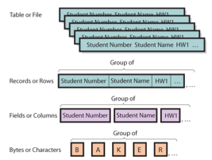Hierarchy of data elements.

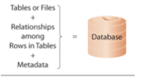

Values in one table may relate to rows in other tables

Keys
Columns that identify unique row in table
Each table has a key

Foreign keys
Keys in a different table than the one in which they reside

Relational database
Database using tables, keys and foreign keys

A database is a self-describing collection of integrated records
Self-describing means that a database contains, in itself a description of its contents

Metadata
Data that describe data
Makes databases more useful than spreadsheets
Makes databases easier to use

Question 5. What is a DBMS and what does it do ?

DBMS Database management system: program that creates, processes, and administers a database
Usually licensed from vendors
Microsoft, oracle, IBM, MySQL (opensource)
DBMS products: DB2- IBM, Access and SQL – Microsoft, Oracle- Oracle
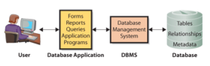

Creating the Database and its Structures
DBMS is used to create tables, relationships and other structures in the database
Used to define a new table or modify tables

Processing the Database
DBMS processes database
Applications use DBMS to read, insert, modify, or delete data

Structured Query language (SQL)
International standard for processing a database

Administering the Database
DBMS provide tools to assist in administration of database
Can be used to set up a security system
Used to back up data
Add structure to improve performance
Remove data

Question 6: what is a database application

Collection of forms, reports queries and application programs that process a database

Databases can have more then one application

Each application can have more than one user 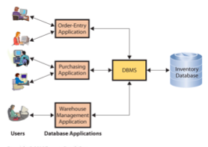

Forms: used to read, insert, modify and delete data

Reports: Show data in structured context, may compute values

Queries: means of getting answers from database data

Forms reports and queries work for standard functions

Application programs
Process logic specific to business need
Enables database processing over Internet
Serves as intermediary between webserver and database
Respond to events
Reads, inserts, modifies and deletes data

Multi-User Processing
Common

Unique problems
Lost-update problem
Locking used to coordinate activities of multiple users (creates new probs)
Data conflicts produce inaccurate results 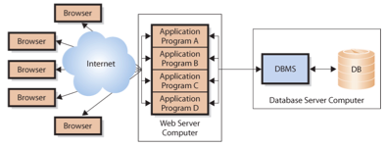
Four application programs on a web server computer

Question 7 What is the difference between an enterprise DBMS and personal DBMS

Enterprise DBMS
Process large organizational and workgroup databases
Support many users and many different database applications
EX: IBMs DB2, Microsofts SQL server

Personal DBMS
Designed for smaller, simpler database applications
Supports fewer than 100 users
EX: Microsoft ACCESS

APPENDIX 5A

A fundraising manager needs a database to
Find volunteers
Track volunteers (years, productivity, personal information)

Q2 How are database application systems developed ?
Database application system consists of
Database
DBMS
One or more database applications

Database application consists of
- Forms
- Reports
- Queries
- Application programs 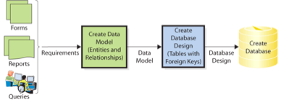

Developers interview users
Develop requirements for new system
Analyze existing reports forms and user activity
Requirements summarized in data model
Logical representation of structure of data
Contains description of data and relationships
Users validate and approve the data model
Design implemented in a database
Database filled with user data

A Database must
Include all data necessary for users to perform jobs
Contain only that amount of data, no more
Developers rely on users to
1 tell them what to include
- Check data model
- Verify correctness and completeness

What are the components of the Entity-Relationship data model ERD

Techniques for creating data model
Entity relationship E-R data model
Unified Modeling Language (UML)

E-R data model components
Entities (things) stored in the database
Relationships among those entities

Entities: something that users want to track
Physical object
Logical construct

Example: order, customer, salesperson, and item, contract

Entity names are always singular

Entities have
Attributes- describe characteristics of the entity
Identifier-attribute whose value is associated with one and only one entity
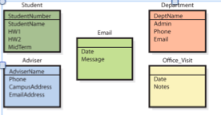

Relationships
Entities have relationships to each other

1:1: one entity to another
1:N relationship- one to many
N: M Many-to-Many

ERD diagrams
- Rectangles represent entities
- Relationships shown by lines
- Crow’s foot
  - Forks at end of lines
  - Indicate more than one relationship
  - Read “many”
- Vertical line means at least one entity of that type
- Small oval means entity is optional

Cardinality
- Number of entities that can be involved in relationship
  - Maximum cardinality
    - Maximum number involved
  - Minimum cardinality
    - Constraints on minimum requirements
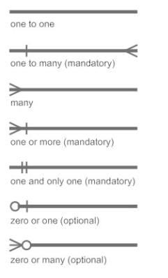
Q4 How is a data model transformed into a database design?

Database Design: The process of converting a data model into tables, relationships, and data constraints
Transform entities into tables
Express relationships
Define foreign keys
Show constraints

Normalization: The process of converting poorly structured tables into two or more well structured tables

Data integrity problems
- Different names for the same entity
- Produces incorrect and inconsistent information
- Resolve by eliminating duplicated data
Normalizing for Data integrity
- Eliminate data duplication
- Slower to process
- Construct tables such that every table has single topic

Relational database design: How to make ERD
Designer creates table for every entity
Entity identifier becomes primary key of table
Attributes of entity become columns
Tables normalized to single theme
Represetn relationships between tables
Add foreign keys

Q5 What is the users role?

Users are
Final judges as to what data should contain
Determine how records are related to each other
Need to review data model
Must insure that model reflects an accurate view of business

Q6 Who will Volounteer?

The whole process

Consultant creates Data model
Based on interviews with users
Data model is reviewed and approved
Database tables constructed
Primary and foreign keys selected
Microsoft access database created
Relationships indicated
Forms and reports constructed 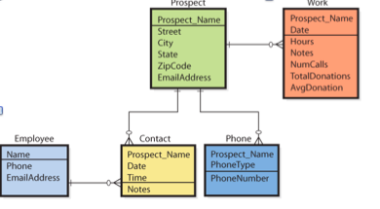

Module 7 Chapter 8 Decision making and Business Intelligence

Q1 What Challenges Do Managers Face When Making Decisions?
Q2 What Is OLTP, and How Does It Support Decision Making?
Q3 What Are OLAP and the Data Resource Challenge?
Q4 What Are BI Systems, and How Do They Provide Competitive Advantage?
Q5 What Are the Purpose and Components of a Data Warehouse?
Q6 What Is a Data Mart, and How Does It Differ from a Data Warehouse?
Q7 What Are Typical Data-Mining Applications?

Q1 What challenges do managers face when making decisions?

For business managers, decision making or choosing from a range of alternatives is the essence of management.

Decision-making is complicated for 3 reasons
- The concept of rationality is hard to define.
- Good outcomes may result from irrational processes and bad can come from good processes.
- Humans tend to be rational but have cognitive limits. (Bounded rationality)

Factors that make decision making challenging
- Uncertainty and complexity
- Information overload
- Data quality

Ackoffs arguments
- Managers have too many possibilities, perfect data doesn’t mean better decisions
- Too much data is a bad thing, information overload

Information Overload
Digital universe doubles in size every two years
Data is growing at the rate of 40 percent a year
Occurs inside and outside organizations

The challenge is to find the appropriate data and incorporate that into the decision making process

Problems with Operational data

Raw data usually unsuitable for sophisticated reporting or data mining
Dirty data
Values missing
Inconsistent data
Data not integrated
Data too course or fine (Granularity)
Too much data (Attributes, rows)

Q 2 What is OLTP, and how does it support decision-making?

OLTP Online Transaction Processing: System collects data electronically and processes the transactions online

OLTP systems- backbone of all functional, cross functional and interorganizational systems

OLTP systems support decision-making by providing the raw information about transactions and status for an organization

Transaction Processing

Real-Time processing
Transactions are entered and processed immediately upon entry
Examples: airline reservation systems, banking systems

Batch Processing
System waits until it has a batch of transactions before the data are processed and the information is updated
Example: transfer of all daily branch transactions to central office for processing

Q3 What are OLAP and the data resource challenge?

While data may be collected in OLTP, the data may not be used to improve decision making yet.

OLAP: Online analytic processing: systems focus on making OLTP-collected data useful for decision-making
OLAP provides the ability to sum, count, average, and perform other simple arithmetic operations on groups of data
OLAP reports has measures, or facts and dimensions

Sports Decisions go high tech
Managers are turning to scientific and statistical techniques that capture more data and reduce biases to choose athletes

Teams are reluctant to discuss the specifics of how they apply the technology to decision making

The number of managers with advanced degrees in stats is increasing

- What process would you use to identify your choice of a first round athletic draft?
- Is choosing athletes any different from hiring any other kind of employee?
- Why do you think these techniques first appeared in baseball, rather than hockey or basketball?
- Why would teams be reluctant to discuss how they use technology?
- Is this increased sophistication in decision making inevitable? How do you make decisions, and how has this changed over time?

Q4 What is BI systems, and how do they provide competitive advantage?

Business Intelligence BI: system provides information for improving decision making

5 Categories of BI systems
- Group decision support systems (GDSS)
- Reporting systems
- Data-mining systems
- Knowledge-management (KM) systems
- Expert systems

GDSS
Allow multiple parties to participate in decision making and improve outcomes by reducing inherent biases
Across different geographical locations and times
Anonymous input is summed up or communicated to the group and contributes to a decision

Reporting systems
Integrate data from multiple sources
Process data by sorting, grouping, summing, averaging and comparing
Formats results into reports
Improve decision making by providing right information to the right user at the right time

Data-Mining Systems
Process data using sophisticated statistical techniques
Regression analysis
Decision tree analysis
Look for patterns and relationships to anticipate events or predict future outcomes
Market-basket analysis
Predict donations

Knowledge-Management systems
Create value from intellectual capital
Collect and share human knowledge
Supported by the five components of the information system
Foster innovation
Improve customer service
Increase organizational responsiveness
Reduce costs

Expert Systems
Encapsulate the knowledge of human experts in the form of IF/Then rules
If the condition is true, then initiate procedure
Improve diagnosis and decision making in non-experts
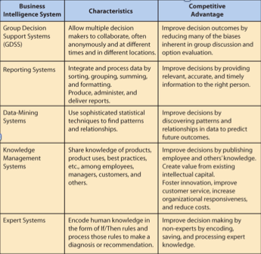

RFM analysis
Way of analyzing and ranking customers according to purchase patterns
The technique
R= How recently they have ordered
F= How frequently they order
M= How much money they spend

Q5 What are the purpose and components of a data warehouse

Data warehouse: is used to extract clean data from operational systems and other sources
Stores and catalogues data for processing by BI tools
Data-Warehouse DBMS
Stores data
May include data from external sources
Metadata concerning data stored in data-warehouse meta database
Extracts and provides data to BI tools
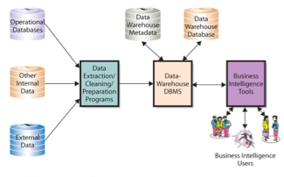

Q6 What is a data mart, and how does it differ from a data warehouse?

Data Mart: is a data collection that is created to address the particular needs of a
Business function
Problem
Opportunity
Smaller than data warehouse
Addresses a particular component of area of the business
Users may not have data management expertise
Knowledgeable analysts for specific function

Ex e commerce company may create a data mart storing clickstream data to enable analysis of website design features

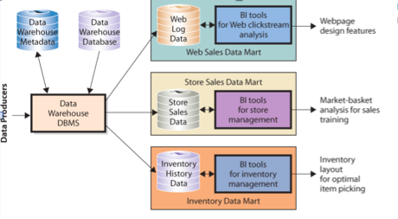

Q7 What is typical data-mining applications?

Data mining: is the application of statistical techniques to find patterns and relationships among data and to classify and predict

Represents a convergence of disciplines
Stats and math
Artificial intelligence
Machinelearning

Data mining techniques take advantage of developments in data management
Unsupervised and supervise techniques

Unsupervised data mining: analysis’s do not create model or hypothesis before running the analysis
Apply data mining technique and observe the results
Hypothesis created after
Example: Cluster analysis; identify groups of entities with similar characteristics

Supervised Data Mining: Model developed before the analysis
Statistical technique applied to data to estimate parameters of the model
Examples
- Regression analysis: measure the impact of a set of variables on another variable (Age and phone use)
- Neural networks: system of non linear equations used to predict values and make classifications, such as “Good prospect” or “Poor prospect” Customers

Big Data: large amounts of varied data from a variety of sources over a period of time that could be used to make better decisions
Controversial (bad definition, adds to excessive data)
Expensive
Imprecise (overly vague or general)
Data Mining in the Real World
- May be different from the way it’s described in textbooks
- Data are always dirty, with missing values, values way out of the range of possibility, and time values that make no sense
- Over fitting is a huge problem
- Data mining is about probabilities, not certainty
- Seasonality and other problems can result in a bad model

CHAPTER 9 Ecommerce, Social Networking and Web 2.0

Q1 What is ecommerce, and how is it used?

E-Commerce: buying and selling of goods and services over public and private computer networks
Definition restricts ecommerce to buying

Checking the weather at yahoo.ca is not ecommerce but buying a weather service subscription over the Internet is.

Ecommerce has a number of implications
Technology perspective
Management and governments perspective

Technology perspective
Defines the need for additional infrastructure
May require interconnectedness of the entire resource planning process

Management and governments perspective
Coordination for smooth business operations
Security must be enabled

Ecommerce Catagories

Merchant companies
- Business to consumer B2C
- Business to Business B2B
- Business to Government B2G

Non-merchant companies
- Auctions
- Clearinghouses
- Exchanges

Merchant companies: those that take title to the goods they sell
They buy goods and resell them
Sell services they provide

Non-Merchant companies
Arrange for the purchase and sale of goods without ever owning or taking title to those goods
Sell services provided by others

Ecommerce Merchant Companies

Business to consumer B2C
Information system for B2C provides a web storefront by which customers enter and manage their orders

Business to Business
Suppliers use b2b systems to sell to manufacturers
Manufacturers to distributors
Distributors to retailers 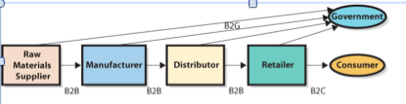

Non-merchant Ecommerce

Ecommerce auctions: match buyers and sellers by using an ecommerce version of a standard auction (EBAY)

Clearing houses: Provide goods and services at a stated price and arrange for the delivery of the goods, but they never take title

Electronic exchanges: Match buyers and sellers; the business process is similar to that of a stock exchange electronic exchanges that match buyers and sellers; the business process is similar to that of a stock exchange. Sellers offer goods at a given price through the electronic exchange, and buyers make offers to purchase over the same exchange. Price matches result in transactions from which the exchange takes a commission. Priceline.com is an example of an electronic exchange used by consumers.

Disintermediation: The removal of intermediaries between parties. E commerce allows cheaper prices because they can sell directly from manufacturer
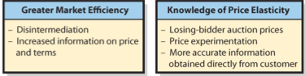

Challenges of Ecommerce
- Channel conflict
- Price conflict
- Logistics expense
- Customer service expense
- Show rooming
- Taxation

Q2 What is social networking, and how is it enabled and affected by IS/IT
Social Network: a structure of individuals and organizations that are related to each other in some way

Social Networking: The process by which individuals use relationships to communicate with others in a social network. This earns social capital

3 types of capital
- Physical capital: The investment of resources for future profit
- Human capital: The investment in human knowledge and skills for future profit
- Social capital: Investment in social relations with the expectation of returns in the marketplace

4 ways social capital adds value
- Information
- Influence
- Social credentials
- Personal reinforcement

Strong Relationships: create the most social capital in a social network
Weak Relationships: contribute the most to the growth of social networks
Weak Tie: The people you know the least but they contribute the most to your network
Weak links: add the greatest number of new connections to your network

How do social networks add value to business?
Organizations also have social capital,
Measured by relationships, strength of relationships and friends resources
Endorsements by high profile people are a traditional way of increasing social capital, also sales people, customer support and public relations
Progressive companies stay on Facebook, LinkedIn and twitter

Besides ubiquity and low cost of computers three other benefits are
- Improved search capabilities
- Reduction in the trade-off of richness and reach
- Network effects

Q3 What is Web 2.0
Tim Reilly is noted for helping to establish the concept of web 2.0
Describe applications and platforms on the web
Refer to the integration and interaction of products and services including smartphones, user created content, social networking, location and context based services and dynamic marketplaces
EX Google, Amazon and EBay 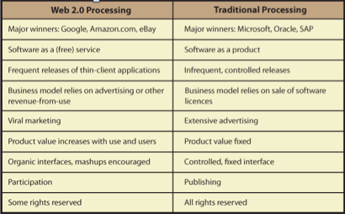
Web 2.0 companies do not sell software licenses because software is not their product
They provide software as a service
Web 2.0 business model relies on ads or other revenue that happens while people use SAAS software as a service.
Several software items are obtained from a thin client browser, with the bulk of the processing done in the cloud, somewhere on the Internet
Ex: search Google, run Google Docs, Google Earth, Gmail

Use increases value

Another characteristic of WEB 2.0 is the extent of Network effects
- The value of the site increases with number of users and their use of the site
- Amazon gains more value the more reviews are written
User-Generated content (UGC): refers to website content contributed by users
Crowdsourcing: combines social networking, Viral marketing, and open-source design, saving considerable cost while cultivating customers.

Web 2.0 interfaces are organic, and may change frequently

Web 2.0 encourages smashup’s, which result when the output from two or more websites is combined into a single user experience

Participation and Ownership Differences

Traditional sites are about publishing
Web2.0 is about participation—users provide reviews, map content, discussion responses, blog entries and so forth
Traditional vendors and websites tend to lock down all the legal rights they can
Web 2.0 locks down only some rights

How Web 2.0 benefits businesses

Businesses can use Web 2.0 for
Advertising
Mashups
Not for all applications
Note that not all business information systems benefit from flexibility and organic growth
Information system that deals with assets requires some level of control

Q4 is there a Web 3.0

Hard to predict the future as some changes are discontinuous and the invention and use of technology are hard to predict
Web 2.0 is a broad overarching term
We cannot predict what Web 3.0 will look like (or even if it will be called web 3.0)
Nobody knows what the next generation of inventors and entrepreneur will invent

MIS in Use
Computing your social capital
Social capital is not an abstract concept that applies only to organizations
It applies to you as well
You and your classmates are accumulating social capital now

Q1 How can information systems be acquired

Five basic ways for acquiring software applications
- Buy it and use it as is
- Buy it and customize it
- Rent or lease it
- Build it yourself
- Outsource it

Acquiring new software is NOT the same as acquiring new information systems, because there is a lot more to think about in systems than just software
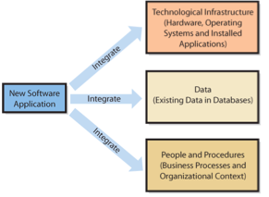
Q2 What is IT projects, and what does PMBOK mean?

Project Management Body of Knowledge (PMBOK)
A project consists of a temporary endeavor undertaken to create a unique product, service or result
Projects often begin with a set of goals or objectives
A scope is developed for the project
Project usually has a start and end date
Projects represent change in an organization

IT Projects

IT projects have a large information technology component (in terms of budget or personnel)
Scope (objective)
Start and end date
Temporary use of resources
Unique
Accomplish something new
Hard to estimate
- Time
- Budget
- Scope
Examples: installing a new email application, a CRM system, Or an enterprise resource planning ERP system.
Projects that require some fundamental changes to business processes are often also called IT projects because the new IT supports the change in processes.
IT projects affect data people and processes

Information Technology Project Management (IPTM): Is the collection of techniques and methods that project managers use to plan, coordinate, and complete IT projects, including
Planning tools
Budgeting methods
Graphical scheduling methods
Risk management techniques
Communication planning
High-tech team development

Q3 What should you know about IT operations and IT projects?

IT Operations: The delivery of service, Maintenance, projection and management of IT infrastructure

IT Projects: The renewal and adaptation of IT infrastructure is normally accomplished through projects

Operational work and project work tend to attract two different types of IT professionals
The two fields rely on each other 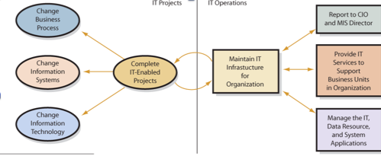

Information Technology Infrastructure Library ITIL: a well recognized collection of books that provide a framework of best-practice approaches to IT operations

ITIL offers a large set of management procedures that are made to help businesses get value from IT operations

ITIL has gone through several revisions; core books from the latest refresh (ITIL V4) were published in June 2011

Web has become an important avenue for delivering IT services to both internal employees and external customers
Internal intranet websites may include frequently asked questions (FAQ), web-based forms for requesting services, and some web-based applications that help support tasks
Public website provides support for external customers, such as FAQ, customer support information and company contact information

Q4 Why are IT projects so risky?

Most IT project definitions are not easy to represent graphically
Lack of a good model is an important risk to recognize in IT projects
Good estimates are difficult to develop because the technology is continually changing
Being able to monitor progress is another challenge for IT projects

Inherent risks in IT Projects
Lack of experience in the team
Lack of support from top management
Lack of participation from system users
Unclear and uncertain project requirements
A high level of technical complexity, and changes in the project environments

Q5 What is an SDLC

The systems development life cycle (SDLC) is the classic process used to acquire information systems.
To acquire and maintain information systems there are basic tasks to be performed
These tasks are combined into phases of Systems development

SDLC 5 phases
- System definition
Management’s statement defines new system
- Requirement analysis
Identify features and functions
- Component design
Based on approved user requirements
- Implementation
Implement, test, and install new system
- System maintenance
Repair, add new features, maintain

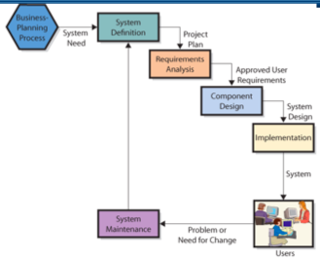

Phase 1: Defining Systems

Define goals and purpose for new system
Must facilitate organizations competitive strategy
Supports business processes
Improves decision making

Defining Projects scope
Simplifies requirements determination and other subsequent development work

Assess feasibility of project
- Cost
- Schedule
- Technical
- Organizational

Phase 2: Requirements Analysis
Form the project team and develop the requirements
Management of scope in an IT project
Determine and document specific features and functions of the new system
Approve requirements
Less expensive to change system in this phase

Q6: How are information systems designed, implemented, and maintained?
5 ways to acquire information systems
- Buy it
- Buy it and customize it
- Rent or lease it
- Build it yourself
- Outsource it
For options 1-3, the IS is already built, so the organization must match its requirements with the capabilities of the available software application,
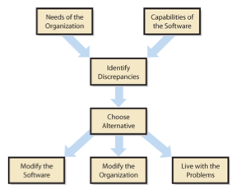

Phase 3: Component Design

Develop and evaluate alternatives
Accurate requirements critical
Hardware design determined by project team
Software design depends on source
Off-the-shelf
Off-the shelf with alterations
Custom-developed programs
Data model converted to database design
Procedures developed for normal processing, backup, and failure recovery operations
Job descriptions created for users and operations personnel
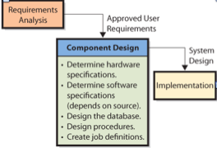
Phase 4: Implementation

Systems must be built
Components constructed independently
Document and review
System Testing
Individual components tested
System integrated and tested
Users must be converted to new system

Systems Testing

Test Plan
- Sequences of actions that users take when employing system
- Both normal and incorrect actions should be considered
- Labor intensive
Product Quality Assurance (PQA)
- Testing specialists
Beta testing
- Future system users try out system on their own

System Conversion
Converting business activity from the old system to the new
- Pilot
- Organization implements entire system on a single limited unit
- If systems fails, it only affects limited boundary
- Reduces exposure
- Phased
- New system installed in phases
- Tested after each phase
- Continues until installed at entire organization
- Cant be used in tightly integrated systems
- Parallel
- New system runs in parallel with old system during testing
- Expensive and time consuming
- Data must be entered twice
- Provides easy fallback position
- Plunge
- Direct installation
- Install new system and discontinue old
- There is no backup position

Design and Implementation for the 5 Components
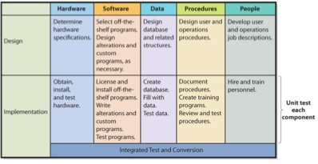
Phase 5: Maintenance
Fixing the system so that it works correctly or adapting system to changes in requirements
- Need a method to track system failures and enhancements
- Corrections usually prioritized based on severity
Group fixes for high priority failures into a patch
Bundle fixes of low-priority problems into larger groups called service packs

Problems with SDLC
SDLC waterfall method
-Phases are not supposed to be repeated
-Often teams have needed to repeat requirements or phases
Difficulty in documenting requirements
-Analysis paralysis or uncertain requirements
Scheduling and budget difficulties
-Multiyear projects difficult to properly schedule
-Estimations on labor often produce insufficient budgets

Q7 What Is Outsourcing, and What Are Application Service Providers?

Outsourcing is the process of hiring another organization to perform a service
The outsourced vendor can be domestic of international
- Offshoring is when vendor is overseas
Application services providers (ASPs) are a special form of outsourcing

Reasons for Outsourcing
- An easy way to gain expertise
- Concern cost reductions
- To reduce development risk
OUTSOURCING RISKS
- 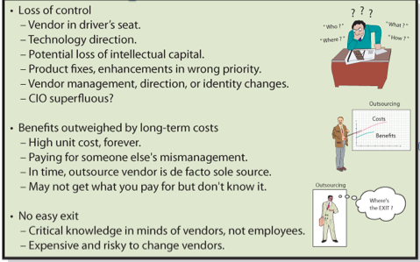

Application Service Providers

ASP: Is a particular form of outsourcing,
ASP agreement, organization contracts with a vendor to rent applications from the vendor company on a fee-for-service basis
Vendor maintains the system at its own web location and the client organization accesses the application on the vendors website
Payments
-Monthly, yearly, based on number of users

