Anna Ranger 2017/02/05
CRM1301-C
The History of Criminological Thought
Prof. Carolyn Gordon
s8718346

Test #1 Notes–Ch.1-4 (2017/02/08)

Ch. 1: Introduction to Theory

TRUE OR FALSE???
- Crime is increasing. – FALSE, Crime rates have been decreasing the past few decades but, due to the MEDIA, many people feel crime is increasing.
- Most people are victimized by strangers. – FALSE, most people are victimized by someone they know, but we don’t want to think someone we know & love would harm us.
- People over 65 are most likely to be victims of crime. – FALSE, people aged 65+ have the highest fear of victimization, but the lowest likelihood of being victimized. Those aged 18-24 have the highest rates of victimization.
- Poor people are much more likely to commit crime than middle-class people. – FALSE, people of all social classes commit a lot of crimes, but it is much more likely someone of lower class will be caught, charged, and convicted than someone of the middle-upper classes. Lower class people cannot afford lawyers, and the influence of the MEDIA again plays a role in influencing our perception of the “typical criminal” as someone of lower socio-economic status.
- Violent crime inflicts the most harm on people in society. – FALSE, hundreds of thousands of people can be affected by fraudulent activity and corporate crime (the scope is often much bigger than that of violent crime). Misconception is again due to the MEDIA.

SOMETHING TO THINK ABOUT…
Q: If someone engages in crime, are they a bad person?
A: No, not necessarily. Someone could be economically disadvantaged or have valid reasons for turning to crime, without the intention to harm anyone. Most people have committed some sort of crime, but would consider themselves criminals if they were never caught.

CRIME & DEVIANCE US RELATIVE TO:
- TIME
- Something could previously have been or have not been a crime but today, over time: it is the opposite (ex. During Prohibition, alcohol was outlawed but today it is legal if you are over a given age).
- 1960s – Homosexual sex/marriage was an offence.
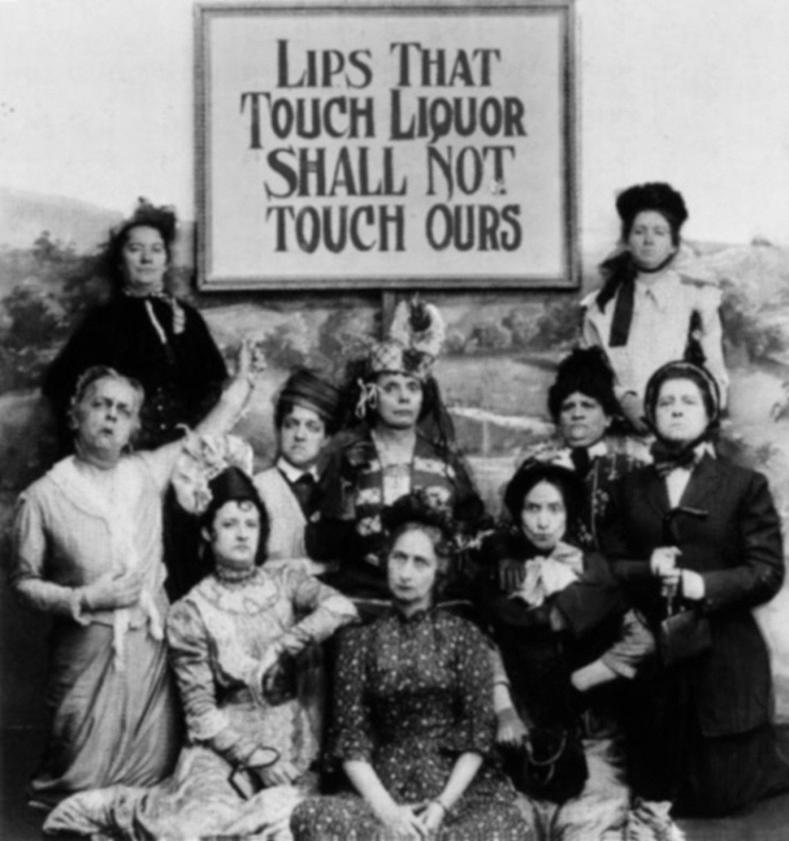
- Not until 1983 could a husband/wife be charged with sexual assault against spouse.
- Former lenience around drinking & driving.
- Current crackdown on hate crime.
- Certain drugs have been criminalized in recent years (ex. Opiates were not illegal in the past).
- Discrimination/refusal of service is no longer allowed.
- Corporal punishment is no longer allowed.
- Smoking in indoor public places such as restaurants, shopping malls, airplanes and on the bus is no longer allowed.
- PLACE
- Chewing gum is illegal in Singapore.

- Alcohol is legal in North America, but illegal in Saudi Arabia.
- Soft drugs and prostitution are legal in Amsterdam.
- Public displays of affection and adultery are sanctioned in some countries.
- Differences in gun laws (ex. USA vs. Canada).

DO WE USE THEORY IN EVERYDAY LIFE???
Yes! Ex. You are out camping and notice dark clouds – You theorize that it will rain and prepare in the event that it does.
Ex. Theorizing about why someone broke up with you.

The Columbine Shooting Mass Murder/Suicide
Why???:
- Marilyn Manson’s influence
- Playing dark, violent video games
- Shooters were members of Trenchcoat Mafia
All of the above possible factors = THEORIZING!!!

WHAT FACTORS CONTRIBUTE TO CRIME???
- Who you spend time with/associate with (peer pressure)
- Your environment
- Class conflict, disparity, & inequalities
All of the above are THEORIES!!!

WHAT IS THEORY???
- THEORY IS a hypothesis, a generalization, an explanation.
- Can be simple, complex, abstract, or concrete.
- THEORY IS NOT the truth or the answer!!!
- Theories are a particular way of looking at something.
- Theories explain how two or more events are related to each other and the conditions under which that relationship takes place.

WHY DO WE HAVE (CRIMINOLOGICAL) THEORIES???
- They attempt to describe, explain, predict, and ultimately control crime.
- If we can understand and explain crime, we can get to the root of the problem with the goal of decreasing crime.
- Ex. Would the introduction of after-school programs decrease crime in a neighbourhood that previously had no after-school programs?

ASSUMPTIONS IN CRIMINOLOGICAL THEORY
- Level of abstraction:
  - Macro? Micro? Bridging?
  - MACRO: (Marx, Durkheim = Macro-theorists) large-scale, focuses not on individuals, but on social structures and society’s impact on criminal behaviour: the more abstract, the bigger the picture.
  - MICRO: Focuses on the individual and why individuals/gangs engage in crime: much more concrete than macro theories, “the smaller picture”
  - BRIDGING: Somewhere between Macro and Micro (ex. Impact of social structure on criminal behaviour).
- Basis of society:
  - Consensus or conflict?
  - CONSENSUS: Most people have shared values/beliefs, working together to benefit the majority (ex. The Criminal Justice System).
  - CONFLICT: (*Marx) Society is divided by conflict, coercion, imbalance of power (have-lots and have-nots). Society is based on groups with varying degrees of power: the powerful make the rules. The Criminal Justice System = Inequality (“The rich get richer, the poor get prison”).
- Individuals:
  - Active or passive?
  - ACTIVE: Individuals possess free will and are able to make their own decisions (*Beccaria and Bentham).
  - PASSIVE: People behave due to certain forces inside them (biological, psychological) or outside them (environment).

Kitty Genovese (1935-March 13, 1964 @ 2AM)
“37 Who Saw Murder Didn’t Call the Police” – The New York Times March 27th, 1964
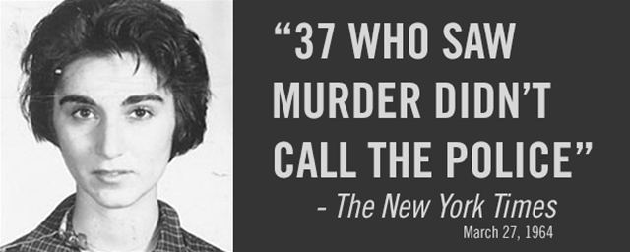
- Kitty Genovese was attacked by a man in her apartment building, whom she fought off fiercely, screaming for help. Lights went on & people looked out their windows… BUT NO ONE HELPED HER!!!
- Diffusion of responsibility (the bystander effect) – everyone assumes that someone else will or has helped the person in need.

- SYSTEMS OF REASONING:
- Inductive Method
- Observe
- Analyse
- Explanation (Theory)
- Howard Becker hung out with jazz musicians and found that they enjoyed recreationally smoking marijuana; based on his analysis, he theorized:
- That the technique for smoking weed must be learned.
- You must learn to recognize the symptoms of being high on marijuana.
- In order to continue smoking marijuana, you must learn to associate the symptoms with pleasure (positive reinforcement).
- Deductive Method
- Explanation (Theory)
- Test
- Verify/Refute
- Experiments to show:
  - When more people are present, it is less likely the person in need will receive help (ex. Genovese case).
  - When less people are present, it is more likely the person in need will receive help (ex. Stranded motorist).

THE STANFORD PRISON EXPERIMENT
- Is variable X a cause of variable Y? (Causality)
  - Independent variable = the variable manipulated by the researcher
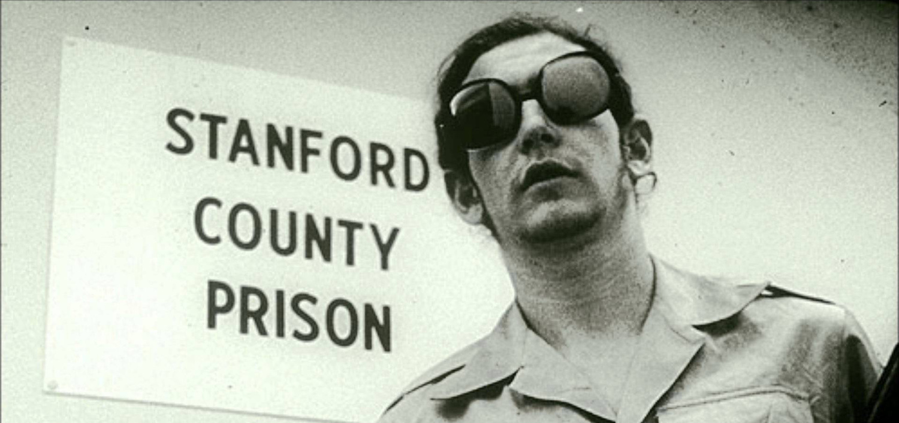
  - Dependent variable = the variable that is measured
- Q: Prisons are often violent institutions, but does the prison setting itself play a part in generating violence and disorder?
- Philip Zimbardo – Stanford Prison Experiment (1971)
- Participants were split into 2 groups at random: the “guards” and the “prisoners”.
- With time, the “guards” became very demanding/harsh on the “prisoners”, even humiliating them, confining them (solitary), removing bedding, toilets, making them clean with toothbrushes.
- As a result, the “prisoners” experienced extreme mental distress and the experiment was terminated after 6 days, when it was supposed to go on for 12.

THE CORRELATION
- Systematically measuring 2 or more variables and assessing the relationship between them.
- NOT CAUSATION!!!
- How much one factor can be predicted by the other.
- Can be positive (both variables move in the same direction – UP OR DOWN) or negative (variables move in different directions – ONE UP, ONE DOWN).
- Ex. More education, more income (positive correlation)
- Ex. 2 More alcohol, less judgment (negative correlation)

WHAT IS A SPURIOUS CORRELATION???
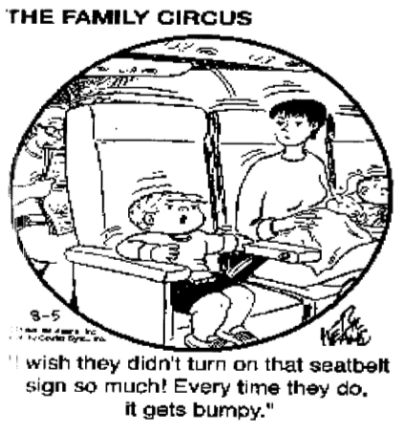
- An apparent, but false relationship between 2 or more variables that is caused by some other variable(s).
- Ex. A research study found that having a pet in childhood is correlated with a reduced likelihood of one becoming a juvenile delinquent.
  - Other explanations:
  - Socio-economic status associated with pet ownership could reduce likelihood of one becoming a juvenile delinquent
  - Pet ownership keeps the child busy
  - Pet ownership teaches the child responsibility/compassion

CRITERIA FOR EVALUATING THEORY
Making sense out of 2 or more opposing facts (ex. Labelling theory)
Sensitizing ability: Focus attention on new direction of inquiry (ex. Classical Criminology, then Marx – Marx has sensitizing ability – reconciles discrepancies, helps us make sense of things).
- Quantitative validation:
- Testability
- Reliability

- Qualitative validation:
- Logical soundness – proposes no illogical ideas
- Tautological reasoning – circular reasoning
- Validity – the quality of measuring precisely what one intends to measure (ex. The invalidity of Reimport)
- Time order problem – Ex. One assuming they won’t get arrested for smoking marijuana because they never have in the past – thinking one thing came before when it really came after.

KNOWLEDGE IS CONTEXT BOUND
- All knowledge must be understood in the context in which it arises:
- Political Context
- Socio-economic Context
- Intellectual Context
- Personal Context

Ch. 2: The Demonic Perspective

- 1693 – Salem, Massachusetts: Puritans
- Tituba = mysterious slave from Barbados working for a Reverend, whose daughter and niece were influenced by her – they became “possessed” by Tituba, an accused witch
- Other accused witches = Sarah Good (poor woman of ill repute) and Sarah Osbourne (wealthier woman with a scandalous reputation – she lived with a man whom she was not married to)

WHAT TO DO WITH THE WITCHES???
- Tituba, Sarah Good, and Sarah Osbourne were put on trial – but were they witches?
- Had they seen Satan?
- If they had not, how could they explain the girls’ behaviour?
- Tituba confessed, but Sarah Good and Sarah Osbourne claimed their innocence
- All 3 were convicted and executed by burning at the stake

SALEM WITCH TRIALS
- Exodus 22:18 Thou shalt not suffer a witch to live.
- Satanic presence blamed for still births, death of livestock, and the spoiling of cheese and milk crops

ASSUMPTIONS OF DEMONOLOGY
- Look for the cause and cure of deviant behaviour in the realm of the supernatural
- The Inquisition – Catholic Church’s tribunal court used to weed out and suppress heretics (anyone who goes against what the Church says/does)
  - 1615 – Roman Inquisition – House arrest for Galileo for presenting facts undermining Church credibility
- Heretics
- Deviance = SIN
- Deviance has cosmic consequences:
- Harmful to victims
- Harmful to God
- Harmful to the entire cosmos

TWO PATHS TO DEMONIC DEVIANCE
- Temptation – Adam & Eve
  - Serpent (representative of the Devil) tempted Eve with forbidden fruit, who then tempted Adam
  - If humans lack willpower, they will give in to temptation
  - People seen as having a choice (active role)
- Possession – The Devil has taken over the person’s body and mind causing evil behaviour: Person is seen as not having a choice (passive role) – Deterministic.

THE TRIALS
- The accused must testify (Refusal = proof of guilt)
- Accused not immediately informed of charges
- Anyone could testify against her/him (Accused was not told who his/her accusers were)
- No supporters (No legal assistance)

5 TYPES OF EVIDENCE TO CONVICT
- Trial by ‘Clever Test’ – The accused would have to recite the Lord’s Prayer in front of tribunal (any errors resulted in automatic guilt)
- Individual testimony – Someone’s misfortune was attributed to the accused
- Physical marks of the Devil – Any physical abnormalities – moles, scars, warts, birthmarks, deformities. The witch’s teat = an area insensitive to pain (accused would be probed with a stick in an attempt to find it)
- Spectral evidence – Dream/vision that someone is a witch (*The Devil could not take the shape of an innocent person)
- Confessions

CONFESSIONS
- Goal of bringing the accused back to the faith
  - Confession = a form of penance
- Confessions could result in forgiveness and/or saving of the soul
  - Sometimes, the life of the accused would be spared, other times not, but a confession was believed to gain the accused access to Heaven, rather than Hell
- Inquisitors better educated than their subjects and trained in questioning (much like the police today)
- Witch hunting = $$ Industry $$ - the more names, the more money and employment
- Use of torture
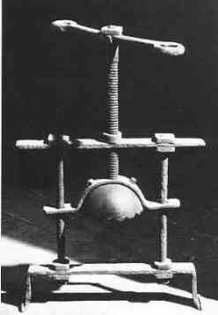
CONFESSIONAL DEVICES
N.B. NOT for punishment of the guilty, but to elicit confessions.
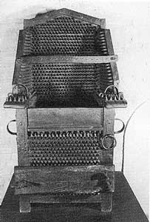
- ‘The Head-Crusher’ – Inquisitor would crank tighter and tighter with every undesirable response, resulting in shattered teeth, broken jaw, eyes literally popping out of sockets.

- ‘The Inquisitional Chair’ – A chair made of sharp spikes that the accused would be strapped into: the inquisitor asks questions and as inquisition progresses, chair can produce heat so it not only punctured skin, but burnt it also.

- The ‘Iron Spider’ and the ‘Cat’s Paw’ – Used to inflict pain all over one’s body.
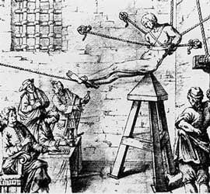
- Judas’ Cradle – A pointed, stool-like device – a person would be hoisted into the air, asked questions, and dropped lower and lower until they were falling down onto the spike.
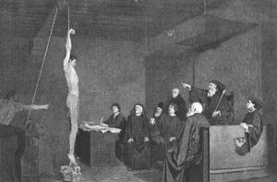
- Strappado – Individual hung from the ceiling by their wrists: shoulders could come out of their sockets (dislocation) as they were continually hoisted up and then dropped; as inquisition progressed, weights could be added to the ankles to intensify pain.
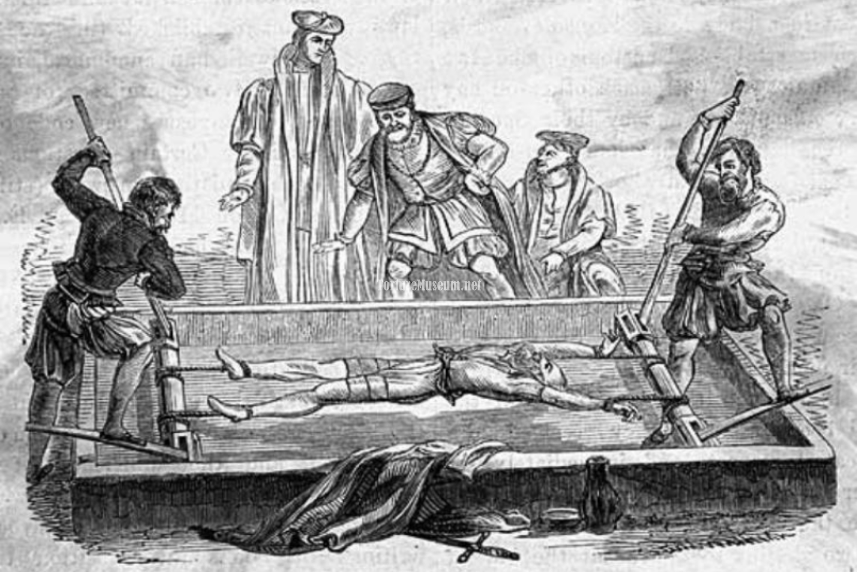
- The Rack – Arms and legs could be torn off as they were continually stretched in all directions (Other devices could be employed additionally)

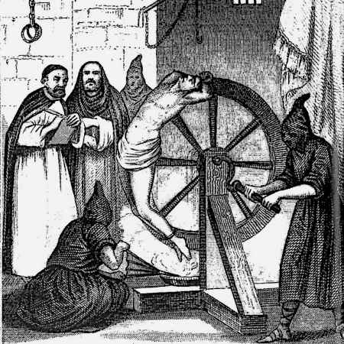
- ‘Breaking on the Wheel’ – The breaking wheel was a torture device used for capital punishment from Antiquity into early modern times for public execution by breaking the criminal's bones/bludgeoning her/him to death while strapped to a wheel. The purpose = Bones are believed to be the strongest and most durable part of one’s body: if the bones are broken, the person should be liberated of demons. *Symbolic punishment*: “If there is harm, then you shall pay life for life, eye for eye, tooth for tooth, hand for hand, foot for foot, burn for burn, wound for wound, stripe for stripe” (Exodus) – LEX TALIONIS

*All these devices elicited false confessions and giving up others just to stop the pain.
*Unfortunately, false confessions still occur today: in order to get a plea bargain, because of wrong eyewitness testimony, police intimidation during interrogation, etc.
*Actus reus and mens rea = the 2 components of a crime – these were provided with confessions: they justified the entire process.

SHAME AND PAIN
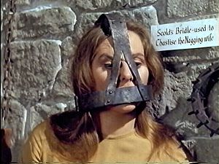
- Punishment was sometimes less physical torture and more shame-oriented (Commonly used on women, men = occasionally).
  - The ‘Hag’s Harness’ – for disrespectful speech, metal spike in mouth would pierce tongue if one spoke
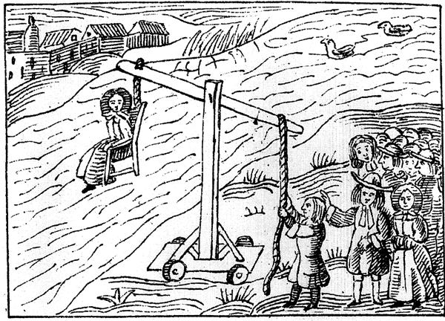
  - The ‘Ducking Stool’ – The offender was paraded through town strapped into a sturdy chair, which was fastened to a long wooden beam fixed as a seesaw on the edge of a pond or stream, where the offender was immersed repeatedly to ‘purify’ them (used for gossipers/those of impure reputation)

WITCHCRAFT IN CONTEXT
*Witch hunts took place during a time of massive social upheaval and rapid social change*
- Provides explanation – for misfortunes in society, i.e. still births, death of livestock & crops (reflects lack of knowledge of the time period)
- Maintains status quo – protect privileges, challenge authorities = charged with heresy
- Diverts attention – change focus to witches, the Church becomes indispensable (holds power and knowledge as to how to handle the witches (reinforced by confessions)
- Scapegoat – target powerless/threatening groups and discourage rebellious behaviour

RATIONALE FOR PUNISHMENT
- Rooted in Christianity (Biblical Law – Lex Talionis: retribution)
- Penance through physical pain (There was nothing considered sacred about the body during this time period) – Concerned about saving the ‘soul’ through confession
- Restore order of the world (Maintain balance) – Cosmic consequences
- Eliminate evil spirits through death – Symbolism of fire (burning in Hell), breaking bones (most durable part of the body for spirits to hide)
- Deterrence (General & specific) – Punishment took place in public areas
  - {deterrence}: to discourage criminal behaviour
  - {general deterrence}: Discourages general public: “If you do what this person did, here’s what will happen to you” – ex. Burning people in the marketplace for all to see
  - {specific deterrence}: has to do with the actual committer of the crime – shaming them, teaching them a lesson (ex. Ducking Stool) – the death penalty = the ultimate form of specific deterrence
- Affirm authority of the Church
- Social control – Rid society of “undesirables”/deviants

MODERN DAY “WITCH HUNTS”?!?
- A ‘witch hunt’ occurs any time a group of people persecutes another group unfairly, usually blaming that group for larger problems in society.
- Ex. Senator Joseph McCarthy’s “communist witch hunts”
- Ex. Drug use in Canada – early 1900’s – Chinese immigrant railroad workers in B.C. who worked for lower wages, outraging Canadian workers. In an attempt to stop this phenomenon, William Mackenzie King spearheaded a “moral crusade” to portray opium-smoking Chinese as undesirables – smoking opiates in dens was outlawed in 1908; other forms still allowed.
- Ex. Emily Murphy’s “Black Candle” portrayed cannabis negatively. Hemp was becoming a competitor in the paper industry, thus it needed to be eliminated.
  - 1936 movie: “Reefer Madness” – pro-criminalization of marijuana


SOCIALLY CONSTRUCTED PROBLEMS: THE MORAL PANIC
- What is a moral panic? – An intense feeling expressed in a population/society about any issue that appears to threaten the social order. Ex. Trump’s wall, terrorism (post-9/11 especially), abortion, homosexuality (up until 1969), crime, drugs (change in drug over time), etc.
- Moral entrepreneurs? – Necessary in creating moral panic, moral entrepreneurs are individuals/groups/organizations who start the panic – they instill their moral beliefs on society (ex. political figures, MEDIA, the Church). Opium example – moral entrepreneur = Mackenzie King. Moral panic = drunk driving, moral entrepreneurs = MADD.
- Folk devils? – Those individuals who are targeted by the moral panic – the deviants/wrongdoers (fictional or not).

DOCUMENTARY: “THE BURNING TIMES”
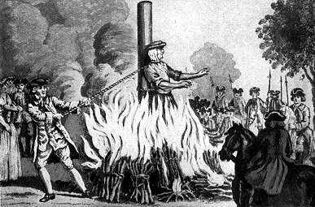
- What groups were particularly vulnerable to the witch hunts?
  - Women – widows, spinsters, beggars, vulnerable and elderly people, anyone who spoke against the Church (heretics), anyone who wanted change from the Church, midwives (no one did more harm to the Catholic Church – they eased the pains of giving birth – God’s punishment; made available birth control & they performed abortions), Pagans, women who held sacred knowledge, women gathering in groups (especially at night), non-conformists, people in rural areas, independent women who held property, etc.
- What factors made the witch hunts happen?
  - The Black Plague – we didn’t know why masses of people were dying so we blamed the witches on the word of male doctors that women were less susceptible
  - Business – monetarily profitable – the witch had to pay for her own trial
  - Suppression of women – control sexuality
  - Criminalize all non-Catholic religions
  - Means of conformity/social control
  - Publishing of the Malleus Maleficarum
- There is a cross that has been erected in France commemorating the lives lost as a result of the witch hunts.
- Christianisation of Europe = millions of lives lost.
- Church of Rome – Inquisition – those who questioned the word of the Church were executed for heresy
- Out of religious persecution came the witch hunts (up to 85% of victims were women) – sometimes called “The Women’s Holocaust”, they left no written records and shared a common grave.
- Witch craze = destruction of a way of life – men and women working side by side in rural communities, oral tradition
  - British dance on the hill to welcome Spring, the Pagan belief that the Earth was their Mother (all this was considered “witchcraft”)
- The arrival of Christianity meant adhering to the Christian beliefs and way of life – Christian Churches were built over sacred Pagan sites, goddesses replaced with saints
- Pagans venerated Mary as a goddess; they had a cathedral dedicated to her
- 2 kinds of religion: Elite (Catholicism) and Common (Pagan – belief in goddesses, nature, spirits)
- Joan of Arc was accused of heresy and witchcraft, then elevated to sainthood by the same Church who accused her
  - The Church became more and more rigid and defensive due to changes taking place in society, i.e. males taking over medicine.
  - Witches/wise-women/healers = counsellors who needed suppression.
  - Midwives eased the pains of labour, which were God’s punishment for sin. Midwives also provided birth control and performed abortions – thus acted against God’s will and needed to be punished.
- The witch hunts = a way of removing control women had of their own sexualities and bodies (housewife-ization).
- Peasant rebellion – charges of witchcraft (public punishments)
- Husbands were advised from pulpits to beat their wives, not out of rage, but in order to “save their souls”.
- Eve (women) introduced temptation and sexuality; women = obstacles to men’s holiness
- The Black Plague = God’s punishment for sin. When the sacraments did not ease the pain, village “wise-women” were sought out.
- Male numbers decreasing especially resulting in a disproportion of women to men (more single, independent women).
- Those who held onto their property were held under suspicion and envy, as well as the elderly ladies, widows, beggars, and spinsters (all targeted for witchcraft).
- Witch craze = answer for institutions (i.e. The Church) that felt threatened.
- Hag (used to mean “sacred knowledge”) now means “the Devil’s agent”.
- Females from children to the elderly were persecuted and killed.
- Groups of women gathered together were seen as conspiring against men, especially when gathered at night.
- Age of superstition, thus no one doubted witches’ existence – hard not to believe when people were confessing and being burned.
- *Renaissance & Reformation
- Scientific Revolution – used techniques of Inquisition to glean secrets of Mother Earth.
- Each witch trial was monetarily profitable – potential witch’s possessions/assets were seized and used to pay for her own capture, etc.
- One accusation by neighbour set the wheels in motion.
- Rural, small town phenomenon.
- Hair on head and pubic area were shaved and clothes removed so no demonic marks could be hidden – the accused witch also had to walk backwards so as to not give Inquisitor the ‘evil eye’.
- The ‘Iron Maiden’ simulated being burned alive.
- ‘The third degree’ = the third level of torture when the accused either confessed or died.
- The only letter that survived was written by Rebecca Lemp in 1590.
- 2 entire villages exterminated near Truyère, only 2 lived in another
- It took the Church 200 years to transform folk culture (i.e. secular carnivals led by men) and Paganism into the “Devil’s work” and “heresy”.
- Women = more susceptible to the Devil’s charms.
- Women “signing contract” with the Devil was completed by sexual union with the Devil, causing the woman pain/discomfort due to the Devil’s “icy member”.
- The most popular handbook as to how to deal with the witches = Malleus Maleficarum, published in the late 15th century.
- The Malleus Maleficarum was a pure study of repression and was highly sexual in nature.
- Women = primary source of witchcraft.
- No monuments have been made in their memory.

Ch. 3: The Age of the Monarchy

THE EARLY MIDDLE AGES
*Ultimate authority = King Harold
- England broken up into principalities (Princes held absolute power within their own borders).
- Communications were poor (law was localized) – literacy rates were low and no printing press meant no universal law was written down. Instead, laws were localized and decided upon by princes.
- William of Normandy won battle over King Harold – William of Normandy then ruled England, had men rule his land and make decisions, but ultimate allegiance was always to him.

THE RISE OF THE MONARCH
- Absolute Monarchy – The power to rule land freely, with no laws or legally organized direct opposition in force. Local autonomy taken away in exchange for peace and safety.
- Society based on feudalism (Lords & Serfs) – Conflict between Lords settled by battles between their serfs.
- Lord’s courts were developed, so no longer were battles between serfs (controlled by their lords) used to settle disputes.

THE EMERGENCE OF THE KING’S COURT
*King Henry II
- Redefined private wrongs as crimes against the State (ex. If someone stole from someone or assaulted someone, it was no longer seen as a crime against another individual, it was seen as a crime against the State).
- Streamlined procedures and made them fairer – Stare decisis – Deciding cases on the basis of situations of similar facts.
- Circuit judges – replaced informal methods of seeking justice based on local practices.
Aside: the Code of Hammurabi (circa 1792 to 1750 B.C.) = an eye for an eye.
- JUDGES, not Henry II, established Common Law.
- Why is this important?
  - Fair treatment and equal punishment for same crime.
  - Remove bias as the decision was that of the institution, not of the individual.
  - Trying to remove discrimination and bias from judicial decisions.
- Instances of King’s Courts were increasing, Lord’s Courts were decreasing.

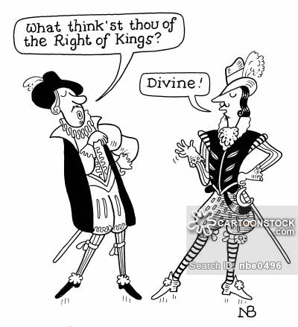
THE DIVINE RIGHT OF KINGS
- The King inherited his authority directly from God (Kings were ordained to rule by God).
- What did this mean for the commoner? If one had a problem with the King, one had a problem with God and the Church. Questioning the King or his behaviours would be like questioning God or the Church. Doing so could result in being charged with heresy and treason. It was also a means of social control (divine right was used to keep citizens “in line”).

Ancient forms of trial required the accused person to submit to a dangerous or painful test on the theory that God would intervene and disclose his or her guilt or innocence.

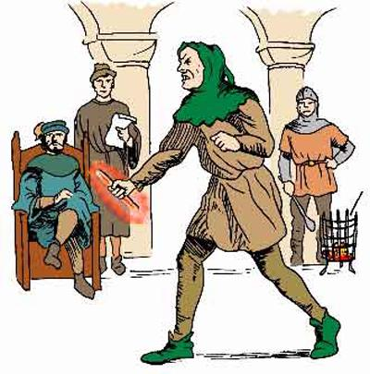
TRIALS BY ORDEAL (TORTURE)
- Trial by Heat/Hot Iron – suspect had to walk a certain distance holding a burning hot iron in his/her hand. The hand would then be bandaged and a few days later, if the wounds were healing, the person would be found innocent, but if they were infected, the person would be found guilty.
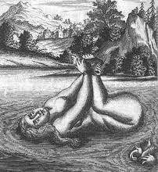
- Trial by Cold Water – suspect was bound in the fetal position and cast into a pond or river. If the suspect floated to the surface without any action of swimming, she was deemed guilty. If the suspect sank, she was pulled out and pronounced innocent.

TRIAL BY BATTLE
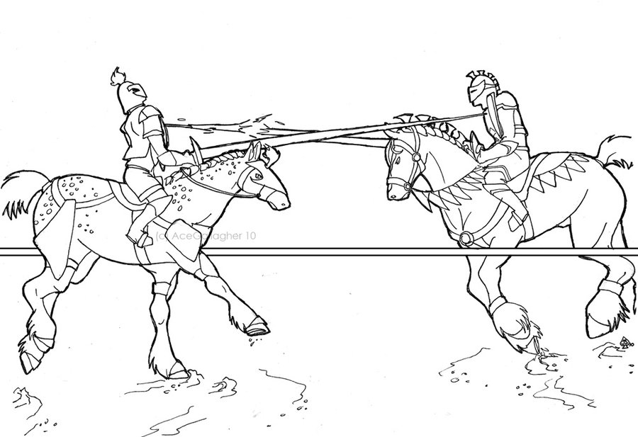
- Reserved for the wealthy (i.e. Nobles): often champions would be hired to fight battles for the involved persons, meaning battle was more just about who could afford the better fighter (similar to today: winning a case is sometimes only a matter of who can afford the better lawyer). The innocent would live, the guilty would die because God would not allow the innocent to die.
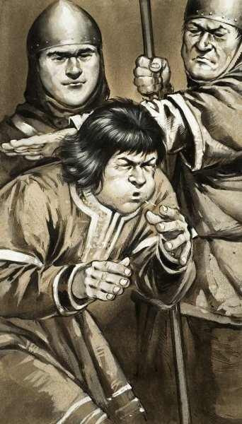
TRIAL BY CURSED MORSEL (for the clergy)
- In the ordeal of the cursed morsel, the suspect swallowed a piece of dry bread with a feather in it. If the suspect did not choke, he was found innocent. If he/she did choke, he/she was found guilty.

TRIAL BY WAGER OF LAW
- The accused was given the opportunity to find 12 members of the community who would be willing to attest to his/her character and swear, under oath, that the accused was innocent. If they failed to come up with 12 members (ex. They could only find 9), they would be found guilty.

THE KING’S COURTS
- Trial by wager of law was replaced with trial by jury:
    - Grand assize: Body if men summoned by the King to discover and charge all those who have potentially violated the law.
    - Petit assize: The Jury – a group of people tasked with judging the accused.
      - This was a problem because members of the Grand assize could also be members of the Petit assize, so the accuser and the juror (deciding accused’s fate) could sometimes be the same person.
- Three different types of King’s Courts:
  - Exchequer – Ministry of Finance
  - Court of Common Pleas – Matters that did not directly involve the King.
  - King’s Bench – All criminal cases were heard here, as well as appeals. It represented the highest court in the land where final decisions were made (like The Supreme Court of Canada).
- A jury could be put on trial if the judge/King did not like their verdict:
  - Crime of perjury
  - A jury of 12 would be judged before a jury of 24

THE KING’S JUSTICE: ROYAL CASES
- All crimes became considered crimes against the King’s peace (esp. treason) – Deviance and crime now reserved for King’s Court (including assault, robbery, murder that may not even have directly involved the King).
- Massive criminalization of previously non-criminal acts (ex. Taking underwood, taking fish from ponds, damaging orchids, harming animals, cutting down trees, etc). WHY??? The more crimes that were committed, the more money there was to be made. Also protected the property of the upper class.
- What is the Bloody Code? The number of crimes punishable by death increased dramatically (from 50-225) ex. Taking horses/sheep, pickpocketing, etc.
- Why so bloody?
  - Because the wealthy/royal were unsympathetic to criminals – they thought of criminals as sinful, greedy, and lazy. They were, therefore, merciless towards them.
  - Because the rich were trying to control the poor.
  - So many crimes resulting in the death penalty was a means of deterrence (general & specific).

THE KING’S JUSTICE: A DEMONSTRATION OF POWER
- Public execution = spectacle & impress, a form of entertainment that typically took place mid-day in the marketplace and watched by large crowds.
- The power of the King’s mercy was demonstrated in his ability to take or grant life. He also had the power to lessen one’s pain (ex. By commanding their torture be stopped). *The accused individual had to plead his/her allegiance/mercy to the King.
- Protect emerging economic/social/political systems.

THE USE OF TORTURE
*The State needed to protect the community from further wrath from angry God.
Objective of torture = to elicit a confession because it legitimized everything
- Justification of torture:
  - Suspected of crime
    - Only half-proof (tiniest bit of incriminating evidence) required for guilty sentence
  - Inquisition
    - Questions asked under oath while enduring physical pain
  - Torture – 2 stages
    - Preparatory (get confession)
    - Preliminary (give up other criminals/accomplices)
- England:
  - A person accused of committing a crime could avoid torture by consenting to trial by jury.
  - If one refused a trial by jury – they would be subjected to “pressing”.
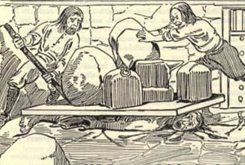
    - Peine forte et dure (French for "forceful and hard punishment") was a method of torture formerly used in the common law legal system, in which a defendant who refused to plead ("stood mute") would be subjected to having heavier and heavier stones placed upon his or her chest until a plea was entered, or as the weight of the stones on the chest became too great for the condemned to breathe, fatal suffocation would occur. Some survived only hours, some survived up to DAYS
- Why would anyone refuse trial by jury???
  - If accused died without being convicted, the State could not legally confiscate property from the deceased’s family.

MEANS OF CAPITAL PUNISHMENT
- Beheading – Nobles (swift death)
- Hanging – Commoners (for commoners, whatever the method, execution was slow)

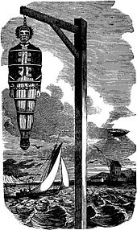
GIBBETING
- An upright post with an arm on which the bodies of executed criminals were left hanging in public areas as a warning or deterrent to others, demonstrating the King’s power.

CORPORAL PUNISHMENT
- Stocks & Pillory
  - Stocks: Sitting
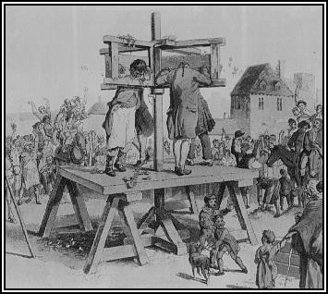
  - Pillory: Standing
  - Both took place in the middle of the day, typically in the marketplace
- Audience participation was key – they could hurl verbal insults, rocks, plants, excrement, dead animals, vegetables, etc.
- For serious crimes, offender’s ears were nailed to the board so as they tried to avoid the objects being hurled at them, their ears could be ripped off.

- Flogging was used mostly for petty theft and prostitution.
- Branding was symbolic – it combined the elements of physical pain and public shame (T for treason, scarlet letter for adulteress).
- Banishment/Exile – if a person was found guilty of a crime, s/he could be outcast by society, and all property seized, forcing person to live in complete isolation.
- Transportation – The convicted were obligated to go to the British colonies and serve a period of indentured servitude as a slave (usually about 7 years). They then could become settlers. Problem: The colonies then declared their independence and stopped accepting slaves, leaving nowhere for these criminals sentenced to transportation to go. Solution: Hulks (floating prisons where convicts worked on land and slept on boats that were unhygienic and ridden with disease and corporal punishment).

THE AGE OF THE MONARCHY & IMPLICATIONS FOR JUSTICE
- Changes in the administration of justice
- Explanation of deviance
- Definitions of deviance
- Response to deviance


‘BRAVEHEART’
What characteristics of the King’s justice/King’s court/age of the monarchy are illustrated in this video?
- William Wallace beaten by guards – destined to be hung
- William Wallace accused of high treason against the King – he never in his whole life swore allegiance to him
- King’s Court: “Confess and you will receive a quick death, deny and you will be purified by pain” (torture)
- Princess begs him to swear his allegiance to the King in order to avoid torture and receive a quick death & tries to give him something to numb the pain he will feel
- Wallace: “If I swear my allegiance to Him, everything I am will already have died”
- She begs the dying King to have mercy and spare the life of William Wallace, which she believes will earn him the respect of his people
- She says he is incapable of mercy
- Public execution – the “pre-show” spectacle with dwarves mock-fighting
- Wallace wheeled in by horses, hands tied to a board while citizens throw things (heads of cabbage?) at him – shame
- He is untied and instructed to fall to his knees, declare himself King’s loyal subject, beg his mercy and he would receive it
- Wallace is hoisted up into the air with a noose around his neck then dropped, gasping for air
- Again he is instructed to fall to his knees, declare himself King’s loyal subject, beg his mercy and he would receive it
- He gets to his feet, again refusing to do so
- Then his arms are pulled one way by ropes, his legs tied to horses which pull them in the opposite direction
- He is untied and let go once more, strapped to a table shaped like a cross, his shirt is ripped open and he is gutted
- The Cardinal (?) instructs him to beg for mercy, but still he does not: instead, he cries “FREEDOM!”, so he is decapitated
- The film makes note of how Wallace’s body parts and head were put up for public display and sent to “the four corners of England”. This is historically accurate.
- His entire punishment was called “Hanged, drawn and quartered”

Ch. 4: Classical Criminology


ECNOMIC/SOCIAL CONTEXT: LIFE DURING THE 18TH CENTURY
- Shift from feudalism to early forms of capitalism
  - Feudalism = Age of Monarchy – Lords/Barons had power/land & serfs/slaves who owed everything to them: an economic system based on repression.
  - Moving away from an absolute monarchy.
  - Emergence of modern nation states – capitalists (bourgeoisie) now have power and control in society, not Kings.
  - Society becoming much more democratic.
- Protestant Reformation
  - Took place before the 18th century
  - This is when Martin Luther came forth and presented the idea that Man is capable of interpreting the Bible without the Pope
  - Economic & political power of the Catholic Church begins to weaken
- Population growth
  - There is a great deal of urbanization
  - Population dramatically increasing in Europe
  - Shape/distribution of population becoming much more dense & diversified (heterogeneous)
- Need new forms of social control
  - Social control used previously was no longer as effective. WHY???
    - Moving away from the Church
    - Less social bonds that were present in small communities
    - “I don’t care as much about what happens to someone I don’t know as I would if he were my neighbour” attitudes
    - Public shaming also not going to be as effective for this reason (in a massive population, very few people know one another)

INTELLECTUAL CONTEXT: THE ENLIGHTENMENT (THE AGE OF REASON) (1650-1800)
- Focus on philosophers and philosophy
  - Voltaire, John Locke, Thomas Hobbes, etc.
- Start producing different views of the world, that move away from supernatural explanations
- Applied reason, humanitarianism; much more secular
- Reason is idealized – This challenged the medieval beliefs that God directly controlled all human behaviour – they no longer believed that the Church’s word should be accepted without questioning
- People start to adopt these more secular views & believe that through reason, the good life will be possible
- Doctrine of free will – people possess free will, have the ability to make choices as to what they will and won’t do; their fate is not decided by some higher being
- Rationality – people can rationally weigh the pros and cons of different actions & attempt to calculate the most beneficial outcome
  - If risks outweigh rewards, crime will not be committed
  - If rewards outweigh risks, crime will be committed
- Natural Rights Exist – this is a time when everyone in society is seen as having natural rights, not just the upper class, and the State has the role to ensure that people’s rights are upheld and that individuals pursuing their own happiness are not affecting other people’s happiness – start to see the emergence of a Democratic State
- Humans are hedonistic – they will weigh the potential pleasure of an action against the possible pain associated with it; people are egoistic – this went for any type of behaviour, including committing an illegal act

  - Offenders make choices about committing crimes based on the anticipated rewards (A classical criminologist would definitely agree with this statement)
  - Possible rewards of crime:
    - Not having to pay for something
    - Revenge
    - Some sort of power/prestige/popularity
    - Money
    - Adrenaline/stimulation/excitement
    - Drugs
  - Individuals will decide NOT to commit crimes when the risks are too high or the rewards are not adequate (A classical criminologist would definitely agree with this statement as well)
  - Possible risks of crime:
    - Getting caught
    - Time in prison
    - Losing freedom
    - Losing money in fines
    - Loss in influence/status
    - Guilt
    - Death
    - Loss of contact with loved ones
    - Negative attention – labelled, criminal record, hard to get a job
    - If religious – going to Hell

WHAT IS THE SOCIAL CONTRACT???

- An unwritten agreement shared by everyone in a society in which people give up some freedom in exchange for security.
- “A legalistic contract between freely consenting human individuals.”
- The government is necessary in order to fulfill this contract.
- Society should work for the individual, rather than the individual working for the Church, King, or Society.
- People living together with some laws produces a much happier, harmonious life than living in anarchy/chaos.
  - Ex. We will follow speed limits though we may not always want to because they benefit everyone.
- What is a crime?
- Anything that breaches/breaks/violates the social contract.
- So, the State has the authority to punish anyone who does the above.
- The greater the harm, the more punishment there will be.
- Society has agreed that the State is authorized to punish.
- Punishment = demonstrable social harm.

ACCORDING TO CLASSICAL THEORISTS…
- What should be the punishment for homosexuality?
- Since there is no demonstrable social harm (i.e. no victim), there should be no punishment for homosexuality.
- The seriousness of crime is measured by the harm done to society.
- If there are no demonstrable victims, there should be no punishment.
- According to the Demonic perspective?
  - There was absolutely no difference between immorality, deviance, crime, and sin (they were all interconnected). Therefore, homosexuality would have been punished severely.

WHAT WAS THE ‘JUSTICE SYSTEM’ LIKE DURING THE MIDDLE AGES???
- Torturous
- Forced
- Focus on shaming & public humiliation
- Unjust – inhumane, barbaric, people had no voice, no legal representation
- Bias, prejudice, discrimination
- What mattered was who you were rather than what you did
- The punishment did not usually fit the crime (i.e. petty crimes were punishable by death) – Severity
- Half-proofs could lead to a determination of guilt

CRITIQUE OF CRIMINAL JUSTICE DURING THE 18TH CENTURY
- Capital Punishment
- Capital = losing one’s life, Corporal = punishments on the body (i.e. branding, burning)
  - Negative Effect
  - Judges reluctant to convict
  - Limitations of effectiveness
- Transportation
  - What to do with all the prisoners???
  - Prisoners would be sent to the colonies to serve periods of indentured servitude (usually about 7 years), but colonies declared independence in 1776 and refused to take convicts thereafter
  - Convicts were then transported to Australia, but Australia then objected strongly to being a “dumping grounds” for Britain’s criminals
  - Short-term solution turned long = Hulks
- Jails
  - Industry – private enterprises run for profit ($$$)
  - Breeding grounds – Moral: housing all individuals together led to corruption & Physical: germs and disease were rapidly spreading
  - If unable to pay jailor for services, convict had to remain in jail
  - No system of classification of offenders, everybody was housed together; young & old, man & woman, convicted of major offences & convicted of minor offences, mentally ill & sane
  - Much reform was needed (Beccaria)
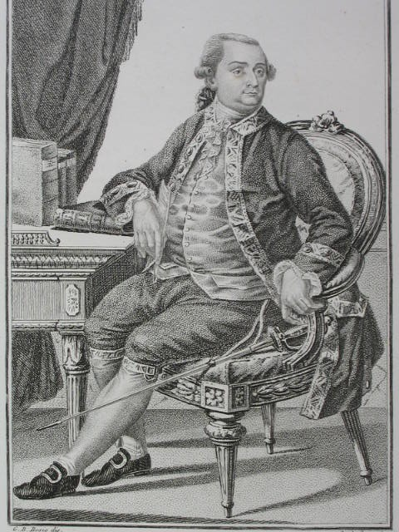
CESARE BECCARIA (1738-1794)
- Founded the Academy of Fists with some of his friends – one of whom worked in a jail, thus gaining Beccaria access inside to witness the horrible conditions
- Essay on Crimes and Punishments 1764
  - Published anonymously for fear of persecution
  - Having unwritten laws, secret trials, horrible prison conditions, etc. was cruel and inhumane
  - Believed that people are generally good and need to be discouraged from committing crime
    - Crimes = irrational/ineffective laws
    - Reforms needed = Rational system for controlling crime

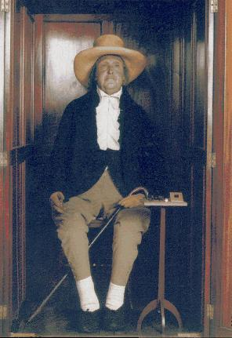
JEREMY BENTHAM (1748-1832)
- Utilitarianism – the premise of the greatest good for the greatest number of people (laws should serve this function) – social contract: underlying concept
- Bond between individuals and society, when broken = punishment
- Hedonistic Calculus
  - Intensity – how intense is the pleasure?
  - Duration – is the pleasure going to be short-term or longer lasting?
  - Certainty – is it a guarantee that this pleasure is going to be achieved?
  - Immediacy – how immediate is the pleasure?
- Punishment must be rationally calculated
  - For a punishment to be rational, it must be just slightly more severe than the harm done by the act
  - Ex. If a robbery = 6 units of pleasure, punishment should be 7 units of pain
  - If punishment is too harsh/severe, it is simply going to encourage more crime
- Goal of punishment = Deterrence
  - Specific – Discourages/prevents a specific person from committing crime (ultimate example: capital punishment), fines/tickets
  - General – Witnessing others receive punishment deters general population from committing crime


DOES PUNISHMENT DETER???
FOR PUNISHMENT TO BE EFFECTIVE, IT MUST BE…
- Certain
- Swift – Otherwise, individual will not make the connection between wrongdoing & punishment
- Proportionate – Punishment too severe = people can commit even more severe crimes if punishment is the same for less severe crimes, BUT too lenient = does not deter enough
Q: Which aspect is the most important???
A: Certainty.


THREE STRIKES AND YOU’RE OUT???
- Classical criminology in practice
- ‘3 Strikes’ U.S. Legislation
- Based on baseball analogy of 3 strikes, and you’re out
- California = the most stringent/strict with this policy
- Commit 1 felony, you will be punished accordingly; commit a 2nd felony, you will be punished accordingly, but commit the 3rd felony and you certainly get life imprisonment (eligible for parole only after 20 years!!!)
- Problem: Even if you committed 2 more serious offences first, and the 3rd was less serious (etc. petty theft) and showed signs of criminal trying to better him/herself, 3rd offence = life in prison
- Is this proportionate? Excluding California, some people argue that yes, it is, because the first two offences are punished accordingly and if criminal hasn’t learned his/her lesson by felony #3, they deserve life in prison.

REFORMS FOR LAWS
- Beccaria wrote Essay on Crimes and Punishments in 1764
- Laws must be written, widely available, and understandable
- Laws must equally apply to all
  - “No one should be held above the law” such as aristocracy, the Church elites, Monarchs were in the past

REFORMS FOR PUNISHMENT
- Judges determine guilt only
  - Judge = Unbiased mediator who listens to the facts presented and ultimately decides guilt or innocence
  - All punishments already set out. If person committed ‘X’ crime, ‘X’ punishment would follow
- Punishment determined by legislator
- Focus on the actus reus – The judge is only concerned with the crime that has taken place and disregards the circumstances.

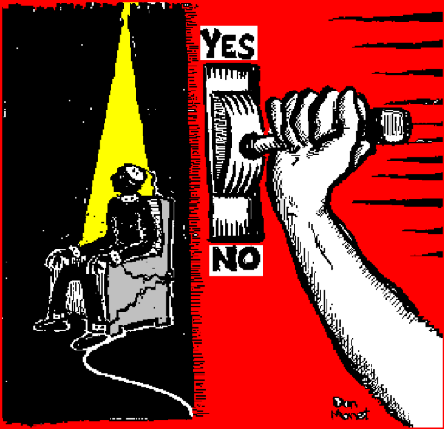
CAPITAL PUNISHMENT
- Canada-wide, capital punishment was abolished in 1976.
- Arguments FOR Capital Punishment:
- Ultimate specific deterrence
- If a heinous murder has taken place for example, the idea of retribution – an eye for an eye, lex talionis
- Eliminates risk of dangerous criminals re-entering society through escaping from jail or being released
- Cost-effective (jailing is expensive)
- Peace of mind to victim’s family
- If we don’t hold true to the idea of rehabilitation, capital punishment makes sense
- Arguments AGAINST Capital Punishment:
- Wrongful convictions could kill innocent people
- Perhaps death is giving the criminal what they want (especially mentally ill criminals) – not really a form of retribution if criminal would rather die than rot in jail – most of us would
- Family of victim might prefer to picture offender rotting in jail than them being dead, no longer needing to repent for the harm they caused
- Too extreme of a measure, who is the play the “role of God” in deciding when someone should die?
- What lesson is being taught? We say killing is wrong, so as a result of you killing someone, we are going to kill you?
- There are “fates worse than death” (i.e. solitary confinement)
- As a matter of fact, housing criminals on Death Row is actually much more expensive than regular incarceration
- Creates new set of victims – the offender’s loved ones affected if we kill them

THE DEATH PENALTY
- Q: Classical criminologists for or against?
- A: Against.
  - Contrary to social contract (we give up some rights, but we do not give up the right to life)
  - Barbaric (what kind of message are you sending if you are engaging in the exact same behaviour as the offender?)
  - Not proportionate
  - No general deterrence (they felt the death penalty was much too quick to leave a lasting impression on people, that’s why they favoured long, continuous punishment, i.e. incarceration)
  - Society needed disciplined workers (don’t kill these able-bodied people, incarcerate them & allow them to be disciplined workers in industrialized society upon release)

CHANGES IN THE ADMINISTRATION OF JUSTICE
- Abolish torture (no more punishment before guilt was even determined)
- Right to speedy, (swift) public (no secrecy) trial & the right of the accused to present evidence, trial by jury
- Improve prison conditions (Beccaria = reformer, appalled by prison conditions, but did not advocate their abolishment, they just needed to be reformed i.e. no more charging prisoners for their own stay in jail, improved sanitation conditions, etc.)
- Classifications of offenders needed to be established

SOMETHING TO THINK ABOUT…
Are there any Classical ideas and/or premises that are present in the Canadian Criminal Justice System today?
- Classifications of Criminals:
  - Provincial vs. Federal
  - Youth/Minor (12-17) vs. Adult
  - Violent offenders vs. Property offenders
  - Male vs. Female
  - Minimum-risk (minimum security), medium-risk, high-risk (maximum security)
- The right to a swift trial
  - Summary (18 months) vs. Indictable Offense (30 months)
- We hold certain conditions for our prisons (ex. Shutting down of Kingston Penitentiary for poor conditions)
- Proportionate system (Fines, community service, probation, or house arrest for less serious crimes)
- The right to legal aid
- As Canadians, we have the Charter (sections 7-14 are our legal rights, each of which can be considered reflective of Classical Criminology)
- Mandatory minimum sentencing (ex. Someone found guilty of first-degree murder = life in prison, eligible for parole after 25 years, impaired driving after a certain number of convictions, associated with firearms, associated with prostitution)
What flaws might there be within the Classical perspective?
In other words, what critiques would be directed towards the Classical school of Criminology?
- Sole focus on actus reus (judge did not care about your circumstances, motive, or intent)
- How they viewed the criminal as a person who behaves rationally – we don’t always behave rationally when intoxicated, mentally ill, etc.
- Limitations to deterrence (discussed earlier)
- Focus on how the criminal weighs pros and cons before committing a crime; in reality, many criminals are much more impulsive
- Assuming that people know all the punishments attached to certain offences
- Focus on harm – i.e. environmental crimes would not even exist
- No one engages in behaviour thinking they are going to get caught
- Punishments do not affect everyone the same way (i.e. a fine is much harder to pay for someone who is poor, jail time would be more difficult for people with many social ties, a family, who were previously a contributing member of society)

NEOCLASSICAL THEORY
- Certain factors might inhibit the exercise of free will:
  - Legal defences (people are not always operating under free will) – Not Criminally Responsible on Account of Mental Disorder (NCR), Duress, Self-Defence, Mistake of Intent
  - Mitigating factors (when present, will lead to a more lenient sentence) – showing remorse, no prior record, good character, good social standing
  - Aggravating factors (when present, will lead to a more severe sentence) – hate crimes, use of weapon, repeat offender, vulnerability of victim, abuse of authority

