BIOL*3130 Midterm 1 Review

Conservation biology is the scientific study of the nature and status of earths biological diversity with the aim of protecting species, habitats, and ecosystems from excessive extinction rates that are linked to the modern human enterprise

Guiding principles
1. Evolution is the basic axiom that unites all of biology (the evolutionary play)
2. The ecological world is dynamic and largely non-equilibrium (the ecological theatre)
3. The human presence must be included in conservation planning (humans are part of the play)

The idea of “biodiversity” was popularized in 1988
- The term can be used in a variety of ways, makes managing more difficult
- Definition crisis:
  - 1. More extinctions occur unknowingly
  - 2. Most “conservation management” occurs unknowingly
    - 88% are “unprotected protection”
  - 3. Most species have not been formally classified
  - 4. The range and abundances of most classified species are poorly understood

Rarity enigma:
- A species is rare, therefore more likely to go extinct
  - rare species often concentrated to one area, more likely to go extinct
- Can be good to be rare however
  - Closely related species compete more, therefore rare unrelated species don’t compete as much for resources

Defining biodiversity
- Richness: number of species per unit area
- Abundance: a population level measure
  - Population size per unit area
- Evenness: a community level measure
  - Relative abundance of species on a 0 – 1 ranking
- Diversity: the proportional abundance of species

Levels of biodiversity
- Genetic biodiversity
- Population level biodiversity
  - Group of individuals of a species living in an area at the same time. Variability drives speciation
- Species level biodiversity
  - Phylogenies: hypothetical descent-histories of a group of species from some common ancestor
- Cultural diversity
  - Culture: unique solutions and perspectives on the challenges of making a living and coexisting
Composition: the genes, species, and habitats found at a time and place
- Similar to richness
Structure: the vertical and horizontal arrangement of physical space (snags, riffles, litter layers, canopy height, etc)
- Human activity homogenizes structure
Function: the processes that affect and are affected by biodiversity (biochemical cycling, invasion, natural selection)
- Ecosystem services

Protection requires
- Understanding what diversity is
- How it is created
  - speciation
- How it is maintained
  - Coexistence mechanisms
- How it is lost
  - Extinction

Inventory challenges
- Redundancy
- Gaps
  - White holes: areas without adequate survey information (difficult to access the area eg swamp) or not containing many species
    - Opposite of diversity hotspot
- Over-emphasis on species protection is costly in time and effort
  - Alternatives
    - Higher-order taxonomic targets
      - Target area of landscape with lots of families (group higher up the phylogenetic tree)
    - Community and ecosystem classification
      - Preserving functional diversity
      - Assumes that this method captures multiple species and the processes that maintain them

Extinction
- 5 major extinctions in the past, currently facing 6th great extinction (caused by human activities)
  - Occurring much faster than in the past
- Diversity is the balance between speciation and extinction
  - Extinctions followed by increased speciation
- Not all species ae similarly vulnerable to the effects of global environmental change
  - Determining vulnerability starts with
    - Understanding how species was created
    - Understand how diversity is created
    - Understand how diversity is maintained

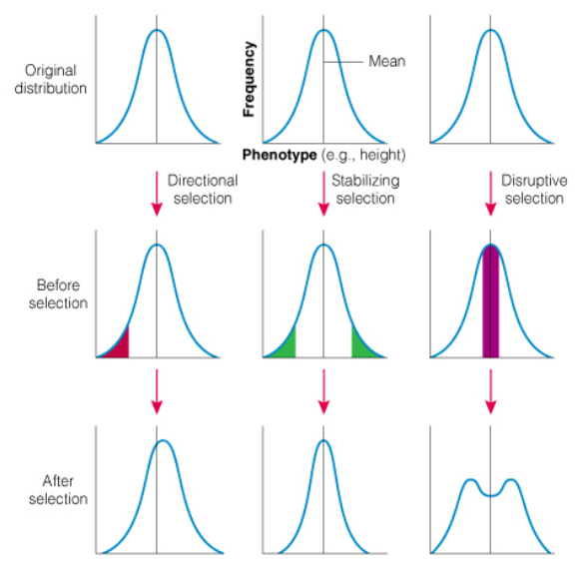
Types of selection
- Directional: selection against phenotype at one extreme
  - Eg. Moths during industrial revolution
- Stabilizing: mean is fitter than extremes
- Disruptive: extremes fitter than mean
  - Eg. Golden-winged warblers and blue-winged warbler, extremes favoured by hybrids are poor competitors against both GWW in edge areas and BWW in forest areas

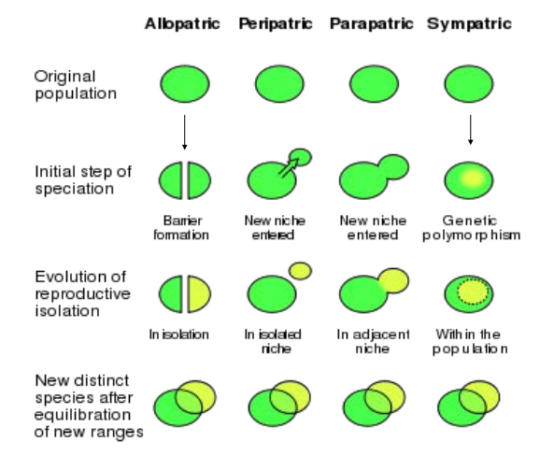
Speciation
Allopatric speciation: population splits into geographically isolated populations as a result of a physical barrier

Peripatric speciation: small subpopulation is isolated
- Founder effect: is the loss of genetic variation that occurs when a new population is established by a very small number of individuals from a larger population
- Population bottleneck: a sharp reduction in the size of a population due to environmental events or human activities. Such events can reduce the variation in the gene pool of a population
- Genetic drift (allelic drift): the change in the frequency of a gene variant (allele) in a population due to random sampling

Parapatric speciation: partial separation of the zones of two diverging populations
- Individuals come back together but reduced offspring fitness leads to selection of mechanisms that prevent inter-breeding
- Eg. Plants growing beside each other, one in contaminated soil and one in uncontaminated soils. Cant interbreed as a result of the speciation

Sympatric speciation: speciation occurs without geographic barriers, species speciation to fill different niches and decrease competition, creating fitness differences
- Rapid speciation because sexual selection leads to reproductive isolation
- Eg. Darwins finches

Types of isolation
- Darwinian islands
  - Created by volcano, never in contact with mainland
  - Species numbers initially increased through immigration, rate depending on degree of isolation
  - Species formation will result in “neo-endemics”
    - When isolation is extreme, ecological space will be filled through speciation and adaptive radiation of neo-endemics
- Fragment islands
  - Continuous land that is broken up into islands, populations are separated
    - Ecological space filled by connection to mainland prior to separating
  - Species numbers decrease following fragmentations through relaxation process
  - If islands become more isolated, species will eventually arise through allopatric speciation (gene flow reduces as isolation increases, causing speciation)
    - Leads to formation of “paleo-endemics”

Endemism: the result of speciation, where a species is found in one area and nowhere else
- Often found where the climate has remained stable
- biodiversity hotspots: areas with a high concentration of endemic species , experiencing rapid habitat loss
  - 1.4 % of land area are hotspots, contained 44% of vascular plant species and 35% of terrestrial vertebrates
  - Hotspots human population is also growing, already has resulted in a loss of 70% of vegetation
- λ = birth rate
  - 1 = equal births and deaths
  - >1 means more births (pop increases)
  - <1 means less births (pop decreases)
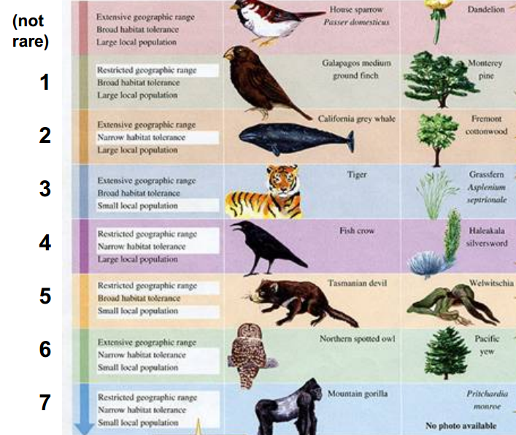
7 levels of rarity

Biological homogenization
- The homogenization of habitat conditions and species around the globe, as a result of human activity
- Lost and gained specialization
  - Eutrophication: nitrogen pollution
- Reverse speciation
  - Decrease in heterogeneity
  - Ecological speciation is reversible through increasing gene flow, weakening ecological selection or both
  - Eg. Sickleback pops became speciated due to isolation, can reverse speciate over time when habitats are reconnected
  - Eg. Bloaters and herring were 2 separate species, habitat heterogeneity removed, reverse speciation occurs
  - Eg. Cichlids, murky waters limited visibility so sexual selection decreased because colours couldn’t be seen

Area and speciation
- Probability of speciation occurring within a region…
  - Increases with the size of the region because of greater opportunity for divergence
    - Larger population sizes -> more genetic variability -> higher probability of speciation
  - Increases as the strength of gene flow decreases, for eg. among organisms with shorter dispersal distances (because gene flow is the main process opposing population differentiation)
- The rate of speciation is assumed to be connected with area
- Almost every species is limited by dispersal
- Dispersal and habitat fragmentation
  - With fragmentation, populations become isolated
    - Creates “islands” in the landscape
    - Greater chance of speciation over large areas, more fragmentation likely
      - Large space, more opportunities to escape gene flow
      - Metapopulations can be formed as a result
  - Fragmentation favours species that can travel large distances
    - Higher fitness to stay at home
      - Natural selection for reduced dispersal may lead to completely isolated populations
- Larger areas are more difficult to contain entirely in the are covered by climatic change or perturbation
  - More likely that only a small portion will be effected by the change, species range will expand past the areas effected by change and will be more likely to survive the event
- Centrifugal speciation: large populations speed up speciation, may have lower extinction and higher speciation rates
- Implications:
  - Human activity reduces habitat area, a loss of x% of area will result in x% of species lost
  - Deterministic extinctions: the loss of all areas in which a species can sustain its demographics
  - Stochastic extinctions: reflecting accidents brought on by global warming, new diseases, and commingling the species of the separate bioprovinces
  - Lottery extinctions: “by sheer chance, habitat loss is going to cause species extinction”

Latitudinal gradient
- States that as you go to higher latitudes, biodiversity decreased
  - Highest diversity found at low latitudes (near the equator)
- Strong gradient is visible just in north American when examining tree species
  - Not many trees can survive very cold temperatures (northern Canada)
- Found that in general, the further north you go, a decrease in biodiversity for all types of organisms and ecosystems is visible
- Some exceptions
  - Parasites
  - Secondary species
    - Species that originally lived in one type of habitat (eg. Land) but have evolved to live in a different type of environment (eg. Ocean)
  - Aquatic plants

Maintenance of diversity: the factors that determine the relative balance of species arrivals and species extinctions
- Factors that influence diversity loss:
  - Large scale
    - History (unprecedented rates of change)
    - Habitat heterogeneity (habitat loss, fragmentation)
    - Climatic and energenics (climate change)
    - Productivity (eutrophication)
    - Disturbance (too much, too little)
  - Small scale
    - Competition (invasive)
    - Predation (added or subtracted predators)

History hypothesis
- More time permits more complete colonization and more evolution of new species
- Eg. Tropics never suffered damage due to receding glaciers, glaciers melting ice caps change global climate patterns
  - A lot of tropical areas become dry due to changing patterns
- Problem with this because no region of the planet was free from glaciation effects

Disturbance hypothesis
- Less disturbed areas are more highly speciated
- Disturbances kill biological life, thereby reducing rates of speciation
  - Tropics thought to be less disturbed than temperate systems
- This is somewhat wrong because disturbances can also be good for diversity
- Intermediate disturbance hypothesis
  - No disturbance – too much competition/predators
  - Too much disturbance – extinction increases
  - Intermediate disturbance – best for speciation
- So, tropics experienced more disturbance than we thought

Habitat heterogeneity hypothesis
- Tropical regions tend to have more environmental complexity per unit area
- Heterogeneity can restrict “escape”, relates to importance of area
- Eg. Bison grew to massive population because they had a great distance to migrate for resources, then the ice age decreased the resource availability and population decreased dramatically
  - Habitat size decreased and became more homogeneous

Available energy hypothesis
- Available energy from the sun correlates with speciation
- Greater sunlight = longer growing seasons = greater seasonal stability = greater annual NPP
- The tropics receive more direct solar radiation than any other location on the planet
- More radiation, higher GPP, results in higher NPP
- Increasing CO₂in atmosphere, GPP will increase and photosynthesis will be more effective
- Can be difficult to measure GPP and R_{a} so we use biomass as a measure of NPP
  - Amount of carbon left in plant after respiration that can be turned to biomass
- More energy in food chain, more individuals can be supported
  - More individuals, lower extinction rate
  - More resources may lower competition
- Resource availability can favour specialization and speciation
- Does not apply to tropical corals
  - Relatively equal energy supplies yet speciation varies
  - Energy-rich areas have more species, depend on gradients of warm and cool water
    - Warmer areas mean higher rates of metabolism and greater rates of molecular evolution
- Problem
  - More resources means ‘more to go around’, but also greater likelihood of intense competition
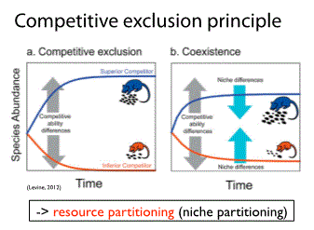
  - “competitive exclusion principle”
    - inferior competitor will eventually be driven to extinction
    - Coexistence: competing species have something that makes them different and able to live together
    - Different food source, habitat specialization, etc
  - Most productive ecosystems in the world (estuaries, hot springs, etc) have very high NPP but low diversity

Competition hypothesis
- Greater resources in the tropics and greater ‘relative’ stability over time intensifies species interactions, drives character displacement
- Dominant species will consume the majority of resources and the other species will be forced to run away, die or adjust
- How competition explains higher tropical diversity
  - 1. Tropic species are limited more by biological factors than by physical factors
  - 2. Tropical species are affected more by interspecific interactions than by intraspecific interactions
    - Point back to competitive exclusion principle
  - 3. Niches of tropical species overlap more than those of higher-latitude species and so tropical species compete more intensely
    - Plants competing in a small area for the same resources, plants cant more to access more resources
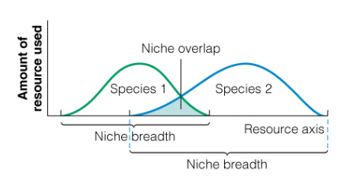
  - 4. Tropical species are more specialized, have narrower niches and so compete less intensively than species at higher latitudes
    - 3 and 4 do not occur at the same time, 4 comes after 3
- Niche breadth (range): the wider the niche breadth, the fewer the species (more generalists than specialists, fewer species because generalists compete more for resources)
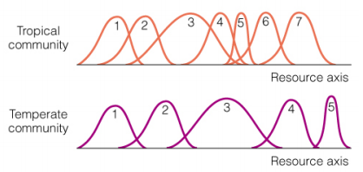
- Niche overlap: the narrower the niche overlap, the fewer the species (the inability to coexist spatially)
  - Less overlap means less competition for resources, however large distance between them suggests that competition is stronger
- More tropical diversity because of the narrower breadths and greater overlaps

Predation hypothesis
- Tropical species are more subject to controls by predation, parasites and pathogens
- Evolved traits of attack, tolerance and avoidance
  - Animals have become specialized in order to avoid predation attacks
    - Eg. Toxic caterpillar
- As population size increases, the probability of being attacked by a predator, pathogen or disease increases
  - If pop gets too abundant, predators attack and they will be decreased by being eaten

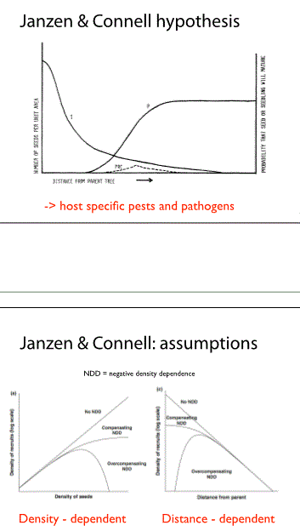
Janzen and Connell hypothesis
- p = probability seeds will survive to maturity
- Always expect more seedlings to be found closer to the parent plant
- Probability that seedling will reach maturity increases as you get further from parent plant
  - Higher chance they will be attacked by same disease/pest that has already infected the parent plant

- Density of recruits = density of seedlings able to survive
- Highest number of recruits found in middle seed density

Experiments
- Fungicide experiment
  - Found that plants not treated with fungicide and effected by pathogens follow hypothesis
- Grasslands
  - More successful in soils they don’t usually live in
    - Not exposed to pathogens that attack them
- Terborgh et al. (2001)
  - Due to loss of predators, herbivore populations exploded and decreased vegetation exponentially
  - Trophic cascade
  - Boreal forest not effected like the tropics was with the removal of predators

Species pool hypothesis
- More species means more species, just by probability

