Drugs and Behavior Midterm #1

Chapter 1: Bio-psycho-social determinants of drug use

Class of drug | Effects | Examples of drugs
Psychostimulants (aka “uppers” | Increases in brain activity, energy levels, and wakefulness; increases in heart rate and blood pressure; euphoria | Cocaine, methamphetamine, Ritalin, Adderall, caffeine, nicotine, MDMA
Depressants (aka “downers”) | Decreases in brain activity, energy levels, and wakefulness; sedation and possibly unconsciousness; decreases in heart rate and blood pressure; euphoria | Alcohol, barbiturates, benzodiazepines
Hallucinogens | Marked changes in sensation or perception; marked changes in emotions / spirituality; euphoria | Magic mushrooms (psilocybin), Peyote (mescaline), LSD, ayahuasca (DMT), Salvia, MDMA
Opiates | Pain reduction (analgesia); at higher doses depressant-like effects; euphoria | Morphine, heroin, codeine, Oxycontin, Vicodin
Marijuana | Very complicated effects with similarities to stimulants, depressants and hallucinogens; changes in appetite; euphoria | Marijuana
Table 1.x: Classes of drugs according to behavioural and physiological outcomes
Class of drug
Effects
Examples of drugs
Psychostimulants (aka “uppers”)
Increases in brain activity, energy levels, and wakefulness; increases in heart rate and blood pressure; euphoria
Cocaine, methamphetamine, Ritalin, Adderall, caffeine, nicotine, MDMA
Depressants
(aka “downers”)
Decreases in brain activity, energy levels, and wakefulness; sedation and possibly unconsciousness; decreases in heart rate and blood pressure; euphoria
Alcohol, barbiturates, benzodiazepines
Hallucinogens
Marked changes in sensation or perception; marked changes in
emotions / spirituality; euphoria
Magic mushrooms (psilocybin), Peyote
(mescaline), LSD, ayahuasca (DMT), Salvia, MDMA
Opiates | Pain reduction (analgesia); at higher doses depressant-like effects; euphoria | Morphine, heroin, codeine, Oxycontin, Vicodin
Marijuana | Very complicated effects with similarities to stimulants, depressants and hallucinogens; changes in appetite; euphoria; pain suppression | Marijuana

Risk factors- circumstances, experiences or biological characteristics (etc.) which are correlated with increased drug use;
- Community, parental, and peer / friends’ attitudes and behaviours that support, model, or do not discourage, drug use
- Antisocial/problem behaviours
- Poor school performance
- Early-life stressors
- Acute (current) stressors
- Mental illnesses
- Boredom
- Curiosity
- Desire to have fun

Protective-(resiliency) factors are associated with lesser amounts of drug use or abstinence.
- • Intact home environment with parental involvement (e.g., high rates of reading to children)
- • Parents are educated; parents expect children to earn an education
- • Positive school experience; good attachment to teachers; high scores in school
- • Perceive that drug use is high risk
- • Involvement in religious activities

Antecedent-varible that precedes drug use
- aggressiveness
- • conduct problems
- • poor academic performance
- • attachment to a drug-using peer group
- • parental and community norms that support drug use

Types of drugs
-licit-legal drugs (age could be factor)
-illicit-illegal drugs

-the younger you start using a drug the more likely you are to become more dependent

Four Categories of Drug-taking behavior
1)licit instrumental-coffee to keep you awake, valium with prescription to relieve anxiety
2)licit recreational-drinking alcohol to have “fun”
3)illicit instrumental-smoking mary to relieve anxiety
4)illicit recreational- taking MDMA at party to “fun”

Chapter 2: Drugs, Society and the Law
-early government approach ‘laissez-faire”(1800s)- letting things take their course
-subsequent approach “control” (1900s)

-toxicity-potential harms associated with the drug
-physiological-effects of drug on users body
-behavioral- what the user does while on the drug
-acute-immediate harmful effects
-chronic-effects that occur after repeated use
-acute physiological toxicity-refers to overdoes that cause user to stop breathing and heart to stop beating
-acute behavioral toxicity-person is rendered incapable of responding to surroundings
-chronic physiological toxicity- long-term organ damage that can occur from repeated use of many drugs
-chronic behavioral toxicity-refers to the long-term changes in interpersonal, family, social, and work relationships

-Pharmacological crime: Specific drugs cause short-term changes in decision-making areas of the brain that may be associated with the commission of impulsive or violent crimes

-Economically compulsive crime: Drugs cost money, and if you have no money you may need to commit crimes to fund drug purchases

Systemic crime: Depending on the drug, the use of the drug itself may be a crime

-changing attitudes towards drugs caused the change in laws
-what caused the shift
-toxicity
-dependence
-crime

DAWN (Drug Abuse warning network)
-program reports the number of drug-related emergency room visits in major metropolitan hospitals in the United States

Report released Jan 2012:
-250,000 people die each year from illegal drugs (3%)
-2.3 million per year from alcohol (30%)
-5.1 million per year from tobacco (67%)

-Alcohol: assume even 70% consume alcohol in some amount each year N.A. population = 300 million; therefore 210 million drinkers 125,000 deaths per 210 million users = 1 death per 1680 users / annum

-Cocaine: about 3 million users in N.A. 8100 deaths per 3 million users = 1 death per 370 users / annum

-Tobacco: assume roughly 20% of the N.A. population smokes chronically N.A. population = 300 million; therefore 60 million smokers 434,000 deaths per 60 million smokers = 1 death per 138 users / annum

-Heroin: about 180,000 users in N.A. 6500 deaths per 180,000 users = 1 death per 28 users / annum

Substance use disorder DSM-V
- Taking the substance in larger amounts or for longer than you meant to
- Wanting to cut down or stop using the substance but not managing to
- Spending a lot of time getting, using, or recovering from use of the substance
- Cravings and urges to use the substance
- Not managing to do what you should at work, home or school, because of substance use
- Continuing to use, even when it causes problems in relationships
- Giving up important social, occupational or recreational activities because of substance use
- Using substances again and again, even when it puts you in danger
- Continuing to use, even when you know you have a physical or psychological problem that could have been caused or made worse by the substance
- 10. Needing more of the substance to get the effect you want (tolerance) 11. Development of withdrawal symptoms, which can be relieved by taking more of
the substance
-2 or 3 symptoms: mild substance use disorder
-4 or 5 symptoms: moderate substance use disorder
-6+ symptoms: severe substance use disorder

Rank of the harmfulness of recreational drugs

Table 2.x: Rank ordering the harmfulness of the most common recreational drugs.
Rank | Drug |  |  | Risk Score
1 | Heroin |  |  | 9.3
2 | Cocaine |  |  | 7.7
3 | Barbiturates |  |  | 7.0
4 | Street methadone |  |  | 6.3
5 | Alcohol |  |  | 6.3
6 | Ketamine |  |  | 5.7
7 | Benzodiazepines |  |  | 5.7
8 | Amphetamines |  |  | 5.7
9 | Tobacco |  |  | 5.3
10 | Cannabis |  |  | 4.3
11 | Solvents |  |  | 4.3
12 | LSD |  |  | 4.0
13 |  | Steroids | 4.0
14 |  | GHB | 3.7
15 |  | Ecstasy / MDMA | 3.7

Schedule 1 “hard drugs”
-Opium poppy derivatives (opium, heroin, codeine, morphine, oxycodone, etc.)
-Coca and derivatives (coca leaves, cocaine)
-PCP, Ketamine, Fentanyls Methamphetamine
-amphetamines, MDA MDMA, MDEA, MBDB
-flunitrazepam
-GHB

Schedule 2 “Cannibis”
-Cannabis and derivatives
Marijuana, cannabis resin, THC, hash, hashish, etc Excludes fibres derived from cannabis stalks (Hemp)

Schedule 3 “medical sedatives, hallucinogens”
-Some Barbiturates (pentobarbital, secobarbital, etc) LSD, DMT Mescaline, but not Peyote Psilocybin, Harmaline

Schedule 4 “Prescriptions: Steroids and Sedatives”
-Anabolic Steroids Benzodiazepines (valium, xanax) Most Barbiturates (phenobarbital, sodium thiopental, etc)

Schedule 5 “Cold Medication”
-Propylhexedrine (cold medication)
Schedule 6 “precursers”

-Class A
-Ephedrine (easily reduced into methamphetamine) Isosafrole (used in making MDMA) Lysergic acid (used in making LSD) Pseudoephedrine (easily reduced into methamphetamine)

Class B
-Acetone, Ethyl Ether, Hydrochloric acid, Methyl ethyl, ketone, Sulfuric acid, Toluene

Chapter 3: Basic Principles of Drugs and behavior

Drug dose- amount of drug that is taken into the body (not amount of pills/ injections)

Dose response curve- S-curve shows the increasing probability of a certain drug effect as the dose rises
-past certain threshold you pass out

effective dose-minimal dose necessary to produce intended drug effect in given percentage population

lethal dose-minimal dose capable of producing death in given percentage population
-more ED response curve and the LD response curve overlap the more dangerous it is
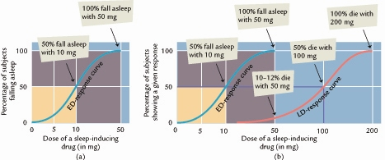

iatrogenic-illness caused by medical examination or treatment

Therapeutic index
--ratio of LD50 to ED50. If LD50 is 100 and Ed50 is 20, then therapeutic index is 5
LD50/ED50

Other Factors
-weight
-body fat percentage
-body water content
-sex
-age-very young entirely different neuropharmacology
-Very old- possibly unpredictable
-genetics
-10% Asians cannot metabolize alcohol 40% do so poorly

how do drugs get into the body
-must reach bloodstream to be effective
-psychoactive must reach brain

How do Drugs Get Into The Body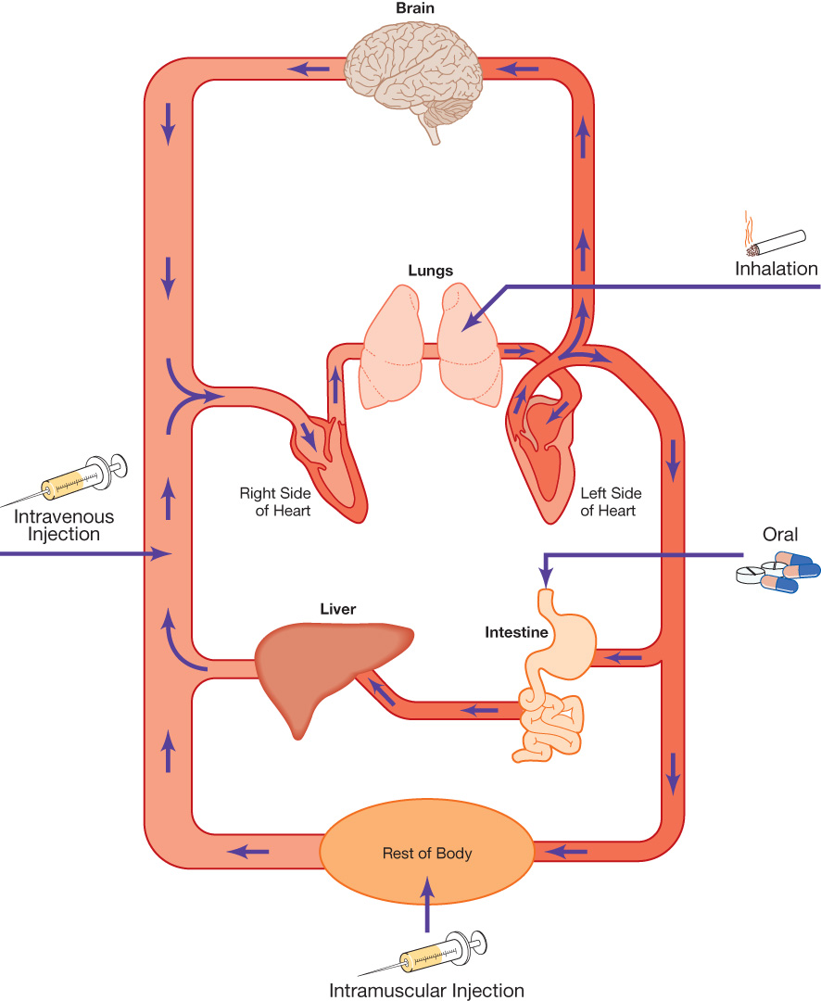
Oral Administration
-Adv
-slow absorption (5 to 30 min) or destroyed by digestive enzyme
-reject poison
-stomach pump opportunity
Disadvantages
-slow absorption- no immediate effect

Injection-Intravenous (I.V)
-Adv- very rapid effects (<15 sec)
-high conc can be delivered
Disadv- must have I.V and antidote if mistake
-damaged veins
-blood-borne disease transmission

Injection (other)
-subcutaneous injection-(under the skin)
-””skin popping”
-can cause necrosis
Intramuscular injection-absorption is more rapid from intramuscular injection due to greater blood supply in muscles

Inhalation
-Two strategies
-vaporous inhalation
-burn drug and inhale smoke
Adv- fast absorption (<5 sec)
Disadv-potential shorter duration of drug effect
-lung throat irritation with chronic use
-risk of cancers from tars/hydrocarbons if smoked

Topical Application
-Transdermal- absorbs across skin (slowly but stable)
Intranasal- across mucous membranes (rapidly)
-insufflation

Suppository/Enema
-injected through rectum
-Effective for delivering medication across the highly vascular ,membranes of the large intestine; good for out patients who cant swallow or vomiting

Basic structures of a Neuron
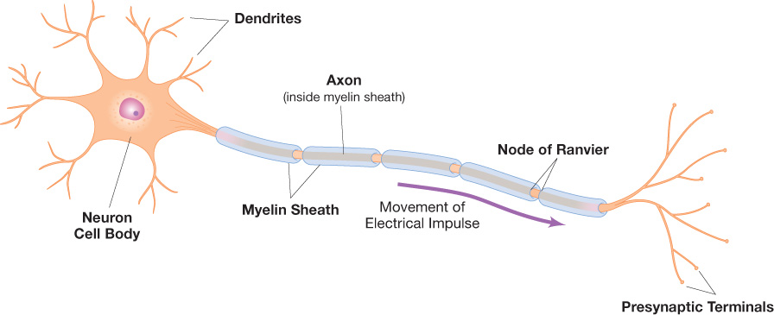
pharmacokinetic tolerance-Outside of the brain, increases in the function of liver enzymes which break down a drug will increase the dose of drug required to reach the desired effect

pharmacodynamics tolerance-long-term decreases in the number of neurotransmitter receptors of the type that the drug binds, which helps maintain homeostasis

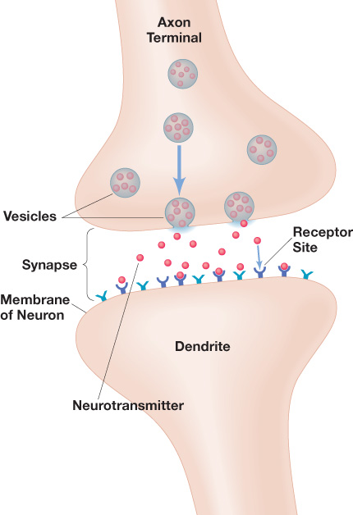
drug molecular structure often mimics the molecular sturture of a endogenous neurotransmitter
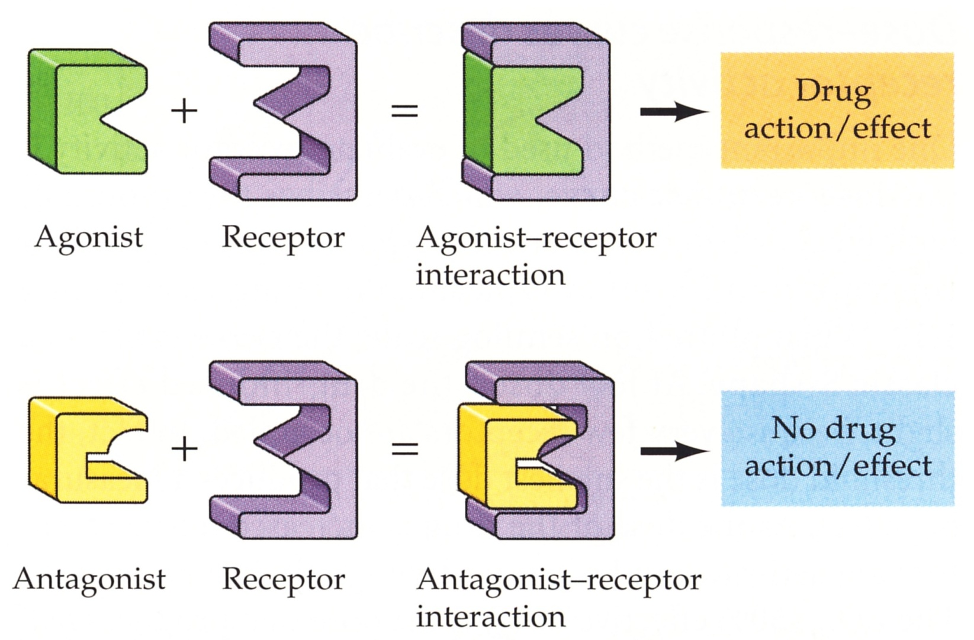
Lobes of the Human Cerebral Cortex

-Drug effects are mediated by activating (or inhibiting)
neurons in specific areas (could be dose/time-dependent)

-frontal lobe-planning and inhibition of inappropriate behaviors
-temporal lobe-hearing/ memory
-parietal lobe-bodily sensations
-occipital lobe- vision
-cerebellum-
-cerebrum
-medulla oblongata
-reticular activation system

The autonomic nervous system is a major drug target
- and thus a tell tale sign that certain drugs have been recently used
-sympathetic nervous system-adrenergic receptors(epinephrine/ adrenaline)
-fight or flight
-parasympathetic nervous system-muscarinic acetylcholine receptors
-relaxation

-cross-tolerance--results from the chronic use of one drug inducing a tolerance wirh regard to the second drug that has never been used
Alcohol- with barbiturates or other depressant drugs

-cross-dependence-One drug is used to reduce withdrawal symptoms following discontinuation of another drug
-Ex. Substituting benzodiazepines for alcohol

Drug Interactions
- Additive interaction (additively)
5 + 5 = 10 (barbiturate + tranquilizer)
- Hyper additive (synergistic) interaction
5 + 5 = 20 (barbiturate + alcohol)
- Potentiation (a special kind of synergism)
5 + 0 = 10 (antihistamines + narcotics)
- Antagonistic interaction
5 + 5 = 0 (certain antibiotics + birth control pills)

Drug Deactivation
Drug deactivation-many drugs are metabolized into inactive metabolites by enzymes and then excreted; others excreted unchanged

Elimination half lifes for certain drugs
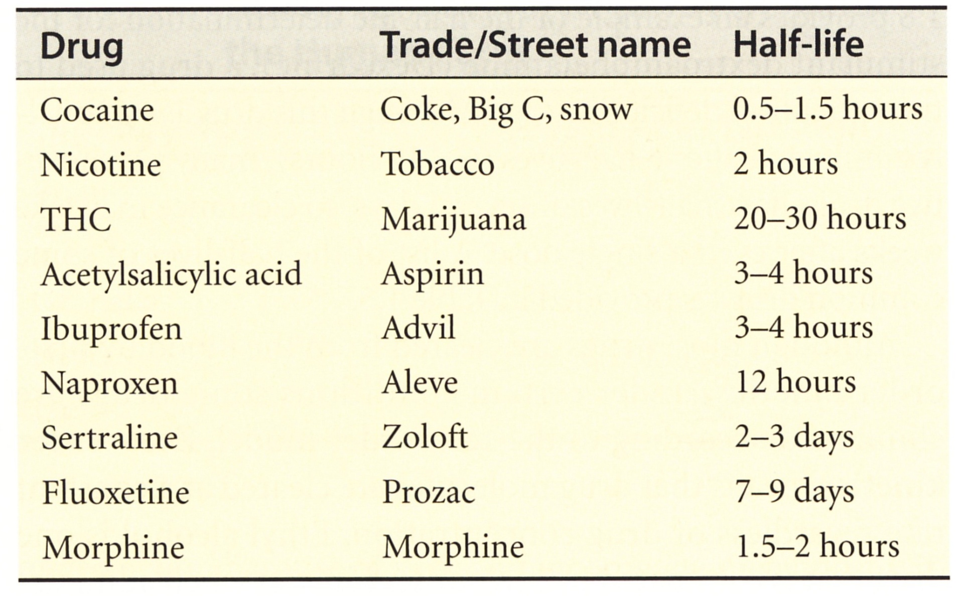

How are drugs Finally Eliminated from the Body
-Urine
-Exhaled breath
-Feces
-Sweat
-Saliva
-Breast milk

Chapter 4: Alcohol (Ethanol)

1920s prohibition… Why did it come to an end?
--public outcry
-massive loss in tax revenue (very small relationship between taxation and drinking rates
-make alcohol illegal= massive increase in organzied crime

Three basic categories of alcoholic beverages
1)beer- approximately 4.5% of alcohol
2)wine- 12-14% alcohol
3)distilled spirits (liquor) 40-50% alcohol

Making wine (Fermentation)
-Fermentation: a biological process by which sugars such as glucose are converted by yeast to ethanol and carbon dioxide

Organic material with sugar content
(honey, grapes, berries, molasses, rye, apples, corn, sugar cane, rice, dandelions, etc)
+yeast
=ethyl alcohol + carbon dioxide (max 12-14%)
C₆H₁₂O₆ 2 C₂H₅OH + 2 CO₂

Making Beer
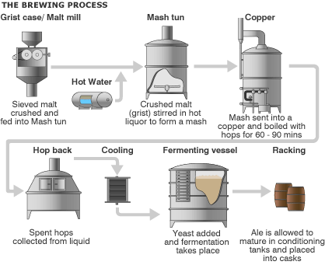
-Malt = germinated and then kiln-dried grain
Grist = crushed grain kernels

Making Liquor (distillation)
-Distillation: a physical process by which chemicals are separated on the basis of differences in their boiling points. In the process of making liquor, fermented liquids are boiled and then cooled to produce a higher alcohol content

-ethanol (BP=78 ºC) ------ ethanol rich vapor-----------------ethanol rich solution
(distilled spirits) (max 40-50%)

water (BP=100 ºC) boiling condensation
mixture

-lab ethanol is 95-almost 100%(95%=190 proof)
-Old British army custom:
-pour solution of alcohol and water on gunpowder
-if solution is <50%, gunpowder cannot be ignited
-solution >50% gunpowder will ignite
-use that to check proof
Proof= 2 alcohol consumption

Alcoholic beverages and alcohol equivalencies
-1 five-ounce glass of wine = 5 oz x 0.12 = 0.60 oz alcohol
-1 twelve-ounce beer = 12 oz x 0.05 = 0.60 oz alcohol
-1 1.5-ounce shot of 80-proof liquor = 1.5 oz x 0.40 = 0.60 oz alcohol
-1 twelve-ounce bottle of wine cooler = 12 oz x 0.05 = 0.60 oz alcohol
-(1 pint = 16 oz, therefore 1 pint of beer = 1.3 beers)
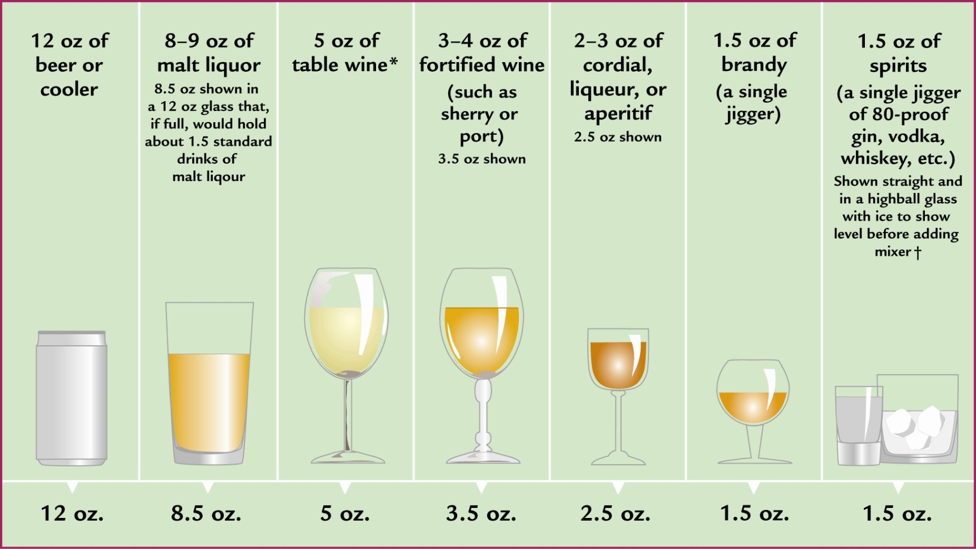

Alcohol consumption varies substantially from person to person
-20% of the population consumes 80% of alcohol
-3 people share 0%
5 people share 20%
1 person drinks 20%
1 person drinks 60%

Binge Drinking
-The 5/4 criterion
-5 drinks for more man
-4 drinks in a row for girls
or
-An extended bout of drinking or other substance use (often lasting at least two days) in which a person neglects other actiivities in order to engage un this behavior

Preferred terms “heavy episodic drinking” or “episodic high-risk drinking”
Student binge drinking patterns
-typically restricted to once a week or once a month and primarily on weekends
-cyclical-heaviest earlier in the semester and then again following exams; peaks for football weekends and reading week
-living within the university environment is key-behavior patter ends for most students when they graduate

When Should you Call 911
-Steps you must follow:
1. Someone stays with them at all times
2. Regularly ASK them QUESTIONS and GIVE them ORDERS
- name?
- open your eyes
- quiz them
- ask them to move a body part
- etc
If necessary, test for PAIN – squeeze their trapezius muscle
(if they are sleeping, this will likely wake them)

Three responses to look for (they must pass all of these tests):
EYES OPEN - do they open their eyes when you talk to them?
Yes – keep monitoring them
No – call 911
- do they open their eyes only when you apply pain?
Yes – call 911
VERBAL RESPONSES – can they answer your questions?
Yes – keep monitoring them
No – call 911
MOTOR RESPONSES – can they move on command?
Yes – keep monitoring them
No – call 911
- can they localize a painful stimulus (e.g., grab their neck/shoulder when you squeeze their trapezius)
Yes – keep monitoring them
No – call 911

-liver metabolizes 0.5-1 drink per hour

Acute behavioural effects of alcohol are dose-dependant
-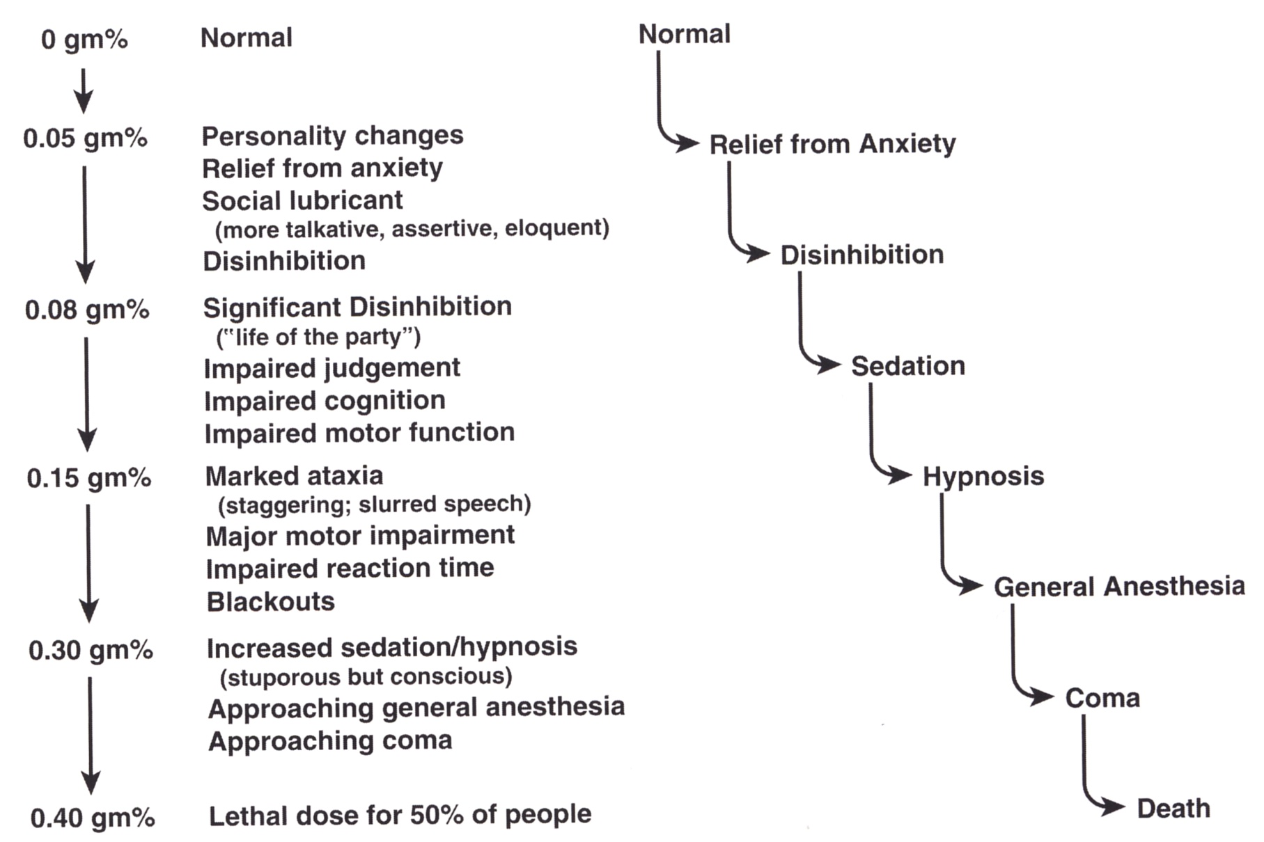

Major Acute Psychological effects
-Sleep effects- with alcohol on board , decreased REM – decreased synthesis = decreased memory consolidation
-during withdrawal, increased REM = nightmares
-alcohol sleep memory studies
-Diuretic effects- alcohol inhibits anti-diuretic hormone (ADH)
-Heat loss and saint Bernard myth- alcohol is a vasodilator; facilitates heat loss
-Bladder rupture-person may not be aware of need to empty bladder (stupor)
-vision and balance effects-changes in vestibulo-ocluar function in the brain
-leads to balance problems, ataxia and visual impairments
Beer goggles is a judgment effect (frontal lobe) not a true change in visual function

Hangovers
-Hangovers- headache, nausea, fatigue

Contributors
-non-oxidized acetaldehyde in the blood (irritant)
-irritation in the stomach
-low blood sugar from previous nights elevated levels
-inflammation from ADH rebound may continue to headache

Good cures for hangovers
-gato before bed

Major acute toxic effects of alcohol
LD50/ED50 ratio = ~6
Toxic reactions (death)
2 protective mechanisms
gastric irritant – vomiting (fails when BAC >0.20)
sedation – passing out.

proactive drug-facilitated rape- an assailant administers a drug to the victim and then assaults them

opportunistic drug- facilitated rape- the victim voluntarily ingests drugs and the assailant assaults them once they become extremely intoxicated

Table 4.x: Relative risks of a fatal single-vehicle crash for male drivers.
 | 0.02-0.049% | 0.05-0.079% | 0.08-0.099% | 0.10-0.149% | 0.15%+
Ages 16-20 | 5 | 17 | 52 | 241 | 15,560
Ages 21-34 | 3 | 7 | 13 | 37 | 573
Ages 35+ | 3 | 6 | 11 | 29 | 382

Table 4.x: Punishments in Ontario for drinking and driving
BAC 0.05 – 0.079
1st offense
• 3 day license suspension
• car impounded
• $150 administrative fee
• goes on permanent record
2nd offence:
• 1 week suspension of license
• impounded car
• fine
• driver education
3rd offence:
• 1 month suspension of license
• impounded car
• fine
• driver education
• installation of ignition breathalyzer lock on the car
￼
BAC 0.08 or higher
• license suspension up to 1 year
• fine up to $600
• possible imprisonment for second offence
• big increase in insurance premiums
￼
Chronic Effects of Alcoholism
Organ Damage

Liver damage
-damage begins as a fatty liver, characterized by deposits of fat in the liver; this is reversible. Next, alcoholic hepatitis sets in, which is characterized by inflammation of the liver; this may be reversible. Finally, the liver undergoes alcoholic cirrhosis, which is characterized by irreversible deterioration of the liver; at this point, a new liver must be transplanted

Cardiovascular problems
-at least one in four alcoholics develops cardiovascular problems related to their drinking, including heart attacks and strokes

Cancer
-Chronic alcohol consumption results in marked increases in the incidences of cancers of the larynx, pharynx, esophagus, liver and elsewhere in the body; additionally, females have an elevated risk of breast cancers

Brain: Wernicke-Korsakoff syndrome
-With chronic alcohol abuse there is a widespread and progressive loss of brain tissue; damage to specific brain regions results in marked impairments in learning and memory, resulting in significant forgetting of recent activities. In early stages, sufferers compensate for their forgetfulness by confabulating – they make up stories about their recent behaviours which could be true, but aren’t. In later stages the amnesia becomes insurmountable, and the afflicted individual becomes generally apathetic

Fetal alcohol syndrome
- Alcohol is a teratogen – no amount of drinking has been shown to be SAFE, or UNSAFE
- Growth retardation
- CNS abnormalities (average IQ: 68; 4th grade reading level; 2nd grade math
- Characteristic skull and facial appearance
- Deformed heart, kidneys, and fingers and toes
- 3rd week of pregnancy is the most vulnerable
- Incidence: 0.5 to 3 per 1000 live births; much higher on reservations

