Lab #5: LATCHES AND FLIP-FLOPS

ITI 1100 A - Digital Systems

Winter 2017

School of Electrical Engineering and Computer Science
University of Ottawa

Course Coordinator: Fadi Malek
Teaching Assistants: Hind
Heli

Objectives

- Provide insight into the characteristics of several important latches and flip-flops.
- Build latches and flip-flops from basic gates.
- Explain concepts of latching and edge-triggering.
- Test latches and flip-flops to understand their operation

Equipment & Components

- Quartus II Student Edition Software

- Altera UP-1 circuit board

Circuit Diagrams:

Part 1 - SR Latch
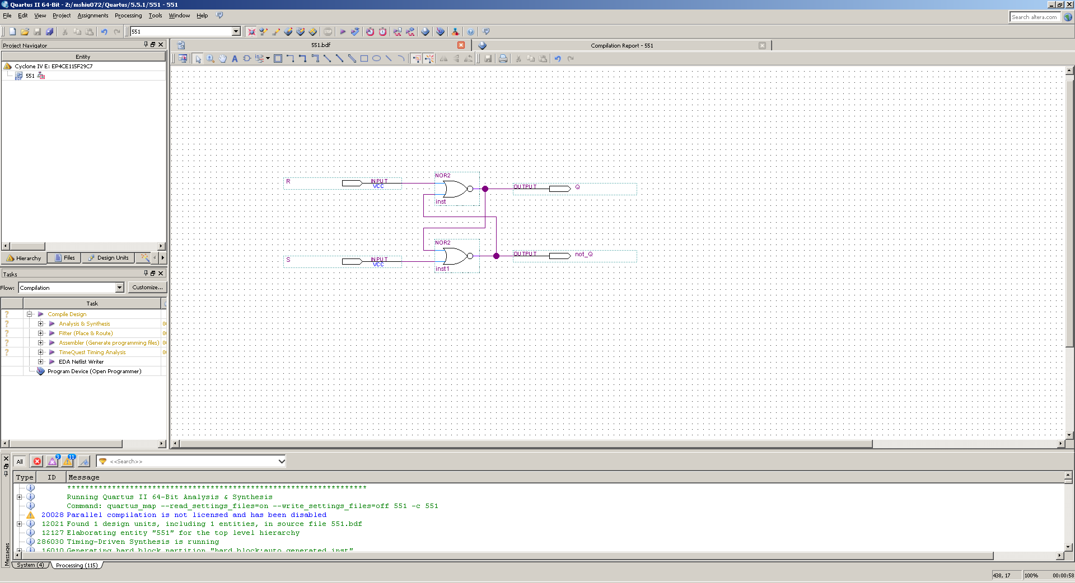

Part 2 - D Latch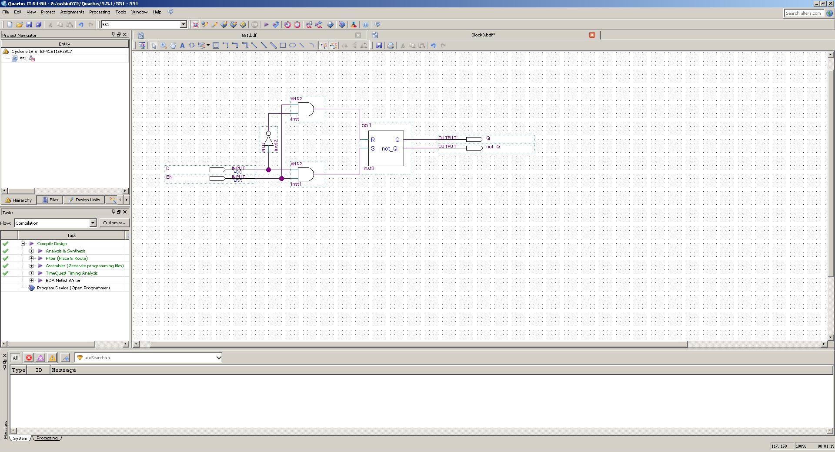

Part 3 - D Flip-Flop
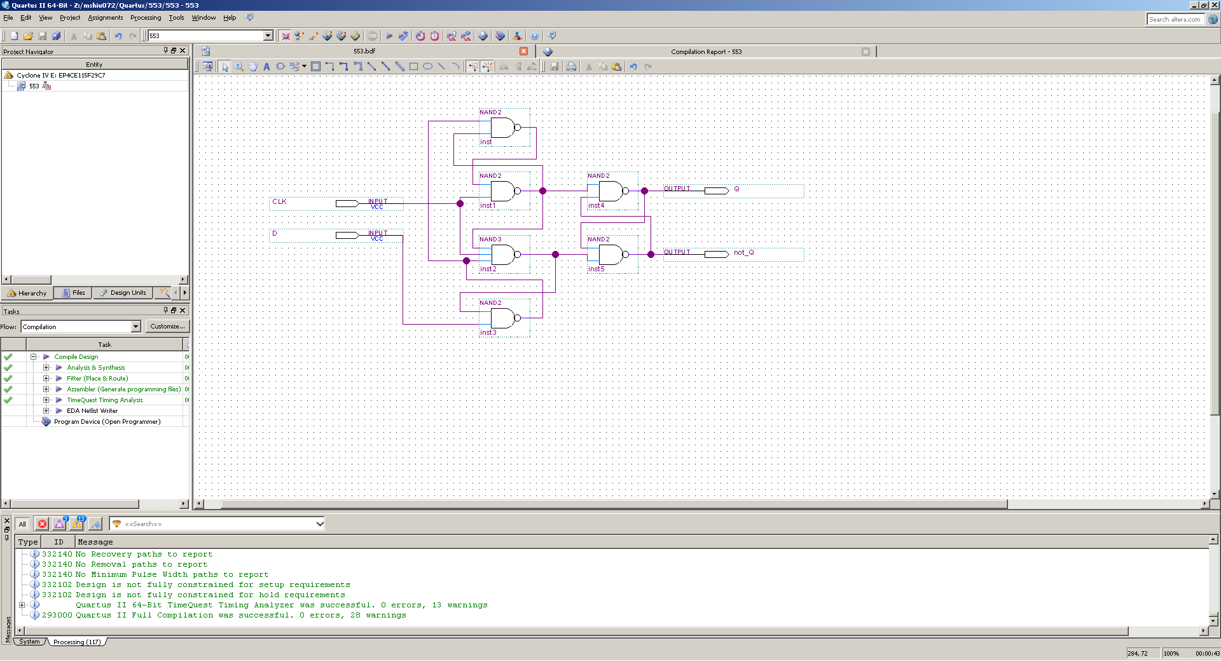

Part 4 - T Flip-Flop
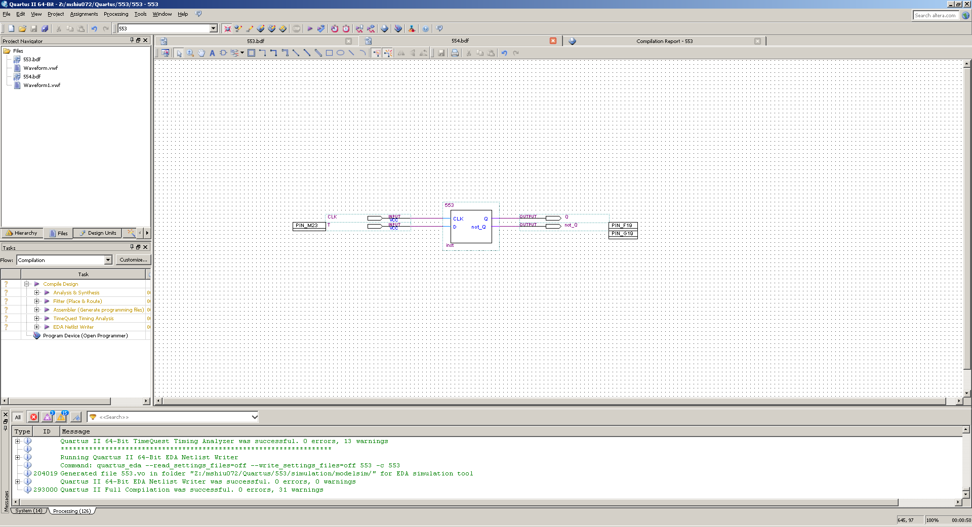

Experimental Data and Data Processing

Part 1 – SR Latch
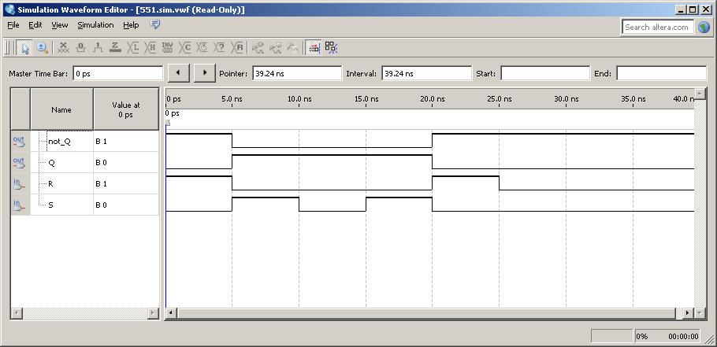
Table 1
S | R | Q | not_Q
0 | 0 | Q | not_Q
0 | 1 | 0 | 1
1 | 0 | 1 | 0
1 | 1 | 0 | 0

Part 2 – D Latch
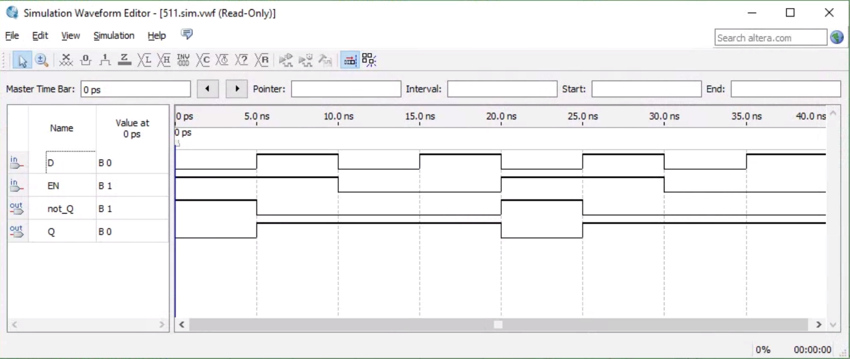
Table 2
EN | D | Q | not_Q
0 | 0 | Q | not_Q
0 | 1 | Q | not_Q
1 | 0 | 0 | 1
1 | 1 | 1 | 0

Part 3 – D Flip-Flop
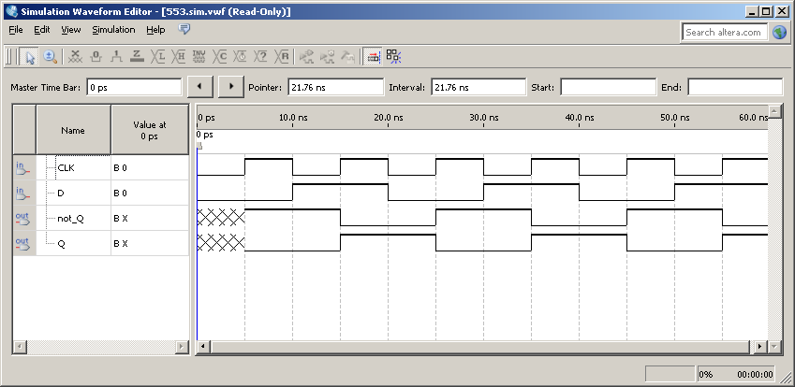
Table 3
CLK | D | Q | not_Q
0 | 0 | Q | not_Q
0 | 1 | Q | not_Q
1 | 0 | 0 | 1
1 | 1 | 1 | 0

Part 4 – T Flip-Flop
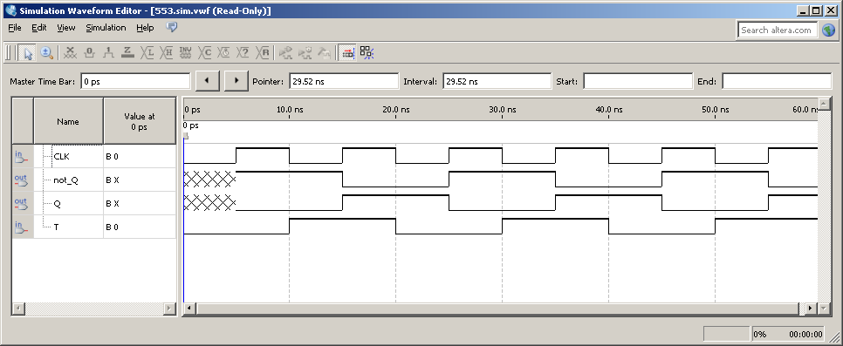
Table 4
T | CLK | Q | not_Q
0 | 0 | Q | not_Q
0 | 1 | 0 | 1
1 | 0 | Q | not_Q
1 | 1 | 1 | 0

Comparison of Theoretical Data and Experimental Data

Part I – Sr Latch
Table 5: Theoretical results for SR Latch
S | R | Q | not_Q
0 | 0 | Q | not_Q
0 | 1 | 0 | 1
1 | 0 | 1 | 0
1 | 1 | 0 | 0

Part 2 – D Latch
Table 6: Theoretical results for D Latch
EN | D | Q | not_Q
0 | 0 | Q | not_Q
0 | 1 | Q | not_Q
1 | 0 | 0 | 1
1 | 1 | 1 | 0

Part 3 – D Flip-Flop
Table 7: Theoretical results for D Flip-Flop
CLK | D | Q | not_Q
0 | 0 | Q | not_Q
0 | 1 | Q | not_Q
1 | 0 | 0 | 1
1 | 1 | 1 | 0

Part 4 – T Flip-Flop
Table 8: Theoretical results for T Flip-Flop
CLK | D | Q | not_Q
0 | 0 | Q | not_Q
0 | 1 | Q | not_Q
1 | 0 | 0 | 1
1 | 1 | 1 | 0

Discussion & Conclusions
The objective for this lab was to build, test, and discover the characteristics of certain latches and flip-flops as well as explore the concept of edge triggering and latching. During the lab, we built an SR Latch which was an essential part of the D Latch which we created shortly after. The next build was the D Flip-flop which was used in the building of the T Flip-flop. All the builds were successful and were successfully uploaded onto the Altera DE2-115 device with favorable results. The first attempt at creating the D Latch was successful until the creation of the waveform. When attempting to create a waveform for the D Latch an error was encountered. The waveform application would crash every time an attempt was made to create it leading to unknown results when uploading it onto the Altera device. However, the correct build was successful in its upload onto the device and functioned normally. The error was fixed when recreating the two builds on a different computer.
Our lab was successful in replicating the theoretical data. We were able to create the latches and flip-flops to provide results which matched the data that we calculated. Comparison of the results between the theoretical and experimental data yielded no deviation leading to our conclusion that the data we produced is accurate. Possible forms of error would have most likely been human error or a computer glitch which might have led to the error in the D Latch waveform. However, the results were not altered by possible computer faults or human error leading to favorable results obtained in the experiment.

