BPS1101 Midterm I Review

1 – History

Finding Information
- Internet can be a great source of information and can give a great starting point
- Be careful because anymore can post anything on the web and there can be a lot of misleading information
- Be sure to check multiple sites and compare
- Suggest using regulated drug company websites, government websites like Health Canada or the FDA, WHO, NIH, university sites, or scientific journals

Science vs. Magic

- Science
-Collect facts
-Draw conclusions based on those facts
-Test your conclusions in several ways
-A thought process of looking at the world realistically and modifying theories and conclusions to what the world really represents

- Magic
-Draws the conclusions you want
-Find some facts to fit those conclusions
-Avoids testing or challenging those conclusions
-Not realistic or based on anything of what the world really represents

The human brain’s default mode is “magic” because:

- We are convinced we are right
  - Draw the conclusions you want
  - Find some facts to fit those conclusions
  - Avoid testing or challenging your conclusions
- This is a survival mechanism
  - Quick decision making in dangerous situations
- This type of thinking slows progress
  - Does not deal in reality

The concept of science is new….

- Developed in last 150 years
- This type of thinking speeds progress
  - Grounded in reality

Life Expectancy (2009)
Rank | Country | Years of Life
1 | Macau | 84.4
2 | Andorra | 82.5
3 | Japan | 82.1
4 | Singapore | 82.0
5 | San Marino | 82.0
6 | Hong Kong | 81.9
7 | Australia | 81.6
8 | Canada | 81.2
9 | France | 81.0
159 | World Average | 66.6
224 | Swaziland | 31.9

*Know rough ball
park numbers*

Life expectancy through history

- Approx. 30 to 35 years for most of recorded history (last 6,000 years)
- Approx. 30 to 35 years through the stone age (500,000 to 6000 years ago)
- 82 years in 2009 (Canada) most improvements over the last 150 years

Disease was common and dangerous
-Quality of life was also very poor
-It was normal for you to be sick for a large proportion of your life and often your sickness could become very serious and in many cases it would be fatal
-Now if we get sick it is often very mild and non-fatal

Lice and fleas on humans
-This was also very common around 150 years ago
-Unsanitary and would be carriers of lice and fleas
-Was common that you would always have lice or fleas

Life with worms
-Would suffer with hookworms, tapeworms, roundworms and pinworms
-150 years ago you could expect to have worms in your body
-Because of this they used to deworm children in the 1950-60s but this is not very common today

Main reasons for improved health… (because of the scientific method)

Improved sanitation
- Very simple improvement but a huge reason to why the life expectancy and health of people improved
- Outhouses were common in cities
-They did not have the sewage systems that we have today
-Wasn’t until later in the 20th century that this was improved
- If no outhouse available, used cesspits
-Buckets called cesspits were used if you didn’t have an outhouse or you need to go to the washroom in the middle of the night
- Open vs. closed sewers
-Used open sewer systems with sewage around the houses and cities
-In the early 1700s closed sewer systems were developed
-Although open sewer systems are still common in developing countries today
- Populations exposed to death and dying
-Dead bodies would lay out in the streets
-If someone died in your house, you would be responsible to carry them out and deal with them and wouldn’t know how to do it properly
-They were very close to the dead bodies and the infections they carried
-Now we don’t get that kind of exposure since most people die in the hospital or hospices in which health care professionals deal with the body properly. Important not to be exposed to the infectious body

Safe water supply
- Nature does not make pure water
-In history, people drank directly from streams
-Nowadays we treat our water before we drink it, which has led to our improvements in health
- One major factor was because of guinea worms (dracucculiasis). These animals are able to survive in your GI tract and lays eggs which migrate through your body and develop as worms which then live within your muscles. The worms burst out of your body and secrete a liquid that causes excruciating pain.
-Simple water treatment makes the difference and remove these types of microorganisms
- Chlorination was also a contributor to major improvement. It acts as a sanitation preserver (kills bacteria and microorganisms) as the water travels from the treatment site to the pipes to the consumer’s faucet

Refrigeration
- Food spoilage was common before refrigeration
-If you lived in the 1800s it would be normal to eat rotten foods that would make you sick
-Everything had to be pickled or preserved
- Because of modern refrigeration we are available to a fresh food supply all day, everyday. It has also helped to create seasonal availability in which you can get all types of produce all year long

Vaccination
- Immunization created greatest achievement in medicine
- Very successful against viral diseases
- Smallpox was eliminated in 1977. It now only exists in labs or as biological weapons. Those born before 1972 often have a vaccination scar for smallpox but now we don’t need to vaccinate because the disease essentially doesn’t exist in humans anymore
- Polio was eradicated from North America in 1991
-Currently there are less than 1000 cases world-wide within 10 or 11 countries
-Major eradication barrier is politics

Antibiotics
- Kill bacteria selectively without harming the rest of the body
- Penicillin was a major improvement and reduced maternal mortality because it fought against infection that was common in childbirth

Modern Drugs Work…
- Each starts with a scientific idea
- Each is optimized using scientific methods
- Each is tested scientifically
- Overall they work because they are based on facts of reality that are practical and useful

North American Drug Market
- Prescription drugs
  - $ 300 billion
- Over-the-counter (OTC) drugs
  - $25 billion

Worldwide Drug Market
- Prescription drugs
  - $ 600 billion
- Over-the-counter (OTC) drugs
  - $50 billion

United States | 49.1 %
Japan | 14.1 %
Germany | 7.7 %
France | 7.1 %
United Kingdom | 4.2 %
Canada | 3.8 %
Italy | 3.8 %
All Others | 10.3 %

**The United States consumes half the pharmaceuticals that are produced per year and so pharmaceutical companies often base their work on the US regulatory agency (FDA) since pharmaceuticals are used the most in the US and they want them to be catered for this market

The modern pharmaceutical industry is young…
- Started in 1856
- Uses scientific methods
  - Chemistry
  - Biology
  - Molecular biology
  - Epidemiology
- Works hard to remove bias
- Regulated by government
- But remember drug companies are there first and foremost to make money since they are a business. But because they are regulated by the government they have to make sure that what they do it correct since they can be sued or fined
- Nasty situations do exist but mostly all drug companies produce high quality material because if they don’t they will suffer consequences

Most ancient medications were useless
- “Made-up” cures
- People believe in magic and would use their imaginations or superstitious thinking to create treatments
- Feel better just by getting treatment. The idea of feeling better often convinces us that it does something for the disease but in reality it is only making us feel better
- Only a small number of treatments actually worked
  - A few of these are still used today
  - Would often be more harmful than useful

Most ancient drugs were from plants…
-They would get their drugs from the natural environment and from whatever they could find
-Why plants?
- Plants are fundamentally different than animals. They are defenseless except for that they produce poisons to protect themselves from being eaten by animals
- These poisons in the ancient times were derived to make their medicines

Drugs are poisons
- Drugs
  - Produce desired (beneficial) biological effect
- Poisons
  - Produce undesired (harmful) biological effect

- These poisons were used and controlled to produce the desired medical effect
- The amount of something you give will determine if what you have is a poison or a drug. Only the dose makes the poison (poison = kill, potion = cure)

Dosages
- Normally we assume
  - low doses produce beneficial effects (drug)
  - high doses produce harmful effects (poison)
- Sometimes
  - low doses produce harmful effects (poison)
  - higher doses produce beneficial effects (drug)
  - For example: not taking enough insulin

How were drugs discovered?
- Observation (rare)
  - People observed the effect of the drug
  - Strong poisons
- Philosophy (very common)
  - Based on belief
  - Cure arrived at by reasoning
  - Healing often connected with superstition, magic, religion

Drugs from observation
- Strong poisons (common)
  - Easily identified
  - Low dose makes it into a drug
    - Opium, digitalis, nicotine, cocaine
- Weak poisons (uncommon)
  - Large quantity for effect
    - Caffeine, salicin

Papyrus Ebers
- Egyptian medial document 1500 BC
- Scroll about 20 m long
- Thousands of medical treatments
  - Most useless
  - A few are still used today

Egyptian document identifies opium for pain
- Opium observed as… (extracted from poppy seeds)
  - Narcotic painkiller
  - Sedative
- Toxic in high doses
- Drug in low doses

Opium has become the basis of modern painkillers
Analgesics
  - Reduce pain
- Codeine
- Oxycodone
- Fentanyl
- Methadone
- Demerol

Egyptian document identifies cocaine as a stimulant
- Observation
  - extracted from coca leaves
    - Topical painkiller
    - Stimulant
- Coca leaves were used in high altitudes as a stimulant to pick them up during the day (their version of coffee)

Modern anesthetics designed from cocaine
Anesthetics
  - Reduces sensation
- Novocaine
- Procaine
- Lidocaine
- Benzocaine

Quinine observed as a malaria treatment through tonic water
-The British army introduces quinine use in India through the British colonials
-Their tonic water contains quinine as a flavor component
-The iconic gin and tonic kept the British healthy

Problems with observation
- Human brain searches for patterns even when they are not there
-Apophenia: seeing patterns or connections in random or meaningless data
-Pareidolia: perceiving sounds or images as something else

- Ancients did not use experiments or statistics

- Relied on their own experience

- Anecdotal evidence unreliable since it is based on personal accounts
  - Drug and effect may be coincidence
  - Perceptions subject to placebo effects
  - People lie
  - Relies on chance… Medication and cure may not be connected since you may eat a plant at same time you were getting better anyway
  - Tomatoes once thought to be poisonous since they linked a chance when someone felt sick after eating a tomato

- Once “evidence” is available, hard to contradict
  - Many harmful remedies retained because of this
  - Parent’s cold remedies

Only experimental evidence is reliable
- Reliable meaning it can be reproduced and get same effect
- Measurements are made properly and accurately
- Experimental evidence must give statistical significance in which averages and trends are pooled from a large number of experiments

Problems with traditional remedies
- Poor control over dose
-Plants produce variable amounts of active ingredient
- Preparation changes chemical composition
- No standardization
-Verbal instructions were used and important information would get lost
-Imprecise and poor reproducibility

Philosophy used to identify cures
- Cure arrived at by reasoning (make it up)
- Search for “proof” afterward
- Healing often connected with superstition, magic, religion

- Hippocrates developed doctrine of humors and their properties
- Universe if made of 4 elements
-Earth (dry)
-Air (cold)
-Fire (hot)
-Water (wet)
- Body is made of 4 humors
-Blood (cold)
-Phlegm (wet)
-Yellow bile (hot)
-Black bile (dry)

- The humors are normally in balance but if there is too much or not enough or a humor disease is caused. They would diagnose based on the properties of the humors and the cure would be to rebalance the humors. For example: fever was associated with hot and dry and so the cure was to use cold and wet.

- Bloodletting: was used to rebalance the blood humor. They used creative methods such as leeches or instruments to cut the skin in order to remove blood. Although, bloodletting often killed the patient due to too much blood loss.

- Emetics and purges: would induce vomiting for rebalance of the humors.

- Fasting and special foods were also used

Overall the doctrine of humors was stupid
- Based on an incorrect idea that was made up
- Treatments that were developed were harmful and painful

The Doctrine of Signatures
- Idea developed by Jakob Bohne, shoemaker and philosopher (1575-1624)
- Plants meant to heal certain organs and body parts, like the liver or the eye, must show a certain “signature” by resembling the thing they treat.
- Thought that God left clues to tell us how to use things
- Disease and cure were linked to the shape of things
- This approach is/was used by almost all cultures

Examples

- Walnuts look like brain and so eating walnuts is good for brain health.

- Boneset stems grow “through” the leaves
- Boneset plant was thought to help with cold and fever but can actually cause poisoning if taken too much by mouth

- “Sharks don’t get cancer” because they have cartilage
-Thought that cartilage wasn’t able to get cancer and so if they consumed this it would slow down our own cancer growth

- Breath mints have chlorophyll
- Fresh breath – Parsley
- Parsley – Green
- Green – Chlorophyll
- Chlorophyll – Fresh breath

- Mandrake roots look like people
-Mandrake roots used for many medicinal and magical purposes
  - Primary use was a cure for demonic possession
-Would use a dog in harvest to protect against the screaming of the mandrake when it would be pulled to ensure the magic was preserved

- Rhino horn is a phallic symbol
-Powdered rhino horn used in Chinese medicine as an aphrodisiac

- Mercury is a heavy liquid
-People would drink mercury as a purgative

Doctrine of Signatures was crap
- Most remedies developed this way were harmful
- At best were harmless
  - Denied the patient proper treatment
- Lack of rationality or evidence
  - Based on appearance or location
  - Required imagination to see connections

Surgery
- Some problems required surgery
- Often amputation was done but no anesthetic was used
- Amputation was done quickly and by trial and error

- Sir Humphry Davy discovered nitrous oxide (laughing gas)
-Originally used as a propellant and recreational drug
-Later it was recognized as a pain inhibitor but would not be good enough for intense surgeries

William T.G. Morton and ether 1846
- American dentist who first publicly demonstrated the use of inhaled ether as a surgical anesthetic in 1846

But less than 30% survived surgical treatment…
-Surgery would often result in later infection that would cause death

Joseph Lister uses phenol as antiseptic in 1867
-This pushed the idea of sterile surgery
-Carbolic acid sprayer was used during surgery
-BUT there would be toxic effects on doctors. Spraying and inhaling it over a long period of time would be toxic. Patients were fine since they would only be exposed once or twice in their lifetime
-It was found that washing and glove use was safer and outweighed the risks of carbolic acid spray

Antisepsis brought to Canada by Thomas Roddick in 1877
- Canadian surgeon who brought the idea of sterilization and antiseptics to preventing disease and spread of disease to Canada

Listerine becomes household product
-Promoted as an antiseptic to be used in the home
-Gets name from Joseph Lister
-Listerine was also used for dandruff
-Listerine no longer contains phenol because it was found unsafe in case of ingestion

The first artificial drug

William Perkin first synthetic dye (1856) dye companies became pharmaceutical companies (Bayer started as a dye company) first artificial drug produced in 1897 (chloral hydrate, as a sedative-hypnotic)

Found that artificial drugs were better and cheaper, now most pharmaceuticals are made synthetically

Patent medication in the 1800s
- No regulation
  - Industrialization created big markets
  - Lots of opportunity for fraud
- All these problems had/have always existed, but there was a dramatic increase in the 19th century
- The emergence of science made people trust claims
  - “scientifically proven”
  - “patented”

Examples:

William J.A. Bailey makes Radithor

-Bailey was a Harvard University dropout who falsely claimed to be a doctor of medicine
-He promoted the use of radioactive radium as a cure for coughs, flu and other ailments
-Claimed it would cure by stimulating the endocrine system

Eben M. Byers
-Athlete who promoted the use of Radithor
- Had an injury and started taking excessive amounts of radithor
-He had accumulated significant amounts of radium in his bones resulting in the loss of most of his jaw. His brain was also abscessed and holes were forming in his skull.
-His illness and eventual death led to a heightened awareness of the dangers of ingesting radioactive materials as well as laws that increased the powers of the FDA

Medicine from Death’s Laboratory

-Patent medicines were increasingly constricted in the US in the early 20th century as the FDA added regulations to prevent fraud and poisoning

Board of Food and Drug Inspection
- Formed in 1907
  - First government regulations for medicines
  - Labeling only
  - No regulation of therapeutic claims
  - No safety testing

Massengill company and drug safety…
- Company was responsible for the elixir sulfonamide disaster
- Placed product on the market with no safety testing, only appearance, fragrance and taste tests
- They introduced this new drug which used diethylene glycol (ethanol) as a solvent which is toxic and led to many deaths labelling of this finally forced drug off the market
- Government inspectors tracked down drug
-Recovered 234 of 240 gallons that were sold
-107 dead and 206 permanently disabled

Food and Drug Administration (FDA) created
  - Ensure the safety of drugs
  - Animal testing was now required (safety only)
  - Clinical trials were done to follow safety in humans
  - Directions for proper use were required on the label

Although problems still occur….

Thalidomide
- Developed as a sedative – 1957
  - Very few side effects
- By 1962, thalidomide recognized as a teratogen (caused birth defects)
  - Phocomelia
  - Never marketed in the U.S.
    - Teratogenicity was discovered before
FDA approval was given
- Thalidomide was tested in rats
  - Rats do not often give birth to deformed pups
  - In humans, problems with
a fetus result in
miscarriage, stillbirth or
birth defects

Modern safety standards
  - Safety testing done in at least 2 species
  - At least one must be a primate
  - Must show that the drug is bioavailable
    - Gets into body
  - Must use relevant doses

Industry needs regulation
- Ensures safe products
- Ensures products work
- Ensures good manufacturing quality
- Regulation increases costs

Modern drugs work
- Each starts with a scientific idea
- Each is optimized using scientific methods
- Each is tested scientifically
- Manufacturing is standardized
- Drug industry is tightly regulated
  - Must provide scientific proof

2 – Pain

Top OTC meds (North America 2008)

- Cough and cold $4.1 billion
- Pain reliever $2.7 billion
- Antacid $1.4 billion
- Toothpaste $1.2 billion
- Laxative $0.8 billion

*Pain relievers are the most commonly used BUT cough and cold medications have a bigger industry since they are more expensive

Important considerations when buying…

Safety
-Dose makes the drug and dose makes the poison
-Taking 1 or 2 pills is based on body size. Smaller body size only requires 1 pill whereas if you are larger you will most likely require 2
- Taking 2 pills is usually a psychological thing. One pill often works just as well as 2
-Be careful and look for safeties such as do no exceed more than so many pills per 24 hours

Side effects
-ALL drugs have side effects
-Effect is usually easy to find but how common this effect is, is often not as easy to find
-Remember you need both effect and incidence in order to evaluate the risk

Indications
-Tells you what the medication is used for
-Many people take the wrong drug (for example: wrong cold medications for certain symptoms)
-Many people take drug unnecessarily (for example: laxatives are mostly taken unnecessarily. They were created for old people who have troubles with bowel movements. Many people think they need to have a bowel movement every day, although, this only depends on the person and their body. This belief has led to people using this product when they really don’t need to. Their body becomes addicted and needs the laxative in order to function normally).

Counter indications
-When you should NOT use based on
  - Conditions: diabetes, pregnancy, heart issues, blood pressure, etc.
  - Drug combinations: certain drugs together produce harmful effects
  - Foods: can increase or decrease effects
  - Natural substances: have biomedical effects that also interfere with drugs

Pain relievers are the most common OTC drug
- $2.7 billion per year (North America)
- 50 billion tablets (North America)
- 16,000 tonnes/year
- 500 dump trucks

Aspirin – one of the World’s most popular drugs
- Alcohol
- Caffeine
- Aspirin
- Nicotine

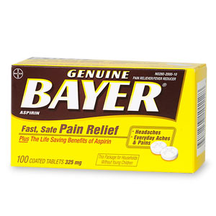
-One of the top medications used throughout the world
-First artificial drug produced by humans

Salix
- Genus (family)
  - Willow
  - Poplar
  - Beech
  - Wintergreen
- Starts with a plant. These plants create salicylates

Sumerians used willow leaves for pain 2,200 BC
Egyptians used willow for inflammation

Knowledge of herbs were lost in the dark ages…
-There became a domination of the church and people were told by the church what was real or not
-They would dictate which plants were acceptable and which were not based on the connection between healing and spirit
-They lost precious information during this time because even if a plant worked they were not allowed to use it

Reverend Edward Stone (1702-1768)
-Rector in Church of England
-Described treatment for ague (fever) in 1763
-Edward was walking in a swampy area and had a fever at the time, he noticed the willow bark and took a bite of it. Had a very bitter taste like quinine, he used this taste and applied it to the doctrine of signatures

Willow bark for fever and pain
-Dried bark ground to a powder and given for fever
-Expensive, limited supply and variable effectiveness

Active ingredient in willow is salicin
- Became isolated in 1829
- Although you would need 1.5kg (1500g) of bark to extract only 30g of salicin

Salicin was converted to salicylic acid in 1838
- Better drug than salicin (lower dosages)
- Occurs naturally in meadowsweet flowers in very small quantities
- It is an analgesic (reduces pain), antipyretic (reduces fever) and anti-inflammatory (reduces inflammation)

Salicylic acid manufacture from coal tar
- No longer had to use salicin which required a lot of willow bark
- Salicylic acid was found to be manufactured by coal tar by the Kolbe-Schmitt reaction
- Coal tar was a waste product in the 1800s and so they found an efficient use for this waste

Synthetic vs. “Natural”
- Natural (58 billion tablets requires 2,000,000 tonnes of bark)
- Synthetic (58 billion tablets requires 62,000 tonnes of oil)
- Can get more from less ingredients and it is using up a waste product
- Would be 100 million trees needed for that much bark which is not sustainable at all
- Natural means we have isolated from a plant, bark, etc.
- Synthetic means it is usually coming from oil
- Today coal tar is sourced from petroleum

Dye companies specialized in coal tar chemistry
- Had a lot of coal tar waste
- Salicylic acid made and sold by dye companies
- Dye companies branched out into pharmaceuticals

BUT salicylic acid was a drug with problems…
-It had a bitter taste but more importantly it caused stomach irritation that could be life threatening

Felix Hoffmann (1868-1946)
- Father had arthritis
  - Took salicylic acid
for pain
  - Suffered from
stomach problems
- Decided to figure out a better version of this drug to get rid of the side effects by processing it differently

Process of drug optimization
-He made chemical modifications to salicylic acid and lost the side effects but also lost the effectiveness
-By August 10, 1897 he found a modification of salicylic acid called acetasalicylic acid which had no bitter taste, less stomach irritation but at the same time maintained the effectiveness of salicylic acid
-This was the first artificial drug (aspirin), which does not occur in nature (*do not confuse synthetic with artificial*)
-Hoffmann used a biological assay to measure the impact of this drug on the stomach. He did an animal experiment with fish gills to represent the stomach. This is realistically not the best experiment but back then it was a state of the art testing tool

Aspirin (Acetasalicylic acid)
- Initially sold as a powder
- Eventually Bayer were the first to manufactured the tablet/pill form

Benefits
-Reduces pain, fever, inflammation, and heart attack risk

Side effects
-Tinnitus, stomach irritation, blood clotting

- A.S.A was also only effective for muscle pain NOT visceral pain. This is because it effects prostaglandins which are local hormones where they are produced and “used” in same cell and exist for short amounts of time.

Prostaglandin biosynthesis

- A.S.A works by blocking the action of the enzyme cyclooxygenase which leads to no production of prostaglandins
- Prostaglandins are not involved in pain mechanism for internal organs and so A.S.A is not effective for visceral pain

Aspirin & heart disease

Clinical research finds…
Myocardial infarction | Aspirin | Placebo
Fatal | 10 | 26
Non-fatal | 129 | 213
British men were given one aspirin tablet every 2 days for 5 years
This was needed in order to lower heart attack risk
Since cyclooxygenase is also involved in blood clotting it prevents the blood clotting process which decreases blood pressure and heart attack risk

Long-term aspirin use & stomach effects
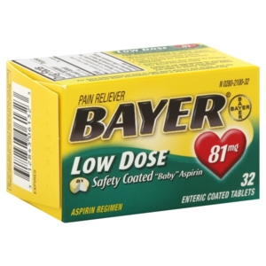
- Aspirin does protect heart attack after taking it over a period of time BUT it can cause negative consequences for the stomach and so it is important to take aspirin under the directions of your doctor who will most likely prescribe a lower dosage

Aspirin and Cancer?
- Reduction was seen but in reality it is not a very big reduction, there are actually a lot of other things that reduce your risk more

A.S.A to make explosives…
- Anders Breivik
- Bought cases of aspirin tablets to isolate salicylic acid in order to make picric acid

Side effects of Aspirin
- Death
-More than 60 tablets at once
-Often suicidal
- Tinnitus
-More than 10 tablets
-This is a warning of salicylism (aspirin poisoning)
- Stomach irritation
-Prostaglandins help protect the stomach by decreasing HCl production and increasing mucus production
-Aspirin inhibits prostaglandins and causes access HCl and decreased mucus production
-This happens if you are taking aspirin over a prolonged period and can cause overall stomach damage
-Was also found that the tablets caused more stomach irritation, especially when taken on an empty stomach

How to counteract this stomach irritation….

Bufferin
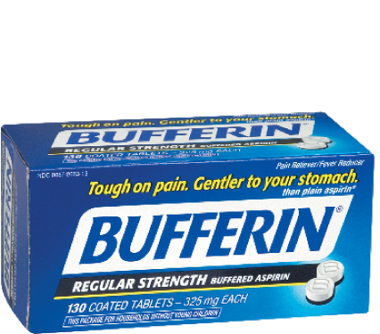

- Contains an antacid to counteract the stomach irritation
- MgSO4 (gypsum)
- Pills dissolve quickly

Plastic coated Aspirin tablets
- Also created to counteract the stomach irritation that regular aspirin tablets cause
- Will do so by passing through the stomach and will only dissolve when they reach the intestines

Drinking lots of water with Aspirin
- This is another useful method in counteracting the stomach irritation of aspirin

Children’s Aspirin (Rye syndrome and influenza)
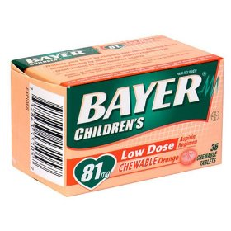
- Association between children taking aspirin and getting rye syndrome
- No causative link but Bayer’s decided to take this product of the market as a precaution

Regular vs. extra strength Aspirin
- Extra strength contains the higher dose
- Often people buy the extra strength because they believe it will get them a better desired effect quicker and longer

Tablets vs. caplets vs. gelcaps

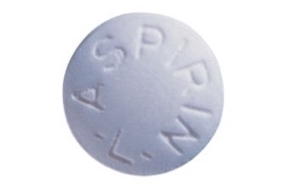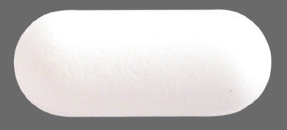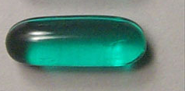
- Gelcaps are often more expensive because companies claim they give you a faster effect. It is true that they dissolve quicker in the stomach but it will not necessarily cure your headache faster since it takes a long amount of time no matter what form the pill is in.
- In reality it is not a huge difference between the two. The gelcaps may provide relief within 20 minutes compared to 25 minutes
- Often companies will tell you things like this that are scientifically true but often don’t translate into a large impact in reality. The differences are realistically small

Some forms add caffeine for headaches
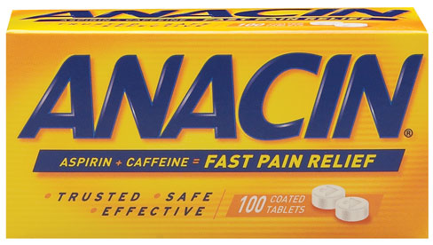
- A.S.A = 325 mg, Caffeine = 32 mg
- This is a very small amount of caffeine and it is useful to instead just drink a cup of coffee
Generic vs. name brand
- Often we associate higher price and thus better quality in name brands but this is not the case when it comes to drugs
- Generic drugs have the same…
-chemical structure
-dosage
-bioavailability
- When looking for generic brand use the name brand to find the scientific name and compare

Price per 100 tablets

Bayer aspirin | $ 9.49
Bayer aspirin (extra strength) | $ 9.99
Bufferin | $12.49
Bayer coated aspirin | $15.82
Anacin | $11.49
Bayer Aspirin Low Dose | $17.99
Generic A.S.A. | $2.50
Generic A.S.A. | $7.99
- Extra strength is basically the same price as regular strength because they tend to sell a lot less of regular strength so the jack up the price to account for storage, shipping, etc.
- Low dose aspirin is for continued use for the heart – usually it is taken by prescription and so they charge you the higher price since it often goes through insurance companies. In reality you could just take ¼ of a regular pill

A. Cahn & P. Hepp 1886 – Antikamnia (antifebrin)
- Experimenting to find a vermifuge (dewormer)
- Noticed fever reduction and pain relieving effects in person who was given acetanilide which used to be called Antikamnia (antifebrin) and was made from coal tar

Carl Duisberg
- Chemist at Bayer
- Needed to dispose of 50 tons of aminophenol
- Made Phenacetin which turned out to have pain and fever reducing abilities

Phenacetin
- APC tablet
  - Aspirin
  - Phenacetin
  - Caffeine

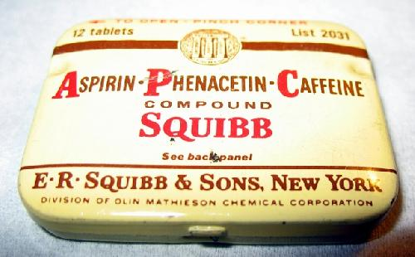

It was found that BOTH Antikamnia (antifebrin) & Phenacetin were converted to acetaminophen in the body (1947) ….

Acetaminophen
- Reduces pain by raising the bodies pain threshold
- Nothing to do with prostaglandin production
- Found to be good for both visceral and muscle pain
- Also found to be an antipyretic

Acetaminophen and Arthritis
- Can help with osteoarthritis and rheumatoid arthritis
- But found to be less effective since it does not help with inflammation (prostaglandins)
- Especially not beneficial for rheumatoid arthritis since it is characterized by inflammation
- Tylenol can be packed for arthritis or muscle and body with a higher dose

Stomach irritation and Acetaminophen
- A.S.A caused a strong and chronic irritation
- Acetaminophen has a listed precaution for weak irritation of the stomach only because it is in the same drug family

No risk of Rye Syndrome
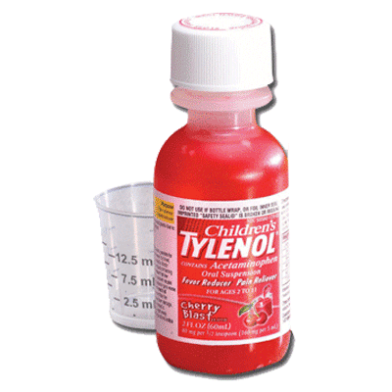
- No association was found for acetaminophen
- Produced in small bottles for safety reasons

Acetaminophen and risk of death
- More than 60 tablets
- #1 suicide drug in England

Acetaminophen liver toxicity

- This has become a big problem these days since acetaminophen is being used in many other products such as prescription medications or OTC meds such as cold meds
- If you take high doses or take while drinking (or for hangover) the bottom pathway gets switch on

Tylenol migraine
- Acetaminophen 500 mg
- Caffeine 65 mg
- Used because caffeine constricts the basal blood vessels that are dilated and causing pressure on the brain’s membranes
- Might as well drink a cup of coffee since this amount of caffeine is not worth the extra cost

Tylenol PM
- Acetaminophen 500 mg
- Diphenylhydramine 15 mg (antihistamine found in Benadryl that makes you drowsy)

Tylenol and cyanide – 1982
- Person bought a bunch of boxes of Tylenol, emptied the acetaminophen and resealed it with cyanide. Randomly put boxes of these on the shelf and about 7 people died
- Company recalled the drug every single capsule of this around the world to deal with the problem
- Episode led to safety measures and these capsules were replaced with caplets (more difficult to counterfeit these)
- They started to use caplets to replace capsules and created safety seals

Price for 100 tablets

Tylenol | $10.49
Tylenol extra strength | $9.00
Tylenol migraine | $13.88
Tylenol muscle and body | $18.74
Tylenol arthritis | $22.98
Tylenol PM | $17.98
Children’s Tylenol | $32.99
Generic acetaminophen (brand X) | $3.20
Generic acetaminophen (brand Y) | $7.99
- Regular strength costs more than extra strength
- Arthritis costs more even though it is exact same pill and dose as muscle and body

Ibuprofen
- Developed 1961
- Originally by prescription only
- OTC use approved 1984

Inhibits cyclooxygenase
- Ibuprofen works by inhibiting cyclooxygenase by blocking the active site. Ibuprofen does the same thing as aspirin except it binds to a different spot. Because of this it gives the same type of pattern of affects

Summary
- Effective for pain, fever, inflammation, reduced blood clotting, causes stomach irritation, doesn’t prevent heart attack, not associated with Rye syndrome or liver toxicity, no reduced visceral pain, relief often lasts longer

Advil & Motrin
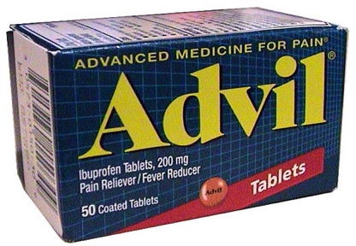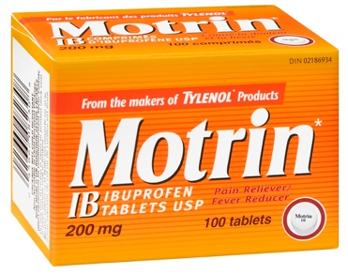
- Both contain Ibuprofen

Read the back of the box NOT the front…
- Back of the box satisfies government regulations whereas the front is used to sell you the product (marketing tricks)
-Migraine products seen as way better (even if they may not have a migraine they buy it because they think it is stronger)
-But regular Advil actually has the same amount as he migraine one but the migraine one is more expensive

Price for 100 tablets
Advil | $23.60
Extra strength Advil | $24.29
Advil Migraine | $32.40
Motrin | $12.49
Extra Strength Motrin | $14.69
Super Strength Motrin | $24.98
Children’s Motrin | $45.79
Generic Ibuprofen Brand X | $4.59
Generic Ibuprofen Brand Y | $17.68
- Motrin is half the price of Advil
- Motrin doubles the price for the Super strength but to manufacture these the amount of ingredient in there is actually .20 more expensive…. They double the price because they can because the consumers assume it costs twice as much since there is twice as much to manufacture but really that isn’t true and they are super cheap to add extra because it isn’t expensive to buy those ingredients

Naproxen
- Aleve
- Very good for
inflammation
- Generic now available
- Relatively expensive
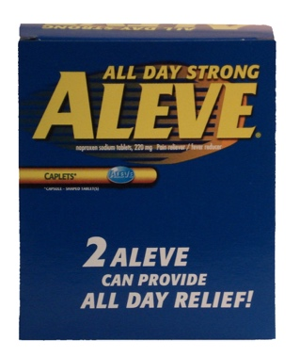

Top pain relievers (North America)
- Acetaminophen 43 %
- A.S.A. 28 %
- Ibuprofen 26 %
- Naproxen 3 %

COX-1 and COX-2
- Cyclooxygenase has different forms that affect different parts of the body
- Carry out same chemical reactions but different shaped

Effect of COX-1 inhibition
- Stomach
  - HCl production increases
  - Mucus production decreases
- Platelets
  - Clotting is inhibited
- Long term COX-1 inhibition
  - Ulcers in stomach can bleed severely
- Harmful effects!

Effect of COX-2 inhibition
  - Reduces pain
  - Reduces inflammation
  - Reduces fever
- Beneficial effects!

Current arthritis treatments…
- Inhibit both COX-1 and COX-2
- COX-2 is beneficial
  - Reduce pain
  - Reduce inflammation
- COX-1 is harmful
  - Stomach irritation
  - Blood clotting inhibited
  - Bleeding ulcers in chronic users

Selective COX-2 inhibitor for arthritis: VIOXX

Clinical trials
- Approximately 60 studies were done
  - More than 5000 patients
  - No serious side effects
  - No difference in cardiovascular disease vs placebo
- Drug approved in 1999
  - Sales averaged $ 2.5 billion/year
- When drug went onto market they continued their clinical research and started getting carried away
- Illustrated reduced risk of ulcer
  - 18-month study
  - Used naproxen as a placebo
    - Used VIOXX at twice the normal dose
    - naproxen was given at the normal amount
  - Study showed 54 % reduction in serious GI side effects with VIOXX
    - 56 out of 4047 for VIOXX
    - 121 out of 4029 for naproxen

BUT when the FULL data was released to the FDA…
- Increase risk of heart attack
  - 0.4 % for VIOXX (45 out of 4047 patients)
  - 0.1 % for naproxen (19 out of 4029 patients)
  - No difference in mortality
- Paper in NEJM reported no adverse effects
  - Only data from first 10 months was included
- This caused a media outbreak toward VIOXX

FDA Analysis of 1.4 million patients
- Estimated that VIOXX caused 88,000 – 139,000 heart attacks during 1999-2004
- In 2004, Merck voluntarily removed drug from market
  - Cut 7000 jobs
  - >10,000 lawsuits

2005 Advisory Panel Conclusions
- FDA conferred an expert panel and found that Vioxx should be allowed back on the market since benefits outweigh risks…

- Current arthritis treatment
  - FDA estimates 10,000 to 20,000 deaths/year from gastrointestinal bleeding
- VIOXX as an arthritis treatment
  - FDA estimates 18,000 – 28,000 heart attacks/year
  - Risk of heart attack similar to ibuprofen
  - Improved labeling and MD education
- Merck refused to re-introduce the drug
  - Risks outweigh benefits
  - >10,000 lawsuits

3 – Headaches

Cephalagia
- 90% of population experiences it

It was once believed that headaches caused by demons…
- Thought that the demon needed to be removed to relieve pain
- Used methods such as putting head in ovens, metallic tractors (hot needles) to pull out the pain
- Surgically they would use trepanation as a cure for headache in which they would cut holes in the skull to relieve the pressure. Not many people survived this although it is still done today… Peter cult movement believes holes are important to relieve pressure

Brain does not feel pain
- The brain doesn’t actually feel pain
- It is the thin tissue surrounding the skull which has nerves which feel pain

Understand the headache before treating
- 12 types of headache
  - 60 sub-types
- Headaches grouped into 2 classes
- Muscular
- Muscle band around skull contracts and put pressure and pain on the thin tissues
- Caused by STRESS
- Treat: A.S.A, acetaminophen, ibuprofen and naproxen. In particular use prostaglandin inhibitor because muscle contraction linked to prostaglandins Tylenol (A.S.A) won’t be as effective
- Vascular
- 3 major types
-Toxic
-Migraine
-Cluster (don’t need to know this one)

- Toxic headaches are caused by ingestion of poisons. For example: alcohol. The pain is caused by vasodilation when there is an increased blood flow around the skull and cause pressure and pain to surrounding tissue. This is why we feel hungover after a night of drinking.

The metabolism of alcohol contributes to this type of headache…
-Our hangover depends on the availability of the enzymes that break down alcohol (alcohol and acetaldehyde dehydrogenase). Often people will gain alcohol tolerance because they have more of these enzymes produced.
-Others lack the copies of the second enzyme needed to break down acetaldehyde (second bi-product). This creates large amounts of acetaldehyde in the bloodstream which contributes to the hangover
-This is most common in people of Asian descent

Aging adds to the pain (not able to break it down as it used to)

Presence of congeners increases severity
-The darker the color of the alcohol, the worse the hangover
-For example: whiskey and red wine will give you worse headache than vodka or gin

Alcohol & increased liver function
- Don’t take acetaminophen for hangover

Other vasodilators that trigger headaches…

- Red wines that contain histamines
- Fermented food that contain histamines
- Aged cheeses that contain tyramine
- Chocolate that contains phenolaphelamine
- Processed meats that contain nitrites
- Nitroglycerin found in saw dust to make dynamite

MSG (monosodium glutamate) & headache association
- MSG is often associated with headaches
- Popular in Asian foods
- Millions were spent researching potential effects
- MSG does NOT cause headaches
- MSG is in virtually all prepared food disguised as hydrolyzed vegetable protein
- MSG is a normal human metabolite (5% of our protein and produced constantly in the body)

Caffeine
- Often experience rebound or withdrawal
- Once you dose yourself up with a vasoconstrictor the body pushes back and enlarges blood vessels when you don’t have enough of the coffee in your system

Brain freeze
- Short term
- Soft pallet in your mouth interprets that your upper part of the body is cold and so it wants to heat up
- The cold in this case is acting as a toxin

- Migraine headaches

- Often an overused term
- Migraines affect smaller % of the population
-Only 16% of women get migraines
-And 6% of men get migraines

Migraine headaches are a two-stage process:

Phase 1: Vasoconstriction
- This happens before and after pain is experienced

Phase 2: Vasodilation
- This is when pain occurs

Migraines initiated by triggers…
- Tension
- Lack of sleep
- Menstruation
- Foods
- Stress
- Relaxation
- Too much sleep
- Pregnancy
- Drugs
- Strong smells

Migraine headaches follow a progression
- Prodrome
-Warning phase in which you experience mood swings
-30 to 40% of sufferer’s experience this
- Aura
-One or two hours before pain phase
-Experienced by 20 to 30%
-Scotomas: flashes of light, visual disturbances
-Olfactory hallucinations
-Auditory hallucinations
-Vertigo
-Reduced sensation
-Hypersensitivity
- Pain
-Involves half of the head (hemicranias/hemigrania)
-Lasts 1 to 72 hours
-Nausea is common
-GI disturbances: constipation or diarrhea
-Movement will make it worse (stay as still as possible)
- Postdrome
-“Hung over” phase
-May take hours or days
-Characterized by exhaustion, poor concentration, depression or euphoria

- May not experience all four steps*

Treatment
- Pain meds and ride it out
- A.S.A, acetaminophen, ibuprofen, naproxen
- Prescription pain meds – codine takes edge off but not fantastic fix
- Triptans can abort a migraine BUT once pain stage starts it’s hard to help

Rye bread & ergotism (St. Anthony’s fire)
- Rye bread common in medieval Europe
- Ergot is a fungus that grows on rye
- People would eat contaminated rye which causes gangrene which causes vasoconstriction of the blood vessels in the extremities
- Gangrene would require amputation

Midwives & Ergot
- Midwives used ergot to induce labor involuntary muscular contractions

BUT ergot is a powerful hallucinogen…
- Ergot poisoning seen as demonic possession
- There was an inquisition in Europe and women were accused of witchcraft
- Normal law was suspended for witches and there were special laws against witchcraft
- Would torture them. This included throwing them in water to see if they would float or sink. If they would float they were a witch, if they sunk they weren’t but would die

Extracts of ergot for migraine 1862
- Treatment for migraine in proper doses
- But when you use an extract you can’t control the amount of active ingredient

Arthur Stoll isolates ergotamine in 1918
- Powdered form standardized for migraine treatment
- Accurately measured quantity
- Cafergot is available today (ergotamine and caffeine)

Ergotamine is not drug-like
- Prevents migraine
- Poison in high doses
  - Hallucinations
  - Muscular contractions
  - Vasoconstriction
  - Gangrene
  - Death

Drug-like substances…
- Provides beneficial effect
  - Specific
- Limited side effects
  - Low incidence
  - Low severity
- Cheap to manufacture
- Patentable

Albert Hoffman discovers LSD by accident
- Chemist was finding new drugs for mental illnesses
- Ingested it and discovered it wasn’t safe as he was riding his bicycle

LSD & the CIA
- Would use CIA at McGill in 1950s
- Used it for mind control
- Gave it to them without knowing and many of the students killed themselves due to flashbacks of the event

LSD Ergotamine
-hallucinations -hallucinations

Migraine starts with serotonin

- Serotonin is used in the center of the brain which controls mood and emotions
- In the aura phase serotonin decreases before the pain phase
- You can then prevent migraine by replacing missing serotonin with a drug
- Do this by using an artificial neurotransmitter that mimics serotonin

BUT serotonin is a poor drug
- Used in many parts of the brain
  - Drug must only affect migraine
- Does not easily pass from blood to brain (blood brain barrier)
  - Drug must travel from stomach to brain in the blood

Sumatriptan
-Selectively engineered to mimic serotonin
-Doesn’t cause hallucinations, gangrene, death, etc.
-Goes to stomach and the center of the brain needed to stop migraine

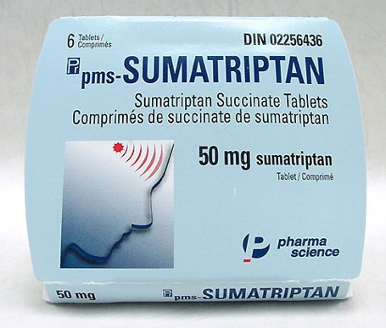
-Needs to be taken before the pain in the aura phase to work

Many options for migraine
- Sumatriptan
- Rizatriptan
- Naratriptan
- Zolmitriptan
- Eletriptan
- Almotriptan

Important to have a choice of these different medications because:
- Create market place competition to reduce price
- Patient may respond well to one drug than another
- One may have more intense side effects
- Choice really important so you can find which one works for you

4 – Colds

Colds are the most common infection
- Outnumber all others by 25 to 1

More than 200 viruses cause colds
- Rhinovirus 30 to 50 %
- Unknown 20 to 30 %
- Cornavirus 10 to 15 %
- Influenza virus 5 to 15 %
- Respiratory scincitial virus 5 %
- Parainfluenza virus 5 %
- Adenovirus <5 %
- Enterovirus <5 %
- HMPV 1 %
- Bocavirus 1 %

- You will not get the same virus twice

Viruses destroy tissue, immune system makes symptoms…

No cure for the common cold
- Average cold lasts a week
- Some cold medications relieve symptoms
- Many remedies do nothing
  - Doing something makes you feel better
  - Even if you do nothing, your cold will last the same amount of time
- No medication will prevent colds

Common Cold Research
- Common cold research unit in Salisbury, England
- Advertised a free vacation for research
- A lot of intense testing was involved

They found that…

Sneezes do not spread colds well
- They measured this through a sneeze collector. They would induce an artificial sneeze by dropping liquid within the nose

Being cold does not cause colds
- Winter time and cold temperatures has nothing to do with causing colds
- Wet hair will not cause colds

Direct exposure to virus doesn’t always cause cold

Cold virus found mostly in nasal secretions
- Common source of spreading virus from one person to another
- Human beings touch their face a lot and pick up the mucus on their hands and spread it by touching common surfaces
- They did experiments to see how easy nasal secretion can spread and found it was spread very easily (experiment was later confirmed by the Myth busters)

Cold viruses are transferred by touching
- Most likely by commonly touched objects

Colds are more common in crowds
- School season is cold season. Cold season tracks perfectly with school season since in the summer we are not in school
- For example: Tristan ca Cunha is an isolated island and would only get outbreaks when ships would come. Would never get ships in the winter (for them it is between June and August) since the weather would be so bad. There would be no outbreaks even though it was winter

Washing hands may reduce colds
- Hand sanitizer works good for bacteria (not viruses). But don’t overdo it because it can cause skin damage and break the natural oil there that protects the skin

Incidence of colds decrease with age

- Behavior changes
-Young children are more social
-They are not shy in their behavior
-May not be as diligent in washing their hands or covering their mouth

- Acquire immunity
-Body makes antibodies when you get infection
-After each infection you build up memory cells
-Later exposure to same virus does not make you sick

$4.1 Billion on colds each year in North America

*Read the back NOT the front of the box
- The front of the box is for marketing the product so you will buy it
- Back of the box is the most important. For example: Buckley’s ingredients include non-active ingredients such as potassium bicarbonate and ammonium which have no real therapeutic remedy. Menthol and camphor are artificial flavors that don’t do anything but make you feel a bit better

Cold remedy ingredients
- Pain reliever or fever reducer
- Decongestant
- Antihistamine
- Antitussive
- Expectorant

- Pain relievers and fever reducers

Acetaminophen vs. Ibuprofen
- Too many products are made with acetaminophen which is dangerous for the liver
- Ibuprofen is becoming a common replacement

No such thing as a sinus cold
-No difference between a cold and sinus infection. If you have a cold your sinuses are often infected
-Idea that sinus cold is worse than a regular cold and so sinus medication would be more effective, but this isn’t true
-Good cold medication usually does have sinus on it but look at the back of the box to find pseudoephedrine because this is effective

Menthol for sore throat?
- Menthol is a weak topical analgesic
- Buckley’s has 22mg of menthol but most of it goes to waste since you swallow Buckley’s quickly and it won’t reach the topical surface it needs to treat which is your throat
- Menthol cough drops have 2.5mg but are more effective because they give topical contact

Cepacol contains topical anesthetic

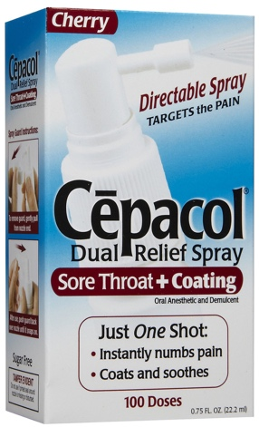

- Contains Benzocaine 15mg which is an anesthetic
- Completely reduces sensation
- Only to be used for severe cases
- Not recommended for small children or extended use

- Decongestants

- Dry a runny nose
- Pseudoephedrine and Phenylephrine

Snot is mostly water with a little protein called mucin

Water is supplied by the blood
-As the blood vessels get larger from vasodilation the cells stretch and causes water
to leak out through the spaces to contribute to mucus
-Decongestants dry up the water supply by constricting the blood vessels

Amphetamine – the original decongestant
- For cold symptoms
- Became very widely used
- Great at the beginning but starts to become a recreational drug in the 50s and 60s

Phenylpropanolamine (PPA) – Amphetamines
- The cold companies decided to switch to related structures called phenylpropanolamine
- Side effect is appetite suppression

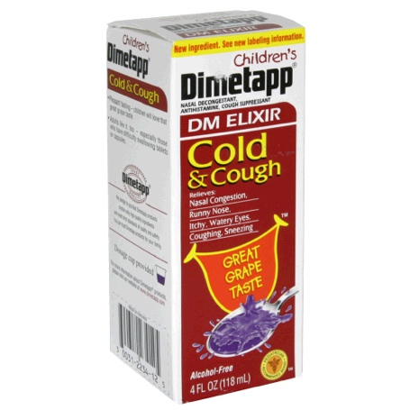

Diet pills used phenylpropanolamine (PPA)
- Side effect was decongestion

Over-use of diet pills caused hallucinations
- Amphetamine psychosis
- Overuse caused hallucinations
- Also caused strokes since it stimulates the heart to beat faster and puts pressure on the blood vessels and can cause stroke
- Found that these diet pills would help lose the first 10lbs but after that its takes more work to lose the weight. People would overdose because they were not longer get the effects which started causing these hallucinations and strokes

Sudafed & Pseudoephedrine

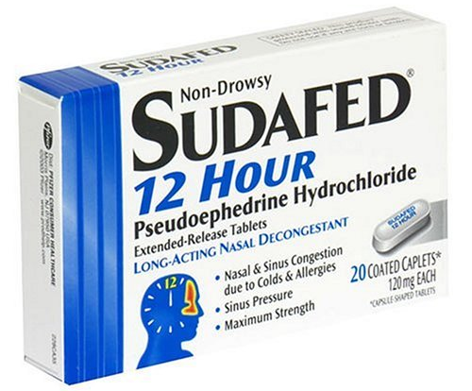
- Excellent medication to dry up runny nose
- Difficult to get

Pseudoephedrine to make methamphetamine…
- Similar to meth in chemical structure
- Drug dealers used to buy direct
- It was found that up to 50% of pseudoephedrine used to make methamphetamine
- Dealers turned to “smerfing” go to local drug stores and pick up every single box of Sudafed
- In the early 2000s they passed regulations in which you need to ask for Sudafed behind the counter
- But criminals were still breaking into warehouses

Now in the States Sudafed contains Phenylephrine
- They changed the ingredient but this one is not an effective alternative

Pseudoephedrine is still widely available
-Can still get it in Canada
-Code word to look for is “sinus”
-Read back of box to make sure it is pseudoephedrine

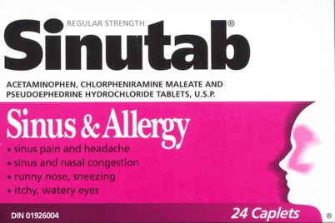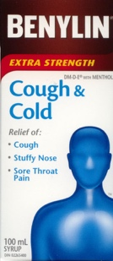

Nasal sprays contain decongestants

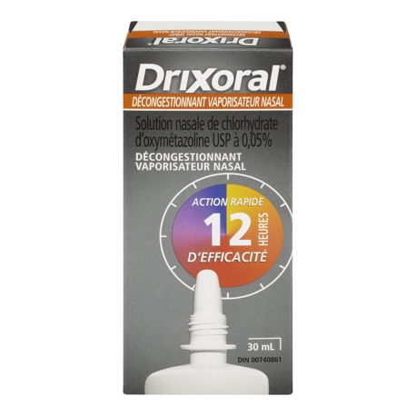

- Antihistamines

- Used for sneezing, runny nose, watery eyes
- Main side effect is drowsiness

- Chlorpheniramine is most common antihistamine for colds

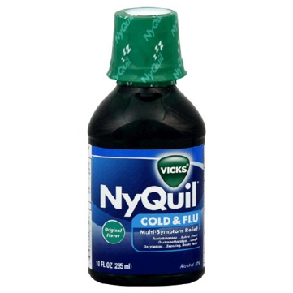*Side effect is drowsiness

Second generation antihistamines
- Do not enter the brain and do not cause drowsiness

Antihistamines and nausea
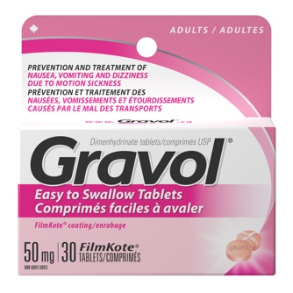
- Contain dimenhydrinate
- Stimulant added to counter the effects of drowsiness

- Antitussives

Cough Syrup
- Marketing trick
- No added benefits of cough syrup compared to taking a pill
- Goes back to the 1800s, these compounds such as opium were super useful for cough suppression and got the reputation that these syrups work well
- Heroin used to be the best way to reduce your cough. It was also an original cough medication sold as a syrup

Dextromethorphan used today
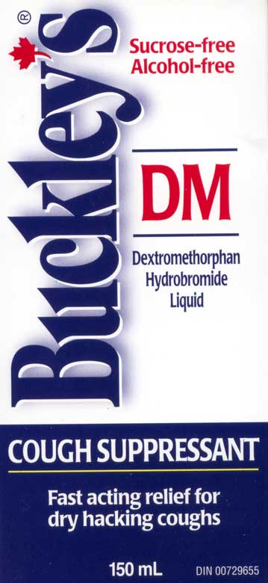

- Structurally similar to heroin
- Mirror image forms of one another
- Heroin is a narcotic with cough suppressant qualities

- Expectorants

- Used for productive cough
- Do not suppress the cough reflex
- Cause you to cough up mucus
- Since thick mucus is difficult to remove the expectorants increase water content to make the mucus watery and easier to cough up
- Makes it easier to dislodge and reduces the amount of times you cough
- It is important to cough a bit to get rid of that mucus though as well as drinking water with them to make them effective
- Guaifenesin is responsible for making mucus watery
-Actually never been clinically proven to work
-Only saw after that is was actually an effective decongestant

BEWARE of multi-symptom medications
- Look out for these
- Sold because people want to buy them not because they are truly effective
- You can’t really do that in an effective way
- Pick and choose your symptoms
- Decongestant and expectorant together – decongestant dries up by reducing water where the other one increases water and they cancel each other out no effect
- Cough suppressant and expectorant – removing urge to cough and expectorant generates more mucus (need to cough) --> clogging up with more mucus, being harmful for patient, especially children

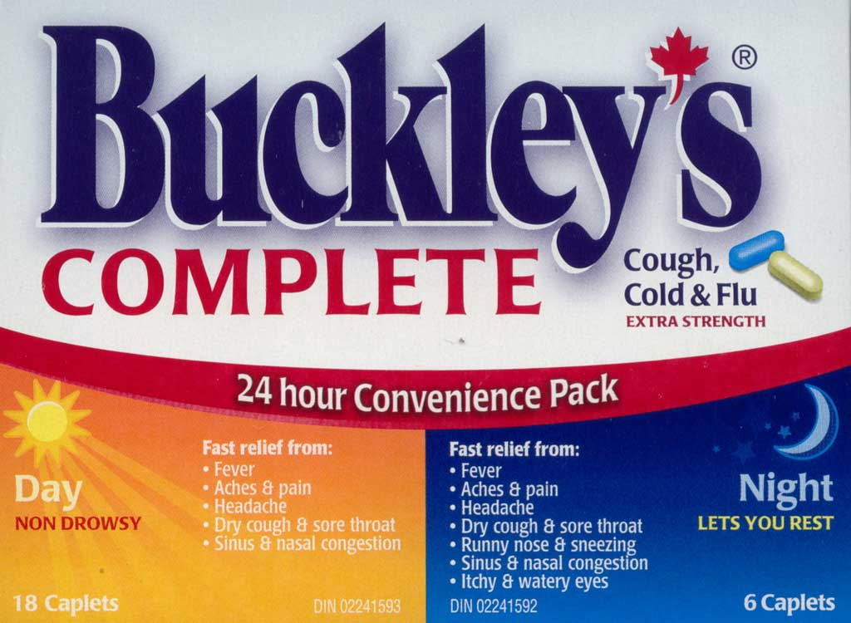
- Beware… Pseudoephedrine actually keeps you awake and gives you more energy and should not be taken at night
- Not good to mix pseudoephedrine and chlorpheniramine maleate

Health Canada advises no cold meds for children under 6
- Because people mix and match and can overdose the children – can be harmful for children

Vitamin C
- People often think vitamin C prevents cold
- Vitamin C will not prevent or cure a cold
- No real benefit

Cold-FX
- Basically selling sugar
- Nothing in here to give benefit No evidence for its effectiveness
- Used Ginseng
-Used for many things
-Resembles a human body (doctrine of signatures idea)
- No evidence for its effectiveness
- Clinical studies are low quality and do not show benefit

Buyer beware
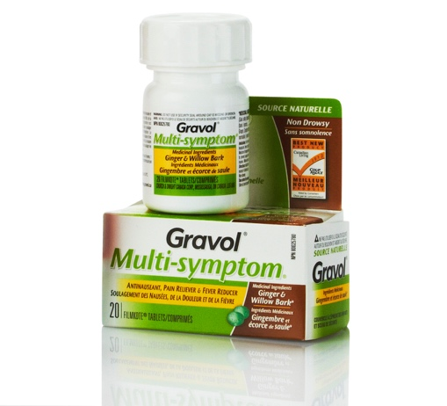

- Willow and ginger Gravol as cold medication
- Evidence showed very weak effect, only killed 80% of viruses in test tube
- Contains much less amount of willow needed to reduce fever

15% of colds due to flu virus
- Symptoms of a cold are the same with viruses

Common viruses….

Influenza
- Normally infects 5 to 15 % of population
- New virus formed every year
- Most forms not dangerous
  - Very young and very old are at risk
- Occasionally very virulent strain occasionally arises

The virus contains an outer envelope
  - Hemagglutinin (viral entry into cell)
  - Neuraminidase (viral exit from cell)

Flu virus classified using envelope protein

Avian flu H5N1 (2007)
- Up to 60% mortality rate
- Millions of birds were killed to prevent spread

Swine flu H1N1 (2009)
- Emerged in Mexico
- Initially mortality rate was 70% and people were very concerned
- Disease turned out to not be as bad as we thought but the media was responsible for the hype
 | Infection rate | Deaths | Fatality rate
Spanish flu (1918) | 30% | 20 million | 2.5 %
Asian flu (1957) |  | 1 million | <0.1 %
Hong Kong (1968) |  | 700,000 | <0.1 %
“normal” (seasonal) | 5 to 15% | 250,000 - 500,000 | <0.1 %
H1N1 (2009) |  | 12,000 | <0.05 %

