4340w11
Selected issues in HTA
Underused Technologies
- HTA can result in the reduction or elimination of technologies that are unsafe, ineffective, or costly.
- Less attention is given to technologies that are underused.
- Especially disconcerting when their use could save lives, decrease healthcare costs and/or have a positive effect on the economy.
- Example:
  - nicotine replacement therapy and counseling to reduce smoking
  - Lower vaccination rates in poorer communities
Some Underused Technologies
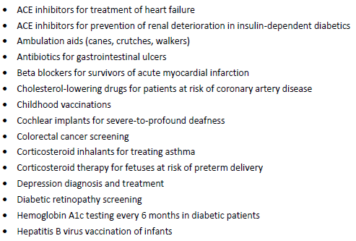
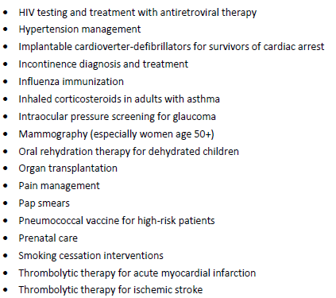

Why technologies are underused
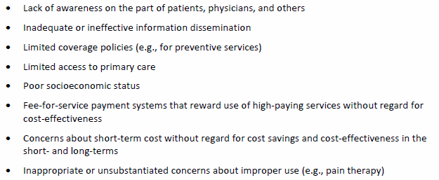
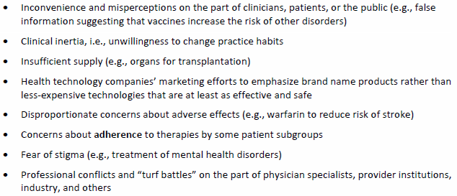
Managing Bias and Conflict of Interest
- Bias and conflict of interest are conditions, not behaviours, i.e., individual does not have to act on bias
- Can balance biases on an expert panel or disqualify individuals because of bias
- Can be at three levels:
  - Sponsors;
  - Investigators;
  - Health technology assessors.
Sponsors
- Health technology (HT) and other primary research organizations influence and control the research that is conducted
- Financial conflicts of interest are common
- HT companies sponsor trials that focus on their products and not on head-to-head comparisons
- Studies are designed to increase the likelihood of positive results
- Studies with negative results are not published or disclosed
Investigators
- Could result from salary support, consulting agreements, shares in the company or its affiliate
- Common in clinical trials of pharmaceuticals
- More likely to report positive results, biased designs, suppression of negative results
- Report in major journals
Heath Technology Assessors
- Should consider potential conflicts of interest in studies
- Consider sponsorship, investigators
- Drop or give less weight where bias or conflicts of interest are suspected
- Conflicts can be personal or non-personal, financial, status positions
- Create guidelines to protect against bias/conflicts
- See INAHTA Checklist for HTA reports

Fixed-Price Basket
The $10,000 Basket
- Say you had $10,000 to pay for healthcare in a small community
- Do you think that you should allocate $10,000 for heart surgery for one person or allocate $1,000 to vaccinations, $7,000 for primary care and antibiotics, and $2,000 on emergency needs?
Comparisons
Cost Evaluations
Intervention 1 Intervention 2
Cost1 Cost2
Item1 vs Item2
(Cost₁ – Cost₂) / (Item₁ - Item₂)

Example 1: QALY
Intervention1 Intervention 2
Cost $30,000 Cost $35,000
QALY 28 vs QALY 27
- Intervention 2 is dominated by intervention 1, so there is nothing to calculate

Example 2: QALY
Intervention 1 Intervention 2
Cost $30,000 Cost $24,000
QALY 28 vs QALY 25
(Cost₁ – Cost₂) / (Item₁ - Item₂)
($30,000 - $24,000) / (28.0 QALYs – 25.0 QALYs)
$6,000 / 3 QALYs
$2,000 / QALY

Combinations
 | Intervention 1 | Intervention 2
Cost | More | Less
Item | More | Less
Cost | More | Less
Item | Less | More
Cost | Less | More
Item | More | Less
Cost | Less | More
Item | Less | More

 | Cost | Hospitalization days
Drug A | $12,000 | 5
Drug B | $4,000 | 10
Hospital/day | $1,000
- Really only 2 distinct combinations and ones in black are dominated

Comparing Drugs

Assume that they have similar characteristics.
- Which is more cost-effective?
- What is the incremental cost?
- Which one should be funded?
 | Cost | QALY | Hospitalization days
Drug A | $12,000 | 35.0 | 5
Drug B | $4,000 | 34.5 | 10
Hospital/day | $1,000

- What is the incremental cost-effectiveness?
Case Study: Composite Tissue Transplant of Hand or Arm


Background
- Severe trauma can result in injuries to arms and legs and result in the loss of large areas of tissue. This may disrupt healing and result in amputation.
- People experiencing amputations of the hand or arm may benefit from composite tissue transplant, i.e., hand or hand and arm transplant.
- After transplant, patients must take drugs for the rest of their lives in order to prevent rejection.
- Anti-rejection drugs can lead to increased infections, heart failure, kidney damage, and cancer.
- Composite tissue transplant is being performed in some countries, but not Canada.
Research Questions
- What is the effectiveness of the transplant in adults as measured by rates of functional recovery, acute and chronic rejection, post-transplant amputation, complications, and mortality?
- What is the cost-effectiveness?
- What is the budget impact to MOHLTC?
Methods
- Conduct a systematic literature review for effectiveness and cost-effectiveness of hand and arm transplant
- Assess quality of literature using GRADE.
- Develop a Markov model to illustrate standard care vs transplant
- Calculate ICERs
- Estimate budget impact

Literature Review 1: Amputation
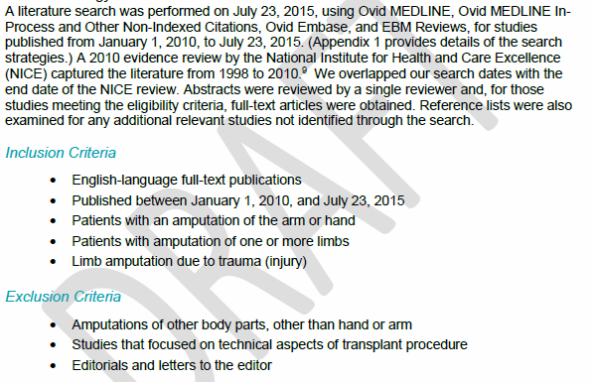
Outcomes of Interest
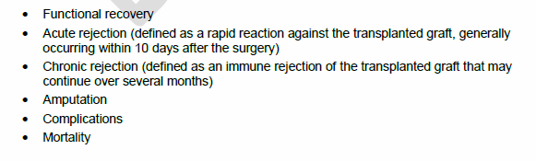

Articles Found
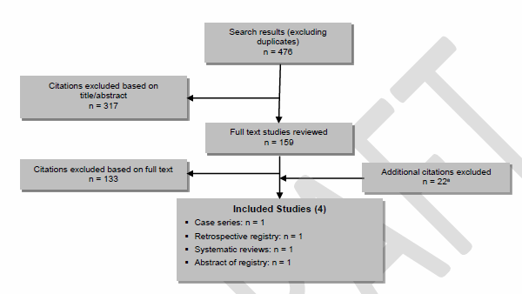

Complications
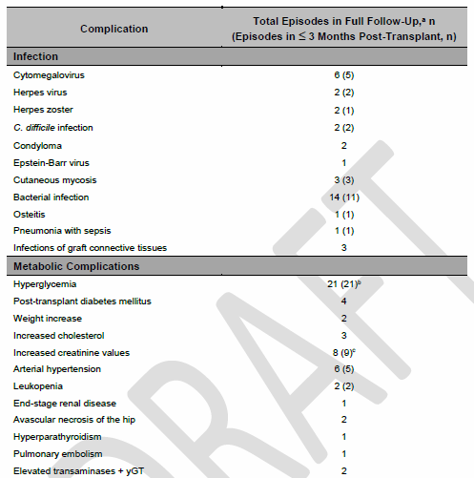
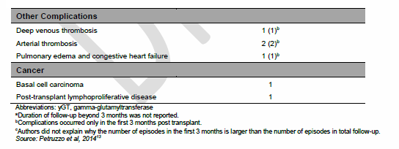
Quality of Evidence

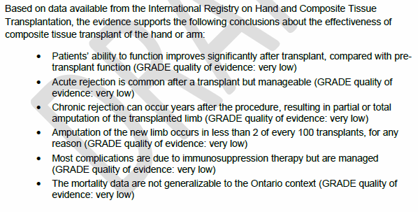
Literature Review 2: Cost Effectiveness of Amputation


Outcomes of Interest
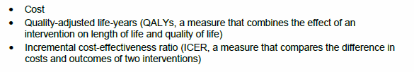
Articles Found
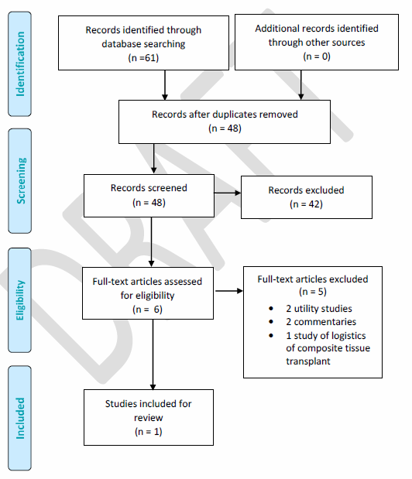
Cost Effectiveness from Literature Review
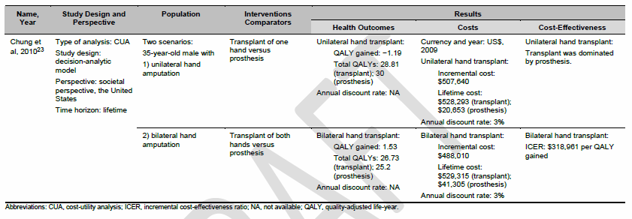
- A single study showed that a hand transplant in the US was not cost-effective.
- The HTA did not generalize the costs to Canada.
Analytic Model: Standard Care vs Transplant
Goals and Assumptions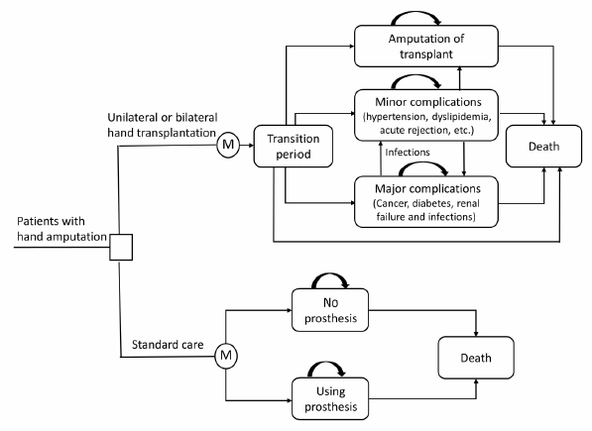
Goals and Assumptions
- Estimate the differences in costs and effectiveness between standard care and transplant.
- Estimate ICER.
- NOTE: did not consider costs where they would likely be similar between the two approaches or where they would be assumed to be minimal.
Clinical Outcomes
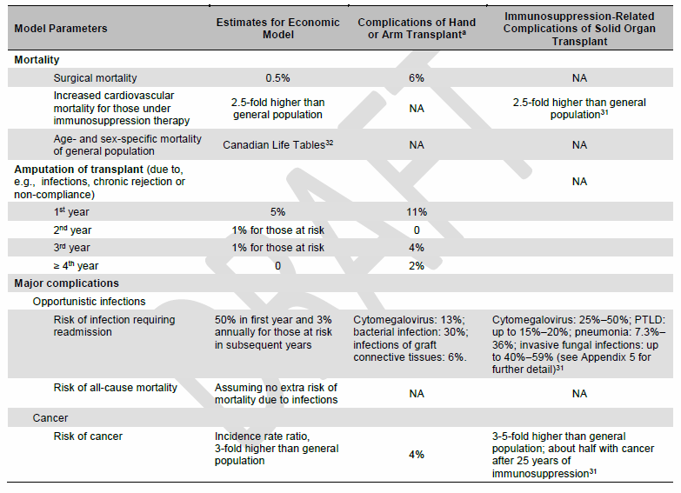
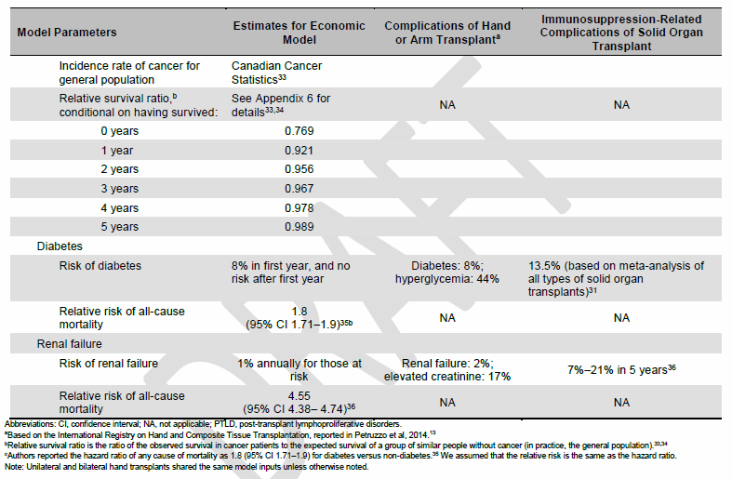
Utilities
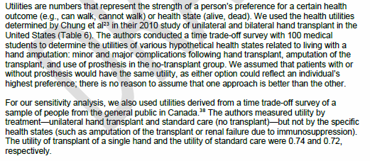

Utilities Table
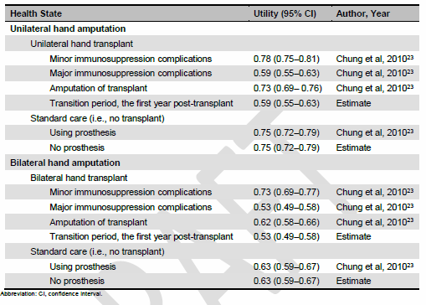
Transplant Costs
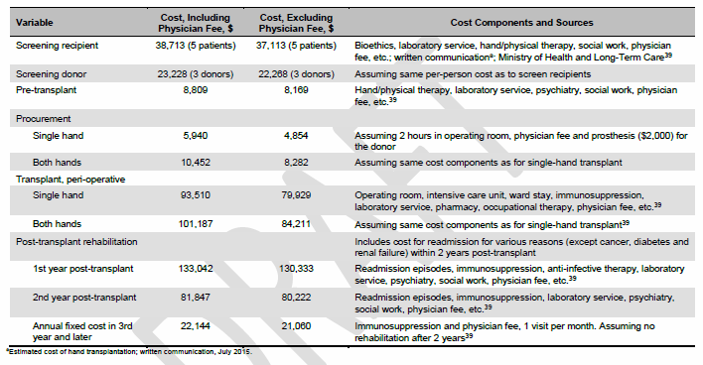

Costs of Immunosuppression Complications
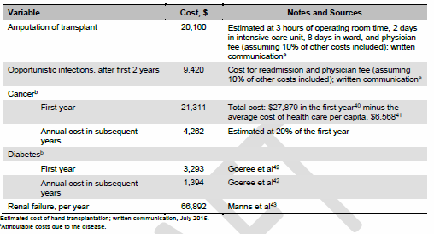
Cost of Using a Prosthesis
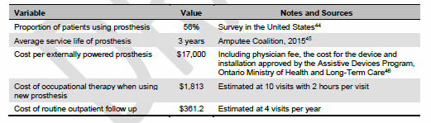
Analysis
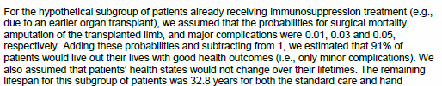
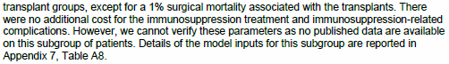
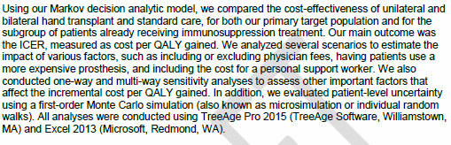
Primary Evaluation
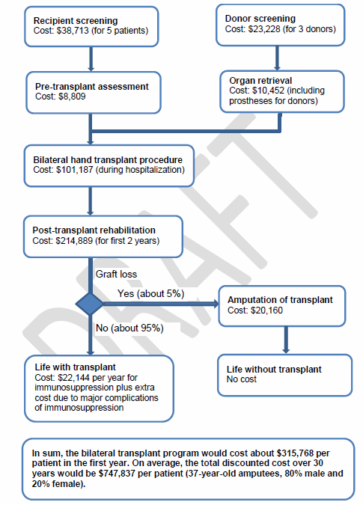

Cost Analysis
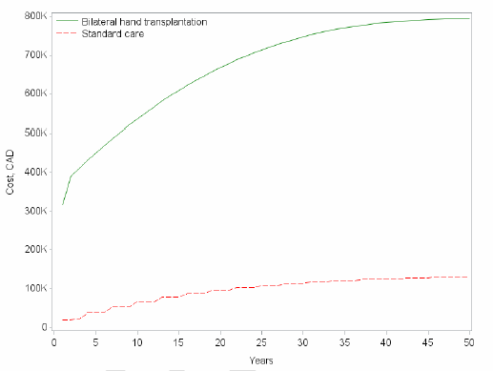
QALY Gained
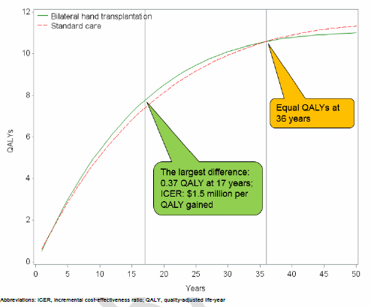

Incremental Cost Per QALY Gained
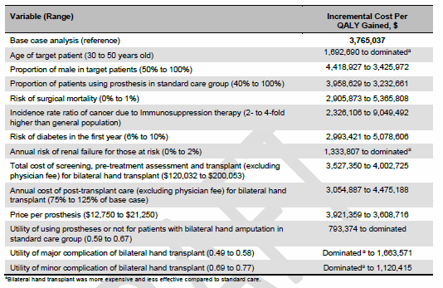
From Simulation Model
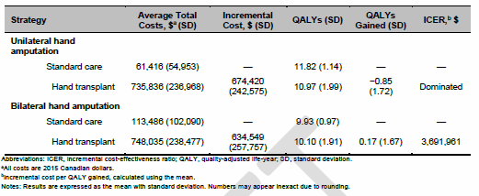

Budget Impact
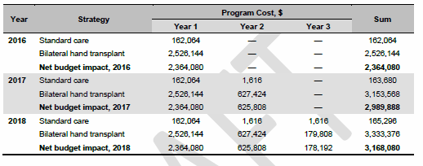
Conclusions
- Hand transplant is an expensive treatment with lower QALY than the current standard treatment
- Bilateral hand transplant is unlikely to be cost-effective
- A hand transplant program would cost $2.4 million and treat 8 adults in 2016
- Further investigation is needed
Utility
Utility from Cheng et al
- Health state from 0 (death) to 1 (perfect health)
- Based on preference of affected parties
- Survey people using a time-trade off of
  - X years of perfect health OR
  - T years of less than perfect health
  - Vary X until the respondent feels that the choices are equivalent
  - Calculate utility as X/T
- So, for example, given a 40 year life expectancy, if a respondent indicates that living with a prosthetic for 40 years is equivalent to 20 healthy years, the utility is 20/40 = 0.50
Decision Tree for Unilateral Transplant
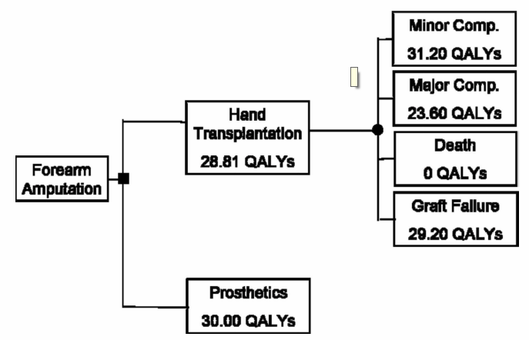

Decision Tree for Bilateral Transplant
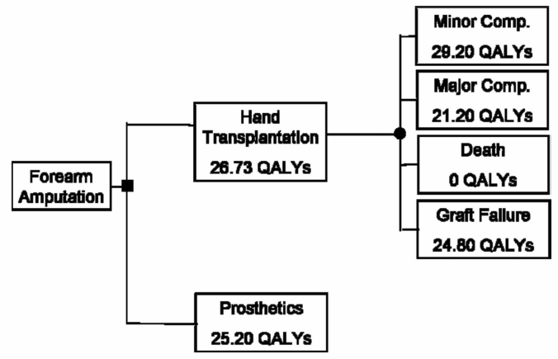
Costs
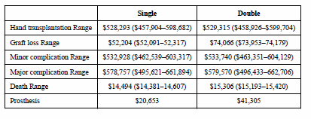
ICUR
- Survey respondents indicated a highest utility of 0.78 and 0.73 for unilateral and bilateral transplantation respectively, and lowest of 0.59 and 0.53
- Used TreeAge Software to create decision trees
- ICUR = (Cost_{trans}-Cost_{prost} )/(QALY_{trans}-QALY_{prost})
- Prosthesis preferred for unilateral amputation vs transplant -> cheaper, so nothing to calculate
- ICUR of bilateral amputation and transplant was $318,961/QALY >> WTP

Sensitivity Table
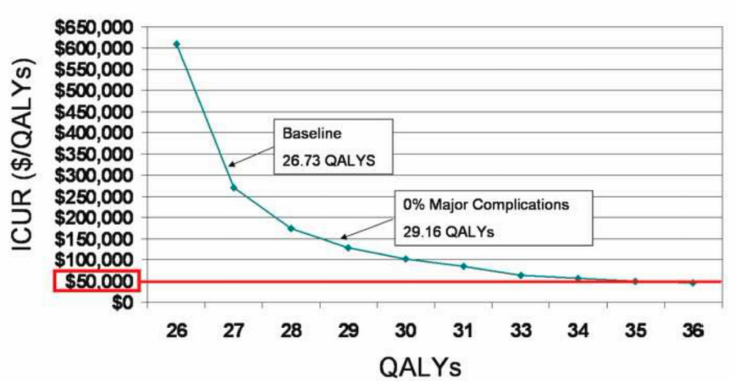
QALY Calculation
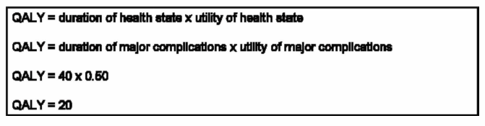
- Perfect health for the 40 years of life remaining would yield a QALY of 40 x 1 = 40.
- The utility with major complications was calculated as X/T = 20/40 = 50%.
- So, the QALY becomes 20 at 95% confidence level.
Sensitivity Analysis Varying Rate of Complications for Bilateral Transplant

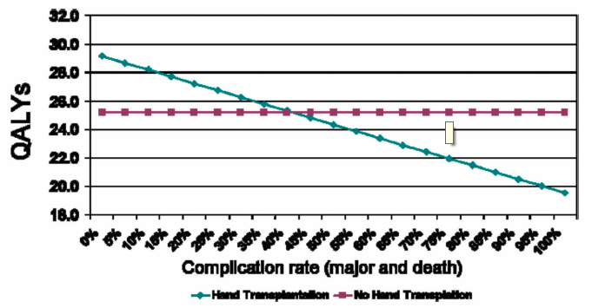

Increment QALY to get ICUR for Sensitivity Table
Cost | Cost | QALY | QALY | Cost
Trans | Prost | Trans | Prost | /QALY
$529,315 | $41,305 | 26.73 | 25.2 | $318,961
$529,315 | $41,305 | 26 | 25.2 | $610,012
$529,315 | $41,305 | 27 | 25.2 | $271,117
$529,315 | $41,305 | 28 | 25.2 | $174,289
$529,315 | $41,305 | 29 | 25.2 | $128,424
$529,315 | $41,305 | 30 | 25.2 | $101,669
$529,315 | $41,305 | 31 | 25.2 | $84,140
$529,315 | $41,305 | 32 | 25.2 | $71,766
$529,315 | $41,305 | 33 | 25.2 | $62,565
$529,315 | $41,305 | 34 | 25.2 | $55,456
$529,315 | $41,305 | 35 | 25.2 | $49,797
$529,315 | $41,305 | 36 | 25.2 | $45,186

