OB Class Notes

Chapter One- Introduction

- Three factors of individual and group behaviours in organizations
  - Individual
  - Interpersonal
  - Organizational

Levels of Analysis

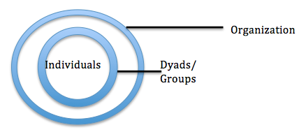

What is Organizational Behaviour?

Organizations: Social inventions for accomplishing common goals through group effort

Organizational Behaviour

- Interactions within and at different levels
- Company’s culture

- Understand- asking what
- Explain- asking why
- Improve- asking how

- People’s attitudes and behaviour in context of work
- Organizational behaviour is not common sense – for example, money is not a top motivator and people at the bottom have more stress

Evidence-Based Management

- Making managerial and organizational decisions based on recent and robust scientific evidence

Research Methods

- Hypothesis
  - Independent vs. dependent variable
  - You can tell if your hypothesis was supported through correlation
    - Correlation (r) describes the statistical relationship between two variables
    - Can be negative or positive, range from -1 to +1
    - 0 is no correlation, -1 or +1 is perfect statistical relationship

Chapter Two- Job Performance

Two Elements of Job Performance

Results

- Objective measures of outcomes
- Example: Comcast’s % of retained customers

Pros

- Easy to assess
- Objective/ comparable

Cons

- Doesn’t capture “beyond bottom line”
- Not always controllable
- No focus on improvement
- No “why”

Behaviour

- Specific behaviours employees engage in
- Example: How does a Comcast employee retain a customer

Job Performance

- Employee behaviours that contribute either positively or negatively to the accomplishment of organizational goals

Job Performance Behaviours

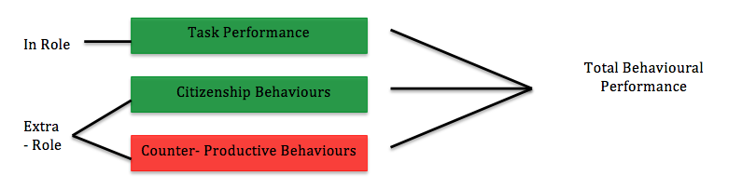

Task Performance

- In role performance, positive
- How well do you do the job you were hired to do?
- Behaviours that are directly involved in the transformation of resources into the goods or services
- Included in a job description

Three Subtypes

- Routine: Habitual responses to predictable tasks
- Adaptive: Thoughtful responses to unpredictable tasks
- Creative: Novel and useful ideas

Citizenship Behaviours

- Extra-role, positive
- Voluntary behaviours that contribute to achieving organization goals
- Can be interpersonal or organizational
- Great things people do for their organization and coworkers that go above and beyond formal requirements

Six Subtypes

- Helping
Interpersonal
- Courtesy: mindful, respectful
- Sportsmanship: good attitude
- Voice: speaking up
Organizational
- Civic Virtue
- Boosterism: represent organization in a positive way

Counterproductive Behaviours

- Extra-role, negative
- Intentional behaviours that hinder the achievement of organizational goals
- Can be interpersonal or organizational
- Can be minor or serious

Subtypes

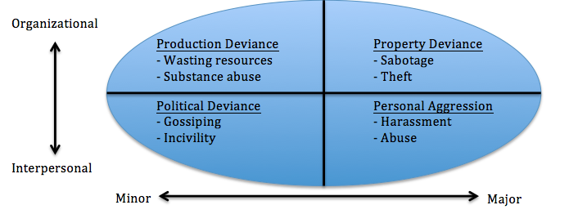

Important Takeaways

- Breaking down performance into types = greater insight
- Changes to influence behaviour = multiple outcomes

Recap

- How we define job performance has serious implications for employee behaviours and organization function (including profits)
- Need to incorporate the multi-facets of behaviours that contribute to the organization
- Job performance should be considered with the system in mind- what does the organization need?

Chapter Three- Commitment

- Know the difference between task (job) performance and organizational commitment

Why is Commitment Important?

- Turnover is expensive
- Unengaged employees are expensive (they are not working as smart or as hard)

Voluntary- when you quit because you found somewhere better

Involuntary- when you get fired

Organization Commitment

- The desire to remain a member of the organization
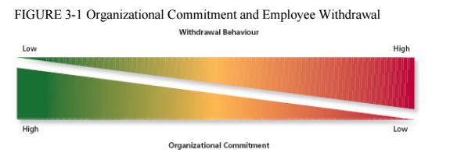

- Day dreaming at work, being late, missing meetings = low commitment

Drivers of Overall Organization Commitment

- Heart
- Calculations (money)
- Compass

Affective Commitment (The Heart)

- Employees’ emotional attachment to, and involvement with, the organization
- Staying because you want to

Two Models that Focus on Affective Commitment

- Erosion Model:
- Those with fewer social bonds are more likely to leave the organization

- Social Influence Model:
- If the person with the most bonds leaves the organization, what affect will that have? The people connected to that person might want to leave as well

Continuance Commitment (The Money)

- Perceptions of costs associated with staying vs. leaving
- Staying because you need to

Two Mechanisms with Continuance Commitment

- Alternatives

- Embeddedness
- Within the organization and within the community
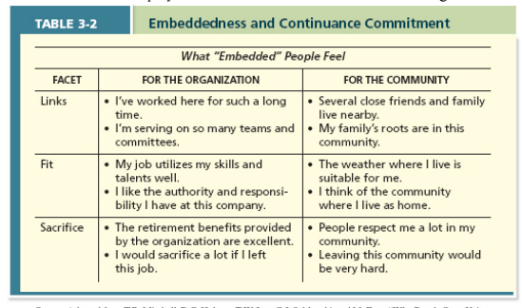

Normative Commitment (The Moral Compass)

- Feeling obligation to remain loyal
- Staying because you ought to

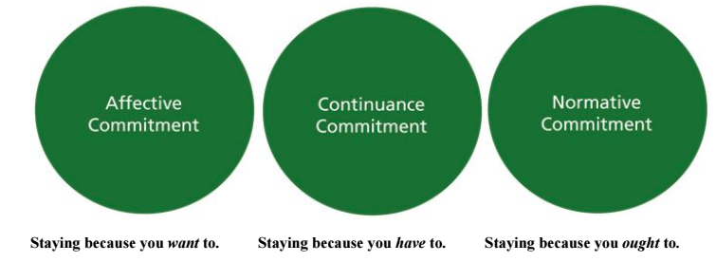
- Guilt
- Anxiety
- Sadness

How Do Employees Respond to Negative Work Events?

Voice - you are sharing your opinion on how to do things quickly (positive response)

Loyalty – “We will get through this” (positive response)

Psychological Withdrawal (Neglect) – When you can’t escape from work but mentally try and get away

Physical Withdrawal (Exit) – Actually quitting

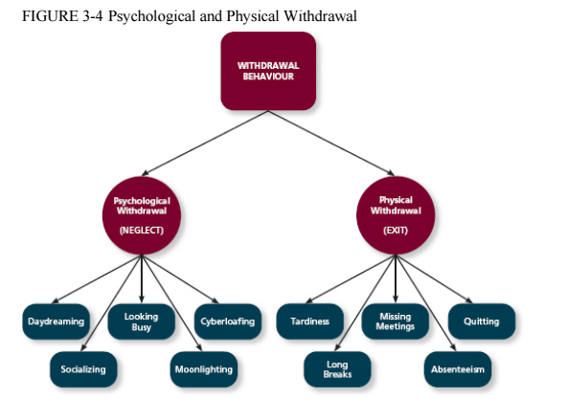

- As a manager, they should look at the signs early on of negative work responses
- Absenteeism (exit)
- Daydreaming, moonlighting, cyber loafing (neglect)

Commitment and Employment Relationships

Physical Contract – job title, duties, benefits

Psychological Contracts – the unwritten expectations that we have going into organizations

Two Types of Psychological Contracts

- Transactional Contracts
- Tit for tat

- Relational Contracts
- Looser
- I trust the organization will take care of me
- Open ended subjective obligations
- Because they are so loose, they are easy to break

Trends That Influence Commitment

- Diversity of the workforce
- The changing employee – employer relationship

Chapter Four- Job Satisfaction

What are Attitudes?

- Fairly stable (un) favourable evaluations of:
  - Specific objects, situations, persons, or categories of people

- Components: ABC’s

Affective (Feel)
+
Cognitive (Think)
Behaviour

Job Satisfaction

Job Satisfaction- pleasurable emotional state resulting from appraisal of one’s job or job experiences

- Represents how a person feels and thinks about their job

What Determines Job Satisfaction?

- Satisfaction can fluctuate on a daily basis

Disposition

- Some people are predisposed to be more satisfied

Value Fulfillment

- Does it satisfy my values?

Value-Percept Theory

Facets of Satisfaction

- Pay
- Promotions
- Supervisors
- Coworkers
- Work task
Job Characteristics Theory/ Model

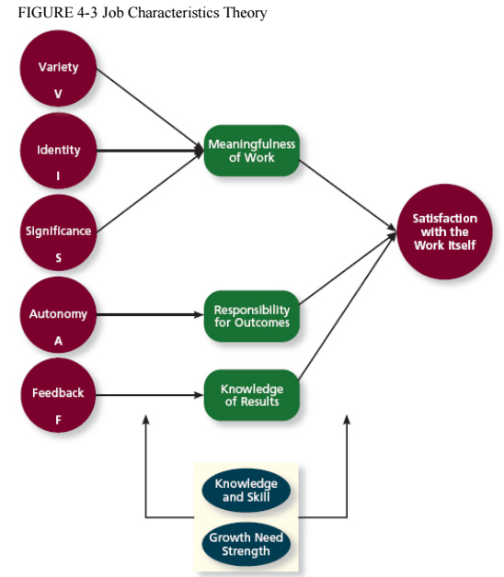

Characteristics

Variety – doing multiple things, using multiple skills

Identity – doing a job from beginning to end

Significance – doing something you feel has an impact on people

Autonomy – having independence and discretion with how you do your job

Feedback – knowing results of your job

Critical Psychological States

- Meaningfulness of work
- Responsibility of outcomes
- Knowledge of results

Mood and Emotions

- Moods and emotion differ in terms of length of time and whether they have a target or not

Affective Events Theory

- Workplace events can cause emotional reactions that impact satisfaction
- Emotions impact workplace behaviours

Measuring (Tracking) Job Satisfaction

Job Descriptive Index – a facet measure of job satisfaction that assesses an individual’s satisfaction with pay, promotion opportunities, supervision, co-workers, and the work itself

Job in General Scale – companion survey that assesses overall job satisfaction

How Important is Job Satisfaction?

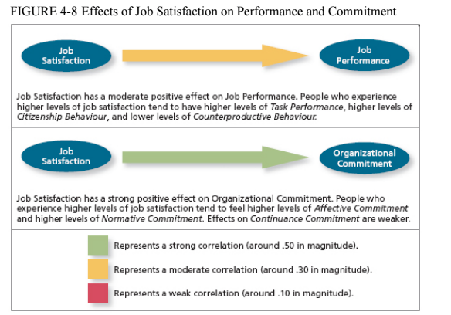

Emotional Labour – the need to manage emotions to complete job duties successfully (example: flight attendants acting happy for customers)

Emotional Contagion – The idea that some emotions can be transferred from one person to another

* Dan Ariely – Ted Talk – What makes us feel good about our work? *

Chapter Five- Stress

What is Stress?

- Psychological response to demands
- When something is at stake
- When demands > capacity to cope
- Stress process is very individual

The Stress Process

Concepts

- Stressors
- Appraisal
- Strains

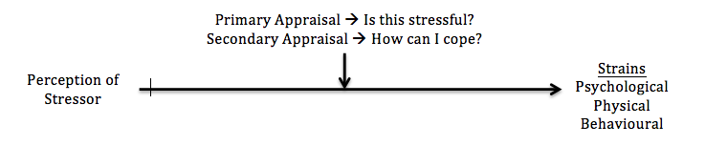
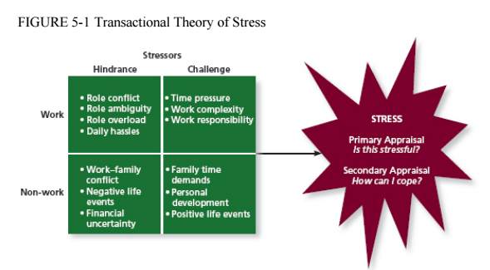

Work Hindrance Stressors

- Role overload (work load) or underload
- Role conflict
- Role ambiguity
- Daily hassles

- Interpersonal Conflict
  - Difficult coworkers/ supervisors
  - Sexual and psychological harassment

- Working Conditions and Lack of Control
  - Inadequate training
  - Physical conditions (noise, weather)

Work Challenge Stressors

- Time pressure
- Work Complexity
- Work responsibility

Non-Work Hindrance Stressors

- Negative life events
- Financial uncertainty
- Work-life conflict (not work-family conflict)
  - Time-based
  - Strain-based
  - Behaviour-based

Non-Work Challenge Stressors

- Family (friends) time demands
- Positive life events
- Personal development

Strain

- Stress reaction
- Strains can be
  - Psychological
  - Physical (physiological)
  - Behavioural

Psychological

- Anger
- Anxiety
- Frustration
- Depression
- Job dissatisfaction
- Reduced affective commitment
- Difficulty concentrating

- Burnout – extreme psychological strain
  - Emotional exhaustion
  - Cynicism (reduced level of empathy)
  - Low self-efficacy (feeling like you can’t achieve your goals or targets)

Physical

- Dizziness
- Headache
- Pounding heart
- Stomach distress
- Difficulty sleeping
- Shortness of breath
- Illness and death (“karoshi”)

Behavioural
Likely due to concentration issues
- Accidents at work
- Changes in performance
- Substance abuse (including smoking)
- Absenteeism and turnover
- Aggression (retaliation)
- Other counterproductive work behaviours

Productive Stress Reactions

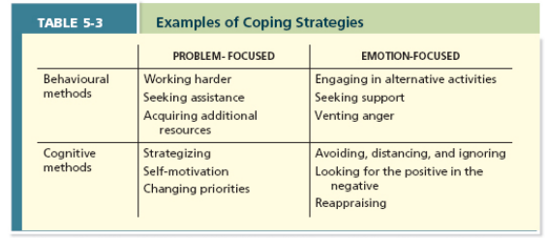

Consequences of Hindrances

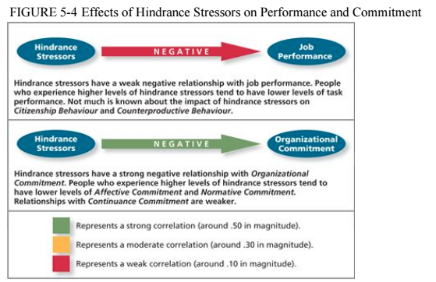

Reducing and Managing Stress

Work Planning - Help provide time and control

- Decreased/ compressed workweek (4/40 plan)
- Flextime
- Flexplace/ telecommuting
- Personal days/ hours
- Job sharing/ part-time work

Work Training – Provide control

- Knowledge
- Skills

Other Practices that Improve Resources – Time and/ or control

- Employee assistance programs (EAP)
  - Stress management
  - Time management
  - Mindfulness training (recovery)
- On-site daycares
- Gym memberships
- Connection to health specialists
- Etc.…

Type A Behaviour Pattern

- People who tend to experience more stressors, to appraise more demands as stressful, and to be prone to experiencing more strains

Chapter Six- Motivation

- Energetic forces that determine the direction, intensity, and persistence of effort

Basic Characteristics

- Intensity
- Persistence
- Direction
- Goals (formal and informal)

Two Broad Classes of Theories

- “What” Motivates
  - Need theories
- “How” to Motivate
  - Process theories

Need Theories

- Every person has different needs they try to find though work
- Maslow’s Hierarchy of Needs
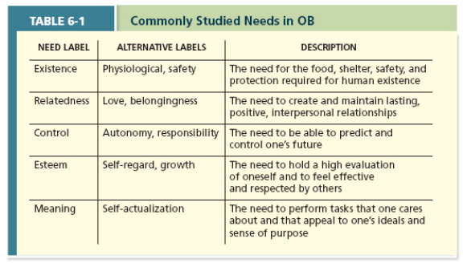
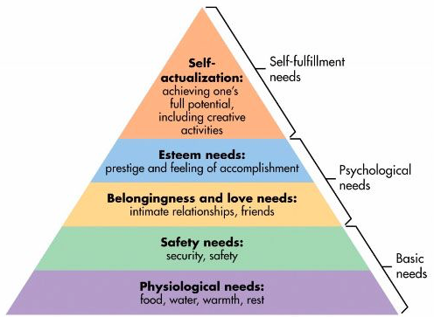

Process Theories

- Job characteristics model (Chapter 4)
- Expectancy Theory
- Goal Setting Theory
- Equity Theory
- Psychological Empowerment

How: Managerial Principles

- Employees want to see clear relationships between effort, performance, and desirable outcomes
- Employees need goals
- Employees want to be treated fairly
- Job design is a powerful motivator

Expectancy (VIE) Theory

- Employees need to see clear links between effort, performance, and outcomes
- People motivated to perform activities that they can accomplish and that lead to valued outcomes

Three core components:

- Expectancy – belief that effort performance

- Instrumentality – belief that performance outcome

- Valence – degree to which an outcome is valued

Managerial Implications:

- Boost expectancy
  - How?
- Boost instrumentality
  - How?
- Boost valence
  - How?

Extrinsic vs. Intrinsic Motivation

Extrinsic – motivated by what my performance will lead to (external forces)
- More money
- Promotion
- Praise from others
- Job security
- Expectancy Theory focuses on extrinsic

Intrinsic – motivated by value of the work itself
- Personally meaningful work
- Provides autonomy
- Allows me to display my competence
- Allows me to have an impact
- Intrinsic being Psychologically Empowered

Goal Setting Theory

- Goals are more motivating when:
  - They are specific and measurable
  - They are challenging (but not impossible)
  - People are committed to them
    - Self-set goals
  - People get feedback on their progress

- Pitfalls of Goal Setting:
  - Goals can narrow our focus
  - Aggressive goal setting can lead to unethical behaviour
  - Should place safeguards

Equity Theory

- Employees want to be treated fairly
- Our motivation suffers when we believe we got less than we deserve
- Perceived equity of distribution of rewards among employees

Equity = My Outcomes vs. Other’s Outcomes
My Inputs Other’s Inputs

- Components:
  - Outcomes
  - Inputs
  - Comparison other

Inequity:

Undercompensation = My Outcomes < Other’s Outcomes
My Inputs Other’s Inputs

Overcompensation = My Outcomes > Other’s Outcomes
My Inputs Other’s Inputs

- Ways to restore equity:
  - Modify
    - Own I or O
    - Comparison Other’s I or O
  - Change the Comparison Other
  - Leave the situation

Psychological Empowerment

- An energy rooted in the belief that tasks are contributing to some larger purpose

How Important is Motivation?

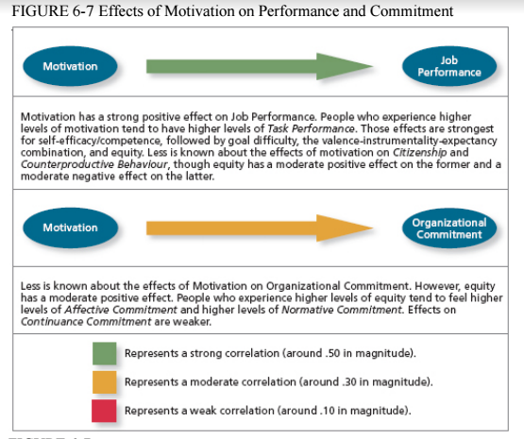

Chapter Seven- Trust, Justice, and Ethics

Trust Is…

- The willingness to be vulnerable
- Based on positive expectations
- That the other party has
- Good intentions and actions

- Disposition- based
- Cognition- based
- Affect- based

Disposition- Based Trust

- Rooted in personality

Cognition- Based Trust

- Person deemed trustworthy when they provide evidence of…
  - Ability:
    - Can I rely on this person’s skills or knowledge?
  - Benevolence:
    - Does this person want to do good for me?
  - Integrity:
    - Does this person live by a desirable set of values/ principles?

Affect- Based Trust

- More emotional than rational
- May supplement the other types of trust

Factors that Influence Trust Levels

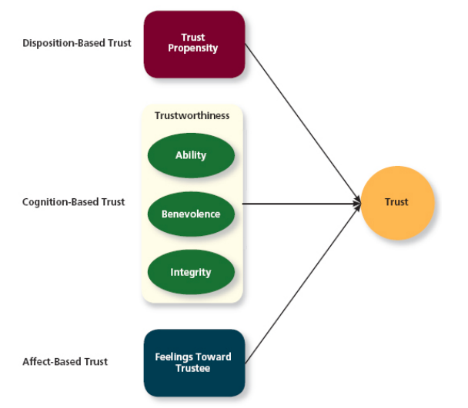

Types of Trust Over Time

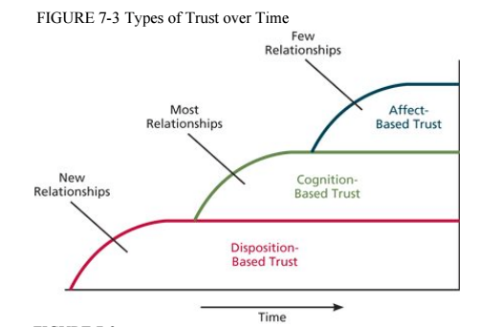

Justice (Fairness)

- Employees want to be treated fairly
  - Being treated fairly increases trust in the other party
- Four justice considerations
  - Distributive
  - Procedural
  - Interpersonal
Interactional Justice
  - Informational

Distributive Justice

- How fair are the outcomes of the decision?
  - Equity
  - Equality
  - Need

Procedural Justice

- How fair is the process that was used to make the decision?
  - Voice
  - Correctability
  - Consistency
  - Bias suppression
  - Representativeness
  - Accuracy

Distributive vs. Procedural Justice

- When outcomes are favourable:
  - Procedures matter less
- When outcomes are unfavourable:
  - Procedures matter more

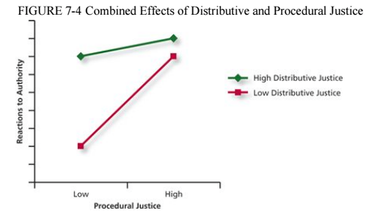

Interpersonal Justice

- How fair is interpersonal treatment?
  - Respect
  - Propriety

Informational Justice

- How fairly is the info communicated?
  - Justification
  - Truthfulness

Justice Rules (Norms, Principles)

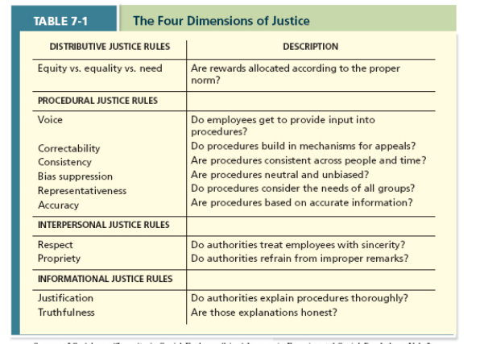

Ethics

- Are the behaviours of an authority figure in accordance with generally accepted moral norms?

Four-Component Model of Ethical Decision Making
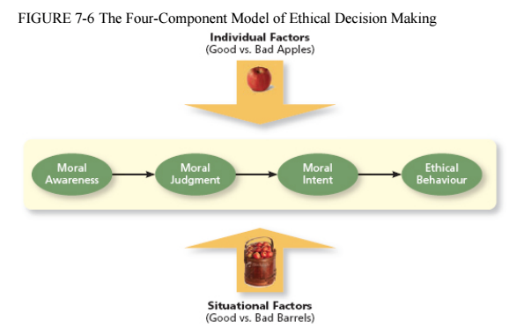

Component #1: Moral Awareness

- What determines whether a person “sees” the moral issues at stake?
  - Moral Intensity
    - Situational factor
  - Moral Attentiveness
    - Individual factor

Component #2: Moral Judgment

- What is the “right” course of action and what is “wrong”?
  - Moral Development
    - Individual factor
  - Moral Principles
    - Prescriptive guides, define what is “right”

Component #3: Moral Intention

- What influences whether someone intends to “do the right thing”?
  - Organizational Culture/ Norms
  - Moral Identity
    - Individual factor

Component #4: Moral Behaviour

Strength of Four-Component Model

- Recognizes that moral awareness, judgment, intention and behaviour don’t always coincide

Criticisms of Four-Component Model

- Strict emphasis on rational processes
- Undervalues situational factors
- Weak links between the components

Motivation Theories and Unethical Behaviour

- Motivation: effort, persistence, direction, goals
- Organizational pressures unethical behaviours

Chapter Eight- Learning and Decision-Making

What is Learning?

- Relatively permanent change in knowledge, skill, or behaviour that occurs due to practice or experience

What do Employees Learn?

- Practical skills
- Intrapersonal skills
- Interpersonal skills
- Cultural awareness
Tacit Knowledge
(Knowledge after years of experience)
Explicit Knowledge
(Book knowledge)

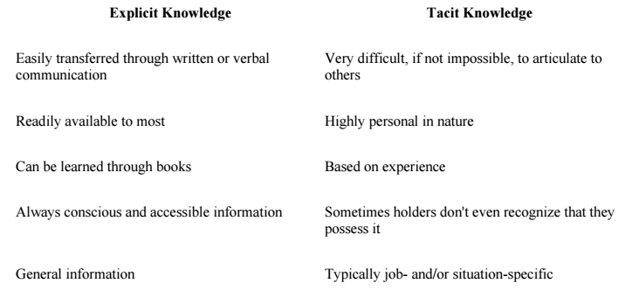

How do Employees Learn?

- Operant Learning:
  - Behaviour Consequences
- The “consequences” either
  - Increase the probability of behaviour
  - Decrease the probability of behaviour

Increasing the Probability of a Behaviour

- Reinforcement:
  - The process by which stimuli strengthen behaviours
  - Two types
    - Positive
    - Negative

- Positive Reinforcement
  - Adding (or giving) something positive after the behaviour

- Negative Reinforcement
  - Removing something negative after the behaviour
  - Not as effective as positive reinforcement

Decreasing Probability of Undesirable Behaviour

- Punishment
  - Two types
    - Positive
    - Negative

- Positive Punishment
  - Adding (or giving) something negative after behaviour
    - Ex. Speeding tickets

- Negative Punishment
  - Removing something positive after the behaviour

- Extinction
  - Removing positive outcome that used to follow undesirable behaviour

Schedules of Reinforcement

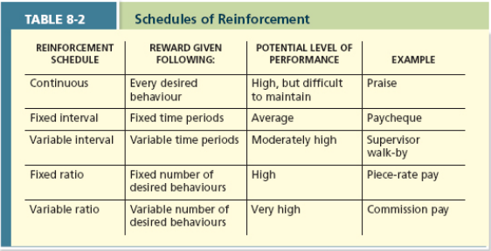

Observation

Social Learning Theory – People in organizations learn by observing others

- Could be primary way in whish people gain knowledge in organizations

Behavioural Modeling – When employees observe the actions of others, learn from what they observe, and then repeat the observed behaviour

Goal Orientation

Learning Orientation – A predisposition or attitude according to which building competence is deemed more important by an employee than demonstrating competence

Decision-Making

Programmed Decisions
Intuition
(Encountered in the past)

Non-Programmed Decisions
(New, complex)
Rationality

Decision-Making Problems

- Information Problems
- Faulty Perceptions
- Faulty Attributions
- Escalation of Commitment
- Advice Discounting

Information Problems

- Bounded rationality
  - Satisficing
    - Vs. maximizing
  - Searching for too little information
    - Confirmation bias
  - Searching for too much information
    - Information overload

Faulty Perceptions

- Primacy
  - First impression error
  - Rely on information you get first
- Recency
  - Last impression error
  - Rely on information that happened recently
- Availability bias
  - Rely on information that is easier to recall
- Central traits
  - Focus on information you feel stands out most about the person
- Projection bias
  - Assigning our own thoughts and feelings to others
- Stereotyping
  - Making assumptions because of someone’s membership to a group
- Contrast effect
  - Compare people to one another

Faulty Attributions

- How motives are assigned to explain people’s behaviour
- Two classes of attributions
  - Dispositional
  - Situational
- Fundamental attribution error
- Self-serving bias

- Cues used to make attributions:
  - Consistency
    - Does the person engage in the behaviour consistently in this situation?
  - Consensus
    - Do most people engage in this behaviour, or is it unique to this person?
  - Distinctiveness
    - Does the person engage in the behaviour in many situations, or is it distinct to one situation?

Escalation of Commitment

- A common decision-making error, in which the decision maker continues to follow a failing course of action

Advice Discounting

- Advice is ubiquitous to decision-making
- Main finding:
  - Egocentric advice discounting
- What promotes advice utilization?
  - Trust in advisor
    - Advisor is an expert in the decision/ task
    - Advisor is seen as having good intentions
  - Advice is explicitly solicited
  - Advice is framed as information

Chapter Nine- Personality, Cultural Values, and Ability

What is Personality?

- Relatively stable psychological characteristics that influence how individuals interact with their environment

The “Big Five”

C – Conscientiousness
- Dependable, organized, reliable, ambitious, hard-working, persevering
A – Agreeableness
- Friendly, cooperative
N – Neuroticism (vs. emotional stability)
- Clam, even-tempered, self-confident
O – Openness to experience
E – Extraversion

Do the “Big Five” Matter?

- Task Performance
  - Conscientiousness
  - Extraversion
  - Agreeableness
  - Openness
  - Neuroticism
- Organizational Citizenship Behaviours
  - Conscientiousness
- Counterproductive Work Behaviour
  - Conscientiousness
- Training Proficiency
  - Openness to experience
  - Extraversion
  - Conscientiousness

What Determines Behaviour (at work)?

- Both personality and the environment
- Situational strength

The Conscientiousness- Task Performance Relationship

- More pronounced when occupations lack
  - Structure
  - Situational constraints
  - Industry norms, rules, and procedures to follow

Other Personality Traits

- Locus of Control
  - Belief about what causes experiences in life
    - External vs. internal
- Self-Monitoring
  - People observe and regulate how they appear and behave in social settings
- Self-Esteem
  - Degree to which a person has a positive self-evaluation
- General Self-Efficacy
  - Belief in one’s capability to perform successfully across situations
- Positive and Negative Affect
  - View the world in a positive or negative light

What are Values?

- Guiding principles
  - Mission statements

Work Centrality

- Job identity
- The extent to which work itself is an individual’s central life interest

What is Your Work Centrality?

- The major satisfaction in my life comes from my job
- The most important things that happen to me involve my work
- I live, eat, and breathe my job
- I would probably keep working even if I didn’t need the money

Cultural Values

- Societies in which we were raised exerts a strong influence on the development of our personalities and the way our traits are expressed
- One of the most important aspect of societies is culture

Culture – The shared values, beliefs, motives, identities, and interpretations that result from common experiences of members of a society and are transmitted across generations

Geert Hofstede

- Employees working in different countries tended to prioritize different values, and those values clustered into several distinct dimensions

Individualism–Collectivism - The degree to which a culture has a loosely knit social framework (individualism) or a tight social framework (collectivism)

Power Distance - The degree to which a culture prefers equal power distribution (low power distance) or an unequal power distribution (high power distance)

Uncertainty Avoidance - The degree to which a culture tolerates ambiguous situations (low uncertainty avoidance) or feels threatened by them (high uncertainty avoidance)

Masculinity–Femininity - The degree to which a culture values stereotypically male traits (masculinity) or stereotypically female traits (femininity)

Short­Term vs. Long­Term Orientation - The degree to which a culture stresses values that are past­ and present­oriented (short­term orientation) or future­oriented (long­term orientation)

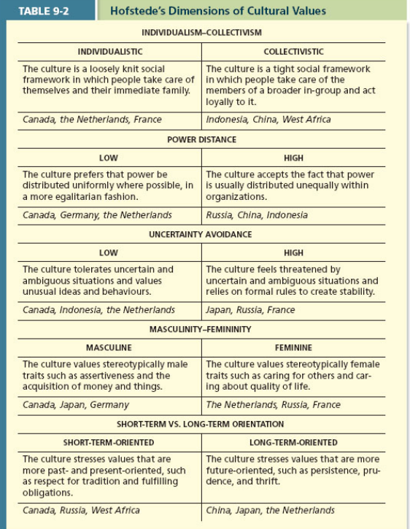

Project GLOBE

- (Global Leadership and Organizational Behavior Effectiveness)
- Main purpose of Project GLOBE is to examine the impact of culture on the effectiveness of various leader attributes, behaviours, and practices
- Project researchers asked managers to rate the values held within their organizations and within their societies
- Identified nine different dimensions used to summarize cultures
- Some of those dimensions can be viewed as replications of Hofstede's work
  - Power distance
  - Uncertainty avoidance
  - Collectivism

Gender Egalitarianism - The culture promotes gender equality and minimizes role differences between men and women.

Assertiveness - The culture values assertiveness, confrontation, and aggressiveness in social relationships.

Future orientation - The culture engages in planning and investment in the future while delaying individual or collective gratification.

Performance orientation - The culture encourages and rewards members for excellence and performance improvements.

Humane orientation - The culture encourages and rewards members for being generous, caring, kind, fair, and altruistic.

- The lion's share of cross­cultural research focuses on individualism–collectivism, perhaps the most fundamental means of differentiating cultures

Cognitive/Mental Ability

- General Intelligence
- Involves ability to:
  - Reason
  - Plan
  - Solve problems
  - Comprehend complex ideas
  - Learn from experience

Facets of Cognitive Ability
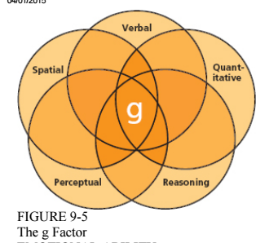

Managerial Implications

- Does cognitive ability matter in predicting job performance? (YES)
- Maximal vs. typical performance

Emotional Ability (Emotional Intelligence)

- Self-awareness
- Other-awareness (empathy, active listening)
- Emotion Regulation (recover quickly from negative emotion)
- Use of emotions

Physical Abilities

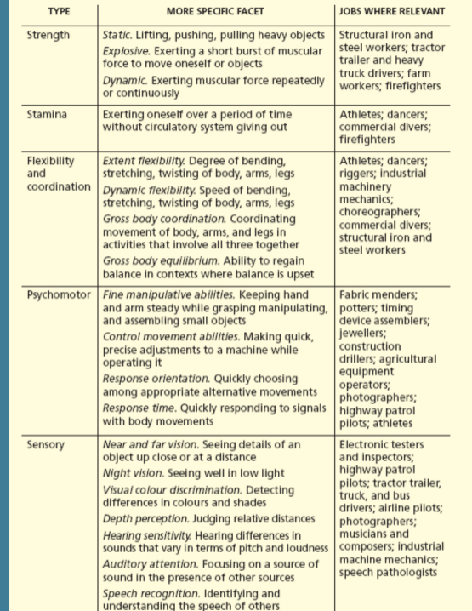

Predictors of (Task) Performance

- Want to be in the multi-measure tests
- If you could only measure one thing you would measure cognitive ability

Key Managerial Takeaways

- Personality, Values, and Intelligence are highly stable human characteristics
- Each is related to job performance
  - Some more than others
- Can be easily measured and used as hiring criteria

Chapter Ten- Teams and Diversity

What are Teams?

- 2 + people who:
  - Work interdependently over time
  - Toward a common goal
  - Related to task-oriented purpose
  - Accountable to one another

Group – A collection of people who share a common characteristic

Stages of Team Development

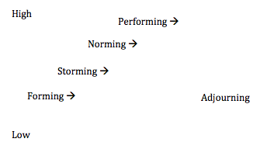

Time

Team Interdependence

- Interdependence of:
  - Goals
  - Outcomes
  - Task

Types of Interdependence

- Poled interdependence

- Reciprocal interdependence
- Comprehensive interdependence

- Important
  - Using a type of task interdependence is NOT called for
    - Poor goal accomplishment

Team Composition
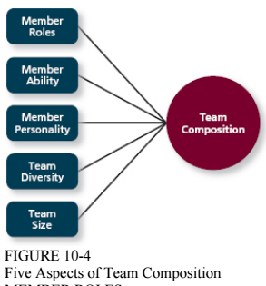

Member Personality

- Conscientiousness
- Agreeableness
- Extraversion

- Tasks:
  - Disjunctive task
  - Conjunctive task
  - Additive tasks

Member Ability

- Tasks:
  - Disjunctive: one member with great ability = team success
  - Conjunctive: one member with poor ability = team failure
  - Additive: more members with great ability = team success

Team Size

- Tasks:
  - Disjunctive: larger size = greater team success
  - Conjunctive: larger size = weaker team success
  - Additive: larger size = greater team success

Team Composition

Team Diversity

- Surface level diversity
- Deep level diversity

Norms

- Shared expectations regarding behaviour within the group
- Codes of conduct for the group established in order to provide regularity and predictability

Team Process/ Process loss

- Getting less than expected from the team
  - Coordination problems
  - Motivation problems
    - Social loafing

Team States

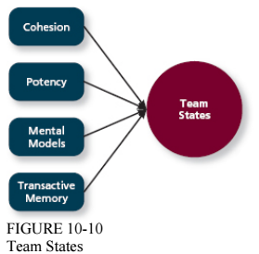

Cohesion

- When members have strong emotional bonds to other members and the team itself
- Threat and competition
- Success
- Group size
- Toughness of initiation

- Is usually good but it depends on what the team’s norms are

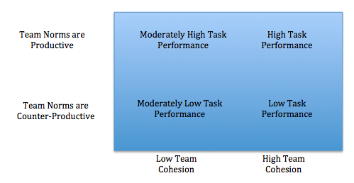

- Not if groupthink takes over
- Support for conformity and team harmony at the expense of other priorities
- Good way to avoid this: appoint a devil’s advocate

Potency

- Degree of confidence among team members that the team can be effective across situations and tasks

Mental Models

- Shared knowledge of team members’ knowledge and abilities
- Shared understanding of the work to be done

Transactive Memory

- Degree to which team members’ specialized knowledge is integrated into an effective system of memory for the team

Chapters Eleven and Twelve- Leadership and Power

Power

- The ability to influence others
- The ability to resists influence

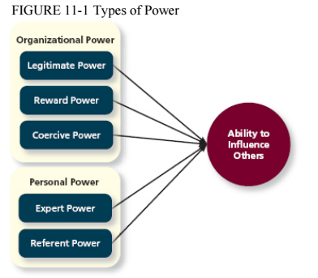

Power and Influence

- Substitutability
- Centrality
- Discretion
- Visibility

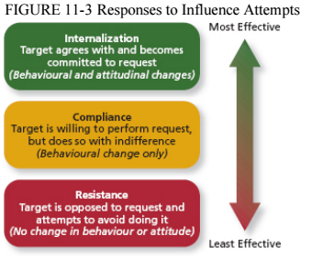

How to Build your Personal Power

- Develop your expertise and industriousness
- Develop your charisma

Negotiation – Conflict Resolution

- When conflict arises in organizations, leaders have the ability to use their power and influence to resolve it

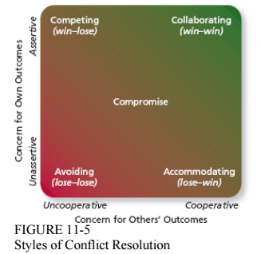

Negotiation - A process in which two or more interdependent individuals discuss and attempt to reach agreement about their differences

- Two general strategies leaders must choose between
  - Distributive bargaining
    - Negotiation strategy in which one person gains and the other person loses
  - Integrative bargaining
    - Negotiation strategy that achieves an outcome that is satisfying to both parties

What does it Mean to Lead?

- Influencing others so that they are more motivated to contribute to the realization of your goals

Early Leadership Theories

- Great man/woman theory
  - What traits do effective leaders possess?
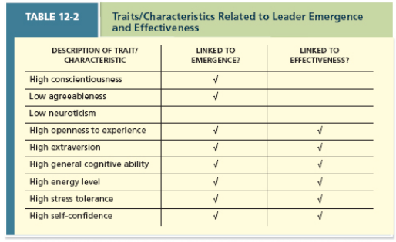

The Behavioural Approach

- What are effective leadership behaviours? It depends on the situation…

Leader Decision-Making Styles

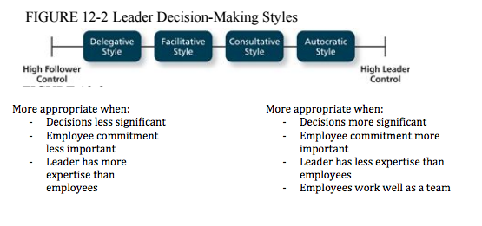
(switch)
Delegative Style

- A leadership style where the leader gives the employee the responsibility for making decisions within some set of specified boundary conditions

Facilitative Style

- A leadership style in which the leader presents the problem to a group of employees and seeks consensus on a solution, making sure his or her own opinion receives no more weight than anyone else's

Consultative Style

- A leadership style in which the leader presents the problem to employees asking for their opinions and suggestions before ultimately making the decision him­ or herself

Autocratic Style

- A leadership style where the leader makes the decision alone without asking for opinions or suggestions of the employees in the work unit

Day-to-Day Leadership Behaviours

- What do leaders actually do?
  - Initiating Structure
    - Directive
    - Task-oriented
  - Consideration
    - Supportive
    - Relations-oriented

Dominant Leadership Theories

- Transactional/Transformational Leadership
- Leader-Member Exchange

Transactional and Transformational Leadership
(The “Full Range” model of leadership)

Transactional Leadership Behaviours

- Contingent reward
  - Most important/effective
- Management by exception
  - Degree to which a leader takes corrective action for a follower
  - Active
  - Sometimes necessary
- Management by exception
  - Let followers make mistakes and expect them to learn from it
  - Passive
  - Not good

Transformational Leadership Behaviours

- Idealized influence
  - Charisma
  - Extent to which you behave in desirable ways in the eyes of your followers
  - Emotional bond, taking a stand on certain issues
- Inspirational Motivation
  - Provides a vision, challenge to status quo
  - Optimistic view of future
- Intellectual Stimulation
  - Challenged status quo
  - Encouraging creativity
- Individualized consideration

Managerial Implications

- When to use transactional?
  - Times of change, high uncertainty, when there’s a crisis
  - Works well in day-to-day operations
- When to use transformational?
  - Builds on strong transactional foundation
- Ted talk about charisma

What about Followers?

Leader-Member Exchange (LMX)

- The quality of the work relationship between the leader and the follower

What does it Mean to Follow?

- Supporting someone’s leadership by endorsing his/her goal and contributing to its realization

Possible Followership Styles

- Passive
  - “Yes sir/ma’am!” (Highly deferent)
  - Waits for leader to determine solutions, give directions
  - Does best to carry out directions given
- Proactive (should earn leader’s trust first)
  - “What if…?”, “Have you thought of…?”
  - Helps leader make decisions by
    - Proactively sharing salient information
    - Challenging leader’s ideas/assumptions

Chapter Fourteen- Culture and Change

What is Culture?

- The shared values, beliefs, and assumptions
- Considered to be the appropriate way to think and act within an organization

Functions of Culture

- Provides appropriate standards for what employees should say or do
- Defines boundaries
- Conveys a sense of identity

How to Really Know a Culture

Observable Artifacts

Espoused Values

Basic Underlying Assumptions

Artifacts and Creations

- What you see, hear and feel
- “Physical” aspects of the organization
  - Material Symbols
  - Physical Structure
  - Rituals
  - Language
  - Stories

Strong Cultures

- High agreement among members
- Can occur in organizations of all sizes
- Advantages:
  - Coordination
  - Conflict resolution
  - Financial success

The Liabilities of Culture

- When/Why can that happen?

- Culture as a barrier to
  - Change
  - Diversity
  - Mergers and acquisitions (culture clash)
- Pathological Cultures
  - Rent “Enron: The Smartest Guys in the Room”

How is an Organization’s Culture Maintained?

Socialization

- Process by which people learn norms, knowledge, attitudes, and behaviours needed to become an organizational member

- Happens in 3 stages:
- Anticipatory Stage: A stage of socialization that begins as soon as a potential employee develops an image of what it would be like to work for a company
- Encounter Stage: A stage of socialization beginning the day an employee starts work, during which the employee compares the information as an outsider to the information learned as an insider
- Understanding and Adaptation: The final stage of socialization, during which newcomers come to learn the content areas of socialization and internalize the norms and expected behaviours of the organization

Socialization Domains

- Performance proficiency
- Role clarity
- History and values
- Language/ jargon
- Politics
- People/ social integration

Socialization Methods

- Realistic job previews
- Employee orientation programs
- Mentoring

Realistic Job Previews – The provision of a balanced realistic picture of the positive and negative aspects of a job to job applicants

Employee Orientation Programs – designed to introduce new employees to their job, the people they will be working with, and the organization

Mentoring – Career-related mentoring, psychosocial mentoring

ASA Model

Attraction Selection

Attrition

Chapter Thirteen (and Ten)- Communication and Organizational Structure

Communication

- Process by which information and meaning is transferred from a sender and receiver

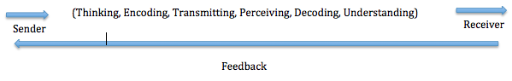

Superior-Subordinate Relationship: Some Barriers to Communication

- Communicator competence
- Gender differences (I, we)
- Information richness
- Noise
- Conflicting role demands
- Physical distance
- Network structures

Communication Networks

Communication Networks – Systematic lines of communication among various senders and receivers

- Two types:
  - Centralized networks
  - Decentralized networks

Communication Network Structure

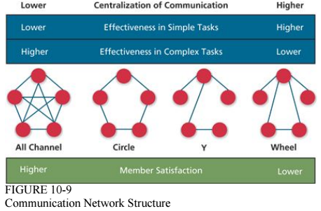

- All channel is open door policy

Organizational Structure

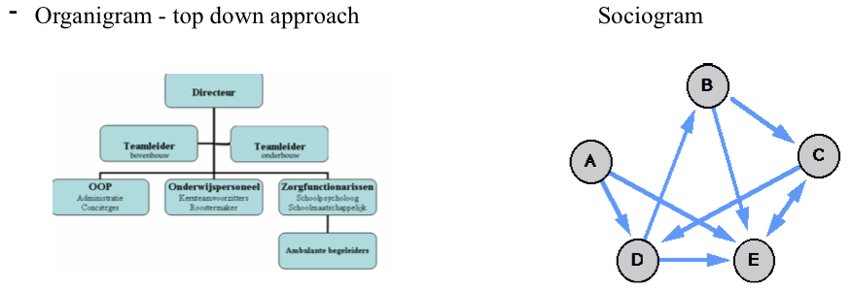

- Organizational Structure:
  - How job tasks are formally divided, grouped, and coordinated
  - Two basic dimensions
    - Vertical
    - Horizontal

Vertical Division of Labour

- Apportioning authority for planning and decision-making

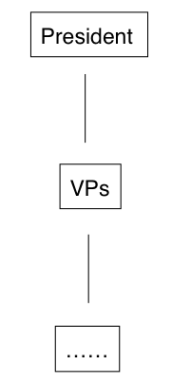

- Relevant Concepts
  - Chain of command
  - Span of control

Horizontal Division of Labour

- How should the organization divide or group its areas of specialization?
- Different possibilities:
  - Functional structure
  - Divisional structures
    - Product structure
    - Geographic structure
    - Client-based structure

Departmentalization by Function
(Or division by product, customer, geography)

- CEO VP Marketing, VP Finance, VP HR Employees

