Experiment #5
Mechanical Testing of Materials (Mortar, Brick and Masonry)

Laboratory Report
CIVI 321 - Engineering Materials
Section V VV
Faculty of Engineering & Computer Science

John Snow
ID: 40009999

Dr. M. Nokken

Date of Lab Performed: Friday March 24th 2016
Date of Report Submission: Friday April 8th 2016

Concordia University Laboratory HH - 0015

Table of Contents
Contents
Objective 2
Introduction 3
Materials, Methods, and Procedure 3
Results 5
Discussion 8
Conclusion 9
Appendix 9
Figure 1: Table of Values 11
Figure 2: Tested Samples 12
References 12

Objective
The main objective of this experiment is to test the mortar and brick specimens which have been prepared by the laboratory technician.

Introduction

Mortar has many uses in construction and building materials. It is primarily used as a binding tool for other building blocks such as stone and brick prisms. Mortar is composed of cement, sand, and water to keep the materials stuck together. In the construction industry, this material is heavily depended upon and for that reason it is necessary to properly understand its varying capacity loads in compression and in tension. To test its compression, the mortar has been pre-assembled and prepared into cubes which ideally fit a typical compression testing machine. Its flat roof surface is meant to reduce any inconsistencies in testing the correct compression load. After failure, the cubes are expected to show visual signs of cracking on its side and after removing cracked debris, it resembles a rugged hourglass. To test the tensile strength of mortar, the mix was prepared as briquettes resembling "dog bones" in shape. Using a machine to measure tensile strength, the briquettes were tested and the result was its failure which can be visually seen by its dislocation offset from the center by a few centimeters. Bricks are known to be a very ancient yet popular material of choice for construction especially in buildings. They are usually stacked in a manner where the brick's center lies at the contact point of two other bricks. This pyramid-like stacking permits the bricks to hold up stronger against unnaturally strong wind conditions and major human accidents (car crashes). Another reason why bricks are so reliable is the holes they contain throughout the prism permits mortar to enter it and other bricks in order to help keep the structure connected and avoid any unwanted incidents.

Materials, Methods, and Procedure
Mortar Cubes & Dog Bones
- The Mortar Cubes and the Dog Bones must first be surface-dried and any imperfections within the cube must be cleared from the specimens before testing may begin. If there are any loose or chipped grains on the specimens prior to testing, the result of the failure load will be different than the actual expected capacity before failure.
- The Mortar Cubes will be tested in the main compression testing machine where there will be an incremental load of approximately 200 to 400 pounds per second on the cubes until failure. The result of the failure will then be noted. The Dog Bones will be placed in their respective machine where they are inserted in a fitted slot and then tested until failure. It is important to note that the machine undergoes testing automatically until failure where it will then automatically return to its original position and thus hands should be cleared until the machine comes to full rest. The cross sectional area of the failed specimens are then measured using a digital caliper and noted, then subsequently sketched out in the report.
Brick Prisms
- Place the brick prisms in the support frame of the flexural testing machine and then clamp them firmly into a stable position using the lower clamping bracket. The bricks should be oriented such that the clamping screws in are positioned on the same side as the face of the joint intended to be subject to flexural tension.
- The upper clamping bracket is then attached to the top brick and each clamp must be tightened using a torque of no greater than 5.7 N∙m.
- The base support must then be lowered so that no contact is made with the bricks when testing.
- Apply the load incrementally and uniformly until failure. The test should last between 1 and 3 minutes. Note down the failure result. The maximum allowed error is 22N.
Results
The following displays the results obtained following the compression test done on the mortar cubes.
Table 1: Mortar Cubes Results
Type N:

Cube # | Area (mm²) | Load (kN) | Strength (MPa) | Average | Standard Deviation
Cube 1 | 2500 | 25.51 | 10.20 | 10.76 | 0.170
Cube 2 | 2500 | 29.05 | 11.62 | 10.76 | 0.170
Cube 3 | 2500 | 26.16 | 10.46 | 10.76 | 0.170

Type S:

Cube # | Area (mm²) | Load (kN) | Strength (MPa) | Average | Standard Deviation
Cube 1 | 2500 | 54.26 | 21.70 | 20.92 | 0.664
Cube 2 | 2500 | 52.41 | 20.96 | 20.92 | 0.664
Cube 3 | 2500 | 50.26 | 20.10 | 20.92 | 0.664

As expected under compression loading, Type S mortar withstood a greater amount of strength than Type N before failure. Type N however, is the most generic type of mortar that is used because of its balance of medium strength and efficiency. The values that were obtained indicated a small standard deviation which means that the tested specimens were uniformly prepared and that error was quite low. It is difficult to attain zero error when dealing with the preparation of these materials and when failure testing so this approximate is considered a realistic and acceptable one.
Table 2: Mortar "Dog Bones" Results
Type N:

Bone # | Area (mm²) | Load (N) | Strength (MPa) | Average | Standard Deviation
Bone 1 | 800 | 412.1 | 0.447 | 0.407 | 0.0299
Bone 2 | 800 | 366.6 | 0.399 | 0.407 | 0.0299
Bone 3 | 800 | 299.6 | 0.375 | 0.407 | 0.0299

Type S:

Bone # | Area (mm²) | Load (N) | Strength (MPa) | Average | Standard Deviation
Bone 1 | 800 | 641.8 | 1.110 | 1.152 | 0.0334
Bone 2 | 800 | 654.4 | 1.152 | 1.152 | 0.0334
Bone 3 | 800 | 715.0 | 1.193 | 1.152 | 0.0334

Testing out these "dog bone" briquettes enabled an understanding of the tensile strength of mortar. Similarly, the results indicate that Type S mortar contain a higher tensile strength before failure than Type N. The standard deviation is also low for this test which once again is an indication of the uniformity of the mix and great accuracy of the test. After tensile failure has been reached inside the machine, the briquettes do not dislocate at the centre line as one would expect but rather they separate usually more to one side than the other as shown in the sketch below. Interestingly, after measuring the cross-sectional area of the failure space, the Type N briquettes were consistently higher in area which could mean that the failure location was even more to one side than it was for Type S.

Sketch of the Failed Specimens:

"Dog Bone" Briquettes after Failure
- The failure point is not located at the centre point of the specimen.
Mortar Cube after Failure

Table 3: Brick Results
Type N:

Brick # | Load (N) | Average | Standard Deviation | Flexural Strength (MPa)
Brick 1 | 165 | 266 | 87.78 | 94.73
Brick 2 | 254 | 266 | 87.78 | 94.73
Brick 3 | 379 | 266 | 87.78 | 94.73

Type S:

Brick # | Load (N) | Average | Standard Deviation | Flexural Strength (MPa)
Brick 1 | 101 | 394 | 213.97 | 148.96
Brick 2 | 475 | 394 | 213.97 | 148.96
Brick 3 | 606 | 394 | 213.97 | 148.96

The average of the failure loads for Type S are higher than Type N for the brick prism test. However, the loads fluctuate greatly while certain Type S failure loads even rank below those from Type N. The Standard deviation was tremendously high in this test due to the varying results. This may stem from poor preparation of the bricks, misuse of testing equipment, and the order in which the bricks have been stacked.

Discussion
Table 4: Summary of Results
 | Type N | Type S
Compressive Strength | 13.00 MPa | 30.55 MPa
Tensile Strength | 0.41 MPa | 1.15 MPa
Flexural Strength | 266 MPa | 394 MPa

Based on the above data, it can be stated that mortar behaves very differently with regards to its particular usage. Mortar is known to be much weaker in tension than it is in compression and these results are indicative. Thus, the only correlation that can be drawn from this data is that lower values indicate tension while the higher values represent compression and flexure. Another correlation that can be analyzed is the mortar type. Type S mortar is known to have a much higher strength capacity than Type N. However, Type M mortar is considered to contain an even greater strength capacity than Type S and is usually only used in limited settings. Type N is the most generic and efficiently used mortar types in the construction and building industries. Aside from the error in the preparation of the mortar and bricks, noticeable error could have been a result of inconsistent measurements, result calculation, and machine error.

Conclusion
Through this experiment, mortar has shown itself to be a material that can withstand a great amount of load in compression which makes it a suitable choice to use as a reinforcement material. The brick prisms have also shown themselves to be efficient and simple materials that withstand a great deal of compressive strength while maintaining its rugged composition. Bricks can be subject to weathering and the mortar layered between bricks could also be affected by this weathering and thus it becomes a duty to follow constant maintenance and to ensure these materials have not been significantly weakened since their placement in the complex chemical environment we live in.

Appendix
- All Mortar Cubes are assumed to have an initial cross-sectional area of
50mm x 50mm = 2500mm²
-All dog bons are assumed to have an initial cross-section area of
800mm²
- Compression Strength of Mortar:
$$σ=\frac{P}{A}=\frac{\left(25.51*{10}^{3}\right)N}{(2500*{10}^{-6})m^{2}}=10204000 Pa=10.20 MPa$$
- The Standard Deviation of the Compressive Strength:
$$σ=\sqrt{\frac{1}{N}\sum_{i=1}^{N}{(x_{i}-μ)^{2}}} \\ N*σ^{2}=(10.20-10.76)^{2}+(11.62-10.76)^{2}+(10.46-10.76)^{2} \\ σ=0.170$$
- In order to determine the flexural strength of the brick prisms:
$$F_{g}=\frac{6\left(PL+P_{l}L_{l}\right)}{bd^{2}}-\frac{\left(P+P_{l}\right)}{bd}$$where F_{g} = Gross Area Flexural Strength
P = Maximum Applied Load
P_{l} = Weight of Loading Arm = 92.06 N
L = Distance from centre of prism to loading point = 360 mm = 0.360 m
L_{l} = Distance from centre of prism to centroid of loading arm = 70 mm = 0.070 m
b = Cross sectional width = 90 mm = 0.090 m
d = Cross sectional depth = 10 mm = 0.010 m
$$F_{g}= \frac{6*\left(606*0.360+92.09*0.070\right)}{\left(0.090\right)*(0.010)^{2}}-\frac{\left(606+92.06\right)}{\left(0.090\right)*\left(0.010\right)} \\ =148961877.8 Pa=148.96 MPa$$

Figure 1: Table of Values
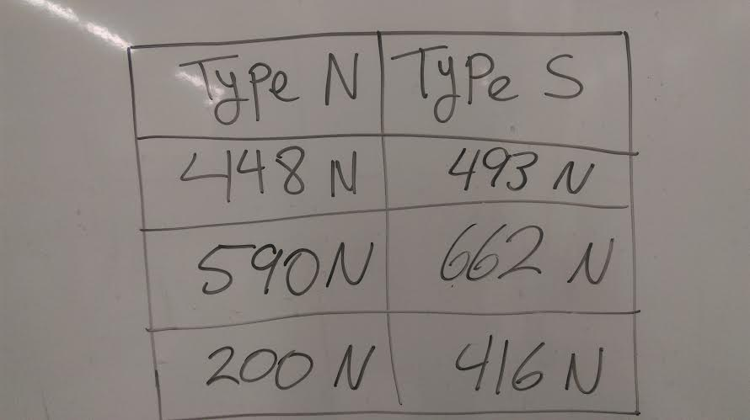

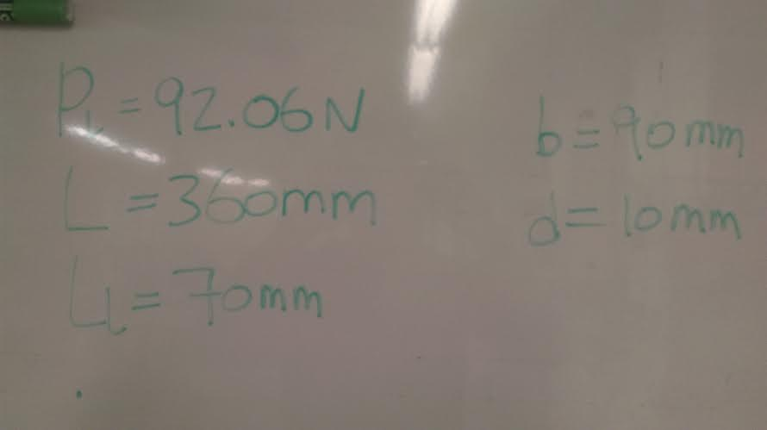

Figure 2: Tested Samples

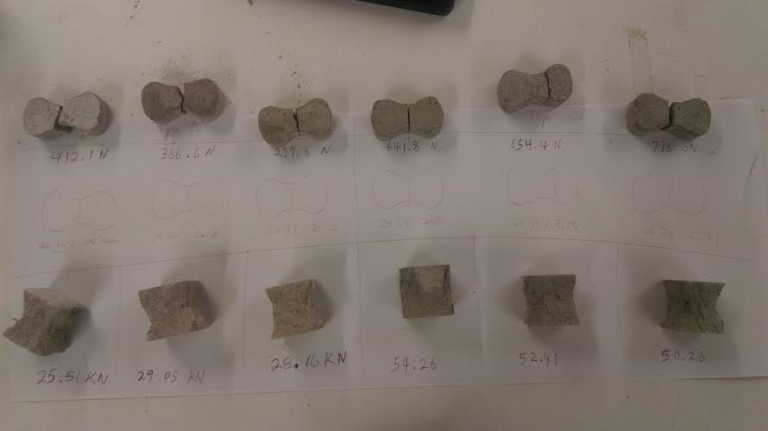

References
- CIVI 321 Laboratory Manual

