The Muscular System (Part 2)

Muscles of the Pelvic Floor and Perineum
- Levator Ani (pubis to inner coccyx):
  - Supports pelvic viscera and forms a supportive muscular “sling” around the male prostate (or female vagina), urethra, and anorectal junction before meeting the median plane
  - Supports and maintains position of pelvic organs
    - Also resists increase in intra-abdominal pressure
- Coccygeus (spine of ischium to sacrum & coccyx):
  - Supports pelvic organs and coccyx
- Urogenital diaphragm:
  - Supports pelvic viscera and constrict urethra

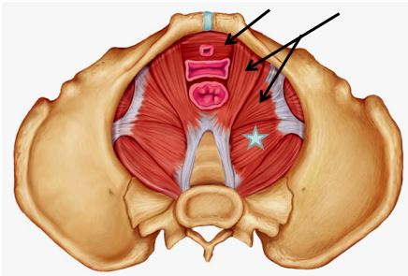
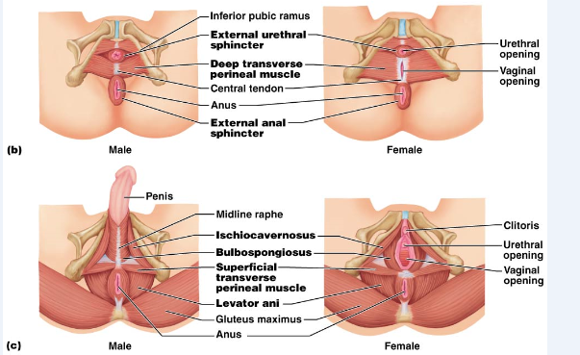

Superficial Muscles of Thorax: Arm Movements
- Pectoralis Major (sternum/rib cartilages to humerus):
  - Prime mover of arm flexion
  - Rotates arm medially and adducts arm
  - Activated during climbing, throwing, and pushing
- Latissimus Dorsi (vertebrae to humerus):
  - Broad, flat, triangular muscle of lower back
  - Prime mover of arm extension
    - Powerful arm adductor
    - Medially rotates arm at shoulder
    - Activated during rowing and swimming
- Deltoid (clavicle/scapula to humerus):
  - Thick, multipennate muscle forming rounded shoulder mass
  - A common site of intramuscular injection
  - Prime mover of arm abduction when all fibers contract simultaneously
    - If only anterior fibers are active, can act powerfully in flexing and rotating arm medially (a synergist of pectoralis major)
    - If only posterior fibers are active, causes extension and lateral rotation of arm
    - Active during arm-swinging movements while walking
- Trapezius (occipital & vertebrae to scapula):
  - Most superficial muscle of posterior thorax
  - Stabilizes, elevates, retracts, and rotates scapula

- Rhomboids (vertebrae to scapula):
  - Two roughly diamond-shaped muscles lying deep to trapezius and inferior to levator scapulae
  - Stabilizes scapula
    - Aid in scapula movements (ie. Squaring shoulders, rotation when lowering arm)
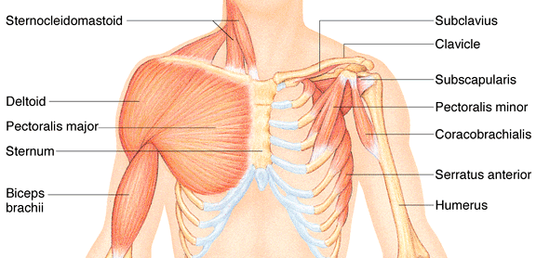
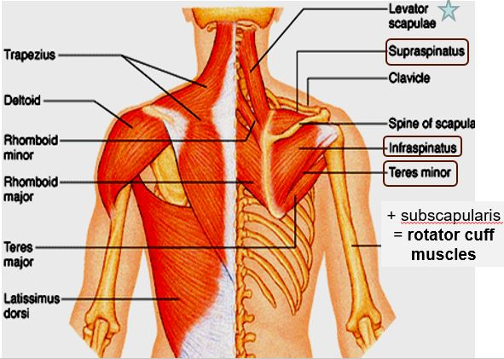
Muscles Crossing the Shoulder & Elbow Joints
- Triceps branchii (scapula/humerus to ulna):
  - Only muscle of posterior compartment of arm
  - Powerful forearm extensor and may help stabilize joint

- Biceps brachii (shoulder to radius):
  - Anterior muscle of arm
  - Flexes elbow joint and supinates forearm
  - Weak flexor of arm at shoulder
- Brachialis (humerus to ulna):
  - Strong muscle that is deep to biceps branchii on distal humerus
  - A major forearm flexor (lifts ulna as biceps lifts the radius)
- Brachioradialis (humerus to radius):
  - Superficial muscle of lateral forearm and extends from distal humerus to distal forearm
  - Synergist in flexing forearm
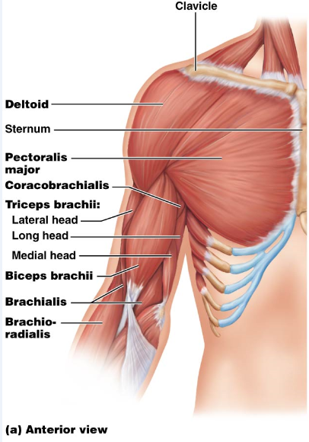
Muscles of the Forearm: Movements of the Wrist, Hand & Fingers
Two functional groups allow for movements of the wrist and of the fingers and thumb:
- Pronator teres (humerus/ulna to lateral radius):
  - Pronates forearm
  - Weak flexor of elbow
- Flexor carpi radialis (humerus to metacarpals):
  - Runs diagonally across forearm
  - Powerful flexor of wrist and abductor of hand
  - Weak synergist of elbow flexion
- Flexor capri ulnaris (humerus/ulna to metacarpals):
  - Powerful flexor of wrist and adductor of hand in synergy with extensor carpi ulnaris (posterior muscle)
  - Stabilizes wrist during finger extension
- Flexor digitorum superficialis (humerus/ulna to phalanges):
  - Two-headed muscle
  - Flexes wrist and middle phalanges of second to fifth fingers
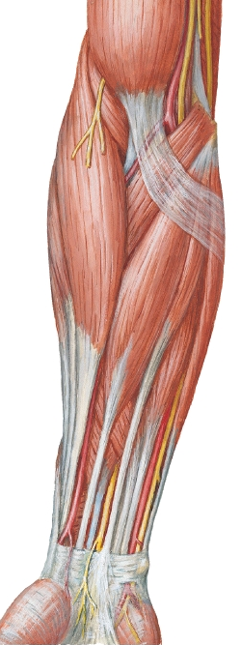
- Extensor carpi radialis longus & brevis (humerus to metacarpals):
  - Extends and abducts wrist/hand
- Extensor digitorum (humerus to phalanges):
  - Prime mover of finger extension
  - Extends hand
  - Can abduct (flare) fingers
- Supinator (humerus to radius):
  - Deep muscle at posterior aspect of elbow
  - Assists biceps branchii to forcibly supinate forearm

Muscles of Hip, Thigh & Leg
- Iliopsoas (iliac crest & lumbar vertebrae to femur):
  - A composite of two muscles: iliacus and psoas major
  - Prime mover of hip/thigh flexion
- Sartorius (iliac spine to medial tibia):
  - Strap-like superficial muscle and longest muscle in body
  - Flexes, abducts, and laterally rotates thigh
  - Weak knee flexor
  - Helps produce the cross-legged position
- Adductors (magnus, longus, brevis) (pubis to femur):
  - They all adduct, flex, and medially rotates thigh
  - Ie. Walking, fixing hip when knee is flexed, and riding a horse
- Pectineus (pubis to femur):
  - Adduct, flexes and medially rotates thigh
- Gracilis (pubis to medial tibia):
  - Adducts thigh, flexes and medially rotates leg (especially during walking)
- Rectus femoris (iliac spine to patella & tibia):
  - Extends leg and flexes thigh at hip
- Vastus (lateralis, medialis,intermedius):
  - All extend the leg/knee
- Tibialis anterior (tibia to tarsals):
  - Prime mover of dorsiflexion
  - Inverts foot
- Extensor digitorum longus (tibia to phalanges):
  - Dorsiflexes foot
  - Prime mover of toe extension

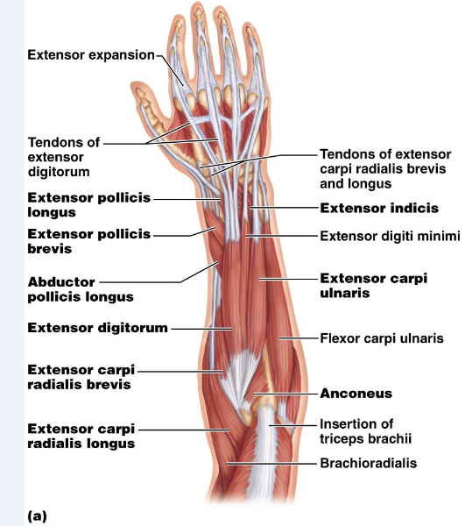
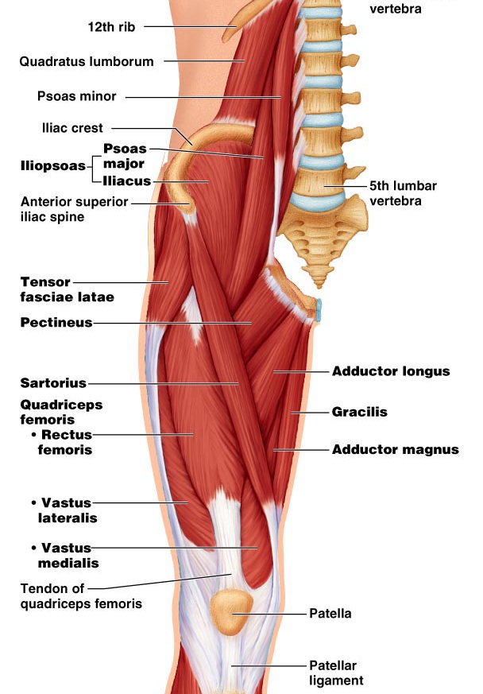
- Gluteus maximus (ilium/sacrum to femur):
  - Largest and most superficial gluteus muscle
  - Major extensor of thigh
  - Active during climbing stairs and running
  - Site for intramuscular injections
- Gluteus medius (ilium to femur):
  - Abducts and medially rotates thigh (especially during walking)
  - Site for intramuscular injections
- Hamstrings (ischial tuberosity to tibia/fibula):
  - Composed of three muscles:
    - Biceps femoris
    - Semitendinosus
    - Semimembranosus
  - They all extend the thigh and flexes the knee/leg

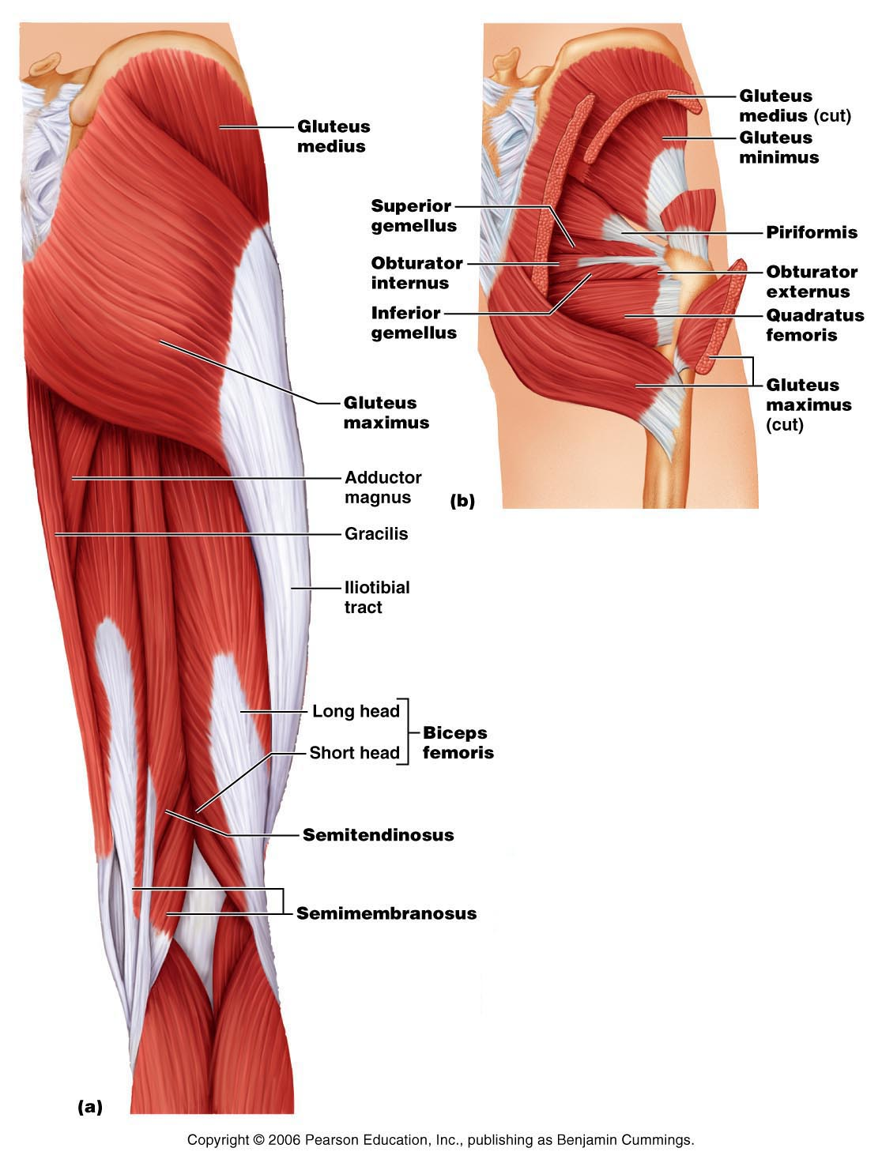

- Gastrocnemius (femur to calcaneal tendon):
  - Plantar flexes foot when leg is extended; because it also crosses knee joint, it can flex knee when foot is dorsiflexed
- Soleus (proximal tibia/fibula to calcaneus):
  - Broad, flat muscle deep to gastrocnemius on posterior surface of calf
  - Planar flexes foot; important locomotor and postural muscle during walking, running, and dancing
- Fibularis (peroneus) longus (fibula under foot to 1st metatarsal):
  - Plantar flexes and everts foot
  - May help keep foot flat on ground
- Calcaneal (Achilles tendon):
  - Largest tendon in body (G &S)



