The Muscular System (Part 1)

Gross Anatomy of a Skeletal Muscle
- Muscle fiber is the name of a single muscle tissue cell
- Several different levels of connective tissue wrapping.
  - Endomysium: a fine layer of areolar connective tissue that surrounds each individual muscle fiber (cell)
  - Perimysium: a layer of dense irregular connective tissue surrounding each fascicle. Within each skeletal muscle, the muscle fibers are grouped into fascicles; they resemble bundles of sticks.
  - Epimysium: an overcoat of dense irregular connective tissue that surrounds the whole muscle (ie. A group of fascicles). Sometimes it blends with the deep fascia that lies between neighbouring muscles or the superficial fascia deep to the skin.
  - Deep fascia: still coarser layer of dense connective tissue that binds muscles into functional groups (ie. Hamstrings vs quadriceps)
- Most skeletal muscles span joints and attach to bones (or other structures) in at least two places.
  - Origin: immovable or less movable bone
  - Insertion: movable
  - Note: when a muscle contracts, the movable bone, the muscle’s insertion, moves towards the immovable or less movable bone, the muscle’s origin.
- Muscle attachments can be direct or indirect.
  - Direct (fleshy) attachment: the epimysium of the muscle is fused to the periosteum of a bone or perichondrium of a cartilage.
  - Indirect attachment: the muscle’s connective tissue wrappings extend beyond the muscle either as a tendon (rope like) or as an aponeurosis (sheet like). The tendon or aponeurosis anchors the muscle to the connective tissue covering the skeletal element (bone or cartilage) or to fascia of other muscle.
  - Note: most attachments are indirect attachments involving either a tendon or an aponeurosis.

Arrangement of Fascicles
- All skeletal muscles consist of fascicles (bundles of fibers)
  - Fascicle arrangements vary, resulting in muscles of different shapes and functional capabilities.
- The four (4) most common patterns of fascicle arrangements are:
  - Circular: fascicles arranged in concentric rings that surround external body openings and contract to close the opening (ie. Orbicularis muscles surrounding the eyes and mouth)
  - Convergent: a muscle that has a broad origin, and its fascicles converge toward a single tendon of insertion. They are triangular or fan-shaped like the pectoralis major.
  - Parallel: the length of the fascicles run parallel to the long axis of the muscle. Can be straplike (satorius muscle of the thigh) or fusiform (biceps branchii)
  - Pennate: the fascicles (and muscle fibers) are short and they attach obliquely to a central tendon that runs the length of the muscle. Pennate muscles come in three forms:
    - Unipennate: in which the fascicles only insert into one side of the tendon (ie. Extensor digitorum longus)
    - Bipennate: in which the fascicles insert into the tendon from opposite sides so the muscle looks like a feather (ie. Rectus femoris)
    - Multipennate: looks like many feathers side by side, with all their quills inserted into one large tendon (ie. Deltoid)

Interactions of Skeletal Muscles
- Muscles can work together or in opposition
- Muscles can be classified into four groups:
  - Prime mover (agonist):
    - a muscle that has the major responsibility for producing a specific movement (Eg. Biceps branchii and elbow flexion)
  - Antagonists:
    - Can provide resistance to prevent overshooting the mark or to control the rate of movement
    - A single muscle can be a prime mover for one action and an antagonist for another action (ie. Biceps branchii and triceps branchii)
  - Synergists:
    - Help prime movers by adding a little extra force to the same movement or by reducing undesirable or unnecessary movements (ie. Finger flexor muscles cross both wrist and interphalangeal joints but can make a fist without bending your wrist because synergistic muscles stabilize the wrist).
  - Fixators:
    - When synergists immobilize a bone, or a muscle’s origin so that the prime mover has a stable base on which to act, they are called fixators
Naming Skeletal Muscles
- Location of muscle: some muscle names indicate the bone or body region with which the muscle is associated (ie. Temporalis is the muscle over the temporal bone, and the intercostal muscles run between the ribs).
- Shape of muscle: some muscles are named for their distinctive shape (ie. Deltoid muscle is roughly triangular, and together the right and left trapezius muscles form a trapezoid)
- Muscle size: terms such as maximus (largest), minimus (smallest), longus (long), and brevis (short) are often used in muscle names (ie. The gluteus maximus and the gluteus minimus are large and small gluteus muscles, respectively).
- Direction of muscle fibers: in muscles with the term rectus (straight) in their names, the fibers run parallel to that imaginary line (axis). Transversus indicates that the muscle fibers run at right angles to that line, and oblique indicates that the fibers run obliquely to it. Examples: the rectus femoris is a straight muscle of the thigh, or femur, and the transversus abdominis is the transverse muscle of the abdomen.
- Number of origins: when biceps, triceps, or quadriceps forms part of a muscle’s name, you can assume that the muscle has two, three, or four heads, respectively, each attached to a different origin.
- Location of the attachments: some muscles are named according to their points of origin and insertion. The origin is always named first. Example: the sternocleidomastoid muscle of the neck has a dual origin on the sternum (sterno) and clavicle (cleiod), and it inserts on the mastoid process of the temporal bone.
- Muscle action: when muscles are named for the movement they produce, action words such as flexor, extensor, or adductor appear in the muscle’s name. Example: the adductor longus, located on the medial thigh, brings about thigh adduction.
  - Note: the name extensor carpi radialis longus tells us the muscle’s action (extensor), what joint it acts on (carpi=wrist), and that it lies close to the radius of the forearm (radialis). It also hints at the size (longus) relative to other wrist extensor muscles.

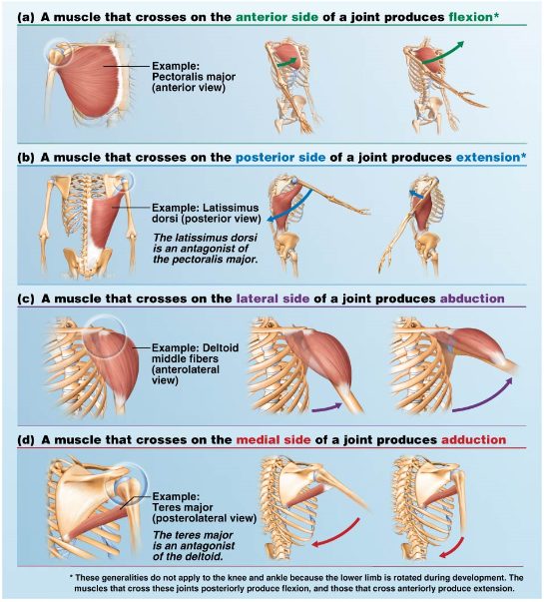

Muscles of the Head—Facial Expression
- The muscles that promote facial expression lie in the scalp and face just deep to the skin
- They are unusual muscles in that they insert into the skin (or other muscles), not bones; innervated by the facial nerve (cranial nerve VII).

- Muscles of the Scalp:
  - Epicranius (occipitofrontalis): the main muscle of the scalp—consists of:
    - Frontalis (frontal belly): raises the eyebrows and wrinkles forehead skin horizontally
    - Occipitalis (occipital belly): fixes aponeurosis and pulls scalp posteriorly
- Muscles of the Face:
  - Orbicularis oculi:
    - surrounds rim of orbit; protects eyes from light/injury—blinking, squinting, and draws eyebrows down
  - Zygomaticus:
    - muscle pair extending diagonally from cheekbone to corner of mouth; raises lateral corners of mouth (smiling muscles)
  - Orbicularis oris:
    - complicated, multilayered muscle of the lips with fibers that run in many different directions (most run circularly)
    - closes, purses, and protrude lips.
    - Includes: kissing and whistling.
  - Mentalis (mandible to chin):
    - One of the muscle pair forming a V-shaped muscle mass on chin
    - Wrinkles chin; protrudes lower lip (as in pout)
  - Buccinator (mandible/maxilla to orbicularis oris):
    - Thin, horizontal cheek muscle; principle muscle of cheek; deep to messeter
    - Compresses cheek (as in whistling and sucking); holds food between teeth during chewing; draws corner of mouth laterally; well developed in nursing infants
  - Platysma (fascia of chest to mandible):
    - Tenses skin of neck; helps depress mandible; pulls lower lips back and down
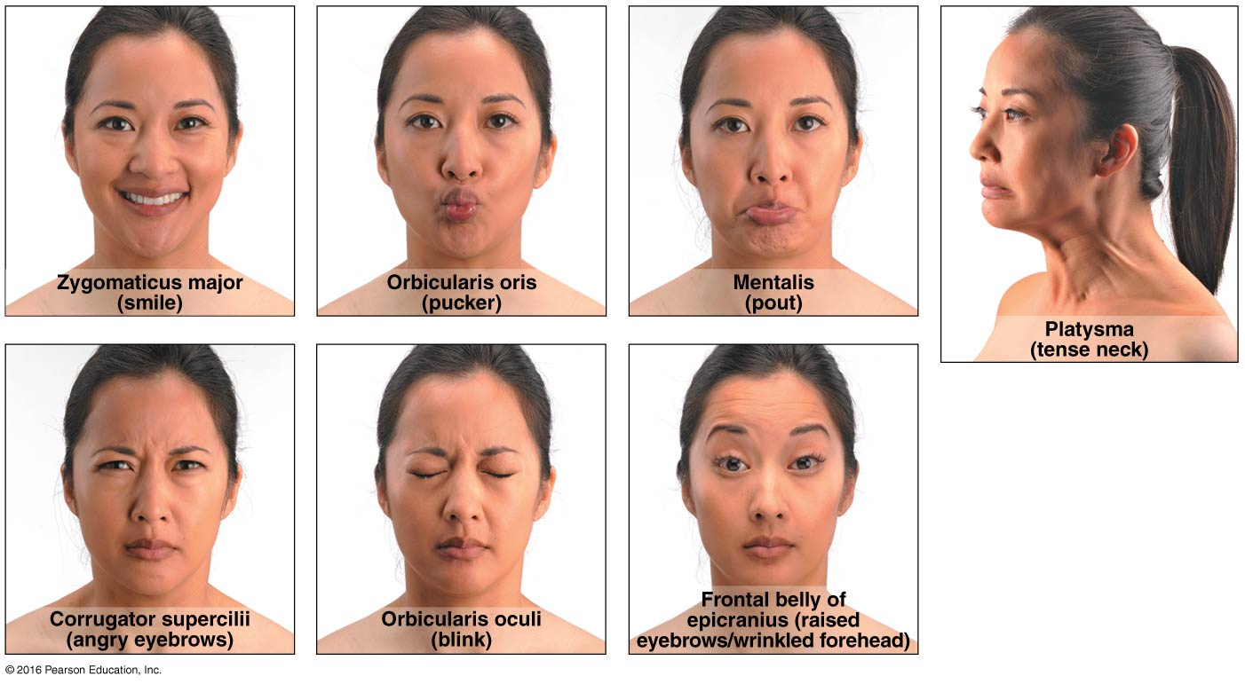
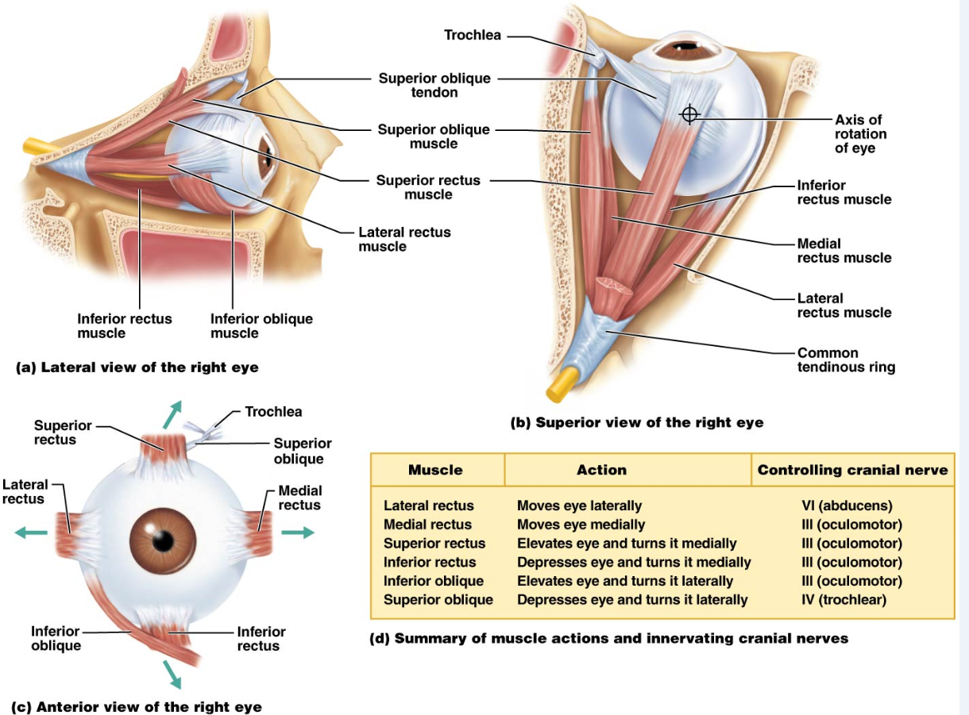

Muscles that move the tongue (Nerve: Hypoglossal Nerve-- cranial XII)
- Genioglossus (mandible to inferior tongue and hyoid bone):
  - Prime mover for tongue protrusion
  - Its attachment to mandible prevents tongue from falling backward and obstructing breathing
- Hyoglossus (hyoid bone to inferolateral tongue):
  - Depresses tongue and draws its sides inferiorly; especially lateral margins
- Styloglossus (styloid process of temporal bone to inferolateral tongue):
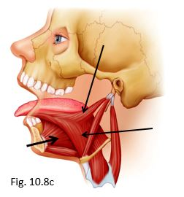
  - Retracts and elevates tongue

Muscles of Mastication
- Four pairs of muscles are involved in chewing (mastication).
- They are all innervated by the mandibular branch of cranial nerve V.
- Masseter (zygomatic to mandible):
  - Prime mover of jaw closure (powerfully); elevates mandible
- Temporalis (temporal to mandible):
  - Closes jaw; elevates and retracts mandible; maintains position of the mandible at rest
- Medial and Lateral Pterygoid (sphenoid to mandible):
  - Both two-headed; additional jaw movements (ie. Side-to-side grinding movements)
- Buccinator (mandible/maxilla to orbicularis oris):
  - Compresses the cheek; helps keep food between grinding surfaces of teeth during chewing
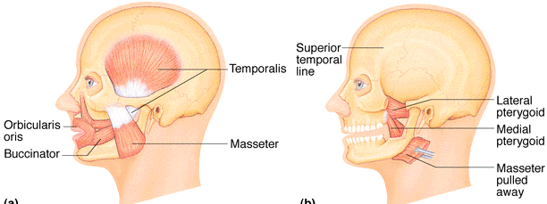

Muscles of the Neck & Vertebral Column: Head & Trunk Movements
- Muscles originating from the axial skeleton move the head.
- Sternocleidomastoid (manubrium/clavicle to mastoid process of temporal):
  - Two-headed muscles located deep to platysma on anterolateral surface of neck
  - Flexes and laterally rotates the head
    - Simultaneous contraction of both muscles flexes neck, generally against resistance as when raising head when lying on back
    - Acting alone, each muscle rotates head toward shoulder on opposite side and tilts or laterally flexes head to its own side
- Scalenes (cervical vertebrae to 1st/2nd ribs):
  - Located more laterally than anteriorly on neck; deep to platysma and sternocleidomastoid
  - Elevate first two ribs (aid in inspiration); flex and rotate neck, role in coughing
- Splenius (vertebrae to mastoid process of temporal bone):
  - Broad bipartite superficial muscle (capitis and cervicis part) extending from upper thoracic vertebrae to skull; capitis portion known as “bandage muscle” because it covers and holds down deeper neck muscles
  - Extend or hyperextend head
    - When splenius muscles on one side are activated, head rotates and bends laterally toward same side
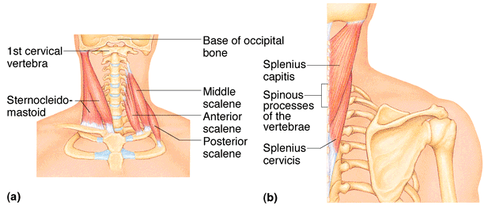

- Erector spinae:
  - Prime mover of back extension
  - Each side consists of three columns of muscles: iliocostalis, longissimus, and spinalis
    - Resistance to bending forward and extensors for return to erect position
- Semispinalis:
  - Composite muscle forming part of deep layer of intrinsic back muscles; extends from thoracic region to head
  - Extends vertebral column and head and rotates them to opposite side; acts synergistically with sternocleidomastoid muscle of opposite side
- Quadratus lumborum (iliac crest to lumber vertebrae):
  - Laterally flexes vertebral column when acting separately
  - When pair acts jointly, lumbar spine is extended and 12th rib is fixed
  - Maintains upright posture; assists in forced inspiration
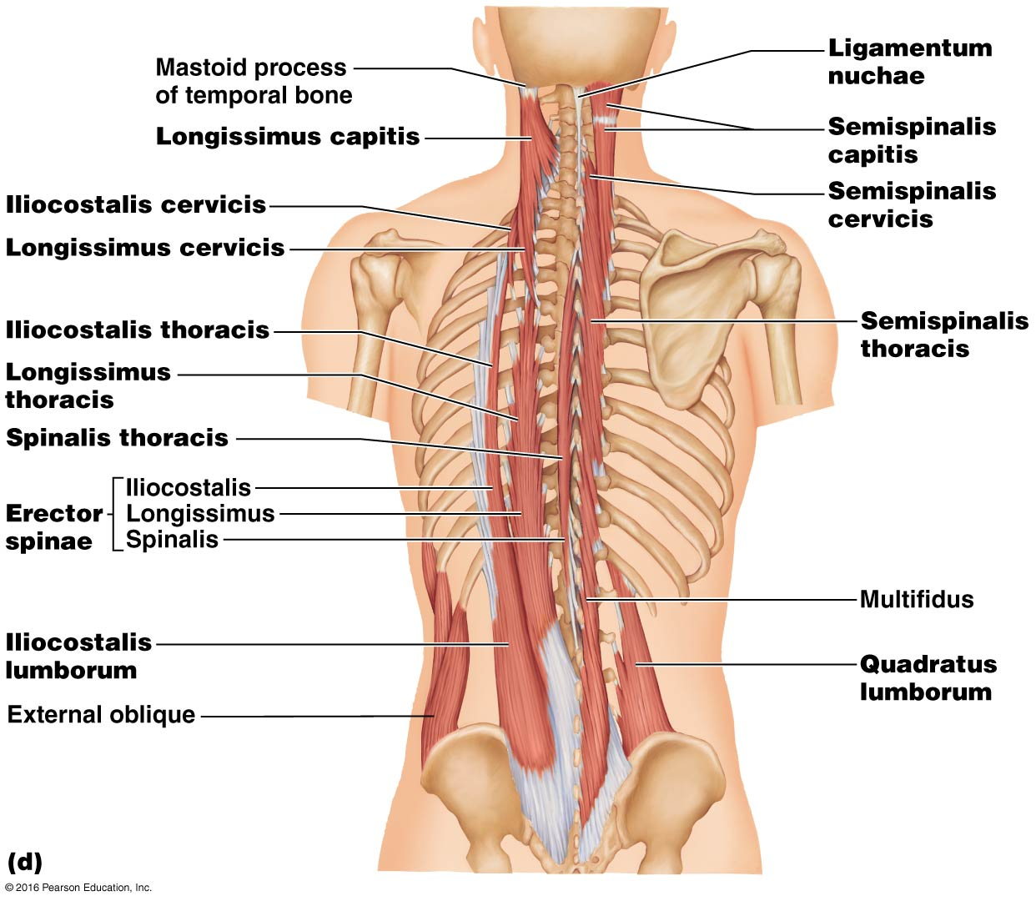

Muscles of Respiration
- External Intercostals:
  - 11 pairs lie between ribs
  - Fibers run obliquely (down and forward) from each rib to rib below
  - With first ribs fixed by scalene muscles, pulls ribs toward one another to elevate rib cage
    - Aid in inspiration
    - Synergists of diaphragm
- Internal Intercostals:
  - 11 pairs lie between ribs
  - Fibers run deep to and at right angles to those of external intercostals (ie. Run downward and posteriorly)
  - With 12th ribs fixed by quadratus lumborum, muscles of posterior abdominal wall, and oblique muscles of the abdominal wall, they draw ribs together and depress the rib cage.
    - Aid forced expiration
    - Antagonistic to external intercostals
- Diaphragm:
  - Dome shaped when relaxed
  - Prime mover of inspiration; flattens on contraction
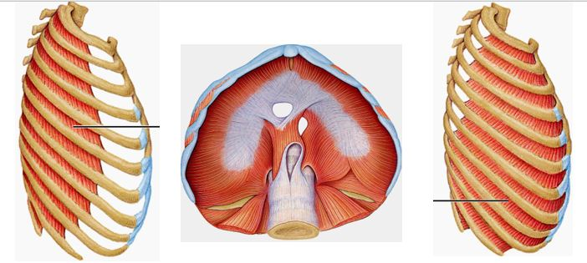

Muscles of the Abdominal Wall
- Rectus Abdominis:
  - Medial superficial muscle pair; extend from pubis to rib cage
  - Flex and rotate lumbar region of vertebral column
    - Fix and depress ribs, stabilize pelvis during walking
    - Used in sit-ups and curls
- External oblique:
  - Largest and most superficial of the three lateral muscles
  - When pair contract simultaneously, flex vertebral column and compress abdominal wall and increase intra-abdominal pressure
    - Acting individually, aid muscles of back in rotating trunk and flexing laterally
    - Used in oblique curls
- Internal Oblique:
  - Deeper, but same actions as external obliques
- Transversus abdominis:
  - Deepest (innermost) muscle of abdominal wall
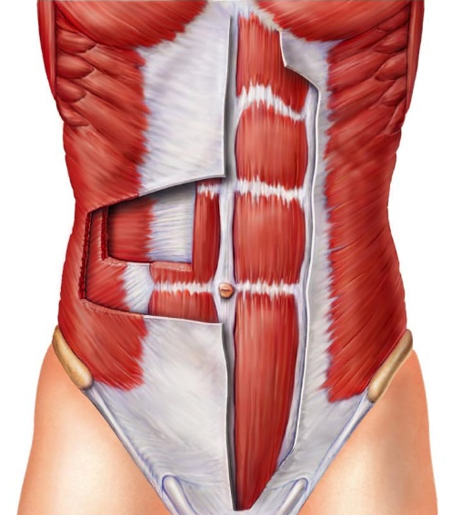
  - Compresses abdominal contents


