Anatomy of the Skeletal System (Topic 2)

Appendicular Skeleton
- Consist of the pectoral girdle and pelvic girdle
Pectoral (Shoulder) Girdle
- Consists of two pairs of bone: clavicles and scapulae
  - The make almost a complete circle around the upper trunk to make shoulders
  - Anteriorly, the medial end of each clavicle joins the sternum
  - Laterally, the distal ends of the clavicles meet the scapulae
  - Posteriorly, the scapulae fail to complete the ring because their medial borders do not join each other or the axial skeleton
- The pectoral girdles attach the upper limbs to the axial skeleton and provide attachment points for many of the muscles that move the upper limbs.
- These girdles are very light and allow the upper limbs a degree of mobility not seen anywhere else in the body.
- This mobility is due to the following factors:
  - Because only the clavicle attaches to the axial skeleton, the scapula can move quite freely across the thorax, allowing the arm to move with it.
  - The socket of the shoulder joint (the scapula’s glenoid cavity) is shallow and poorly reinforced, so it does not restrict the movement of the humerus (arm bone).
    - Although this arrangement is good for flexibility, it is bad for stability—shoulder dislocations are common.
- Clavicles (Collarbones):
  - are slender, S-shaped bones
  - Besides anchoring many muscles, the clavicles act as braces: they hold the scapulae and arms our laterally, away from the narrower superior part of the thorax
  - The curves in the clavicle ensure that it usually fractures anteriorly (outward), away from the subclavian artery
- Scapulae (Shoulder Blades):
  - Are thin, triangular flat bones
  - The scapulae lie on the dorsal surface of the rib cage, between ribs 2 and 7.
  - Each scapula has three borders:
    - Superior border
    - Medial (vertebral) border
    - Lateral (axillary) border
  - Notes: spine acromion (articulates with the acromial end of the clavicle- acromioclavicular joint), and coracoid process (help anchor the bicep muscle of the arm)

Upper Limb
- Consists of 30 separate bones and include the:
  - Arm
  - Forearm
  - Hand
- Arm:
  - Humerus:
    - longest bone of the upper limb
    - it articulates with the scapula at the shoulder and with the radius and ulna (forearm bones) at the elbow
    - Note: head (fits into the glenoid cavity of the scapula in a manner that allows the arm to hang freely at one’s side), anatomical neck, greater tubercle, lesser tubercle (sites of attachment for the rotator cuff muscles), intertubercular sulcus, surgical neck (the most frequently fracture part of the humerus)
    - At the distal end of the humerus are two condyles: trochlea (articulates with the ulna), and capitulum (articulates with the radius)
    - The ulnar nerve, which runs behind the medial epicondyle, is responsible for the painful, tingling sensation you experience when you hit your “funny bone.”
- Forearm:
  - Composed of two parallel long bones: radius and ulna
  - They articulate with the humerus and wrist bones
  - They also articulate with each other at superior and inferior radioulnar joints
  - They are connected along their entire length by a flat, flexible ligament—the interosseous membrane.
  - Ulna (Forms Elbow Joint):
    - Slightly longer than the radius
    - Bares two prominent processes: olecranon (elbow) and coronoid processes
    - The olecranon locks into the olecranon fossa, keeping the forearm from hyperextending
    - On the lateral side of the coronoid process is a small depression, the radial notch, where the ulna articulates with the head of the radius.
    - Styloid process has a ligament that runs to the wrist
  - Radius (Wrist joint):
    - Head at proximal end which is thin and wider at its distal end
    - Distal end has a medial ulnar notch and a lateral styloid process
- Hand:
  - Contains 27 bones in total and includes the bones of: carpus (wrist), metacarpus (palm), and phalanges (bones of the fingers)
  - Carpus (wrist):
    - Consist of 8 marble sized short bones (carpals)
    - Only scaphoid and lunate articulate with radius
    - The carpals are arranged in two irregular rows of four bones each.
    - Scaphoid, lunate, triquetrum, pisiform, trapezium, trapezoid, capitate, hamate
    - Remember: Sally Left The Party To Take Cindy Home

  - Metacarpus:
    - Consist of 5 long bones and at the distal ends are knuckles
    - Numbered 1-5 from the thumb to little finger
    - The proximal ends are articulated with wrist bones
  - Phalanges:
    - Numbered 1-5 from thumb to little finger
    - Each finger has three phalanges: proximal, middle, and distal; except for the thumb which has only proximal and distal
Pelvic Girdle
- The pelvic (hip) girdle is formed by the sacrum and a pair of hip bones, each also called an os coxae or coxal bone.
- The pelvic girdle attaches the lower limbs to the axial skeleton, transmits the full weight of the upper body of the lower limbs, and supports the visceral organs of the pelvis.
- Forms a complete circle
- Left and right hip bones (coxal bones) unite anteriorly and with the sacrum at the back
- Each large, irregularly shaped hip bone consists of three separate bones during childhood:
  - Ilium
  - Ischium
  - Pubis
- In adults, these bones are firmly fused.
- At the point of fusion of the ilium, ischium, and pubis is a deep hemispherical socket called the acetabulum on the lateral surface of the pelvis
  - The acetabulum receives the head of the femur, or thigh bone, at this hip joint
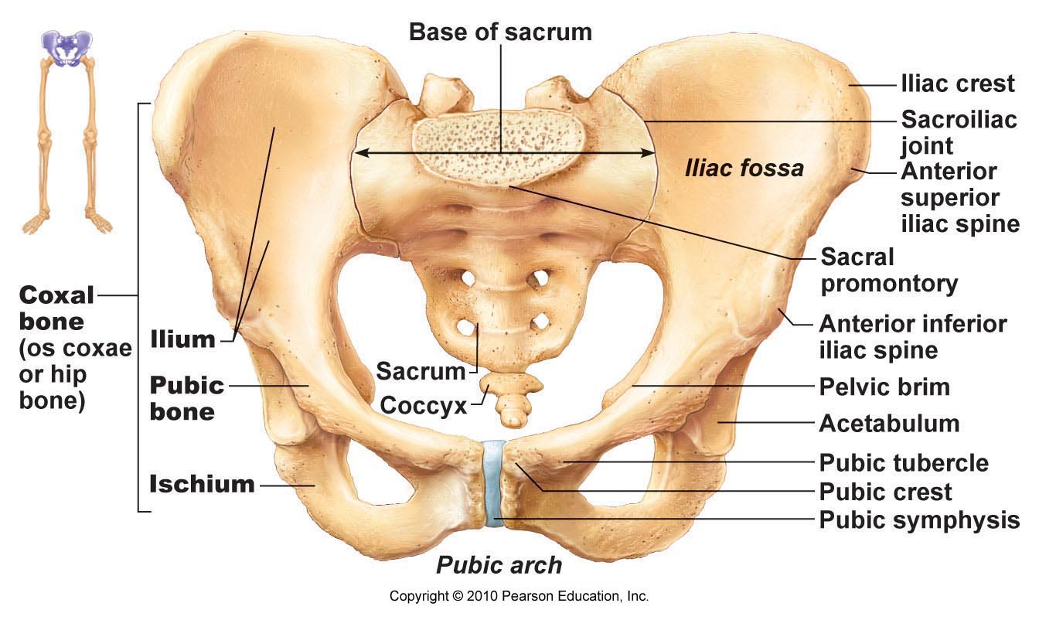

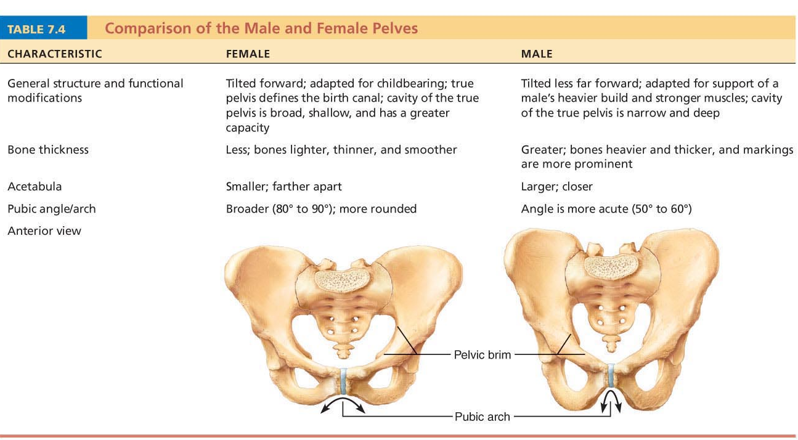

- Ilium:
  - A large flaring bone that forms the superior region of a hip bone
  - Note: iliac crest (superior border); iliac spines (attachment of muscles)
  - The pelvis brim is superior margin of the true pelvis
  - Anteriorly, the body of the ilium joins the pubis; inferiorly it joins the ischium.
- Ischium:
  - Forms the posterior-inferior part of the hip bone
  - Roughly L- or arc-shaped, is has a thicker, superior body adjoining the ilium and a thinner, inferior ramus
  - When we sit, our weight is borne by the ischial tuberosities, which are the strongest parts of the hip bones.
- Pubis:
  - Form the anterior portion of the hipbone
  - The bodies of the two pubic bones are joined by a fibrocartilage disc, forming the midline pubic symphysis joint.
  - Note: pubic crest, obturator foramen (blood vessels and nerves pass)
Lower Limb
- Consist of the thigh, leg, and foot
- Thigh:
  - The femur is the longest, largest, and strongest bone in the body
  - Note: head, fovea capitis (ligament to acetabulum), neck (angles laterally to join the shaft; weakest part of the femur and is often fractured, an injury called the broken hip), and linea aspera.
    - Distally, the femur broadens and ends in the wheel-like lateral and medial condyles, which articulate with the tibia of the leg.
    - The medial and lateral epicondyles are sites of muscle attachment
    - The smooth patellar surface, between the condyles on the anterior femoral surface, articulates with the patella (kneecap)
- Leg:
  - Two parallel bones form the skeleton of the leg: tibia and fibula
  - These two bones are connected by an interosseous membrane and articulate with each other both proximally and distally.
  - Note: the tibiofibular joints of the leg allow essentially no movement
  - The fibula does not contribute to the knee joint and merely helps stabilize the ankle joint
  - Tibia (Shinbone):
    - Receives the weight of the body from the femur and transmits it to the foot
    - It is second only to the femur in size and strength
    - Note: medial and lateral condyles, anterior crest, tibial tuberosity (patellar ligament attaches)
  - Fibula:
    - Stick-like bone with slightly expanded ends
    - Its proximal end is its head and its distal end is the lateral malleolus
    - The lateral malleolus forms the lateral ankle bulge and articulates with the talus
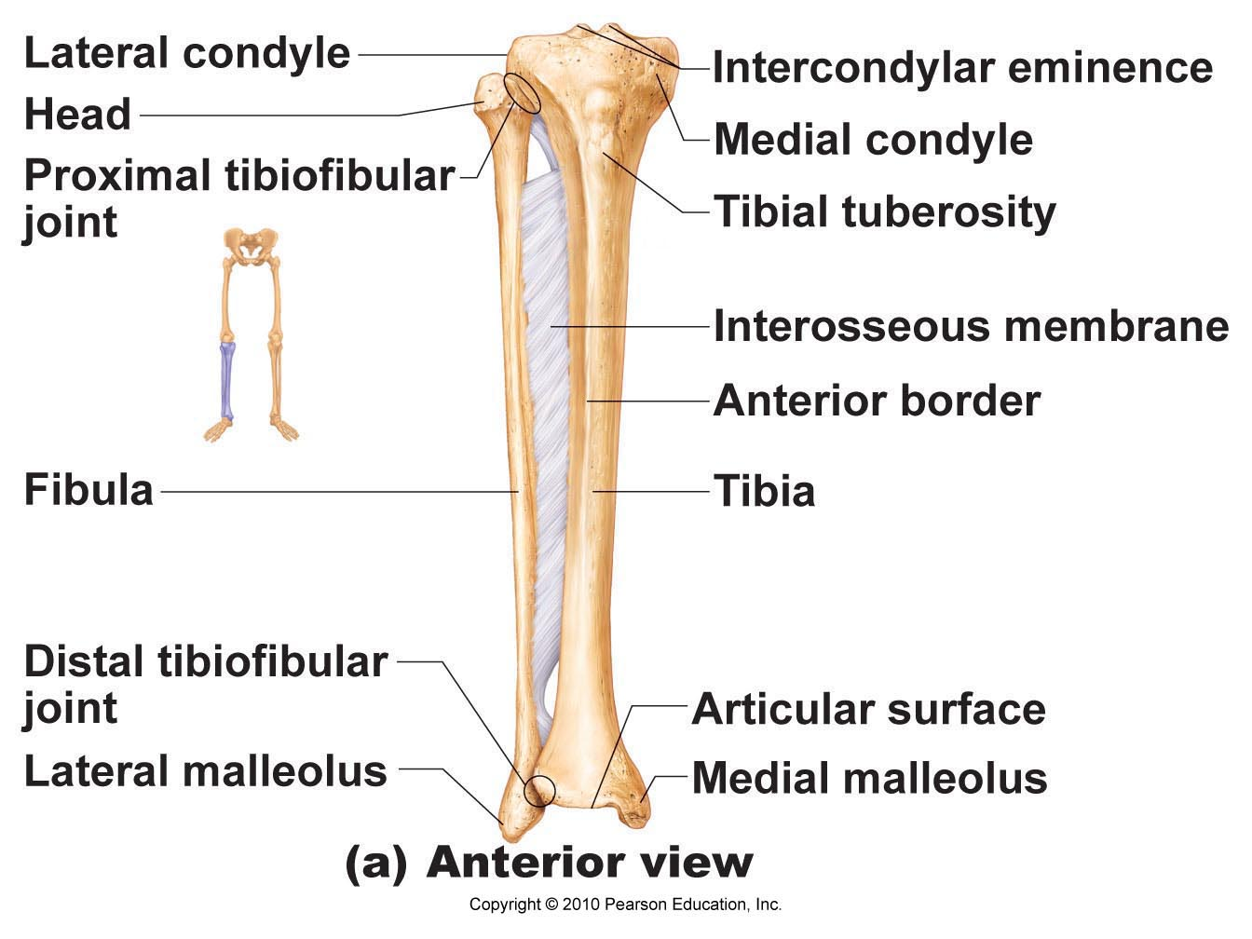
- Foot:
  - Contains a total of 26 bones and includes the: tarsus (ankle bone), metatarsus, and phalanges
  - Tarsus:
    - The tarsus is made up of 7 bones called tarsals that form the posterior half of the foot.
    - Body weight is carried primarily by the two largest, most posterior tarsals: the talus (ankle)—which articulates with the tibia and fibula superiorly, and the strong calcaneus (heel bone)-- which forms the heel of the foot and carries the talus on its superior surface.
  - Metatarsus:
    - The metatarsus consists of five small, long bones called metatarsals
    - These are numbered I to V beginning on the medial (great (big) toe) side of the foot
  - Phalanges:
    - The big toe (hallux) has two phalanges; only the proximal and distal
    - The remaining toes have 3 phalanges (proximal, middle, distal)


