Anatomy of the Skeletal System (Topic 2)

Axial Skeleton: Skull
The Skeleton
- There are 206 bones in the human skeleton which make up about 20% of body weight
- These bones are divided into two groups:
  - Axial skeleton includes: the bones of the skull, vertebral column, and rib cage
  - Appendicular skeleton includes: bones of the upper and lower limbs, and pectoral/pelvic girdles (attach limbs to axial skeleton)
The Axial Skeleton
- Contains 80 bones segregated into three major regions:
  - The skull
  - Vertebral column
  - Thoracic cage
Skull
- The skull is the body’s most complex bony structure
- It is formed by two sets of bones: facial and cranial
  - Both sets add up to 22 bones in total
- Most skull bones are flat bones except the mandible and are united by sutures
- Facial bones form the anterior part of the skull and cranial bones form the rest
- The skull has:
  - eye orbits and paranasal sinuses
  - houses organs of hearing
  - 85 openings for nerves
  - Passageways for blood vessels and spinal cord
- Cranium/Cranial Bones
- The cranium can be divided into a vault and a base
- Cranial Vault/Calvaria: forms superior, lateral, and posterior aspects of the skull, as well as the forehead
- Cranial Base: inferior aspect of the skull
- Internally, there are three bony ridges that divide the cranial base into three distinct areas:
  - Anterior (highest) fossa
  - Middle fossa
  - Posterior (lowest) fossa
- The cranium surrounds and protects the brain, and organs of hearing and balance
- Facial bones or Face:
- These are bones that from the framework of the face
- Contains the cavities for the sensory organs of sight, smell, and taste
- Provide openings for passage of air and food
- Responsible for securing the teeth
- Anchor the facial muscles that we use to physically show our feelings
The Cranium
- There are eight (8) cranial bones:
  - The paired ^{[1,2]} parietal and ^{[3,4]} temporal bones
  - The unpaired ^{[5]} frontal, ^{[6]} occipital, ^{[7]} sphenoid, and ^{[8]} ethmoid bones
- Curvature allows then to be self-bracing and can be strong while being quite thin
- Frontal Bone:
  - The dome shaped frontal bone forms the anterior cranium.
  - It articulates posteriorly with the paired parietal bones via the prominent coronal suture.
  - Forms the roofs of the orbits
  - Note: supraortibal margin, supraorbital foramen (notch), and glabella area lateral to glabella has left and right frontal sinuses within the bone.
- Parietal Bones:
  - The two large parietal bones are curved, rectangular bones that form most of the superior and lateral aspects of the skull
  - They form the bulk of the cranial vault
- Occipital Bone:
  - The occipital bone forms most of the skull’s posterior wall and base.
  - It articulates anteriorly with the paired parietal and temporal bones via the lambdoid and occipitomastoid sutures, respectively.
  - The basilar part of the occipital bone also joins with the sphenoid bone in the cranial base.
  - Internally, the occipital bone forms the walls of the posterior cranial fossa
    - This supports the cerebellum of the brain
  - In the base of the occipital bone is the foramen magnum (large hole) through which the inferior part of the brain connects with the spinal cord
  - Occipital condyles are located on each side of the foremen magnum.
    - It is also the site of articulation with the first vertebra of the spinal column in a way that permits the nodding motion of the head
  - External occipital protuberance is a projection at the back of the skull
    - This is more prominent in males
- Temporal Bones:
  - There are two temporal bones that from the inferior and lateral aspects of the skull and parts of the cranial floor
  - Temporal bones are located just below the two parietal bones.
  - Each temporal bone has a complicated shape and is described in terms of its three major parts; three (3) very different areas or regions:
    - Squamous Region:
      - The flaring squamous part ends at the squamous suture.
      - Its bar-like zygomatic process meets the zygomatic bone of the face anteriorly
      - These two bony structures form the zygomatic arch, which you can feel as the projection of your cheek.
      - The mandibular fossa on the inferior surface of the zygomatic process receives the condylar process of the mandible (lower jawbone), forming the freely moveable temporomandibular joint.
    - Tympanic region:
      - The tympanic part of the temporal bone surrounds the external acoustic meatus or external ear canal.
    - Petrous Region:
      - Found on the internal aspect of temporal bone
      - Contributes to the cranial base and houses middle and inner ear cavities
      - The mastoid process acts as an anchoring site for some neck muscles
      - The styloid processes an attachment point for several tongue and neck muscles.
      - Several important foramina associated with this part of the temporal bone include: jugular foramen, carotid canal, and internal acoustic meatus
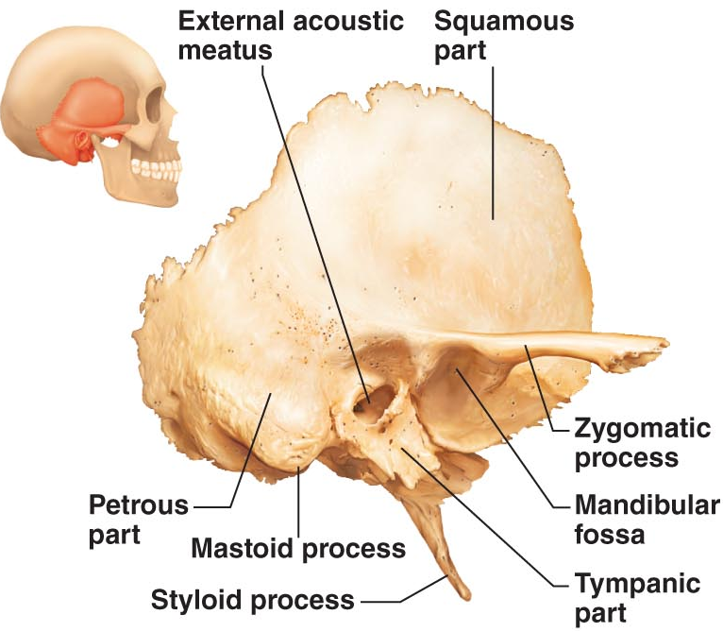
- Sphenoid Bone:
  - Complex bone shape which is difficult to visualize
  - Articulates with all other cranial bones
  - Spans the width of the middle cranial fossa
  - Contributes to the base of the anterior cranial fossa
  - Within the body of the sphenoid are the paired sphenoidal sinuses
  - It consists of a central body with three pairs of processes:
    - Greater Wings: form parts of the middle cranial fossa and the posterior walls of the orbits
    - Lesser Wings: forms part of the floor of the anterior cranial fossa and the medial walls of the orbits
    - Pterygoid processes: anchor the pterygoid muscles which are important in chewing
  - Optic Foramina (canals): allow the optic nerves to pass to the eyes
  - Superior orbital fissure: a long slit between the greater and lesser wings.
    - It allows cranial nerves that control eye movements to enter the orbit

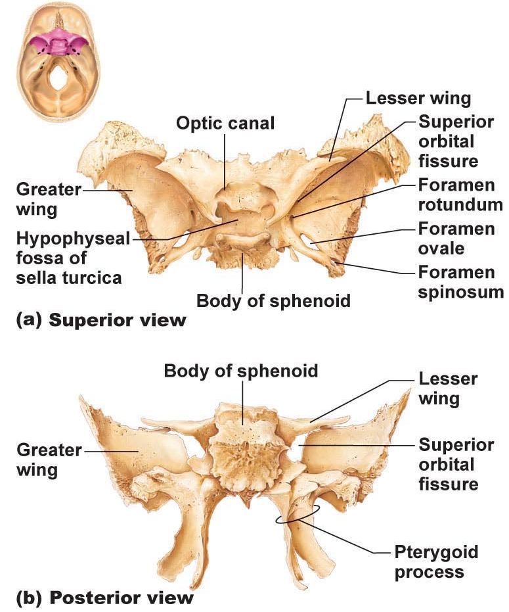
- Ethmoid bone:
  - Approximates a cube that lies deep between the sphenoid and the nasal bones of the face
  - It forms most of the bony area between the nasal cavity and the orbits
  - Cribriform plates: help form the roof of the nasal cavity and the floor of the anterior cranial fossa.
    - The cribriform plates are punctured by tiny holes called cribriform (olfactory) foramina that allow the filaments of the olfactory nerves to pass from the smell receptors in the nasal cavity of the brain.
  - Crista Galli: the outermost covering of the brain (the dura mater) attaches to the crista galli and helps secure the brain in the cranial cavity.
  - Perpendicular Plate: projects inferiorly in the median plane and forms the superior part of the nasal septum, which divides the nasal cavity into right and left halves
  - Lateral masses contain sinuses called ethmoidal air cells.
  - Extending medially from the lateral masses are the delicately coiled superior and middle nasal conchae.
  - The lateral surfaces of the ethmoid’s lateral masses are called orbital plates because they contribute to the medial walls of the orbits

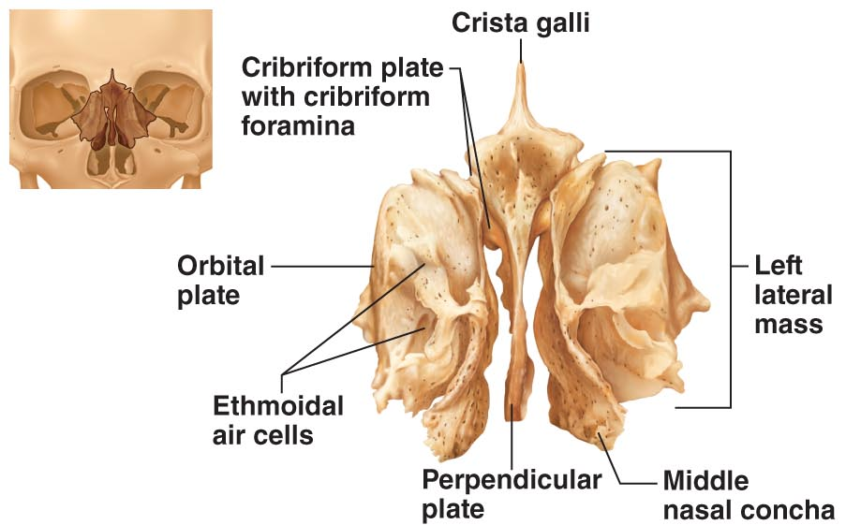
Major Cranial Sutures
- The bones of the adult skull are firmly united by sutures
- There are four (4) main sutures that connect the cranial bones:
  - Coronal suture: connects the frontal bone and two parietal bones
  - Squamous suture: connects the parietal bone and temporal bone
  - Lambdoid suture: connects the occipital bone and two parietal bones
  - Sagittal suture: connects the two parietal bones
- Sutural bones: are tiny, irregular shaped bones or bone clusters that occur within sutures, most often in the lambdoid suture.
  - Can occur within cranial suture additional ossification centres that appeared rapidly during fetal development
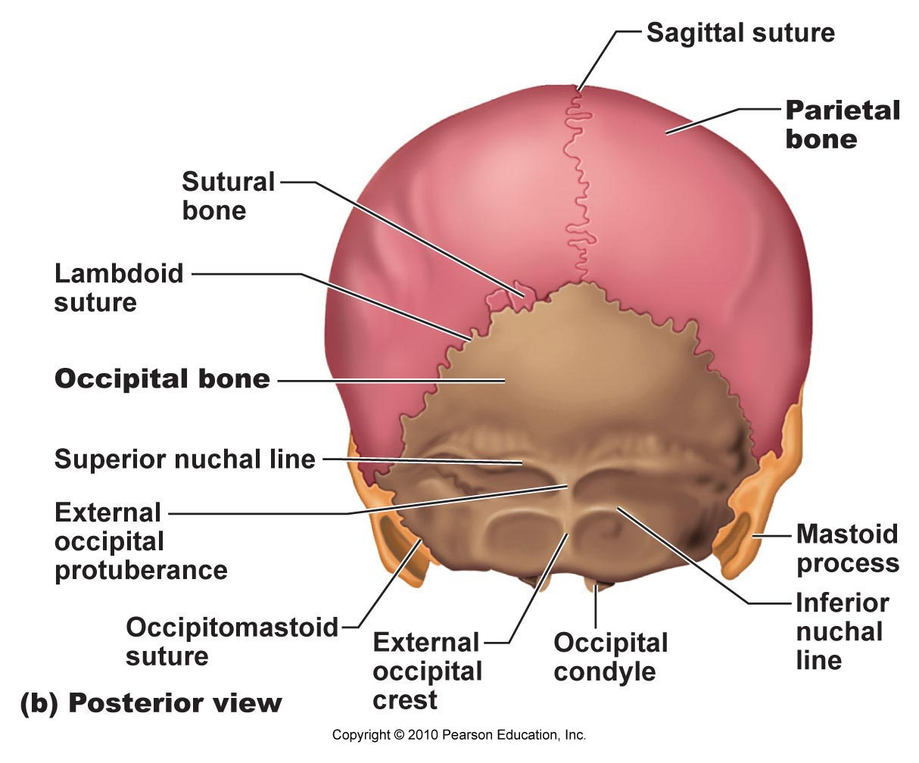
Facial Bones
- The facial skeleton is made up of 14 bones of which only the mandible and the vomer are unpaired.
- The maxillae, zygomatics, nasals, lacrimals, palatines, and inferior nasal conchae are paired bones.
- Mandible:
  - The U-shaped mandible or lower jaw bone, is the largest and strongest bone of the face
  - It has a body, which forms the chin, and two upright rami
  - Each ramus meets the body posteriorly at the mandibular angle.
  - Note: mandibular notch, coronoid process (insertion of temporalis muscle), mandibular condyle, alveolar margin (contains tooth sockets), mandibular foramina (permits the nerves responsible for tooth sensation to pass to the teeth in the lower jaw), and mental foramina (allow blood vessels and nerves to pass to the skin of the chin and lower lip)
- Maxillary bones:
  - The maxillary bones or maxillae are fused medially
  - They form the upper jaw and the central portion of the facial skeleton.
  - The maxillae carry the upper teeth in their alveolar processes
  - The palatine processes of the maxillae project posteriorly from the alveolar processes and fuse medially at the intermaxillary suture, forming the anterior two-thirds of the hard palate (bony roof of the mouth)
  - Note: Incisive fossa (passageway for blood vessels and nerves), frontal processes (form part of the lateral aspects of the bridge of the nose), and zygomatic processes
  - The regions that flank the nasal cavity laterally contain the maxillary sinuses, the largest of the paranasal sinuses.
    - These are the sinuses that get infected
- Zygomatic bones:
  - The irregularly shaped zygomatic bones commonly celled the cheekbones
  - Articulate with zygomatic processes of the maxilla, frontal and temporal bones
  - Contribute to inferolateral margins of the orbit
- Nasal bones:
  - Two tiny, rectangular bones that fuse medially to form the bridge of the nose
  - They articulate with the frontal bone superiorly and the maxillary bones laterally
- Lacrimal bones:
  - Two fingernail-shaped bones that contribute to the medial walls of each orbit
  - The articulate with:
    - Frontal bone
    - Ethmoid bone
    - Maxillae
  - Each lacrimal bone contains a deep groove that helps form a lacrimal fossa.
    - The lacrimal fossa houses the lacrimal sac, part of the passageway that allows tears to drain from the eye surface into the nasal cavity
- Palatine bones:
  - Each L-shaped palatine bone (two of them) is fashioned from two bony plates, the horizontal and perpendicular.
  - The three important articular processes:
    - Pyramidal
    - Sphenoidal
    - Orbital
  - The horizontal plates complete the posterior portion of the hard palate
  - The perpendicular (vertical) plates form part of the posterolateral walls of the nasal cavity and a small part of the orbits

- Vomer:
  - Single, thin bone that lies in the nasal cavity, where it forms part of the nasal septum.
- The paired inferior nasal conchae are thin, curved bones that project medially from the lateral walls of the nasal cavity, just inferior to the middle nasal conchae of the ethmoid bone.
- They are the largest of the three pairs of conchae and they form part of the lateral walls of the nasal cavity.
The Hyoid Bone
- Only bone that does not articulate with any other bone
- It is horseshoe shaped, with a body and two pairs of horns (cornua)
- The hyoid bone acts as a moveable base for the tongue
- Its body and greater horns are attachment points for the neck muscles that raise and lower the larynx during swallowing and speech.
The Paranasal Sinuses
- Made up of five skull bones:
  - Frontal
  - Sphenoid
  - Ethmoid
  - Paired maxillary bones
- They contain mucosa-lined, air-filled sinuses
- Paranasal sinuses lighten the skull and enhance resonance of voice
- They connect to the nasal cavity so it helps to warm and humidify incoming air

Axial Skeleton: Vertebral Column
- Composed of 33 bones of which 24 remain separate (allowing flexibility) and the remaining 9 fuse to form 2 composite bones (sacrum and coccyx)- 70 cm long
- Five major regions:
  - Cervical curvature: 7 vertebrae
  - Thoracic curvature: 12 vertebrae
  - Lumbar curvature: 5 vertebrae
  - Sacral curvature: 5 fused vertebrae
  - Coccyx: 4 fused vertebrae
- Three main functions:
  - Weight-bearing
  - Anchor for muscles and ligaments
  - Protection of spinal cord
- Curvatures of the vertebral column:
  - Allows for resilience and flexibility
  - Cervical and lumbar curvatures: concave
  - Thoracic and sacral curvatures: convex
Supporting Elements of Vertebral Column
- Ligaments:
  - Strap-like ligaments and the trunk muscles support column of bones so they stay upright
  - The major supporting ligaments are the anterior and posterior longitudinal ligaments
    - These run as continuous bands down the front and back surfaces of the vertebrae from the neck to the sacrum
  - The broad anterior ligament is strongly attached to both the bony vertebrae and the discs
    - Along with its supporting role, it prevents hyperextension of the spine (bending too far backward.)
  - The posterior ligament, which resist hyperflexion of the spine (bending too far forward), is narrow and relatively weak.
    - It attaches only to the discs
- Intervertebral Discs:
  - Intervertebral discs are the cushioning between the bony vertebral bodies which absorb shock and account for 25% of the height in the vertebral column
  - It is composed of two parts where each is circular with a nucleus pulposus in the centre and an annulus fibrosus around the periphery
  - The nucleus pulposus is like a rubber ball giving the disc’s elasticity and compressibility
  - The annulus fibrosus holds together successive vertebrae and resists tension in the spine
  - The discs are thickest in the lumbar and cervical regions, which enhances the flexibility of these regions
  - Note: A herniated (prolapsed) disc, or slipped disc, usually involves the rupture of the annulus fibrosus followed by the protrusion of the spongy nucleus pulposus through the annulus.
    - If the protrusion presses on the spinal cord or on spinal nerves exiting from the cord, numbness or excruciating pain may result
    - This is caused by severe or sudden physical trauma to the spine (ex. From bending forward while lifting a heavy object); may result in herniation in one or more discs
General Structure of Vertebrae
- The vertebra gets larger as one descends the column
- Each vertebra consists of a body (centrum) and a vertebral arch
  - The body is the weight-bearing region
- Together, the body and vertebral arch enclose an opening called the vertebral foramen
  - Successive vertebral foramina of the articulate vertebrae form the long vertebral canal, through which the spinal cord passes.
- Two (2) pedicles and two (2) laminae form the vertebral arch
- The pedicles have notches on their superior and inferior borders, providing lateral openings between adjacent vertebrae called intervertebral foramina
  - The spinal nerves issuing from the spinal cord pass through these foramina
- Seven (7) processes project from the vertebral arch:
  - 1 spinous process: a median posterior projection arising at the junction of the two laminae
  - 2 transverse processes: extends laterally from each side of the vertebral arch
    - The spinous and transverse processes are attachment sites for muscles that move the vertebral column and for ligaments that stabilize it.
  - Paired superior and inferior articular processes: link the vertebrae above and below
    - The smooth joint surfaces of the articular processes are called facets
    - Facets are covered with hyaline cartilage and collagen
Regional Vertebral Characteristics
- Cervical Vertebrae:
  - The 7 cervical vertebrae (C₁-C₇); C₁ and C₂ have an unusual structure and no intervertebral disc
  - The typical cervical vertebrae (C₃-C₇) have the following distinguishing features:
    - The body is oval—wider from side to side than in the anteroposterior dimension
    - Except in C₇, the spinous process is short, projects directly back, and is bifid (split at its tip)
    - The vertebral foramen is large and generally triangular
    - Each transverse process contains a transverse foramen through which the vertebral arteries pass to service the brain
  - Atlas (C₁):
    - Has no body and no spinous process
    - It is a ring of bone consisting of anterior and posterior neural arches and a lateral mass on each side.
    - Each lateral mass has articular facets on both its superior and inferior surfaces—articulation with brain and with C₂
  - Axis (C₂):
    - Has a body and other typical vertebral processes
    - Its only unusual feature is the knoblike dens (or odontoid process) projecting superiorly from its body
    - The dens act as a pivot for the rotation of the atlas
- Thoracic Vertebrae:
  - Contains 12 thoracic vertebrae (T₁-T₁₂)
  - The thoracic vertebrae increase in size from the first to the last
  - All thoracic vertebrae articulate with the ribs
  - The body is roughly heart shaped and bears facets for ribs (paired demi-facets)
  - The vertebral foramen is circular
  - The spinous process is long and points sharply downward
  - Except for T₁₁ and T₁₂, the transverse processes have facets, the transverse costal facets, that articulate with the tubercles of the ribs.
- Lumbar Vertebrae:
  - The lumbar vertebrae receive that most stress
  - The enhanced weight-bearing function of the five lumbar vertebrae (L1-L5) is reflected in their sturdier structure.
  - Their bodies are massive and kidney shaped; it also increases in size from top to bottom
  - The pedicles and laminae are shorter and thicker than those of other vertebrae.
  - The spinous processes are short, flat, and hatchet shaped and are easily seen when a person bends forward.
    - These processes are robust and project directly backward, adaptions for the attachment of large back muscles
  - The vertebral foramen if triangular
  - The orientation of the inferior and superior facets is unique
    - Curvature: superior faces in, and inferior faces out
- Sacral Vertebrae:
  - Starts as 5 separate vertebrae (S₁-S₅) then fuses as you become an adult to form the sacrum
  - It articulates with the 5th lumbar vertebrae and laterally with the hip bones to form the sacroiliac joint
  - Note: sacral promontory, transverse lines, and sacral foramina
  - Note: median sacral crest, sacral canal, and sacral hiatus
- Coccygeal Vertebrae (Coccyx):
  - The coccyx, our tailbone, is a small triangular bone
  - It consists of three or four vertebrae fused together
  - It is an attachment area for some pelvic ligaments, but otherwise, it is quite useless

Axial Skeleton: Thoracic Cage
Thoracic Cage (Bony Thorax)
- Elements of the thoracic cage include:
  - Thoracic vertebrae
  - Ribs
  - Costal cartilage: secure the ribs to the sternum
  - Sternum
- Bony thorax functions:
  - Form a protective cage around the heart, lungs, and major blood vessels
  - Supports the shoulder girdles and upper limbs
  - Provide an attachment point for man muscles of the neck, back, chest, and shoulders.
- Sternum (Breastbone):
  - Lies in the anterior midline of the thorax
  - The sternum results from the fusion of:
    - Manubrium: articulates with the clavicles via clavicular notches; also articulates with the first two pairs of ribs
    - Body: forms the bulk of the sternum; has notches for articulation with the 2nd to 7th ribs
    - Xiphoid process: attachment point of some abdominal muscles
  - The sternum has three important anatomical landmarks:
    - Jugular (suprasternal) notch: the central indentation in the superior border of the manubrium; in line with the disc between the second and third thoracic vertebrae; the point where the left common carotid artery issues from the aorta
    - Sternal angle: a horizontal ridge across from the sternum, where the manubrium joins the sternal body; this cartilaginous joint acts like a hinge, allowing the sternal body to swing anteriorly while we inhale
    - Xiphisternal joint: the point where the sternal body and xiphoid process fuse; it lies at the level of the 9th thoracic vertebra.
- Ribs:
  - Twelve pairs of ribs form the flaring sides of the thoracic cage
  - All ribs attach posteriorly to the thoracic vertebrae (bodies and transverse processes) and curve inferiorly toward the anterior body surface.
  - The superior seven rib pairs attach directly to the sternum by individual costal cartilages; these are true (vertebrosternal) ribs.
  - The remaining five pairs of ribs are called false ribs because they either attach indirectly to the sternum or entirely lack a sternal attachment
  - Rib pairs 8-10 attach to the sternum indirectly, each joining the costal cartilage immediately above it; these ribs are called vertebrochondral ribs.
  - The inferior margin of the rib cage, or costal margin, is formed b the costal cartilages of ribs 7-10.
  - Rib pairs 11 and 12 are called vertebral ribs or floating ribs because they have no anterior attachments.
  - A typical rib is a bowed flat bone
  - Each rib has a:
    - Shaft
    - Head
    - Neck
    - Tubercle
  - The main portion of the rib is the shaft.
    - Its superior border is smooth, but its inferior border is sharp and thin and has a costal groove on its inner face that lodges the intercostal nerves and blood vessels
  - The head articulates with the vertebral bodies by two facets:
    - One joins the body of the same numbered thoracic vertebra
    - The other articulates with the body of the vertebra immediately superior
  - The neck is the constricted portion of the rib just beyond the head
  - The tubercle articulates with the costal facet of the transverse process of the same-numbered thoracic vertebra.

