Anatomy of the Skeletal System (Topic 2)

Bone and Skeletal Tissue
Connective Tissue
- Connective tissue is largely non-living, extracellular matrix which separates the living cells of a tissue.
- It can bear weight, withstand great tension, and endure physical trauma and abrasion
- There are four classes of connective tissue:
  - Connective Tissue Proper: fat, and fibrous tissue of ligaments
  - Cartilage
  - Bone
  - Blood
- Composed of ground substance, fibres and cells
  - Extracellular matrix is made up of the ground substance and fibers
  - Ground substance: is unstructured material that fills the space between cells and contains the fibres
- Connective tissue contains a large amount of glycosaminoglycans (GAGs)
  - Note: The higher the GAG, the more viscous
Cartilage
- Skeletal cartilage: is made of a variety of cartilage tissue molded to fit its body location and function.
  - Found between dense connective tissue and bone
  - Tough but flexible
  - Contains no nerves or blood vessels
  - Ground substances contains lots of the GAGs (chondroitin sulfate & hyaluronic acid—also chondronectin, an adhesive protein)
  - Contains collagen fibers (can have some elastic fibers) and up to 80% water.
- Perichondrium:
  - Connective tissue surrounding cartilage which contains blood vessels which provide nutrients to cartilage. This mode of nutrient delivery limits cartilage thickness
  - Acts like a girdle to resist outward expansion when the cartilage is compressed
  - In damaged areas, perichondrium can form scar tissue because poorly vascularized cartilage repairs badly; ossification of cartilage with aging.
- Chondroblasts:
  - Immature cartilage cells that actively form cartilage
- Chondrocytes:
  - Mature cartilage cells which maintain cartilage
- Lacunae:
  - Small localized cavities with clusters of chondrocytes in cartilage
Types of Cartilage
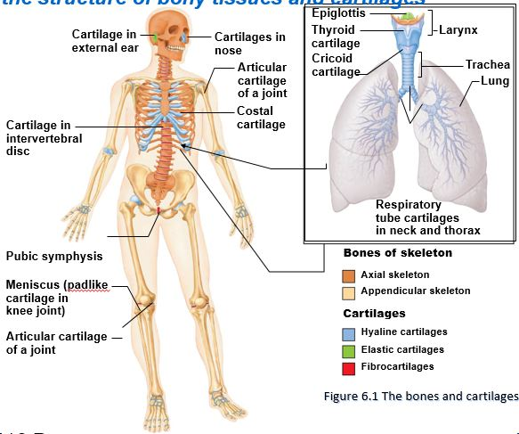
- Hyaline Cartilage:
  - Looks like frosted glass when freshly exposed (appears glassy blue-white)
  - Hyaline cartilages are the most abundant skeletal cartilages
  - Their chondrocytes are spherical, and the only fibre type in their matrix is fine collagen fibres (which are undetectable microscopically).
  - Function: provide support with flexibility and resilience, also resists compressive stress
  - Location: embryonic skeleton, ends of long bones (epiphyseal plates in growing children), costal cartilages of ribs, cartilages of nose, trachea, larynx
  - Skeletal hyaline cartilages include:
    - Articular cartilages: covers the ends of most bones at moveable joints
    - Costal cartilages: connect the ribs to the sternum (breastbone)
    - Respiratory cartilages: form the skeleton of the larynx (voice box) and reinforce other respiratory passageways
    - Nasal cartilages: support the external nose
- Elastic cartilages:
  - Resemble hyaline cartilages but they contain more stretchy elastic fibres.
  - Better able to stand up to repeated bending.
  - They are found in only two skeletal locations:
    - External ear
    - Epiglottis (the flap that bends to cover the opening of the larynx each time we swallow)
  - Function: maintains shape while giving lots of flexibility
- Fibrocartilage:
  - Structural intermediate between hyaline cartilage and dense regular connective tissue
  - Consist of roughly parallel rows of chondrocytes alternating with thick collagen fibres
  - Fibrocartilages occur in sites that are subjected to both pressure and stretch
    - Location: the pad-like cartilages (menisci) of the knee, the discs between vertebrae, intervertebral discs, and pubic symphysis.
  - Function: tensile strength with ability to absorb compressive shock
Growth of Cartilage
- Cartilages has a flexible matrix that can accommodate mitosis.
- It is the ideal tissue to use to rapidly lay down the embryonic skeleton and to provide for new skeletal growth
- Cartilages grows in two ways:
  - Appositional growth: cartilage-forming cells in the surrounding perichondrium secrete new matrix against the external face of the existing cartilage tissue.
  - Interstitial growth: the lacunae-bound that divide and secrete new matrix, expanding the cartilages from within.
- Cartilages growth ends during adolescence when the skeleton stops growing
- During normal bone growth in young and during old age, cartilage can become calcified (hardened due to deposit of calcium salts); this calcified cartilage is not bone.
Bone (Osseous tissue)
- Bone is a living dynamic tissue which responds to its environment:
  - Bone reacts to the amount of force applied by increasing both the density and the amount of roughening on bone, or decreasing density when force is reduced or eliminated (ex. Paralysis) (deposition vs resorption)
  - Bone stores calcium which is resorbed and transferred to bloodstream when needed
  - Description of bone: hard, calcified, and very well vascularized
- Calcium salts give hardness and strength for support and protection of softer tissues; cavities for fat storage and synthesis of blood cells
- Matrix containing many collagen fibers
- Cells: Osteoblast, osteocytes lie in lacunae, osteoclasts
- Functions:
  - Support: bones provide a framework that supports the body and cradles its soft organs.
  - Protection: the fused bones of the skull protects the brain while the vertebrae surround the spinal cord
  - Movement: skeletal muscles, which attach to bones by tendons, use bones as levers to move the body and its parts.
  - Mineral and Growth Factor Storage: bone is a reservoir for minerals, most importantly calcium and phosphate.
  - Blood Cell Formation: most blood cell formation, or hematopoiesis, occurs in the red bone cavities of certain bones.
  - Triglyceride (fat) storage: fat, a source of energy for the body, is stored in bone cavities
  - Hormone Production: bones produce osteocalcin, a hormone that helps to regulate insulin secretion, glucose homeostasis, and energy expenditure.
Classification of Bones
- Bones come in many shapes and sizes.
  - Example: the pisiform bone of the wrist is the size and shape of a pea, whereas the femur (thigh bone) is nearly two feet long and has a large, ball-shaped head.
- The unique shape of each bone fulfills a particular need
  - Example: the femur withstands great pressure, and its hollow-cylinder design provides maximum strength with minimum weight to accommodate our upright posture.
- Bones are classified by their shape; not their size
  - Bone classifications include: long, short, flat, and irregular
- The structure of bones is the same for all bone shapes:
  - Compact bone provides an external surface
  - Spongy (trabecular) bone forms the internal surface
    - A honeycomb of trabeculae
- Long Bones:
  - Long bones are longer than they are wide
  - Contains a shaft plus two ends, which are often expanded
  - All limb bones except the patella (kneecap), the wrist, and the ankle bones are long bones.
  - Note: the three bones in each of your fingers are long bones, even though they are small.
  - Consists of mostly compact bone with a hollow centre (marrow cavity) with spongy bone near joint ends
- Short Bones:
  - Short bones are roughly cube shaped
  - Consists primarily of spongy bone with a thin outer layer of compact bone
  - Example: wrist and ankles
  - Sesamoid bones: are a special type of short bone that form in a tendon (ex. Patella)
  - Some sesamoid bones act to alter the direction of pull of a tendon
- Flat Bones:
  - Flat bones are thin, flattened, and usually a bit curved.
  - Examples: sternum (breastbone), scapulae (shoulder blade), ribs, and most skull bones
- Irregular Bones:
  - Irregular bones have complicated shapes that fit none of the preceding classes.
  - Consists primarily of spongy bone with a thin layer of compact bone
  - Examples: the vertebrae, and the hip bone
Classification of Bone on the Basis of the Osseous Tissue
- Calcified Tissue:
  - Compact bone: dense outer layer
  - Spongy bone: trabeculae (red marrow found in spongy bone)
    - In living bones the spaces between trabeculae are filled with red or yellow bone marrow
- Linings:
  - Periosteum: consists of an outer fibrous layer with an inner osteogenic layer
  - Endosteum: covers the trabeculae of spongy bone and lines the canals of compact bone.
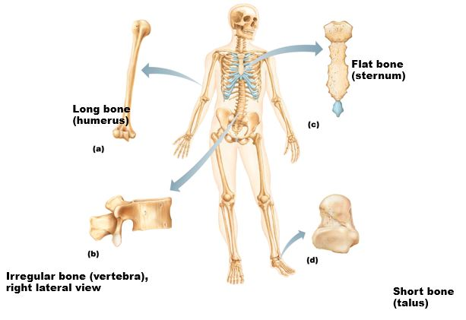
Structure of Long Bones
- Diaphysis:
  - A tubular diaphysis or shaft, forms the long axis of the bone.
  - It is constructed of a relatively thick collar of compact bone that surrounds a central medullary cavity or marrow cavity
  - In adults, the medullary cavity contains fat (yellow marrow) and is called the yellow marrow cavity.
- Epiphyses (sing.=epiphysis):
  - The epiphyses are bone ends
  - They are broader than the diaphysis
  - An outer shell of compact bone forms the epiphysis exterior, and the interior contains spongy bone.
  - A thin layer of articular (hyaline) cartilage covers the joint surface of each epiphysis.
    - This cushions the opposing bone ends during movement and absorbing stress.
- Epiphyseal Line:
  - Found between the diaphysis and each epiphysis of an adult long bone.
  - The epiphyseal line is a remnant of the epiphyseal plate.
  - Epiphyseal plate: a disc of hyaline cartilage that grows during childhood to lengthen the bone.
  - This is sometimes called the metaphysis
- Membranes:
  - Covers the outer and inner surfaces of long bones
  - The periosteum covers the outer surface and contains osteoblasts and osteoclasts
  - The endosteum covers the inner surface (lines marrow cavity).
    - This is a delicate layer of connective tissue that also contains osteoblasts and osteoclasts.
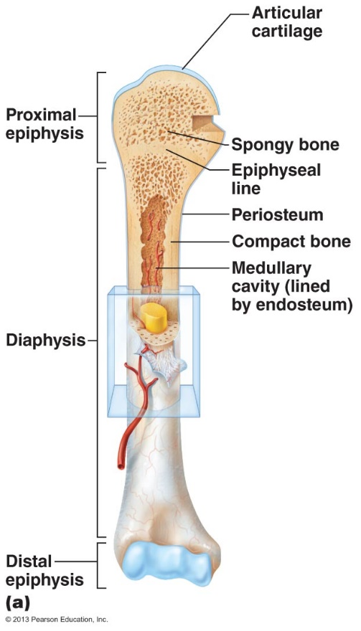
- Note: hematopoietic tissue, red marrow, is typically found within the trabecular cavities of spongy bone of long bones and in the diploe of flat bones
Structure of Other Bone Types
- All three other types have similar structure
- Compact bone outside with spongy bone inside
- Compact bone covered with periosteum and spongy lined with endosteum
- They are not cylindrical so not shaft, marrow cavity or epiphyses—but do contain bone marrow between trabeculae
Microscopic Anatomy of Bone
- Five major cells types populate bone tissue:
  - Osteogenic (osteoprogenitor) cells: mitotically active stem cells found in the membranous periosteum and endosteum.
  - Osteoblasts: bone forming cells that secrete the bone matrix.
    - The un-mineralized bone matrix they secrete includes collagen (90% of bone protein) and calcium-binding proteins that make up the initial -mineralized bone or osteoid.
  - Osteocytes: mature bone cells that occupy spaces (lacunae) that conform to their shape.
    - Osteocytes monitor and maintain the bone matrix.
    - If they die, the surrounding matrix is resorbed.
    - Osteocytes act as stress or strain sensors
  - Bone lining cells: flat cells found on bone surfaces where bone remodelling is not going on.
    - They are thought to help maintain the matrix (like osteocytes)
    - Periosteal cells: bone lining cells on the external bone surface
    - Endosteal cells: bone lining cells on the internal surfaces
  - Osteoclasts: bone remodelling cell
    - Osteoclasts are giant multinucleated cells located at sites of bone resorption
- Osteoid: un-mineralized bone matrix composed of ground substance and collagen fibers
- Calcium salts: gives hardness and strength for support and protection of softer tissues
  - Cavities for fat storage and synthesis of blood cells
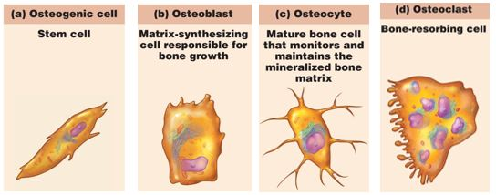
Microscopic Structure of Compact Bone
- Osteon (Haversian) System:
  - This is structural unit of compact bone
  - Osteon: an elongated cylinder oriented parallel to the long axis of bone
    - Osteons are tiny weight-bearing pillars
  - An osteon is a group of hollow tubes of bone matrix; think of the rings of a tree
    - Each matrix tube is a lamella, and for this reason compact bone is often called lamellar bone.
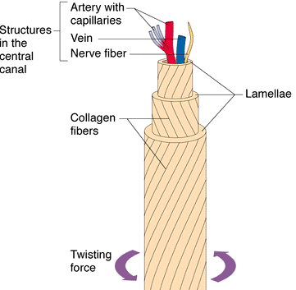
- Haversian (central) Canal: run through the core of each osteon and contain small blood vessels and nerve fibers that form the osteon’s cells.
- Volkmann’s (perforating) Canal: canals of a second type that lie at right angles to the long axis of the bone and connect the blood and nerve supply of the medullary cavity to the central canals.
- Osteocytes: mature bone cells that sit within small cavities (lacunae) within the bony matrix in areas where adjacent lamellae meet
- Canaliculi: small canals that connect the lacunae with each other and is also connected to the central canal of the Haversian system.
- Interstitial Lamellae: fill the gaps between forming osteons or are leftovers of osteons that were partially destroyed by bone remodelling.
- Circumferential Lamellae: sheets of bones located just deep to periosteum and extends around the entire circumference of the shaft
Microscopic Structure of Spongy Bone
- Contains trabeculae and lamellary arranged osteocytes and canaliculi
- Trabeculae is arranged along lines of stress and helps bone to resist stress
- Trabeculae is only a few cell layers thick and contains irregularly arranged lamellae and osteocytes interconnected by canaliculi
- There are no osteons
- Nutrients diffuse through canaliculi from the marrow spaces between the trabeculae to reach the osteocytes
  - Textbook: nutrients reach the osteocytes of spongy bone by diffusing through the canaliculi from capillaries from the endosteum surrounding the trabeculae.
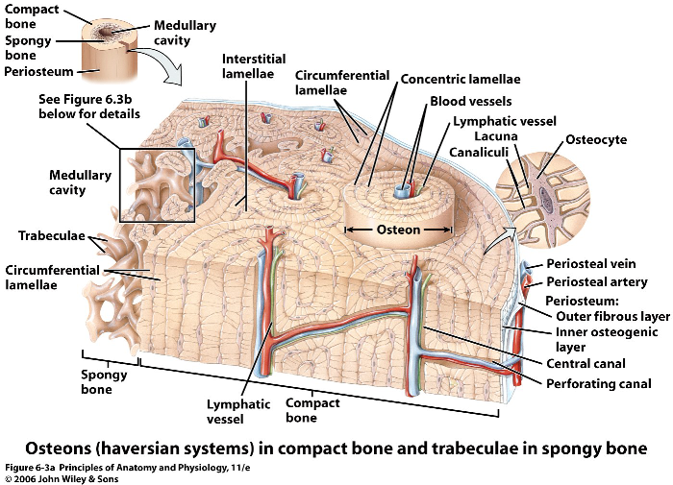

Describing Bone Formation & Remodelling while Explaining the Factors that affect them
- Osteogenesis or Ossification: is the formation of bony skeleton in embryos, growth of bones during childhood and adolescence, and remodelling/repair of bones in adults.
- Intramembranous Ossification:
  - Bone develops from fibrous connective tissue containing mesenchymal cells
  - Cranial bones of the skull and the clavicles
  - Most bones formed by this process are flat bones
  - Begins at about 8 weeks of embryonic development
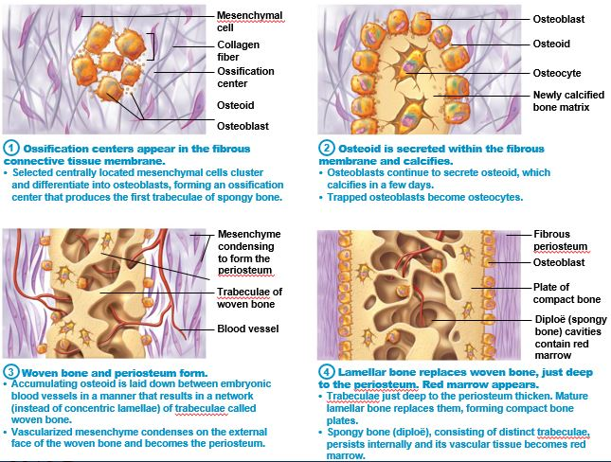
- Endochondral Ossification:
  - Bone development via the replacement of a hyaline cartilage model
  - Forms all bones below the skull (except the clavicles)
  - Begins in the second month of development
  - It is more complex than intramembranous ossification because the hyaline cartilage must be broken down as ossification proceeds.
  - Note: in short bones, only the primary ossification centre is formed while most irregular bones are formed using several distinct ossification centres
  - When secondary ossification is complete, hyaline cartilage remains:
    - On the epiphyseal surfaces as the articular cartilages
    - At the junctions of the diaphysis and epiphyses where it forms the epiphyseal plates; this is the area where long bones continue to growth
Mechanisms of Bone Growth
- During infancy and youth, long bones lengthen entirely by interstitial growth of the epiphyseal plates and all grow in thickness by appositional growth
- Most bones stop growing during adolescence or in early adulthood. However, some facial bones (ex. Nose & lower jaw) continue to grow (almost imperceptibly) throughout life

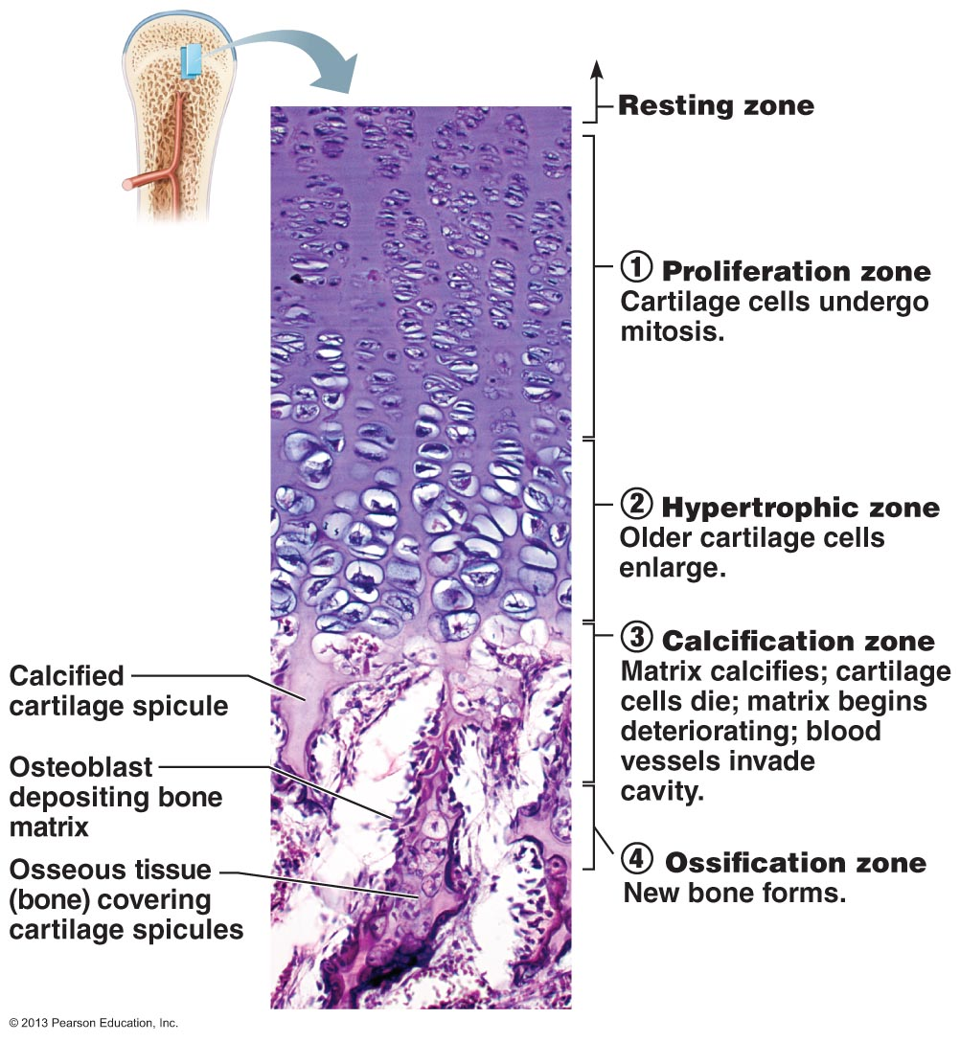
Bone Remodelling
- As the long bone lengthens, the shape of the ends must be altered (remodelling); remember that the ends are wider than the shaft
- As length increases, the external surface of the ends is made slimmer while the internal surface is thickened
- In summary: bone is destroyed by osteoclasts and laid down by osteoblasts on both the inner and outer surfaces of a growing long bone
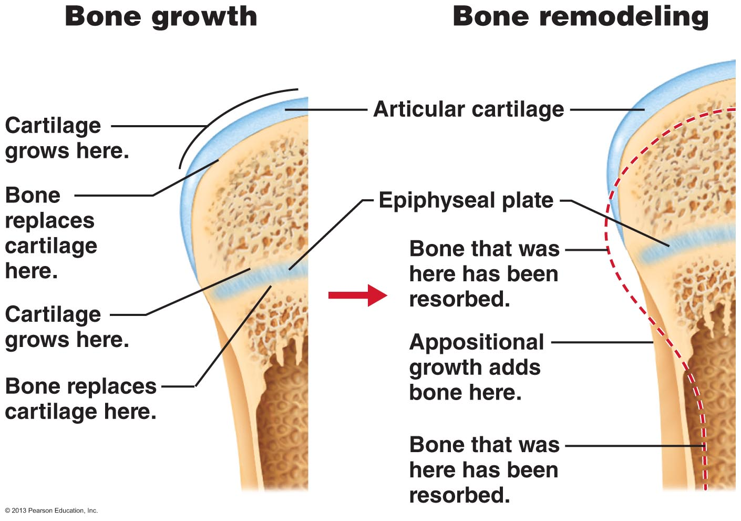
- The epiphyseal plate maintains constant thickness throughout childhood and adolescence because the rate of cartilage growth on its epiphysis-facing side is balanced by its replacement with bony tissue on its diaphysis-facing side
- As adolescence ends, the chondroblasts of the of the epiphyseal plates divide less often.
  - The plates become thinner and thinner until they are entirely replaced by bone tissue.
- Longitudinal growth ends when bone of the epiphysis and diaphysis fuses, this process is called the epiphyseal plate closure
  - Epiphyseal plate closure occurs at about age 18 in females and age 21 in males.
Growth in Width
- Growth in the width of bones is referred to as appositional growth
- Layers of bone are laid down on top of one another
  - Osteoblasts on periosteal side secretes bone matrix
  - Osteoclasts on the endosteal side removes bone matrix
- Normally there is slightly more building up than breaking down.
  - This unequal process produces a thicker, stronger bone but prevents it from becoming too heavy.
Parathyroid Hormone (PTH) Control of Blood Calcium
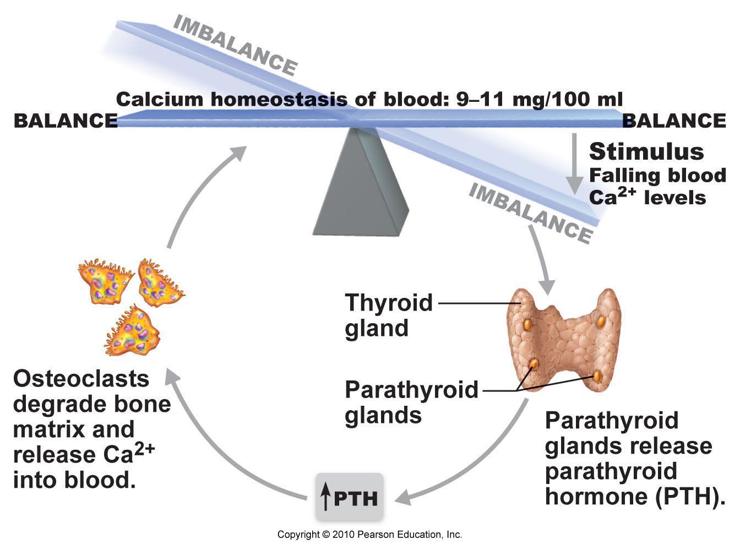
Clinical Note: Osteoporosis
- Osteoporosis refers to a group of diseases where bone resorption outspaces bone formation/deposit.
  - This causes the bone to become fragile
- The composition of the matrix remains normal but bone mass declines, and the bones become porous and light.
- Some areas of the skeleton are especially vulnerable (ex. Spine, neck of femur)
- Age is a factor
  - Estrogen and androgen promote bone health by restraining osteoclast activity and promoting deposition of new bone
- Other contributing factors include: insufficient exercise, diet poor in calcium and protein, abnormal vitamin D receptors, and smoking which reduces estrogen levels



