BUS 352 Final Exam Notes

Chapter 6
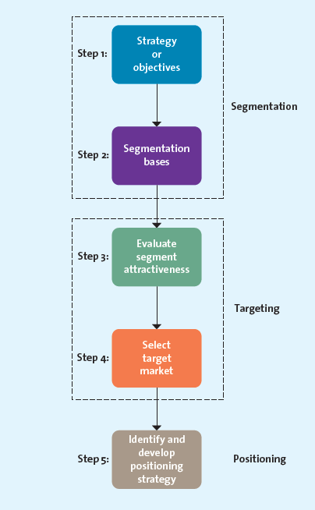
STP analysis:
Used to identify market segment
Step 1: Establish overall strategy and objectives
- Strategy must be consistent and derived from company mission, vision and SWOT

Step 2: Segmentation Bases
- Involves segmenting the market using a formal approach
- Segments are:
  - Geographic: grouping consumers based on where they live
  - Demographic: grouping consumers based on easily identifiable characteristics such as age, gender, income, race, home-ownership
  - Psychographic: grouping consumers based on how they describe themselves. Requires 3 components: self-values (overriding desire of how a person lives), self-concepts (what they think of themselves), lifestyles
    - VALS: system developed to segment using psychographics:
      - Innovators: Take charge, Purchase reflect cultivated taste
      - Thinkers: Mature, Like durability and clear value
      - Believers: Conservative, Choose familiar and known brands
      - Achievers: Goal oriented lifestyle, prestigious products
      - Strivers: Trendy fun loving, Spend as much as they can
      - Experiencers: Variety and excitement, Want to have cool stuff
      - Makers: Practical people, Prefer value over luxury
      - Survivors: Loyal to favorite brands, Love good deals
  - Behavioral: grouping consumers based on value derived from the product/service, loyalty of consumers, occasion it was bought for
    - Occasion Segmentation: Based on when product/service was sold
    - Benefit Segmentation: Based on what benefit was acquired from product/service
    - Loyalty segmentation: Based on loyalty of a consumer

Step 3: Evaluate Segment Attractiveness
- Identifying the attractiveness of various segments
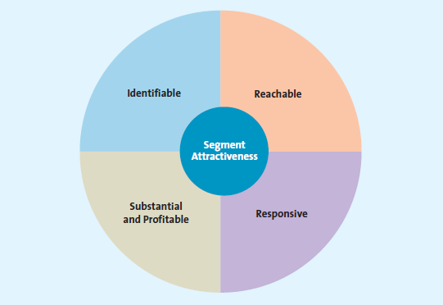
- Use the following approach:
  - Identifiable: Who is within market and how much overlap is there between segments
  - Reachable: Can the segment be reached/accessed
  - Responsive: Customers must react positively to the product
  - Sustainable/Profitable: If segment size to small or low buying power no profit can be generated

Step 4: Select Target Market
- Must pursue the selected target segment
- Mass Marketing: If product provides same benefit to all segments no need to develop separate strategies for each segment
- Differentiated Target Strategy: Target each segment based on what benefit they will get out of the product
- Niche Target Strategy: Focus on single primary target using all resources to meet that segments needs
- Micromarketing:
  - One-to-One tailors each product individually to each customer
  - Mass customization: Providing one-to-one to the masses (eg. Name on jersey)

Step 5: Identify and Develop Positioning Strategy
- Positioning: Mental picture people have about the product
- Positioning Methods:
  - Value: Relationship between price and quality
  - Product Attributes: Focusing on attributes most important to the customer
  - Benefits and Symbolism: Benefits of the brand as well as the psychological meaning of the brand
  - Competition: Position their product head-to-head against a rival product
  - Market Leadership: Position as market leaders
  - Positioning Statement elements:
    - Target market
    - Name of brand
    - Product/Service offered
    - Unique benefit product offers

Chapter 7 (NOT TESTED)
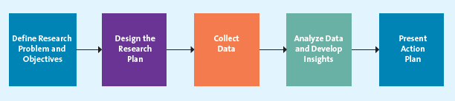
- Market Research: Techniques and procedures to analyze, compile and interpret data for decision makers for the purpose of marketing
- Marketing Research Process steps:
  - Step 1: Define Research Problem and Objectives
    - Need to understand what the problem is that we need to solve
  - Step 2: Design Research Plan
    - Determine type of data and research needed
  - Step 3: Collect Data
    - Primary Data: Focus Groups, interviews, surveys
    - Secondary Data: Data collected prior to project
  - Step 4: Analyze Data and Develop Insights
    - Analyze and Interpret the data
    - Explain, Evaluate and Predict a situation
    - Misinterpretation can lead to the wrong decision
  - Step 5: Present Action Plan
- Secondary Data
  - Internal Secondary Data: Most widely used. Internal cache of customer information and purchase history
  - External Secondary Data: Can be accessed quickly and at relatively low cost
    - Scanner Data: From scanning UPC codes
    - Panel Data: Collecting data from a panel over time
- Primary Data
  - Used when secondary data not available for the problem
  - Reliability: Extent to which you get same result when carrying out the same experiment
  - Validity: The extent to which a study measured what it was supposed to measure
  - Qualitative Research Methods:
    - Observation: Ethnography (Study people in certain ethnicity)
    - Social Media
    - In-Depth Interviews
    - Focus Groups
    - Projective Technique: Provided a scenario and asked to express thoughts about it
  - Quantitative Research Methods
    - Survey Research
    - Panel Research
    - Experimental Research
- Customer Lifetime Value: The expected financial contribution from a particular customer to the firm’s profits over the course of their relationship.
  - 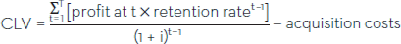

Chapter 8
- Why Companies create new products:
  - Changing Customer needs
    - By adding new products companies can deliver on new customer needs
  - Market Saturation
    - The longer a product remains in the market the more likely it is the market will be saturated
    - Companies can sustain growth by keeping consumer excited for new products
  - Managing Risk through Diversity
    - Companies don’t want to keep all their eggs in one basket
  - Fashion Cycles:
    - Certain products are cyclical and so new products are needed for the new time periods
  - Improving Business Relations:
    - Sometimes the goal may be to improve supplier relations hence why new products are launched
  - Innovation and Value:
    - New products can open avenues into new markets and add tremendous value to firms
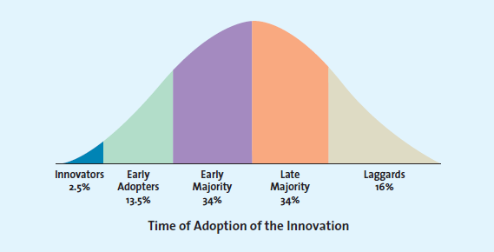
- Diffusion of Innovation: Process by which use of a product spreads through a market group
  - Innovators: Buyers who want to be first on the block
  - Early Adopters: Not as big risk takers as Innovators. Will wait and purchase product after careful review
  - Early Majority: If this group doesn’t become large enough product may fail
  - Late Majority: When they enter product has achieved its full market potential
  - Laggards: Typically avoid change and rely on existing products
- Factors affecting Product Diffusion:
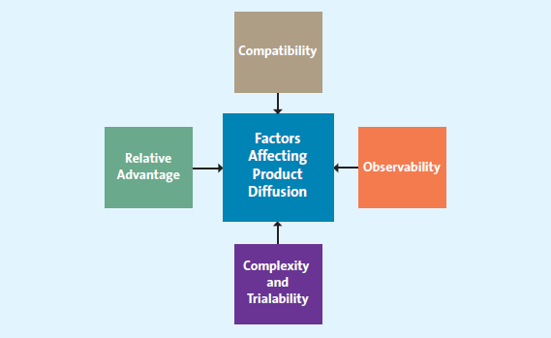
  - Relative Advantage: If product perceived better than competition relative quick diffusion
  - Compatibility: If product is compatible with target market culture quick diffusion
  - Observability: If the benefits of a product are easily observed fast diffusion
  - Complex and Trialability: Products that aren’t complex are easy to try and there is quick diffusion
- How Firms develop new products
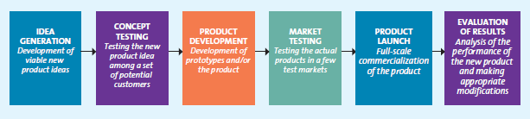
  - Idea Generation
    - Internal Research and Development: Have your own R&D department. Product development costs are quite high.
    - Licensing
      - Buying rights to use technology or idea of other research based firms
    - Brainstorming
    - Competitor’s Products
      - Reverse engineering a competitor’s product to develop a new product
    - Customer Input
      - Listening to customers for ideas for a new product
  - Concept Testing
    - Ideas developed into statements that are shown to customers to get their input
    - Reactions can help predict sale volume of product
  - Product Development
    - Prototype: First physical form of product description
    - Alpha Testing: Attempt to see whether product will perform according to its design
    - Beta-Testing: Customers examine product to determine functionality and potential problems
  - Market Testing
    - Pre-Market Test: Conducted before a product is brought to the market to see how well it will do
    - Test Marketing: New product introduced to limited geographical area. Costs more than pre-market tests
  - Product Launch
    - Promotion: Test results helps firm develop integrated marketing communication strategy
    - Place: Firm must have enough stock. Product offering should also be complete
    - Price: Firm needs to ensure price is just right
    - Timing: Depending on product timing of launch may be very important
  - Evaluation of Results
    - Determine whether launch was success or not and what can be done to improve offering
- Product Life Cycle
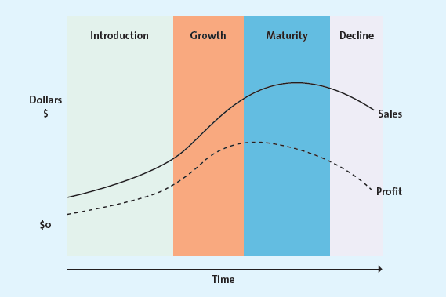
  - Introduction Stage: Market Skimming, Market Penetration
  - Growth Stage: New features, Improve quality, Add channels, New segments
  - Maturity Stage: Enter new markets/segments, develop new product
  - To extend product life: Increase amount of use, Increase # of users, find new uses, change labeling/quality
  - Decline Stage: Maintain, Discontinue, Drop from Line
- Why do new products fail:
  - Target market too small
  - Poor design
  - Poor quality
  - Incorrect positioning
  - Error in pricing
  - Poor marketing communication
  - Competition

Chapter 9
- Core Customer Value: Basic problem solving benefits that customers are seeking
- Types of Products:
  - Specialty Products/Services: Strong preference that customers will search for best suppliers
  - Shopping Products/Services: Customers will spend fair amount of time comparing alternatives
  - Convenience Products: Customers will not be willing to spend any time to evaluate options prior to purchase
  - Unsought Products/Services: Products consumers do not think of buying
- Product Mix and Product Line Decisions
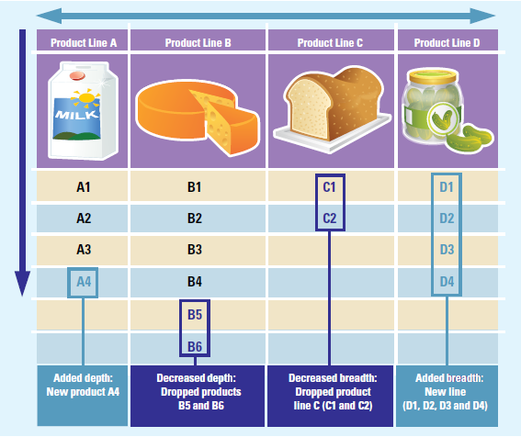
  - Product Mix: Set of all products offered by a firm
  - Product Lines: Groups of products consumers think belong in same category of products
  - Product Mix: Number of Product Lines
  - Product Line Depth: Number of products within a product line
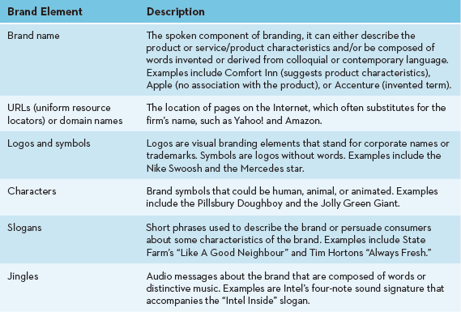
- Branding
  - Value of Branding:
    - Brands Facilitate Purchasing
    - Brands Establish Loyalty
    - Brands protect from competition and price
    - Brands reduce marketing cost
    - Brands are assets
    - Brands impact market value
  - Brand Equity: Set of assets and liabilities that add or subtract the value of a brand
    - Brand Awareness: Number of consumers aware about the brand
    - Perceived value: Relationship between brand’s benefits and its costs
    - Brand Associations: Mental links consumers make between a brand and its key attributes
    - Brand Loyalty
  - Brand Owenership
    - Manufacturer brands: Brands owned and managed by manufacturers
    - Private-label brands: Brands developed and marketed by a retailer and only available from that retailer
    - Generic: Product sold without a brand name
  - Naming Brands and Product Lines:
    - Corporate Brands: Firm can use its corporate brand to brand all its products
    - Family Brands: Combination of original name and corporate name eg. Kellogs
    - Individual Brands: Each product has an individual name
  - Brand Extension: Use of same brand name for new products being introduced into the same markets
    - To avoid negative effects of brand extension firms must
      - Evaluate fit of product and brand name
      - Evaluate perception of brand in eyes of consumer
      - Refrain from extending brand name to too many products
      - Brand extension should not be distanced from core brand
  - CoBranding: Marketing 2 or more brands together
  - Brand Licensing
Chapter 10
- Service: intangible offering that cannot be physically processed
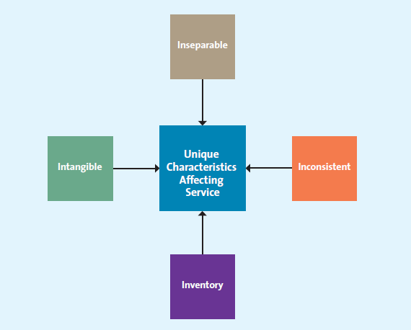
- Customer Service: Human or mechanical activities firms undertake to improve customer satisfaction
- Characteristics affecting service:
  - Intangible: Most fundamental difference
  - Inseparable: Service produced and consumed at same time
  - Inconsistent: Quality may vary because manufactured by humans
  - Inventory: Service is perishable and cannot be stored for future use
- Service Gap: When service fails to meet expectations customer has
- Gaps Model:
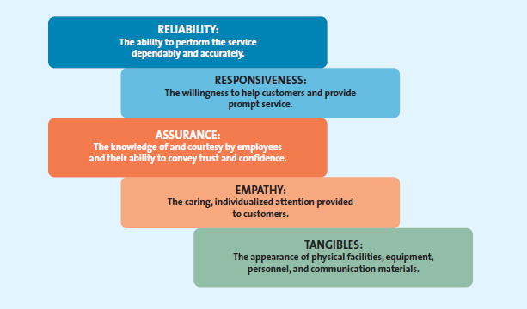
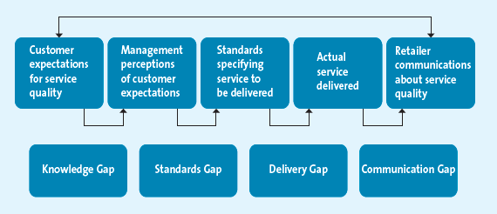
  - Knowledge Gap: Difference between customer expectation and firm’s perception of those expectations
    - Understand customer expectations
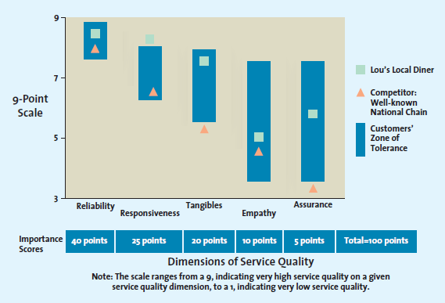
    - Evaluate service quality using well-known metrics
      - Zone of Tolerance: Area between customer expectations and minimum level of acceptable services
  - Standards Gap: Difference between firm’s perception of expectation and the standards it sets
    - Achieve service goals through training
    - Commitment to service quality

  - Delivery Gap: Difference between firm service standards and actual service provided
    - Empowering service providers
    - Provide support and incentives
    - Using Technology
  - Communication Gap: Difference between actual service provided and the service advertised
- Service Recovery: When customer expectations not met amends need to be made
- Effective service recovery involves
  - Listening to the Customer
  - Provide a fair solution
    - Distributive fairness: Customer’s perception of the benefits received compared to the costs resulting from service failure
    - Procedural fairness: Customer’s perception of fairness of process used to resolve complaints about service
  - Resolve problems quickly

Chapter 11
- Importance of Pricing:
  - Consumers judge benefits of a product against sacrifice it needs to get it
  - Price only element of marketing mix that generates revenue
  - Most challenging of 4 Ps to manage
- 5 Cs of Pricing
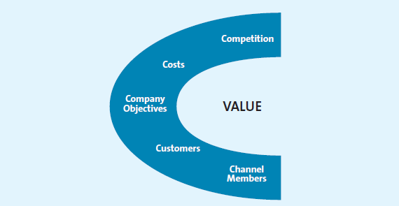
  - Company Objectives
    - Profit Orientated: Maximize profit
    - Sales Orientation: Maximize Sales
    - Competitor Orientation: Measure against competitor
    - Customer Orientation: Use customer value and set prices to match customer expectations
- Factors affecting price elasticity of demand:
  - Income Effect: Change in income affects quantity of product demanded
  - Substitution Effect: More substitutes mean same price lower quantity
- Break-even point:
  - 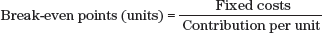
- Grey Market: Irregular not illegal. Circumvents authorized channels of distribution to sell goods at lower prices than what manufacturers intended
- Pricing Methods
  - Cost-Based Methods: Start with cost
  - Competitor based Methods
  - Value Based Methods: Over all value of product offered
    - Improvement value method: How much more customers are willing to pay compared to competitors products
    - Cost of ownership method: total cost of owning product over its useful life
  - Price Skimming: Charge high for innovators and early adopters and then lower price for rest
  - Market Penetration Pricing: Set price low for high volume and high market share
- Psychological factors affecting Value Based Pricing Strategies
  - Consumer’s use of reference pricing
    - Reference pricing: When customers compare actual price of product and that facilitates their evaluation process
  - Odd Prices: Consumers mentally truncates prices
  - Everyday low pricing: regulate price between regular, non-sale and deep sale prices their competitors offer
  - High/Low pricing: Promotion of sale where prices are lowered to encourage consumer spending
- Pricing Tactics: Short-Term pricing that focuses on company objectives, competition or channel members. Price adjustment-> reduce list price
  - Aimed at customers
    - Price Lining: Setting price floor and ceiling for entire line of products and setting points in between to distinguish differences in quality
    - Price bundling: Selling more than one product for a single lower price
    - Leader Pricing: Pricing at just above store cost to increase store traffic
  - Consumer Price Reductions:
    - Markdowns: Reductions retailers take on initial selling price
    - Quantity discounts for customers
    - Coupons and Rebates
    - Seasonal discounts
  - B2B Pricing Tactics and Discounts
    - Seasonal Discounts
    - Cash Discounts
    - Allowances
    - Quantity Discounts
    - Uniform Delivered vs Geographic Pricing
- Legal and Ethical Dilemma of Pricing
  - Deceptive Reference Prices
  - Loss Leader Pricing: Lower price below store cost
  - Bait and Switch
  - Horizontal Price Fixing
  - Vertical Price Fixing

Chapter 12
- Distribution Channel: Institution that transfers ownership of good from producer to consumer
- Supply Chain Management: When firms use certain approaches to integrate supplier, manufacturers and transportation into a seamless value chain where merchandise is produced in the right amount at the right time
- Channel Structure
  - Direct Distribution: Manufacturers deal directly with consumers
  - Indirect Distribution: When one or more intermedieries work with manufacturers to deliver goods to consumers
  - Multichannel Distribution: Use both direct and indirect distribution
- Push vs Pull Strategies
  - Push marketing: Increase demand by focusing on wholesalers, distributors or salespeople
  - Pull marketing: Focus is on end consumer. Increase demand by focusing on end consumer
- Distribution Intensity: Number of channel members used at each level of supply chain
  - Intensive distribution: Get products into as many outlets as possible
  - Exclusive distribution: Grant exclusive rights to certain retailers to carry products
  - Selective distribution: Between Intensive and Exclusive. Limit to number of retailers in an area that can carry product
- Distribution channels add value:
  - Transactional function:
    - Purchase goods for resale to other intermediaries or consumers
    - Own inventory can become outdated
    - Promote product to attract customers
    - Transact with potential customers
  - Logistical Functions
    - Transport goods to point of purchase
    - Maintain inventory and protect goods
  - Facilitative Functions
    - Share competitive intelligence
    - Extend financial credit and other financial services to consumers
- Managing Distribution Channels
  - Channel Conflict: When supply chain members not in agreement
  - Managing via Vertical Marketing Systems
    - Members act as unified system. 3 types:
      - Administered: no common ownership or contractual. Dominant member controls channel relationship
      - Contractual: Different firms at different levels join via contracts to reduce conflict and increase economies of scale
      - Corporate: Parent company has control and dictates priorities to other levels of supply chain
- Information flows in channels:
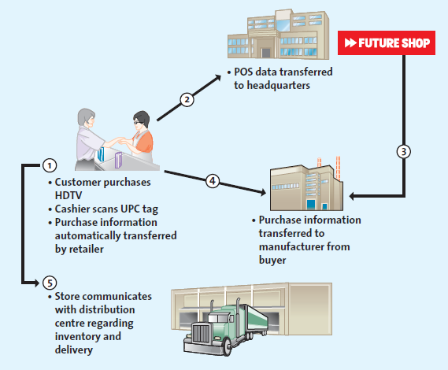
  - Customer-to-store (1)
  - Store-to-Buyer (2)
  - Buyer-to-Manufacturer (3)
  - Store-to-Manufacturer (4)
  - Store-to-Distribution Center (5)
- Supply Chain strategic relationships:
  - Mutual Trust
  - Open Communication
  - Common goals
  - Credible Commitments
- How to make merchandise flow:
  - Inbound transportation
  - Receiving and Checking inventory
  - Storing and Cross-Docking: 2 types
    - Traditional: When merchandise needed store clerk goes and picks it up and drops it to staging area
    - Cross docking: Manufacturer prepackages the item which goes directly to staging area
  - Getting merchandise store ready
  - Shipping merchandise to Stores
  - Inventory management through Just in Time

Chapter 13
- Channel Structure: The difficulty of a manufacturer to get a retailer to carry its product depends on how well the channel is vertically integrated
- Customer Expectations: Retailers care about what its customers want to buy. If a manufacturer’s product is not liked by customers retailers won’t pick up product
- Channel Member characteristics: The more sophisticated and larger a channel member the lesser chance it will use supply chain intermediaries
- Types of Retailers:
  - Food Retailers
    - Conventional supermarket
    - Big box food retailer: Supercenters, hypermarkets
    - Convenience stores
  - General Merchandise Retailers:
    - Discount Stores: Broad variety, limited service, low prices
    - Speciality Stores: Limited number of complimentary merchandise in small store
    - Category Specialist: Narrow variety but deep assortment
    - Department Stores: Many different types of variety and deep assortment
    - Drug Stores
    - Off-Price Retailers: Inconsistent assortment at low price
    - Services Retailers: Sell services rather than goods
- Develop a retail strategy using the retail mix:
  - Product (merchandise assortment): Retailers need to customize assortment of products they carry based on target market. Eg. Loblaw’s Real Canadian vs Loblaw’s No Frills
  - Price: Pricing goods sets the image a firm wants to create.
  - Promotion: Promoting the product is very important for retailers. A lot of co-operative advertising (eg. Putting advertisments at POS)
  - Presentation (Store design and Layout): Focus on making shopping easier, more interesting and faster
  - Personnel: Personal selling and customer service is also part of retail package. Successful retailers concentrate on providing more value to customers
  - Place: Need to be in convenient locations

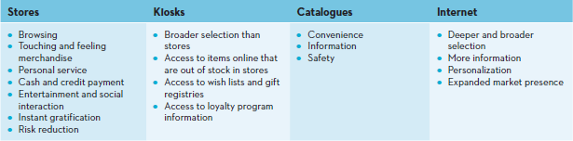
- Benefit of Different retail channels to customers:
- Effective Multichannel Retailing
  - Role of Brands: Brands help provide a consistent experience for customers to help overcome customer’s issue for no touch or feel
  - Using Technology: Can use tech to convert touch and feel into look and see information
  - Increasing share of wallet: Although offering an electronic channel may draw away some sales from other channels, using it with other channels can result in consumers making more total purchases from the seller
    - Share of Wallet: amount of the customer's total spending that a business captures in the products and services that it offers
  - Gaining insights into customer’s shopping behaviors: Online retailing gives good insight into this.

Chapter 14
- Communication Process
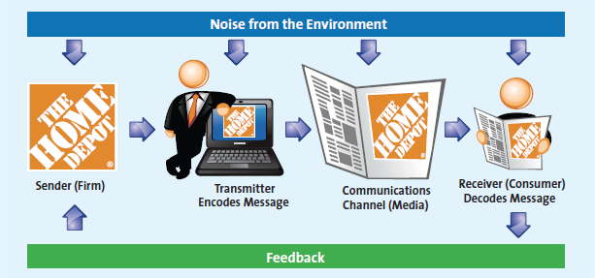
  - The Sender: Where message originates. Must be clearly identified to intended audience
  - Transmitter: Sender works with in-house creative department or advertising agency
  - Encoding: Converting sender’s ideas into a message
  - Communication channel: medium via which message is sent
  - Receiver: The one who processes the information. Also the decoder of the message
  - Noise: Interference that stems from competing messages, lack of clarity or flaw in medium
  - Feedback loop: Allows receiver to communicate with sender
- How consumers perceive communication
  - Receivers decode messages differently: Each receiver decodes message in his/her way which may not be the intended message
  - Senders adjust messages according to receiver and medium traits
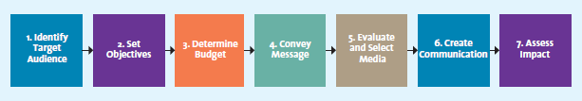
- Steps in planning an Integrated Marketing Communication
  - Identify target audience
  - Set Objectives: Firms must know outcomes they hope to achieve
  - Determine Budget
    - Objective-Task based method: Determine cost required to undertake certain tasks
    - Competitive parity method: Communication expense in line with market share
    - Percent of Sales method: Fixed percent of forecasted sales
    - Affordable method: Based on what is left after other operating costs are covered
  - Convey Message
    - The Message: The message should communicate the product’s problem-solving ability clearly and in a compelling fashion
    - The Appeal: three main types of appeals: logos (logical), ethos (ethical), and pathos (emotional)
      - Rational Appeals: offering factual information and strong arguments built around relevant issues
      - Emotional Appeals: aims to satisfy consumers’ emotional desires rather than their utilitarian needs
  - Evaluate and Select Media
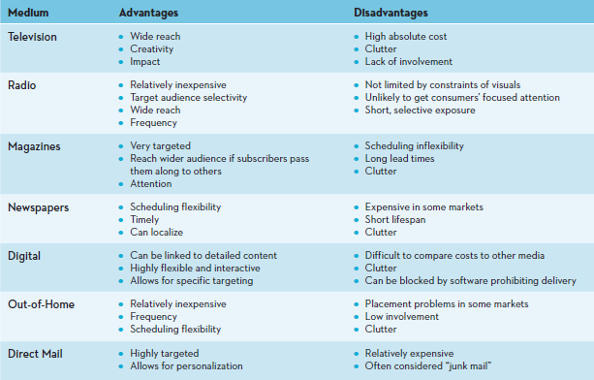

    - Determine advertising schedule:
      - Continuous Advertising Schedule: Runs through the year
      - Flighting Advertising Schedule: Implemented in spurts
      - Pulsing Advertising Schedule: Combination of continuous and flighting. Constant through year with spurts
  - Create Communication: Actual creation of Ad
  - Assess impact using marketing metrics
    - Pretesting: Before Ad is rolled out. To test if various elements are working in integrated fashion
    - Tracking: Monitoring key metrics such as sales volumes
    - Post-Testing: Evaluation of IMC after implementation
- Integrated Marketing Communication Tools:
  - Advertising: Most visible of IMC components
  - Personal Selling: 2 way flow of communication designed to influence buyer’s purchase decision
  - Sales Promotion: special incentives or excitement-building programs that encourage the purchase of a product or service
  - Direct marketing: communicates directly with target customers to generate a response or transaction
    - Targeted
    - Motivates and action
    - Measurable
    - Can provide development of marketing database
    - Examples are:
      - Direct mail/Email
      - Catalogues
      - Direct Response TV
      - Kiosks
  - Public Relations
  - Digital Media
    - Websites
    - Blogs
    - Social Media
    - Mobile Apps

Chapter 15
Advertising
Marketing communications move consumers step-wise through a series of mental stages – several models for this
Most common model: AIDA (Attention-Interest-Desire-Action) - A common model of the series of mental stages through which consumers move as a result of marketing communications: Attention leads to Interest, which leads to Desire, which leads to Action. 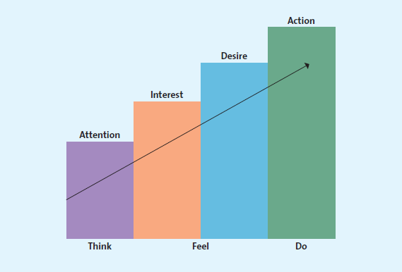
Attention:
- Marketing communication worthless if cant grab attention
- Brand awareness refers to a potential customer’s ability to recognize or recall that the brand name is a particular type of retailer or product/service
- Awareness metrics:
  - Aided recall: remember brand when name is shown
  - Top-of-mind awareness: highest level of awareness, brand has prominent place in memory, triggers response without requiring any thought (ex: Xerox, Kleenex, Harley-Davidson)
    - Top-of-mind awareness created through memorable names, extensive marketing, memorable symbols
Interest:
- Next step following awareness
- Not enough for consumers to just know about product, marketing communication should now persuade consumer to find out more about product
Desire:
- Once product/brand/firm has consumer interest, goal is to take consumer from “I like” to “I want”
Action:
- This is the last step: the ultimate goal of marketing communication
- Once firm has acquired interest and shown the customer that this product satisfies a specific desire, the consumer will likely make the purchase

Lagged Effect: a delayed response to a marketing communication campaign.
- It generally takes several exposures to an ad before a consumer fully processes its message
- In turn, measuring the effect of a current campaign becomes more difficult because of the possible lagged response to a previous one

Advertising Objectives:
Advertising: is a paid form of communication from an identifiable source, delivered through a communication channel, and designed to persuade the receiver to take some action, now or in the future.
Advertising different from other promotion because:
- It is not free, IT IS PAID
- Must be carried by some medium; TV, radio, t-shirt, sidewalks, etc.
- Legally, source must be known or knowable
- Persuasive, designed to motivate consumer to take an action
Word of mouth advertising is not true advertising
All advertising campaigns aim to achieve certain objectives: to inform, persuade, and remind customers
Informative advertising: Communication used to create and build brand awareness, with the ultimate goal of moving the consumer through the buying cycle to a purchase.
Persuasive Advertising:
- When a product has gained a certain level of brand awareness, firms use persuasive advertising to motivate consumers to take action.
- Persuasive advertising generally occurs in the growth and early maturity stages of the PLC, when competition is most intense, and attempts to accelerate the market’s acceptance of the product.
- In later stages of the PLC, persuasive advertising may be used to reposition an established brand by persuading consumers to change their existing perceptions of the advertised product.
- Firms often use persuasive advertising to convince consumers to take action: switch brands, try a new product, or even continue to buy the advertised product
Reminder advertising: Communication used to remind consumers of a product or to prompt repurchases, especially for products that have gained market acceptance and are in the maturity stage of their life cycle.

Focus of Advertisements:
Product-focused advertisements are used to inform, persuade, or remind consumers about a specific product or service.
Institutional advertisements is to inform, persuade, and remind consumers about issues related to places, politics, an industry, or a particular corporation.
Product placement: Inclusion of a product in nontraditional situations, such as in a scene in a movie or TV program.
Public Service Announcements: ads focused on public welfare, usually sponsored by NGO, civic groups, religious org, etc; a form of social marketing
Social Marketing: using marketing to change people’s attitudes and behaviors

Regulatory and Ethical issues in Advertising
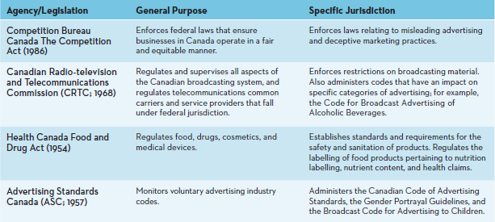
Puffery: the legal exaggeration of praise, stopping just short of deception, lavished on a product
Sales Promotions
Consumer Sales Promotions:
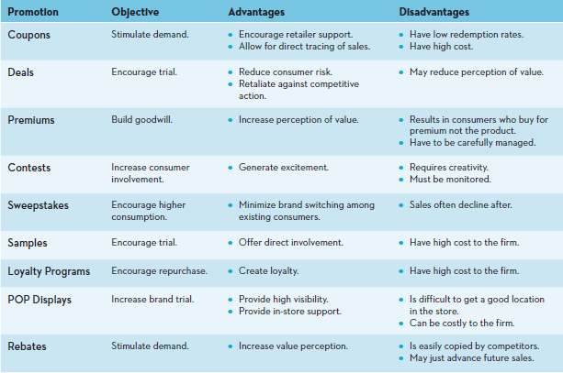
Trade Channel Sales Promotions:
- Discounts and Allowances
- Cooperative Advertising: manufacturer shares percentage of advertising costs with retailer up to a certain limit, depending on how much retailer sells for manufacturer
- Sales Force training: manufacturer trains retailer to better sell product
Using Sales Promotion Tools:
- Pop-up stores: temporary store front
- Cross-promoting: promoting 2 products together reaching same market
To evaluate a trade promotion, retailers consider:
- the realized margin from the promotion
- the cost of the additional inventory carried because of buying more than the normal amount of the product
- the potential increase in sales from the promoted merchandise
- the long-term impact on sales of the promotion
- the potential loss suffered when customers switch to the promoted merchandise from more profitable TVs
- the additional sales made to customers attracted to the store by the promotion
Personal Selling: Salesman (of the year)
Value-add by personal selling:
- sales people build relationships
  - relationship selling: maintain relationship over long term, investing in opportunities mutually beneficial
- sales people educate and provide advice
- sales people save time and simplify buying
Personal Selling Process:
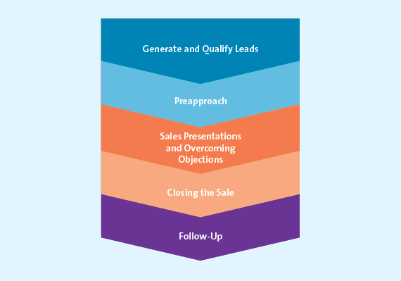
- trade shows, cold calls (telemarketing)
- preapproach: research and plan for meeting customer
- 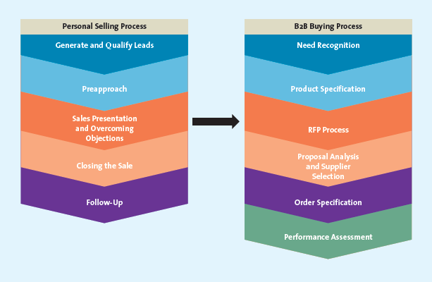
- get a commitment from customer
- possible to apply 5 service quality dimensions (chapter 10)

Chapter 16
4E framework for Social Media:
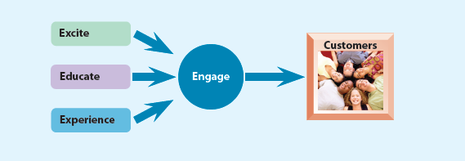
Categories of Social Media:
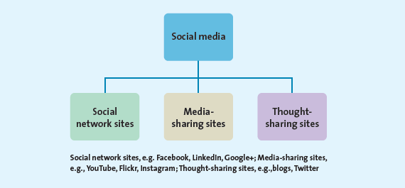
Paid/Owned/Earned Media:

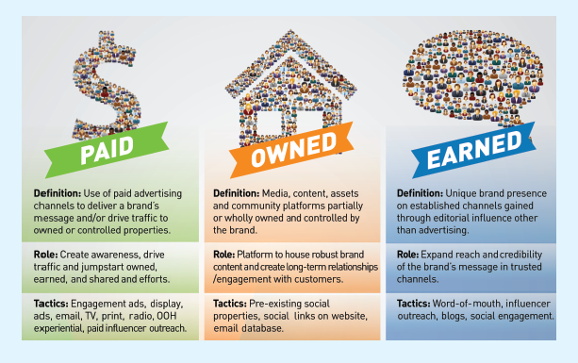

Understanding Mobile apps:
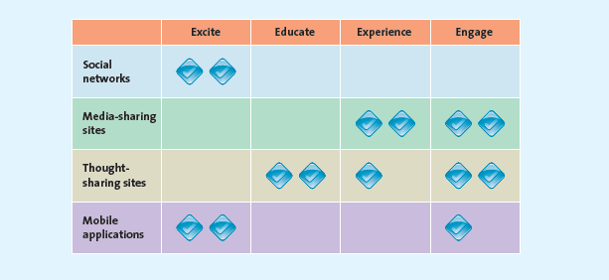

Engaging Customers through Social Media:
Listen:
- companies can learn a lot about their customers by listening (and monitoring) what they say on their social networks, blogs, review sites, etc
- Sentiment analysis: is online contentment favorable or unfavorable?
Analyze
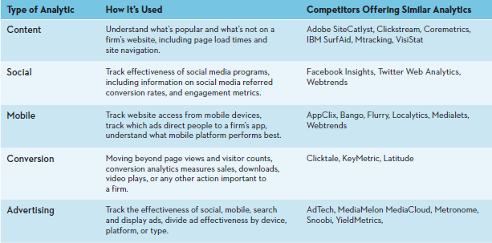
- Hits
- Page views
- Bounce rate: percentage of time visitor leaves site almost immediately
- Click paths: how user goes through info
- Conversion rates
- Keyword analysis: words customers use to find specific products
Do
- Identify strategy and goals
- Identify target audience
- Develop campaign
- Develop budget
- Monitor and change

Managing personal brand in social media
Social reach: number of people a said person can influence

Chapter 17
Assessing global markets:
PEST:
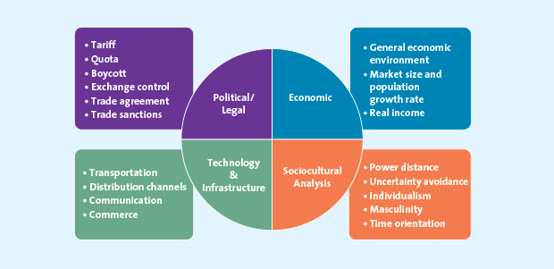
Significant growth in 4 countries: BRIC countries:
- Brazil
- Russia
- India
- China

Choosing a global entry strategy:
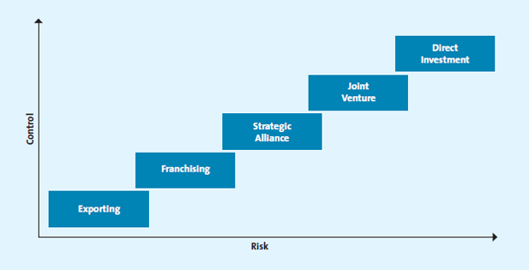

Choosing a global marketing strategy
Global Marketing Mix:
Global product or service strategies:
- Same product in home and host market
- Product or service similar to home country but with adaptions for host market
- Totally different product/service
Global pricing strategies:
- Competitive forces have similar effect, but must follow local pricing structure due to possible difference in positioning
Global distribution strategies:
- Additional intermediaries required, add more cost
Global communication strategies:
- Require alteration based on culture, beliefs, literacy, language, etc.

Ethical Issues in global Marketing:
- Environmental concerns
- Global labor concerns
- Impact on host country culture

Chapter 18
Business ethics: branch of ethical study dealing with rules and principles relating to a commercial context, moral/ethical problems that may arise in business setting, duties/obligations that apply to business people
Marketing ethics: ethical issues specifically dealing with marketing
Ethical climate: set of values in marketing firm or branch guiding decision making
CSR: Voluntary actions to be GOOD, ethically, socially, environmentally

Ethics vs Social Responsibility:
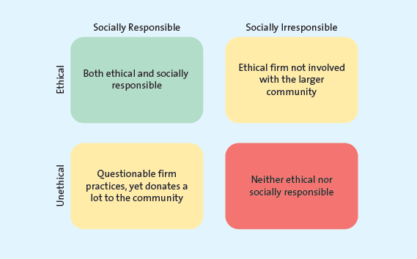

Consumerism: social movement to protect consumer rights from being infringed by businesses

Framework for Ethical Decision Making:
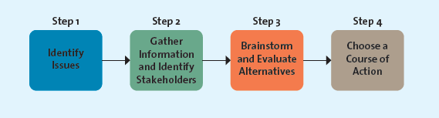

Include ethics in all phases:
Planning Phase
Implementation Phase
Control Phase: double check method, managers evaluated on actions from ethical perspective: systems must be in place to ensure ethical issues raised in planning phase were successfully implemented

