Module 1

1.3 What is Media?
https://www.youtube.com/watch?v=M89_wjcwzfY
Marshall McLuhan
- He has contributed to media by redefining the field and having a name forever associated with it
“all technologies are extensions of our physical and nervous systems to increase power and speed…Any extension, whether of skin, hand, or foot, affects the whole psychic and social complex”
(Marshall McLuhan. Understanding media: The Extensions of Man. Cambridge: The MIT press, 1994)
- From this we can make the connection: the wheel is a mere extension of our feet, clothes of our skin, the phone of our voice, television of our eyes and ears, the computer of our brain and electronic media of our whole central nervous system.

Media
- A host of ever changing, ever developing interfaces, impacting the world around us
- Newspaper, radio, television etc.

1.4 What does media do?
- People believe that “people watch TV to kill time or be entertained” however this is a misinformed notion
- There is a school of thought dedicated to the study of why people use media
  - The Uses and Gratifications research strives to describe the many needs that media satisfies
- There are very strong personal, cultural, socio-economic, educational and circumstantial factors associated with the consumption of media

Main roles of media
- Inform
- Educate
- Entertain

1.5 Media Taxonomy

Broadcast media
- Radio, television, recorded music and film
- The electronic way through which they transmit their information

Print Media
- Books, newspaper, magazines, flyers
- All use a physical support on which to distribute their content

Outdoor Media
- Billboards, sports stadiums, commercial buildings, bus shelters, public transportation vehicles and buildings
- Out of home advertising

Digital Ecosystem
- Defines how we live today
- Anything associated with the internet and mobile communication falls under this

Social Web
- Provoked a complete re-ordering of what was once a very stable media environment
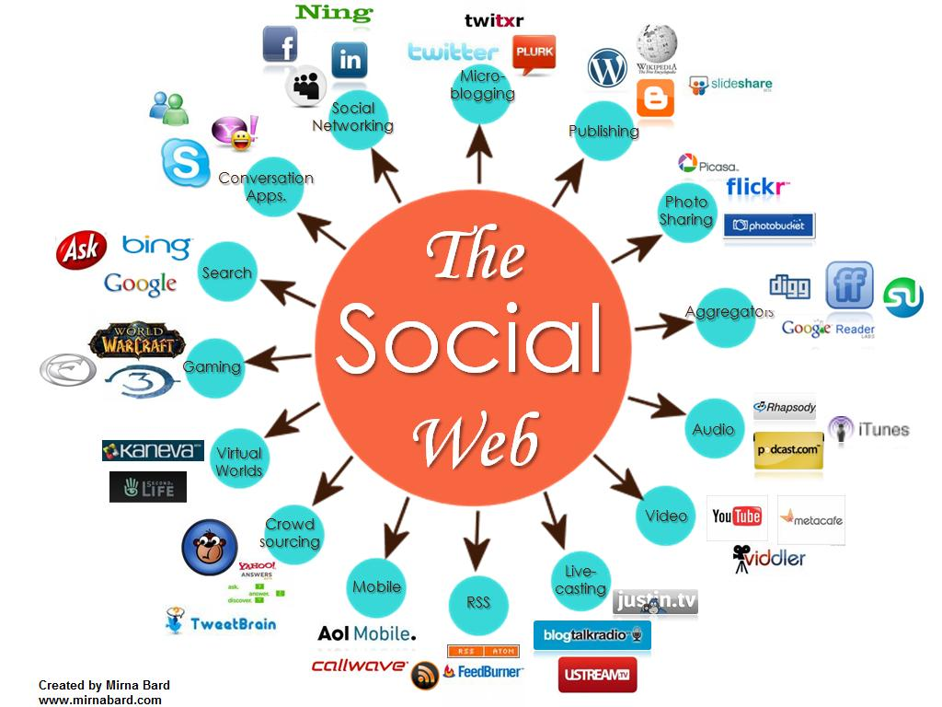
- This graphic illustrates the range of media categories and functions that are now filled through media and applications

1.6 Media Effects
- Many people come up with negative examples of the media’s influence on human behavior
  - Too much exposure to violent TV programming/cinema leads to aggressive behavior; sexual stereotyping in the media fosters inappropriate expectations vis-à-vis members of the opposite sex or the gay community; depiction of bad language creates a tolerance of its general use
- The effects can’t be denied however the media pays a relative role and contributes many factors
- https://www.youtube.com/watch?v=qvgURfZMGoQ
  - Priming: May help us recall old experiences, for example new about the French election may trigger thought about the French economy , a trip to France, or remind someone to put brie on their shopping list.
  - Agenda-setting: also called gate-keeping, the controls the information we get and therefore the things we think about. Editors have power because they ultimately choose what we think about. Which stories to tell.
  - Framing/ Spinning: the particular spin to a message, which ends up shaping our opinion of the news and who is painted as the good guy in any situation. How to tell the story.
  - Cultivation: After hours in front of the TV people begin to blur the lines between reality and fiction. Some media messages are designed to change are attitudes. Such as likeability, attractiveness etc. Persuades people to adopt new ways and behaviors of practice.

1.7 Media as Industries
- Depending on your political position there are different ways to study media. Some see media as a propaganda machine
  - Whose main function is to broadcast messages to the masses into submission while creating a consumerist behavior for financial gain of corporations
- Other view media as a window on the world
  - Functional way to bring people information, educational and entertainment content which makes people more informed and critical citizens for the betterment of a democratic and just society
- The fundamental underpinning is: They all function as businesses
  - The employ workers, produce “things”, generate revenue, subject to rules and regulations, most listed in the stock market and the aim at getting bigger, better and more profitable quarter after quarter
  - The only exceptions would be publicly-owned media such as TVO or CBC in Canada which are driven more by mandate and mission. However, CBC has given rise to much debate and critique

1.8 Media as a field of Studies
- Our professional and family activities, as well as our leisure time, are all shaped to a degree by information and communication technologies, be they more traditional (print media, radio, cinema, television) or more recent (Web, cellphones)
- With a sound grasp of persuasion techniques, we can better analyze and interpret political and governmental communications, whose numbers and complexity grow
- Communication is one of the engines of modern times. We need to study its internal mechanisms so that we can better understand and influence the world we live in

Module 2: CRTC
https://www.youtube.com/watch?v=asZHcIriiGA

2.1 Key Terms

Telecommunications
- Compass communication over long distances by telephone, cable or broadcasting, through the transmission of electromagnetic signals
- The CRTC regulates telecommunications by governing overseeing and establishing conditions for all companies working in the field, with respect to the rights, needs and expectations of Canadians regardless of where they reside

Broadcasting
- Transmission of programs by means of telecommunication for reception by the public
- A Broadcast Distribution Undertaking (BDU) refers to a cable or satellite service provider. It is a term that is frequently used in vocabulary of the CRTC
  - Public broadcasters, such as CBC receive most of their funding from taxpayers
  - Private broadcaster such as Rogers, Shaw and Bell Media receive most of their funding from advertising and subscription revenues

Cable
- The transmission of television programs to a subscriber via coaxial cable

2.2 Public vs. Private Broadcasting
Features | Public Broadcasting | Private Broadcasting
Ownership | Owned by the public (established by law, neither commercially or government owned) | Owned by private corporations most often times, they are on the stock exchange
Funding | Financed by tax-payers, through either or a combination of government subsidies, licensing fees and individual subscriptions  In many cases can be partially ad-funded without being fully dependant on it | Financed by commercial revenues, through: advertisements, investments and subscriptions revenues (from cable and satellite providers)  In certain cases, can receive public funding; but are not dependant on it
Accountability | Accountable to the public (in some cases subject to broad oversight by the government (such as CRTC) while remaining independent) | Accountable to advertisers and investors
Purpose | Non-for-profit: serve the public (inform, educate and entertain) see the “public” as citizens  Acquire money to invest into programs | For-profit” entertain the public, attract as many viewers as possible see the “public” as consumers  Make programs to generate profits
Advantages | Informative and educational content  Little to no advertisements  Non-partisan free from political interference or pressure from commercial forces  Can create quality, niche programming aimed at smaller audiences (particularly minorities)  Can contribute to the national economy by funding, supporting and broadcasting homegrown content | Entertaining content with broad appeal  Generally have more funding than public broadcasters, which can be used to invest in programming
Disadvantages | The focus on information and education can result in less entertaining content with lower ratings  Generally have less funding than private broadcasters, which can affect the resources available to invest into programming | The ratings driven focus can result in the production of mediocre, commercialized content  Many advertisements  Owned by large media conglomerates who can have their own agendas and partisan interests  Can threaten the national economy by principally purchasing and broadcasting foreign programs (particularly from the US)
Examples | CBC, TVO, Tele Quebec, Alberta’s CKUA. BC’s Knowledge Network | CTV, Global, City, Hot 89.9

2.3 What is the CRTC
- The CRTC is a regulatory organization born out of a long series of attempts to preserve and promote Canadian culture and industries in broadcasting and telecommunications. The public interest continues to guide the CRTC today. The companies that make up the Canadian media landscape must meet various requirements and conditions designed to ensure that the industry complies with CRTC regulations. We will examine these regulations in more detail throughout the course
- The CRTC: is the body responsible for the radio, television and telecommunications industry in Canada. Think of it as the court of communications.

2.4 The Structure of the CRTC
- The CRTC is an independent federal body under the responsibility of the Department of Canadian Heritage, reporting to the Government of Canada
- Composed of:
  - One chairman or CEO
  - Two vice-chairpersons (one for broadcasting and one for telecommunications)
  - Up to 10 National and Regional Commissioners
  - One Secretary General of Corporate Services and Operations
  - One Senior General Counsel One Executive Director for Broadcasting
  - One Executive Director for Telecommunications
  - One Executive Director of Communications and External Relations
  - One Chief Consumer Officer
  - Chief Compliance and Enforcement Officer
- Focus on the roles and responsibilities of the Chairman, the two Vice-Chairpersons and the National and Regional Representatives, as it is they who are responsible for participating in the important public hearing and consultations as discussed

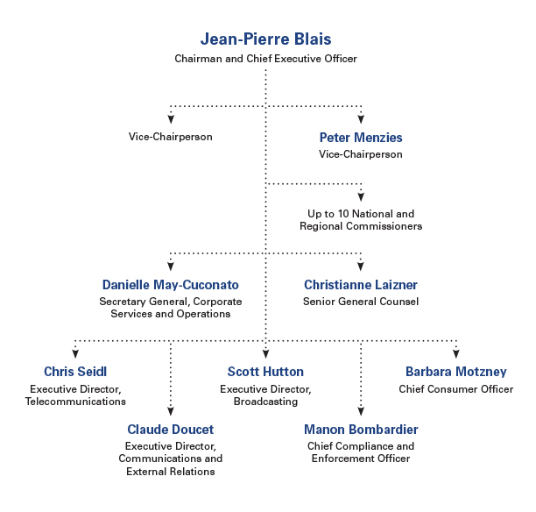

2.5 The Role of the CRTC
https://www.youtube.com/watch?v=PweJmI9ZHFk
- Mandate: Achieving the policy objectives established in the Broadcasting Act, Telecommunications Act and Canada’s Anti-Spam Legislation (CASL)
- Mission: Ensuring that Canadians have access to and are at the centre of a world-class communication system, supported by three pillars:
  - Create: promote compelling and diverse content
  - Connect: ensure quality and affordable service options
  - Protect: provide a safe environment for commercial and personal activities

Main Activities
- Licensing
  - You can assume that every radio station you listen to or TV channel has received previous permissions from the CRTC to broadcast, in the form of a license
  - Issuing, reviewing, renewing (every 5-7 years), amending and revoking Canadian broadcasting licenses and regulating the types of content broadcast by those broadcasting distribution undertaking (BDUs)

- Compliance
  - Encouraging and enforcing compliance with various regulations and legislation, such as the Broadcasting Act; Telecommunications Act; Canada’s Anti-Spam Legislations (CASL); the National Do Not Call List (DNCL); etc…
- Providing Approval
  - The CRTC strives to manage the concentration of media ownership in the hands of a few large companies also known as a monopoly
  - Making decisions on mergers, acquisitions and changes of ownership in the broadcasting sector; approving tariffs and certain agreements for the telecommunications sector
- Encouraging Competition
  - Ensuring that Canadians have a choice of innovative and affordable services in telecommunications market
- Providing Information and Taking Complaints
  - Holding public consultations and open hearings, listening to the views of Canadians and interested parties to uncover the public interest and how best it can be served
Let’s Talk TV was a widespread public consultation conducted by the CRTC between 2013 and 2015, aiming to create a conversation with Canadians about the future of television. Following this exercise, many new regulations were announced concerning the content, price and subscription options to basic cable services (skinny basic); new cancellation policies for TV, internet and telephone services; simultaneous substitution of Live Super Bowl ads; etc.

2.6 What the CRTC does NOT do
- It is not engaged in all facets of media and telecommunication activities in Canada
- Only regulates radio, televisions and telecommunications
- The CRTC does not intervene in newspapers, magazines, the quality and content of television and radio programs or retail rates from most communication services
- The CRTC does not regulate Internet content ; Netflix does NOT have to abide to Canadian regulations in either broadcasting or telecommunication
- The CRTC does regulate Internet Service Providers (ISPs) to ensure that Canadians have affordable access to quality high-speed Internet

2.7 Canadian Content (CanCon)
- CRTC imposes the regulation of the promotion of Canadian content. Aims to encourage the development exposure, and availability of Canadian talent in radio, television and film.
- The ultimate goal is to ensure that the cultural products consumed by Canadians on Canadian media be predominantly Canadian in nature. Some might see it as a form of protectionist measure but most recognize its need
- The CRTC defines as promotionist, not protectionist

How does the CRTC promote CanCon?
- Quotas: mandated quotas of content that qualifies as being “Canadian” according to the CRTC’s standards
- Investment: requiring Canadian media companies to invest as percentage of their revenues in the development of Canadian programming
- Licensing Conditions: When a broadcaster seeks the renewal of its license every 5 to 7 years, the CRTC can impose licensing conditions directly related to CanCon. For example, when the CBC renewed its licenses in November 2013, the CRTC imposed the following condition: during each broadcast year, the licensee must spend a minimum of 75% of the broadcast day and a minimum of 80% of prime time on Canadian programming
The long-term effects of new media on the visibility and prevalence of Canadian content in the Canadian media landscape remains a largely open question. As we witness the rapid rise of digital media where anyone can access any kind of content from anywhere in the world in a few clicks notions such as “broadcasting licenses” and “Canadian content quotas” begin to seem obsolete
CRTC president Jean-Pierre Blais discussing the future of Canadian content and CRTC regulations: https://www.youtube.com/watch?v=dFj35ez963U
- As stated by Jean-Pierre Blais in the video, the CRTC is adapting to the evolving media landscape. They have loosened CanCon quotas for TV broadcasters but maintained the requirement to spend a certain amount of revenue on Canadian TV production
- This will allow broadcasters to spend more creating fewer and hopefully better, TV shows
- New CRTC focus: promoting quality over quantity

Summary of Module 2
- The meaning of the terms “telecommunications”, “broadcasting” and “cable” in the context of the CRTC;
- An overview of the CRTC’s composition, mandate, mission, responsibilities and significance in the Canadian media landscape;
- The CRTC’s regulations concerning Canadian Content

Readings
- CRTC, "About Us" and Canadian Radio-television and Telecommunications Commission | 3 pages
[Sites: http://www.crtc.gc.ca/eng/acrtc/acrtc.htm; and
http://www.thecanadianencyclopedia.ca/en/article/canadian-radio-television-and-telecommunications-commission/]
- CRTC: "It’s your CRTC" | 3 pages
[Site: http://www.crtc.gc.ca/eng/info_sht/g10.pdf]
- Dwayne Winseck (Dwayne Winseck's Media Blog), "Arm’s Length or Strong Arming the CRTC?: Minister Moore’s 'Mandate Letter' to CRTC Head Jean-Pierre Blais" | 10 pages
[Site: http://dwmw.wordpress.com/2014/01/09/arms-length-or-strong-arming-the-crtc-minister-moores-mandate-letter-to-crtc-head-jean-pierre-blais/]
- CRTC: "Canadian Content Development Contributions and Eligible Initiatives"(Read all after "What is an eligible CCD initiative") | 7 pages
[Site: http://www.crtc.gc.ca/eng/general/ccdparties.htm]
- CRTC: "ARCHIVED – Public Notice CRTC 1999-197" | 5 pages
[Site: http://www.crtc.gc.ca/eng/archive/1999/pb99-197.htm]
Supplementary
- Canadian Communications Foundation, "The Birth and Death of The Canadian Radio Broadcasting Commission (1932-1936)" | 10 pages
[Site: http://www.broadcasting-history.ca/index3.html?url=http%253A//www.broadcasting-history.ca/networks/networks_CRBC.html ]
- CRTC "Public Notice CRTC 1999-97" | approx. 17.5 pages, excluding tables
[Site: http://www.crtc.gc.ca/eng/archive/1999/pb99-97.htm#t3]
Supplement: CRTC, Public Notice CRTC 2000-42 | 10 pages, excluding tables
[Site: http://www.crtc.gc.ca/eng/archive/2000/pb2000-42.htm]
- CBC News, "10 Commissions that Changed Canada – Timeline" | 6 pages
[Site: http://www.cbc.ca/news2/interactives/tl-inquiries/timeline.swf]
- CRTC, "Radio's Support for Canadian Talent" | 3 pages
[Site: http://www.crtc.gc.ca/eng/cancon/r_support.htm]
- CRTC, "TV’s Support for Canadian Talent" | 1 page
[Site: http://www.crtc.gc.ca/eng/cancon/t_support.htm]
- CRTC, "Broadcasting Order CRTC 2012-409" | 11 pages
[Site: http://www.crtc.gc.ca/eng/archive/2012/2012-409.htm]
- Peers, F. W., Nationalization, "The Politics of Canadian Broadcasting, 1920-1951 " | 475 pages
[Site: http://site.ebrary.com/lib/oculottawa/docDetail.action?docID=10560407].

videos
- CRTC’s role in Canada’s digital economy! (Duration: 1:45 minutes)
[Site: https://www.youtube.com/watch?v=PweJmI9ZHFk]
- Supporting the creation of content made by Canadians for Canadians and global audiences (Duration: 6:08 minutes)
[Site: https://www.youtube.com/watch?v=dFj35ez963U]
- Pierre C. Bélanger CRTC (Duration: 2:37 minutes)
[Site: https://www.youtube.com/watch?v=asZHcIriiGA]

Module 3: The CRTC and “Let’s Talk TV”
https://www.youtube.com/watch?v=EjJwWCISLFM

3.1 Challenges of Regulating the Digital World
- consumers ability to access content of their choice on the platform of their choice and whatever time has posed regulatory challenges
- Canadians are now able to produce, edit and publish their own content from smartphones or other devices
- In two major decision in 1999 and 2003 the CRTC chose NOT to regulate Internet services or content, due to complexity
- CRTC does not regulate: Internet retail rates, quality of service, billing, marketing practices, equipment offered or customer relations of ISPs except in rare cases where competition is deemed insufficient
- CRTC does not regulate internet content because consumers can already control access to unsuitable material on the internet using filtering software; while illegal content can be addressed the judicial system
- Emerging content distributor giants such as Netflix can offer their services to Canadians without being subjected to the same types of regulations as conventional broadcasters
- This is a HUGE issue in the eyes of broadcasters who feel they are unfairly treated in comparison to the deal Netflix is getting
- This was one factor leading to: Let’s Talk TV

3.2 The Let’s Talk TV Initiative

What is it?
- In 2013, the CRTC decided to open the door to a national conversation by publically consulting Canadians on their needs, expectations and opinions regarding broadcasting
- In later phases, media companies and interest groups were also invited to submit evidence in public hearings

Why embark upon such a project?
- Let’s talk TV was initiated in order to ensure that the regulatory system adapts to the many technological advances that have had a significant impact on how we consume content

3.3 The CRTC vs. Netflix
- As part of the Let’s Talk TV public hearing, the CRTC requested the appearance of Internet giants Google and Netflix
- The CRTC asked foe subscriber and revenue numbers from Netflix in order to determine whether it was or was not operating within the interest of the Canadian public. This request was also an attempt by the CRTC to determine whether or not Netflix was a threat to Canadian media companies which MUST abide by the Canadian content requirements for television
- The request was initially brought forward by major Canadian media companies who complained that they were being unfairly required to contribute financially to the development of Canadian content while Netflix, an Internet-based media provider and increasingly important competitor, was not required to pay such a contribution or abide by the Canadian content quotas, because of the Exemption Order for Digital Media Broadcasting Undertakings
- Netflix refused the CRTC’s request for information and Google soon did exactly the same
  - The non-compliance of Netflix and Google angered the CRTC chairman, Jean-Pierre Blais, so much that he stormed out of the hearing and convened with his commissioners in private
    - Fiery exchange between the CRTC and Netflix: http://www.cpac.ca/en/programs/cpac-special/episodes/35620446/
  - The exemption order that Netflix benefits from means that the CRTC is effectively blocked from ordering the company to provide such information
  - At one point, the CRTC threatened to revoke Netflix’s exemption, which would have opened up a veritable Pandora’s Box of regulatory nightmares
- No information was provided by either Netflix or Google, no exemptions were revoked, and no major regulatory changes resulted from the discord. Most importantly, the limits of the CRTC’s power with respect to digital media were exposed, inciting discussion about the CRTC’s continued relevance in the digital age

3.4 Let’s Talk TV Decisions
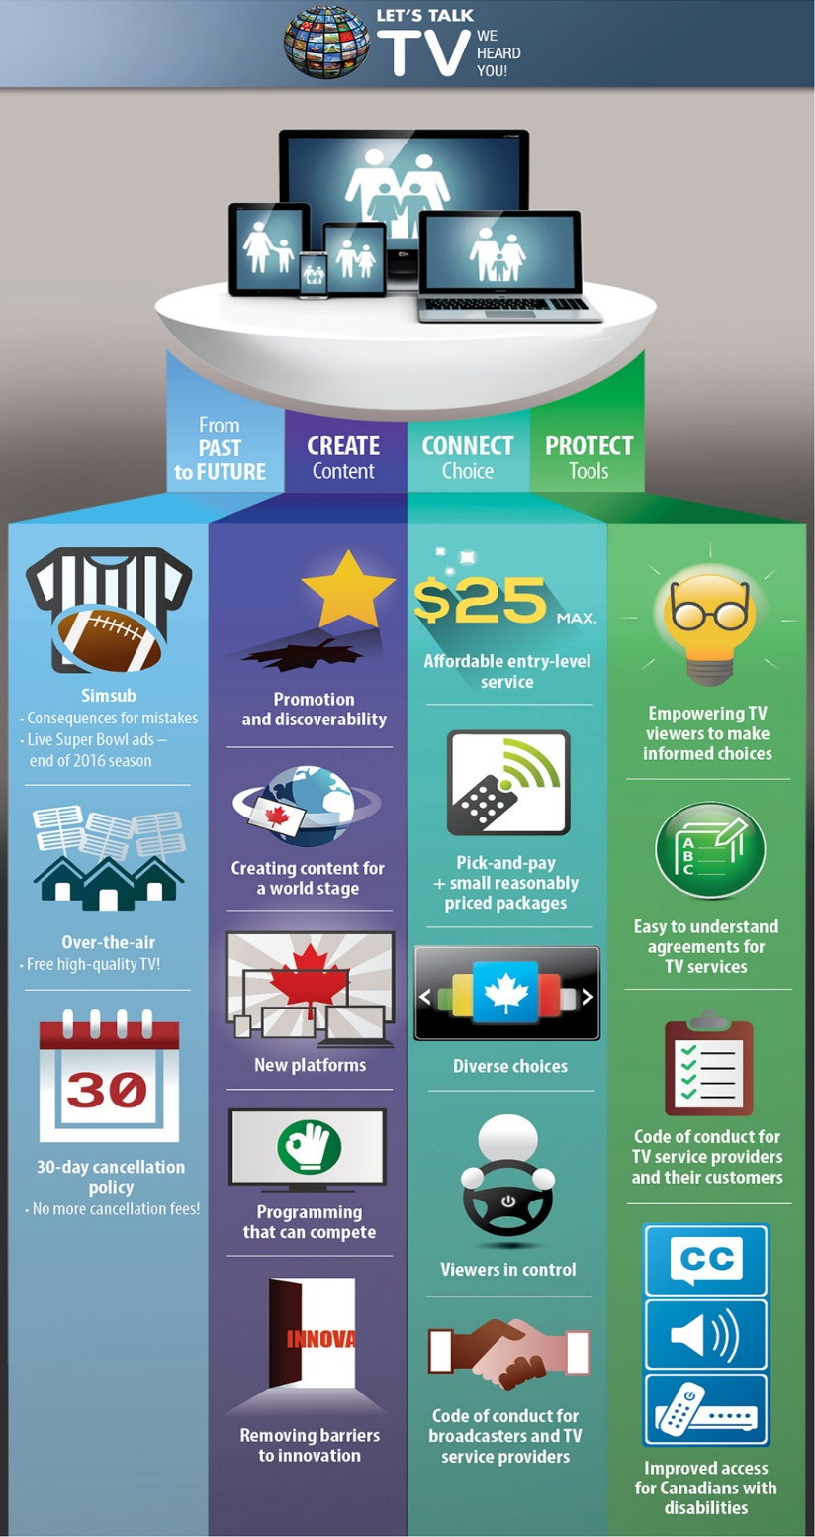
Among the most salient new regulations we find:
- Requiring that BDU’s offer an affordable entry level basic package with “pick-and-pay” options
- Banning simultaneous substitution of ads during the super bowl
- Ending 30-day cancellation policies
- Creating a new code of conduct for broadcasters and TV service providers
On January 7th 2016, the CRTC makes an important announcement regarding television service providers and the nature of their relationship with Canadian consumers. Indeed, following Let’s Talk TV hearings, the Council announces the establishment of a new Code that will « help Canadians make more informed choices about their television service providers and resolve disputes in a fair and effective manner ». The Code will ensure more transparency in the industry and will protect consumers from unclear contracts. For more details, read the following news release from the CRTC
- CRTC « Canadians to be better informed about products and services from television service providers » :
[Site: http://news.gc.ca/web/article-en.do?nid=1026939&_ga=1.59110957.1094451857.1446771778]

Summary of Module 3
- The challenges in regulating the Internet in this digital age;
- The purpose of the CRTC’s Let’s TV Talk public consultation
- Some key decisions stemming from Let’s Talk TV
Readings
- CRTC « Canadians to be better informed about products and services from television service providers » :
[Site: http://news.gc.ca/web/article-en.do?nid=1026939&_ga=1.59110957.1094451857.1446771778]
- CRTC (2014). Let’s Talk TV: A report on comments received during Phase I
[Site: http://www.crtc.gc.ca/Broadcast/eng/HEARINGS/2013/2013-563oc2.htm]
- CRTC. Let's Talk TV Decisions at a Glance
[http://www.crtc.gc.ca/eng/com300/infograph1.htm]
- CRTC (2013). Broadcasting Notice of Invitation CRTC 2013-563.
[Site: http://www.crtc.gc.ca/eng/archive/2013/2013-563.htm]
- CRTC (2015). A Roadmap to Choice and Affordability.
[Site: http://www.crtc.gc.ca/eng/com300/infograph2.htm]
- Snider, M. (2014). How to understand the CRTC's 'Let's talk TV' hearings without pulling your hair out
[Site: http://www.theglobeandmail.com/report-on-business/how-to-understand-the-crtcs-lets-talk-tv-hearings-without-pulling-your-hair-out/article20491293/]
- Bradshaw, J. (2014). CRTC to strike Netflix, Google testimony from ‘Let’s Talk TV’ record
[Site: http://www.theglobeandmail.com/report-on-business/crtc-to-decide-tv-outcome-without-netflix-google-evidence/article20836870/]
Supplementary
- CRTC (2015). Broadcasting Regulatory Policy CRTC 2015-96
[Site: http://www.crtc.gc.ca/eng/archive/2015/2015-96.htm]
- Bradshaw, J. (2014). Changes are coming to Canadian TV: Here are the issues and where the big players stand
[Site: http://www.theglobeandmail.com/report-on-business/changes-are-coming-to-canadian-tv/article20704609/?from=2049129]

Videos
- Let’s Talk TV: A Conversation with Canadians (Duration: 2:05 minutes)
[Site: https://www.youtube.com/watch?v=j_KzIajJris ]
- CPAC Special - CRTC Hearing (Duration: 26:00 minutes)
[Site: http://www.cpac.ca/en/programs/cpac-special/episodes/35620446/ ]
- Pierre C. Bélanger, The CRTC and “Let’s Talk TV” (Duration: 4:28 minutes)
[Site: https://www.youtube.com/watch?v=EjJwWCISLFM]

Module 4: Canadian Media Ownership
https://www.youtube.com/watch?v=2YGZ5V-zYec
https://www.youtube.com/watch?v=1UJxmFinLW8

4.1 Who Owns the Media in Canada?
- Media conglomerates
  - Large companies that own many smaller entities, subsidiaries or outlets within the same or different sectors of the media, such as radio television, internet print, wireless, etc. Usually comes about as a result or mergers and acquisitions. In Canada and around the world, there are clear trends of convergence and consolidation in the media industry

4.1.1 Canada’s Private Media Conglomerate
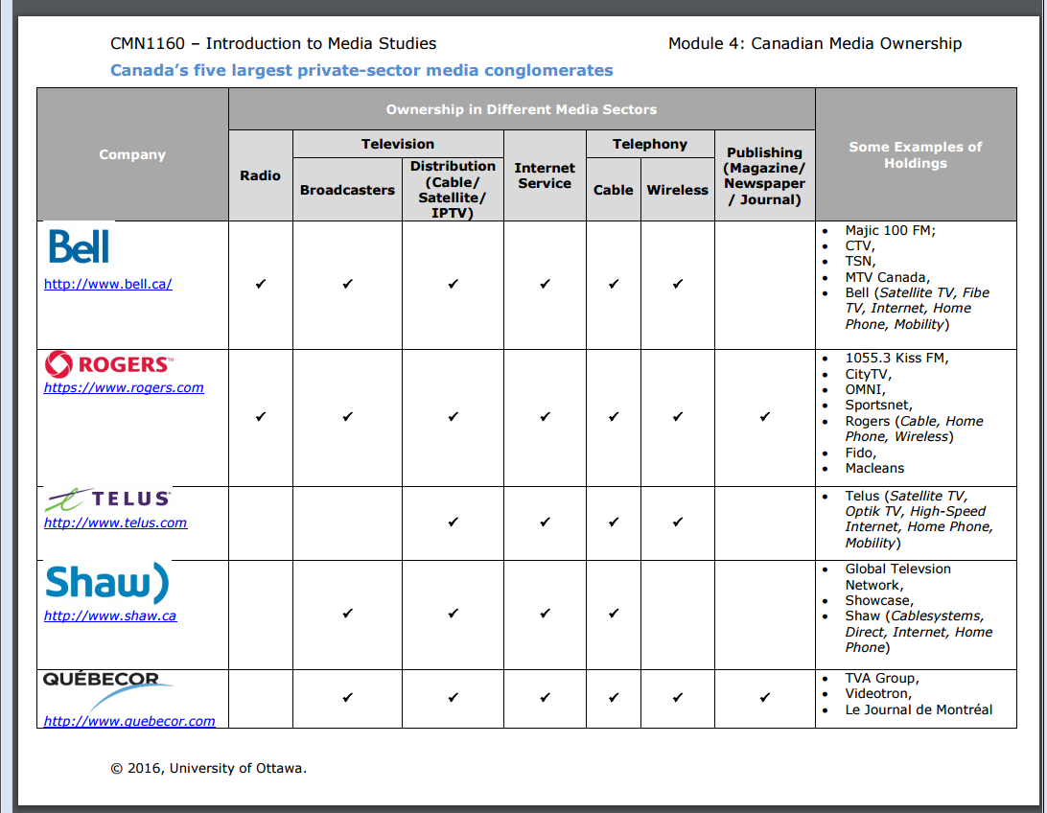
Many of Canada’s largest media conglomerates offer both telecommunications and broadcasting services. This is known as cross media ownership.

4.1.2 Canada’s Public Media Conglomerate
- The CBC/Radio Canada is Canada’s largest public conglomerate with its comprehensive range of radio, television, internet and satellite-based services
- The CBC currently operates:
  - 88 radio stations
  - 27 television stations
  - Over 10 digital platforms in the country providing its services in both official languages (as well as eight aboriginal languages in the North, and Mandarin, Spanish and Arabic on radio Canada International)
- The CBC is unique in that it is the only conglomerate mandated by law to have a presence from coast to coast

4.2 Concentration of Media Ownership
- With exception of magazines, ownership of most sectors of the media industry (telecom, wireless, internet, cable, broadcasting, newspapers, etc.) is highly concentrated in the hands of the five private media conglomerates (Bell, Rogers, TELUS, Shaw and Quebecor)
- These companies are large horizontally and vertically integrated entities, often owning subsidiaries across different sectors of the media industry
- In 2014, these top 5 conglomerates accounted for 84% of the total revenues for the entire Canadian media sector ($56.88 Billion)

4.3 Forms of Concentrated Ownership

Horizontal Integration
- When a parent company owns similar subsidiaries operating at the same level and sector of the media industry
- Example, Rogers: while providing its own wireless telephone service, it has also acquired several other wireless telephone service providers over the years. Acquiring Fido in 2004 for $1.4 billion, and sprint in 2005
- Most Canadian media conglomerates have engaged in horizontal integration through mergers and acquisitions

Vertical Integration
- When one parent company own subsidiaries operating within the same sector of the media industry but at different levels
- Can increase the company’s market share in the sector, as it can use its ownership over content production to drive consumers to its distribution services (i.e by providing exclusive content)
- Example Bell Media: own television broadcasters (CTV and TSN), owns Bell Satellite and Bell Fibe. Which distributes that television content to consumers http://www.cmcrp.org/media-and-internet-concentration-in-canada-report-1984-2014/

Cross-media ownership
- When one parent owns subsidiaries in multiple sectors of the media industry
- This increases market share in the media industry as a whole in that conglomerates are thus able to: offer consumers bundles (i.e. discounts for subscribing to a range of services); provide advertisers with package deals; achieve efficiencies by sharing resources and content between media; and engage in cross-promotion. An example of a company with cross-media ownership is Rogers, owning various radio stations, television broadcasters, and magazines. In fact, all of the five major conglomerates we discussed above own assets in at least a few different media sectors.
What is the overall impact of these forms of concentrated ownership on the media industry?
- A reduction in competition and diversity

4.4: CRTC Regulations: Concentration and Competition
- Media ownership of broadcasting and telecommunications in Canada is governed by the CRTC. A very important point for you to know is that the CRTC does not regulate ownership of newspapers or Internet media. Nonetheless, ownership in those sectors may be taken into consideration in decisions pertaining to a licensee’s broadcasting or telecom operations
- Industry Canada’s Competition Bureau is an independent law enforcement agency which ensures that Canadian businesses and consumers have a competitive marketplace. The bureau has the power to reverse agreements concerning mergers or acquisitions if it believes that they are contrary to the principles of healthy competition.
- In 2008, the CRTC brought in new regulations to restrict cross-media ownership in an effort to limit concentration, promote competition and ensure a diversity of editorial voices in the same market. Among the most important changes are:

Sector Restrictions:
- A company can now only own a maximum of two types of media, out of three (radio, television and newspapers), in a given market (i.e. one city).

Market Share Cap
- No company can own broadcasting assets which 45% of the country’s total television viewership

Television Distribution Restriction
- The CRTC will not approve transactions between cable and satellite companies that would result in one group effectively controlling the delivery of television programming in a market

Summary of Module 4
- Understand the three main forms of ownership concentration
- Know what a media conglomerates is and identify the major Canadian conglomerates
- Explain the implications of the concentration of ownership in the Canadian media industry
- Recognize the regulation that the CRTC has imposed to mitigate these trends

Resources
Readings
- CRTC (2015). Communications Monitoring Report 2015.
Site: [http://www.crtc.gc.ca/eng/publications/reports/policymonitoring/2015/cmr3.htm#a3
  - Note: Read the following section: 3.0: The Communications Industry
- The Canadian Press (2014). Experts on the concentration of media ownership.
Site: [http://www.macleans.ca/news/canada/experts-weigh-in-on-concentration-of-canadian-media-ownership/]
- CBC (2008). CRTC imposes cross-media ownership restrictions.
Site: [http://www.cbc.ca/news/business/crtc-imposes-cross-media-ownership-restrictions-1.767311
- Winseck, D. (2015). Media and Internet Concentration in Canada Report, 1984 – 2014.
Site: [http://www.cmcrp.org/media-and-internet-concentration-in-canada-report-1984-2014/
  - Note: Read the following sections:
    - Introduction
    - Why Media Concentration Matters, or Who Cares?
    - Competitive Openings and Three Phases of Telecom, Media and Internet Consolidation
    - The Content Media Industries
    - Concluding Thoughts

- Mainville-Neeson, A. Why vertical integration in Canada’s communications market should be a concern to Canadians.
Site: [http://blog.telus.com/public-policy/why-vertical-integration-in-canadas-communications-market-should-be-a-concern-to-canadians/
- Read the entire report from above: Winseck, D. (2015). Media and Internet Concentration in Canada Report, 1984 – 2014
Site: [http://www.cmcrp.org/2015/11/10/media-and-internet-concentration-in-canada-report-1984-2014/

