INTE 290 – Computer Usage and Document Design
Notes

Lesson 2 : Introduction to Computers

OBJECTIVES :
- Describe the main types of computers
- List the main operations of a computer
- Distinguish personal computers from other types of computers
- Understand computer components
- Understand the difference between bits and bytes
- Identify input, output and storage devices

- What is a computer?
- “Someone or something that computes”
- Oxford dictionary definition: a computer is
(1) an electronic device for storing and processing data, according to instructions given to it in a variable program or
(2) a non-electric device that assists in making calculations

- The Evolution of Computers
- Early computers were non-electronic, and assisted us in making calculations. Included the abacus and the slide rule.
- Next evolution non-electronic, but allowed primitive programming. Mechanical calculating machines.
- 1940s: first appearance of electronic computers
- ENIAC (Electronic Numerical Integrator And Computer)
- First binary computers: developed in the 1940s. little similarity to today’s computers.
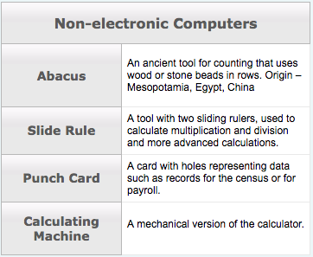

- Computers Today
- Desktop computer: modular, stationary computer comprised of a system unit, keyboard, monitor and mouse.
                - Must be plugged in the wall
                - Can’t be carried easily
                - Laptop Computer: notebook, portable
                - Small portable pc
                - Rechargeable battery

- LCD (Liquid Crystal Displays) screens
  - Made it possible to develop small flat monitors birth of laptops
- Laptops
    - Very convenient way to use computers in conferences, while traveling, or at school
    - Compact
    - Contain everything a desktop contains (smaller in size)
    - More expansive than a desktop computer

- Computers now come in various sizes and types to solve all kinds of problem. They can usually be categorized according to their cost, size, storage capacity, number of users and processing speed.

- 3 most common categories

- Mainframe
- 1940s: first general-purpose computer to be developed
- can be used by many people at the same time
- can handle very complex problems or large volume jobs
- Generally used for data processing for business and scientific applications

Example:

Major banks can process bills for credit card holders all over the world with the aid of a mainframe. Large research projects also use the mainframe’s vast memory, storage capacity, and super-fast processing speed to conduct tests and co-ordinate operations.

- Minicomputer
- Introduced in 1963
- Scaled-down version of the mainframe computer
- Can perform many jobs that old mainframe accomplished in the past
- Cost-effectiveness its most important contribution has been the introduction of distributed computing, where a number of small computers can be used instead of one giant computer.

- Microcomputer
- 2 major events that led to the first microcomputer:
  - development of the 1rst microprocessor in 1969
  - creation of the first general-purpose microprocessor chip in 1971
- Major economic impact due to their small size and drastically improved cost-effectiveness
- Powerful & easy to operate
- Called home computers, laptop, notepad, personal computers (PC), palmtop computers and micros.
- Can perform jobs that were previously only handled by the largest computers.

4th less known category: embedded computers

- .
- .
- .
- .
- .
- ..
- .
- .
- .
- .
- .

