Infotech (lol)

Lecture 17
Database: An organized collection of data meant to facilitate one or more purposes.
- Often used to model relevant aspects of reality
Data: raw facts or observations that describe the characteristics of an entity.
Information: data converted into a meaningful and useful context.

Why does data management matter?
- No enterprise can be effective without high quality y data that is accessible when needed.
- Data that’s incomplete (or out of context)
Random stat – Organizations w/ at least 1,000 knowledge workers lose $5.7 million annually in time wasted by employees reformatting data as they move among applications.

Goal of data management
To provide infrastructure and tools to transform raw data into usable information of high quality.

Challenges of data management
- Exponentially growing volume of data
- Data is scattered through organization
- Data is created/used offline without going through quality control checks.
- Data may be redundant or out of date
MDM – Master Data Management: process to integrate data from several sources and apps to create a unified view of data
DMS – Document management system: Hardware and software to manage, archive, and purge files and other electric documents (e-documents).
ECM – Enterprise Content Management: Includes documents and records management, web content management, search optimization, workflow features, collaboration tools, scanning & capture systems.
The purpose of ECM is to manage the life-cycle of information from initial publication/created to archival and eventually disposal.
DBMS – Database Management Systems: 3 points
- Facilitate access to centralized data
- Allows users to manage data efficiently
- Provides application programs access to stored data

Traditional file approach
When organizations began using computers, they started with one application (accounting, billing, payroll) at a time. Each app is a stand-alone system, which led to data problems.
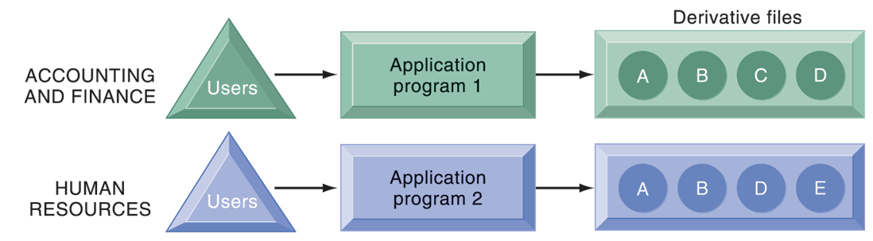
Issues with traditional file environment
- Presence of duplicate data in multiple files
- Inconsistent data (same attribute has different variables
- When changes in program requires changes to data accessed by program
- Lack of flexibility
- Poor security
- Lack of data sharing and availability

Database Approach to Data Management
Database serves many applications by centralizing data and controlling redundant data
DBMS – Database management systems:
- Interfaces between applications are physical data files
- Separates logical and physical views of data
- Solves problems of traditional fire environment (controls redundancy, eliminates inconsistency, uncouples data, enables the centralization of data management and security)
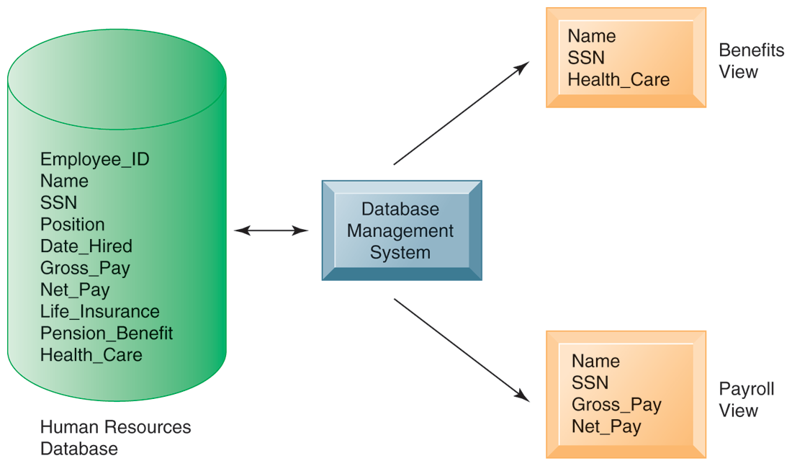

Lecture 21 (lol)
Unit 3 (lol)
Query: a set of instructions used for working with data. It is somewhat that of a question asked of a database. The results can be sorted, grouped or filtered. A query can get data from one or more tables, existing queries, or from a combination of the two. These tables or queries from which a query gets its data are referred to as its record source.
Select Query: most basic type of database query. It just selects records from a specific database table based upon a specific criteria.
Create query, check columns you want shown, in the criteria row of the target column write “Poor” or “M” or whatever.
Criterion Query: Uses rules to identity records to be included in query results. Like a formula. Some are simple and use constants while others use complex functions and special operations.
Parameter query: allows user to interactively specify one or more criteria values. It expands flexibility and instructiveness.
*in critera, write [Enter a City]* City is an example.
EXAM: IVEN A SQL QUERY, what of the 3 operations is occurring? Select, Join, or Project????????????
Select: Creates a subset of records that meet certain critera
Join: Combines tables into one with more info
Project: Creates a subset of columns (basically joins the tables without showing all of the columns.
Enterprise DBMS: More complex functions, can scale up to large amounts of data and support thousands of users.
Desktop/personal DBMS: allows you to store, update, insert new data. Can generate forms and run queries. Can’t be scaled up very high, or accessed by too many people at once (generally 100 but most are fewer than 15). Access is a good example.
Distributed databases are stored in more than one physical locations. In partitioned database, parts are stored in different physical locations. In duplicate database, duplicate the entire database at all remote location. This results in increased reliability (if a machine goes down) and greater efficiency (from multitasking).

Network Database:
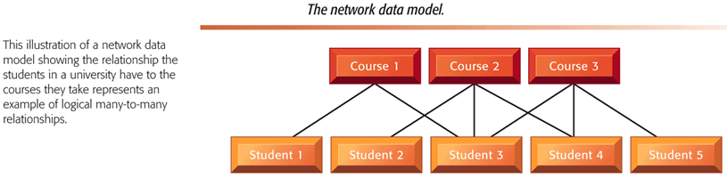
Disadvantages of Hierarchical and Network DBMS
- Outdated and not used for new applications
- Less flexible than relational DBMS
- Lack support for ad-hoc and English language-like queries
“THE FOLLOWING IS AN EXAMPLE OF BLOB (BIANARY LARGE OBJECT) DATA IN AN EMPLOYEE DATABASE: EMPLOYEE’S PICTURE, OTHER IMAGES, VIDEO FILES, MULTIMEDIA FILES, AUDIO, ETC”
This contrasts Atomic data which can be split up into smaller chunks.
Data warehouse: a large data store (e.g. database of some sort) that is being gathered from within and outside an organization. This may include customer feedback, competitor data, etc. All sources are sorted into a logical structure, extracted (retrieving specific parts) and transformed (transforming into what you want it to be), and put into a data warehouse.
A data warehouse is not a destination, it’s a journey. It is a continuous work process.
Extraction, transformation, and loading (ETL):
- a process that extracts information from internal and external databases, transforms the information using a common set of enterprise definitions, and loads the information into a data warehouse
Data mart: a subset of data warehouse information. Contains summarized or focused portion of data for a specified business unit or group of users. This is a snapshot of operational data for specific business contexts. Know difference between data mart and warehouse.

Lecture 22 (file name L23)

ETL= EXTRACT TRANSFORM LOAD
ETL: a process that extracts information from internal and external databases, transforms the information using a common set of enterprise definitions, and loads the information into a data warehouse.
OLAP – Online Analytical Processing: Allows users to analyse large volumes of data and present the same data in different ways. (Differs from transactional processing as analytical processing is more about gathering insight. Transactional is processing into the data warehouse.) Each aspect of information represents a dimention.
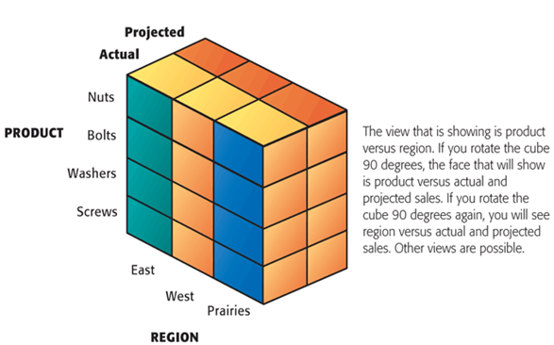
The point of the cube is that the software can rotate the cube to present several different basic graphs. (ex: the current (left facing) face shows the production levels of each product for each region)
OLAP provides the ability to sum, count, average, and perform simple arithmetic operations on groups of data. OLAP reports are dynamic and can change. The viewer can change the report’s format (the term) online. It is possible to drill down into the data. Gives a multidimensional view, and lets you view how the data is changing over time (temporal inquiry processing).

Data Mining
Its about discovering patterns and relationships in typically large pools of data. This will teach the identification of rules that can be used to predict future behaviour and guide decision making. For example, retail stores source through data mining to learn purchase behavior/buying patterns. Fraud detection (the bank notices when you have ‘unusual behaviour’, internet security, etc.
5 types of relationships
- Associations: things done together, like buying bread and milk.
- Sequences: events that follow each other (buying a house then a refrigerator)
- Classifications: recognizing patterns that lead to rules (a store learns when to offer specials)
- Clusters: Defining group that go together (identify market segments) (ie demographics)
- Forecasting: predicting future situations (likelihood that a customer switches to competitor)

Quiz/Exam Questions

Which is more descriptive notation for crating ERDs (Entity Relationship Diagrams)?
Crows feet notation or diamond notation?
A: Diamond notation. Diamond notation is the one where you see the types of relationships, for every table you can see the primary key, and it shows the cardinality (one to one, one to many, many to many, etc) ex: parts database. Crows feet is easier and quicker, but not descriptive. You should be familiar with either but you can use either (crows feet is easier and Ruhi prefers it)
Which is NOT a stardard procedure in Data Normalization?
Breaking down larger database into smaller, dublicating tables to create backups, resolving many-to-many relationships between identities, or designating primary keys for legitimate tables?
A: Duplicating tables to create backups. There is no such thing. Normalization is about making more streamlined and more efficient and more effective tables. It is also about resolving many-to-many relationships, and designating primary keys is also part of normalization.
What is the best way to describe a Data Warehouse:
Data warehouse as a Comprehensive Process. (multiple parts, multiple stages)
“give me the best 2 methods of social media emergency management”
“different stages of things”
“tools of business intelligence”
“tell me what kind of uristic would u use for somone who is a risk avoider or risk taker / he might give u a small table with values (max to max or what)”

