CHAPTER 2: Modeling Data in the Organization

Objectives:
Define Terms
- Term: word or phrase with specific meaning.
- Fact: association between two or more terms.
Understand importance of Data modeling
Write good names and definitions for entities, relationships, and attributes
- Good data names
  - Related to business, not technical, characteristics
  - Meaningful and self-documenting
  - Unique
  - Readable
  - Composed of words from an approved list
  - Repeatable
  - Written in standard Syntax
- Good data definition
  - Concise description of essential data meaning
  - Gathered in conjunction with systems
  - Accompanied by diagrams
  - Achieved by consensus and iteratively refined
- Existence dependency
  - Instance of one entity cannot exist without the existence of some other related entity.
  - Ex. OFFERING is existence-dependent on SUBJECT.
- Weak entity
  - Existence dependent, has a primary key that has been totally or partially constructed from the entity it depends on.
For example:
We have established that OFFERING is existence-dependent on SUBJECT, but OFFERING has its own primary key (Offering#), which has not been derived from SUBJECT. Therefore, OFFERING is not a weak entity.
However, in the case of an Invoice that has Invoice Lines, an INVOICE LINE must be associated with an INVOICE. Therefore INVOICE LINE would be existence-dependent on INVOICE. Furthermore, part of the primary key for INVOICE LINE would contain the primary key of INVOICE, in order that it be associated with an Invoice. Therefore, INVOICE LINE is a weak entity. The primary key of a weak entity is sometimes called a weak key.
INVOICE (Invoice#, Date, Customer#)
INVOICE LINE (Invoice#, Part#, Quantity)
A weak entity is represented by a double lined rectangle.

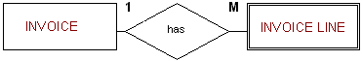

Distinguish unary, binary, and ternary relationships
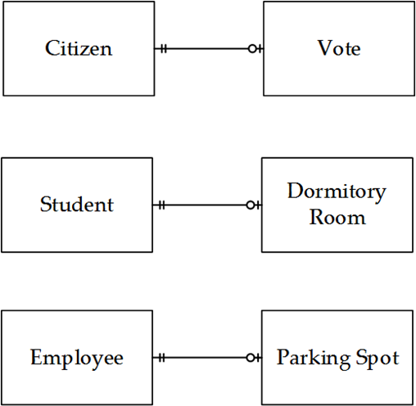

One to one
- 1:1
- Principle teacher managers one department.
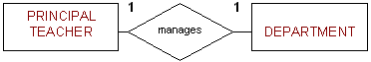
- Each department managed by one principle teacher.
One to many
- A subject can be offered many times.
- Each offering belongs to one subject.
- 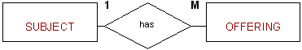
Many to many
- A teacher can teach many different subjects.
- Each subject can be taught by many teachers.
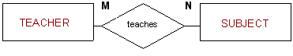

Binary relationship
- Two entities participate and is the most common relationship degree.
- Ex. Teacher teaches subject.
Unary relationship
- Both participants in relationship are the same entity.
- Ex. Subjects may be prerequisites for other subjects.
- Recursive relationships
  - Occur within unary relationships.
  - May be 1:1, 1:M, or M:N
  - M:N
    - A Subject may have many other Subjects as prerequisites and each Subject may be a prerequisite to many other Subjects
    - 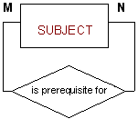
  - 1:M
    - An Employee may manage many employees, but an employee is managed by only one employee.
    - 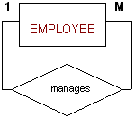

- 1:1
  - A person may be married to only one person.
  - 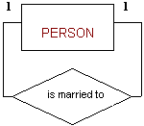

Ternary relationship
- Three entities participate in the relationship.
- Ex. University might need to record which teachers taught which subjects in which course.
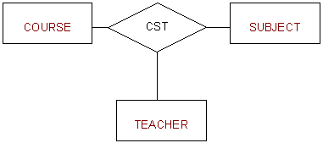
Mandatory/Optional relationships
- Participation by an entity in a relationship may be optional or mandatory.
- Ex. University, teachers may or may not teach a subject (if they're involved in non-touching projects). Conversely, subjects may or may not have a teacher currently assigned to teach it. Therefore, teacher is optional to subject and subject is optional to teacher.
- Optional entity represented by a CIRCLE on the side of the optional entity.
- 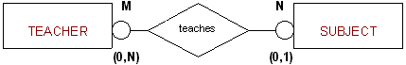
Model Different types of attributes, entities, relationships, and cardinalities
- Entities:
  - Entity instance: person, place, object, event, concept (often corresponds to a row in a table).
    - Object that will have many instances in the database
    - Object that will be composed of multiple attributes
    - SHOULD NOT BE
      - User of database system
      - An output of database system
      - 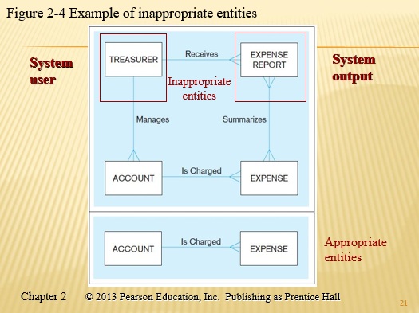

- Entity Type: collection of entities (often corresponds to a table).
- 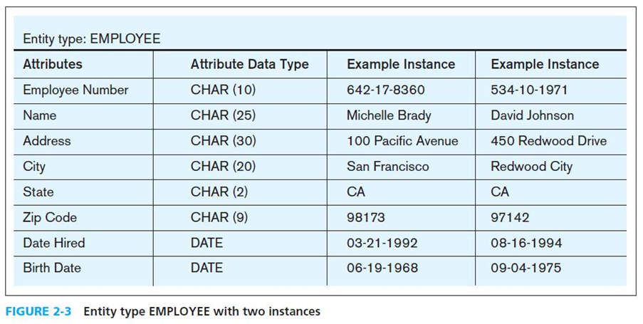
- Relationships:
  - Relationship instance - link between entities (corresponds to primary key-foreign key equivalences in related tables)
  - Relationship type- category of relationship… link between entity types
  - Degree:
    - Number of entities that participate in a relationship
  - Cardinality
    - The number of instances of entity B that can be associated with entity A.
    - There is a min and max cardinality for each relationship, with an unspecified maximum cardinality being shown as N.
    - Ex.
organisations policies or external constraints.
For Example:
At the University, each Teacher can teach an unspecified maximum number of subjects as long as his/her weekly hours do not exceed 24 (this is an external constraint set by an industrial award). Teachers may teach 0 subjects if they are involved in non teaching projects. Therefore, the cardinality limits for TEACHER are (O,N).
The University's policies state that each Subject is taught by only one teacher, but it is possible to have Subjects that have not yet been assigned a teacher. Therefore, the cardinality limits for SUBJECT are(0,1).
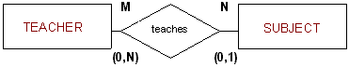
- Business rules: statements that define or constrain some aspect of the business.
  - Derived from policies, procedures, events, functions
  - Assert business structure
  - Control/influence business behavior
  - Are expressed in terms familiar to end users
- Good business rule
  - Declarative–what, not how
  - Precise–clear, agreed-upon meaning
  - Atomic–one statement
  - Consistent–internally and externally
  - Expressible–structured, natural language
  - Distinct–non-redundant
  - Business-oriented–understood by business people

- Attributes:
  - Properties or characteristics of an entity or relationship type (often corresponds to a field in a table).
Draw E-R diagrams for common business situations
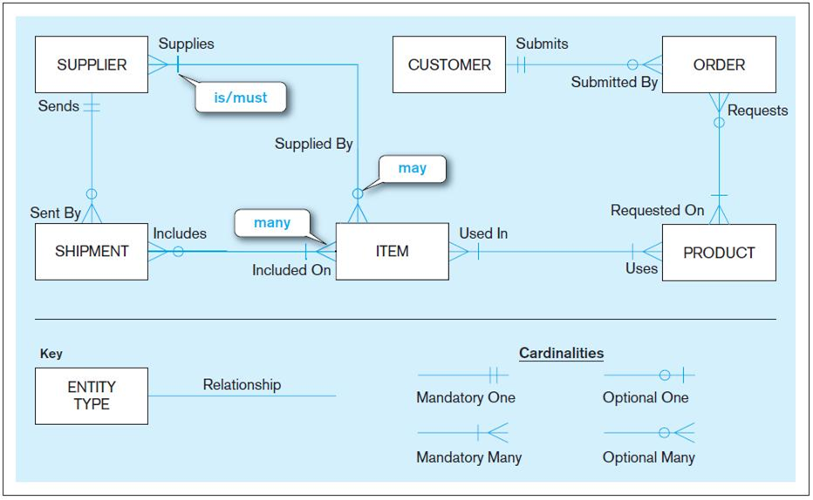
Sample E-R Diagram

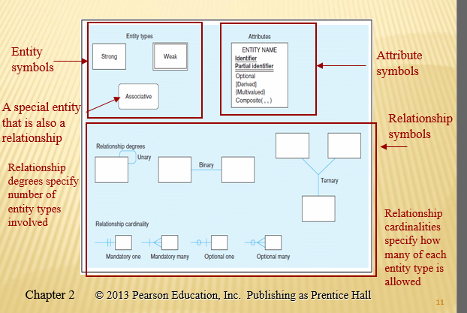
Basic E-R notations
Convert many-to-many relationships to associative entities
Model time-dependent data using time stamps

