Lab Experiment #2

RESISTOR NETWORKS
ELG-2138B

John-Martins Ogbonna (7932277)
Korede Ejiwunmi(7860157)

TA Signature:

OBJECTIVES
- To verify experimentally the design concept of a voltage divider.
- To design and build a simple analog ammeter based on the current-divider concept.
- To verify experimentally the Thevenin equivalent circuit and the maximal power transfer property.
PARTS AND EQUIPMENT
- 1 voltage source.
- 1 trim-pot (variable resistor) with a range of 0-50kΩ .
- 2 analog multimeters.
- Two 1KΩ resistors, 10 KΩ and 0.5 KΩ.

Preparation Questions:
Problem 1
V₂= 0.5v
R₂=1kohms

I=0.5/1*10³ = 0.5mA

5v-V₂-V₁=0
V₁=5-0.5=4.5v

R₁ = 4.5V/0.5ma = 9000ohms

Problem 2
R₂=1000ohms
R₁=9000ohms
R₃=10000ohms

R_{eq}=(1/(10000⁻¹+1000⁻¹)) = 909ohms
V₂=(909/(909+9000))*5 = 0.458V

Problem 3
KVL around loop 2
5 = 500c₁+1000c₂
c₁ = (5-1000c₂)/500 = (1/100)-2c₂
c₂ = 0.6/1000 = 0.6ma
c₁= (1/100)-2(0.6ma) = 8.8ma
c₃= 8.8ma-0.6ma = 8.2ma

R=(V/I) = (0.6/(8.2*10⁻³) = 78ohms

Problem 4
Max power occurs when R_{eq}=R_{th} =R₀
R₀=500*1000/500+1000(ohms)= 333ohms

Problem 5
Selected values: 200ohms, 300ohms, 333ohms, 350ohms, 400ohms, 500ohms
Corresponding power: 0.00781W, 0.00831W, 0.00833W, 0.00828W, 0.00826W, 0.00800W

Graph of Resistance vs power Dissipated:
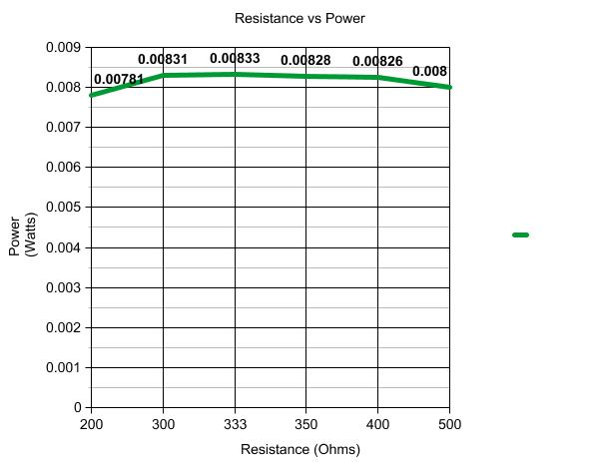

Voltage Divider

Circuit 1a.
From the calculations obtained from the prelab, we expected these results for fig. 1a:
V₁=4.5 V
V₂=0.5V
Upon performing the experiment in the lab, we measured these results:
V₁=4.4776V
V₂=0.488V
The measured results were very close to what was calculated in the prelab. The minor discrepancies may be attributed to the loading effect and possible human errors
Circuit 1b
Expected results from the prelab:
V₁=4.583V
V₂&V₃=0.458V
Actual measurement results:
V₁=4.518V
V₂&V₃= 0.447V
The experiment results are fairly close to the theoretical results, therefore the experiment can be verified
- Changing the value of R₃ had no effect on the voltage divider
- If R₃ is the voltage of the voltmeter, then R₂ =
(1000x10000/11000) x5/(9000+909)=0.459 ohms
We implemented the circuit in figure 2 with variable resistor R_{o}. We then measured the voltage and current. The Thevenin voltage is the same as the voltage across variable resistor.
 | R₀=100Ω | R₀=200Ω | R₀=300Ω | R₀=400Ω |  | R₀=500Ω | R₀=600Ω |  | R₀=700Ω | R₀=1KΩ
V₀ | 0.760 | 1.243 | 1.560 | 1.824 |  | 1.993 | 2.084 |  | 2.270 | 2.476
(V) | 0.760 | 1.243 | 1.560 | 1.824 |  | 1.993 | 2.084 |  | 2.270 | 2.476
I₀  (mA) | 7.53 | 6.11 | 5.14 | 4.36 |  | 3.90 | 3.53 |  | 3.15 | 2.48
Power  ( (W) | 0.005776 | 0.007623 | 0.008112 |  | 0.008317 | 0.00794 |  | 0.00724 | 0.00736 | 0.0061

The corresponding power dissipation was calculating using the equation P=V²/R.

Graph of Voltage vs Current:

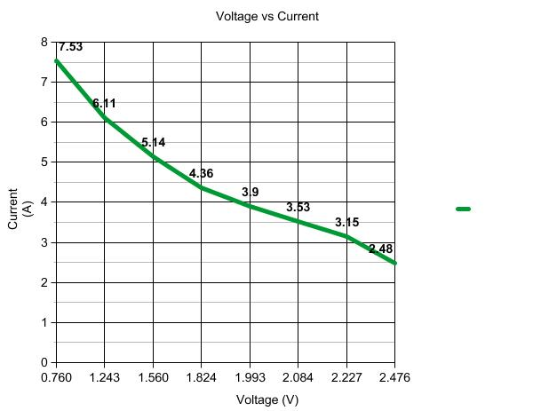

Graph of Resistance vs Power Dissipated:

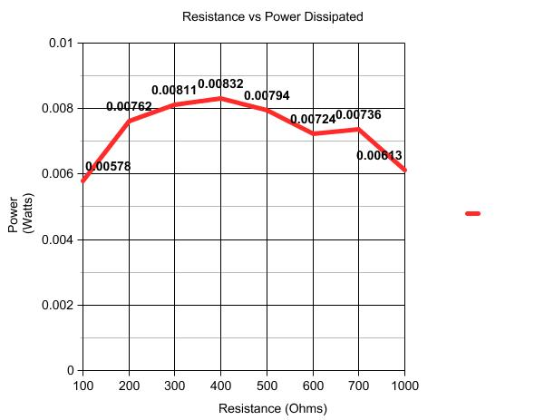
The value of resistance that gave the highest power dissipation that was physically measured in the lab was 400 ohms. Using Thevenin’s theorem in P4, this value was calculated to be 333 ohms, but this value was not explicitly tested in the experiment, but rather, values close to it. However, the measured results are close to what was predicted in the preparation, as the two numbers that the predicted highest dissipation were closest to (300 and 400 ohms), had the highest power dissipation in the data set. Reasons for deviation include; resistors that were not completely precise, measurement errors, and basic human lab error.

