Chemistry Lab (#4) 1321-B05: Stereochemical Analysis of the Reduction of Benzyl
March 9, 2017
TA: Ying Sun

Introduction:
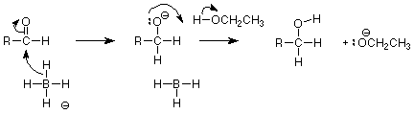
This image displays the mechanisms or the reduction with sodium borohydride. With the assistance of a protic solvent sodium borohydride is a strong reducing agent. Borohydride is a nucleophilic hydride in these reactions. It is used to reduce the carbonyl compound in the reaction. The protic solvent sits at equilibrium. This is useful because it can donate electrons as it is nucleophilic in its alkoxide state. Also, by breaking the π bond the carbonyl group can gain electrons from the oxygen-boron bond previously produced. This thn form with another group pf solvent, taking the H+ and forming a bond with the electron. Lastly, the general equation for the acetalization is:
Procedure:
- Accurately measured 1g of benzil using a folded piece of weighing paper and placed the compound in a 50 mL Erlenmeyer flask.
- Carefully paced a magnetic stir bar in the flask. Tilted the flask to one side and gently slid the stir bar into the flask.
- Added 10 mL of ethanol. Clamped the flask over a magnetic stir plate. Placed an empty ice bath underneath the flask. Added ice and the water to the ice bath. Stirred for 5 minutes.
- Added 0.3 g of sodium borohydride in three equal portions to the reaction flask, waited 2 minutes between additions. Continued stirring for 10 minutes. The mixture lost its original yellow colour.
- Removed the ice bath and stirred your solution while allowing it to warm to room temperature.
- Took a TLC of the reaction mixture to determine if the reaction is complete. The TLC plate had three lanes: reference (benzil, dissolved in dichloromethane), co-spot, and the reaction mixture. Used 1:9 EtOAc:Hexanes as the eluent.
- While the reaction was running, warmed 50 mL of water. Placed the water in a second Erlenmeyer flask along with stir bar. Placed the flask on a hotplate, and heated to 80 °C while swirling occasionally.
- Poured 10 mL of hot water into the reaction mixture. Transferred the reaction mixture into a clean Erlenmeyer flask and placed it on a hotplate, swirling occasionally as the mixture heats. The solution cleared and turned pale yellow. Continued swirling until the intense bubbling stopped.
- Added an additional 20 mL of hot water to the reaction mixture. Stirred while heating for 10 minutes. The mixture boiled during this time.
- Removed the flask from heat and allowed it to cool undisturbed until it reached room temperature.
- Collected the crystals that were formed using suction filtration. Washed the crystals with a small amount of cold water. Maintained suction for 5 minutes to dry the crystals.
- Determined the mass of the product and the percent yield. Performed a TLC of the final product (1:9 EtOAc:Hexanes). Placed a few crystals in a small vial and dissolved by adding a few drops of acetone.
- Placed 600 mg of the diol product in a 50 mL round bottom flask. Once the compound was dissolved it was carefully added to 500 mg of sodium sulfate and a stirring bar to the flask.
- Added 1.0 mL of 2-methoxypropene and 50 mg of ptoluenesulfonic acid. Stirred the mixture at room temperature for 30 minutes.
- Took a TLC of the reaction mixture using the diol product as the reference. Used 1:9 EtOAc:Hexanes as the eluent.
- Prepared two TLC plates. The reaction mixture was spotted on each plate. For references, one plate was spotted with the reference sample of the syn acetonide, the other plate was spotted with the reference sample of the anti acetonide.
- Eluted both plates using 1:9 EtOAc:Hexanes as the eluent and determined which stereoisomers of hydrobenzoin were present in the product.
Observations:
Benzyl is a yellow crystal with no scent. Ethanol is a transparent liquid with no scent. When the benzyl and the ethanol were added together it created a yellow transparent liquid. Sodium borohydride is a transparent liquid with no scent. It was added in three equal portions to the compound and the mixture lost it’s original yellow colour. After the compound was submerged in the ice bath it became a milky liquid with no scent. Once benzyl was dissolved in dichloromethane to produce the co-spot on the first TLC plate it created a transparent liquid with no scent. As water was being added the reaction turned into a pale yellow. Once the hot water was added it turned cloudy with bubbles on the top. Also, crystals appeared. The crystals that were obtained were white and shinny. 1:9 EtOAc:Hexanes is a transparent liquid with no scent it was used as a solvent. The compound was added to sodium sulfate which is a transparent liquid. 2-methoxypropene and ptoluenesulfonic are clear liquids and when mixed with the compound, the mixture turned dark red and increasing lessened into a light orange. Lastly, syn acetonide and anti acetonide are clear liquids used as reference samples on the final two TLC plates.
Table of reagent:
Reagent | Amount (g or mL) | Molecular weight (g/mole) | # Mol | Density (g/mL)
Benzyl  Ethanol  Sodium borohydride  Water | 1  10  0.31  30 | 210.2  46.07  38.75  N/A | 0.0048  0.17126  0.008  N/A | N/A  0.7854  N/A  N/A
CH₂Cl₂  Sodium sulfate  2-methoxypropene  p-toluenesulfonic acid  Diol | 25  0.5  1  0.05  0.6 | 84.93  142.04  72.11  172.2  212.01 | 0.390  0.0035  0.0104  0.00029  0.00283 | 1.325  N/A  0.753  N/A  N/A

TLC:
Reaction mixture of ethanol and sodium:
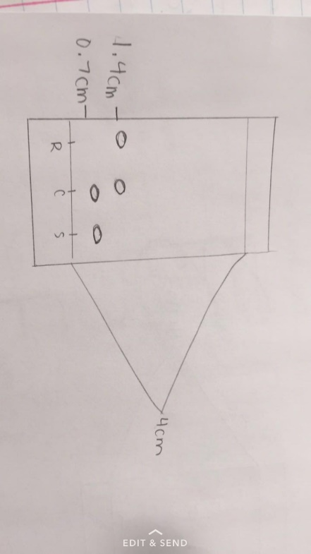
Rf= distanced travelled by solute
distance travelled by solvent
=0.7/ 4
= 0.175
Final mixture:
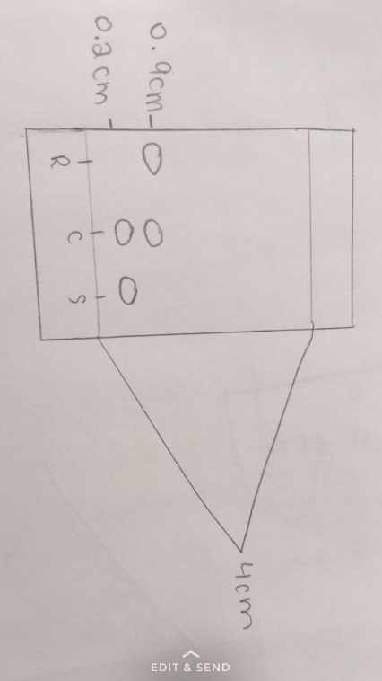
Rf= distanced travelled by solute
distance travelled by solvent
=0.2/ 4
=0.05
Reaction mixture using diol product:
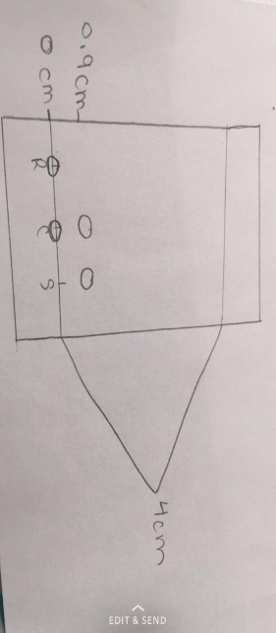
Rf= distanced travelled by solute
distance travelled by solvent
=0.9/ 4
=0.225
Sample of syn acetonide:
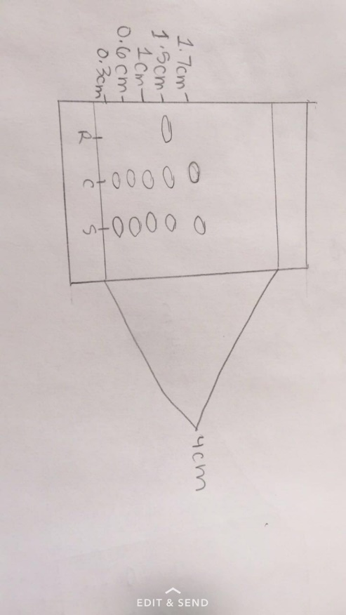
Rf= distanced travelled by solute
distance travelled by solvent
=0.3/4
=0.075
Rf= distanced travelled by solute
distance travelled by solvent
=0.6/4
=0.15

Rf= distanced travelled by solute
distance travelled by solvent
=1/4
=0.25
Rf= distanced travelled by solute
distance travelled by solvent
=1.5/4
=0.375
Rf= distanced travelled by solute
distance travelled by solvent
=1.7/4
=0.425
Sample of anti acetonide:
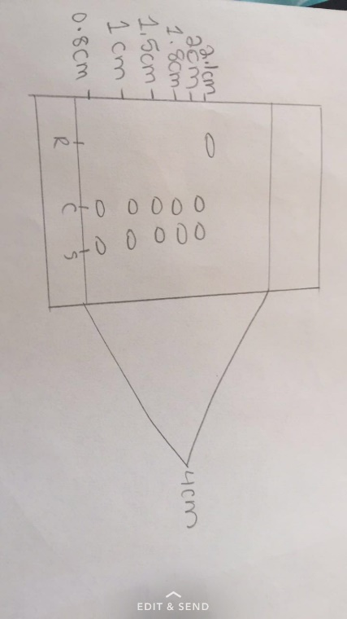
Rf= distanced travelled by solute
distance travelled by solvent
=0.8/4
=0.2
Rf= distanced travelled by solute
distance travelled by solvent
=1/4
=0.25
Rf= distanced travelled by solute
distance travelled by solvent
=1.5/4
=0.375
Rf= distanced travelled by solute
distance travelled by solvent
=1.8/4
=0.45
Rf= distanced travelled by solute
distance travelled by solvent
=2/4
=0.5

Rf= distanced travelled by solute
distance travelled by solvent
=2.1/4
=0.525

Table of results:
Product | Amount (g or mL) | Molecular weigh (g/mole) | # Mol | % yield
Benzoin | 1.47 | 214.26 | 0.006861 | 145.6

Calculations:
Percent yield= actual yield *100%
theoretical yield
= 0.006861 mol *100%
0.004712 mol
=145.6%

Discussion:
In the reduction of sodium borohydride, sodium borohydride acts as a reducing agent to benzil in ethanol. To speed up the process and ensure this reaction went to completion a magnetic stir bar was used. By placing the mixture in an ice bath benzil would be able to stay unreduced. To create the diol, three equal parts of sodium borohydride to ensure it fully reacted. Before taking the TLC the reaction was warmed to room temperature. The TLC was taken to show the reaction was completed so the rest of the experiment would go remotely. For the crystals to quickly form the flask was heated. After heated it was once again cooled to form crystals. Suction filtration allowed the crystal to dry and purify leaving only white crystals. Once the reaction was pure a TLC was taken to prove this to be correct. The mixture had a percent yield of 145.6% as the crystal obtained was 1.47g and originally started at 1g. The percent yield was higher than 100% because when filtering the mixture not all water was filtered creating a heavier product then showed have been obtained. Next, to identify the stereoisomer the diol was made into an acetonide. In the third TLC plate used it was gain to test to see if the reaction had gone to completion. On the TLC plate it showed the refernce spot and the sample spot in different positions (sample higher than reference). This shows a distinct difference in anti and syn and was therefore ready to be used further. By looking at the last two TLC plates produced, a conclusion can be draw that the syn acetonide is the cis stereoisomer and the anti acetonide is the trans stereoisomer.
There could be many possible sources of error throughout this lab. Firstly, even though tested using TLC plates the various reaction may not have gone to completion. Also, using the ice bath to ensure benzil would stay unreduced may not have been completely effective. The percent yield obtained was 145.6%. This is a huge error as the weight obtained was larger than the one originally given. This is because the water used with the suction filtration was not fully filtered adding mass to the crystals. Lastly, if the mixture did not fully become room temperature the TLC plate in step six could have been misleading.
Questions:
- Minimum volume of solvent needed:
16 g = 10 g
100mL X mL
X= 62.5 mL
At 20 °C:
1 g = X g
100mL 62.5mL
X= 0.625 g
In solution A:
3.5g- 0.625g= 2.875g
In solution B:
10g- 0.625g= 9.375g
Total solid= 2.875g + 9.375g
=12.25g
Percent composition of A:
=2.875 g
12.25 g *100%
=23.5%
Percent composition of B:
=9.375 g
12.25 g *100%
=76.5%
Yield of process:
=12.25
(10g + 3.5g) *100%
=90.7%
Composition of mother liquid:
A: 1 g = X g
100g 62.5 g
X= 0.625g

B: 1 g = X g
100g 62.5 g
X= 0.625g
Therefore, the mother liquid has 0.625g of compound A and 0.625g of compound B.
- Percent yield= 10.25g/12.25g *100%
=83.7%
- The recovery was so poor because the crude oil was only dissolved at 25 degrees Celsius when it’s boiling point was much higher. If it was dissolved in a higher temperature it would create a better recovery and improve the process.
- a) 1- butanol is not obtained because the reducing agent of sodium borohydride is not strong enough to be able to reduce butanoic acid. Also, bubbling and heat are still being produced because the decomposition of sodium borohydride is decomposing.
b) The product of this reaction is hydrogen gas.
- In both structures the nucleophile attacked the carbon which created a fifth bond on the central carbon. Because of this the double bond attaching to the oxygen broke and became a single bond leaving the oxygen unstable. For+ this reason, the oxygen atom became protonated. Two diastereomers were created because of the difference of the (R) and (S) rotations.
Conclusion:
Overall, the benzoin had a percent yield of 145.6% after suction filtration. Also, after examining the two TLC plates it was found that the syn acetonide is the cis stereoisomer and the anti acetonide is the trans stereoisomer.


