- Psych215.2012@gmail.com
- February 16th – Midterm
- April 3rd – Midterm
- Best of the two = 35%
- Final exam = 65%
- _____________________________________________________________________________=
- ABC Triad: Affect (how people feel inside), Behavior (what people do), Cognition (what people think about)

- Behaviorism: theoretical approach that seeks to explain behavior in terms of learning principles, without reference to inner states, thoughts, or feelings

- Evidence of reflections about the essence of human nature since the earliest writings

- Plato: mind-body dualism, immortality of the soul

- Aristotle: vital fluids, associationism

- Renee Descartes: passions of the soul (1649)
- Dualism-internationalism
- Mechanistic body as influencing the mind-perception
- Sketched rudiments of physiology of perception and actions
- Attached rudiments of physiology of perception and action
- ‘the body is an automaton and contains

in itself the corporeal principle of those

movements for which it is designed along

with all that is requisite for its action’
- The rational soul as the driving force of behavior
- Incomplete control over the body
- Inhibition of reflexive action
- Subjectivity of perception

Thomas Hobbs: human nature
- Subjectivity-mechanistic
- Objects agitating internal substances of the brain
- Mind as ‘cognitive’ and ‘motive’
- Contiguity (things that happen together in time) as fabric of coherence
- Attraction: attracted to something you have a positive orientation for, and un-attracted to something you have a negative orientation for

‘either to draw near the thing that

pleaseth, which is called appetite, or to

retire from the thing that displeaseth,

which is called aversion.’
- There is nothing without us which we call an image or a color

John Locke: an essay concerning human understanding
- Influenced b Newton
- Absence of physiological mechanisms in his theories
- Proposed that purely psychological model
- Agued against innate ideas (which Descartes believed in)
- Advanced the doctrine of psychological empiricism
- Believed humans are a blank slate shaped by sensory experiences

‘Let us suppose the mind to be white

paper, void of all characters, without any

ideas. How comes it to be furnished? To

this I answer in one word, from

experience’.
- Primary and secondary perceptions
- Matter and motion primary perception
- Odors, colors, taste, sounds as secondary

George Berkeley: principles of Human Knowledge (1710)
- Argued against Locke’s distinction between primary and secondary perception.
- Impossible to conceive of primary characteristics without secondary characteristics
- No valid psychological distinction could be drawn between primary and secondary perception.
- Argument led to conclusion that all perception was a ‘construction’ of some indefinable external reality

Norman Triplet: observer effects on performance
- Cyclists raced faster when observers were present

Max Ringelman: collective performance associated with poorer individual performance

Fathers of social psychology:
- William MacDougall (1908)
- Edward Ross (1908)
- Floyd Allport (1924)

Major Influences:
- Hitler
- Sherif (1936) – conformity
- Lewin (1935) – influence
- Milgram (1960) – authority

Social Psychology: how humans think, feel and behave in regard to other people and how individual thoughts and feelings and behaviors are effected by other people

Social thinking: How we perceive ourselves & others, what we believe, judgments we make, our attitudes

Social influence: Culture and biology, pressures to conform, persuasion, groups of People

Social relations: Helping, aggression, attraction & intimacy, prejudice

Social Psych vs Sociology

How are they different?
- Sociology tends to focus on the group level
- Social psychology tends to focus on the individual level

How do the fields intersect?
- Both share an interest in many issues, such as violence, prejudice, culture, and marriage

Social Psych vs Clinical Psych

How are they different?
- Clinical psychologists seek to understand and treat people with psychological issues.
- Social psychologists focus on the more typical ways in which individuals think, feel, behave, and influence each other

How do the fields intersect?
- Both are interested in how the individual engages with others and his or her environment

Social Psych vs Personality Psych

How do the fields differ?
- Personality psychologists are interested in differences between individuals that occur across a variety of situations
- Social psychologists are interested in how different situations affect most individuals

How do the fields intersect?
- They complement each other

Social Psych vs Cognitive Psych

How do the fields differ?
- Cognitive psychologists study mental processes overall
- Social psychologists are interested in mental processes with respect to social information and how these processes influence social behaviour

How do the fields intersect?
- Social cognition has become an important area within social psychology.

- Science may have questions that are biased
- A study must be a process that is systematic and reproducible

- Methods
- 1. Select a topic based on a theory

- Theory: an organized set of principles used to explain observed phenomena

- Usually evaluated in terms of three criteria:
  - Simplicity.
  - Comprehensiveness.
  - Generativity

- 2. Researching the relevant research literature

- 3. Formulating hypotheses

- Hypothesis: an explicit, testable prediction about the conditions under which an event will occur

- 4. Selecting research methods

- Basic research: goal is to increase our understanding of human behavior
- Often designed to test a specific hypothesis from a specific theory

- Male Female
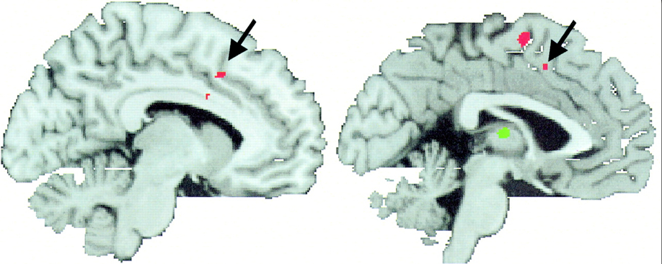

- Applied research: goal is to enlarge our understanding of naturally
- Occurring events
  - Additional goal is to find solutions to practical problems
- 

- Define variables:

- Conceptual variables: are abstract or general variables

- An operational definition: states specifically how the conceptual variable will be manipulated or measured.
- Transforms the variable from the abstract (conceptual) to the specific (operational)

- 1. Independent Variables: the factors experimenters manipulate to see if they affect the dependent variable

- 2. Dependent Variables: the factors experimenters measure to see if they are affected by the independent variable.

- 3. Subject Variables: variables that characterize pre-existing differences among study participants.

Construct the validity of the cause: the extent to which the independent variable is a valid representation of the theoretical stimulus

Construct the validity of the effect: the extent to which the dependent variable is a valid representation of the theoretical response

- Research design:

- Social psychologists use several different methods in the research process

- Descriptive Methods:
- Goal is to describe people and their thoughts, feelings, and behaviors

- Observational studies: simply observing behavior

- Archival studies: examining existing records of past events and behaviors

- Surveys: involves asking people questions about their attitudes, beliefs, and behavior
- Importance of random sampling

- Correlational Methods
  - Goal is to learn about the relationship between variables
  - How similar or distinct are two different variables?
  - How well does one variable predict another variable?
  - Role of the correlation coefficient
  - Measure of the strength and direction of the relationship between 2 variables

- Concurrent vs. prospective

- Advantages:
  - Can study the associations of naturally occurring variables that cannot be manipulated or induced
  - Can examine phenomena difficult or unethical to create for research purposes

- Disadvantages:
  - One very serious disadvantage
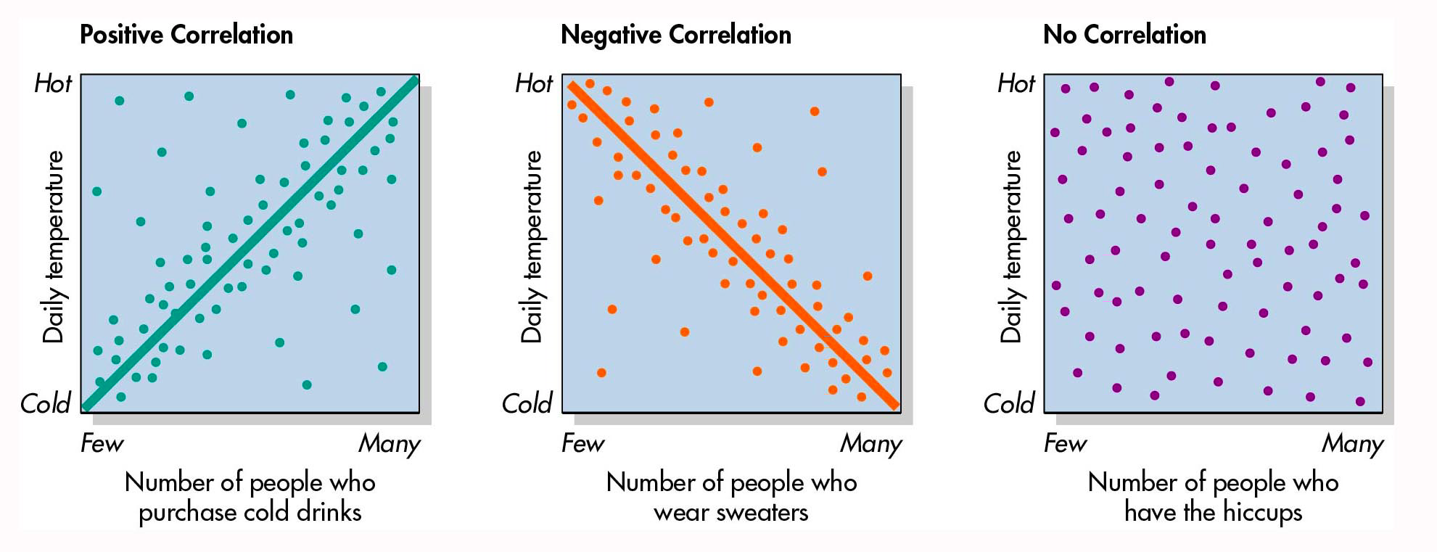
  - CORRELATION IS NOT CAUSATION!

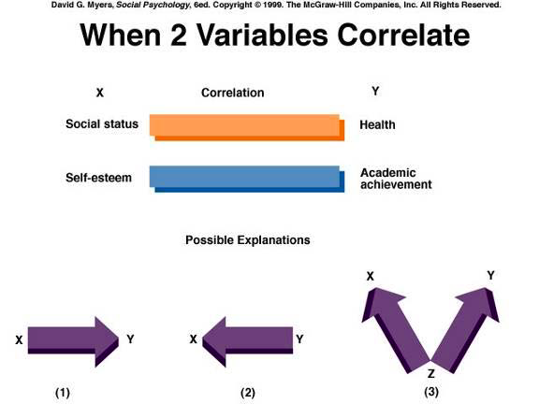

- Experiments
- Used to examine cause-and-effect relationships

Two essential characteristics:
  - Researcher has control over the experimental procedures, manipulating the variables of interest while ensuring uniformity elsewhere
  - Participants are randomly assigned to different treatment conditions

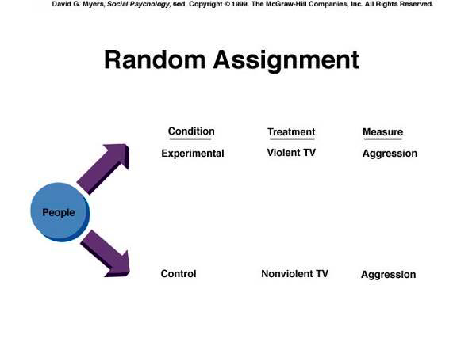

- Random Assignment: procedure whereby each study participant has an equal chance of being in each treatment group

- Quasi-experiment: a type of study in which the researcher can manipulate an independent variable but cannot use random assignment

- Internal validity: the extent to which changes in the independent variable caused changes in the dependent variable

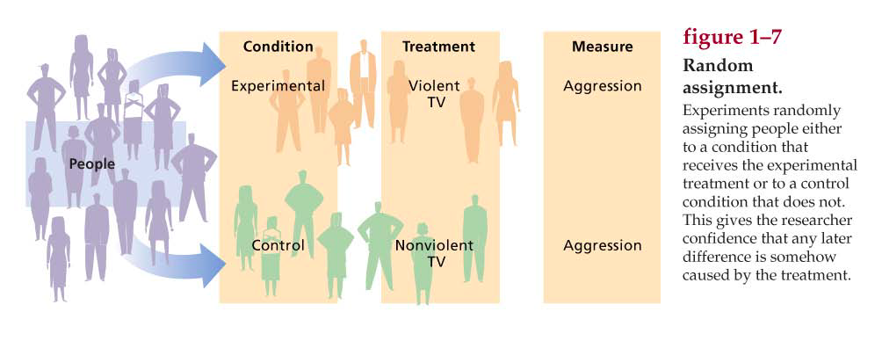
- Confounding: occurs when the effects of two variables cannot be separated

- Non experimental Studies

- Correlational approach: a nonexperimental method in which the researcher merely observes whether variables are associated or related

Correlation: the relationship or association between two variables

- Correlation coefficient: the statistical relationship or association between two variables

- Meta-analysis: a quantitative literature review that combines the statistical results (e.g., correlation coefficients) from all studies conducted on a topic

- Correlation vs Experiments
- 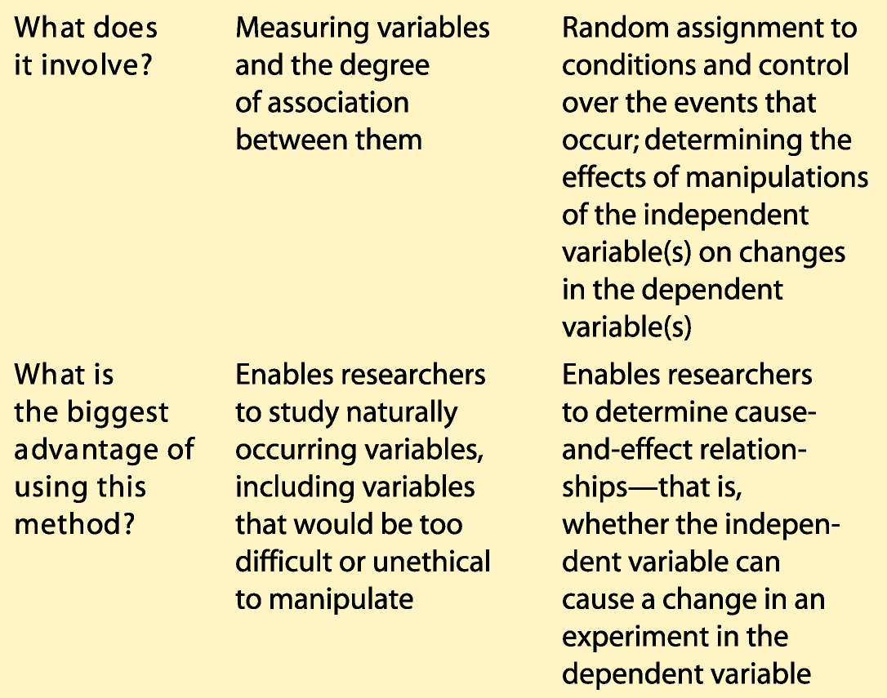

- Random Sampling vs Random Assignment 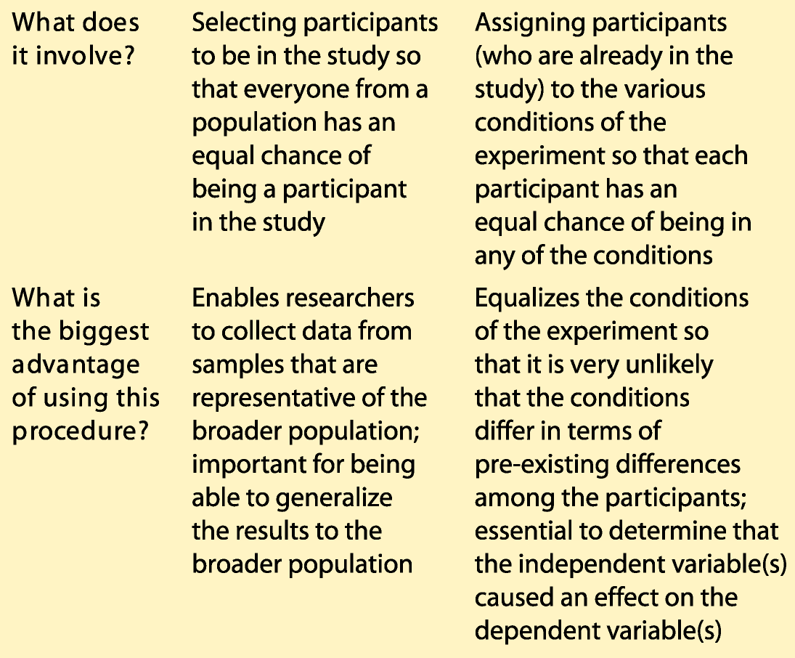

- Factorial Design: an experiment that includes more than one independent variable or factor

Main effect: the effect of a single independent variable on the dependent variable, ignoring the effects of other independent variables

Interaction: refers to the joint effects of more than one independent variable on the dependent variable

Field Experiments: field experiments are conducted in real world settings

Reactance: an unpleasant emotional response that people often experience when someone is trying to restrict their freedom

- Experimental realism: the extent to which study participants get so caught up in the procedures that they forget they are in an experiment

- Mundane realism: the extent to which the setting of an experiment physically resembles the real world

- External validity: the extent to which the findings from a study can be generalized to other people, other settings, and other time periods

- Advantage:
  - People are more likely to act naturally

- Disadvantage:
  - Experimenter has less control

- 5. Collecting the data

- 6. Analyzing the data

- Main Effect: the overall effect of the independent variable on the dependent variable, ignoring all other independent variables.

- Interaction: how the effect of each independent variable is
- Different as a function of other independent variables

- Statistical Significance
  - How likely is it that the results could have occurred by chance?
  - t (30) = 5.3, p < .05.
  - If 5 or fewer times in 100 possible outcomes, then considered to be “statistically significant”

- 7. Reporting the Results

8. Interpretation of Findings
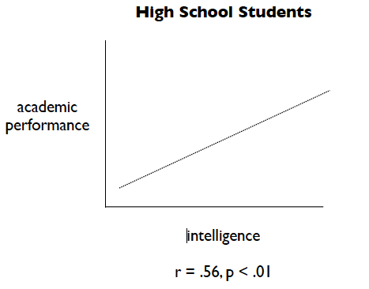
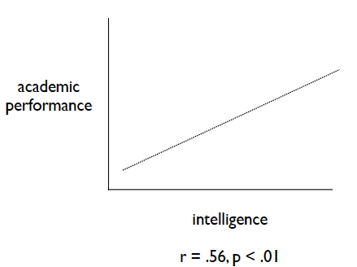

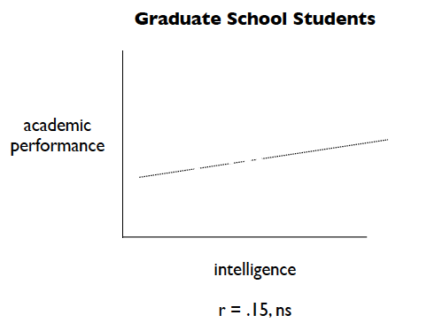
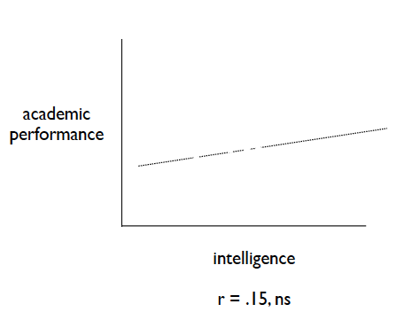

- ***must be able to replicate the experiment

- Deception and Ethics

- Protecting participants
  - Sensory deprivation experiments.
  - New drugs.
  - New surgical procedures.

- Ethics and Values in Social Psychology
  - Researchers have a moral and legal responsibility to abide by ethical principles.
  - The use of deception has caused particular concern in social psychology.
  - Virtually every study now has to be evaluated for its ethics by other people before the study can be conducted.

- Current Policies and Procedures
  - Role of Institutional Review Boards (IRBs)
  - Importance of informed consent
  - An individual’s deliberate and voluntary decision to participate in research
  - Necessity for debriefing
  - A disclosure made to participants after research procedures are completed
  - Potential negative feelings are resolved

- Nature and Nurture
  - Understanding the contributions of constitutional/genetic and environmental factors to human development.
  - Not ‘Nature vs Nurture’ but how do
  - Nature and Nurture interact in their influence on human development.

- Brenda/David Reimer
  - Twins born in Winnipeg, 1965
  - During circumcision, penis is badly burnt.
  - Parents choose to raise ‘David’ as a girl.
  - First reports positive; supportive of socialization of gender identity.
  - Later reports indicate significant problems.

- Brenda’s Problems
  - Never fit in.
  - Preferred rough and tumble games and was interested in typical ‘girl’ activities.
  - In adolescence, Brenda learns she is a boy. Refuses further hormone treatment, undergoes surgeries to reverse gender assignment.
  - Marries woman who already has two children.
  - Commits suicide at age 38.

- Limits of the power of socialization
  - If gender identity was completely a matter of socialization, Brenda should have been a normal girl.

- Psyche: a broader term for mind, encompassing emotions, desires, perceptions, and all other psychological processes
  - To understand something, you have to know what it is designed to do
  - If we can learn the purpose, we can understand people much better
  - In the genes dictate how they will act

Nature: human behavior invokes the sorts of processes that natural science have shown

Behavior geneticist: seek to understand behavior as the result of genes and show how people are born with tendencies to feel and act in certain ways

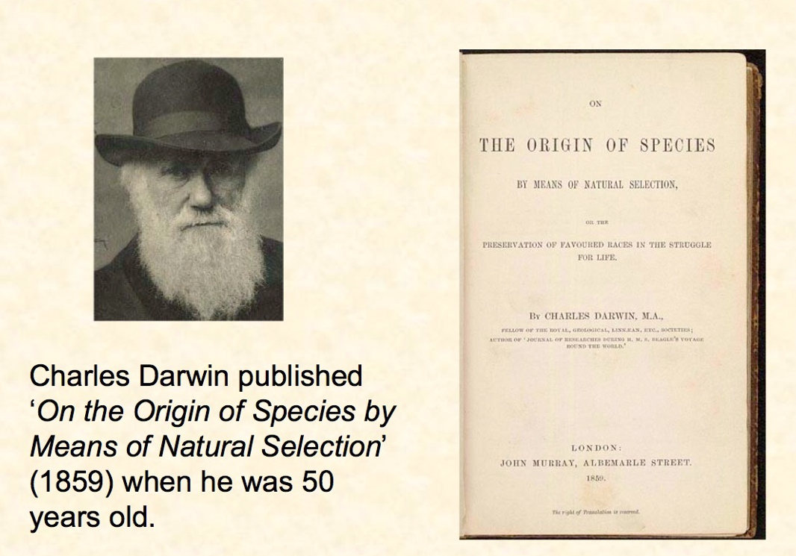
- Theory of Evolution
  - Evolution
  - Most powerful explanatory model in the life sciences
  - Natural Selection
  - Survival of the fittest
  - No ears, one long leg, good vision

- Evolution and Survival

  - Genetic diversity
  - ‘Survival’ is about reproduction
  - Traits that favour reproduction are more likely to be passed on
  - Reproductive success means living long enough to reproduce.

- Natural selection: the process whereby those members of a species that survive and reproduce most effectively are the ones that pass along their genes to future generations

Survival: living longer

- Evolution and Sex

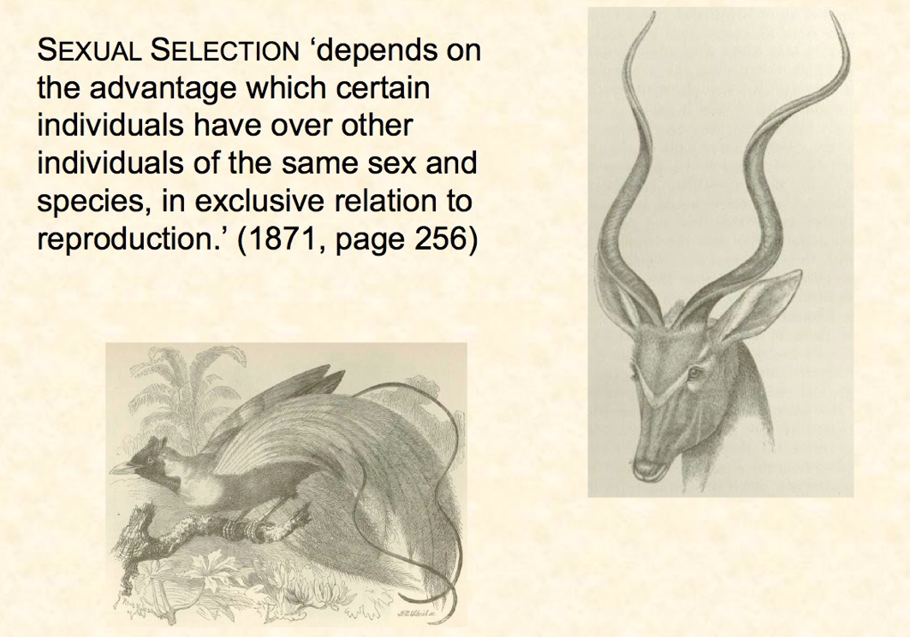
- Differences:

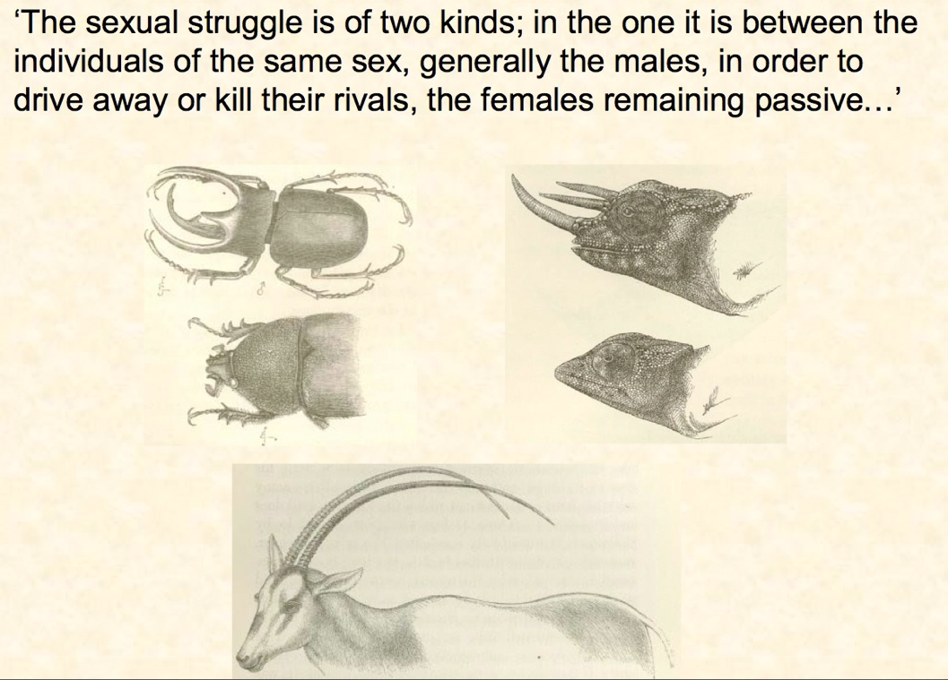

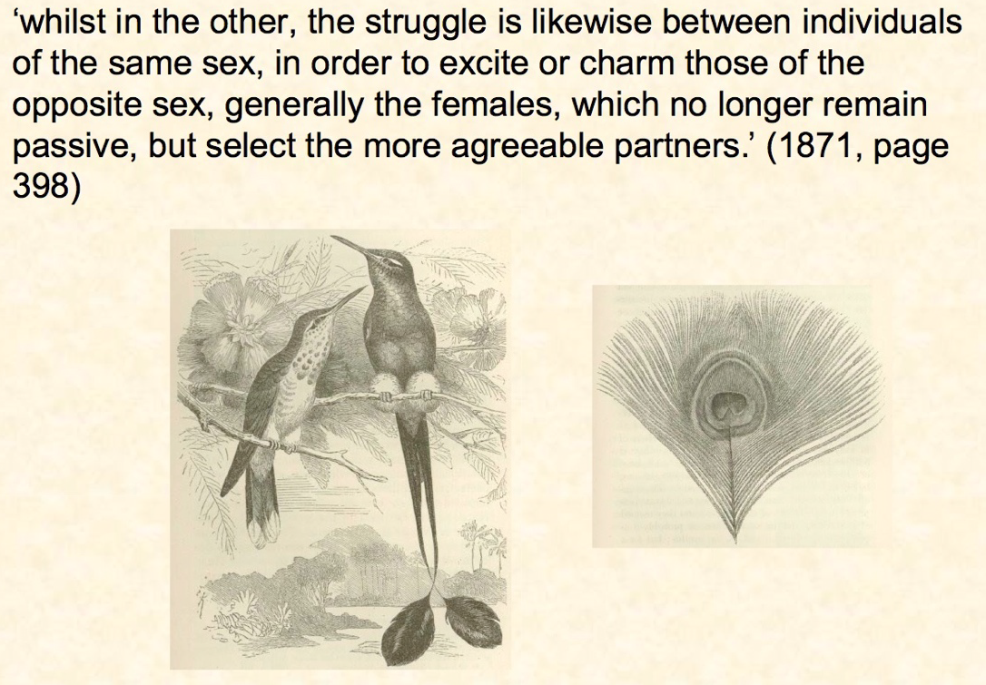

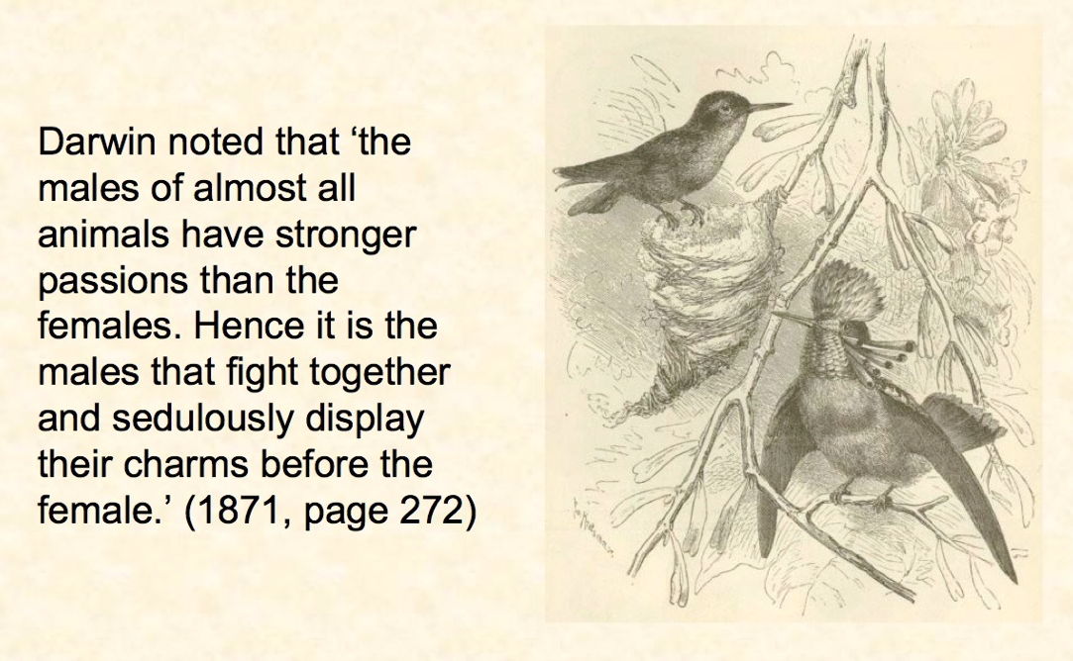

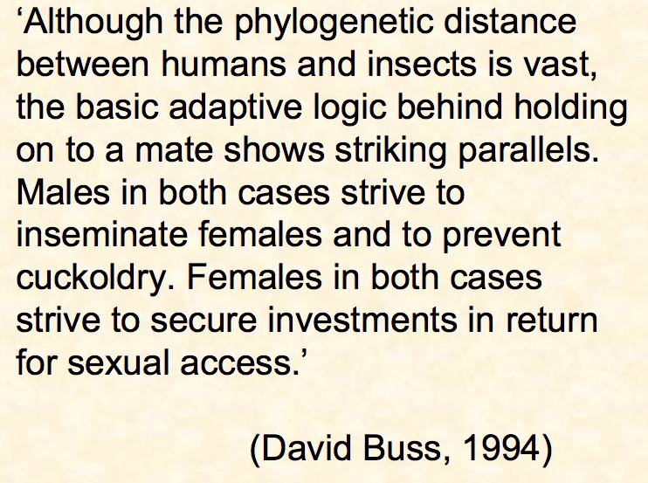

- Sex Differences:
  - Men desire more sexual partners than women
    - For men: strategy is to reproduce widely
    - For women: strategy is to reproduce wisely

- Social Living:
  - Humans have a propensity to live socially
  - Being social increases probability of survival
  - Being social is also more complicated; requiring greater intelligence
  - Social species have larger brains
    - Smaller brains means they live alone

- Culture: information based system of shared ideas and common ways of doing things
  - Facilitates interaction among group members
  - Easier to interact with a stranger of same culture than a stranger of different culture

- Social animals: animals that seek connections to others and prefer to live, work, and play with other members of their species

Cultural animals: the view that evolution shaped the human psyche so as to enable humans to create and take part in culture
- Cultural Diversity: system of shared ideas and behavioral scripts varies from one culture to another
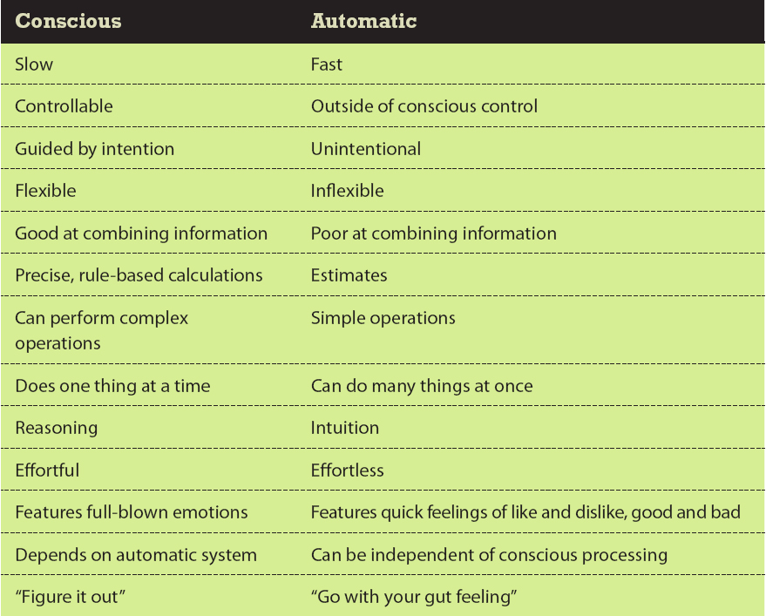
- Duplex Mind

Duplex mind: the idea that the mind has two different processing systems (conscious and automatic)

Automatic system (impulsive mind): the part of the mind outside of consciousness that performs simple operations
- Eg, understanding language; driving a car

Conscious system (reflective mind): the part of the mind that performs complex operations
- Eg, problem solving; learning new skills, counting from 1 to 10

When Nature says ‘go’ and Culture says ‘stop’

- Nature has made us selfish: Culture makes us resist and consider the common good

Morality: all cultures have a system for morality, and one of the main thrusts of morality is to do what is best for the community rather than what is best for the self
  - Morality is most effective in smaller groups
  - In larger groups, laws must be established to minimize selfish behavior that compromises the common good.

Function of the self

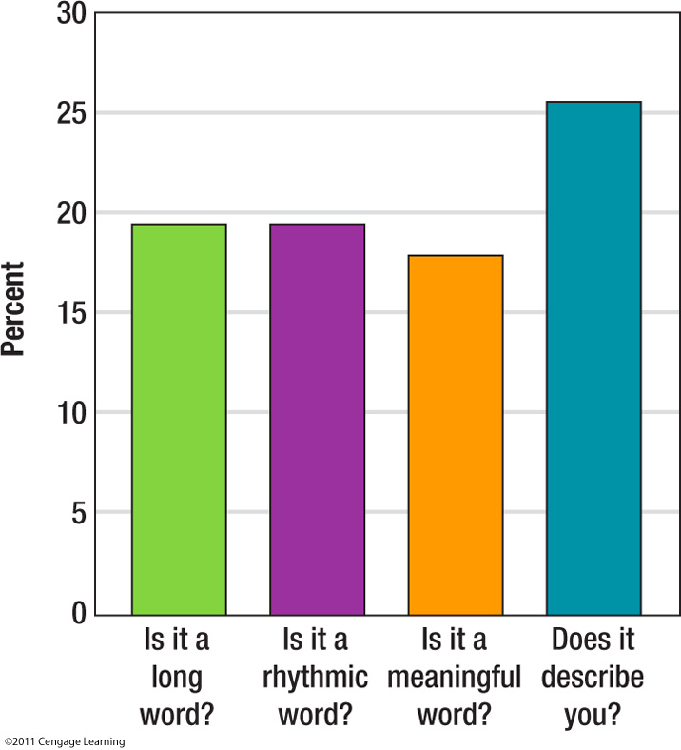
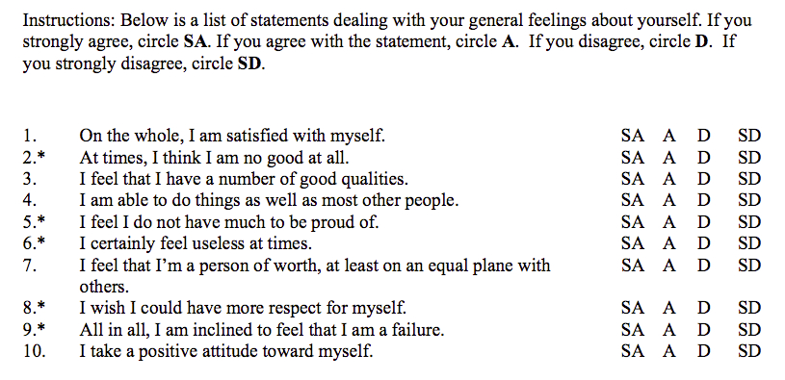
The Self Concept

Self-concept: a set of beliefs about oneself
  - Tell me about yourself.
  - What are you all about?
  - So who are you?
  - What defines you?

Morals often tell you that you should do what is best for the group instead of what is best personally

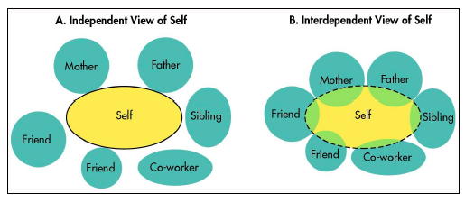

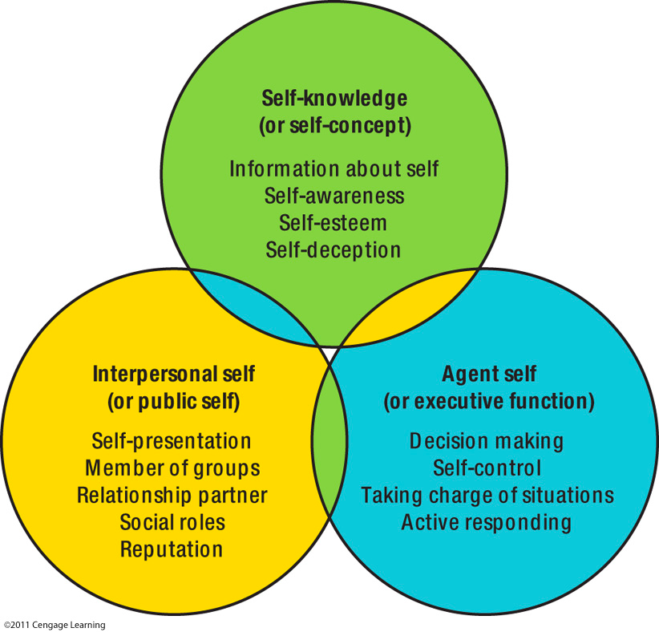
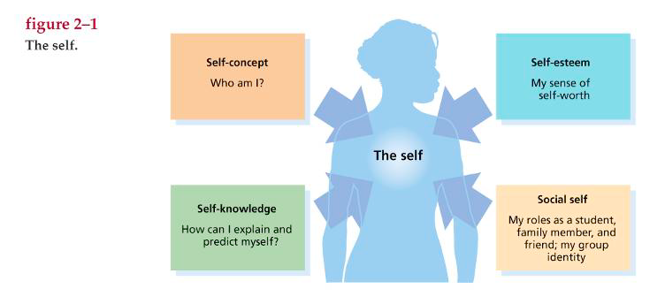

Public Self

Interpersonal self/public self: the image of the self that is conveyed to others
  - Self-Presentation Strategies.
  - The First Date

Agent Self

Executive function/agent self: the part of the self involved in control, including both control over other people and self-control
  - Makes decisions.
  - Gets things done

Beginnings of the Self-Concept

  - Except for human beings, only the great apes (and dolphins?) seem capable of self recognition.
  - Self-recognition, or the ability to see yourself as a distinct entity, is an important first step in the development of a self-concept

Self as impulse: a person’s inner thoughts and feelings
- Cultures that emphasize this up play the inner feeliings and places significance on individual persons

Self as institution: the way a person acts in public, especially in official roles
- Cultures that emphasize this down play the inner feeliings and places significance on roles in society

Independent self-construsal: a self-concept that emphasizes what makes the self different and sets it apart from others

Interdependent self-construsal: a self-concept that emphasizes what connects the self to other people and groups

Social roles: the different roles a person plays, as in a play or a movie

Standards: ideas (concepts) of how things might possibly be

Self-regulation: the self’s capacity to alter its own responses; self-control

The Self-Concept

  - Self is an important object of our attention.
  - Cocktail party effect.

Self-Concept: the sum total of beliefs that people have about themselves.

- Self-concept is made up of self-schemas.
  - Self-Schema: Beliefs about oneself that guide processing of self-relevant information

The Looking Glass Self

Charles Horton Cooley (1902): people learn about themselves through other people.
- “You have a lot of charisma”
- But should be little discrepancy between what others think of you and what you think of yourself

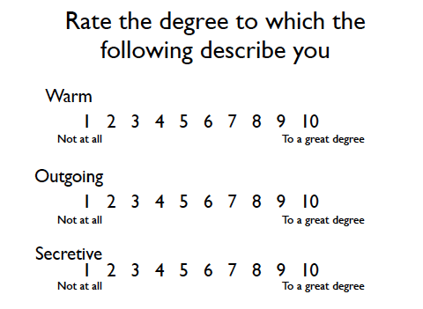

Sources of the Self-Concept

Five sources of the self-concept:

1. Introspection: the process by which a person examines the contents of his or her mind and mental states

2. Perceptions of our own behaviour

3. Influences of other people

4. Autobiographical memories

5. Culture

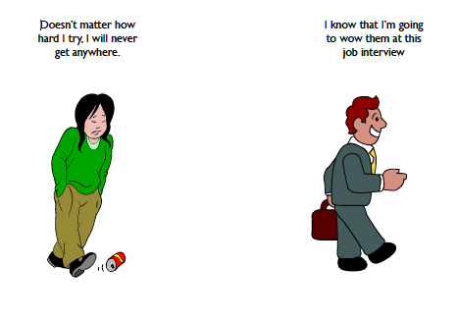

Self-Concept and Motivation

  - Learned Helplessness
  - Self-Efficacy

Learned Helplessness

  - Martin Seligman
  - Exposure to uncontrollable events
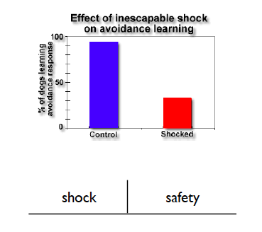
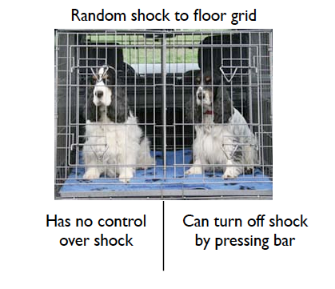

Self-Efficacy

Albert Bandura: confidence in the ability to achieve desired outcomes.
  - Outcome expectancies.
  - Domain specific.
  - Increases motivation

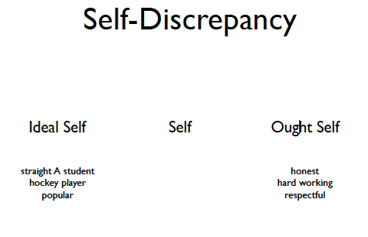

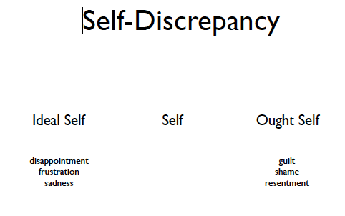

What am I all about?

- The unexamined life is not worth living.
- The unexamined life is likely to be happier than the examined life.

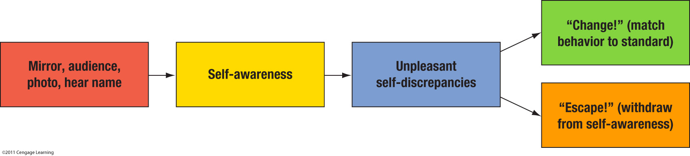

Self-Awareness

Self-awareness: attention directed at the self

Private self-awareness: looking inward on the private aspects of the self, including emotions, thoughts, desires, and traits

Public self-awareness: looking outward on the public aspects of the self that others can see and evaluate

Self-Awareness and Behaviour

  - Self-awareness makes people behave in ways more consistent with their attitudes and beliefs.
  - Less cheating.
  - Less opportunistic.

- We tend to over-estimate the intensity of the emotions we will feel in different situations.

3 main reasons motives shape the quest of self-knowledge
- Appraisal motive: the simple desire to learn the truth about oneself, whatever it is
- Self-enhancement motive: the desire to learn favorable or flattering things about the self
- Consistency motive: a desire to get feedback that confirms what the person already believes about himself or herself

Self handicapping: putting obstacles in the way of one’s own performance so that anticipated or possible failure can be blamed on the obstacle instead of on lack of ability

Automatic egotism: response by the automatic system that “everything good is me, and everything bad is not me”

Development of Social Self

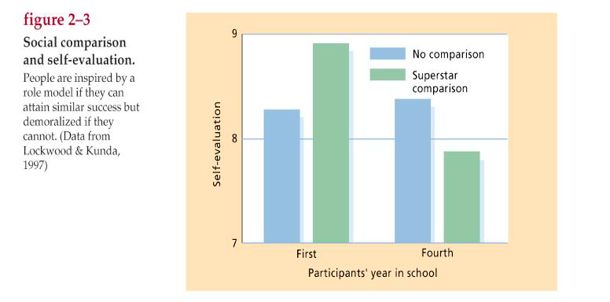

Social comparison: examining the difference between oneself and another person

Upward social comparison: comparing yourself to people better than you

Downward social comparison: comparing oneself to people who are worse off

Perceptions of Our Own behaviour

Daryl Bem (1972): People can learn about themselves simply by watching their own behaviour.

Self-Perception Theory: when internal cues are difficult to interpret, people gain insight by observing their own behaviour.
  - But only in the absence of compelling situational pressures.

Phenomenal self (working self-concept): the image of self that is currently active in the person’s thoughts

Self reference effect: the finding that information bearing on the self is processed more thoroughly and more deeply, and hence remembered better, than other information

Endowment effect: the finding that items gain in value to the person who owns them

Sources of Motivation

Motivation:
  - Learned helplessness
  - Self-efficacy
  - Intrinsic and extrinsic
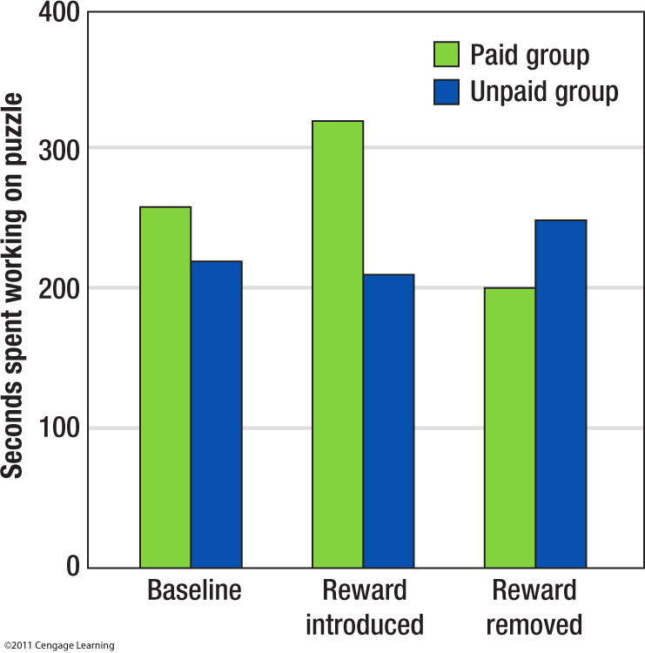

Intrinsic versus Extrinsic:

Mark Lepper et al (1973): studies time spent playing with felt markers.
  - No reward, unexpected reward, expected reward
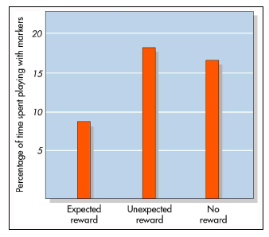

Self-Perceptions of Motivation

Intrinsic Motivation: Originates in factors within a person.

Extrinsic Motivation: Originates in factors outside the person.

Overjustification effect: the tendency for intrinsic motivation to diminish for activities that have become associated with a reward
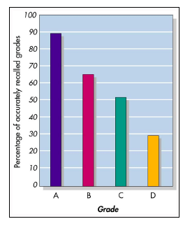

Strategic Recall

  - Autobiographical memory
  - Selective memory of the past.
  - “The past is remembered as if it were a drama in which the self was the leading player”

Explaining negative outcomes
  - My dog kept eating my homework.
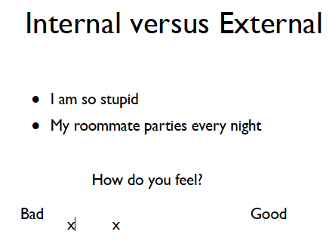
  - My roommate parties every night.
  - My alarm clock didn’t work.
  - I did not have time to study.
  - I was really sick

Strategic self-deprication?

  - I am so stupid.
  - How could I have failed that test.
  - I’ll never get anywhere in life.
  - My father was right, I’m a loser

Self-presentation

  - False Modesty
  - Self-handicapping
  - Reduce preparation for athletic events
  - Give opponents an advantage
  - Report feeling depressed
  - Perform poorly at the beginning of a task
  - Not try as hard

Self esteem: how favorably someone evaluates himself or herself

Self-protection: trying to avoid loss of esteem

Self-deception strategies: mental tricks people use to help them believe things that are false

Self-serving bias: the tendency for people to take credit for success but deny blame for problems and failures

Sociometer: a measure of how desirable one would be to other people

Narcissism: excessive self-love and a selfish orientation

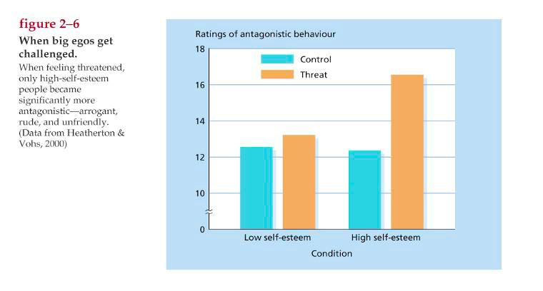
Dark Side of Self Esteem

Error Management Theory: Both men and women make decisions so as to minimize the most costly type of error, but men's worst error is not the same as women's.

The Most Costly Error: what will drive our desires
  - For women, pregnancy with a man who is not prepared to stay.
  - For men, not having the opportunity to reproduce

Free Will

  - If behavior has causes, then it cannot be determined by free will.
  - Believing in free will might be an important dimension of prosocial behavior
    - Feeling like one has no free will, bad behavior is a result

Free Will Challenged

  - When manipulations induce people to reject their belief in free will, they are more willing to cheat, and steal, and more likely be behave aggressively.
  - Evolutionary psychologist would say that reproduction is not an act of free will it is a fact of our species’ evolution that embeds us with the desire to reproduce (illusion, behavior determined by genes)

Self-Determination Theory: the theory that people need to feel at least some degree of autonomy and internal motivation

Acting Autonomously

  - People who believe they act autonomously derive more satisfaction, are more interested in and excited about what they are doing, have greater confidence, and often perform better, persist longer, and show greater creativity. Autonomous action also contributes to vitality, self-esteem, and general well-being
  - The people who believe they have free will feel better about themselves and are happier people

Illusion of Choice

  - Even perceived choice can have benefits. Participants who believe they could turn off a stress loud noise performed better than participants who did not believe they could turn off the noise.

Self-determination theory: the theory that people need to feel at least some degree of autonomy and internal motivation

Panic button effect: a reduction in stress or suffering due to a belief that one has the option of escaping or controlling the situation, even if one doesn’t exercise it

Goals: is an idea of some desired future state.
  - (personal projects, personal strivings)
  - The meaningful link between values and behaviour.
  - Humans only species with future-oriented goals.

Zeigarnik effect: a tendency to experience automatic, intrusive thoughts about a goal whose pursuit has been interrupted

Goal shielding: when the activation of a focal goal the person is working on inhibits the accessibility of alternative goals

Choosing Goals

  - Multiply determined.
  - What do you want to be in life?
  - Answer will be partially determined by socially proscribed social norms

Influences on choice:

- Risk aversion: in decision making, the greater weight given to possible losses than possible gains

- Temporal Discounting: in decision making, the greater weight given to the present over the future

- Certainty effect: in decision making, the greater weight given to definite outcomes than to probabilities

- Keeping options open

Why people don’t choose

Status quo bias: the preference to keep things the way they are rather than change

Omission bias: the tendency to take whatever course of action does not require you to do anything (also called the default option)

Reactance

Reactance theory: the idea that people are distressed by loss of freedom or options and seek to reclaim or reassert them

Choice and Change:

Entity theorists: those who believe that traits are fixed, stable things (entities) and thus people should not be expected to change

Incremental theorists: those who believe that traits are subject to change and improvement

Learned helplessness: belief that one’s actions will not bring about desired outcomes, leading one to give up and quit trying

Capacity for change: the active phase of self-regulation; willpower

Goal Setting and Pursuit

- Pursuing goals involves at least two major steps:
- Setting goals (which may involve choosing among competing goals, evaluating how difficult or feasible a goal is, and deciding how much you want to pursue it.
- Pursuing the goal, which may include planning what to do and carrying out those behaviors
- Positive illusions are just as important as attaining the goal
      - Know the idea
      - Hard to anticipate the obstacles
      - Resilient to the stresses in the oath to the goal
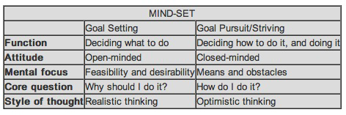

Planning Fallacy: belief that one's own project will proceed as planned, even while knowing that the vast majority of similar projects have run late (not as planned)
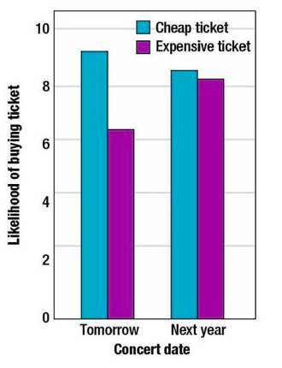
  - Excessive optimism

Self-Regulation: refers to the self's capacity to alter its own responses. It is quite similar to the everyday term "self-control." People regulate their thoughts, their emotions, their impulses and desires, and their task performance
  - Self-regulation enables people to be flexible, to adapt themselves to many different circumstances, rules, and demands

Failure to self-regulate

  - Can result in drug and alcohol abuse, addiction, eating disorders, obesity, anxiety and anger control problems, unwanted pregnancy, unsafe sex and sexually transmitted diseases, gambling, overuse of credit cards, debt and bankruptcy, underachievement in school, poor physical fitness, violence and crime, and many more.

Components of Self-Regulation

  - Standards (social norms, values)
  - Monitoring (tracking behaviors)
  - TOTE- test, operate, test, exit ( self-regulation feedback loop)
  - Strength (capacity for change, will power)
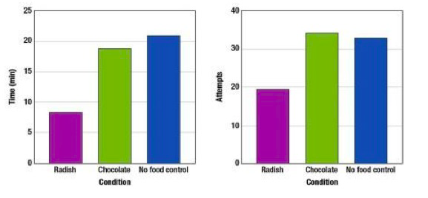

Limited Will Power

Self-Defeating Behavior

Self-defeating behavior: any action by which people bring failure, suffering, or misfortune on themselves

  - Smoking.
  - Eating unhealthy foods.
  - Engaging in high risk sexual behavior.
  - Non-compliance with medication

Trade-offs: accepting long term consequences for short term gain.
  - Long term consequences have minimal impact on behavior

Suicide

  - The ultimate self-destructive behavior.
  - Trading off one’s future for immediate relief of suffering.

Capacity to delay gratification: the ability to make immediate sacrifices for later rewards

Social cognition: a movement in social psychology that began in the 1970s that focused on thoughts about people and about social relationships

Cognitive miser: a term used to describe people’s reluctance to do much extra thinking

Stroop test: a standard measure of effortful control over responses, requiring participants to identify the color of a word (which may name a different color)

Stroop effect: in the Stroop test, the finding that people have difficulty overriding the automatic tendency to read the word rather than name the ink color

Knowledge structures; organized packets of information that are stored in memory

Schemas: knowledge structures that represent substantial information about a concept, its attributes, and its relationships to other concepts

Scripts: knowledge structures that define situations and guide behavior

Counterregulation: the “what the heck” effect that occurs when people indulge in a behavior they are trying to regulate after an initial regulation failure

Attribution

Attribution: cognitive process of assigning meaning to a symptom or behavior; the causal explanations people give for their own and others’ behaviors, and for events in general

  - The person – something about the person was the cause of the behavior
    - E.g., Canadians won because they are an amazing team
  - The situation – something about the situation was the cause of the behavior
    - E.g., the Canadians won because the Capitals played a bad game

Self-serving bias: the tendency for people to take credit for success but deny blame for problems and failures

Actor/observer bias: the tendency for actors to make external attributions and observers to make internal attributions

Attributional processing increases

  - For negative or unexpected outcomes
  - More motivated to search for explanations when outcomes are negative or unexpected



Attributing Pickton’s Behaviour
  - He is deranged.
  - He is a sick man.
  - He is a murderer

Attributing Pickton’s Behaviour
  - He was upset.
  - Someone made him do it.
  - He wasn’t aware it was against the law

Heider

  - We favour dispositional explanations of others’ behaviour.
  - To provide us with a sense of meaning and predictability in our social world.
  - Attributions as the basic unit of analysis in social psychology

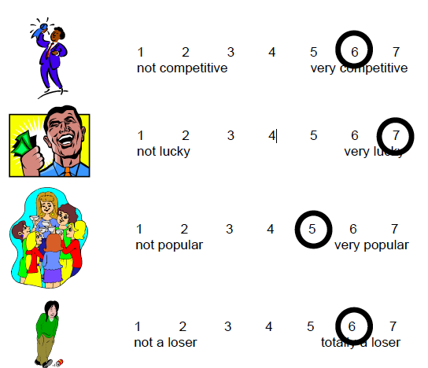

Are attributions automatic?

  - Without attention
  - Not affected by concurrent cognitive demands

Kelley’s Covariation Theory

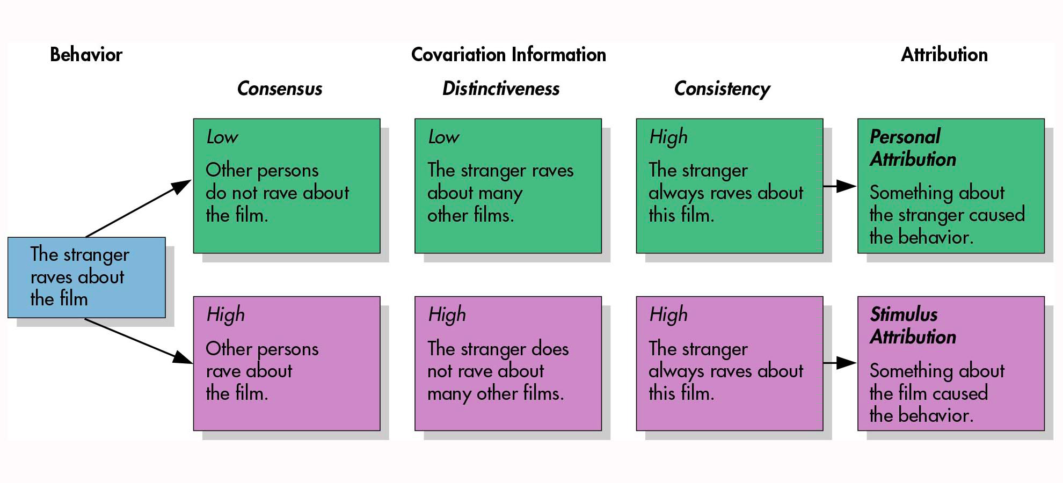

Consensus: in attribution theory, whether other people would do the same thing in the same situation

Consistency: in attribution theory, whether the person typically behaves this way in this situation

Distinctiveness: in attribution theory, whether the person would behave differently in a different situation

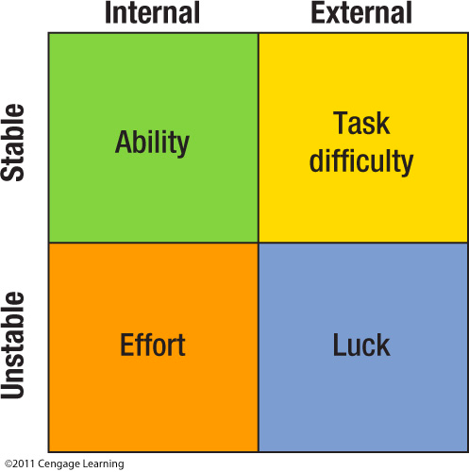

Attribution cube: an attribution theory that uses three types of information: consensus, consistency, and distinctiveness

Fundamental Attribution Error

Fundamental attribution error: the tendency for observers to attribute other people’s behavior to internal or dispositional causes and to downplay situational causes

Ultimate attribution error: the tendency for observers to make internal attributions (fundamental attribution error) about whole groups of people

Covariation principle: for something to be the cause of a behavior, it must be present when the behavior occurs and absent when the behavior does not occur

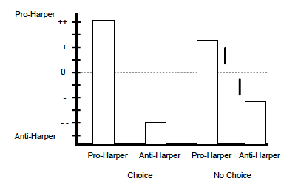

What Does the Speechwriter Really Believe?

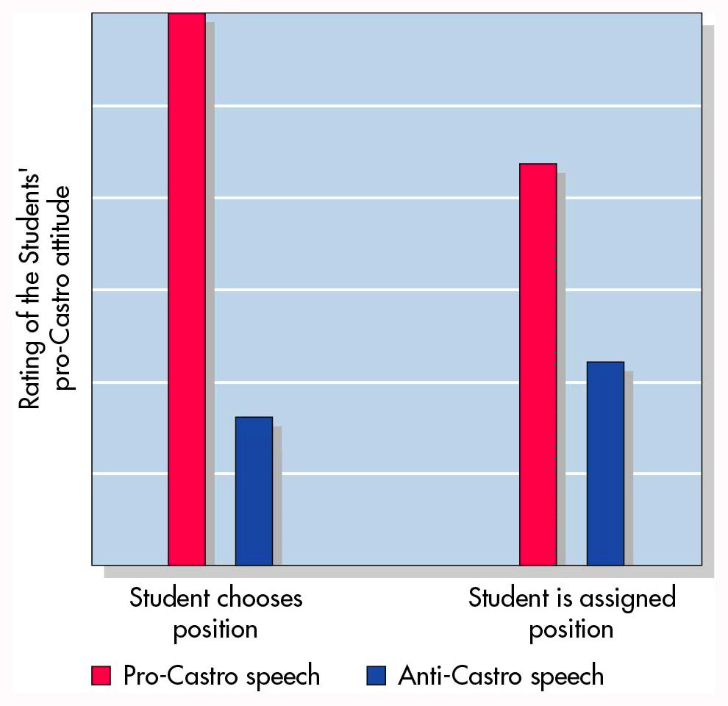

Why do we fail to acknowledge the role of the situation?

Gilbert and Malone (1995)

  - Social perception is a two-step process
  - Involves both automatic and controlled processes
  - Heavily influenced by cognitive resources

Two-Step Model of the Attribution Process

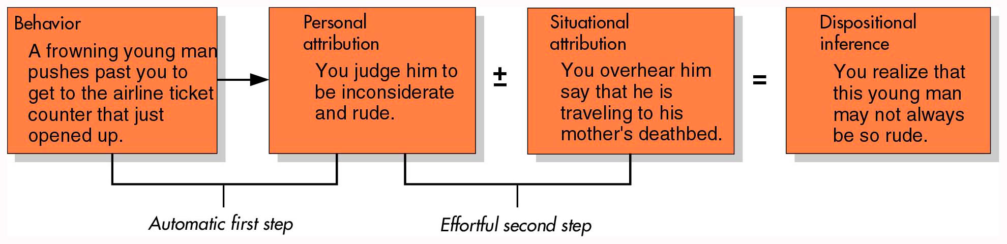

Attributions and Reactions

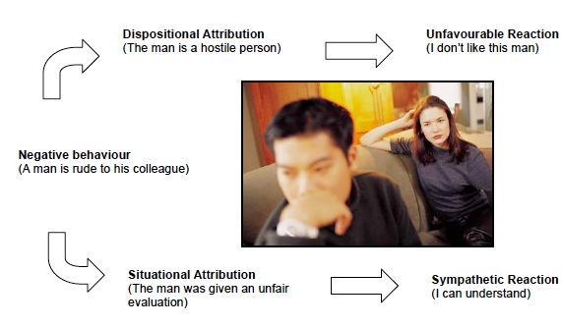

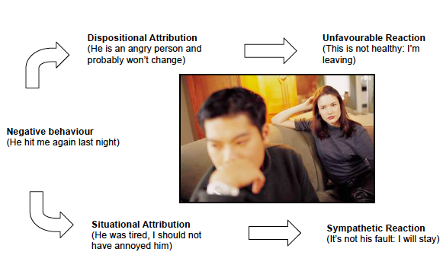
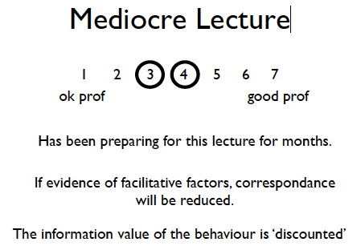
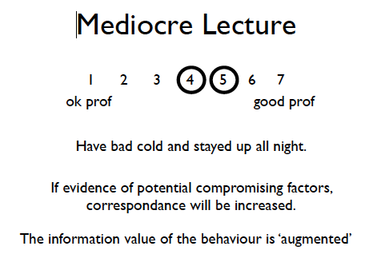

- Information about facilitative or compromising influences on behaviour will have more influence BEFORE rather than after observing the behaviour.

Impression Management

  - Provide audience with information about compromising factors ‘before’ execution of behaviour.
  - Strategically engineer compromising situation

- Why is information about about facilitative or compromising influences more effective before rather than after observing the behaviour?

Judgment Processes

  - We combine relevant ‘behavioural’ and ‘situational’ information when making attributions or inferences.
  - If we judge that information is being put forward to deliberately influence our inferences, the information will be less effective.

Inferences based on initial information

  - You don’t get a second chance at making a first impression

The Primacy Effect: The tendency for information presented early in a sequence to have more impact on impressions than information presented later

Explanation #1: Once we think we have formed an accurate impression of someone, we pay less attention to subsequent information

Explanation #2: Change of Meaning Hypothesis

Once we have formed an impression, we start to interpret inconsistent information in light of that impression.

Confirmation Bias: the tendency to notice, search for, and focus on information that supports one’s expectations or beliefs and to ignore information that contradicts them

Information overload: having too much information to comprehend or integrate

  - Once we make up our mind about something, how likely are we to change it, even when confronted with new evidence?

Perseverance of Beliefs

  - We interpret ambiguous events in ways that confirm our existing beliefs

Belief Perseverance: The tendency to maintain beliefs even after they have been discredited
  - Can be reduced or eliminated when we are asked to consider why alternative explanations may be true

Priming Effects

  - The characteristics we focus on vary based on recent experiences

Priming: The tendency for recently used words to come to mind easily and influence the interpretation of new information
  - Priming can influence person impressions
  - Motivations, as well as social behaviours, can be influenced by priming

E.g.,
  - brave, independent, adventurous.
  - reckless, foolish, careless.
- Read about a man who climbs a mountain: most likely to describe the man as the characteristics that we were previously exposed to

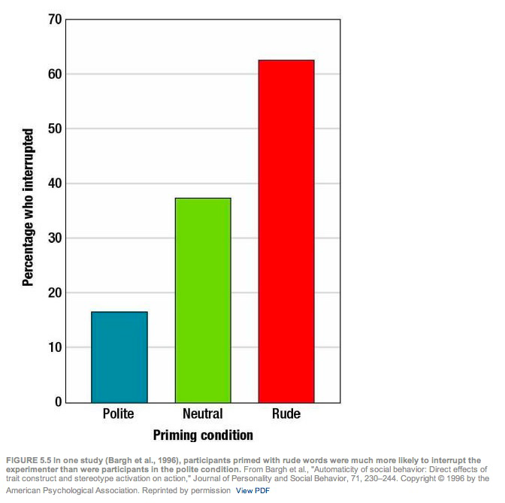

Emotions
  - Some but not all emotions are associated with a distinct facial muscle display.
  - “Triggering stimuli” can be specified for some but not all emotions.
  - “Triggering stimuli” can be objective characteristics of the environment or they can be mental constructions.
  - Some situations appear to be able to give rise to several emotional responses at once.
  - Some emotional responses change rapidly while others are more enduring

Emotion: conscious evaluative reaction to some event

Mood: feeling state not clearly linked to some event

Affect: automatic response that something is good or bad

Conscious Emotion: powerful and unified feeling state

Automatic Affect: quick response of liking or disliking; good or bad feelings

Emotional Arousal

Arousal: a physiological reaction, including faster heartbeat and faster or heavier breathing, linked to most conscious emotions

James-Lange theory of emotion: the proposition that the bodily processes of emotion come first and the mind’s perception of these bodily reactions then creates the subjective feeling of emotion
  - Physiological arousal precedes emotional experience

Weakness: Physiological expression does not always constitute the same emotion

Facial Feedback Hypothesis: feedback from face muscles evokes or magnifies emotions

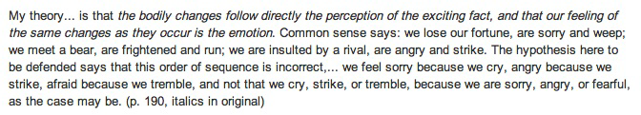
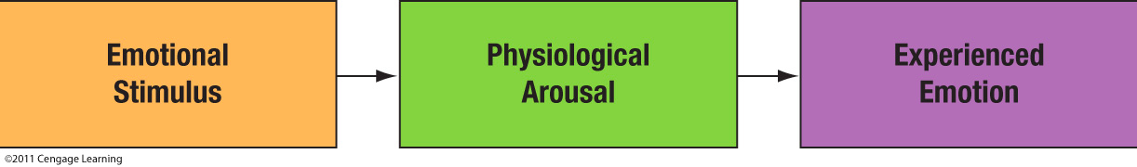

Emotional Arousal

Canon-Bard theory of emotion: the proposition that emotional stimuli activate the thalamus, which then activates both the cortex, producing an experienced emotion, and the hypothalamus and autonomic nervous system, producing physiological arousal
  - Thalamus sends two simultaneous messages to produces the emotional experience and the physiological arousal
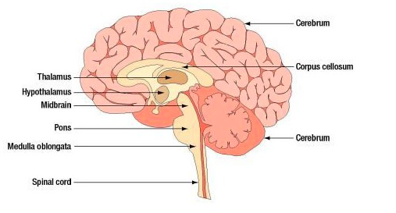

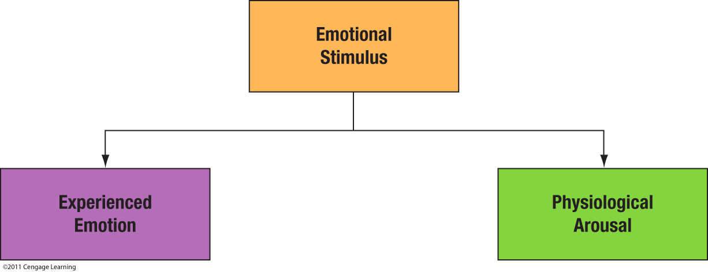

Schacter-Singer theory of emotion: the idea that emotion has two components: a bodily state of arousal and a cognitive label that specifies the emotion
  - Emotion has two components
  - Bodily state of arousal
  - Cognitive label specifying the emotion

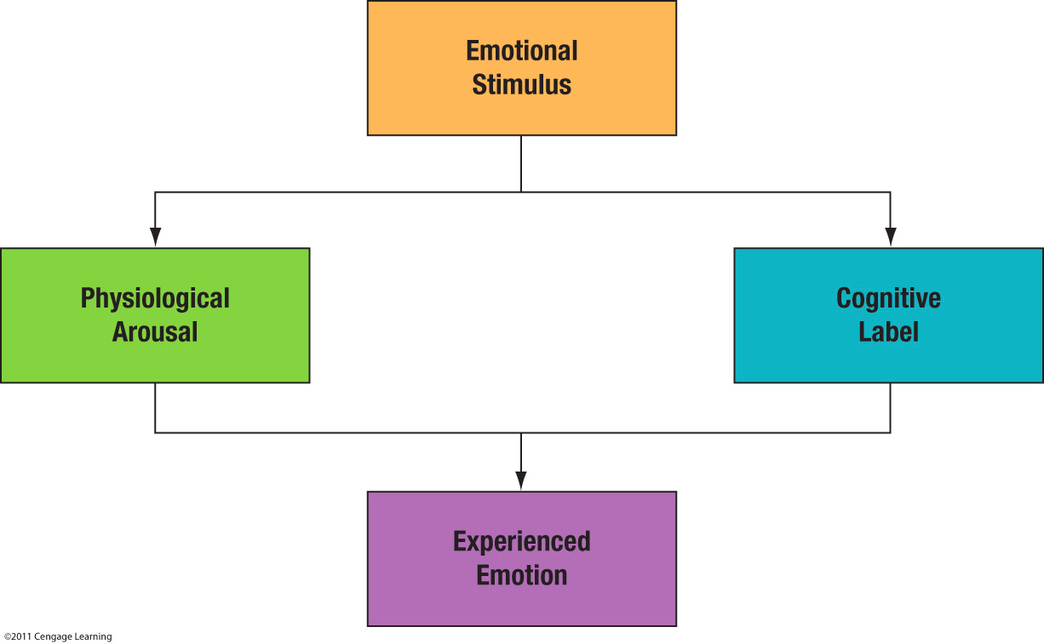

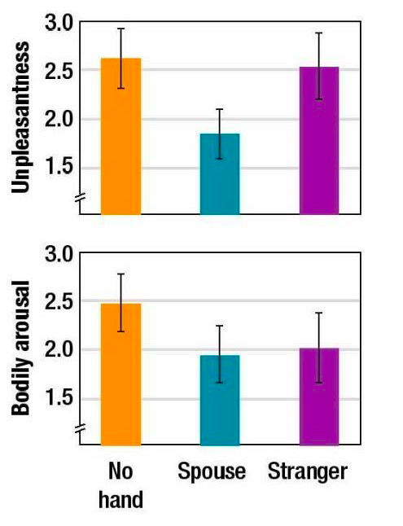
Schacter-Singer
  - Excitation transfer
  - Misattribution of arousal
  - Adrenaline study

Arousal Transfer

Excitation transfer: the idea that arousal from one event can transfer to a later event
  - Can yield unexpectedly intense emotional reactions.
  - More likely to occur within ‘valence’ rather than across ‘valence’.
  - Positive arousal transferring to a positive mood.

Why have emotions?
  - Emotions promote belongingness.
  - Social contact/acceptance is associated with positive moods.
  - Social rejection/loss is associated with negative emotions.

Emotion and Behaviour
  - Fight vs flight: anger vs fear
  - Not all emotions are associated with specific action patterns.
  - Guilt, love, joy.
  - Depressed mood increases helping.
  - Due to increased empathy?
  - As a means of changing one’s mood?
  - Cialdini experiments.

Anticipated Emotion
  - People tend to avoid engaging in behaviours that are likely to give rise to a negative emotion.
  - In trying to avoid feeling guilty, people are more likely to behave in a prosocial manner.
  - Staying in an unhealthy relationship for fear of feeling lonely.

Emotions and Thinking

  - Would the world be a better place in the absence of emotion?
  - Emotion plays a role in decision-making.
  - Damascio’s brain-injured patients.

Role of Positive Emotions

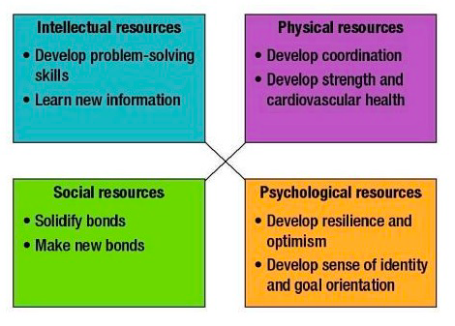
Positive Emotions
  - More flexible, more creative.
  - More persistent, more motivated.
  - Take fewer risks.

