BTM-200

Assignment #1: Computer Configuration

Assuming graphics design, animations, and “promo-material” all require the same hardware, and assuming all of the necessary media work could be done on a single computer; here are what I believe to be the most important hardware parts to produce such a computer:

The computer will first and foremost need a powerful graphics card, capable of creating and editing graphics, animations and promotional material
In order to execute any of these above tasks in a quick manner, a powerful Quad-Core central processing unit is essential to render all of the visual data.
In order to be able to manage the redundancies in raw visual data, a hefty amount of RAM memory (32GB) will also be required so that the visual data under development will not go over capacity and force the processor to take memory from the hard drive. Also, with 4k technology making its mark in the world, an Ultra HD 4k monitor (4096x2160 pixel resolution) gives the absolute edge to professionals in work relating extremely detailed graphics rendering.
Last but not least, the computer will need a lot of storage (HDD and possibly SSD so that select software in the SSD can run and execute very quickly) for the endless amount and large-sized visual media files.
A cost-effective cooling unit will also be included in the basket purchase to help prevent the CPU from overheating due to the heavy data processing.
Despite the need to cut down on cost, it is also important that a relatively strong power supply is purchased so that all of the hardware can run without the risk of a power failure.

Inserted below is a screenshot of my generated quotation for the rig.

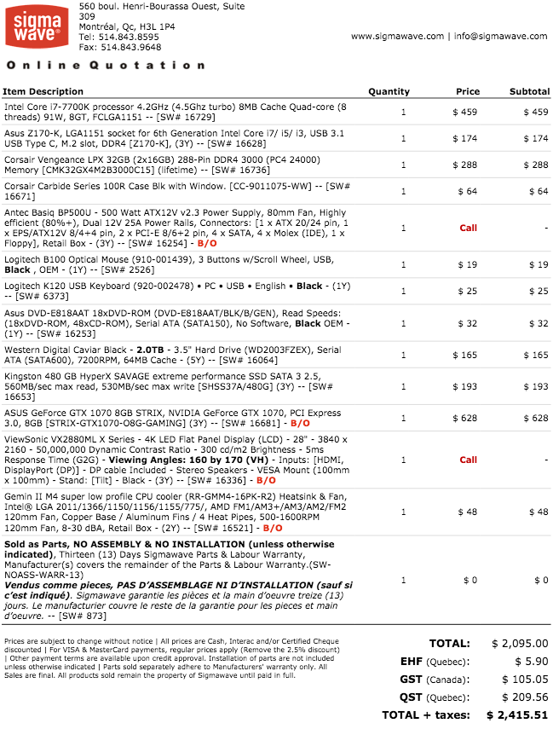

Professor Bo Yu
BTM 200
March 17, 2017
Assignment 2: Assess Your Hardware
My Computer’s Main Components:
- CPU: Intel(R) Quad Core(TM) i7-3770 @ 3.40GHz
- RAM:8GB RAM DDR3 669MHz
Video Card: Nvidia 670 GTX 950MHz
- Sound Card: Nvidia High Definition Audio
Wireless Adapter: D-Link DWA-582 Wireless AC1200 Dual Band PCE Express Adapter
- Motherboard: ASUS Z87-A
- Memory: 128GB SSD HyperX, 1TB Kingston HD
Dual Monitors: (ViewSonic VX2770SMH-LED, ASUS VG278HE)

User Type
On a typical school day, my CPU usage varies with the activities that I am doing. Most of the time I will be playing videos or streaming media on a second monitor while I work. When I am not working, I play games that require a lot of CPU/GPU usage while also watching something on my second screen and/or streaming an online voice communication software. I am a power user, so my CPU needs to have multiple cores and my graphics card needs to be powerful.

CPU/RAM memory usage on a school day when not playing:
- CPU at 20% usage
- RAM at 40MB Hardware Reserved, 3093 MB In Use, 58MB Modified, 4772 MB Standby

CPU/RAM memory usage on a school day when I am running video games/software/video streams simultaneously:
- CPU at 65%-80% (depending on game’s video rendering demands and resolution options)
- RAM at 40MB Hardware Reserved, 7324 MB In Use, 87MB Modified, 649 Standby

Benchmarking
I tried all of the benchmarking software mentioned in the assignment and was personally impressed with Maxon’s Cinebench. All of the benchmarking software performs tasks like CPU compressing, encrypting, single threading, cached/uncached memory reading, and writing. The softwares also test the CPU’s performance on 2 dimensional and 3 dimensional rendering as well as evaluating the framerates of Directx 9-10-11 API’s. Maxon’s Cinebench has advanced benchmarking capabilities which allows users to test not only the multi-core aspect of their CPU, but also the performance of a single core within the CPU.

Listed below are all of the results:
Passmark’s Benchmark (comparing CPUs within the same total core number and GHz bracket for accurate results):
- 2nd best in graphics
- 3rd in memory reading tasks
- 4th in disk writing tasks
→ Overall rating of 4000.5 (2nd best)

Primate Lab’s Geekbench Benchmark
Primate Lab’s Geekbench Benchmark (checked GPU performance only): Score of 55854 in the OpenCL API GPU performance test; On their list of graphics cards, I noticed that my graphics card (mentioned in the beginning of this assignment) has a score of 37320. The overclocking of my graphics card must be the reason why I had received a higher score.

Maxon’s Cinebench Benchmark
Maxon’s Cinebench results:
- OpenGL API performance result → 86.91 FPS (1st on comparative list)
- CPU multi-core performance result (disregarding comparison to 6 and 12 core CPUs) → score of 646 (3rd on comparative list)
- CPU single core performance result → score of 130 (2nd on the list in the 3.40GHz bracket)

Personal Hardware Assessment:
One must ask the question; is it time to buy a new computer? In my opinion, buying a new computer as a power user can be very costly. Eventually, I will need to replace my CPU and graphics card. Increasing my memory storage capacity and RAM memory capacity will improve my computer’s functionality. This is essential for future software and games that may take up more storage and RAM memory.
Finally, a power user like myself should make the cost-effective decision for upgrading the core components of the computer. Overall, my computer will be able to consistently handle future software and video games.

