Y=C+I+G+NX
Y is actual GDP.
I in investments.
There are two types of “I”s: one is growth (IG) – Growth investment, one is net (I net). The difference b/w them is depreciation in capital growth.
NDP (net domestic product): is the same thing but “I” in its equation is without depreciation.
In GDP, the “I” is with depreciation.
Both have the same equation but different “I”s – Y=C+I+G+NX
- Nominal and Real GDP. Our well-being as an economy does not depend on prices, but the volume of products produced is what our well-being depends on. That’s why we remove increase or decrease of prices while calculating the real GDP.
You must be familiar with a flow variable and a stock variable.
Flow variable is like the water in our bathtub, after a couple of hours it might be full. A flow variable is measured over a period of time. (from January to March) (Savings, investments, consumptions, and incomes are measure over time.)
A stock variable is measured at a point of time. (December 31st, 2012) (wealth is measured at a period of time)
^^^ Check out slides.
Physical capital is everything used in production of goods and services.
Physical capital at a period of time =K
Depreciation = D
Ig= Gross Income
In= Net Income
K(1) at January 1. K(2) at December 31. If K2>K1, our GDP rose.
K(2) = K(1) + Ig – D
In = Ig – D
Nominal GDP = P.Q
Real GDP= P-(constant).Q
2011 Nominal GDP= P (prices of 2011, or that year)*Q(quantity/volume of products of that year too)
2012 Real GDP= P (prices of a reference year, any past year, ex: 2009)*Q(quantity/volume of products produced of the year 2012)

Inflation rate between year 1 and year 2 = (GDP deflator rate of year 2 – GDP deflator rate of year 1)/(GDP deflator rate of year 1) * 100.
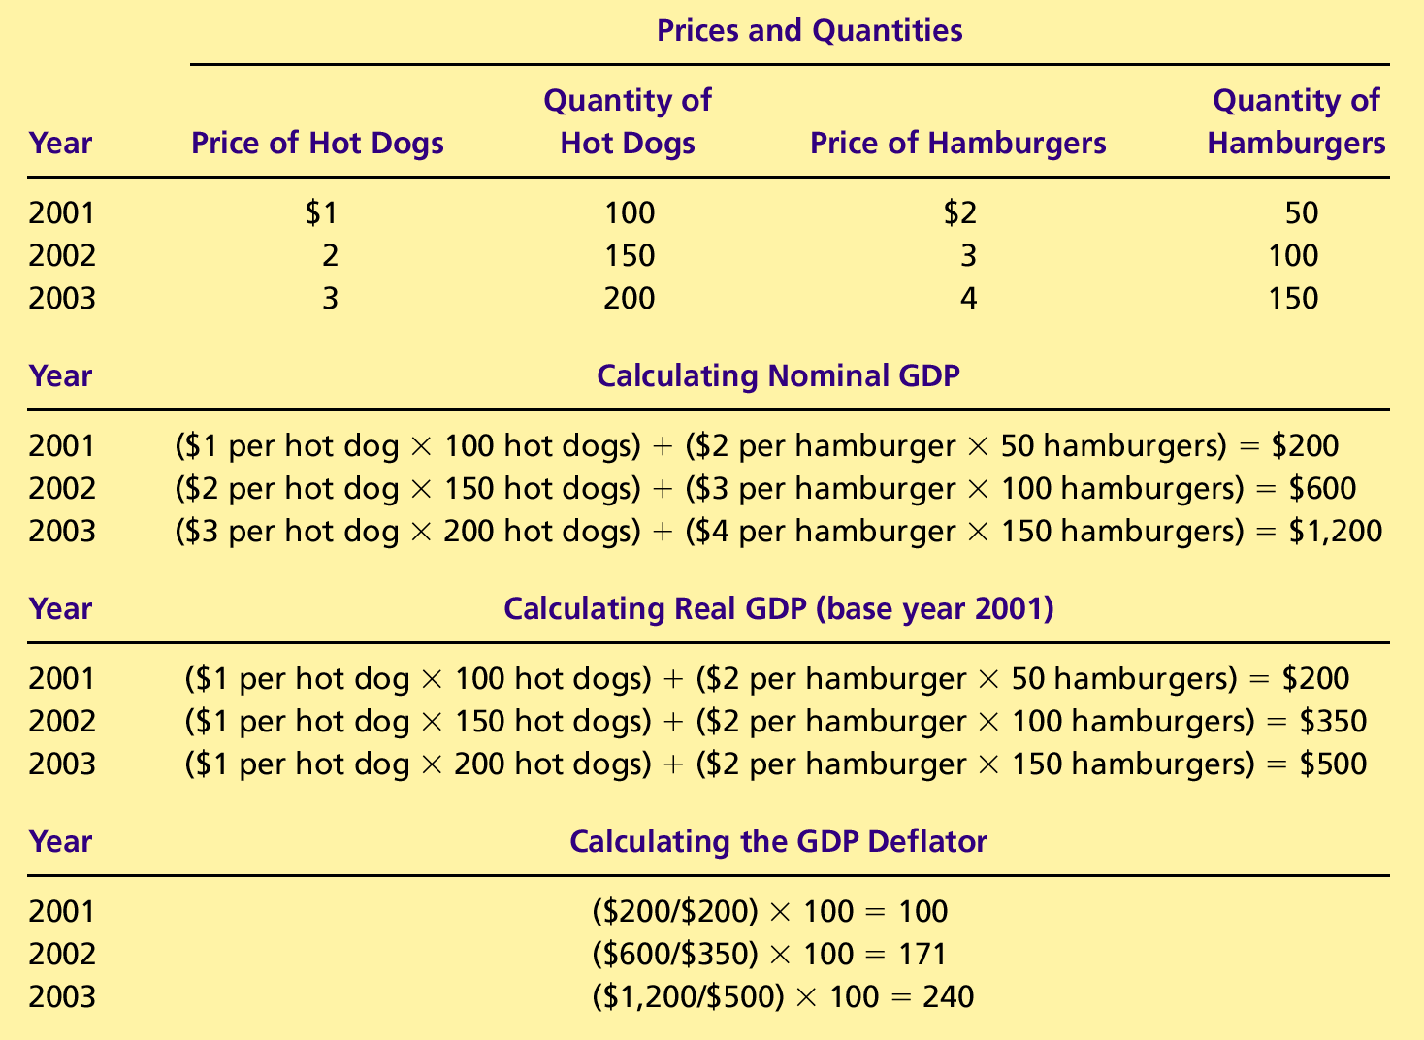
Inflation rate b/w (2001 & 2002) = (GDP deflator of 2002 – GDP deflator of 2001)/100 * 100=71%
Inflation rate b/w (2002 & 2003) = (GDP Def of 2003 – GDP Def of 2002)/171 *100= 40%
Things you do yourself are EXCLUDED from the GDP. Things you do that add to the value of your well-being: playing outside, free activities, spending time with your parents, having a clean environment.
A Highway is it C or I or G? School, university, hospitals? : It’s in Investments, because it will continue to provide services for a long time.
Government: wages, salaries.

