Experiment #2:
The Kinetic study of Nucleophile Substitution

Demonstrator: Daniela Marquez

Date of Lab: 27/09/2016

Due: October 4, 2016
Time: Tuesday morning
CHM2123 Section C
University of Ottawa

Introduction

Chemical reactions proceed at different rates which is known as kinetics. Kinetics lets us predict and decide the rate of reaction by altering many parameters of a reaction. Such as the concentrations of the reactants. The rate of a general reaction is given by:

A + B C + D and r= k[a]^{x}[b]^{y}

Where k represents the constant rate and is multiplied by the concentrations of the reactants. The exponents x and y represent the order of the reaction and are determined experimentally.

There are 3 different type of reactions such as the zero order, first order and the second order.
The zero order reaction will generate a negative linear slope= -k, when plotting the reactants concentration with respect to time. It’s equation is: [A]=[A]0-kt

A first order reaction will generate a linear negative slope= -k, when plotting ln[A] with respect time. Its equation is: r= -kt+ln([A]_{o})

A second order reaction will generate a straight linear slope =k, when plotting 1/[A] with respect to time. Its equation is: r= (1/[A]) + kt

Organic reactions will be done during this experiment and will involve a nucleophile and electrophile.

The goal for part A of the experiment is to observe the effect of the leaving group on a substitution reaction and to determine the order of the reaction, rate constant k and the type of reaction. In our case, we’re observing the effect of 1-bromobutane with KOH acting as a nucleophile. Rate of concentration of KOH can be determined through titration over period of time.

Part B of the experiment involves the hydrolysis of 2-chloro-2-methylpropane. The goal of the experiment is to examine how varying the amount of solvent along with its composition, will affect the rate of reaction. The kinetics of the reaction will be determined through the amount of time taken to consume a known reactant under these varying solvent conditions. An acid-base indicator, bromothymol blue, will determine the reaction time. The reaction is complete when a colour change from light blue to colourless is observed. As HCl is a product of the completed reaction, it will react with the indicator signifying completion.

Table of reagents

Compound | Mol. Mass (g/mol) | Quantity (g or mL) | Density (g/ml) | mol | Equivalents
HCl  (0.1M) | 36.5 | 75mL | 1.49 | 3.06 | -
1-bromobutane (0.5M) | 137 | 40mL | 1.23 | 0.359 | 1
KOH  (2.0M) | 56.1 | 10mL | 0.789 | 0.141 | 1
tBuCl  (0.1M) | 92.5 | 24mL | 0.84 | 0.456 | 1
NaOH (0.02M) | 40.0 | 30mL | 2.13 | 3.12 | N/A
Distilled H2O | 18.0 | 94mL | 1 | 0.254 | N/A
Acetone | 58.1 | 12mL | 791kg/m³ | 0.102 | 1

Procedure
Refer to organic chemistry II lab manual, pages 34-44

Observations and Results

Part A
Step6: The mixture is colorless and clear.
Step8: The mixture turns light pink when the indicator is added.
Step9: as the mixture is being titrated with HCl and swirled it turns colorless and back into light pink until its neutralized and complete which then turns into clear, colorless solution.

Part B
Step 1: Over filled the water bath at first, caused Erlenmeyer flasks to float and solution to topple. Roughly 1cm of water needed to keep reaction cool and flask grounded
Step 4: 4. tBuCl very strong scent, watch glass needed in order to work with
85:15 H20: Acetone
  - The 10% conversion was much faster than the 40% conversion
  - The difference in time taken between the 30% and 40% conversion was the longest
  - The colour change from light blue to colourless happens quickly, dissimilar to a titration. You cannot see the process of the colour change, it is blue one second and colourless the next
70:30 H2O: Acetone
  - 10% conversion took much longer than in the previous solvent
  - Mild reaction between acetone, water, and NaOH creating fumes before the addition of tBuCl
  - Colour change happened just as instantaneously as in previous solvent – blue one second and colourless the next

Results

Part A
Reaction time | 2 minutes | 15 minutes | 30 minutes | 45 minutes | 60 minutes
V aliquot (mL) | 4.8 | 4.9 | 4.8 | 5 | 4.9
Vi HCl (mL) | 0 | 0 | 0 | 0 | 0
Vf (mL) | 12.2 | 7.7 | 5.6 | 3.5 | 3.3
Vf-Vi (mL) | 12.2 | 7.7 | 5.6 | 3.5 | 3.3
Moles of HCl titrated | 0.00122 | 0.00077 | 0.00056 | 0.00035 | 0.00033
Moles of KOH neutralized | 0.00122 | 0.00077 | 0.00056 | 0.00035 | 0.00033
[KOH] nuetralized | 0.254 | 0.157 | 0.116 | 0.07 | 0.0673
Ln[KOH] | -1.37 | -1.85 | -2.15 | -2.66 | -2.70
1/[KOH] | 3.94 | 6.37 | 8.62 | 14.3 | 14.8

Part B
85:15 H₂0: Acetone
% Conversion | 10% | 20% | 30% | 40%
0.10M tBuCl in acetone | 3.0 mL | 3.0 mL | 3.0 mL | 3.0 mL
0.02M NaOH in water | 1.5 mL | 3.0 mL | 4.5 mL | 6.0 mL
Distilled water | 15.5 mL | 14.0 mL | 12.5 mL | 11.0 mL
Time to colour change #1 in s | 8.51 | 22.5 | 44.37 | 124.2
Time to colour change #2 in s | 8.96 | 22.2 | 46.67 | 126.10
Time to colour change #3 in s | 8.22 | 21.59 | 46.67 | 120.0
Average time of trials 1-3 | 8.56 | 22.1 | 44.80 | 123

70:30 H₂O: Acetone
% Conversion | 10% | 20% | 30% | 40%
0.10M tBuCl in acetone | 3.0 mL | 3.0 mL | 3.0 mL | 3.0 mL
0.02M NaOH in water | 1.5 mL | 3.0 mL | 4.5 mL | 6.0 mL
Distilled water | 12.5 mL | 11.0 mL | 9.5 mL | 8.0 mL
Acetone | 3.0 mL | 3.0 mL | 3.0 mL | 3.0 mL
Time to colour change #1 in s | 8.51 | 22.5 | 44.37 | 124.2
Time to colour change #2 in s | 8.96 | 22.2 | 46.67 | 126.10
Time to colour change #3 in s | 8.22 | 21.59 | 46.67 | 120.0
Average time of trials 1-3 | 8.56 | 22.1 | 44.80 | 123

Calculations

Part A

Data calculated from minute 2 results:
Moles of HCl titrated = 12.2mL x (0.100Mol/L) x (L/1000mL)
= 0.00122Mol
since its an 1:1 , KOH mol: HCl mol reaction:
Moles of KOH neutralized in the titration= Moles of HCl titrated = 0.00122
[KOH] neutralized= (mol KOH neutralized/volume of aliquot)
= (0.00122mol/0.0048L)
= 0.254M
ln[KOH] = ln(0.254)
= -1.37
1/[KOH] = 3.94M⁻¹
finding the rate of reaction k by using second order reaction (from Tuesday section data):
1-bromobutane
1/[KOH] = (1/[KOH]) + kt
4.34 = 3.22 + k(900)
k = 0.00124
1-chlorobutane
1/[A] = (1/[A]) + kt
3.03 = 2.94 +k(900)
k = 0.0001

Part B

Group Data
[tBuCl] = ((tBuCl initial x initial volume)/final volume) x % conversion
= ((0.1 tBuCl x 3.0mL)/(20.0mL)) x 0.10 = 0.0015 for 10% conversion

[tBuCl] remaining = initial [tBuCl] x %remaining
= 0.0015 X (0.90) = 0.0135 for 10% conversion

85:15 H₂O: Acetone
% Conversion | 10% | 20% | 30% | 40%
Group average for trials 1-3(s) | 17 | 41.5 | 85 | 262.4
[tBuCl]  Reacted | 0.0015 | 0.003 | 0.0045 | 0.006
[tBuCl]  Remaining in Solution | 0.0135 | 0.012 | 0.0105 | 0.009
ln[tBuCl] | -4.31 | -4.42 | -4.56 | -4.71
1  [tBuCl] | 74.1 | 83.3 | 95.2 | 111.1

70:30 H₂O: Acetone
% Conversion | 10% | 20% | 30% | 40%
Group average for trials 1-3(s) | 54.9 | 157.3 | 303.3 | 878.8
[tBuCl]  Reacted | 0.0015 | 0.003 | 0.0045 | 0.006
[tBuCl]  Remaining in Solution | 0.0135 | 0.012 | 0.0105 | 0.009
ln[tBuCl] | -4.31 | -4.42 | -4.56 | -4.71
1  [tBuCl] | 74.1 | 83.3 | 95.2 | 111.1

Graphs

Part A
Correlation= R²
____ 1-bromobutane
____ 1-chlorobutane

Figure 1:
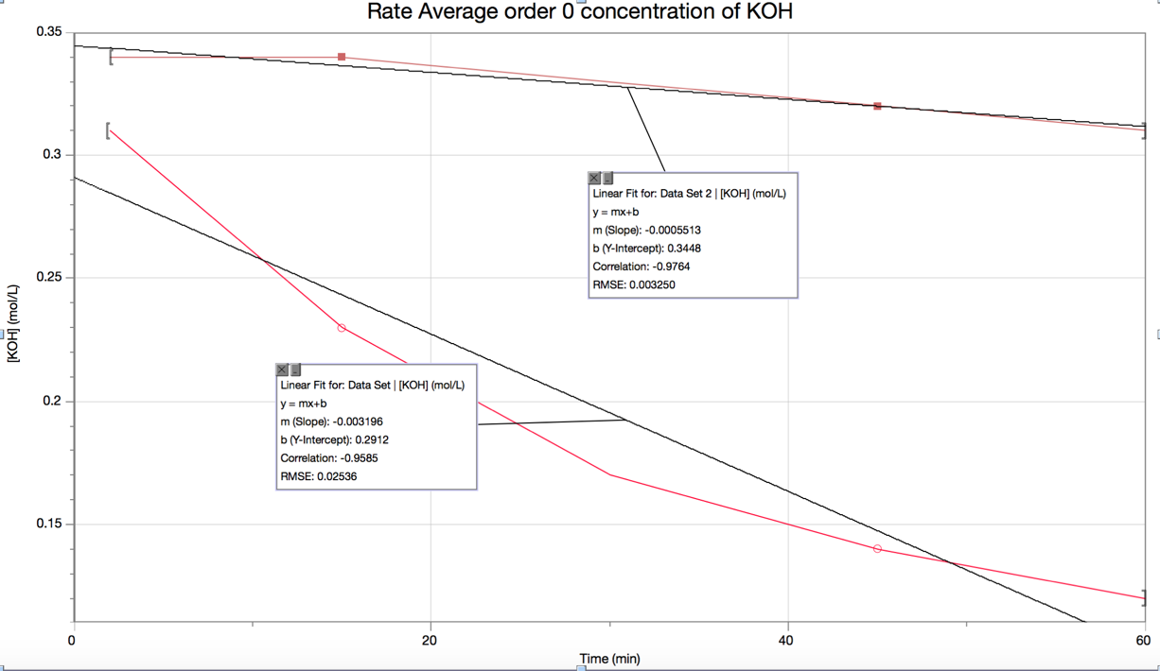

Figure 2:
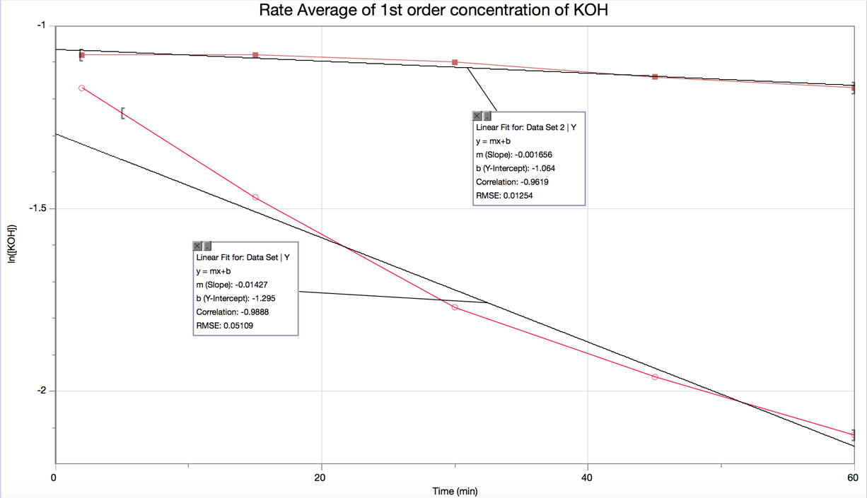
Figure3:
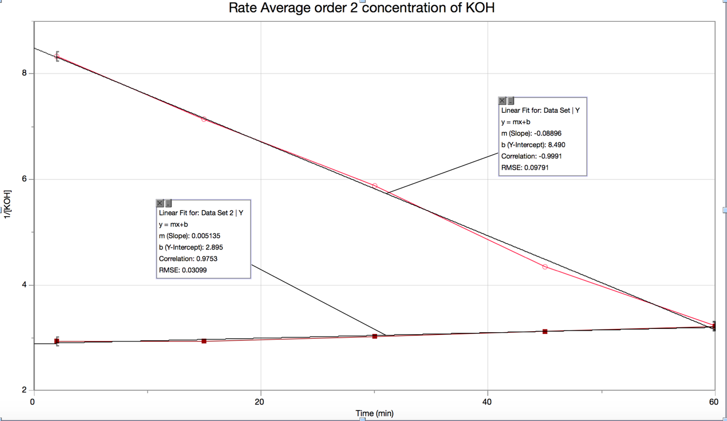

Part B
K = rate constant = - slope
____ 85:15 Solvent
____ 70:30 Solvent

Figure 4: Zero order reaction using group data average
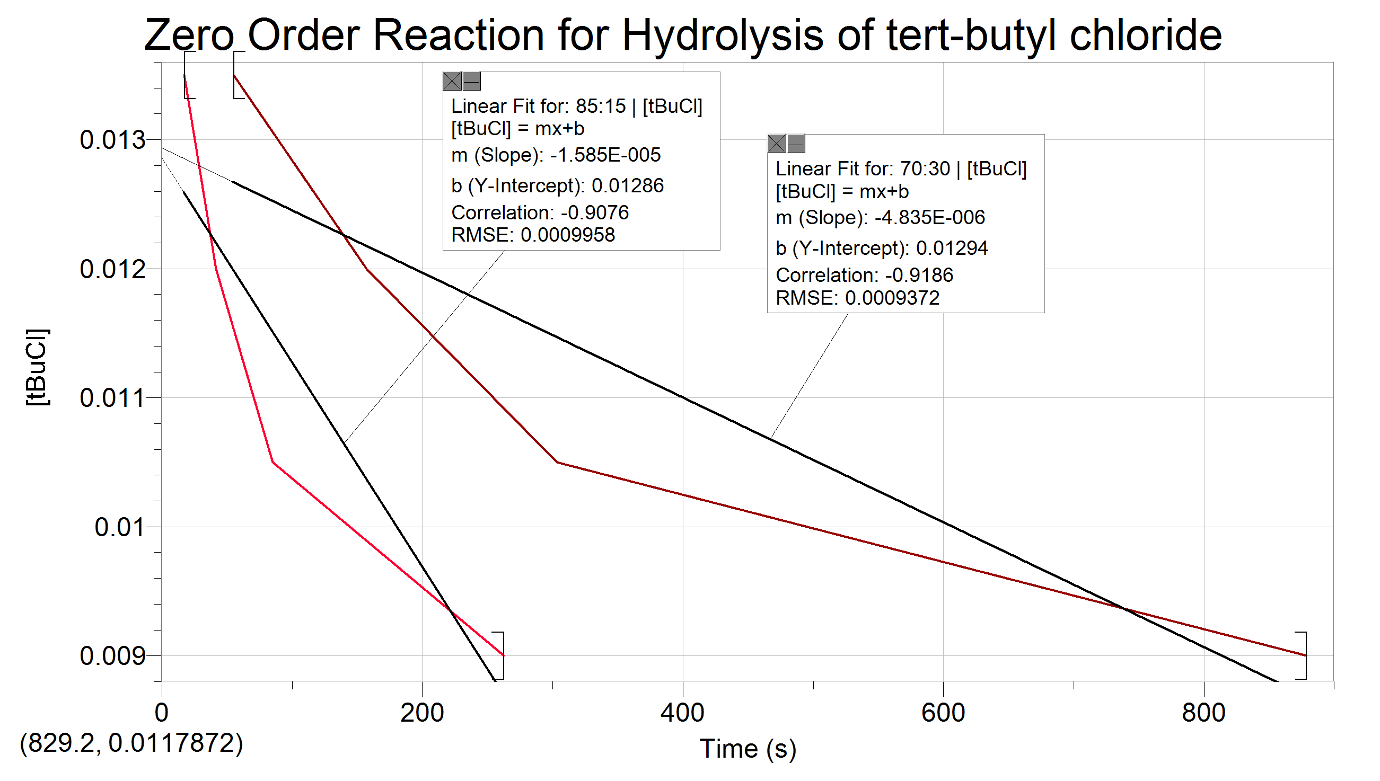
Figure 5: First order reaction using group data average
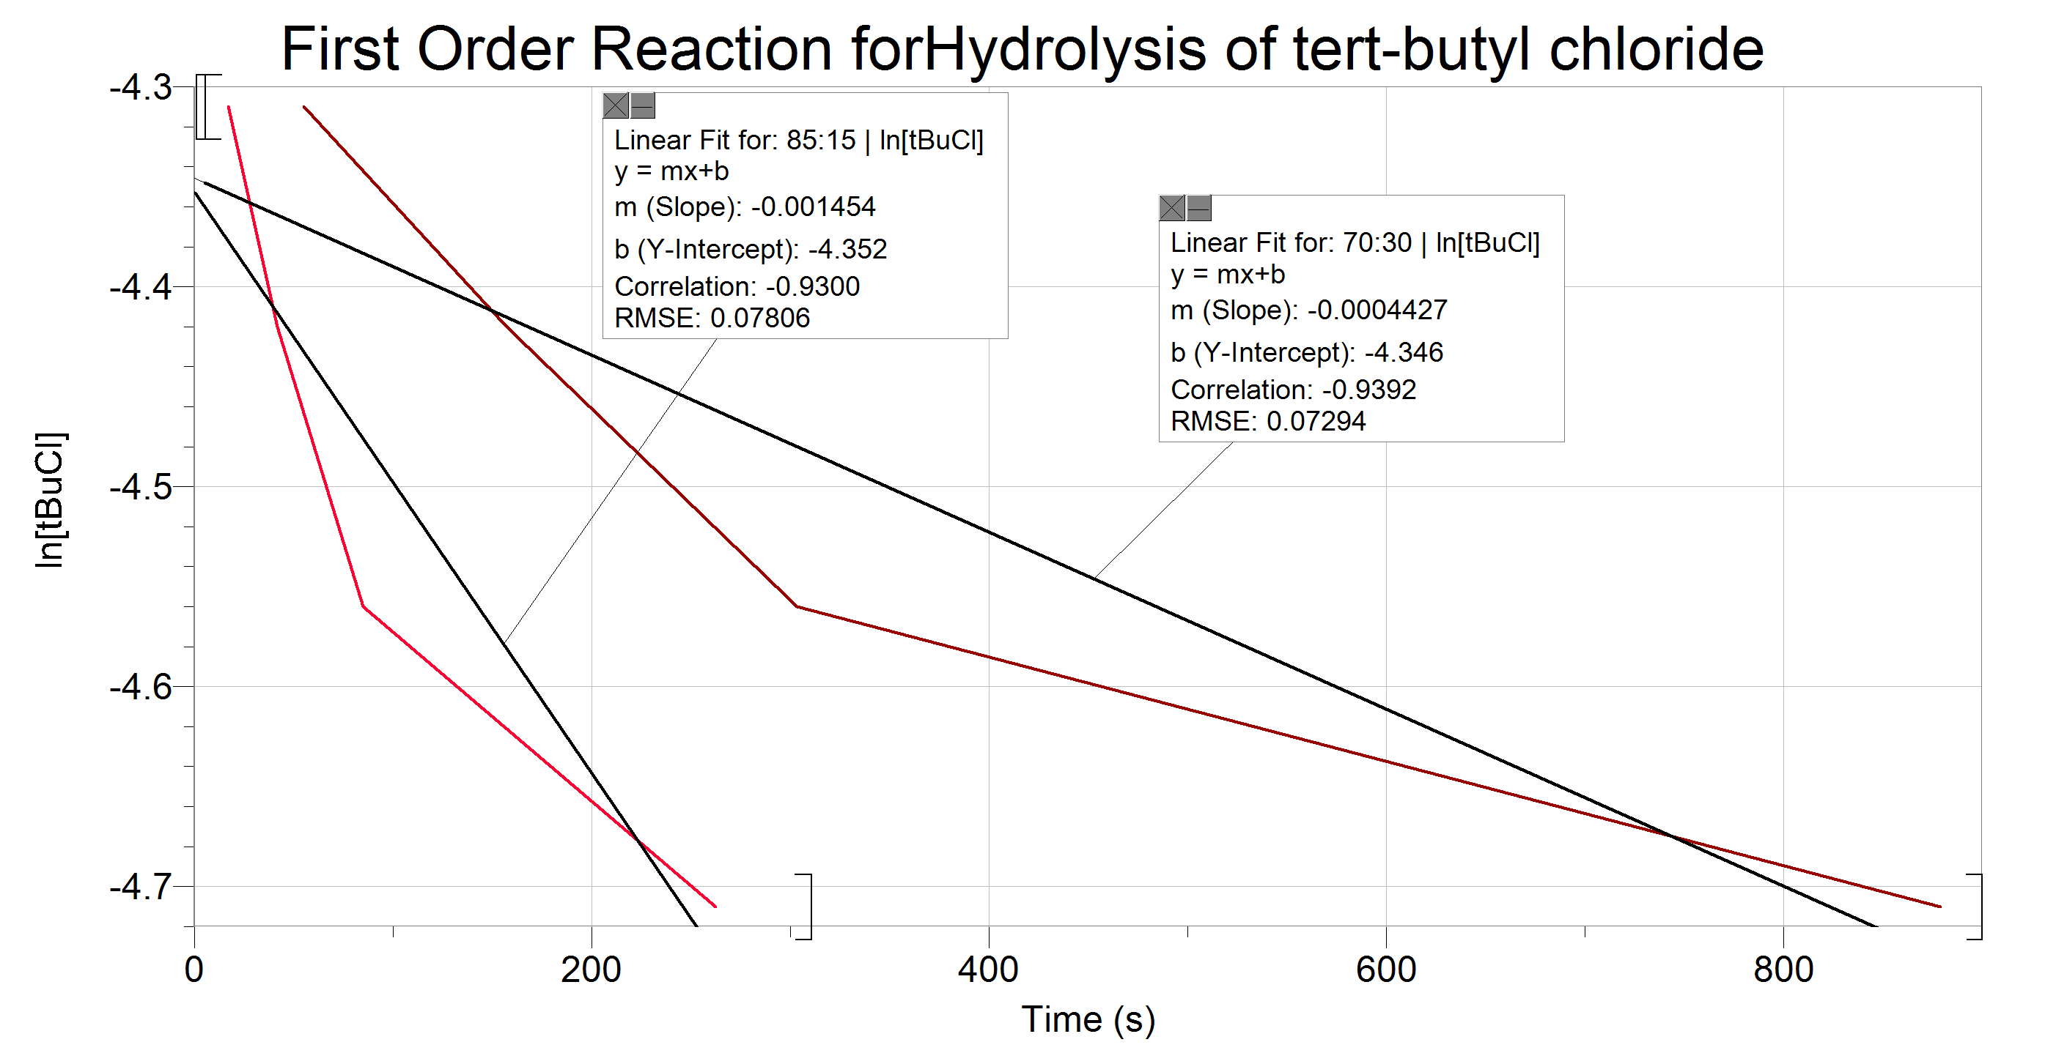

Global Averages

85:15 H₂O: Acetone
% Conversion | 10% | 20% | 30% | 40%
Group average for trials 1-3(s) | 16.9 | 41.1 | 86.4 | 197.7
[tBuCl]  Reacted | 0.0015 | 0.003 | 0.0045 | 0.006
[tBuCl]  Remaining in solution | 0.0135 | 0.012 | 0.0105 | 0.009

70:30 H₂O: Acetone
% Conversion | 10% | 20% | 30% | 40%
Group average for trials 1-3(s) | 60.8 | 169.5 | 334.3 | 615.6
[tBuCl]  Reacted | 0.0015 | 0.003 | 0.0045 | 0.006
[tBuCl]  Remaining in solution | 0.0135 | 0.012 | 0.0105 | 0.009
Figure 6: Zero order reaction using global averages
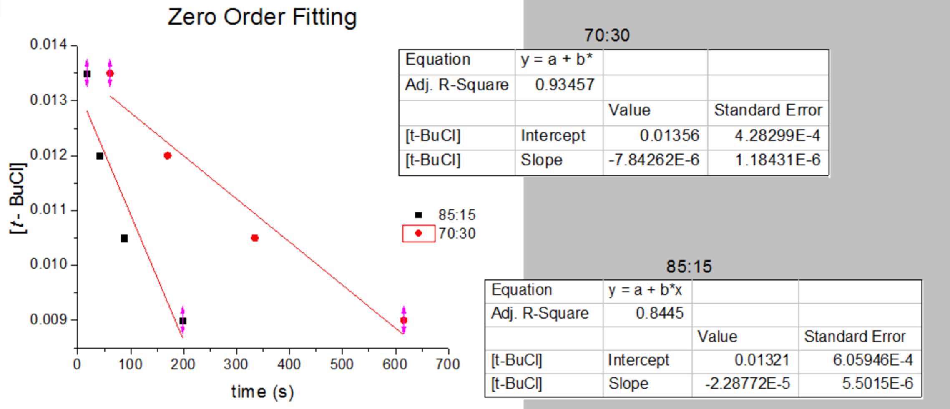

Figure 7: First order reaction using global averages
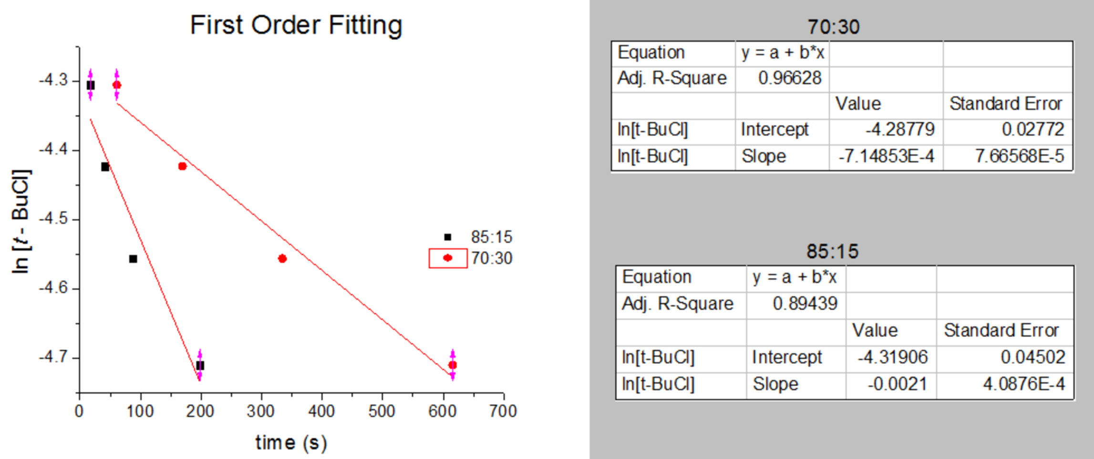

Mechanism

Part A
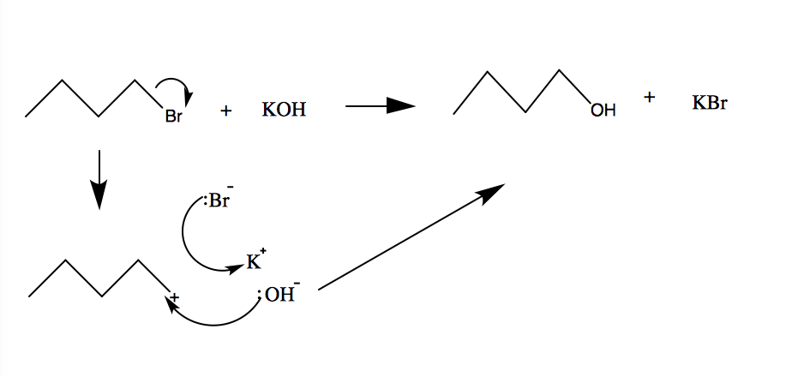
Part B

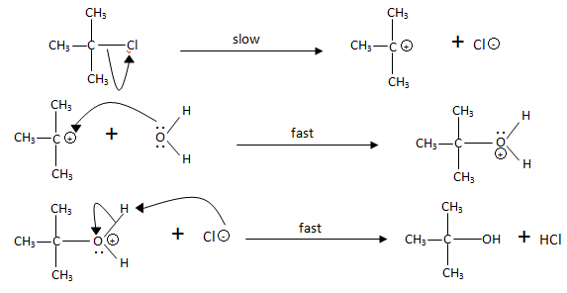

Discussion

The purpose of part A was to observe the rate of a reaction that undergoes Sn2 pathway through titration. In this lab 1-bromobutane was added to a round bottom flask. A reflux condenser was set up and the solution in the flask was left to heat until it refluxes. KOH was added the minute the solution started refluxing which means the reaction has started. SN2 reaction is undergone in one step as shown:
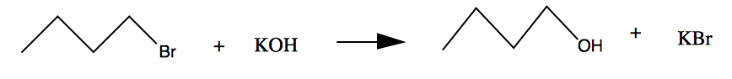
A carbon-cation will form when Br molecule acts as a nucleophile because it’s a good leaving group and creates a partial positive charge on the carbon. The OH- molecule will attack the alpha carbon creating a stable molecule. KBr will also form.
During the lab, the data was collected after 2,15,30,45,60 minutes right after the reaction has started. Around 5mL of the mixture was obtained from the flask into a 10mL cylinder flask and 3 drops of indicator. was added to a flask and was titrated with 0.1M HCl. Since it takes time until the mixture turns clear and colorless from a light pink color means that KOH is still present in the mixture and more acid is needed to neutralize the concentration of KOH. From the results observed, the concentration of KOH is decreased as it's more heated and refluxed and it takes less time for the mixture to neutralize when the indicator was added and titrated with 0.1M HCl. Which means less amount of acid was required as the reaction proceeds.

The rate constant, k can be determined from graphing the different order rates of KOH concentration against time. Whatever graph of the different rates is almost the same as what it supposed to be then that order will indicate what pathway the reaction proceeded at. By looking at the average rate of the 0 order graph, the points form a curve instead of a linear slope. So the reaction isn’t a 0 order reaction. By looking at the graph of 1st order rate reaction, the points also form a curve. So this eliminates all chances expect being a second order reaction. From observing its graph, the points form a linear slop. Since its an 2nd order reaction, it indicates that the reaction of 1-bromobutane and KOH is an Sn2 reaction (bimolecular). Meaning that the rate is determined by both reactants. The r² value of the 2nd order graph is closer to 1 which means it’s a bimolecular reaction (Sn1). The rate constant for the global results for 1-bromobutane is 0.00124. The group rate constant was calculated to be 0.00270. the group value was expected to be higher because the global results were collected from many trials producing the average value. Therefore, the global value of the rate constant is more accurate to what the value should be.

In part B, the goal was to determine how a solvent affects the rate of a reaction. The varying solvents did have an effect on the reaction time and therefore mechanistic steps. As shown in the mechanism for part B, the hydrolysis of tert-butyl proceeds stepwise, first forming a carbocation. The stepwise nature of the reaction means that this is a Sn1 reaction. Another indication that this is Sn1, is that Sn1reactions tend to be favored in the presence of weak nucleophiles. Water is neutral, and is therefore a weak nucleophile. In the first portion of Part B, the solvent is a 85:15 H₂O: Acetone mixture. Because water will interact with the tert-butyl chloride first, the higher proportion of water will yield a faster reaction. More water available, more reactions with tert-butyl chloride. Additionally, as the final fast step also involves water, the formation of HCl, and therefore the end of the reaction will be reached much more quickly when compared to the 70:30 H₂0: Acetone solvent.

Regardless of the solvent, as the % conversion increased, so did the time needed to reach the colour change. As the colour change signifies the completion of the reaction with sufficient HCl produced, a higher % conversion would take more time to react the remaining tBuCl in solution with water. As Sn1 is stepwise, this process was slow in general.

In figures 4, and 5, the same trend is seen: a downward facing linear relationship – the slope. The slope is equal to the rate constant, k. It is expected that the same trend be seen in both 0th and 1st order reactions because Sn1 follows a unimolecular substitution reaction and is only dependent on the concentration of the electrophile – it is independent of the nucleophilic concentration.

The group data graphs shown are similar in slope direction (-) but are not as linear as in the global averages of figures 6, and 7. This is due to the fact that many people participated in the reaction and could have started and stopped timing at different places within the reaction. Contamination would also be a factor in the reaction rate, and as the number of participants in the average increases, as does the possibility of contaminants. The global averages hold true to the data collected by the groups but is much more accurate. Both the group and global averages show the same trends nonetheless.

Conclusion
In part A, the order of the reaction between 1-bromobutane and KOH was determined to follow Sn2 type.

In part B, the order of the reaction for a hydrolysis of 2-chloro-2-methylpropane was determined to follow an Sn1 reaction mechanism.

Questions

- Most reactive: H2C = CHCH(Br)CH3 > CH3CH(Br)CH3 > CH3CH2Br > H2C=CHBr
The most reactive molecule will form the most stable carbocation. In an SN1 reaction, the carbocation is most stable in the tertiary and most stabilized (by resonance) position. The first molecule in the list satisfies these requirements

- Ethanol is an alcohol, meaning it is a polar, protic solvent. In polar protic solvents, nucleophiles are ranked in accordance with the acidity trend of the periodic table; moving down and to the right. So, larger atoms moving down the periodic table are more acidic and less basic. A weak base is a good nucleophile in a polar protic solvent. As such the following would occur:

- CH3CH2ONa > CH3CH2OH
- I > Br
- F3C > CH3

- A Sn2 reaction will take place, a good leaving group like Cl or Br will be broken and create a partial positive charge on carbon which will cause CN molecule to attack the carbon-cation and form the product CH3CH2CH2CH2CN as shown below:



