- ________is the part of a client-server configuration that contains the user interface and other components providing access to the system.
  - data base layer
  - view layer
  - data layer
  - business or process layer
  - both a) and b) above

- The non-primary key that links a data entity to another data entity is the _
  - primary key
  - concatenated key
  - foreign key
  - alternate key
  - none of the above

- A(n)______class is one that reflects and resolves the relationship (cardinality) between classes that are many to many.
  - relational
  - directional
  - associative
  - relative
  - none of the above

- The flow of data that triggers a method in an object or class is a
  - data dictionary entry
  - transform
  - method signature
  - actor action
  - none of the above

- An event is an occurrence that
- can be described
- occurs at a specific time and place
- can come from an external environment or entity
- cane be temporal type or state type
- all of the above

- An Event Table would include the description of a
  - trigger
  - source
  - activity or case
  - destination
  - all of the above

- Balancing a DFD refers to the
  - equivalence of data flows entering and leaving a transform and those entering and leaving the transform at a lower level (decomposed level)
  - equal number of data flows entering a transform to those leaving the
transform
  - appearance of the data flows for those on the left and those on the right
  - equal number of data flows entering process
  - none of the above

- The use case diagram would show the
  - actor
  - automation boundary
  - subsystem or function (case)
  - relationship between functions (includes or uses)
  - all of the above

- Which of the following are normally considered in the definition of the three­ layer architecture?
  - processes or cases
  - view layer
  - data layer
  - business logic layer
  - all of the above

- A system flowchart in the Procedural approach would not show
  - the program(s) involved
  - data files accessed
  - data bases
  - internal program logic or code
  - all of the above
- A method signature could contain
  - the method name
  - the return type or data items
  - a parameter list
  - all of the above
  - none of the above
- The description of the structure and access controls for a data base is known as the
  - DBMS
  - ODBMS
  - schema
  - data model
  - data control
- In ODL, the keyword "extends" identifies
  - a sub-class that is related to a superclass
  - a relationship between two classes or objects of a one to many cardinality
  - a relationship between a group of objects or classes one a one to one cardinality
  - as specific type of object or class
  - A many to many relationship

- An association class is used to
  - handle many to many relationships
  - refer relationship that need association of sub-classes to super-classes
  - handle relationships between one super-class and many sub-classes
  - extend a relationship to sub-classes
  - extend relationships to super-classes

- In assessing the potential risks involved in a project, the project manager or team must consider the
  - Economic feasibility
  - Cultural feasibility
  - Schedule feasibility
  - Resources feasibility
  - all of the above.

A class diagram shows
  - the relationship of the class entity to other classes
  - the data structures or attributes that belong to each class entity
  - the processes that the entity can execute (behaviors)
  - the relationship to higher or lower class entities (classes and sub-classes
  - all of the above

- A logical model of a system
  - shows the system detail with technical specification of the platform and software languages which will be used for the application or system.
  - shows the system detail along with the internet specifications for client interaction
  - shows the system detail without committing to specific technologies
  - shows the system detail and the languages that must be used in programming the system programs
(e) shows the system detail and the type of data bases that must be used including the DBMS involved
- Types of events that occur are
  - temporal, external, incidental
  - external, temporal, and frequent
  - random, temporal and state
  - state, external and temporal
  - state, frequent and external

- Every foreign key in one entity or class must also exist as a primary key value in another entity or class. This is referred to as---
  - class relationship
  - entity relationship
  - referential integrity
  - class integrity
  - none of the above

- With a(n)_______database, the database is split into segments where the users have only the partitions of the database they require for their operations.
  - associative
  - partitioned
  - segmented
  - schema
  - none of the above

- When designing the view or presentation layer, which of the following should be observed or considered?
  - strive for consistency
  - enable frequent shortcuts
  - provide informative feedback and error messages
  - provide easy reversal of actions
  - all of the above

- Which of the following should be considered when designing a system or program that will enhance the maintainability of the system or program?
  - understandability
  - modifiability
  - testability
  - portability
  - all of the above
- Deployment of the system developed through the SDLC would include
  - acquiring hardware and required software
  - training the users
  - packaging and installing the system components
  - converting and I or initializing the data (database)
  - all of the above

- The disadvantage of a direct deployment of a system is
  - the cost of running the previous system is involved
  - the previous system may not be available if the new system fails
  - all the users must have received complete training in proper time
  - both (b) and (c)
  - none of the above
- Beside the integration, system, and usability testing, other tests could involve
  - documentation testing
  - stress testing
  - volume testing
  - security testing
  - all of the above

A Work Breakdown Structure is needed in order to help define
  - the tasks involved in a project
  - the potential time required to complete each task and the project
  - the potential risks
  - given the tasks and time, the potential cost of the project
  - all of the above

- When identifying the risks involved in a project, you should determine
  - the potential occurrence of the risk
  - the impact on the project if the risk occurs
  - who will handle the risk.
  - potential action to be taken (if possible) should the risk occur
  - all of the above

- As part of the Preliminary investigation or Inception Phase, the documents normally delivered include
  - a cost benefit analysis
  - a context diagram
  - a list of the major functional requirements
  - a statement of the technological feasibility
  - all of the above

- The difference between a Time Sequence Diagram and a Collaboration (Communication) Diagram is that
  - the Collaboration Diagram has a time line; the Sequence Diagram has sequence numbers.
  - the Sequence Diagram has a time line; the Collaboration Diagram has sequence numbers.
  - the Sequence Diagram has Method Signatures; the Collaboration Diagram does not have Method Signatures
  - the Sequence Diagram has retim values; the Collaboration Diagram does not have return massages
  - none of the above
- A questionnaire used to gain information can
  - contain close ended questions
  - contain open ended questions
  - ask questions regarding the current system
  - ask questions about required or possible improvements
  - all of the above

- In Black Box testing
  - the data layer is hidden from the user as the test is conducted
  - the internal code is not seen, only the view layer
  - could be the type of testing conducted by the user
  - could be used to ensure all functional requirements have been met
  - all of the above

- In a network diagram or Gantt Chart a Milestone
  - is a completed work item
  - identifies completion of work item
  - is broken down into tasks and activities
  - has no time directly associated with but contains the roll-up of the task and activity times
  - all of the above

- The maintainability of an application will affect
  - the resources necessary to maintain the application while in production
  - the ability to make modifications more easily
  - the ability to plan modifications or functions not completed during the SDLC
  - the ability to distribute the application from a centralized to a distributed application
  - all of the above

- With a(n)______database, the database is split into equal segments where the users have access to the same or congruent schema.
  - associative
  - partitioned
  - segmented
  - schema
  - none of the above

- When considering the required security for an application, the documents to be reviewed could include
  - the Context Diagram
  - the Use Case Diagram
  - the Detailed Use Case Narrative
  - all of the above
  - none of the above

- When deploying the application, the tasks could include
  - converting the current data base to the new schema
  - training the users in the new system
  - installing the required equipment
  - installing the new operating system
  - all of the above.

- The common item/items between the Context Diagram and the Event Table is/are
  - the source
  - the trigger
  - the case I process
  - the destination
  - item (a), (b) and (d)

- The disadvantage of a replicated data base is I are
  - all users have access to the same data
  - synchronizing the data across more than one version of the data base
  - preventing access to the data base while data is being updated
  - all of the abve
  - items (b) and (c) are true

- testing involves as many users logged into the application as are required by the functional or non-functional specification for the application.
  - Volume
  - Recovery
  - Stress
  - Unit
  - System

- When implementing backup and recovery testing, consideration should include
  - the specific application requirements for backup
  - whether current backup and recovery procedures are adequate
  - specific test cases to implement and test the backup and recovery
  - the frequency and type of backup required (i.e. system versus incremental)
  - all of the above

Given the Class Diagram below, answer questions 41 and 42.

- The class entity LOAN
  - inherits the attributes of the class entity CUSTOMER
  - inherits the methods involved in the class entity CUSTOMER
  - is a super class to three subclasses
  - all of the above
  - none of the above

- The class CAR LOAN has
  - the same attributes as LOAN
  - the same behaviours as MORTAGE
  - the same behaviours as LINE of CREDIT
  - all of the above
  - none of the above

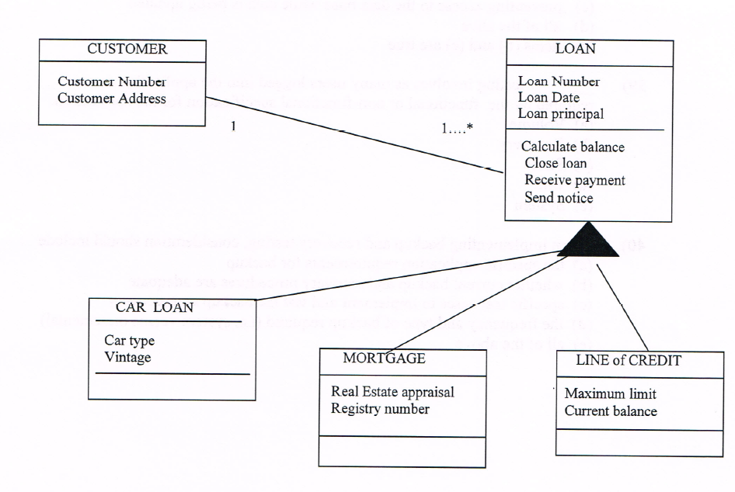
Section B Number 4

Given the Network Diagram below, answer questions 43 to 45
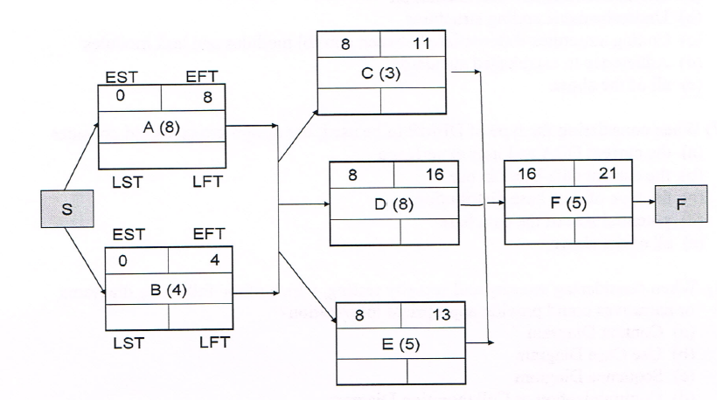

- What is the slack time for work item A?
  - 13
  - 4
  - 8
  - 0
  - none of the above

- What is the total slack time for the whole network?

8
  - 4
  - 3
  - 10
  - none of the above

- What is the Latest Possible Start Time for activity E?
  - 8
  - 4
  - 3
  - 10
  - none of the above

The aspects related to the understandability of an application is I are
  - Internal comments I documentation
  - Understandable coding structures
  - Coding structures differentiate between control modules and task modules
  - Adherence to established standards
  - all of the above

- When considering the type of DBMS to be used, the design group should consider
  - the current DBA and user experience
  - the current data bases in use
  - the type of data base distribution
  - potential size of the data base
  - all of the above.

- When considering security and security testing, which of the following diagrams or narratives could provide appropriate information?
  - Context Diagram
  - Use Case Diagram
  - Sequence Diagram
  - Communication or Collaboration Diagram
  - all of the above

- Relationship between Structure Chart and Data Flow Diagram (DFD)
  - The functional primitives on the DFD would be similar to the lowest level on the Structure Chart.
  - The highest level (Context Diagram or Level 0) of the DFD would be the overall control level for the application.
  - DFD levels between the Level O and functional primitives would be control levels on the Structure Chart.
  - All the above could be true.
  - None of the above are true.

- Which data flow is acceptable on a Data Flow Diagram?
  - from data store to data store.
  - from data store to external entity.
  - from external entity to external entity
  - from transform to transform.
  - from external entity to data store.

- When deploying a system, the advantage( s) of a parallel deployment is (are)
  - Costs would be the same as involved in a direct deployment
  - The older (previous version) of the system provides a backup if the new system fails
  - Data and information from both systems can be compared for validation and verification
  - Both (b) and (c) are advantages
  - none of the above are advantages

- A test case should include
  - the cost involved in the execution of the test case
  - the amount of time required to execute each test case
  - the pre-conditions for the test case
  - the specific and detailed description for the results of the test case
  - both (c) and (d) are included

- Beside the identification of the Use Case, a Detailed Use Case Narrative would include
  - the name of the analyst drafting the narrative
  - the cost involved in validating the narrative
  - the system reaction to the actor's intervention or activity with the system
  - the exception or alternate actions to be taken by the system
  - both (c) and (d) would be included.

- A Structured Walkthrough can be held to
  - validate the Use Case Diagram
  - validate the sequence diagram
  - validate the drafted code against the design documents
  - validate the Detailed Use Case Narrative
  - all of the above

