Island Biography, Metapopulations, and Landscape Ecology
Notes from Turner, Chap 8, 9
Conceptual Development of Organism – Space Interactions
Habitat can be isolated in patches – like islands in an inhospitable ocean.

Concepts of landscape equilibrium vs. non- equilibrium
- System closed vs. open;
- Self-regulating vs. ‘intrinsic & extrinsic’ factors;
- Stable point equilibria vs. no stable point;
- deterministic dynamics vs. nondeterministic;
- Free of disturbance vs. incorporate disturbance;
- Independent of vs. influenced by, humans.

Shift mosaic steady-state concept
Fig 7.14, showing a landscape at different times.
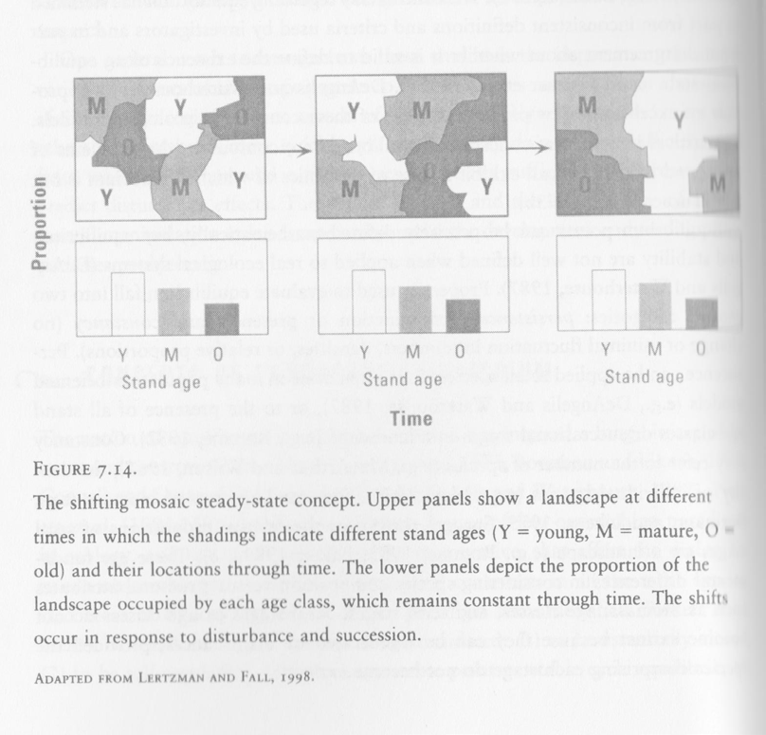

Theory of Island Biography
- Developed as a general theory to predict the number of species found on oceanic islands.
- Was a ‘prevailing paradigm’ guiding the design of conservation reserves.
- Predicts that the number of species on an island will reach an equilibrium that is positively related to island size (larger the island, the more species present) and negatively related to distance from the mainland (fewer spp on islands far from the mainland - and source of new colonists).

The Species-Area Curve
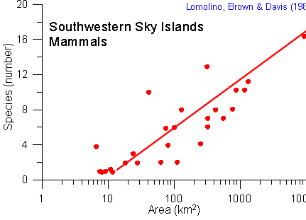
- # species (S) is a function of area (A);
  - e.g. area of an island
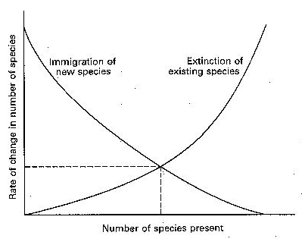

Characteristics of Turnover
- The process is not successional
- Species replacements occur frequently
- Immigration rates decrease with increasing species numbers. Extinction rates increase with increasing species numbers
Model applies under the following conditions
- Islands are real isolates;
- Islands have comparable habitat heterogeneity (complexity). There are no gross environmental changes over the time period of colonization;
- Species counted on islands are residents;
- There is a definable mainland species pool.

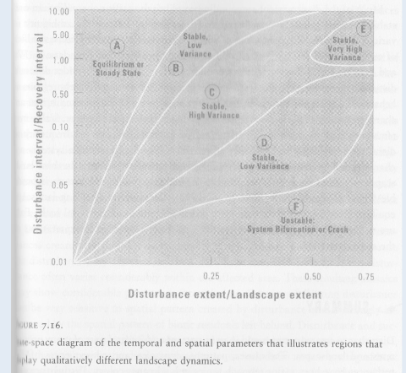
- “This expression shows that the number of species depends on the balance between immigration and extinction – a balance that in turn depends on island size.”
- Analogy made between (increasing) habitat fragmentation and islands, so that island biogeography ‘embraced’ by ecologists.

Metapopulation Theory
- “The interconnected set of subpopulations that function as a demographic unit” (Levins, 1969).
- If a population is fragmented into a patchwork of subpopulations - and the probability of extinction of the subpop. remains small - local extinctions may be balanced by recolonization from neighboring populations.
- Better for LE as concepts can be a better description of population dynamics in natural or artificially fragmented landscapes.

Metapopulation model focus
- Metapopulation models typically focus on idealized habitat patches in a featureless landscape and emphasize:
- local extinction;
- 2. inter-patch movement
- 3. re-colonization.
Sources and sinks
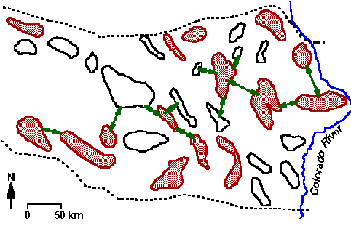
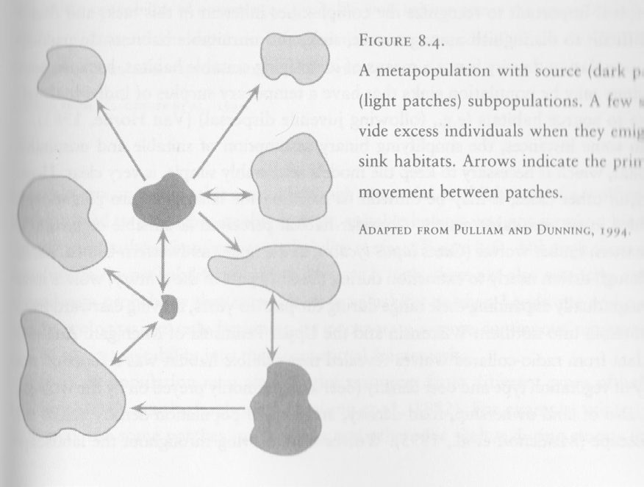
Metapopulation Biology
- Metapopulation in Southern California. Shaded areas indicate mountain ranges with resident populations, arrows indicate documented intermountain movements, the dotted lines show fenced highways (after Bleich et al. 1990).

Identification of a suitable habitat
- In a typical metapop study, a key initial task is to distinguish between suitable an unsuitable habitat and delimit the patches of suitable habitat in a study area.
- Suitable Habitat = those areas defined as having the conditions required for a given species to meet its needs for resources, shelter, and reproduction.

Distinguishing among sources, sinks, and unsuitable habitats
- e.g. timber wolves and range
- found that suitable habitat was a function not only of vegetation type and deer density, but also of land ownership, road density, and human population density across the landscape.

Extinction Debt
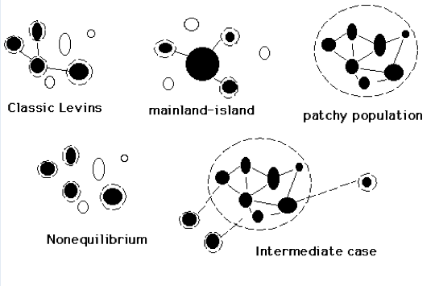
- In Amazo rainforest, it disguises pensing biodiversity disaster

Metapopulations
- A single preserve might hold more species, but it could be wiped out with a single catastrophic event.
- Smaller reserves would each contain fewer species, but some preserves would be likely to survive the catastrophe (providing a source for re-colonization of the damaged areas).
- Some metapopulation models :

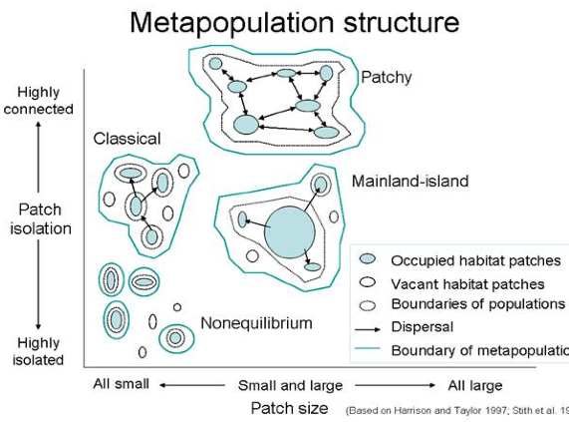
Effects of Spatial Pattern on Organisms
- Size
- Shape: edges vs. interior
- Habitat connectivity
- Effects of Landscape Context

Dispersal between patches
- Dependsonthequality of the matrix; if the matrix is inhospitable, like the ocean, isolation becomes more important.
- e.g.thefragmented urban matrix is essentially impervious to native wildlife.

Metapopulations vs. Landscape ecology
- Four features that characterize landscape ecology are largely missing from metapop. models:
- Variation in patch quality;
- Variation in the quality of the surrounding environment;
- Boundary effects;
- How the landscape influences connectivity among patches.

Effects of Spatial Pattern on Organisms
- In general, larger, more heterogeneous patches support more species.
- “the larger the habitat, the more local environmental variability is contained within it, such as differences in microclimate, structural variation in plants, and diversity of topographic positions.
- Even a seemingly uniform expanse of habitat such as forest or grassland is, at some scale , a mosaic of different habitats.

Loss of interior species or loss of edge species with change in boundary shape
- More opportunities for more resident organisms.
- Smaller patches have greater perimeter-to- area ratios than larger patches; and greater proportion of edge habitat;
- Larger patches will have greater proportion of interior habitat.

Corridors and populations
- are “appealing in a patch-based view of the world in which habitat is either suitable or unsuitable and corridors provide a physical bridge linking islands of habitat.
- Presence of corridors assumed to increase pop. persistence by providing for an exchange of individuals among population that was previously connected but that is now fragmented.

Effects of Landscape Context
- Characteristics of the surrounding landscape can strongly influence local populations.
- Suggests that what happens in small local areas may be influenced considerably by the surrounding landscape.
- Some argue that conservation considerations should include both a patch-based component, such as the design (size and spacing) of nature reserves, and the condition and management of the matrix, (the intervening areas between patches or reserves).

Energy transformations through trophic levels
- 1st level: Primary producers
- 2nd level: primary consumers = Herbivores and secondary consumers (carnivores)
- Omnivores
- Decomposers: micro-organisms and bacteria

Habitat connectivity
- Connectivity is a scale-dependent threshold phenomenon:
- The connectivity of suitable habitat can constrain the spatial distribution of a species by making some areas accessible and other inaccessible.

Metapopulation:
- going into design of a conservation strategy
- a single catastrophic event can whipe out a species, even though a single preserve might hold more speoces
  - so smaller reserves ight have fewer species, but they’ll likely be able to survive such a catastrophic event
- models:
  - levins developed them to get awau form island biogepgraphy:
  - patch isolation vs patch size
    - there could be an impenatreable matrix

Suitable habitat:
- those areas defined as having the conditions required for a given species to meet its needs for resoruces,, shelter, and rep
(must have good introdciton to general species in final project and then focus down to particular species… ex ralk about elephants in general thena specific types of elephanst, ex are they endangered,? Be current)

Extinction dept:
Dept builds up and in our observation of the holon, othe rthings are happening and we put a constraint on it by redicuing prey, introducing dise.ase… and then suddenly we’ll see a drop off of a certain species

Spatial pattenr on organism:
- size, shape (Edge vs interior ex a big peninsula that has a lot of edge or rund that has a ot of interior), habitat connectivity, effects of landscape

Dispersal of Invasive Species:
- humans often help out through transport, ex cars, hitch hiking,
- ex catfish allowing them entry form one ricver to another

