Lecture 5&6 – Turner chapter 2, Scale, Hierarchy
- Ecology vs landscape ecology (test question):
  - Landscape ecology refers to scale, where they have the option to go from small to large scale (much broader area), whereas ecologists look at smaller scales

- Why is the study of landscape ecology becoming relevant with every passing year?
  - Bc of human population dynamics(imposition) on the biosphere, where we’re rapidly expanding, and continuing to want to pursue a higher standard of living and thus have harmful anthropocentric activities. What’s more for humans is less for nature.
  - In the face of technology, growing pop, globalization, how can we protect the environment?
- Ecologists found challenges in using data and understanding usually obtained form fine scales and then infer or project consequences that would occur at broader scales form the small
  - Ex if we were to look at a desert community grading into a grassland community on a steep hill slope
  - At some point we will have a transition that takes place, an abrupt change, where one side of a quadrant can tell us about another quadrant.
  - At one scale you might ask about the relative efficiency of the 2 communities and take samples form 1 and the other and calculate the mean biomass and productivity
- From Fine to Broad Scales:
  - a desert community that grades into a grassland community on a steep hillside.
  - At one scale an investigator might ask questions about the relative efficiency of the two communities and take samples from randomly placed quadrats in each community to calculate mean biomass and productivity.
  - At a broader scale, might ask where on the hillside’s moisture temp gradient one community changes into the other
  - However, the finer scale quadrant within each community often cannot answer the question at the broader scale. So problem is to find satisfactory means of extrapolating form fine to broad scales.
  - Why not just stick to peer sin our explanation of our research, why go public?
    - Bc not everyone has access to peer review research, and these are the people that are the decision makers, the ones making the policies, so we need to make our research public.
  - Scales for humans is not necessarily the scales that were relevant to other organisms or a wide range of ecological processes, form microbes through global change. Biological interactions occur at multiple scales
  - That’s why we talk about fast and slow processes

Scale-related terminology and concepts:
- Absolute scale, Cartographic, Relative, Critical Threshold: (extent –spatiall (distance involved)), Extrapolation:, Grain, Resolution, Hierarchy, Holon, Level of Organization
  - Scale-Spatial or temporal dimension of an object process; grain + extent
- Geographic scale differs form an ecologist scale
  - And how fine for on e an mean broad or coarse grain for another
- Scale dependency:
  - Your object of interest changes with the grain or the extent of measurement
    - So if your grain is large you may collect more info but lose our attention to detail by not focusing on it
  - Should move away form large vs small and use Fine scale to refer to small areas, greater resolution and more detail vs broad to refer to larger areas lower resolution and less detail
  - In general, a small extent will require a small grain size. Scale dependent means that it (a pattern, process or phenomenon) changes with the grain or the extent of the measurement…
  - Large vs. small scale!? = use FINE scale to refer to small areas, greater resolution, and more detail, vs. BROAD scale to refer to larger areas, lower resolution ,and less detail.

  - The scale at which you make any measurement, (the size of the quadrat, transect, census, etc.) influences the numerical answer obtained. See Fig 2.3:
  - Species-area relationships – seabirds and island size. So, the size of the study area had to be accounted for before estimates of species richness among sites or through time could be compared.
    - Species area relationships, such as looking at the abundance of bird species and seeing the area that they go to. So it seems as though a greater area will have a greater abundance of species, but that’s not necessarily the case
- Absolute and relative scale:
  - Extrapolating may be straightforward depends on the results you want to get, its relationship os a variable of changes in scale is linear or additive
  - However:
    - If the relationship is nonlinear and there are critical thresholds at which there is an abrupt change in some quality, then extrapolation is problematic.”
Level of Organization:
- Ex organism, pop, community and biome, with each level characterized by a variety of process that have their own scales of space and time, A pop of a species may occupy a given amount of space, move or disperse a set distance, and reproduce within a certain time period
- However, the community ( to which that pop belongs,) will be characterized by spatial and temporal scales associated with the collection of pops composing the community

Scale is seen as a problem:
- The inherent difficulty of understanding predicting an ecological attribute over a large area
- The logistical problems associated with sampling or experimentation over large areas
  - People are everywhere and they have a right to be everywhere(its hard to find an untouched natural space)
- Summed up as:
- The scale coverage problem: planet large and pose difficulties in mapping and understanding spatial variability
  - We’re getting better through technology, like remote sensing. We’re getting better at interpreting what we’re seeing like creating mapping opportunities through gis. But still a long way to go, bc of politics, money glitches
- Scale linage problem : relating fine scale data to broader spatial scales
- The scale standardization problem: ability to compare diff locations, or assemble diff types of data for the same place influenced by the diff in hoe data are collected and reported
Social data:
- Most social data were reported for areas rather than points (ex census tracts, counties, states, countries) and these areas vary wildly in size and shape, both btw and w/in countries,
- Important when discussion political- ownership boundaries that have been “superimposed “ on ecological units such as watersheds(very important entities, were a series of mountains, will push down water and streams at the bottom, water is shedding off the mountain) … usually the top of mountains are political boundaries, when really we need to work with the whole entity of nature tat is within those boundaries)
  - How can we over come this? Especially over international boundaries.

Scale and Hierarchy:
- Scale concepts and hierarchy theory Levels & Frequencies (rates)
- The simple series:
  - cell, organism, population, community, with each level composed of subsystems on the next LOWER, and is contrained by the level ABOVE it.
- Sub systems: feeds info about object of interest (organism)
Ghost in the Machine:
- Hierarchy: “a system of interconnections wherein the higher levels constrain the lower levels to various degrees, depending on the time constraints of the behavior.”
- (Koestlers “Ghost in the Machine” (1967) a ‘landmark’ publication… Identified entities that were at the same time compose of parts, yet were also a whole that fits within its environment.

Time scales: (figure 2.4)
- Time takes on a diff scale, and we’re not patient by nature
- Fast variable might change so quickly that it might be considered a constant

Holons have characteristic rates of behavior, and these rates place them at certain levels in the “hierarchy of holons”. E.g.
- An individual organism, as a holon, can interact with other individual organisms because both operate at the same space-time scale; but the individual cannot interact with a biome, as they are orders of magnitude different in scale. To the organism, the biome is a relatively constant background or context within which it operates
- Should consider at least 3 hierarchical levels in any study (fig, 2.5)
  - Constraints, level of focus, and components
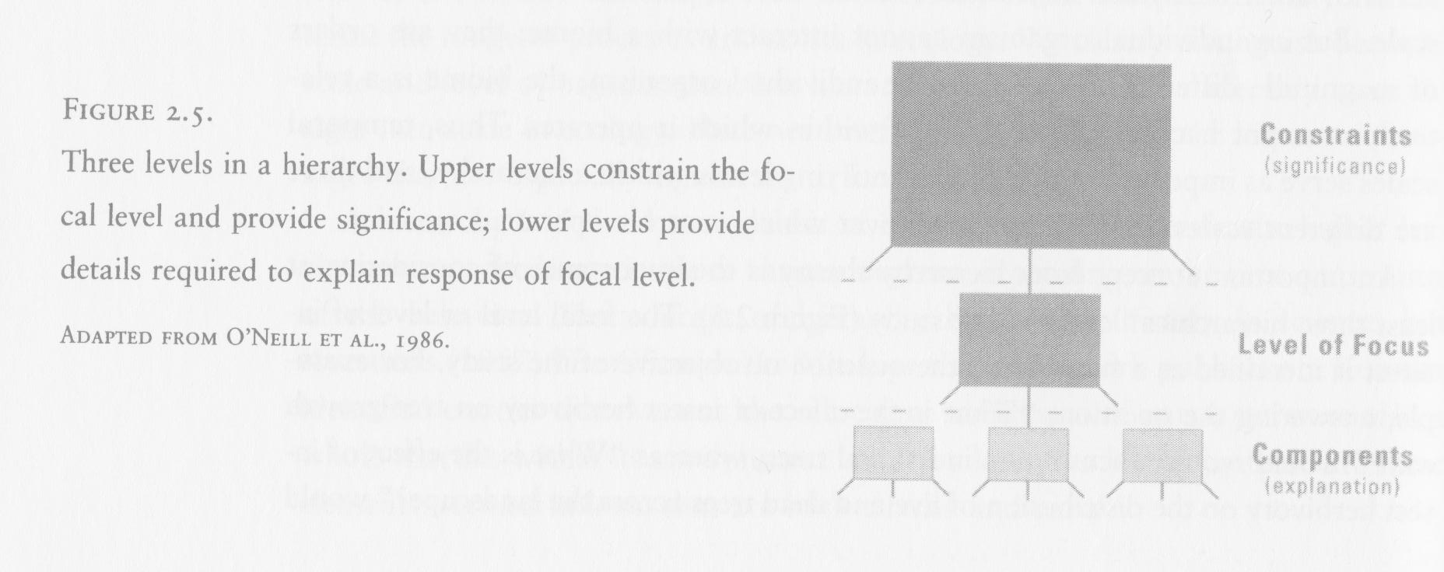
- The focal level (level of interest) is identified as a function of the question or objective…
- We look at how attributes or other aspects make up tat oj of interest (organism). What aspects allow that organism to survive? What are its constraints form the env that keeps it at that level, within its proper scale
  - “What is the effect of herbivory on tree growth rate?” focuses on individual trees, whereas “What is the effect of insect herbivory on the distribution of live and dead trees across the landscape?” focuses on the forest as a whole.
  - The prey could even be a constraints for the predator. (A predator is only as good as its prey…)
  - So what constrains, and what contributes?

- e.g. studying the individual organism as a holon, we can explain how its component parts help it work as a predator;
  - However, the availability of prey species (and ultimately the success of the predator) will be constrained by the broader-scale system in which it is located.
- What makes a predator successful?
  - Agility, being able to keeo up with them
  - Good vision
    - Herbivores tend to have a wider range of movement
    - Crnivores, need better focus, t differnetiwte btw shade and light, so eyes are set forwardvs a bird, that might have eyes much wider apart
  - Physiological features are very important
  - In paper, must state how your organism survives in its particular habitat
  - Claws
  - Space, time, nutrients.. chrnionic disturbance by people
- Although the variables that influence a process may or may not change with scale, a shift in the relative importance of the variables or the perceived direction of a relationship often occurs when spatial or temporal scales are changed. E.g.
- Predicting the rate of decomposition of plant material at a very local scale requires detailed knowledge of the microclimate, characteristics of the litter (e.g. lignin content), etc.;
- however, effectively predicting rates of decomposition at other spatial scales (regional to global scales) can be done based solely on temperature and precipitation.

