The positive outcomes of corporations who are changing their strategies by becoming more environmentally conscious will not only benefit the environment but also their businesses.

Presented to:
Mark Medicoff
Lecturer
John Molson School of Business
Concordia University
Montreal, Canada

Prepared by:
Jenny Khounsombath, Section R
Student at John Molson School of Business
Concordia University
Montreal, Quebec

Thursday, October 27nd, 2016

Letter of Transmittal

To: Mark Medicoff, Lecturer of Business Communications
From: Jenny Khounsombath, Student at the John Molson School of Business
Subject: Assessment of Sustainable Businesses
Date: Thursday, October 27th, 2015

Here is the report, which you asked for on September 9th, on the topic of the positive impacts of sustainable businesses on the environment and internal performances due to consumers’ behavior. The report details the impacts on the environment, the changes that consumers bring by changing their purchasing decisions and sustainable businesses.
The initiatives employed by consumers are becoming their mean of influencing businesses and changing the impacts on the environment. Companies are also discovering the amount of impact that they can do within a few changes in the internal performances to reduce the negatives effects on the environment as well.
Secondary data, newspaper articles and articles in different data banks have been helpful for the analysis of this report.
I hope that this report will provide you with further understanding of a sustainable businesses and the importance of the choices that consumers make to increase the state of the environment.
If you have any further questions, please do not hesitate to contact me by e-mail at Khounsombath_jenny@hotmail.com

Jenny Khounsombath

Table of Contents
Executive Summary 4
I. Introduction 5
I. A) Background 5
I. B) Purpose Statement 5
I. C) Research Methods 6
II. Environmental Impacts on the Environment 6
II. A) Air quality in the United States and China 6
II. B) How global warming has become a concerning issue the past few years 6
II. C) How people are becoming more concerned over the environment 7
III. Consumers’ Behavior towards Green Purchase 7
III. A) How consumers can used their purchasing power to influence businesses to be more ecofriendly 7
III. B) How consumers can easily influence the brand’s reputation 7-8
III. C) Negative incentives of consumers’ purchasing power 8
IV. Sustainable Businesses 8
IV. A) Positive impacts of having a sustainable business 8
IV. B) The main keys of becoming a successful sustainable business 8
IV. C) How big companies became one of the leaders of sustainable business 9
V. Conclusion 10
VI. Recommendations 10
Appendices 11-12
References 13-14

Executive Summary

The environment is downgrading so rapidly due to human activities that the population is not sitting back anymore. Government intervention is not enough, therefore people are using their consumer purchasing power to help. They become more engaged by choosing a specific brand that they like that has a good reputation environmentally and socially. Also, companies are realizing that they do have an impact on the environment and are slowly incorporating sustainability to their long term plan. Therefore, they attract more loyal customers and shareholders, they improve their social, environmental and financial performances and they lower the negative impacts on the environment.

I. Introduction
I. A) Background
Environmental problems such as water pollution, air pollution and global warming have been significantly increasing during the past decades. In fact, in February 2005, the Kyoto Protocol has been created by the United Nations Framework Convention on Climate Change for developed countries to reduce their CO2 emissions (“Kyoto Protocol”, 2014). However, it is still not enough and the population is more aware and concerned of the environmental issues and have decided to be more engaged.
Consumers are using their awareness as a mean of purchasing power to choose amongst brands that are becoming more ecofriendly. As a matter of fact, a lot of corporations are switching their views and strategies to accommodate to consumers and are offering products that are more sustainable.
Global warming has not only affected the population but businesses as well. Companies are becoming more sustainable. Therefore, they are trying to put emphasis on their social and environmental performances to not only attract customers but also aim for long term objectives.
I. B) The Purpose Statement
The purpose of this report is to prove that the positive outcomes of corporations who are changing their strategies by becoming more environmentally conscious will not only benefited the environment but also their businesses.

2.3 Research Methods
All the information contained in this report are drawn exclusively from reliable sources such as scholarly articles, online newspaper articles, academic journals, government websites, E-Book collections and multi-subject databases. The data banks used are EBSCOhost and Proquest. All citations, quotes and references were written using APA style format. All the articles were solely used for the analysis of this report.
Environmental impacts in the environment
How pollution is affecting air pollution in the United States and China
In most countries such as the United States and China, 30% to 60% of air pollution is caused by gasoline cars (Shi et al., 2016). Emissions caused by those vehicles are also one of the main causes of global warming and the substitution for electric cars could play a significant role in reducing climate change (Shi et al., 2016). In 2014, in China, only 8 cities out of 74 met the required standard of air quality. See Appendix A for percentage.
In Beijing, gasoline emissions have become one of the main sources of air pollutants. Air pollution became so big that the government had to intervene and put in place programs to reduce greenhouse emission such as electric taxis (Shi et al.,2016).
How global warming has become a concerning issue the past few years
Global warming has been shown in records of high temperature, rising sea level and severe flooding and droughts are already significantly increasing. In a period of 134 years, the 10 warmest temperature recorded started in 2000 and the highest reached 0.87 °C in 2015 (“Global Temperature”, 2016).

How people are getting more concerned over the environment
People nowadays are more educated than they were 30 years ago. They are also becoming more environmentally conscious and engaged towards any problematic situations that they want to solve. Their decisions are based on their values, knowledge and perceptions.
Consumers’ behavior towards green purchases
How consumers can use their purchasing power to influence businesses to be more ecofriendly
Consumers are using their purchasing power to reduce global warming and reduce the negative impacts on the environment. In fact, a study conducted on 30,000 global online consumers across 60 countries by Neilsen company (a global information and measurement company) shows that 55 % of consumers are willing to pay more for products and services provided by companies that are more committed to positive and environmental impact. See Appendix A for other percentages per regions. Consumers choose to spend on companies that are becoming more engaged towards the environment.
In another global survey lead by Neilsen company in 2011 shows that concerns for air pollution and water pollution ranked the highest with 77% and 75%. The efficient product packaging and the limited waste were also the main positive effects on the environment (Neilsen Global Online Environment and Sustainability Survey, 2011).
How consumers can easily influence a company’s brand’s reputation
As a matter of fact, according to Amy Fenton, global leader of public development and sustainability, Nielsen. “Consumers around the world are saying loud and clear that a brand’s social purpose is among the factors that influence purchase decisions,”. Consumers are purposely choosing brands that have a positive impact on the world.
The use of social media can also ruin a company’s brand. By spreading a picture or sharing a post, it can share thousand of times and affect a company’s reputation badly.
Negative incentives of consumers’ purchasing power
The power of purchasing product held by consumers is so powerful that any negative decisions can become impactful for companies. Boycotting is an example of negative incentives. Boycotting has gone up by 123 per cent over 2010-2012 (BusinessGreen, 2014).
For instance, the boycott of the products coming from an unsustainable palm oil company or other unethical companies can cause bankruptcy or give a bad reputation which will ruin their marketing strategies (BusinessGreen, 2014).
Sustainable Businesses
Positive impacts of having a sustainable business
Sustainability has grown to be a dominant theme in today’s society businesses. It has now become a long-term success plan for any corporation (Eccles, 2012). Businesses discovered the impact that they can have on the environment and many has begun implementing environmental sustainability goals.
The main keys of becoming a successful sustainable business
For a business to be sustainable, it has to have a positive societal influence, being environmentally friendly, openness and transparency are one of the main factors, behaving ethnically, rewarding employee fairly and promoting employee as well.
By applying a green supply chain management, companies are eliminating waste and generating cost savings. They are also recycling and finding ways to protect and improve the environment conditions (University Alliance, 2016).

Sustainable companies are more long-term oriented and attract long-term investors as well. In fact, they are more engaged towards their stakeholders and customers (Eccles, 2012). With a good social and environmental performance, comes a better financial performance as well. It is proven that becoming sustainable is the key to attract loyal customers as well as creating value for stakeholders (Eccles, 2012).
How big companies became one of the leaders of sustainable businesses
Successful companies such as Google, BMW, Walt Disney Company and Microsoft are the pioneer to successful sustainable businesses. They slowly incorporated sustainability into their long term programs to become one of today’s best reputations in corporate social environment (“Google, BMW, Disney, Microsoft Once Again Top List of Best CSR Reputations”, 2015).
According to Forbes, BMW is the world’s most sustainable company of 2016. They earned high marks for their environmental and social aspects (Dill, 2016). Large innovative investments, low CEO to average worker pay ratio, low employee turnover are their strengths in the social performance and the efficient use of water, energy and lack of waste make them a better sustainable company that would always attract customers (Dill, 2016).
Google is one of the leading most innovative companies of 2015. It demonstrated its commitment to being sustainable by using renewable energy to power up their offices, host sustainable cooking classes and trim the grass with goats instead of using lawn mowers.

Conclusion
Global warming is mostly affected by human activities and has not stop increasing every year. Government intervention is not enough to decrease the level of greenhouse emission produces every year so companies and consumers are using other positive incentives to help.
Consumer are using their knowledge and mean of purchasing power to reduce climate change by choosing an environmentally conscious brand. They are also using their power to boycott products and brand that are harmful to the environment and its surrounding.
In order to help, companies are becoming sustainable for their overall performance, but also for the environment. By becoming a sustainable company, they will increase their social and environmental performance which will increase their financial performance as well. They will evolve as a better and long-term goals sustainable companies.
Recommendation
There are many ways to reduce climate change and improve the environment state. The population can start by taking actions and get more involved by boycotting unsustainable products and choosing environmentally friendly brand. By choosing those principles, businesses are reducing their greenhouse emissions and can help protect the environment.
Government can implement stricter programs for businesses to reduce their waste and greenhouse emissions.
Also, businesses can incorporate sustainability to their program, which will help their internal performance and increase their cost saving as well as attract loyal customers and give a better public opinion to their brand.

Appendices
Appendix A
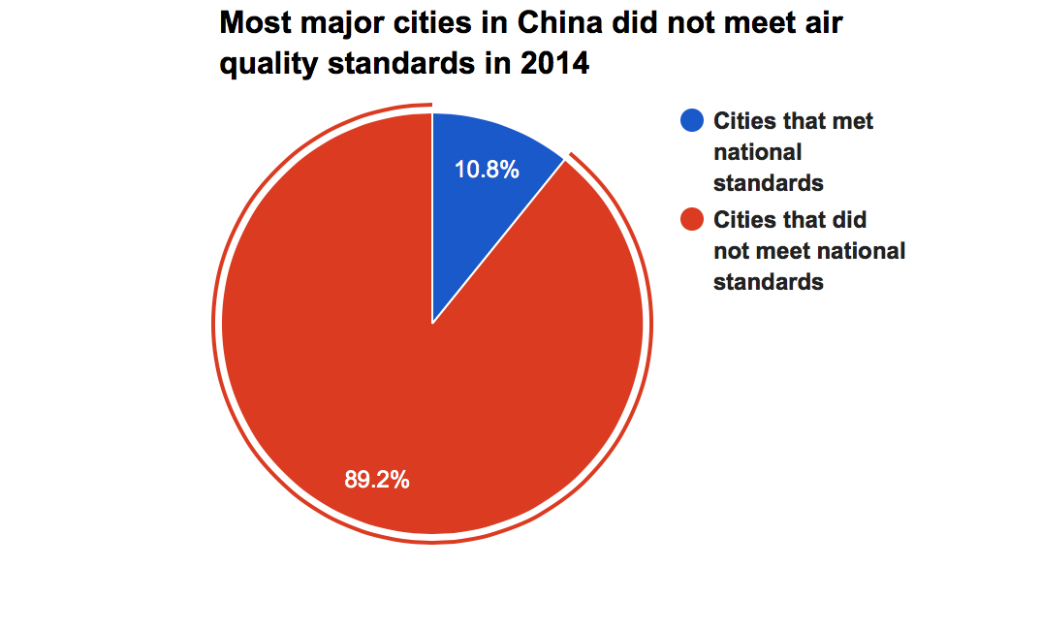
(Air quality standards in 2014 for cities in China, 2016)
Appendix B
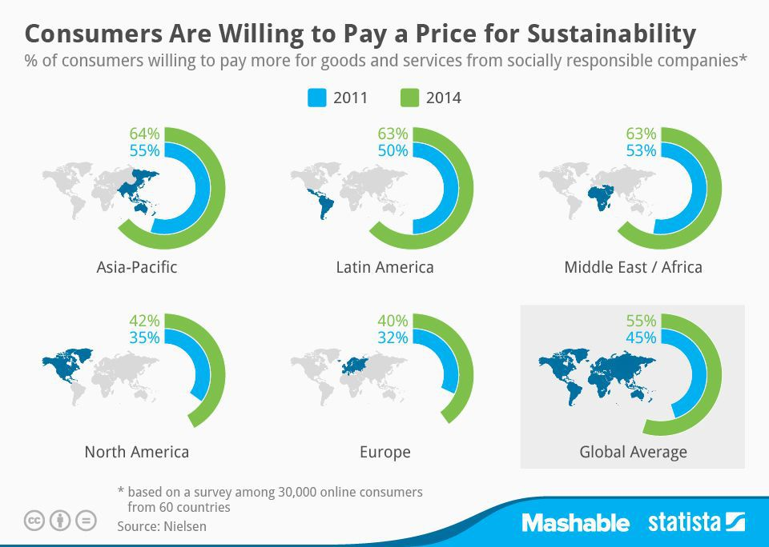
(Percentage of people across 5 regions who are willing to pay for socially responsible companies, 2012)

Appendix C
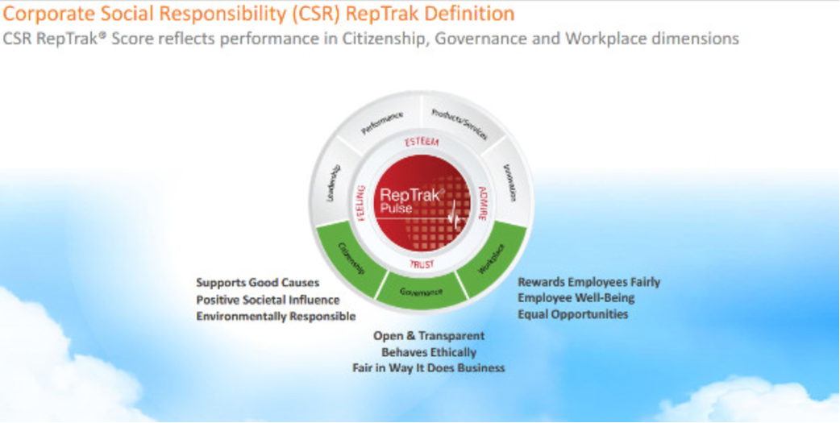
(Characteristics for a social responsible corporation, 2015)

References
Mertl, S. (2008, Mar 31). Demand for eco-friendly cars with performance; automakers struggle to meet consumers' wants. Trail Times Retrieved from http://0-search.proquest.com.mercury.concordia.ca/docview/358110140?accountid=10246
Wicks, A. C., Keevil, A., & Parmar, B. (2012). Sustainable business development and management theories: A mindset approach. Business & Professional Ethics Journal, 31(3-4), 375. Retrieved from http://0-search.proquest.com.mercury.concordia.ca/docview/1272174678?accountid=10246
Canadian, A. A. (2006). Driving Towards a Cleaner Environment : A Healthier Future. Ottawa, CA: Pollution Probe. Retrieved from http://0-www.ebrary.com.mercury.concordia.ca
Richard, B. P. (2012). Environmental Issues for the Twenty-First Century and their Impact on Human Health. Ontario: Bentham Science Publishers.
Ross, A. J. (2010). Probabilistic assessment of the rate of future climate change (Order No. MR70985). Available from Dissertations & Theses @ Concordia University; ProQuest Dissertations & Theses Global. (856598161). Retrieved from http://0-search.proquest.com.mercury.concordia.ca/docview/856598161?accountid=10246
“Kyoto Protocol”. (2014). Retrieved from http://unfccc.int/kyoto_protocol/items/2830.php
Caldeira, K. (2016). STOP EMISSIONS!. MIT Technology Review, 119(1), 40-43.
http://environment.nationalgeographic.com/environment/green-guide/buying-guides/car/environmental-impact/
https://www.theguardian.com/sustainable-business/sustainability-key-corporate-success
http://www.nielsen.com/ca/en/press-room/2014/global-consumers-are-willing-to-put-their-money-where-their-heart-is.html
http://www.forbes.com/sites/kathryndill/2016/01/22/the-worlds-most-sustainable-companies-2016/#6f07f458965f
Hetterich, J., Bonnemeier, S., Pritzke, M., & Georgiadis, A. (2012). Ecological sustainability – a customer requirement? Evidence from the automotive industry. Journal Of Environmental Planning & Management, 55(9), 1111-1133. doi:10.1080/09640568.2011.636578
http://www.businessgreen.com/bg/sponsored/2364029/are-consumers-becoming-more-aware-of-environmentally-sound-business
Petronzio, M., (2014, June 30). Consumers are Willing to Pay More for Sustainability. Retrieved from: http://mashable.com/2014/06/30/sustainability-consumers/#e6v4g1QP5kqb
“Global Temperature”. (2016, October 16). Retrieved from http://climate.nasa.gov/vital-signs/global-temperature/
Du, Y., (2015, March 15). 9 Charts That Show the Level of Pollution in China. Retrieved from http://www.cctv-america.com/2015/03/09/9-charts-that-show-the-level-of-pollution-in-china
“Google, BMW, Disney, Microsoft Once Again Top List of Best CSR Reputations”. (2015, September 22). Retrieved from http://www.sustainablebrands.com/news_and_views/organizational_change/sustainable_brands/google_bmw_disney_microsoft_once_again_top_l
“Three Companies with Best Practices in Environmental Sustainability”. (2016). Retrieved from http://www.usanfranonline.com/resources/supply-chain-management/three-companies-with-best-practices-in-environmental-sustainability/#

