Topic 7

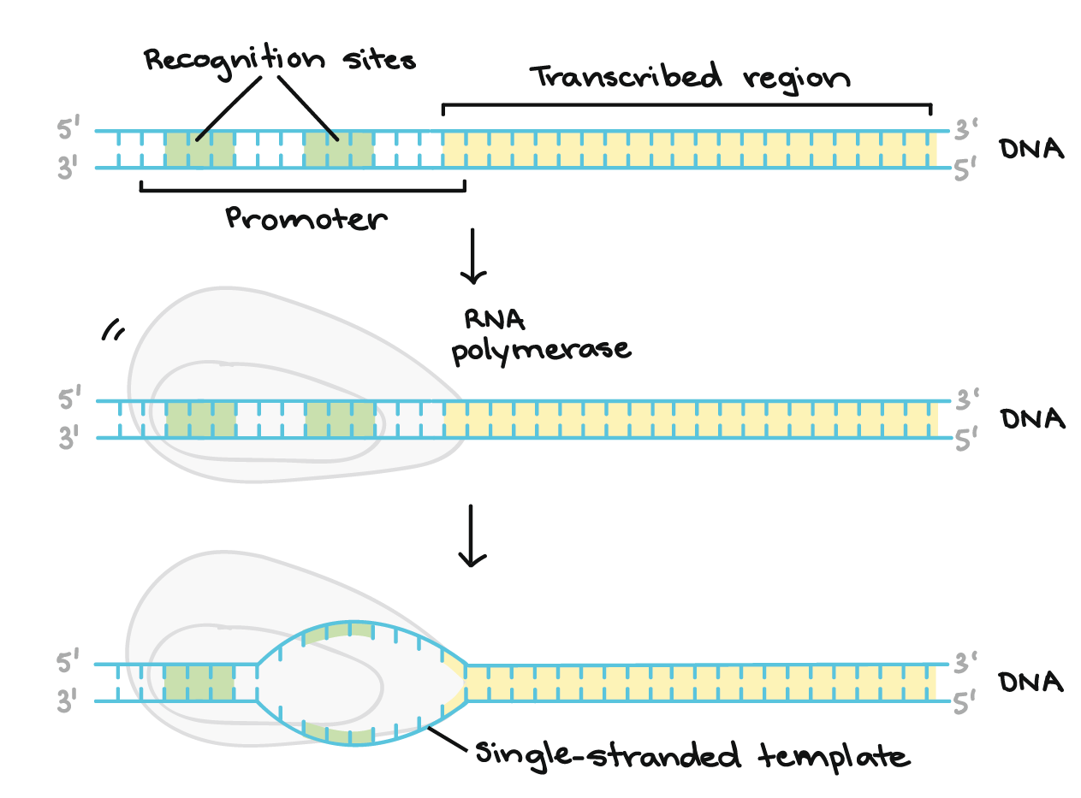
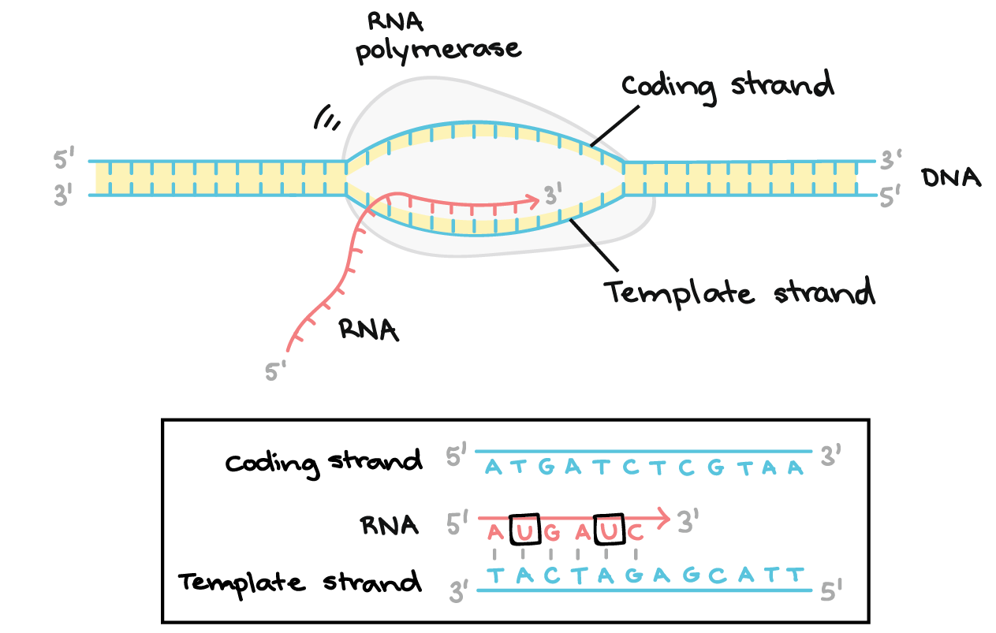
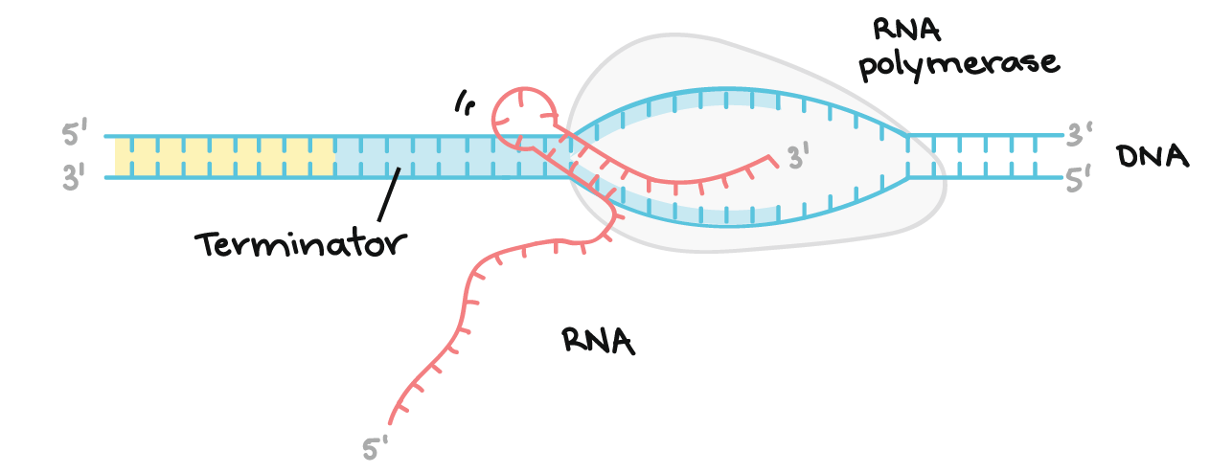
- Be familiar with the elements comprised in a transcription initiation complex and its role
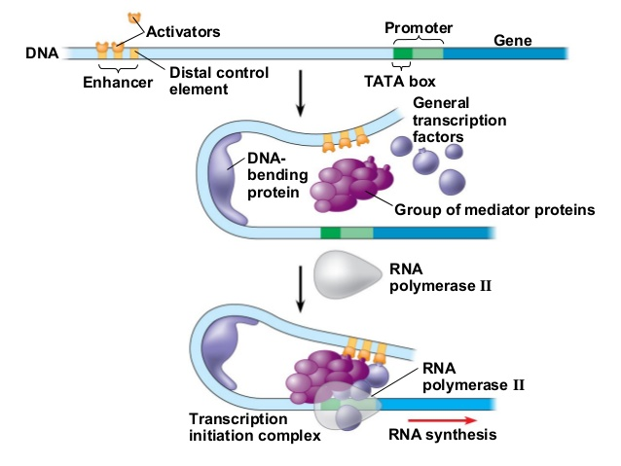
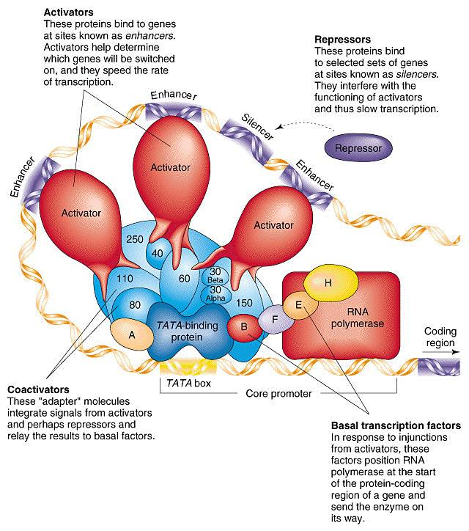
- Explain and demonstrate RNA maturation and splicing 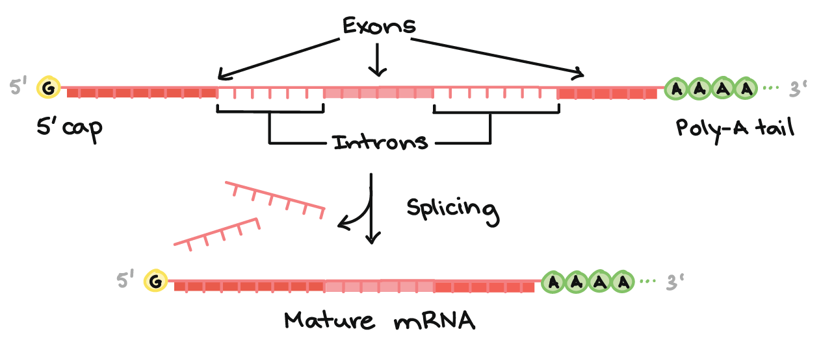
RNA splicing: involves the removal or "splicing out" of certain sequences referred to as intervening sequences, or introns. The final mRNA thus consists of the remaining sequences, called exons, which are connected to one another through the splicing process.
Introns are removed from primary transcripts by cleavage at conserved sequences called splice sites. These sites are found at the 5′ and 3′ ends of introns. Splicing occurs in several steps and is catalyzed by small nuclear ribonucleoproteins (snRNPs, commonly pronounced "snurps").
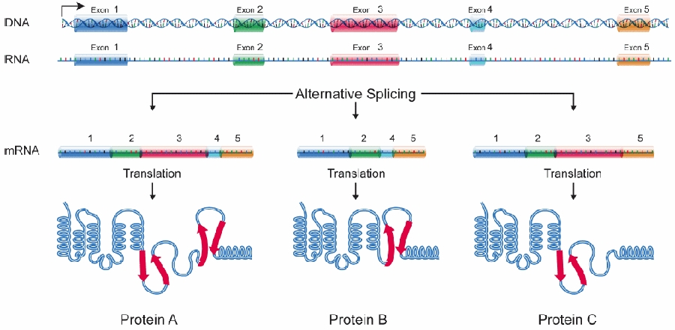Alternative splicing refers to the process by which a given gene is spliced into more than one type of mRNA molecule
RNA Maturation:

