Bio Final Exam Notes: LeBlanc
CYCLE 1
Seth Berkley: HIV and Flu— The Vaccine Strategy

- HIV, humans have no natural immunity
- Vaccines; create catch of weapons for immune system, which you can deploy when you have an infective
- Pre-immunizations, pre-recognized to help fight infections
- Viruses always changing
- Flu virus, mutate and change shape, antibodies don’t know what they’re looking at and are no longer able to fight
- Flu shot is a guess of 3 most common strains of flu for that particular year
- HIV (virus causing aids), mutates furiously, attracts cells trying to fight it, quickly hides itself in genome
- No cure, but drugs extend the life for those infected
- Recently found broadly neutralizing antibodies (latching on a disabling multiple variations of the virus)
  - Found new site on HIV where antibodies can grab onto, this sport changes very little compared to the rest
- Working backwards from an antibody, retrovacinology (never been done before, only with HIV)
- Antibody cocktail (can be sued to treat severe cases of the flu)
- Retrovaccinology is just one technique
- M2e don’t change much, if you could cripple those sports you could eliminate all versions of the flu (universal flu vaccine), wouldn’t need to come up with a guess of 3 viruses
- Viruses only grow on living things
- Flu vaccines come from chicken eggs
  - Never know how well a strain is going to grow
- 350 million doses for flu, up to 1.2 for a specific virus (swine flu)

Reading— Lecture 2 (23.1,23.3,23.4)
23.1
- Viruses are not considered to be living
  - They cannot reproduce on their own (need host cell)
  - They lack metabolic system to provide energy for their life cycle
    - Infect host cells in order to complete these processes
- Structure of virus is reduced to minimum needed to transmit genome form one host cell to another
- Structure: one or more nucleic acid molecule surrounded by a protein coat or capsid
  - DNA or RNA enclosed within a protein coat
  - Some capsid may have membrane (envelope) derived from the host cell’s membrane
  - Can be composed of with a single strand or double strand of DNA
  - All viruses have at least the genes that encode for their coat proteins and the proteins involved in regulation of transcriptase
  - Genomes range from either a couple to a few 100 genes
  - No cytoplasm enclosed by a plasma membrane (which all living organisms do
  - Genomes of enveloped virus’ also include genes required for synthesis of envelope proteins
  - Some include virus-specific enzymes for nucleic acid replication
Viral Structures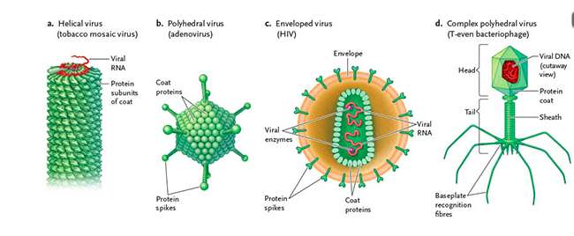

- Most viruses take either a polyhedral or helical shape
- Polyhedral: coat proteins form triangular units (forms that infect animals, plants and bacteria), some have protein spikes
- Helical: rod like structure around the genome
- Both helical and polyhedral viruses can be enveloped in membrane derived form host’s membrane
- In enveloped virus’, proteins synthesized from viral genome are transported and embedded in membrane before virus particle buds to host cell (allow virus to recognize and bind to host cells)
- Categorized by DNA or RNA, single or double stranded and how nucleic acid is replicated
- A virus generally only infects a single species or a few closely related species
  - Some are able to infect different species
- Of 80 viral families, only 21 can cause disease in humans
- There are ‘protective viruses’ that interfere with the replication/ alternate functions of the pathogenic viruses
- Bacteriophages: virus infecting bacteria, helps in some cases to fight off pathogenic viruses
- Much of carbon fixed on earth may be facilitated by virus-controlled photosynthesis
  - Ex. bacteriophages infecting cyanobacteria, shut down host’s protein synthesis, without this photosynthesis would slow due to light damage but the phage keeps the host alive (though for selfish reasons)
- Reverse Transcriptase: HIV is retro virus that contains two copies of single-stranded RNA also carrying several molecules of an enzyme, reverse transcriptase in its capsid
  - Virus’ genome enters the host cell with reverse transcriptase which copies the viral RNA onto complementary strand of DNA, second strand of DNA is then synthesized using first strand as a template
  - Resulting double-stranded DNA integrates into host cell’s DNA as a provirus.
  - DNA is transcribed by host cell into mRNA and translated to produce viral proteins (such as; capsid proteins and reverse transcriptase molecules)
  - New virus particle are released from cell to infect other cells or to be passed to new hosts
- No miracle yet exists for HIV, bc of its fast and extensive mutation rate
- Reverse transcriptase does not have any proofreading ability, like regular DNA replication has (polymerase), therefore, many errors are made when catalyzed from RNA to DNA occurs
- Proteins encoded by this mutated DNA will be different from those of original virus, and won’t be recognized by existing antibodies

23.3- Treatment and prevention of viral infections
- ‘Hidden’ in host cells
- Use host as machinery to survive and replicate, no obvious viral products to be targeted
- Viruses using their own polymerases provide more obvious targets to treat
- Influenza virus- need new combinations every year because of the random mutations in RNA genome of virus that add to variation in coat proteins, making the antibodies ineffective
- HIV was restricted to chimps and gorillas in Africa, now the greatest concentrated of those effected are in sub-Saharan Africa
- Global travel and trade, human involvement with wildlife increases there are more likely to become human-effecting viruses
23.4- evolvement of viruses

Theories on how viruses came about:
(1)- evolved after viruses because they need a host cell to function
- May have ‘escaped’ fragments of DNA molecules that formed part of genetic material of living cells or and RNA copy of fragment
-First became surrounded by protective layer of protein with recognition functions and the fragments then escaped parent cells
(2) Viruses are ancient, predating the first cells
-“Primordial gene pool”: pool of RNA thought of to be first genetic material

-Viruses do not share a common evolutionary origin
No common ancestor, therefore cannot draw phylogenetic tree
-Some have suggested that nucleus originated from a large, double-stranded DNA virus that infected prokaryotic cells, resulting in the first eukaryotic cell

Evolution
  - Evolution; gradual change
- Biological Evolution; gradual change of populations/organisms over time (time in generations not years)
- Not all gradual change is biological evolutions; changes occurring in a single organisms lifetime are not evolutionary
17.2 Early Views on Organisms
Aristotle
- Aristotle believed both living and no n living organisms had fixed characteristics
- Scala Naturae (great chain of being); Mineralsplantsanimalshumans gods of spiritual realm
- Natural Theology; belief knowledge of God may be acquired through study of natural phenomena
Sir Francis Bacon
- Importance of observation, experimentation and inductive reasoning
- Copernicus, Galileo, Descartes and Newton proposed theories to describe physical events; created biogeography, comparative morphology, geology
Biogeography
- Study of the geographic distributions of plants and animals
- Countered the scala naturae concept proposed by Aristotle
Comparative Morphology
- Similar appendages in different species (homologous with different functions, bats wings, dolphins fins etc.)
- Buffon; why do useless structures exist if each species was perfect (ex. feet of pigs have 2 toes never touching ground)
- Vestigial Structures; useless parts on species Buffon observed
  - Must have once functioned in ancestors and have become useless in this day
Geology
- George Cuvier realized layers of fossil he found represented organisms that have lived at sequential past times
- Suggested abrupt changes in layers marked shift in environment
- Catastrophism; theory that Earth has been affected by sudden, and violent events sometimes worldwide
17.2B
- Bishop Ussher calculated Earth’s age based on bible and came up with 4004 BCE as last year of creation (idea Earth was 6000 years old)
- Hutton argues slow, continuous physical processes acting over large periods of time (Gradualism)
  - Argues catastrophism
- Lyell argues geological processes creating Earth (volcanic eruptions, glaciers etc.) are the same processes we see today (uniformitarianism)
17.3 Biological Evolution
Lamarck
- First comprehensive theory of biological evolution on specific mechanisms
- Proposed “perfecting principle”, organisms become better suited to their environment
- Ladder of life; organisms arise from nonliving material (dirt, dead organisms)
- Use and disuse grow in proportion to how much used
- Inheritance of acquired characteristics; changes occurring to species (ex. giraffe’s neck getting longer due to taller trees) are passed to offspring (incorrect)
Contributions leading to development of evolution
- Proposed all species change through time
- Recognized changes are passed from one generation to next
- Suggested organisms change in response to environment
- Hypothesized existence of mechanism causing change

Darwin
- Discovered living organisms has similar aspects to fossils; why was one very similar species living and the other wasn’t
- Saw similarities between organisms resembling those in close proximity (Galapagos islands to south American species)
  - Proposed populations changed after being isolated on the island)
- Galapagos islands created by volcanic eruption 3-5 mya
- Visited the many islands noticing finches that varied in shapes of bills
- He assumed bid on different islands were part of same species

Natural Selection
- Selective breeding with dogs, choosing traits they wanted (Artificial Selection)
- Saw nature could do the same with natural selection; principle by which each slight variation of a trait if useful is preserved
  - Organisms with these traits survived and were fitter passing these traits onto offspring, and those who didn’t have them died off and didn’t produce fit offspring
- Used Malthus theory to nature; observed England’s population was growing faster than its agricultural supply
Darwin’s major observations;
- Individuals within populations vary
- Many variation are passed from parent to offspring
- Some inherited characteristic enable some to survive and reproduce better than others
- Next generation is subject to same process of selection

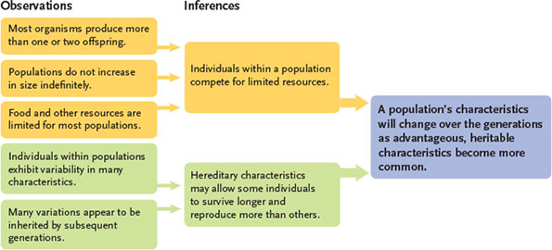
- Natural selection favor adaptive traits (traits increasing organisms likelihood of survival or reproductive output)
- Evolutionary Divergence; process where natural selection or genetic drift causes populations to change over time
Wallace

- Wallace’s work mirrored Darwin’s
- Similar results and ideas that reinforced idea of natural selection
Impact of Theory of Evolution by Natural Selection
- Darwin argued Descent with Modification; evolutionary alteration and diversification of ancestral species (Tree of Life he proposed)
Characteristic’s distinguishing Darwin’s theory from other
- Provided physical rather than spiritual explanation for origins of biological diversity
- Recognized evolutionary change occurs in populations not individuals
- Described evolution as multistage process; variations arise in groups, natural selection eliminated unsuccessful ones, next generation inherits successful variations
- Understood evolution occurs because some organisms function better than others in a particular environment
17.4 Evolutionary Biology since Darwin
- Darwin and Wallace didn’t know about genetics at the time, Mendel’s pea plant experiment was posted around the same time
- Some argued the two conflicted because Darwin’s bird bill example was too complex compared to pea plant height used by Mendel
Modern Synthesis
- Population genetics; recognizes importance of genetic variation
- Modern synthesis combines data from biogeography, comparative morphology, comparative embryology, genetics, paleontology and taxonomy, acknowledges genetic drift, Darwin’s idea of gradual change and de-emphasized sudden trait changes
- Microevolution describes small genetic changed populations undergo (Ex. different bills on finches)
- Macroevolution; describes larger changes in evolution, gradual accumulation of micro evolutionary changes
- Biological evolution; involved combination of heritable changes in individual plus selective pressure and environmental pressures felt by organisms
  - Selective pressures act on phenotype of organisms
Cycle 2XED
CYCLE 2
8.3a-
Mitosis is the result of 3 interrelated systems:
(1)-molecular checks and balances; ensuring orderly and timely check of cell cycles
(2)- process of DNA synthesis replicates each DNA chromosome into two exact copies
(3)- cytoskeleton is able to separate after replication into daughter cells

Meiosis produces daughter nuclei that are different; half number of chromosomes that parental nuclei had
- Most eukaryotes have two copies of each type of chromosome (diploid; 2n)
- Other eukaryotes have one copy of each chromosome (haploid; 1n)
- Some others may have 3n, 4n. Etc. (ploidy)
- Duplication of the chromosome forms two sister chromatids
-Held together by sister chromatid cohesion; encircle the sister chromatids along their length
-Cohesion is removed during mitosis
Chromosomes Segregation: equal distribution after replication
-DNA replication increases DNA content NOT chromosome number
8.3 b
Mitosis
(1)-Interphase (longest phase
(a) G1 phase- cell carries out its function, sometimes growth occurs, many dells stop dividing here and go into G0 phase, in some cases the cell may enter the cycle again form this point
(b) S Phase- DNA replication and chromosome duplication occur
(C) G2 Phase- gap in cell cycle where cell growth continues, and cell prepares for mitosis (m phase)
-Cytokinesis (separation of cytoplasm) occurs at beginning of mitosis but completes itself at the end of mitosis
- Cells metabolize during interphase

MITOSIS
- Internal regulatory control trigger each cell phase
- 5 phases
- Prophase, prometaphase, metaphase, anaphase, telophase
- Immunofluorescent light stages
- Prophase- chromosomes are condensed, nuclear envelope is intact and microtubules are organizes in radial arrays, nucleus generally disappear reflecting the shutdown of all types of RNA synthesis, two centromeres begin to migrate to the two separate spindle poles
- Prometaphase- begins at the start of the nuclear envelope being broken down, allowing chromosomes t interact with microtubules originating from two centromeres, kinetochore has formed on each chromatid at the centromere
- Metaphase- all of replicated chromosomes are aligned at equator, condensation stops and assume their chromosomal shape as determined by the location of the centromere and the length and thickness of the chromatid arms
- Anaphase/telophase- chromosomes are equally divided and are de-condensed to form two daughter nuclei, RNA transcription resumes
Result is two genetically identical daughter cells
-Only during prometaphase are chromosomes condensed enough to take on any shape
- Complete collection of metaphase chromosomes arranged is called the karyotype
- Cytokinesis occurs late anaphase/telophase and by this time the daughter nuclei have usually entered G1 phase of the next cell cycle
Cytokinesis can occur in two ways
- Furrow- girdles the cell wall and cuts the cytoplasm into two separate cells
- Cell Plate (plants)- cell plate forms between the two cells and grow laterally until the cytoplasm is completely divided
- Plane of cytoplasmic division is determined by layer of microtubules persisting at the former spindle midpoints
12.2 DNA Structure
Watson and Crick discovered structure of molecule
- 4 nucleotide each containing five-carbon sugar deoxyribose (numbered 1’ to 5’), one of four nitrogenous bases
- Adenine (purine; two fused rings of carbon and nitrogen atoms)
- Guanine (purine)
- Thymine (pyrimidine; single carbon ring)
- Cytosine (pyrimidine)
- Number of purines in DNA = number of pyrimidine (Chargaff’s rules)
- Nucleotides join to form a polynucleotide chain, deoxyribose sugars are joined by phosphate groups (sugar-phosphate backbone)
  - Each phosphate group acts as ‘bridge’ between 3’ carbon of one sugar and the 5’ carbon of next sugar
- Linkage, including bridging phosphate group is phosphdiester bond
- Chain has polarity, one end hydroxyl end is 3’ (bonded to 3’ carbon), other is 5’ end; antiparallel
- X-ray diffraction was used to study structure of DNA, bean directed at molecule in crystals showed helical shape on photographic plate
- Two polynucleotide chains twist around each other in right-handed way
- Distance between each pair of bases; 0.34 nm, each full twist of DNA double helix is 3.4 nm (10x0.34)
- Purine and pyrimidine paired together are exactly wide enough to fill space between the two backbones
- Adenine and thymine bond together and cytosine guanine bond; complementary base pairing
- Hydrogen bond stabilize pairing between bases (3 hydrogen bonds between G and C and 2 between A and T)
- Covalent bonds between sugar phosphate (stronger than hydrogen)
12.3
DNA Replication
- Semi conservative model (correct model; original DNA acts as template for new strand (half old half new), proven by Stahl
- Conservative Model (not correct); each two strands serves as template for new DNA, after replication original strands come together as do the newly replicated ones
- Dispersive Replication (not correct); neither parental molecule remains interact; both chains of each replicated double helix contain mixture of old and new segments (half and half)
- Stahls experiment to prove semiconservative model; non radioactive nitrogen (N15; heavier than N14), bacteria grown in N15 and transferred to N14 bacteria, then it was centrifuged showing weights of DNA

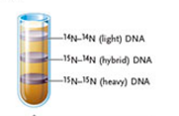

12.3b DNA Polymerases
- DNA is replicated by DNA polymerase
- Deoxyribonucleotide triphosphates are substrates for polymerization reaction cause by DNA polymerase
- Nucleoside triphosphate (Ex. ATP in cellular respiration
- 4 Deoxyribosenucleoside triphosphates in DNA replication (dATP, DGTP, dCTP, dTTP; d=deoxyribose)
- Hydrolysis; breaking down of triphosphate gives energy to add base to new strand of DNA; energy needed to elongate chain
  - When 2 phosphates leave, hydrogen on hydroxyl group and hydroxyl on triphosphate, breakdown to H2O
  - DNA polymerase can only add a nucleotide to the 3’ end of an existing nucleotide
  - OH (hydroxyl) group is always exposed at newest end, oldest end is exposed to 5’ phosphate end
  - Nucleotide chains in 5’3’
  - Anti parallel nature means template strand is “read” in 3’ 5’ direction for new synthesis
- Template strand and 3’ end –OH of new strand meet at active site for polymerization reaction of DNA synthesis in ‘palm’ domain
- Sliding DNA clamp; protein that encircles DNA, binding to the rear of DNA polymerase; it tethers DNA polymerase making replication more efficient, without it enzyme will detach from template after a few dozen polymerizations
12.3 C
- Origin of replication; starts with DNA helicase, creates y-shaped structure called replication fork
- Single Stranded Binding Proteins (SSBs): coat single stranded DNA segments, stabilizing the DNA and keeping two strands from repairing
- Topoisomerase: cuts DNA ahead of replication fork and turns DNA on one side of break in opposite direction of twisting force and rejoins two strands
12.3 d
- RNA Primer; synthesized from enzyme primase, leave template of short RNA and DNA polymerase takes over and primer is removed
- Applies for both leading and lagging strands
12.3 e
- Antiparallel nature of DNA means only one of them runs in direction DNA polymerase can to make 5’3’ copy in direction of unwinding
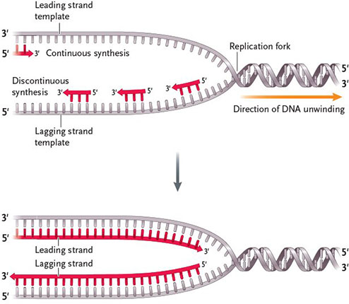
  - One strand is continuous, other is discontinuous
  - Discontinuous replication; short lengths (Okazaki fragments) used by lagging strand and lagging template
  - Continuous strand; leading strand using leading template, replicated normally in 5’ 3’ direction
12.3F

DNA Polymerase 3; main polymerase, extends primer by adding DNA nucleotides
- Primase initiates all new strands by synthesizing RNA primer
Lagging Strand Replication: DNA polymerase 1 removes RNA primer at 5’ end of Okasaki fragment, replacing RNA nucleotide with one with DNA nucleotides
- RNA removal uses 5’ 3’ exonuclease (removes successive nucleotides at end) activity of enzyme
- DNA polymerase 3 extends primer on lagging strand with nucleotides until polymerase 3 reaches 5’ end of next Okasaki fragment
- DNA polymerase 1 stops replacing RNA primer with DNA nucleotide when it encounters DNA nucleotide synthesized in Okasaki fragment
- Nicks left in backbone remains between newly synthesized fragments and he Covalent bond needed is made by DNA ligase
12.3g
Replication Bubble; two replication forks, each moving away from the ore (mirror each other)
- For circular genomes there is a single ore
- Hundreds of origins of replication in eukaryotic organisms, making replication extremely fast
- Forks move away from origin until they eventually meet along chromosomes to produce a fully replicated DNA molecule
  - Normally replication origin occurs only once during S phase in eukaryotic organisms (no DNA is replicated more than once)
- Leading and lagging strand switch half way through a bubble **
12.3h
Telomerase; because RNA primer is needed to initiate DNA replication, linear chromosomes in eukaryotes get shorter after each round of each replication
- At very ends of chromosomes there is no existing nucleotide chain to be elongated once RNA primer is removed by DNA polymerase and gap can’t be filled like it usually is
  - Shortening can become lethal to a cell, this is where telomerase comes in
  - Telomerase adds to template strand, primase than catalyzes synthesizing of new strand
- Telomerase binds to single stranded 3’ end of chromosome using complementary base pairing
- Telomerase synthesizes new telomere DNA using its RNA as the template (uses own template, primase isn’t needed)
- Telomerase synthesizes new telomere DNA, leaves the extended strand and a primer is added by primase and DNA polymerase 3 fills gap with nucleotides, primer is removed and the DNA molecule length is preserved more
- Most eukaryotic organisms are able to loose some dna sequence at end due to telomere; short DNA sequence that is repeated hundreds of thousands of times (in humans this sequence is 5’ TTAGGG3’ on template strand, with each replication this is the part where length is lost
- Telomerase is not active in the somatic cells of multicellular organisms; telomeres shorten when the cells divide
  - Somatic cells can only mitotically divide a certain number of times before cell death
- Telomerase is generally only active in rapidly dividing cells of early embryo and germ cells (embryonic cell) to ensure chromosomes of gametes have telomeres
- Cancer cells divide indefinitely due to telomerase being reactivated which preserves chromosome length and rapid divisions

Cycle 3
12.3A
- DNA polymerase makes few error when proof reading sequences
-Most of the errors that do occur are called base-pair mismatches
Generally become corrected by DNA polymerase or by other DNA repair mechanisms
-Only when the most recently added base is correctly paired with complementary base on template strand can DNA polymerase continue to add nucleotides to growing chain
Correct pairs allow the stabilizing hydrogen bonds to form
- If a mismatch occurs, dna polymerase reverses using a built in deoxynuclease to newly added incorrect nucleotide
- -DNA polymerase adds DNA nucleotides in 5’3’ direction
- Generally there is a 1 in a million error with DNA polymerase, if inhibited, the error rate increases to 1 in every 1000, to 10,000 nucleotides
12.4 b
- Any errors that remain after DNA polymerase has already proofread, then go through another round of proofreading by DNA repair mechanisms
Complementary base pairing:
Adenosine-thymine & cytosine-Guanine
- Mismatched pairs are either too large or too small and disrupt the double-helix shape
  - Distortions provide recognition sites for the enzymes catalyzing mismatch repair
- Mismatch is removed and a gap is left, which is then filled by DNA polymerase using the template strand as a guide \
- Repair is then ‘sealed’ by DNA ligase
- ** Rare replication errors that occur after proofreading are the main source of mutations that remain in the replicated copies
  - Good because it causes variability in species, and may alter the functioning of an organisms which can be positive and allow it to function better off in its environment
9.4 a Mobile Elements
Genetic Recombination: process by which alleles combine and cross over, two parental individuals become combined into an offspring (50/50) only during meiosis
Without genetic recombination, sex would be asexual; offspring would be identical clones of their parents
- Mobile elements: segments of DNA that can move from place to place (cut and paste DNA backbones) doesn’t require homology
- Transposable Elements (TEs): mechanism of movement is transposition
  - Transposition usually occurs at a low frequency in either (2) ways
- Cut and paste process- TE leaves original location and transposes to a new location
- Copy and paste process- copy of TE transposes to new location leaving the original TE behind
- TEs do not exist free of the DNA in which they are a part of
- TEs are never in the air between one location and another
  - Important because they produce mutations and increase or decrease gene expression
  - Mutagens that increase genetic variability
  - Bacterial TEs move from site to site within bacterial chromosome, between bacterial chromosome and plasmids and between plasmids
    - Frequency of transposition is low but constant
    - Some insert randomly at any point, others only at specific sites “hotspots”
Two types of bacterial TEs
- Insertion sequences (ISs): simplest TEs, relatively small, contain only the gene for their transposition (transpotase; catalyzes some recombination for inserting/removing TE from DNA)
*Each end of an IS a short inverted repeat sequence (running in opposite directions), enabling it to identify ends of TE when it catalyzes transposition
- Transposons: inverted repeat sequence at each end with a central region with one or more genes
- Inverted repeat sequences are insertion sequences providing transposase for movement of element
- Additional genes in central region generally code for antibiotic resistance; originating from main bacterial chromosomes or from plasmids (genetic structure that can replicate independently of the chromosomes)
9.4d
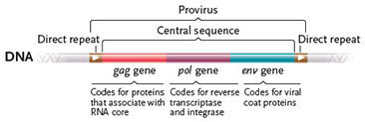
Provirus: inserted viral DNA

- Direct repeat one ach ends is capable of acting as a enhancer, promoter and termination signals for transcription (DNA RNA)
- Retroviruses and retro transposons occupy 40% of human genome
- Sometimes cause DNA rearrangements (deletions and translocations)

Cycle 4
Genetic Recombination and Meiosis

9.1
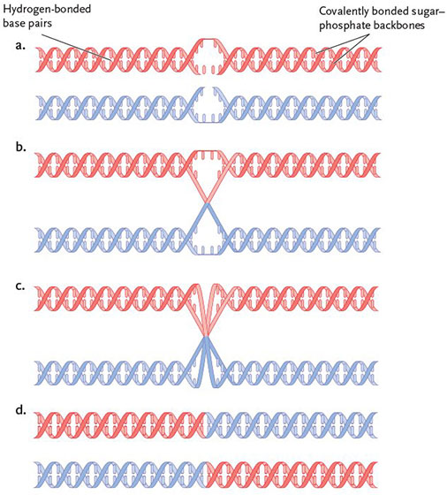

- Backbone of double helix has sugar-phosphate backbone held together by covalent bonds and base pairs are bonded by less strong hydrogen bonds
- Homologous: similar pairs recombine and pair
- Once paired, enzymes break covalent bond in each of four sugar-phosphate backbones, free ends of the backbone are then exchanged to recombine with the other DNA molecule
9.3
Genetic Recombination in Eukaryotes: Meiosis
- Sexual reproduction depends of meiosis which is a process that recombines DNA sequences and produces cells with half the number of chromosomes present in somatic cells (body cells)
- Without halving the number of chromosomes through meiosis, fertilization would double # of chromosomes in each generation

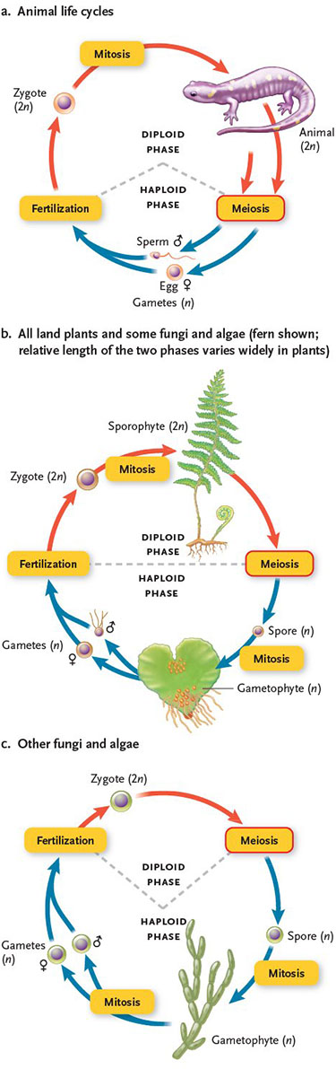

Animals and Meiosis:
- Diploid phase dominates cycle
- Haploid phase reduced
- Meiosis followed by gamete formation
- Diploid stage is multicellular
- Men produce 4 sperm cells, females only 1 of 4 nuclei become a functioning egg
- Fertilization restores cell to diploid
Most Plants and Some Fungi:
- Mitotic divisions occur during diploid and haploid stage and both can be multicellular
- Sporophyte: diploid generation produced through fertilization, produces haploid spores
  - Some undergo meiosis- producing haploid genetically different reproductive cells (spores)
  - Not gametes— germinate and grow by mitotic divisions into haploid individuals, gametophytes
  - Some gametophytes develop into egg or sperm, generally identical because they arise through mitosis not meiosis
  - Meiosis does not occur in gametophytes
Other Fungi and Algae
- Diploid stage is limited to singles cell (zygote), undergoes meiosis to produce haploid phase
- Mitotic division only occurs during haploid phase
- Haploid stage is multicellular
- Gametes are referred to as positive and negative because they are genetically similar due to that they are produced through mitosis and not meiosis
- Recombination doesn’t occur in zygote, only after multiple rounds of replication by mitosis do certain cells in multicellular body recombine by meiosis
9.3b
- Products of meiosis are not intended to contribute to body of organisms that make them
- Paternal chromosome- derived from male parent
- Maternal chromosome-derived from female parent
- Alleles: different versions/ variations of a certain gene (have similar but distinct DNA sequences,)
  - Likely encode variations of RNA or protein gene product which could have a different structure, biochemistry or both
- Each cell produced by meiosis carries only one member of each homologous pair
- Mitotic cell division ensure diploid number is maintained in 2n individuals
9.3c
- Cells destined to divide by meiosis (meiocytes), cycle as usual and enter Meiosis not mitosis after
- MEIOSIS 1
  - Homologous chromosomes find partners and pair lengthwise (Synapsis), recombination occurs during this step
  - Meiocytes continue to end of cycle, creating two daughter cells
  - Creates 2 cells, haploid number of chromosomes but each chromosome still has 2 chromatids
- MEIOSIS 2
- Sister chromatids are further separated, reducing amount of DNA in each product
- Creates 4 cells each with haploid number of chromosomes, each cell receives a sister chromatid, that becomes a single chromosomes so the number of chromosomes is still technically the same as in the product of meiosis 1

*Both stages still under go prophase, prometaphase, metaphase and telophase
- Brief stage of interphase between the meiotic divisions called interkinesis (no replication occurs during this time)
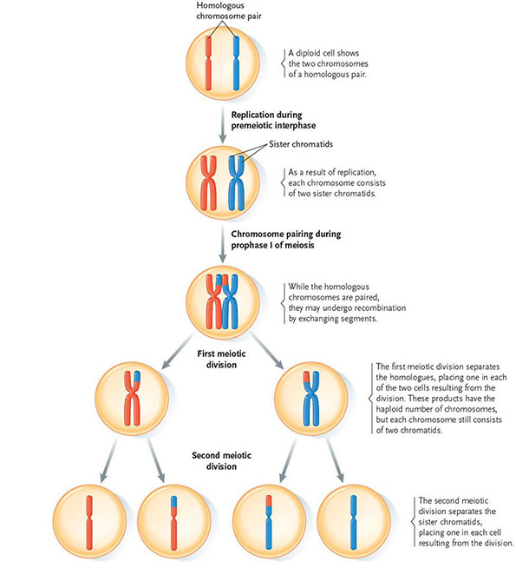

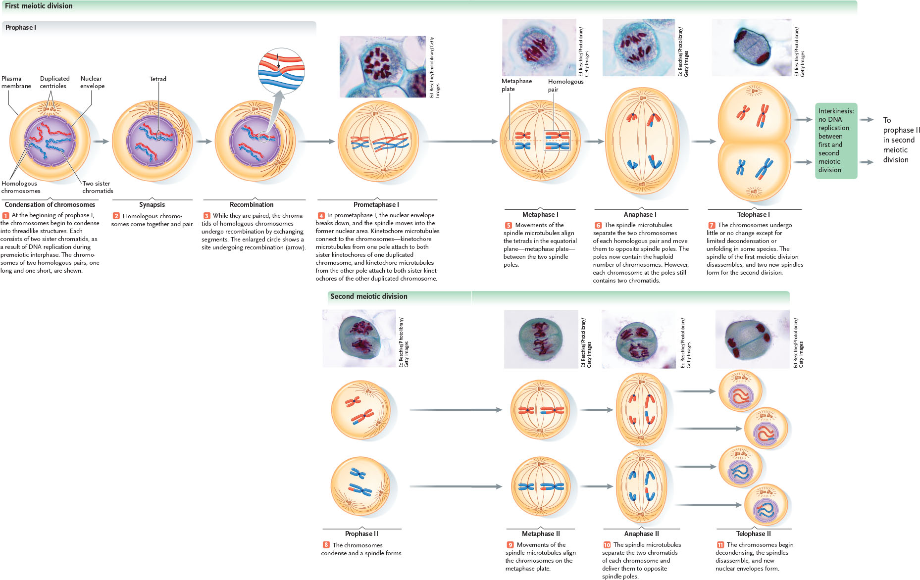

Nondisjunction: spindle fails to separate homologous chromosomes of tetrad
- As a result one pole receives both chromosomes of homologous pair, and one pole has none
- Meiosis 2 will separate chromatids as usual
- Result: gametes will have two copies of chromosome
- Failure at meiosis 2: chromatids do no separate at opposite poles results in gametes will abnormal # of chromosomes
- Zygotes with extra chromosome will have 3 copies of a chromosome instead of 2
9.3d Mechanisms contributing to genetic diversity
Genetic Variability arises from:
- Genetic recombination of homologous chromosomes
- Differing combinations of maternal and paternal chromosomes segregating to poles during anaphase 1 (random segregation)
- Differing combinations of recombined chromatids segregated to poles during anaphase 2 (independent assortment)
- Sets of male and female gamete that unite in fertilization
- Pairing of homologous chromosomes they are held together by the protein framework synaptol complex, involving the breakage and rejoining of DNA molecules by enzymes
- Any pair of non-sister chromatids may recombine
- Cross over regions are called cross-overs or chiasmata
- Pairing occurs on top of one another not side by side so that any 2 chromatids can recombine
Independent Assortment
- Different possible outcomes for the assortment of the recombined chromosomes, that are independent from other assortments
Random Fertilization
- Combination of haploid cells is entirely random
- Variation in meiosis 2 is greater
- Twins exists not from the combination of identical gametes during fertilization but from mitotic division of a single fertilized egg

CYCLE 5
Chapter 10
10.1-beginnings of genetics
- Until 1900 scientist believed in the blending theory of inheritance (traits blend evenly; red and white flower will produce pink)
- Characters: a heritable characteristic, Trait: variation of characters
- Pea plant experiment, didn’t know at the time but the dis and reappearance of certain traits was due to the segregation of chromosomes
- Most important innovation was his quantitative approach to science
10.1a
- Pea plants generally self-fertilize through anthers, so he cut them off and manually cross-pollinated them
- Used true-bleeding (pure breeding): when self-fertilized they passed traits without change from one generation to the next
10.1b
- F1 generation: first generation after a cross
- Paternal (p) generation: plants used in the initial cross, the parents
- F2 generation: second generation from a genetic cross, Mendel allowed the purple flowers to self produce resulting in F2
- White coloured traits appeared after doing so
10.1c
Mendel’s Hypotheses
- Adult plants carry a pair of factor that govern the inheritance of each character (factor=genes), alleles are the variation of factors/genes
- Dominance; if an individual’s pair of genes consists of different alleles, one allele is dominant over the other, recessive allele (dominant alleles do not directly inhibit recessive alleles)
- Pairs of alleles that control a character segregate as gametes are formed; half the gametes carry one allele and the other half carry the other allele; principle of segregation
- Homozygote; ex. PP; true-breeding and is said to be homozygous for the P allele
- Heterozygote; ex. Pp is said to be heterozygous for P trait
- Monohybrid; an F1 heterozygote produced from a genetic cross that involves a single character
- Monohybrid cross: a single cross between two individuals that are each heterozygous for the same pair of alleles
- Genotype; genetic makeup of an organism
- Phenotype; outwards appearance
10.1d
- Outcome predicted on scale of 0 to 1
- Product rule; multiplied probabilities; probability that even A and B will occur at the same time is P (A) x P (B)
- Sum Rule; probability of event A or event B happening = p (A)+p (B)

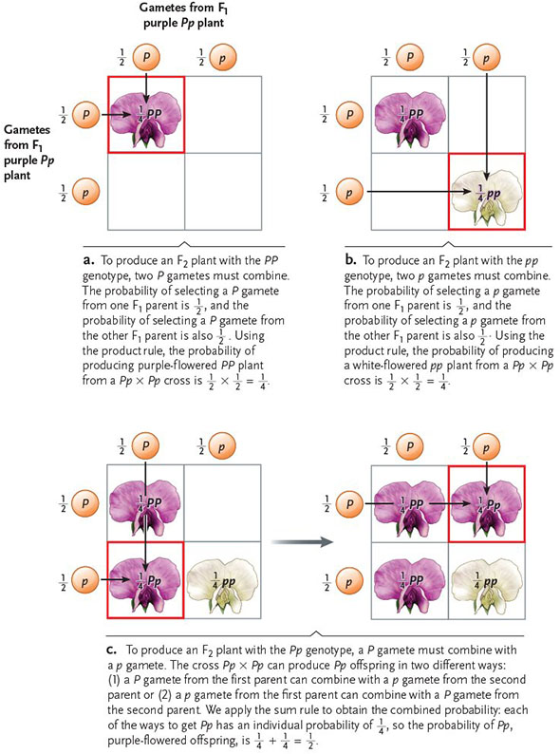

- Punnett Square; method for determining the genotypes and phenotypes of offspring and their expected proportions
10.1e
Mendel’s testcross to check validity of his hypothesis

- Use a test cross as a standard test to determine whether an individual with a dominant trait is as heterozygote or a homozygote, because it cannot be determined phenotypically
10.1f
- Zygote produced involving two characters; dihybrid
- 9:3:3:1 for dihybrid phenotype (ex. 3:1 for round: wrinkled, 3:1 yellow: green)
Principle of independent assortment: Mendel’s principle that alleles of genes governing two characters segregate independently during formation of gametes

- Expected ratio genotype dihybrid cross 1:1:1:1
10.1g
- Mendel was unable to relate behavior of his “factors” (genes) to cell structures because critical info was not yet discovered (meiosis)
10.1h
- Chromosome theory of inheritance: principle that genes and alleles are carried on chromosomes
- Locus; site in which a particular gene is located on
  - Particular DNA sequence encoding a protein or RNA product responsible for the phenotype controlled by gene
10.2 Later modifications to Mendel’s Hypotheses
- Incomplete Dominance: occurs when effects of recessive alleles can be detected in heterozygotes ex. Pink flowers when true breeding red and white are crossed
10.2b
Codominance: occurs when alleles have approx. equal effects in individuals, which make the two alleles equally detectable in heterozygotes
- Multiple alleles (more than two different alleles of a gene) can be present
  - Although one individual can have only 2 alleles for a specific gene, there are more than 2 in existence of the population
- Multiple alleles of agene each contain nucleotide difference at one or more location of DNA sequences
- Antigens responsible for blood types of ABO group are carbohydrate parts of glycoproteins located on the surfaces of red blood cells
10.2B
Epistasis: interaction of genes, with one or more alleles of a gene at one locus inhibiting effects of one or more alleles of a gene at a different locus
Result; some expected phenotypes do not appear among offspring
- Ratio will not be 9:3:3:1, it will differ
10.2E polygenetic inheritance, a character is controlled by common effect of several genes

- Polygenetic inheritance; several genes contribute to the same character
- Quantitative traits have a continuous distribution (skin color and body weight in humans); if normal distributed curve, good indication that is a quantitative (continuous) trait
- Pleiotropy; single genes affecting more than one character of an organism
- Many traits are quantitative and most genes have some pleiotropic effects

11.2 Sex linked Genes
- Autosomes; chromosomes other than sex chromosomes; in humans chromosomes 1-22 are the autosomes
- X chromosome in males allows pairing during meiosis to occur
- Each normal gamete formed by females carries one X and each male gamete carries either an X or a Y to create XX (female) or XY male
- Males receive their X chromosome only from their mother
- SRY gene (sex determining region of the Y); ‘master switch’ directing development toward maleness at an early point in embryonic development (6-8 weeks)
- Starting of growth of testes, degenerates the growth of female body structure (vagina and oviduct) that would otherwise development in the presence of the X chromosome
- Although X and Y chromosomes are considered sex chromosomes, only a few genes they carry can influence sex determination
Genes governing body structures needed by one sex or the other (breast development, facial hair etc.) are on the 1-22 autosomes
- Females still have the gene coding for male structures (penis structure) and vice versa, you just don’t express them but they are still there (carried on to offspring)
- Pedigree; shows all parents and offspring for as many generation as possible for humans, presence or absence of the trait of interest
Females are shown by circle, males by a square, solid circle or Solid Square represents the presence of the interested trait
- In humans and fruit flies, recessive traits occur more often in males than females because males need to receive only one copy of the allele on X chromosome inherited form mothers to develop the trait
Females must receive two copies of trait on X chromosome, one from mother one from father
- Carrier; carry a mutant allele and can be passed to offspring, however it is not expressed on self

Products from genes on X chromosome could be equalized (equal probability of receiving a gene) in males and females if;
- Expression of genes on single male X chromosome were doubled OR
- Expression of genes on both female X chromosomes were halved OR
- One X chromosome were turned of in females
- Females (XX) inactivate most of the genes on one X chromosomes or the other in most body cells, either paternal or maternal
  - Occurs by condensation process that fold and packs chromatin of one of the two X chromosomes into a tightly coiled state (Barr Body)
Inactivation occurs during embryonic growth
- Once one of the X chromosomes is inactivated in a cell, all descendants inactivate the same X chromosomes
One X is active in particular cells and inactive in others (and vice versa)
- If the X chromosomes carry different alleles of a gene, when inactivated, the other allele will show and vice versa
Ex. Calico Cat (black and orange fur, where the orange fur is active, black fur isn’t and vice versa)
*White patches of fur result from interactions with a third autosomal gene that entirely blocks the fur pigment so it becomes white
* Mutant alleles have no effect on fur only show when allele for dominant is inactivated

CYCLE 6

18.2
- Gene pool; sum of all alleles at all gene loci
- P-frequency of one allele, q frequency of other allele

18.3 Evolutionary Agents

Agents of Micro evolutionary Change
Agent | Definition | Effect on Genetic Variation
Agent | Definition | Effect on Genetic Variation
Mutation | Heritable change in DNA | Introduces new genetic variation into population; does not change allele frequencies quickly
Gene flow | Change in allele frequencies as individuals join a population and reproduce | May introduce genetic variation from another population
Genetic drift | Random changes in allele frequencies caused by chance events | Reduces genetic variation, especially in small populations; can eliminate rare alleles
Natural selection | Differential survivorship or reproduction of individuals with different phenotypes | One allele replacing another or allelic variation being preserved
Nonrandom mating | Choice of mates based on their phenotypes and genotypes | Does not directly affect allele frequencies, but usually prevents genetic equilibrium

Mutations; spontaneous heritable change in DNA, rare events, so rare they have little or no immediate effect on allele frequencies, over evolutionary time scales numbers are significant, can be major source of heritable variation
- For most animals, only mutation in germ line (cell lineage that produce gametes) are heritable
- In plants mutations occur in meristem cells, which can alter gene pool
- Classify mutation on an organism’s fitness (advantageous or not) not on underlying molecular changes
- Deleterious mutations; alter individual’s structure, function or behavior in harmful ways
- Neutral Mutations; neither harmful or helpful; may prove to be beneficial later in environmental changes
Gene Flow
- Organisms or their genetic material may move from one population to another
- If immigrants reproduce they may introduce novel alleles into a population, shifting allele and genotype frequencies
- Dispersal agents (ex pollen-carrying wind) are responsible for gene flow inmost plants
- Movement alone of population to another doesn’t alter gene flow, they must reproduce to do so
Genetic Drift
- Chance events that cause a change in allele frequencies of a population
- Dramatic effects on small populations (violating hardy-Weinberg assumption of infinitely large pop’n size)
- Population Bottleneck; stressful factor (disease, starvation etc.) kills large portion of population, dramatically reducing population size
= Reduces genetic variation
- Founder Effect; few individuals migrate and start new population, by chance some alleles may be missing and rare alleles may be more frequent
- Electrophoresis identified many polymorphisms in a population
- Nearly half the loci surveyed are polymorphic
- Variations in protein-coding regions of DNA do not change amino acid sequences of proteins (which genes code)
Natural Selection and Genetic Variability
- Hardy-Weinberg model; require all genotypes in pop’n to survive and reproduce equally well
- Natural selection, some traits become more advantageous in an environment and therefore increase in frequency
- It is phenotype of individual organism, not particular alleles that make it successful or not (because both favorable and unfavorable are passed)
- Relative Fitness; used to evaluate reproductive success, # of surviving offspring an individual produces compared to other members of pop’n
- *** Difference in relative success of individuals are the core of natural selection
- N.S has little effect on trait appearing after an individual reproduces
Nonrandom Mating
- H.W model require individuals o select mates randomly, with respect to their genotypes
- If mating isn’t random, next generation will contain fewer heterozygous offspring and more homozygous (H.W model)
- Inbreeding; non random mating where genetically related individuals mate, generally increases frequency of homozygous genotypes, recessive phenotypes are often expressed
Hardy Weinberg Principle
- Specifies condition under which a population of diploid organisms achieves genetic equilibrium; point where neither allele frequencies or genotype frequencies change in succeeding generations
- In studies using observational rather than experimental data there needs to be controls (null models; what on would see if factor had no effect)
Serve as theoretical reference points
- Genetic equilibrium only possible if;
- No mutations occur
- Population is closed to migration from other populations
- Population is infinite in size (no genetic drift)
- All genotypes survive and reproduce equally well
- Individuals mate randomly with respected trait
(p+q) x (p+q)= P^2 + 2pq + q^2
Ex. Are the predicted frequency of the genotype; 2pq, the predicted frequency of the genotype; and, the predicted frequency of the genotype?

CYCLE 8
47.12, 47.13, 47.14, 47.15
47.12 Social Behavior
- Social behavior effects individual’s reproductive success
- When a new male takes over a pride, he kills all nursing young to ensure his succession (infanticide)
- Females can be more productive (output of young) when part of a pride
- Increased competition for food in groups
- Communal living may facilitate spread of disease
- Not all animals living in groups are social
- Social animals live in groups usually identifiable by a dominance hierarchy, must constantly defend status
- Relative dominance; status depends on circumstance
47.13 Kin Selection and Altruism
- Degrees of relatedness quantifies average percentage of alleles shared by relatives
- Kin selection; helping those related to you
- Altruism; doing something that enhances the situation of another individual (not related to)
- Reciprocal Altruism; individuals will help those not related to them if they expect the favor to be returned in the future
Would be favored by N.S as long as individuals that don’t reciprocate, are denied in the future
- Competitive altruism; individuals compete with one another to be more cooperative, longer lived species are more likely to develop cooperative behavior than shorter lived ones
Eusocial Animals
- Eusocial; usually in insect species, numerous related individuals live and work together in colony for reproductive benefit of queen and her mate(s)
- Haplodiploidy; sex determination where females are diploid and males are haploid
- Queen bee is only fertile female, rest are her sterile daughters
- Worker bees are related to each other on average 75%, off springs inherit all of males alleles and half hers
- High degree of relatedness in eusocial insects may explain high level of cooperation
- Dispersal; mechanism that can reduce chances of incestuous mating and inbreeding
47.15 Human Social Behavior
- Cultural intelligence hypothesis; large brain size in humans reflects cognitive skill sets absent from great apes
- Ultimatum came; used to assess responses of individuals to opportunities and the behavior of other, proposer offered sum of money (or food) if the responder accepts the offer, then both receive their share of the reward. If the responder rejects the offer, then neither gets any reward. The economic model predicts that the proposer will offer the responder the minimum award.
- 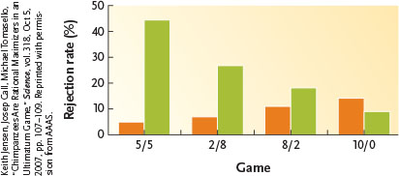
- Chimps are maximum rationalizers because they follow economic model and are not sensitive to fairness of others
- Humans are not rational maximizes because they are sensitive to fairness and interest of other

- Kin selection predict humans (and other animals) that are genetic relatives will benefit from assisting the members of their family

- Child abuse is 40x higher when living with unrelated step parent and one genetic parent, as with children living with both genetic parents

CYCLE 9
20.1 and 20.2
20.1 The Geological Time Scale

- Many fossils are found in sedimentary rock
- If they haven’t been disturbed the strata are arranged in the order in which they formed, with the youngest on top
- Fossils found in a particular stratum represent organisms that lived and died around the same time in the past
- Geologic time scale is created relative to each layer of stratum
- SEE GEOLOGICAL TIME SCALE AND MAJOR EVOLUTIONARY EVENTS AT END
20.2 The Fossil Record
- Tree resin fossils show fine detail
- Incomplete fossil record because some organisms are more likely to fossilize than others and natural processes may destroy many fossils
- Tomography; use of thin sections cut from a fossil to reconstruct its appearance
Early Fossils
- Stromatolites; first fossil evidence of life dates to approx. 3.5 billion years ago
- Unicellular just over 2 bya
- Multicellular 1.2 bya
- History of earth was not gradual
Importance of Skeletons
- Explosions of life marked the beginning of the Cambrian
- Early bacteria and plant fossils are detectable due to presence of cell wall which kept it secure
- Absence of cell walls and analogous structure in invertebrates led to fewer fossils
- Ediacaran fossils suggest there was supporting systems of cuticles
- Insects and arthropods fossilized due to their exoskeletons
- Cretaceous-Paleocene event (66mya) killed most of dinosaurs and 75% of all species, at least 70% of all species went extinct
- Adaptive radiation; each lineage could diversify rapidly, taking advantage of new niches and a reduced amount of competition
- Soft tissues are usually found as moulds, hard tissues fossilize as minerals

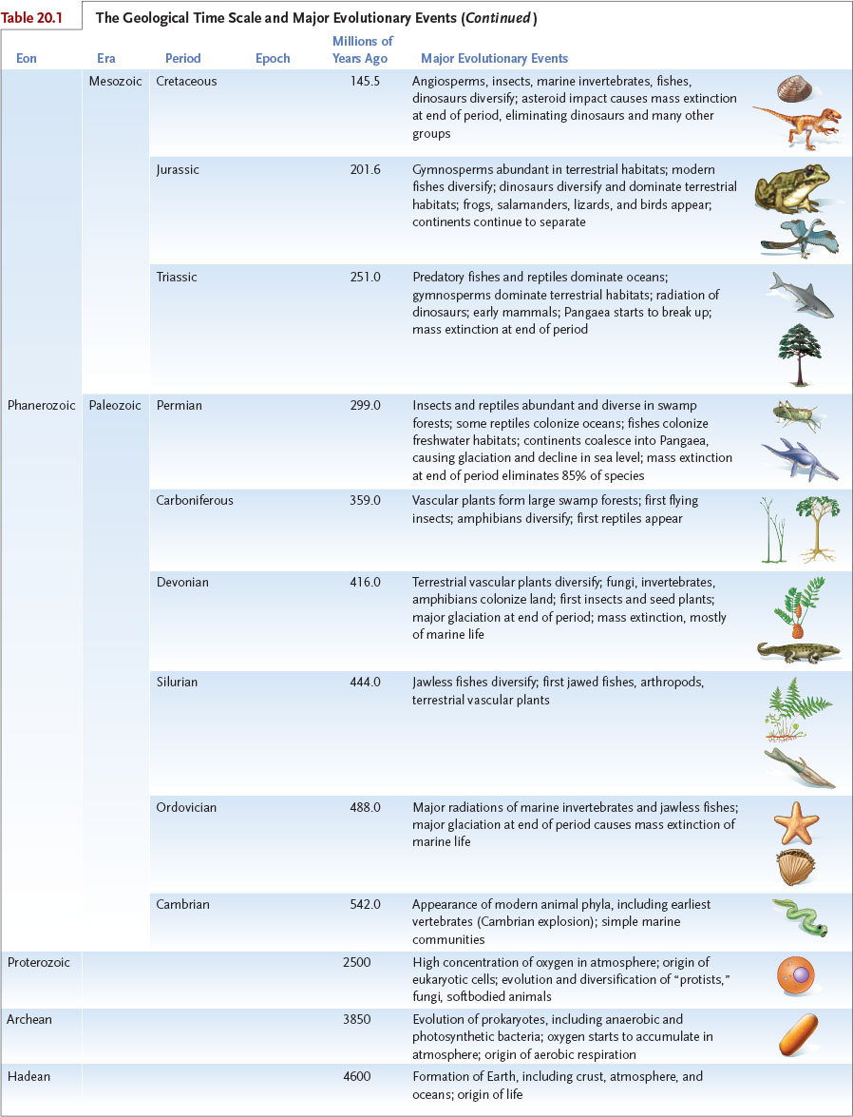
20.4 Phylogeny
- Phylogenies shoe evolutionary history of group of organism, presented as phylogenic trees; formal hypotheses that identify likely relaitonshhips amount group
- Most contain prehistoric organisms, along with modern day ones
- Nodes; branching points define how recently sister clades diverges
- Clades; that stem from common ancestor ex. Humans and chimps, clades emerging from tips of branches are more closely related than clades emerging form older node (root of tree)
- Morphology, patterns of behavior, chromosomal anatomy, detail of physiology, morphology of subcellular structure cells, organ system, molecular sequences of nucleic acids and proteins are characters used to determine phylogeny s
- Used to analyze evolutionary processes
  - Allow us to determine similarities inherited from common ancestor and those evolved independently in response to similar environments
- Most biological experiments need closely related species and the trees are able to determine this
- Used as a comparative method
- Hybrid species would ‘cross branches’ in phylogenic tree, leading to misrepresentation of relatedness
- Fossil record is not complete so systematics rely largely on phenotypic traits as indicator of genetic similarity/divergence
  - Attempt to exclude difference caused by environmental conditions
- Useful characters must be genetically independent
  - Important because different organismal characters can have the same genetic basis
  - Each genetic variation should only be used once
Homologous Characters
- Characters that are similar in evolutionary history but not necessarily function
- Reflect underlying genetic similarities, can indicate common ancestries and genetic relatedness
- Emerge form comparable embryonic structures and grow in similar ways during development
Analogous Characters
- Character in different animals that serve the same purpose
- Homoplasious; phenotypic similarities that evolved independently in different lineages ex. Flattened tails of beavers and platypuses
- Systematics exclude homoplasies from analyses because they provide no info about shared genetic ancestry
- Parallel evolution; not related but similar characters
- Mosaic evolution; in all evolutionary lineages some characters evolve slowly while others evolve rapidly
- Ancestral characters; old form traits
- Derived characters; new forms of traits
  - Derived character provide most useful info
- Out-group comparison; technique used to identify ancestral and derived characters by comparing group with more distant related species
- Principle of monophyly; principle of systematic biology defining monophyletic taxa
- Monophyletic taxa; group of organisms including a single ancestral species and all its decedents
- Polyphyletic taxa; include species from separate evolutionary languages
- Paraphyletic taxon; includes an ancestor and some but not all descendants
- Assumption of parsimony; assumption that simplest explanation should be most accurate
20.4c
- Traditional evolutionary systems; places together groups of species sharing ancestral and derived characters
20.4d
- Cladistics; ignores morphological divergence; only reflects the branching pattern of evolution
- Cladists place species that share derived characters in one group
  - Argue mammals from a monophyletic lineage (clade) due to derived characters
  - Cladograms illustrate hypothesized sequence of evolutionary branching with a hypothetical ancestor at each branching point
- Only portray monophyletic groups using the assumption of parsimony (simplest explanation that fits evidence)
- Out-group still included
- Phylocode; system identifying and naming clades instead of placing organisms into familiar taxonomic groups

CYCLE 10
19.1, 19.2, 19.3
- Evolutionary biologists view speciation as a process, a series of events occurring through time
- Usually study products of speciation
- Species; population of organisms capable of interbreeding and producing fertile offspring, doesn’t work for asexual reproducing organisms, different definition for each group
  - Based on perception that Earth’s biological diversity is discrete, recognizable units not as continuum of forms
  - Carolus Linnaeus was first practitioner of taxonomy; classification of species
  - He invented binomial nomenclature; species assigned Latinized two part-name, species name or binomial
    - First is genus second is specific epithet (species name in binomial)

- Binomials are universal and allow people everywhere to discuss organisms
- Linnaeus’ classification to keep track of species is called taxonomic hierarchy; formal categories of domain, kingdom, phylum, class, order, family, genus, species and subspecies
19.2
Morphological species concept; all individuals of species share measurable traits distinguishing them from other species
- Used by paleobiologist to identify fossilized species
- Doesn’t distinguish some closely related species nearly identical in appearance
- Tell us little about evolutionary processes producing new species
Biological species concept
- Emphasizes dynamic nature of species
- Definition of species based on ability of populations to interbreed and produce fertile offspring
- Defines species in terms of population genetics and evolutionary theory
  - 1st half; genetic cohesiveness of species; same species experience gene flow mixing genetic material (large gene pool divided into local populations)
  - 2nd half; emphasizes genetic distinctness of species; populations of different species are reproductively isolated, they can’t exchange genetic info
- Often morphological characteristics are used to emphasize similarities/differences as markers of genetic similarity or reproductive isolation
- Doesn’t apply to asexually reproducing organisms (don’t interbreed)
- Doesn’t apply to extinct organisms; little or no data on reproductive behaviors
- Provides best evolutionary definitions of sexually reproducing species
- Defines species in terms of population genetics and evolution theory in static world
- Molecular sequences provide data and can be compared between related organisms that share no organismal characters
  - Can be used to study related species with only minor morphological differences
  - Nucleic acids aren’t affected by developmental or environmental factors that cause non-genetic morphological variations
- Drawbacks of molecular characters; only 4 nucleotide bases, if two species have same base at given position in DNA segment, the similarity may have evolved independently (difficult to verify if similarities were inherited from a common ancestor)
Phylogenetic Species Concept; using both morphological and genetic sequence data to construct evolutionary tree
- Define phylogenetic species as cluster of population
- Advantages; can be applied to any group, including extinct, asexually reproducing, different branch reflects absence of gene flow between them (key requirement of biological species definition)
- Disadvantages; not yet able to be applied to all forms of life
19.3 Prezygotic Isolating Mechanisms
- 5 mechanisms that can prevent interspecific (between species) mating or fertilizations which would produce a hybrid
- Ecological isolation: separation of habitats prevents interbreeding
- Temporal Isolation: mating at different times of the year
- Behavioral isolation: signals used by one species aren’t used by another species
- Mechanical Isolation: differences in structure of reproductive organs and other body part preventing interbreeding
- Gametic isolation: incompatibility between the sperm if one species and the eggs of another
Post-zygotic isolating mechanisms
- Hybrid Unavailability: developmental instructions may not interact properly to form successful zygote
- Hybrid Sterility: parent species differ in number or structure of their chromosomes (can’t pair correctly during meiosis), therefore offspring can’t reproduce (ex. mule; cross between female horse and male donkey)
- Hybrid Breakdown: hybrids are capable of reproducing but their offspring have either reduced fertility or reduced viability
21.4 and 21.5
21.4 Dispersal of Early Humans
- Two theories on human ancestry origins
- African Emergence hypothesis; proposes that early hominine descendentz (archaic humans) left Africa and established populations in Middle East, Asia, Europe
- 100 to 200 tya Sapiens arose in Africa and also migrate into Europe and Asia
- Archaic humans were eventually driven to extinction by Sapiens
- Suggests all modern humans are descended from a fairly recent African Ancestor
- Multiple Regional Hypothesis: suggest populations of H.Erectus and archaic humans spread throughout Europe and Asia by 500 tya and H. Sapiens evolved from descendants of these earlier dispersals
- Gene flow between species prevents reproductive isolation and maintained them as H. Sapiens

- Paleontological data doesn’t clearly support either hypothesis
- As of 2011 genetic data favors the African emergence hypothesis
- Work on Y chromosome in men in continents confirms all modern humans are descendants of a single migration out of Africa
- Fossils show homo erectus occupied India 1.5 mya
- Acheulian cultures are identified by large cutting tools with bifaces
- Homo flroensiensis were Flores island (Indonesia) 1 mya
- Human occupied New Guinea approx. 49 tya, they cleared forests and promoted growth of their new plants
21.4 a The Denisovans
- Sister group to Neanderthals
- Lived in southeast Asia and interbred with ancestors of today’s Melanesians
- Components of our immune system we acquired through allele HLA-B*73 inherited from denisovans in west Asia
- Some HLA haplotypes entered modern European and Oceania human populations from Neanderthals and denisovans
21.5 Hominins and Species Concepts
- Ancestors of modern humans interbred with both Neanderthals and denisovans
- Applying biological species concept, they are not separate species (because they were able to interbreed)
- Phylogenetic species concept; distinction is less clear
- Morphological evidence from fossils is incomplete
- Fossils from dmanisi from 1.7 mya identified as homo gerogicus show same morphology of humans and chimps

