Acute Intracranial Problems

Intracranial Pressure
- Factors that influence ICP under normal circumstances are changes in:
  - BP
  - Cardiac function
  - Intra-abdominal and intrathoracic pressure
  - Body position
  - Temperature
  - Blood gases, particularly CO2 levels

Regulation and Maintenance of ICP

Normal ICP
- ICP is the pressure exerted because of the combined total volume of the three components within the skull: brain tissue, blood, and CSF
- If the volume in any one of the three components increases within the cranial vault and the volume from another component is displaced, the total intracranial volume will not change
- If the volume of any one of these three components increases without a corresponding decrease in another component, the result is an elevated ICP
- This hypothesis is not applicable in situations in which the skull is not rigid (ex: in neonates, in adults with unfused skull fractures)

Normal Compensatory Adaptations
- Intrinsic compensatory mechanisms exist to resist increases in ICP
- A major compensatory mechanism involves changes in the CSF volume
- They are achieved primarily by the displacement of CSF into the spinal subarachnoid space or to the basal subarachnoid cisterns and to a lesser degree by altering CSF production and absorption rates
- Alterations in intracranial blood volume occur through the compression of cerebral veins and dural sinuses, regional cerebral vasoconstriction or dilation, and changes in venous outflow
- Brain tissue volume compensates through distension of the dura or compression of brain tissue
- Initially, an increase in volume produces no inc in ICP because of these compensatory mechanisms
- However, compensatory adaptations are finite, and progressive inc in volume eventually exhaust compensatory mechanisms
- The result is inc ICP, neuronal compression, and ischemia

Cerebral Blood Flow
- CBF is the amount of blood in mL passing through 100g of brain tissue per minute
- Adult: approx. 50mL of blood/min/100g of brain tissue or approx. 750mL/min
- Brain uses 20% of the body’s oxygen and 25% of its glucose

Autoregulation of Cerebral Blood Flow
- Autoregulation: the brain’s intrinsic ability to regulate its own blood flow in response to its metabolic needs despite wide fluctuations in systemic arterial pressure
  - Automatic alteration in the diameter of cerebral blood vessels to maintain a constant blood flow to the brain during changes in BP
  - The purpose is to ensure adequate CBF to meet the metabolic needs of brain tissue and to maintain cerebral perfusion pressure within normal limits
- In healthy individuals, autoregulation operates within limited parameters
- In cases of extreme hypotension or HTN, autoregulation fails
- If MAP is less than 50mmHg, CBF is dec and symptoms of cerebral ischemia may occur
- If MAP is greater than 150mmHg, the cerebral vessels are maximally constricted and further vasoconstrictor response is lost; CBF inc and intracranial HTN may occur

Other Factors Affecting Cerebral Blood Loss
- CO2, O2, and H+ concentration
- PaCO2 is a potent factor in vasoactive reactivity
- An inc in PaCO2 relaxes smooth muscle, dilates cerebral vessels, dec cerebrovascular resistance, and inc CBF
- A dec in PaCO2 reverses this process and dec CBF
- PaO2 below 50mmHg results in cerebral vascular dilation
- This dilation dec cerebral vascular resistance and inc CBF
- If PaO2 is not raised, anaerobic metabolism begins, resulting in the accumulation of lactic acid
- As lactic acid inc and H+ ions accumulate, the cerebral environment becomes more acidic
- Within this acidic environment, further vasodilation occurs in a continued attempt to inc blood flow
- The combination of a severely low PaO2 and an elevated H+ concentration (acidosis), which are both potent cerebral vasodilators, may produce a state wherein autoregulation is lost and compensatory mechanisms fail to meet tissue metabolic demands
- CBF can be globally affected by cardiac or respiratory arrest, systemic hemorrhage, and other pathophysiological states (ex: diabetic coma, encephalopathies, infections, toxicities)
- Regional CBF can also be affected by trauma, tumours, cerebral hemorrhage or stroke
- When regional or global autoregulation is lost, CBF can no longer maintained at a constant level but is directly influenced by changes in systemic BP, PaCO2, or catecholamines
- CBF can be indirectly reflected by calculating cerebral perfusion pressure (CPP)
- CPP: the pressure needed to ensure adequate brain tissue perfusion
- CPP = MAP – ICP
- If CPP is inadequate, brain perfusion can be improved by either dec ICP or inc MAP
- As the CPP dec, autoregulation and CBF dec
- Normal CPP is 70-100mmHg, and a min of 50-60mmHg is necessary for adequate cerebral perfusion
- CPP less than 50mmHg is associated with cerebral ischemia
- A CPP below 30mmHg results in cellular ischemia and is incompatible with life
- Under normal circumstances, autoregulation maintains an adequate CBF and perfusion pressure primarily by cerebral vasoreactivity and metabolic adjustments that affect ICP
- It is important to maintain MAP when ICP is elevated

Pressure Changes
- Compliance: the expandability of the brain
  - It is represented as the volume inc for each unit inc in pressure
  - With low compliance, small inc in volume result in greater inc in pressure
- Compliance = volume/pressure
  - Represents the stages of inc ICP
- Stage 1: there is high compliance; the brain is in total compensation, with accommodation and autoregulation intact
- An inc in volume does not inc the ICP
- Stage 2: the compliance is lessening, and an inc in volume places the pt at risk of inc ICP
- Stage 3: there is low compliance as compensatory mechanisms are becoming exhausted
- Any small addition in volume causes a great inc in ICP
- As compensatory mechanisms fail, there is a loss of autoregulation, and the pt may exhibit symptoms indicating ICP:
  - Headache
  - Changes in LOC
  - Pupil responsiveness
- Stage 4: the ICP rises to lethal levels with even slight inc in volume
  - Pt is at significant risk for hypoperfusion and brain herniation and death
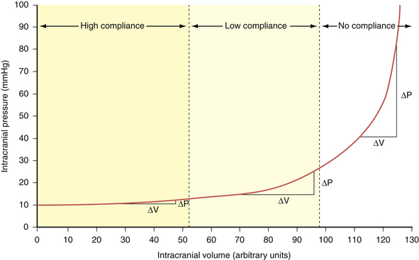

Increased ICP

Mechanisms of Increased ICP
- The brain component of ICP can be inc by cerebral neoplasm, contusion, abscess, or cerebral edema
- Conditions that inc the cerebral blood volume include intracranial hematomas or hemorrhages, metabolic and physiological factors and vascular anomalies
- Inc in the CSF volume can result from CSF-secreting tumours or hydrocephalus
- These cerebral insults may result in hypercapnia, cerebral acidosis, impaired autoregulation, and systemic HTN, which promote the formation and spread of cerebral edema
- This edema distorts brain tissue, further inc the ICP, which leads to even more tissue hypoxia and acidosis
- Crucial to preservation of tissue is maintenance of CBF
- Elevations in pressure that are more evenly distributed throughout the brain or slow inc in ICP preserve blood flow better than a rapid inc, as in primary brain injury

Cerebral Edema
Causes of Cerebral Edema
- Mass lesions
  - Brain abscess
  - Brain tumour (primary or metastatic)
  - Hematoma (intracerebral, subdural, epidural)
  - Hemorrhage (intracerebral, cerebellar, brainstem)
- Head injuries
  - Contusion
  - Diffuse axonal injury
  - Hemorrhage
  - Post-traumatic brain swelling
- Brain sx
- Cerebral infections
  - Meningitis
  - Encephalitis
- Vascular insult
  - Anoxic and ischemic episodes
  - Cerebral infarction (thrombotic or embolic)
  - Venous sinus thrombosis
- Toxic or metabolic encephalopathic conditions
  - Lead or arsenic intoxication
  - Hepatic encephalopathy
  - Uremia

Vasogenic Cerebral Edema
- The most common type
- Occurs mainly in the white matter and is attributed to changes in the endothelial lining of cerebral capillaries
- These changes allow leakage of macromolecules from the capillaries into the surrounding extracellular space, resulting in an osmotic gradient that favours the flow of water from the intravascular to the extravascular space
- A variety of insults, such as brain tumours, head trauma, abscesses, and ingested toxins, may cause an inc in the permeability of the BBB and produce an inc in the ESF volume
- Systemic BP, the site of the brain injury, and the extent of the BBB defect influence the speed and extent of the spread of the edema fluid
- Symptoms: ranging from focal neurological deficits to disturbances in consciousness, including coma

Cytotoxic Cerebral Edema
- Results from a local disruption of the function or morphological integrity of cell membranes and occurs most often in the grey matter
- Develops from destructive lesions or trauma to brain tissue that lead to cerebral hypoxia or anoxia, Na depletion, and syndrome of inappropriate antidiuretic hormone (SIADH)

Interstitial Cerebral Edema
- The result of periventricular diffusion of ventricular CSF in a pt with uncontrolled hydrocephalus
- Can also be caused by enlargement of the extracellular space because of systemic water excess (hyponatremia)
- Fluid moves into the cells to equilibrate with the hypo-osmotic interstitial fluid

Clinical Manifestations
- Change in LOC
  - Result of impaired CBF, which deprives the cells of the cerebral cortex and the RAS of oxygen
  - Interruptions of impulses from the RAS or alteration in the functioning of cerebral hemispheres can cause unconsciousness
- Changes in vital signs
  - Caused by inc pressure on the thalamus, the hypothalamus, the pons, and the medulla
  - Manifestations such as Cushing’s triad (widening pulse pressure, bradycardia with a full and bounding pulse, irregular respiratory patterns) may be present but often do not appear until ICP has been inc for some time or suddenly and markedly inc
- Ocular signs
  - Compression of the oculomotor nerve results in dilation of the pupil ipsilateral to the mass or lesion, sluggish or no response to light, inability to move the eye upward, and ptosis of the eyelid
  - Signs of dysfunction of these cranial nerves (II, IV, VI) include blurred vision, diplopia, and changes in extraocular eye movements
  - Central herniation may initially manifest as sluggish but equal pupil responses
- Dec in motor function
  - A contralateral hemiparesis or hemiplegia may be seen, depending on the location of the source of the inc ICP
  - Decorticate and decerebrate may also be elicited by noxious stimuli
- Headache
- Vomiting

Complications
- Major complications: inadequate cerebral perfusion and cerebral herniation
  - Cingulate herniation occurs when there is lateral displacement of brain tissue beneath the falx cerebri
  - Tentorial herniation occurs when a mass lesion in the cerebrum forces the brain to herniate downward through the tentorial incisura
  - Cerebellar tonsillar herniation occurs when there is lateral and downward herniation of the cerebellar tonsils through the foramen magnum

Dx Studies
- MRI
- CT
- MRA
- CTA
- Conventional cerebral angiography
- EEG
- ICP measurement
- Brain tissue oxygenation measurement
- Transcranial Doppler studies
- Evoked potential studies

Nursing Management: Inc ICP

Nursing Assessment

GCS
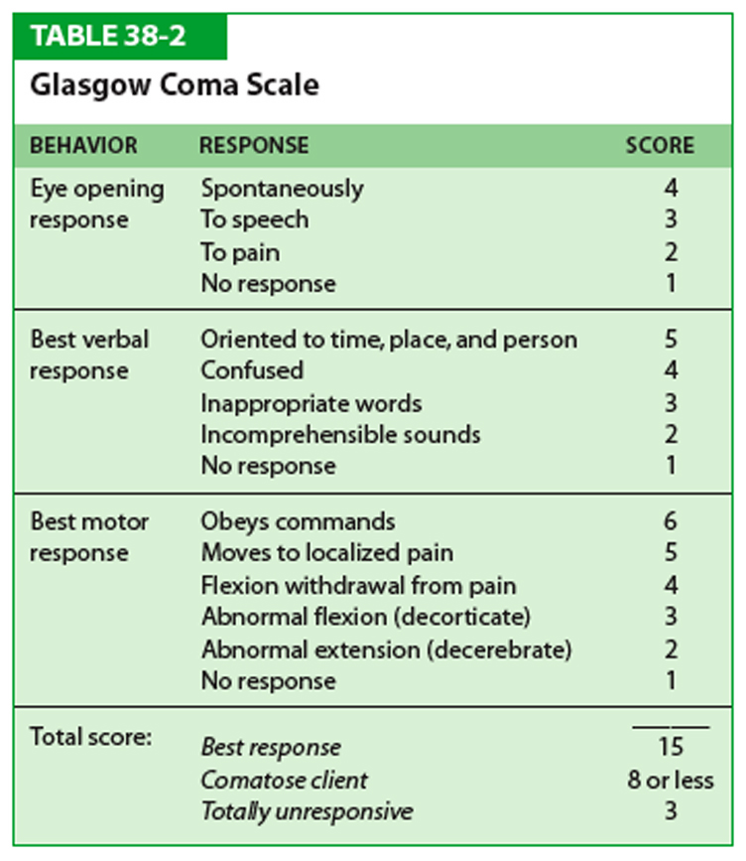

Neurological Assessment
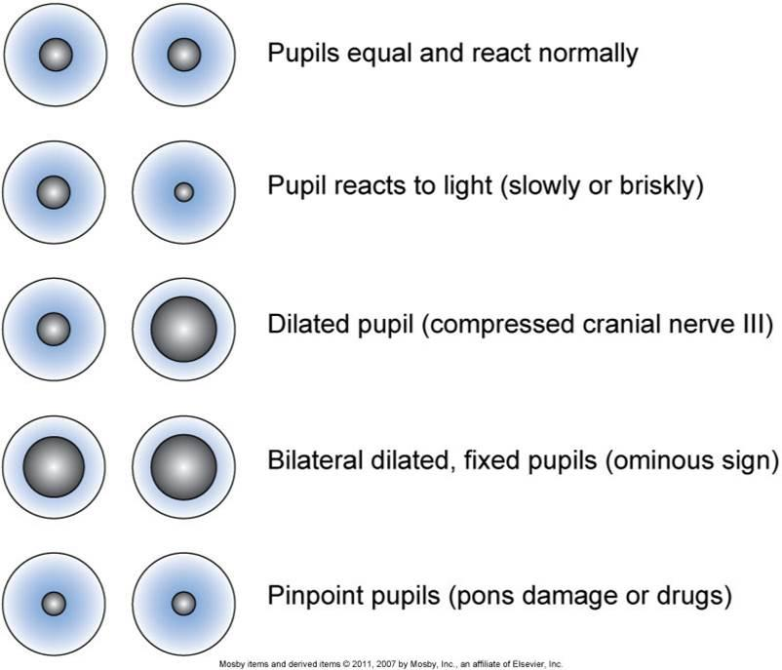

Planning
- Overall goals:
  - Maintain a patient airway
  - Have ICP and CPP within normal limits
  - Demonstrate normal fluid and electrolyte balance
  - Have no complications secondary to immobility and dec LOC

Nursing Implementation

Acute Intervention

Respiratory Function
- As the LOC dec, the pt is at inc risk of airway obstruction from the tongue dropping back and occluding the airway or from accumulation of secretions
- Altered breathing patterns may become evident
- Airway patency can be aided by keeping the pt lying on one side, with frequent position changes
- Must use measures to prevent hypoxia and hypercapnia
- Elevation of the head of the bed by 30o enhances respiratory exchange and aids in dec cerebral edema
- Abd distension can interfere with respiratory function and should be prevented
- Inc intra-abd or intra-thoracic pressures can contribute to elevated ICP by impeding cerebral venous drainage

Fluid and Electrolyte Balance
- IV fluids should be closely monitored with the use of a limited-volume device or a volume-control apparatus for accuracy
- I+O, with insensible losses and daily weights considered, are important parameters
- Electrolyte determinations should be made daily, and any abnormal values should be discussed with the physician
- Especially important to monitor serum glucose, sodium, potassium, and osmolality
- Urinary output is monitored to detect problems related to diabetes insipidus (DI)
- SIADH, which results in dec urinary output; and cerebral salt wasting, a form of hyponatremia caused by excessive renal Na excretion associated with cerebral insult
- DI may result in severe dehydration unless treated
- Usual tx is fluid replacement, vasopressin, or desmopressin acetate
- SIADH results in a dilutional hyponatremia that may produce cerebral edema, changes in LOC, seizures, and coma

Monitoring ICP
- Valsalva’s manoeuvre, coughing, sneezing, hypoxemia, pain, fever, and environmental stimuli are factors that can inc ICP
- Nurses should be alert to these factors and should attempt to keep them to a min

Body Position
- Head-up position
- Prevent extreme neck flexion, which can cause venous obstruction and contribute to elevated ICP
- Traditional practice: elevate the head of the bed to 30o, unless a concurrent cervical neck injury has been identified
- Elevation of the head of the bed reduces sagittal sinus pressure, promotes venous drainage from the head, and dec the vascular congestion that can produce cerebral edema
- Above 30o may dec CPP
- Turn the pt with slow, gentle movements b/c rapid changes in position may inc the ICP

Protection from Injury
- Protection from self-injury (confusion, agitation, and the possibility of seizures)
- Restraints may be considered
- Have a family member stay with the pt

Psychological Considerations
- Anxiety over the dx and the prognosis for the pt with neurological problems can be distressing to the pt and the family
- Need for support, info, and education of patients, families, and caregivers

Head Injury
- Includes any trauma to the scalp, the skull, or the brain

Types of Head Injuries

Scalp Lacerations
- Most minor type
- Most are associated with profuse bleeding
- Major complications: blood loss and infection

Skull Fractures
- Frequently occur with head trauma
- Several ways to describe:
  - Linear: break in continuity of hone without alteration of relationship or parts (low-velocity injuries)
  - Depressed: inward indentation of skull (powerful blow)
  - Simple: linear or depressed skull fracture without fragmentation or communicating lacerations (low-to-moderate impact)
  - Comminuted: multiple linear fractures with fragmentation of bone into many pieces (direct, high-momentum impact)
  - Compound: depressed skull fracture and scalp laceration with communicating pathway to intracranial activity (severe head injury)
- Location alters the presentation of the manifestations
- Two methods of testing can be used to determine whether the fluid leaking from the nose or ear is CSF:
  - To test the leaking fluid with a Dextrostix or Tes-Tape strip to determine whether glucose is present (CSF gives a positive reading for glucose)
  - If blood is present in the fluid, testing for the presence of glucose is unreliable because blood contains glucose
  - In this event, the nurse should look for the halo or ring sign
  - To perform this test, the nurse allows the leaking fluid to drip onto a white pad or towel and observes the drainage
  - Within a few mins, the blood coalesces into the centre, and a yellowish ring encircles the blood if CSF is present
- Major complications: intracranial infections and hematoma, as well as meningeal and brain tissue damage

Clinical Manifestations of Different Types of Skull Fractures
Location | Clinical Manifestations
Frontal Fracture | Exposure of brain to contaminants through frontal air sinus, possible association with air in forehead tissue, CSF rhinorrhea, or pneumocranium
Orbital Fracture | Periorbital ecchymosis (raccoon eyes), optic nerve injury
Temporal Fracture | Boggy temporalis muscle because of extravasation of blood, Battle’s sign, CSF otorrhea, middle meningeal artery disruption, epidural hematoma
Parietal Fracture | Deafness, CSF or brain otorrhea, bulging of tympanic membranes caused by blood or CSF, facial paralysis, Battle’s sign
Posterior Fossa Fracture | Occipital bruising resulting in cortical blindness, visual field defects; rare appearance of ataxia or other cerebellar signs
Basilar Skull Fracture | Otorrhea, bulging of tympanic membrane caused by blood of CSF, Battle’s sign, tinnitus or hearing difficulty, rhinorrhea, facial paralysis, conjugate deviation of gaze, vertigo, bilateral raccoon eyes

Mild Brain Injury
- GCS 13-15 (concussion)
- Signs of concussion: brief disruption in LOC, amnesia regarding the event, and headache

Moderate Brain Injury
- GCS 9-12, often necessitates a CT scan and admission to the hospital for close observation
- Significant cognitive impairment may exist following this
- Post-concussion syndrome (2 weeks-2 months)
  - Symptoms: persistence headache, lethargy, personality and behavioural changes, shortened attention span, dec short-term memory, and changes in intellectual ability
  - May be the beginning of a more serious, progressive problem that can continue for years following the injury

Severe Brain Injury
- GCS 3-8
- Contusions, intracerebral lacerations, and intracranial hemorrhages
- Contusion: the bruising of the brain tissue within a focal area
  - Frequently occurring near the site of a skull fracture
  - Often develops areas of hemorrhage, infarction, necrosis, and edema
  - Coup-contrecoup
- Lacerations: involve actual tearing of the brain tissue and often occur in association with depressed and compound fractures and penetrating injuries
- Many delayed responses are seen, including hemorrhage, hematoma formation, seizures, and cerebral edema

Patho
- Diffuse axonal injury (DAI) is widespread axonal damage occurring after a mild, moderate, or severe TBI
- The damage occurs primarily around axons in subcortical white matter of the cerebral hemispheres, the basal ganglia, the thalamus, and the brainstem
- There is inc evidence that axonal damage is not preceded by an immediate tearing of the axon from the traumatic impact, but rather the trauma changes the function of the axon, resulting in axon swelling (axon ballooning) and disconnection
- This process takes approx. 12-24 hours to develop and may persist longer
- Clinical signs: dec LOC, inc ICP, decerebration or decortication, and global cerebral edema
- Approx. 90% of pts with severe DAI remain in a persistent vegetative state

Complications

Epidural Hematoma
- Collection of blood that results from bleeding between the dura and the inner surface of the skull
- Produces compression of the dura mater and thus of the brain
- Hemorrhage occurs into the epidural space
- Symptoms: typically unconsciousness at the scene, with a brief lucid interval followed by a dec in LOC, headache, N/V, focal findings

Subdural Hematoma
- Collection of blood that results from bleeding between the dura mater and the arachnoid layer of the meningeal covering of the brain
- Usually results from injury to the brain substance and its parenchymal vessels
- The bridging veins that drain from the surface of the brain into the sagittal sinus are the source of most subdural hematomas

Intraparenchymal Hematoma
- Collection of blood within the parenchyma that results from bleeding within the brain tissue itself and occurs in approx. 16% of head injuries
- Usually occurs within the frontal and temporal lobes, possibly from the rupture of intracerebral vessels at the time of injury

Traumatic Subarachnoid Hemorrhage
- Result of traumatic forces damaging the superficial vascular structures that exist in the subarachnoid space
- May dispose the pt to cerebral vasospasm and diminished CBF, inc the risk of ischemic damage following brain injury

Dx Studies and Collaborative Care
- CT scan is considered the best dx test to determine craniocerebral trauma because it allows for rapid dx and intervention
- MRI scan
- Transcranial Doppler studies
- Cervical spine radiographic study
- Principle tx is timely dx and sx, if necessary
- For the pt with concussion and contusion, observation and management of inc ICP are the primary management strategies
- Tx of skull fractures is usually conservative

Topic | Key Points
Medication | Pancuronium (Competitive [Non-depolarizing] Neuromuscular Blocker)
Uses | - Used to provide muscle relaxation during surgery, mechanical ventilation, and endotracheal intubation
Mechanism of Action | - It competes with ACh for binding to nicotinicM receptors on the motor end-plate  - However, unlike ACh, these drugs do not cause receptor activation  - When they bind to nicotinicM receptors, they block receptor activation by acetylcholine, causing the muscle to relax  - Muscle relaxation persists as long as the amount of competitive neuromuscular blocker at the NMJ is sufficient to prevent receptor occupation by ACh  - Muscle function can be restored by eliminating the drug from the body or be inc the amount of ACh at the NMJ  - Elimination is primarily renal  - Vagolytic effects may produce tachycardia
Therapeutic Benefit | - Muscle relaxation:  - Primary effect is relaxation of skeletal muscle, causing flaccid paralysis  - Although these drugs can paralyze all skeletal muscles, not all muscles are affected at once  - The first to become paralyzed are the levator muscle of the eyelid and the muscles of mastication  - Paralysis occurs next in the muscles of the limbs, abd, and the glottis  - The last muscles affected are the muscles of respiration (intercostals and diaphragm)  - CNS  - Cannot cross BBB; no effect on CNS  - They DO NOT diminish consciousness or perception of pain
Adverse effects | - Respiratory arrest  - Paralysis of respiratory muscles can produce respiratory arrest
Drug Interactions | - General anesthetics  - Antibiotics  - Cholinesterase inhibitors
Contraindications | - Myasthenia gravis  - Electrolyte disturbances

Topic | Key Points
Medication | Propofol (IV Anesthetics)
Uses | - Most widely used IV anesthetic  - Induction and maintenance of general anesthesia as part of a balanced anesthesia technique  - Can be used to sedate pts undergoing mechanical ventilation, radiation therapy, and diagnostic procedures (endoscopy, MRI)
Mechanism of Action | - Promotes the release of GABA, the major inhibitory neurotransmitter in the brain  - The result is generalized CNS depression  - No analgesic actions
Therapeutic Benefit

Adverse effects | - Profound respiratory depression (including apnea)  - Hypotension  - Bacterial infection  - Not water soluble, and hence must be formulated in a lipid-based medium, which is ideal for bacterial growth  - In surgical pts, use of preparations that have become contaminated after opening has caused sepsis and death  - Can cause transient pain at the site of IV injection  - Can be minimized by using a large vein and by injecting IV lidocaine (a local anesthetic) at the site just prior to injecting propofol  - Propofol infusion syndrome (rare)  - Characterized by metabolic acidosis, cardiac failure, renal failure, and rhabdomyolysis  - Traumatic brain injuries and young age are major risk factors  - Daily monitoring of creatine phosphokinase (CPK)  - Abuse
Drug Interactions

Contraindications | - Used with caution in elderly patients, hypovolemic patients, and pts with compromised cardiac function  - TBI and young age

