Enantiomers and Diastereomers:
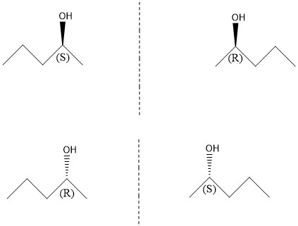
- CH3CH2CH2CH(OH)CH3
These molecules are non-superimposable mirror images, and therefore are enantiomers. The chirality of the molecule is (S) or counter clockwise, while the mirror image is (R) which is clockwise. This is because the priority of the subgroups is counted in those directions. The priority of the sub groups is 1) OH, 2) Propane, 3) Methane, 4) H.
These molecules are also enantiomers because they are non-superimposable mirror images. The chirality of the molecule is (R), while the mirror image is (S). The priority is the same as above.

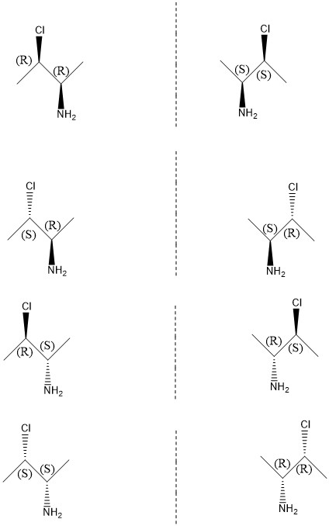
- CH3CClHCH(NH2)CH3
These molecules are enantiomers because they are nonsuper-imposable mirror images. Both the stereo centers on the molecule have (R) chirality, this is because the priority of the subgroups are counted in the clockwise direction. The mirror images stereo centers are both in the (S) configuration. The priority of the first center is: 1) Cl, 2) CH(NH2)CH3, 3) CH3, 4) H. The priority of the second center is: 1) NH2, 2) CH3CClH, 3) CH3, 4) H.
These molecules are enantiomers because they are nonsuper-imposable mirror images. The first stereo center on the molecule has the (S) configuration, while the second is (R). The mirror image simply inverts the direction of the chirality. The priority is the same as above.
These molecules are also enantiomers, due to their nonsuper-imposable mirror imaging. The molecules first chiral center is (R), and the second is (S). Again the mirror image has the opposite chirality. The priority is the same as above.

These molecules are enantiomers because they are nonsuper-imposable mirror images. Both the chiral centers on the molecule are in the (S) configuration, while the mirror image has both in the (R) configuration.

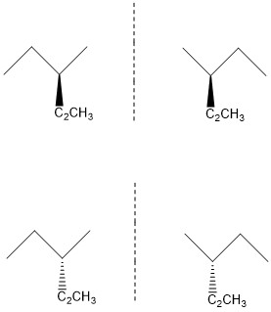
- CH3CH2CH(CH2CH3)CH3
These molecules are nonsuper-imposable mirror images, and are therefore enantiomers. There are no stereo centers because there are no carbons with 4 different subgroups.

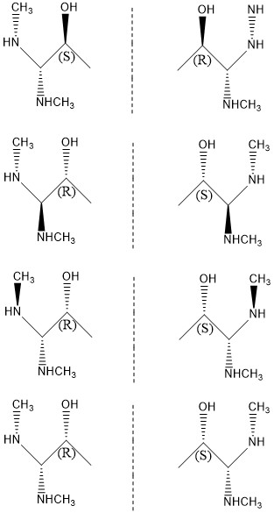
- CH3NHCH(NHCH3)CHOHCH3
These are all enantiomers, because none of them can be superimposed on their mirror image. Moreover, none of them are meso isomers because there is no internal mirror plane within the molecule. There is only one stereo center because only one carbon has 4 different subgroups. The priority of the carbon is: 1) OH, 2) CH3NHCH(NHCH3), 3) CH3, 4) H.

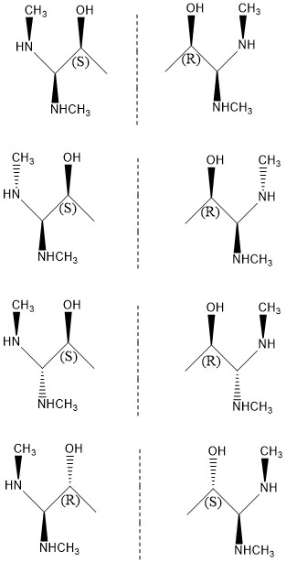

- Oxacyclohexane, 3,5 dichloride
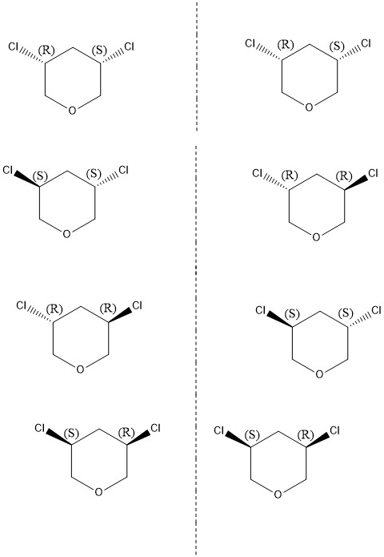
These molecules are super-imposable mirror images. This means they have an internal mirror plane and make them meso isomers. It has 2 stereo centers. The first center is in the (S) configuration, while the second is in the (R) Configuration. The priority of the first center is: 1) Cl, 2)CH2O, 3) CH2CHCl, 4) H.
These molecules are not super imposable mirror images, therefore are enantiomers. This compound is the same as the mirror image of the next compound, and vice versa. The configuration of both carbons is (S), while the mirror image is (R). The priority is the same as above.

These molecules are super-imposable mirror images, therefore they are meso isomers. The configuration on the first carbon is (S), and the second carbon is (R). The priority is the same.

Newman Projections:
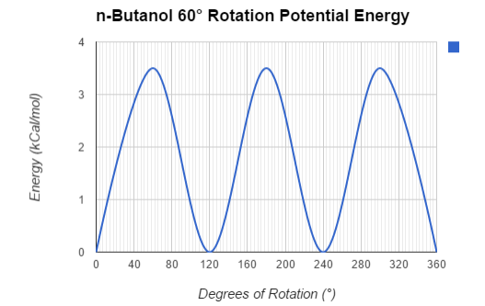
Axis of Rotation: | Newman Projection:
$$0°$$  60$°$  120$°$  180$°$  240$°$  300$°$  360$°$ | 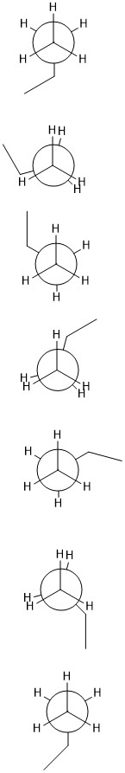
There are four compounds with the most stable conformations, these are at 0, 120, 240, and 360 degrees. Their energy differences are zero because they are essentially the same compound.
Cyclohexanol:
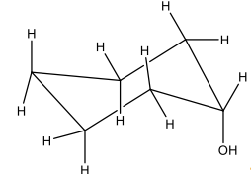
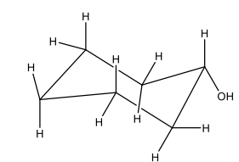
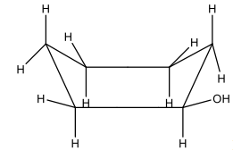
This is the most stable form f cyclohexanol. The hydroxyl group is in the equatorial position, therefore it will not make any steric interactions.

This image shows the inverted chair conformation. In this version, axial to axial bonds become equatorial to equatorial, and vice versa. This is more unstable because it puts the hydroxyl group in the axial formation. This creates the very unstable 1,3-diaxial interaction.

This is the boat formation of cyclohexanol. This can be flipped into a more unstable conformation just like the chair. This flip brings along the same issues as the chair. It creates an unstable axial interaction.

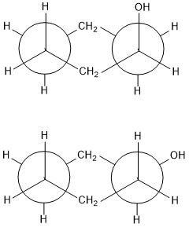
This is the stable chair conformation of cyclohexanol. This form has the hydroxyl group in the equatorial position.

This is the unstable chair conformation of cyclohexanol. This form has the hydroxyl group in the axial position.

Questions:
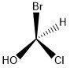

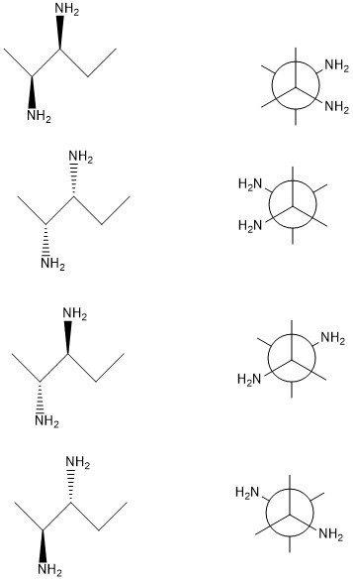

- # of stereoisomers= 2^(# of stereocenters)
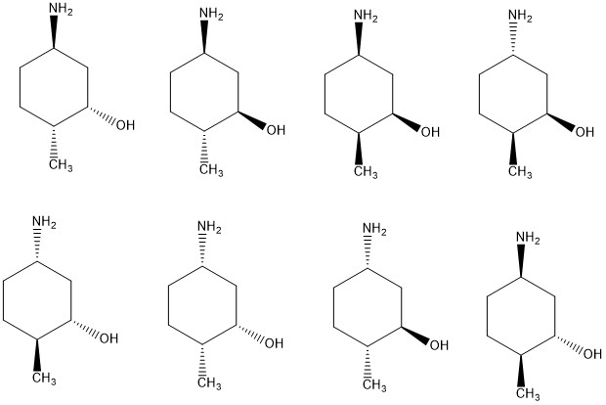
# of stereoisomers= 2^3
# of stereoisomers= 8

