Physics 12 Exam Notes

Glossary
Page Unit
3-5 ∙∙∙∙∙∙∙∙∙∙∙∙∙∙∙∙∙∙∙∙∙∙∙∙∙∙∙∙∙∙∙∙∙∙∙∙∙∙∙∙∙∙∙∙∙∙∙∙∙∙∙∙∙∙∙∙∙∙∙∙∙∙∙∙∙∙∙∙∙∙∙∙∙∙∙∙∙∙∙∙∙∙∙∙ Kinematics and Dynamics
6-7 ∙∙∙∙∙∙∙∙∙∙∙∙∙∙∙∙∙∙∙∙∙∙∙∙∙∙∙∙∙∙∙∙∙∙∙∙∙∙∙∙∙∙∙∙∙∙∙∙∙∙∙∙∙∙∙∙∙∙∙∙∙∙∙∙∙∙∙∙∙∙∙∙∙∙∙∙∙∙∙∙∙∙∙∙∙∙∙∙∙∙∙ Collisions and Energy
8-12 ∙∙∙∙∙∙∙∙∙∙∙∙∙∙∙∙∙∙∙∙∙∙∙∙∙∙∙∙∙∙∙∙∙∙∙∙∙∙∙∙∙∙∙∙∙∙∙∙∙∙∙∙∙∙ Gravitational, Electric, and Magnetic Fields
13-14 ∙∙∙∙∙∙∙∙∙∙∙∙∙∙∙∙∙∙∙∙∙∙∙∙∙∙∙∙∙∙∙∙∙∙∙∙∙∙∙∙∙∙∙∙∙∙∙∙∙∙∙∙∙∙∙∙∙∙∙∙∙∙∙∙∙∙∙∙∙∙∙∙∙∙∙∙∙∙∙∙∙∙∙∙∙∙∙∙∙∙∙∙∙∙∙∙∙∙∙∙∙∙∙∙∙∙∙∙∙∙ Waves
15-17 ∙∙∙∙∙∙∙∙∙∙∙∙∙∙∙∙∙∙∙∙∙∙∙∙∙∙∙∙∙∙∙∙∙∙∙∙∙∙∙∙∙∙∙∙∙∙∙∙∙∙∙∙∙∙∙∙∙∙∙∙∙∙∙∙∙∙∙∙∙∙∙∙∙∙∙∙∙∙∙∙∙∙∙∙∙∙∙∙∙∙∙∙∙∙∙∙∙∙∙∙∙∙∙∙∙∙ Formulas

Physics Kinematics and Dynamics
- Vector-a quantity that has a magnitude and direction (Ex position, velocity, acceleration)
- Scalar-a quantity that does not have a direction (Ex mass, charge, speed, temperature)
  - Magnitude $≥$ 0 (vector)
  - Scalar can be negative, vector can't
  - In one dimension there is no difference between vectors and scalars
- Simple vector: Position e.g $\overset{→}{d}=5.6m[E40°N]$
- Vector Algebra (2-D): Adding and subtracting vectors
- General Algorithm for adding Vectors
  - List vectors: $\overset{→}{x_{1}}=(\left|\overset{→}{x_{1}}\right|\cos\left(ccwθ\right),\left|\overset{→}{x_{1}}\right|\sin\left(ccwθ\right)$)
  - $\overset{→}{x_{2}}=(\left|\overset{→}{x_{2}}\right|\cos\left(ccwθ\right),\left|\overset{→}{x_{2}}\right|\sin\left(ccwθ\right)$)...
  - Add vectors $\left|\overset{→}{x_{1}}\right|\cos\left(ccwθ\right)+\left|\overset{→}{x_{2}}\right|\cos\left(ccwθ\right)=x-dir of recultant vector$
  - $\left|\overset{→}{x_{1}}\right|\sin\left(ccwθ\right)+\left|\overset{→}{x_{2}}\right|\sin\left(ccwθ\right)=y-dir of recultant vector$
  - Then just draw into a triangle and you can solve for the magnitude and direction of the resultant vector
  - If a vector is negative, you can just reverse the directions and change the vector into positive (i.e $\left[N50°W\right]→ \left[S50°E\right]$)
- Sample Question 1: $\overset{→}{a}=4.0m[E20°S]$ $\overset{→}{b}=3.0m[E40°N]$, what is $\overset{→}{a}+\overset{→}{b}$=? (Ans: $6.1m[E3.2°S]$)
- Kinematics (1-D) - The study of motion
  - $V_{av}=\left(d_{2}-d_{1}\right)/(t_{2}-t_{1})$, but we only interacted in instantaneous velocities so we make $∆t→0$, which makes $V_{av}=V_{instantanous}$ (Units=> m/s)
  - $a_{av}=\left(v_{2}-v_{1}\right)/(t_{2}-t_{1})$, as $∆t→0$, $a_{av}=a_{instantanous}$ (Units=> m/s²)
- Kinematics in Vertical Direction (close to the surface of Earth)
  - $\overset{→}{g}≈9.81m/s^{2}$ *Note that g is never negative since it's scalar
  - acceleration can be negative since it's a vector (acceleration due to gravity can be + or - depending on the direction you set as + or -)
  - Tips for solving problems
    - Choose a sign convention (up +, down -) or (up -, down +)
    - Choose an origin
    - Write down all known variables/draw FBD
- Sample Question 2: A ball is dropped from a 25.0m tall cliff, how long does it take to reach the ground and what is it's velocity just before it hits the ground? (Ans: t=2.26s,v=22.1m/s)

- Problems with non-uniform acceleration
  - break down problems into 2 phases
  - relation between phases would be ${Phase 1 v}_{final}={Phase 2 v}_{initial}$
- Sample Question 3: A truck driver takes 0.3s to react to a moose on the road, if the truck is travelling at 25m/s and the acceleration when brakes are pressed is -6m/s², how far away would the moose have to be so the truck driver does not hit it? (Ans: d=59.6m)
- Projectile Motion-motion of an object under the influence of a constant gravitational field
  - sign convention (up +, down -)
  - origin is at the point of launch
  - 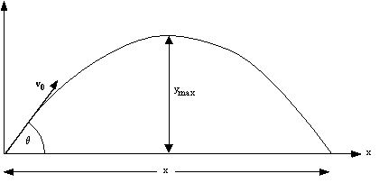
  - Above is a diagram of typical projectile motion, note that projectiles travel in a parabola
- Sample Question 4: A cannon shoots a projectile at 50m/s off a 75m high cliff at an angle of 35$°$ above the horizontal, how far does the projectile travel and what is it's velocity just before impacting the ground. (Ans: d=320m, v=63m/s[49$°$ below horizontal])
- Newton's laws of motion
  - First law - If an object is at rest, it will remain at rest unless acted on by a net force. If an object is in motion at some velocity, it will remain moving at the same velocity unless acted on by a net force
  - Second law - $\overset{→}{F_{net}}=m*\overset{→}{a}$
  - Third law - For every action force from object 1 on object 2 there is an equal and opposite reaction force from object 2 on object 1
- Sample Question 5: A rope connects two masses hanging on either side of a pulley, if m₁=5.0kg and m₂=7.0kg. If friction is negligible, what is the acceleration of the masses? (Ans: a=1.6m/s²)
- Sample Question 6: A rope connects a mass resting on a desk with a mass hanging off a desk over a pulley. If the mass resting on the desk is 300kg and the mass hanging off the side is 30.0kg, what is their acceleration and the tension in the rope? (Ans: a=0.891m/s², F_{t}=267N)
- Sample Question 7: A block on a incline is attached to a mass hanging over the top edge of the slope by a string and pulley system. If the angle is 25.0$°$, the mass on the incline is 5.00kg, and the mass hanging off the edge is 4.00kg, what is the direction of motion and the blocks acceleration? (Ans: dir-up the incline, a=2,05m/s²)

- Physics of Friction - we care the most about contact friction, there must be contact for this friction to exist and if surfaces are in contact $n≠0$
  - static friction ($μ_{s}≡coefficient of static friction$) -> if the relative velocity between the two surfaces is 0
  - kinetic friction ($μ_{k}≡coefficient of kinetic friction$) -> if the relative velocity between the two surfaces is not 0
  - At any given point, either static or kinetic friction can act on an object, but not both on the same point
  - Typically static friction > kinetic friction
- Sample Question 8: If a block is at rest on a ramp that is inclined at an angle of 30$°$, what is the minimum coefficient of static friction for it to remain at rest? (Ans: $μ_{s}=0.58$)
- Sample Question 9: If a 3.00kg block is hanging off the side of a table and is connected by a string over a pulley to a 5.00kg block on the table whose $μ_{s}=0.30$ and $μ_{k}=0.20$. Does the system start moving and if so, what is the acceleration of the system? (Ans: Yes, a=1.84m/s²)
- Circular Motion - assume that the object moves around the circle at a constant speed, even though speed is constant, the object is accelerating since the direction of the speed is changing
- The acceleration that is associated with constant speed and continually changing direction is called "Centripetal acceleration": $\overset{→}{a_{c}}$ and this acceleration always points towards the center of the circle
- Sample Question 10: If a car is moving at a speed of 30m/s in a 100m wide circle, what is it's centripetal acceleration to keep the car moving in the circle? (Ans: a_{c}=18m/s²)
- Sample Question 11: A 5.0kg block is being spun at 3m/s on a flat table by a 2.0m rope at a constant velocity, if it's $μ_{k}=0.3$, what is the total acceleration of the block and the angle it accelerates at? (Ans: 5.4m/s² [33$°$ infront of a_{c}])
- Centripetal Force - is mass multiplied by the centripetal acceleration
- Sample Question 12: A stunt plane is at the bottom of a dive, if it's flying at 45m/s and the pilot feels 3.0g of force acting on him, what is the radius of the diving circle. (Ans: r=69m)
- Sample Question 13: If a car is travelling on a ramped circle at 100s per revolution and the radius of the circle is 500m, what angle does the ramp have to be for the car to remain stationary, friction is negligible. (Ans: $θ=$ 11.4$°$)

Physics Collisions and Energy
- Momentum is $\overset{→}{p}≡m*\overset{→}{v}$ (unit : kg*m/s)
- The conservation of momentum tells us that the total momentum of a system before and after a collision is always equal (cons of mom)
  - The formula is: $m_{1}\overset{→}{v_{1}}+m_{2}\overset{→}{v_{2}}=m_{1}\overset{→}{v_{1}^{'}}+m_{2}\overset{→}{v_{2}^{'}}$
  - Where m₁ and m₂ are the two masses that collide and v_{1,} v₂ are velocities before collision and v₁', v₂' are the velocities after collision
- Sample Question 14: a 5kg ball moving at 3m/s collides with a 3kg ball that was stationary, if the balls stick together after the collision, what is their final velocity? (Ans: v'=1.875m/s)
- Types of collisions
  - Totally inelastic collision is a collision where the mass are either stuck together before or after the collision
  - Inelastic collision is a collision where kinetic energy is not conserved
  - Totally elastic collision is a collision where kinetic energy is conserved
  - Momentum is always conserved
- Energetics - the conservation of energy is the primary law in science (first law of thermodynamics)
  - Energy of isolated system before = Energy of isolated system after
  - $∆E_{system}=∆KE+∆PE_{grav}+∆PE_{elastic}+etc.$
  - conservation of mechanical energy is a special case of the first law of thermodynamics, represented by the equation: $\frac{1}{2}m{\overset{→}{\left|v_{1}\right|}}^{2}+mgh_{1}=\frac{1}{2}m{\overset{→}{\left|v_{2}\right|}}^{2}+mgh_{2}$
- Sample Question 15: a bullet is fired vertically upwards at 900m/s, what is the maximum height it reaches? (Ans: max height = 41,326.53m)
- Sample Question 16: a soccer ball is kicked at an angle of 45 degrees at 25m/s, what is the maximum height the ball reaches (Ans: max height = 15.944m)
- If there are no losses due to friction etc, then Mechanical Energy is conserved, but we also need to take into account friction
  - For example $\frac{1}{2}m{\overset{→}{\left|v_{1}\right|}}^{2}+mgh_{1}=\frac{1}{2}m{\overset{→}{\left|v_{2}\right|}}^{2}+mgh_{2}+W_{work done by friction}$
- Sample Question 17: some dude is sliding down a hill on his dank new roller blades, the hill is at an angle of 20 degrees to the horizontal, the height of the hill is 10m, and $μk=0.15$, if he starts at 1m/s, what is his speed at the bottom of the hill? (Ans: v=11.965m/s)
- Totally elastic collisions are collisions where mechanical energy are conserved and the two objects involved in the collision bounces off each other
- Sample Question 18: a 3kg mass travelling at 4m/s collides in a totally elastic collision with another 4kg mass initially at rest, what are the final velocities of the two masses? (Ans: v₁'=-0.57m/s, v₂'=3.43m/s)
- Springs are described by Hooke's law, in 1-D it states that $F_{on mass by spring}=-k*x$
  - $k≡the spring constant \left(units:\frac{N}{m}\right)$
  - $x≡the displacement of the spring from its equilibrium (units:m)$
- Elastic potential energy is the potential energy stored in a spring
  - represented by the formula: $∆PE_{elastic}=\frac{1}{2}kx^{2}$
- Sample Question 19: a spring hanging from the ceiling is in equilibrium, then a mass of 5kg is put onto the end, how much does the spring stretch from its equilibrium if the spring constant is 200N/m (Ans: x=0.245m)
- Sample Question 20: a 10kg ball is thrown upwards at 10m/s and hits a spring handing from the ceiling 2m above the ground, how much does the spring get compressed from its equilibrium (k=50N/m), ignore change in gravitational potential energy as the spring get compressed? (Ans: x=3.487m)
- Sample Question 21: a 3kg ball rolls down a 50cm tall ramp and collides in an elastic collision with a 1kg ball at rest, calculate the maximum displacements of both balls if this ramp resets on a 1m tall table. (Ans: 3kg ball = 0.707m, 1kg ball = 2.12m)

Physics Gravitational, Electric, and Magnetic Fields
- Gravitational force
  - Theory of gravity given by sir issac newton (1666) and modified by Albert Einstein modifies theory of gravity in 1915
  - Formula: $\overset{→}{\left|F_{gravity}\right|}=\frac{GMm}{r^{2}}$, unit = Newtons(N)
    - G is the universal gravitational constant ($6.67*{10}^{-11}(\frac{Nm^{2}}{{kg}^{2}})$),
    - M is the mass of object 1
    - m is the mass of object 2
    - r is the distance between the center of mass of the two objects
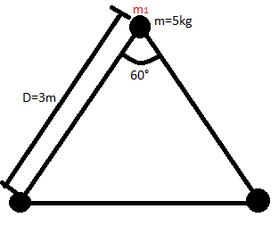
  - Sample Question 22: A spacecraft is 100km above the Earth's surface, calculate it's centripetal acceleration. (Note $M_{earth}=5.98*{10}^{24}kg, R_{earth}=6.4*{10}^{6}m)$ (Ans: a_{c}=9.4m/s² towards the center of the Earth)
  - Sample Question 23: Three masses of 5.0kg are placed at the corners of an equilateral triangle with side length of 3.0m, calculate the gravitational force acting on m₁.
  - (Ans: $\overset{→}{F_{grav}}=3.2*{10}^{-10}N (up)$)
  - Sample Question 24: The Earth orbits the sun at 1au (150 million km), calculate the Earth's orbital speed. (Note $M_{sun}=1.99*{10}^{30}kg$) (Ans: $V_{orbit Earth}=2.97*{10}^{4}m/s$)
- Gravitational Potential Energy
  - Formula: ${PE}_{global}=-\frac{GMm}{r}$, unit = Joules (J)
  - Sample Question 25: If a really buff guy threw a rock straight up at 1000m/s from the surface of the earth, calculate the maximum height the rock reaches above the surface. (Ans: $max height = 5.2*{10}^{4}m$)
  - Local vs Global PE
    - Local PE -> for low altitude projectiles
    - Global PE -> for high altitude rockets
  - Global Conservation of ME: $\frac{1}{2}mv_{1}^{2}-\frac{GM_{e}m}{r_{1}}=\frac{1}{2}mv_{2}^{2}-\frac{GM_{e}m}{r_{2}}$
  - Sample Question 26: Calculate the escape velocity of a rocket from the gravity of the sun. (Note $M_{sun}=1.99*{10}^{30}kg, R_{sun}=6.96*{10}^{8}m$) (Ans: $V_{escape sun}=6.18*{10}^{5}m/s$)
  - Sample Question 27: Calculate the velocity of a rocket at launch needed to put a satellite into orbit at a height of the radius of the Earth above the surface of the Earth. (Ans: $V_{launch}=9.7*{10}^{3}m/s$)
  - Sample Question 28: A 100kg model rocket launched from the surface of the Earth experiences a constant drag force of 10N[Down] from air resistance, if the atmosphere ends at 12km above the surface, calculate the launch velocity needed to escape the Earth's atmosphere. (Ans: $V_{launch}=4.85*{10}^{2}m/s$)
- Basics of Electricity
  - There are two types of charge (+) and (-)
  - Like charges repel, opposites attract
    - (+) and (+) repel
    - (-) and (-) repel
    - (+) and (-) attract
    - (-) and (+) attract
  - Coulomb's Law Formula: $\overset{→}{\left|F_{electric}\right|}=\frac{kQ_{1}Q_{2}}{r^{2}}$
    - k is Coulombs constant ($8.99*{10}^{9})$
    - Q₁ is the charge of particle 1
    - Q₂ is the charge of particle 2
    - r is the distance between the centers of Q₁ and Q₂
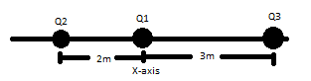
  - Sample Question 29: Three charges are placed onto the x-axis, Q₁ has a charge of e and is at x=0.0, Q₃ has a charge of 2e and is at x=3.0m, Q₂ has a charge of -e and is at x=-2.0m. Find the total electrical force on Q₃. (Note $e=charge of electron=1.602*{10}^{-19}c$)
(Ans: $\overset{→}{F_{elec}}=3.3*{10}^{-29}N(Right)$)
  - Sample Question 30: Two identical charges with a charge of e are attached to 2.0m long strings and hanged from the ceiling, if the angle between the charges is 30°, what is the mass of the charges. (Hint draw a FBD) (Ans: $m_{charge}=8.2*{10}^{-29}kg$)
- Electric Fields (Electrostatics)
  - 3 types of charges
    - 1) Source charges are real particles that cannot move, can be (+) or (-)
    - 2) Test charges are not real particles and their purpose is to determine the direction of an electric field it is very small and (+)
    - 3) Field charges are real particles that are small and can be (+) or (-), they do not produce an electric field but moves in response to electric fields generated by source charges
  - Formula: $\overset{→}{F_{elec}}=q*\overset{→}{ε}$
    - Force is the force on a field charged caused by the electric field
    - q is the charge of the field charge
    - $\overset{→}{ε}$ is the electric field generated by a source charge
  - Sample Question 31: Refer back to the diagram of sample question 8, if Q₁ did not exist, where on the x-axis is the total electric field equal to 0? (Ans: $x=-14m$)
  - Sample Question 32: A 1kg and 3C charge is connected by a rope to a vertical wall, if a 15N/C electric field is coming out of the wall and is perpendicular to the wall, what is the angle the rope makes with the wall? (Ans: $θ=78°$)

- Global (point charges) vs Local (electric plates) Electrical Fields
  - Global Electric field: $\overset{→}{\left|ε\right|}=\frac{k\left|Q\right|}{r^{2}}$
  - Local Electric field: $\overset{→}{\left|ε\right|}=4πk\left|σ\right|$
  - Global Voltage: $V=\frac{kQ}{r}$
  - Local Voltage: $\left|∆V\right|=\overset{→}{\left|ε\right|}\overset{→}{\left|∆d\right|}$
  - $V_{total}=V_{1}+V_{2}+V_{3}+V_{4}+…$
  - $\overset{→}{ε_{total}}=\overset{→}{ε_{1}}+\overset{→}{ε_{2}}+\overset{→}{ε_{3}}+\overset{→}{ε_{4}}+…$
  - ${PE}_{electric}=q_{field}V_{source}$
  - Conservation of ME: $\frac{1}{2}mv_{1}^{2}+qV_{1}=\frac{1}{2}mv_{2}^{2}+qV_{2}$
    - $σ$ is the charge density
    - Q is the charge of the source charge
    - q is the charge of the field charge
    - k is Coulombs constant ($8.99*{10}^{9})$
    - r is the distance between the centers of the source charge and the field charge or test charge
    - $ε$ is the electric field generated by source charges
    - $d$ is the distance between two parallel plates
    - V is voltage and v is velocity!!
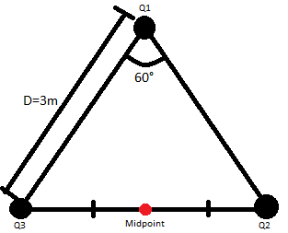
  - Sample Question 33: There are 3 charges Q₁, Q₂, and Q₃ at the corners of an equilateral triangle with a side length of 3m. If $Q_{1}=2.0*{10}^{-9}c$, $Q_{2}=4.0*{10}^{-9}c$, and $Q_{3}=-2.0*{10}^{-9}c$, calculate the voltage at the
midpoint between Q₂ and Q₃. (Ans: $V_{t}=14v$)
  - Sample Question 34: The difference in voltage between two parallel plates 1.0m apart powered by a battery is 1000v, if an electron is placed at the negative plated and released what is the speed of the election just before it smashes into the positive plate? (Ans: $v_{1}=1.9*{10}^{7}m/s$)
  - Sample Question 35: An anti-electron (opposite charge same mass) is fired at a stationary proton, if the minimum distance between the electron and the proton is 1.0*10⁻⁸m, calculate the initial velocity of the electron. (Ans: $v_{1}=2.3*{10}^{5}m/s$)
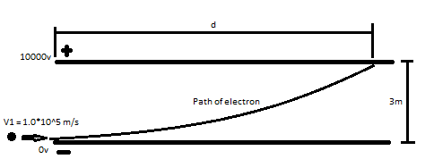
  - Sample Question 36: An electron is fired in between two parallel electric plates that are 3.00m apart and of infinite length, if its fired from the negative plate initially at 1.00*10⁵m/s, and the difference in voltage between the plates is 10000v, find the distance d the electron travels before slamming into the top plate. (Ans: $d=1.01*{10}^{-2}m$)
- Magnetic Fields and Forces
  - We will focus on magnetostatics where the magnitude of the magnetic field is fixed
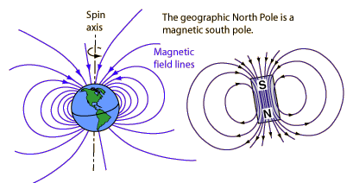
  - All magnets have a North and a South pole
  - Magnetism was used historically for navigation purposes
  - The Earth's magnetic field is similar to that of a bar magnets
  - We represent magnetic field as $\overset{→}{B}$ and we assume that it is given
  - The unit is in Tesla (T)
  - Formula: $\overset{→}{\left|F_{magnetic}\right|}=\left|q_{field}\right|*\left|\overset{→}{v_{field}}\right|*\left|\overset{→}{B_{source}}\right|*sinθ$
    - The force is the magnitude of the magnetic force on the field charge
    - q is the charge of the field charge
    - v is the velocity of the field charge
    - B is the magnitude of the magnetic field
    - $θ$is the smallest angle between the velocity and the magnetic field
  - To find the direction of the magnetic force we need to use the right hand rule
    - Point your fingers in the direction of the velocity and curl them to the direction of the magnetic field
    - The direction your thumb points to is the direction of the magnetic force
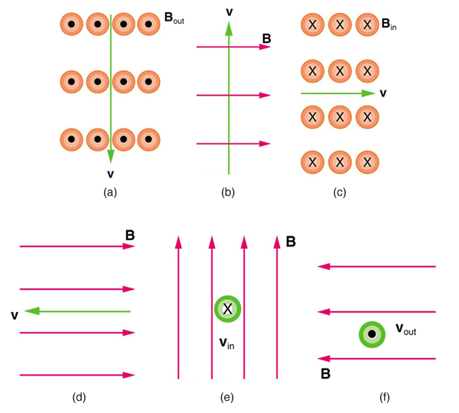
    - If the field charge is negative, you do the same steps but reverse the direction of the force
  - Sample Question 37: Find the direction of the magnetic force for each situation, assume positive field charge for (a), (b), and (c) and negative field charge for (d), (e), and (f).
(Ans: (a)=left, (b)=into page, (c)=up, (d)=no force, (e)=left, (f)=down)
  - Field charge moves in a circle inside a constant magnetic field, therefore we can use centripetal force equations
  - Formula: $\frac{\left|q_{field}\right|}{m_{field}}=\frac{\left|\overset{→}{v}\right|}{r*\left|\overset{→}{B}\right|}$ <-charge to mass ratio
    - r is radius of circle of motion of field charge

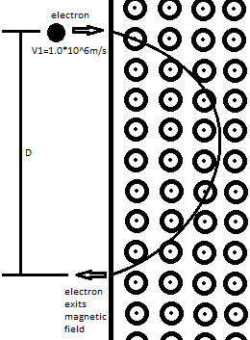
  - Sample Question 38: If an electron is fired into a 20.0T magnetic field coming out of the page at 1.00*10⁶m/s, find distance D between where the electron enters the magnetic field and where it exits.
(Ans: $D=5.69*{10}^{-7}m$)

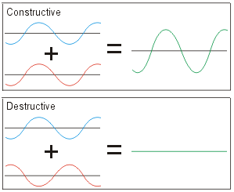
Physics Waves
- From grade 11 we learned about interference of waves
  - Total constructive interference is when two crests or two troughs meet (make some big curves n shit)
    - crests are maximums
    - troughs are minimums
  - Total destructive interference is when a crest and a trough meet (flat as an airplane runway)
  - All other situations are either partial constructive or destructive interference
- Sir Issac Newton wrote a book called OPTICKS → theory of light
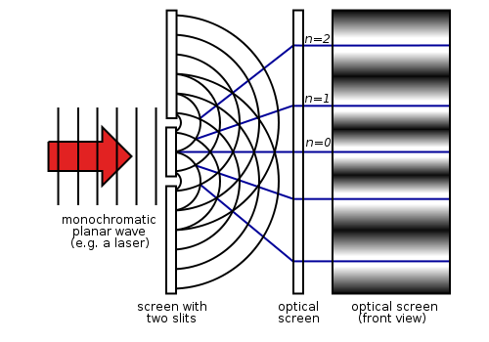
  - light made of corpusculars (small particles)
- Some dude named Thomas Young did a double slit experiment and saw some cool patterns on a wall (he was not high)
  - he explained this through path differences
  - if light wave from one slit takes a distance of $n-\frac{λ}{2}, where n=1,2,3,4,…$ further to reach a point than the other, total destructive interference (Dark spot) occurs as the crests of light from one slit would meet the troughs of light from the other slit
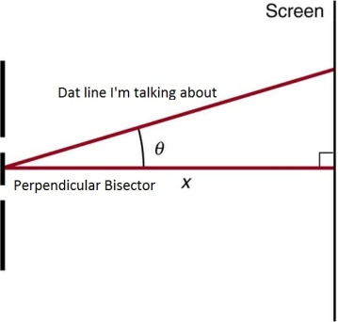
  - if light wave from one slit takes a distance of $nλ, where n=0,1,2,3,4,…$ further to reach a point than the other, total constructive interference (Bright spot) occurs as the crests and troughs of the two waves line up
  - then he did some magical angle shit and came up with the following equations:
    - $d*\sin\left(θ\right)=nλ, where n=0,1,2,3,4, …(Bright spot)$
    - $d*\sin\left(θ\right)= n-\frac{λ}{2}, where n=1,2,3,4,…(Dark spot)$
      - $θ≡the angle between the perpendicular$
$$bisector of the two slits and the line to the bright/dark spot$$
  - $Δx=\frac{λL}{d}$, who cares where this equation came from, just remember it lmao
    - $L≡distance from screen to slits$
    - $d≡seperation between slits$
    - $λ≡wavelength of wave$
    - $∆x≡distance between consecutive dark or bright spots$
  - Sample Question 39: Calculate the angle to the 3rd order dark spot if the distance between the slits is $1.0*{10}^{-4}m$ and the wavelength of the light is $6.2*{10}^{-7}m$ (Ans: $θ=1.1°$
  - Sample Question 40: Calculate the distance between the 1st and 8th order dark spot if the wavelength of the light is $4.2*{10}^{-7}m$, the distance to the screen is $1.0m$, and the distance between slits is $3.4*{10}^{-4}m$ (Ans: $distance=8.6*{10}^{-3}$)
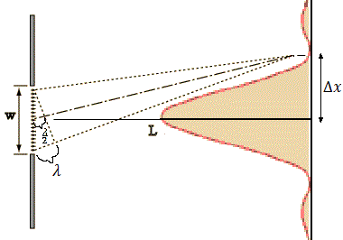
- The some dude named Huygens wondered what happens with just one slit and also saw a pattern (this one wasn’t high either)
  - He theorized that light bends around corners, and this bending is called diffraction
  - When the path difference between the light at one end of the slit and the light at the opposite end is $nλ, where n=1,2,3,…$
    - Then the light from top half and the bottom half cancel each other out through destructive interference (Dark spot)
  - When the path difference between the light at one end of the slit and the light at the opposite end is $n+\frac{λ}{2}, where n=1,2,3,…$
    - Then the light from the bottom 1/3 cancels out the light from the middle 1/3 through destructive interference, but then top 1/3 remains (Semi-bright spot)
  - He’s like related to Young or something because he also did some magical angle shit and came up with these similar equations:
    - $w*\sin\left(θ\right)=nλ, where n=1,2,3,4, …(Dark spot)$
    - $w*\sin\left(θ\right)= n+\frac{λ}{2}, where n=1,2,3,4,…(Semi-bright spot)$
      - $θ≡the angle between the perpendicular$
$$bisector of the slit and the line to the bright/dark spot$$
  - $Δx=\frac{λL}{w}$, similar equation as the previous one except replace d with w
    - $w≡width of the slit$
  - He observed that the width of the central max is 2*$Δx$ and occurs when n=0
  - Sample Question 41: Calculate the width of the central maximum if the wavelength of the light is $6.5*{10}^{-7}m$, the distance to the screen is $2.0m$, and the width of the slit is $4.5*{10}^{-5}m$ (Ans: $width=5.8*{10}^{-2}$)
  - Sample Question 42: Calculate the width of a slit when the second dark spot occurs at $θ=10°$ and wavelength of the light is $6.0*{10}^{-7}m$ (Ans:$width=6.9*{10}^{-6}$)
  - Sample Question 43: Calculate the wavelength of light travelling through a $7.5*{10}^{-5}m$ wide slit and a third order semi-bright spot at $θ=15°$ (Ans: $λ=6.5*{10}^{-6}m$)
- Photoelectric effect (just use these formulas cuz I’m way too lazy to explain this and it’s probably just one question on the exam just plug numbers in anyways so w.e)
  - $E=\left|\overset{→}{P}\right|*c=hf$
  - $\left|\overset{→}{P_{proton}}\right|=\frac{hf}{c}=\frac{h}{λ}$
    - $h≡planks constant=6.63*{10}^{-34} (Units:J*s)$
    - $f≡frequency (Units:s^{-1})$
    - $c≡speed of light in a vacumn=299,792,458 m/s$
    - $\left|\overset{→}{P}\right|≡momentum of proton (Units:\frac{J*s}{m}=\frac{kg*m}{s}$)
Formulas
Kinematic Equations
$$∆d$$ | Displacement
$$a$$ | Acceleration
$$∆t$$ | Time
$$v_{1}$$ | Initial Velocity
$$v_{1}$$ | Final Velocity
$$∆d=\left(\frac{v_{1}+v_{2}}{2}\right)∆t$$
$$v_{2}=v_{1}+a∆t$$
$$∆d=v_{1}∆t+\frac{1}{2}a∆t^{2}$$
$$∆d=v_{2}∆t-\frac{1}{2}a∆t^{2}$$
$$v_{2}^{2}=v_{1}^{2}+2a∆d$$
Friction Coefficient Equations
$$μ_{k}=\frac{F_{k}}{F_{n}}$$
$$μ_{s}=\frac{F_{s}}{F_{n}}$$
Worship this formula
$$\left|F_{net}\right|\left(N\right)=Mass\left(kg\right)*Acceleration(\frac{m}{s^{2}})$$
Projectile Motion
Position $X-dir: x=v_{o}cosθ∆t$
$$Y-dir: x=v_{o}sinθ∆t-\frac{1}{2}g{(∆t)}^{2}$$
Velocity $X-dir: x=v_{o}cosθ$
$Y-dir: x=v_{o}sinθ-g∆t$
Circular Motion
$$\overset{→}{a_{c}}=\frac{v^{2}}{r}=\frac{4π^{2}r}{T^{2}}=4π^{2}rf^{2}$$
$$\overset{→}{F_{a_{c}}}=\frac{{mv}^{2}}{r}=\frac{4π^{2}mr}{T^{2}}=4π^{2}mrf^{2}$$
Conservation of Momentum
$$m_{1}\overset{→}{v_{1}}+m_{2}\overset{→}{v_{2}}=m_{1}\overset{→}{v_{1}^{'}}+m_{2}\overset{→}{v_{2}^{'}}$$
Conservation of Kinetic Energy
$${\frac{1}{2}m}_{1}{\overset{→}{v_{1}}}^{2}+{\frac{1}{2}m}_{2}{\overset{→}{v_{2}}}^{2}={\frac{1}{2}m}_{1}{\overset{→}{v_{1}^{'}}}^{2}+\frac{1}{2}m_{2}{\overset{→}{v_{2}^{'}}}^{2}$$
Conservation of Mechanical Energy
$$\frac{1}{2}m{\overset{→}{\left|v_{1}\right|}}^{2}+mgh_{1}+\frac{1}{2}kx_{1}^{2}=\frac{1}{2}m{\overset{→}{\left|v_{2}\right|}}^{2}+mgh_{2}+\frac{1}{2}kx_{2}^{2}$$
Hooke's law
$$F_{on mass by spring}=-k*x$$
Useful constants
$$G = 6.67*10-11 (Nm2/kg2)$$
$$Mearth = 5.98*1024 (kg)$$
$$Rearth = 6.4*109 (m)$$
$$k = 8.99*109 (Nm2/c2)$$
$$e = 1.602*10-19 (c)$$
$$melectron = 9.11*10-31 (kg)$$
$$mpronton = 1.67*10-27 (kg)$$
Newton's Law of Universal Gravitation
$$\overset{→}{\left|F_{gravity}\right|}=\frac{GMm}{r^{2}}$$
Coulomb's law of Electrostatics
$$\overset{→}{\left|F_{electric}\right|}=\frac{kQ_{1}Q_{2}}{r^{2}}$$
Global and Local Scalars/Vectors
 | Gravitational | Electrical
Global Vector | $$\overset{→}{\left|F_{gravity}\right|}=\frac{GMm}{r^{2}}$$ | $$\overset{→}{\left|ε_{source}\right|}=\frac{k\left|Q\right|}{r^{2}}$$
Local Vector | $$\overset{→}{\left|F_{gravity}\right|}=mg$$ | $$\overset{→}{\left|ε_{source}\right|}=4πkσ$$
Global Scalar | $${PE}_{grav}=-\frac{GMm}{r}$$ | $$V=\frac{kQ}{r}$$
Local Scalar | $${PE}_{grav}=mgh$$ | $$\left|∆V\right|=\overset{→}{\left|ε\right|}\overset{→}{\left|∆d\right|}$$
Electrical Force on a Field Charge
$$\overset{→}{F_{elec}}=q_{field}\overset{→}{ε}$$
Electrical Potential Energy of a Field Charge
$${PE}_{electric}=q_{field}V_{source}$$
Superposition Principle
$$V_{total}=V_{1}+V_{2}+V_{3}+V_{4}+…$$
$$\overset{→}{ε_{total}}=\overset{→}{ε_{1}}+\overset{→}{ε_{2}}+\overset{→}{ε_{3}}+\overset{→}{ε_{4}}+…$$
Useful constants
$$h=6.63*{10}^{-34} (Js)$$
$$c=299,792,458 (\frac{m}{s})$$
Double Slit Experiment (Young)
$$d*\sin\left(θ\right)=nλ, where n=0,1,2,3,4, …(Bright spot)$$
$$d*\sin\left(θ\right)= n-\frac{λ}{2}, where n=1,2,3,4,…(Dark spot)$$
$$Δx=\frac{λL}{d}$$
Single Slit Experiment (Huygens)
$$w*\sin\left(θ\right)=nλ, where n=1,2,3,4, …(Dark spot)$$
$$w*\sin\left(θ\right)= n+\frac{λ}{2}, where n=1,2,3,4,…(Semi-bright spot)$$
$$Δx=\frac{λL}{w}$$
Photoelectric Effect
$$E=\left|\overset{→}{P}\right|*c=hf$$
$$\left|\overset{→}{P_{proton}}\right|=\frac{hf}{c}=\frac{h}{λ}$$

