
#

“…BUT A HOT TEMPER LEAPS O’ER A COLD DECREE”
  - ENTHALPY OF VARIOUS REACTIONS – LAB 2

Table of Contents
- Introduction 2
Background
Hess Law
Calorimetry
Measuring Thermal Energy
Specific Heat Capacity of a Metal
Enthalpy of Neutralization
Enthalpy of Solution
Concept of the Experiment
- Procedure 5
- Data and Observations 5
Recorded Data from Calorimeter
- Calculations 9
Metal - Zn
Acid
Salt B
- Discussion 13
- Conclusions 13
- Appendix 14

Introduction
Background about the Experiment. Equations that are used. Theory and limitations of Theory used Reference one other source other than text or lab manual
The purpose of this experiment is to use various types of experiments to calculate the enthalpies of a variety of different types of reactions. Within the experiment we will attempt to:
- Determine the specific heat capacity and then approximate the molar mass of a metal
- Using a strong acid and a strong base, determine the enthalpy of the reaction between them
- Determine the identity and enthalpy of a solution of an unknown salt.

Background
In order to understand enthalpy of reactions one must begin the standard heat of formation, ∆_{f}Hº. ∆_{f}Hº is a value given to the amount of energy absorbed or released upon the formation of one mole of a substance from its elements in their standard states. “Standard states is usually defined at a pressure of one bar and a temperature of 25 ºC”
. Elements are in their standard state are given an arbitrary value of enthalpy of 0, as this is their most stable state. Therefore, when measuring the enthalpy of a reaction we look to the change in energy needed for a reaction to occur. This energy could be released into the environment, as an exothermic reaction, or absorbed from the environment in an endothermic reaction.

Hess Law
In some cases measuring the enthalpy of a given reaction cannot be easily done. Hess Law states we can calculate the enthalpy of a reaction by comparing the ∆_{f}Hº of the reactants vs the ∆_{f}Hº of the products. This looks like:
∆_{f}Hº_{reaction} = Σ∆_{f}Hº(products) - Σ∆_{f}Hº(reactants) [1]

Calorimetry
A calorimeter is a device used to measure and quantify the thermal changes that occur during a chemical change. One of the simplest types of calorimeters is the “coffee cup calorimeter”. It consists of two nested Styrofoam cups with a lid and a thermometer. The Styrofoam cups provide insulation so that no heat is lost to, or gained from, the surroundings. This allows the thermal changes due to the reaction be measured. There are more complex and accurate versions of the calorimeter but for the purposes of this experiment the “coffee cup calorimeter” will suffice.

Measuring Thermal Energy
Thermal energy can be measured and quantified in a number of different ways. Simply, thermal energy is a way of measuring the kinetic of molecules and is usually expressed as a temperature. Molecules with a higher kinetic energy are moving faster and are said to have a higher temperature.
How molecules react to a change in kinetic energy, or temperature, is important in this experiment. The specific heat capacity of a substance is the amount of thermal energy required to heat one gram of that substance one degree, Celsius or Kelvin. This value does not change with respect to the amount of the substance, it is an intensive property. On the other hand, heat capacity (note the word specific is missing) is an extensive property which means that it is dependent on the mass of the substance. Using water as an example, if we look at the specific heat capacity the value would be the same if we were heating a rain drop or a lake. For heat capacity, in the same experiment the value for the larger mass would be much bigger.
The specific heat capacity of a metal can be determined by heating the metal and submersing it into a known quantity of water. The heat (q_{metal}) lost by the metal is equal to the heat (q_{water}) gained by the water. A negative sign is added to the metal to signfy the loss of heat, thus:
-q_{metal} = q_{water} [2]

Specific Heat Capacity of a Metal
It is important that we understand how q in the previous equation is determined. This will allow us to use the information recorded in the calorimeter to find a number of different variables. The general equation relating the transfer of thermal energy is:
q = (m)(c)(∆T) [3]
Where m = mass of substance
c = specific heat capacity of substance
∆T = change in temperature expressed as T_{final} - T_{initial}
If we combine equation [2] and [3] we see that heat lost by the metal is recovered by the water. With no loss to the environment due to the calorimeter, and ∆T recorded we are able to solve for either c or m depending on the information given. It is important to note that the sign of the answer is important, it shows if heat is gained or lost in the reaction. Also, the specific heat capacity for water is 4.18 J/gºC. The combined formula is:
-(m_{metal})(c_{metal})(∆T_{metal}) = (m_{water})(c_{water})(∆T_{water}) [4]
In 1819, Dulong and Petit proposed that one mole of all metals have roughly the same specific heat capacity and derived the following equation:
c_{metal} x MM_{metal} = 25 J/molºC
Where MM_{metal} = molar mass of the metal
C_{metal} = specific heat capacity of the metal
Using this formula one can approximate the molar mass of a metal using the specific heat capacity, c_{metal}.

Enthalpy of Neutralization
When mixing acids and bases in a neutralization reaction we can use the same principles as above. It is still given that heat generated by the reaction is absorbed by the solution. If q_{n} is the heat of neutralization, m_{total} is the mass of the reagents and c_{solutions} is the specific heat capacity of the solution (which we use the same as water in the case) the formula becomes:
q_{n} = -(m_{total})(c_{solution})(∆T) [5]
In order to create a value that is more easily comparable to other reactions we can express q_{n} in terms of heat per mole of substance. This is the enthalpy of reaction per mole of substance, and is shown as ∆_{n}Hº defined as:
∆_{n}Hº = $\frac{qn}{nx}$
Where n_{x} = number of moles reacted

Enthalpy of Solution
The net thermal reaction when dissolving salt can be exothermic or endothermic due to two processes which occur simultaneously. First, the “lattice energy of salt is the energy required to vaporize one mole of the salt to form gaseous ions and this quantity is endothermic. The second factor, the hydration energy, is the energy released with one mole of gaseous ions is solvated by water to form aqueous ions and is exothermic”. Either of these values can be difficult to measure, however their sum can be recorded in the lab. Depending on the salt the values for the lattice energy and hydration energy will vary. If the lattice energy is larger than the hydration energy the enthalpy of dilution is negative. Similarly the opposite is also true. The enthalpy of solution ∆_{s}Hº is expressed as:
∆_{s}Hº = (-heat loss of H₂O) + (- heat loss of salt) [6]
Because these values are so hard to measure, in the lab we will look at the change in heat in the solution and divide it by the number of moles of salt to get a ∆_{s}Hº per mole. This is expressed as:
∆_{s}Hº = $\frac{qs}{n salt}$ = $\frac{-(mass solution)(specific heat of sloution)(∆T of solution)}{n salt}$ [7]
Where n salt = number of moles of salt

Concept of the Experiment
This lab will be completed in 3 sections.
- We will determine the specific heat capacity of a metal and approximate its molar mass using a “coffee cup calorimeter”
- We will determine the enthalpy of neutralization of 2 strong acids with a strong base and compare the values
- We will determine the enthalpy of solution of an unknown salt and determine the chemical makeup of the salt.

Procedure
As described in Lab Manual
There were 2 assumptions made that were not outlined in the above procedure.
- It was given that water boils at 100 ºC. Therefore the initial temperature of the metal is assumed to also be 100 ºC.
- While the initial temperature of the base in the neutralization reaction was recorded, it is assumed that the acids had the same initial temperature.

Data and Observations
Mass of acid base neutralization not recorded after reaction
METAL | TRIAL 1 | TRIAL 2
Mass of Styrofoam cup (g) | 1.961 g | 1.961 g
Mass of Styrofoam cup and water (g) | 21.435 g | 21.459 g
Mass of Metal – Zinc (g) | 11.492 g | 11.589 g
Amount of water (ml) | 20 ml | 20 ml
∆T_{water} = Temp final – Temp intial (ºC) | 3.53 ºC | 3.63 ºC
∆T_{zinc} = Temp final – Temp intial (ºC) | -73.23 ºC | -72.27 ºC
∆q_{water} (J) | 292.85 J | 303.76 J
Calculated specific heat – Zinc (J/gºC) | 0.348 J/gºC | 0.363 J/gºC
Known specific heat of Zinc (J/gºC) | 0.39 J/gºC | 0.39 J/gºC
Approximate molar mass of Zinc (g/mol) | 71.84 g/mol | 68.87 g/mol
Average approximate molar mass | 70.35 g/mol | 70.35 g/mol
Known molar mass of Zinc (g/mol) | 65.39 g/mol | 65.39 g/mol
% error for specific heat of Zinc | 10.8% | 6.9%
% error for molar mass of Zinc | 9.7% | 5.3%
It was given by the lab coordinator that water boils at 100 ºC and this should be used for our T_{intial} for the Zinc
Initial and final temperatures were calculated using an average of 3 data points before and after the reaction had occurred
ACID | HCL |  | HNO₃
 | TRIAL 1 | TRIAL 2 | TRIAL 1 | TRIAL 2
Volume of NaOH (ml) | 40 ml | 40 ml | 40 ml | 40 ml
Volume of Acid (ml) | 40 ml | 40 ml | 40 ml | 40 ml
Concentration of NaOH (mol/L) | 1.0 mol/L | 1.0 mol/L | 1.0 mol/L | 1.0 mol/L
Concentration of Acid (mol/L) | 1.1 mol/L | 1.1 mol/L | 1.1 mol/L | 1.1 mol/L
∆T_{solution} = Temp final – Temp intial (ºC) | 6.76 ºC | 6.87ºC | 6.63 ºC | 6.67ºC
Total Volume of Solution (ml) | 80 ml | 80 ml | 80 ml | 80 ml
Total mass of Solution (g) | 80 g | 80 g | 80 g | 80 g
∆q_{neutralization} (kJ) | -2.62 kJ | -2.3 kJ | -2.22 kJ | 2.23 kJ
Number of moles H₂O formed (mol) | .04 mol | .04 mol | .04 mol | .04 mol
∆_{n}Hº | -65.5 kJ/mol | -57.5 kJ/mol | -55.5kJ/mol | -55.8 kJ/mol
∆_{n}Hº from literature | -57.1 kJ/mol | -57.1 kJ/mol | -57.3 kJ/mol | -57.3 kJ/mol
% error ∆_{n}Hº | 14.7% | .7% | 3.1% | 2.6%
We did not measure the mass of the cup and contents after the neutralization reaction, therefore the values used in the calculations are based on the sum of the volumes measured on the graduated cylinders using the given density of 1.0g/ml.
Initial and final temperatures were calculated using an average of 3 data points before and after the reaction had occurred

DISSOLUTION OF SALT | TRIAL 1 | TRIAL 2
# of Salt | B | B
Mass of Salt (g) | 2.381 g | 2.137 g
Mass of foam cup and water (g) | 21.663 g | 21.366g
Mass of cup and contents after experiment (g) | 23.982 g | 23.445 g
Volume of H₂O (ml) | 20 ml | 20 ml
Molar mass of salt given (g/mol) | 166.0 g/mol | 166.0 g/mol
∆T solution (ºC) | -3.33 ºC | -3.04 ºC
∆H of solution (J) | 268.53 J | 239.17 J
N_{salt} (mol) | 1.43 x 10⁻² mol | 1.29 x 10⁻² mol
Enthalpy of dissolution per mole ∆_{s}Hº _{salt} (kJ/mol) | 18.79 kJ/mol | 18.54 kJ/mol
Identity of Unknown Salt | Potasium Iodide (KI) | Potasium Iodide (KI)
Known enthalpy of dissolution of KI | 20.3 kJ/mol | 20.3 kJ/mol
% error of enthalpy of dissolution of KI | 7.9% | 8.7%
Initial temperature of salt is assumed to be equal to the initial temperature of the water.
Initial and final temperatures were calculated using an average of 3 data points before and after the reaction had occurred.

Recorded Data from Calorimeter

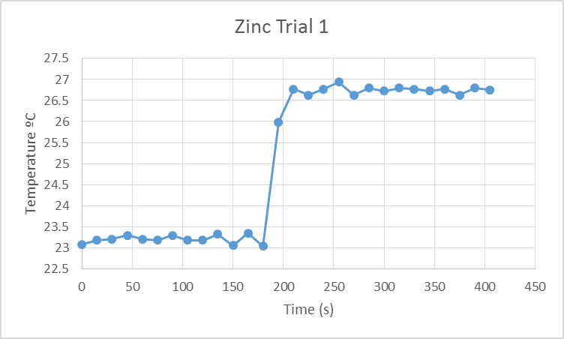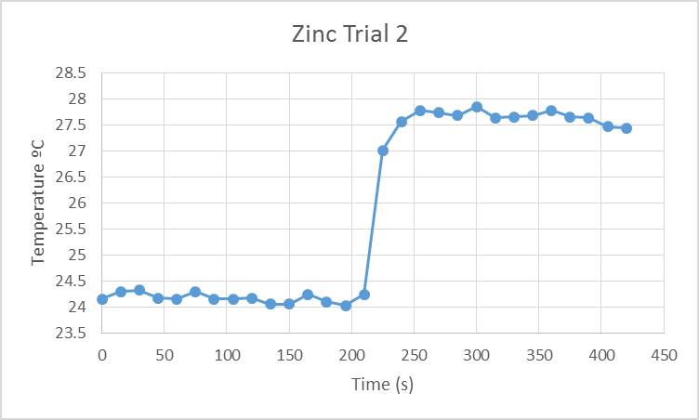
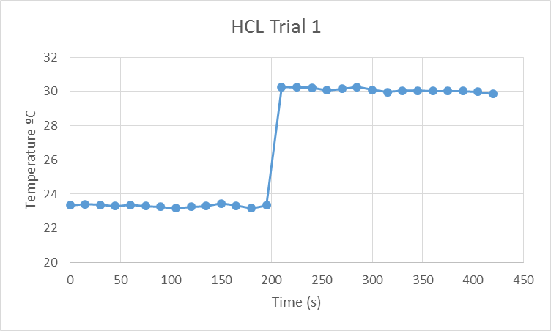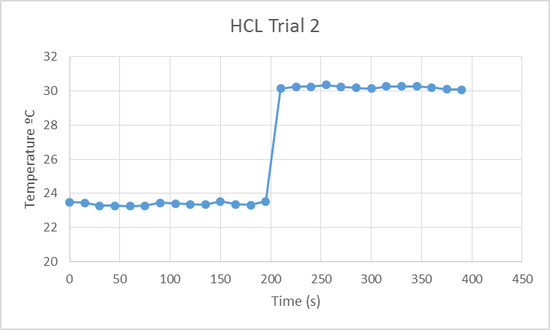
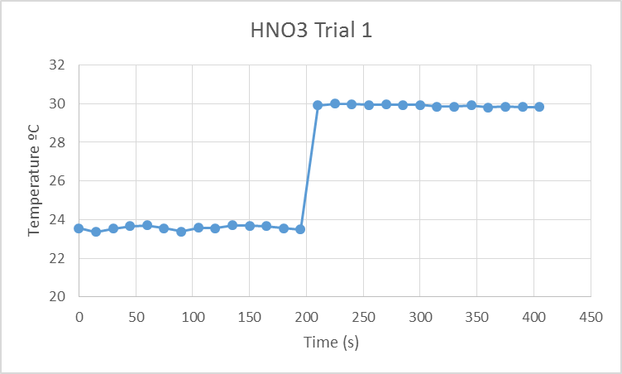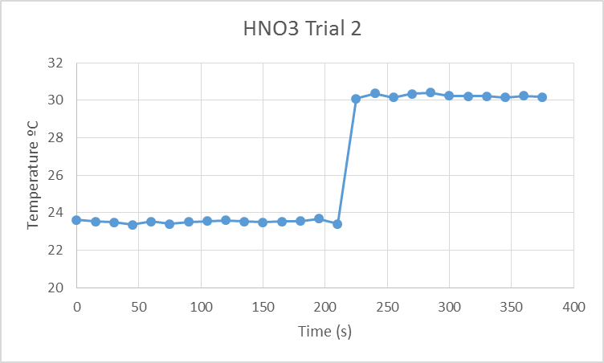

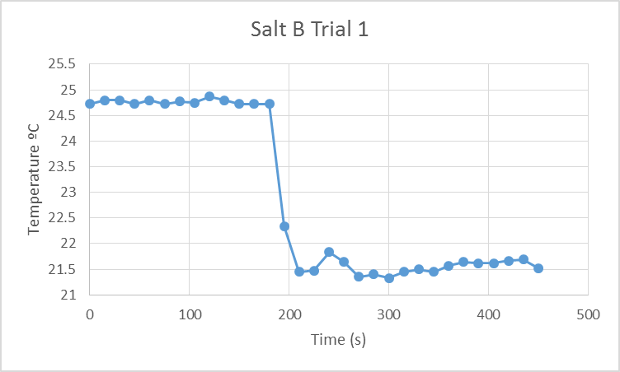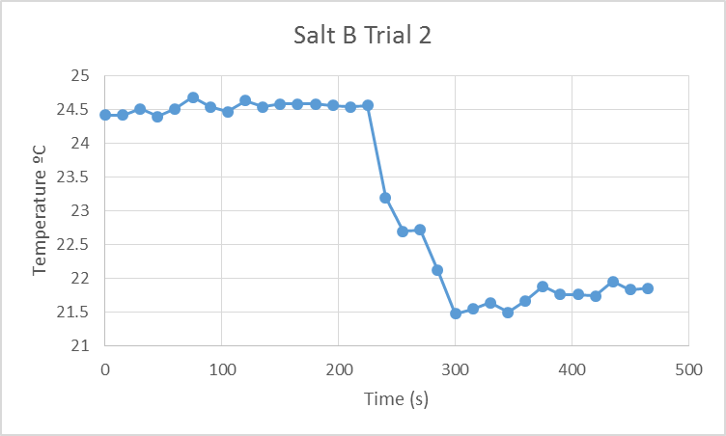

Calculations
All calculations shown use the 1st trail of a given experiment, calculations were repeated to find values for the other trials.

Metal - Zn
Calculate the specific heat capacity of Zinc
-∆q_{metal} = ∆q_{water}
Calculate ∆q_{water} = m _{water} x c _{water} x ∆_{water} T
Find average initial and final temperatures by averaging temperatures recorded before and after the experiment.
∆_{water initial} T = $\frac{Temp initial 1+temp initial 2+temp inital 3}{3}$ = $\frac{23.2+23.2+23.3}{3}$ = 23.23 ºC
∆_{water final} T = $\frac{Temp final 1+temp final 2+temp final 3}{3}$ = $\frac{26.8+26.9+26.6}{3}$ = 26.77 ºC
∆_{water} T = ∆_{water final} T - ∆_{water initial} T = 26.77-23.23 = 3.53 ºC
Calculate ∆q_{water} = m _{water} x c _{water} x ∆_{water} T = (20g)($\frac{1g}{1ml}$)(4.184 J/g ºC)(3.53) = 292.85 J
Calculate c_{metal}
-∆q_{metal} = ∆q_{water} = 292.85 J
∆q_{metal} = -292.85 J
∆_{metal initial} T = 100 ºC
∆_{metal final} T = ∆_{water final} T = $\frac{Temp final 1+temp final 2+temp final 3}{3}$ = $\frac{26.8+26.9+26.6}{3}$ = 26.77 ºC
∆_{metal} T = ∆_{metal final} T - ∆_{metal initial} T = 26.77-100 = -73.23 ºC
c_{metal} = $\frac{q metal}{(m metal)(∆T metal)}$ = $\frac{-292.85}{(11.492g)(-73.23)}$ = $\frac{-292.85}{-841.559}$ = 0.348 J/g ºC
The specific heat capacity of Zinc was measured to be 0.348 J/g ºC in Trial 1

Approximate the molar mass of the metal using the calculated specific heat capacity
C_{metal} x MM_{metal} ≈25 J/mol ºC
MM_{metal} = $\frac{25 J/molC}{.348 J/gC}$ = 71.84 g/mol
Calculate percent error for molar mass and specific heat of zinc using known values versus experimental values
%error_{MM} = $\frac{experimental MM-known MM}{known MM}$ x 100 = $\frac{71.84-65.39}{65.39}$ x 100 = 9.7%
%error_{c} = $\frac{experimental c-known c}{known c}$ x 100 = $\frac{.348- .39}{.39}$ x 100 = 10.8%

Acid
Find ∆_{solution} T
∆_{solution} T = ∆_{solution final} T - ∆_{solution initial} T
∆_{solution initial} T = $\frac{Temp initial 1+temp initial 2+temp inital 3}{3}$ = $\frac{23.3+23.5+23.3}{3}$ = 23.37 ºC
∆_{solution final} T = $\frac{Temp initial 1+temp initial 2+temp inital 3}{3}$ = $\frac{30.2+30.1+30.1}{3}$ =30.13 ºC
∆_{solution} T = ∆_{solution final} T - ∆_{solution initial} T = 30.13 - 23.37 = 6.76 ºC
Calculate volume of solution
V_{solution} = V_{base} + V_{acid} = 40ml + 40ml = 80 ml
Calculate mass of final solution
D_{solution} given as 1.0 g/ml
m_{solution} = V_{solution} x D_{solution} = 80 ml x 1.0 g/ml = 80 g
Calculate ∆q_{neutralization}
c_{solution} is assumed to be the same as water = 4.184 J/gºC
∆q_{neutralization} = - m_{solution} x c_{solution} x ∆_{solution} T = (80g)(4.184 J/gºC)(6.76ºC) = -2.62 kJ

Calculate the amount of the limiting reagent
HCl + NaOH NaCl + H₂O
Concentrations given HCL = 1.1 M NaOH = 1.0M
Mol NaOH = V_{NaOH} x Concentration_{NaOH} = .04 L x 1.0 Mol/L = 0.04 mol_{NaOH}
Mol HCl = V_{HCl} x Concentration_{HCl} = .04 L x 1.1 Mol/L = 0.044 mol_{HCl}
Since ratio is 1:1 for all molecules NaOH is the limiting reagent because .04 mol < 0.044 mol
Find moles of H₂O formed in neutralization
Since ratio is 1:1 for all molecules
0.04 mol_{NaOH reacted} = 0.04 mol_{H2O formed}
Find ∆_{n}Hº
∆_{n}Hº = $\frac{qn}{nx}$
∆_{n}Hº = ∆q_{neutralization}/ mol_{H2O formed} = $\frac{-2.62 kJ}{.04 mol}$ = -65.5 kJ/mol_{H2O}
Calculate %error for experimental vs literature values of ∆_{n}Hº
% error ∆_{n}Hº = $\frac{experimental ∆nHº - literature ∆nHº }{literature ∆nHº }$ x 100 = $\frac{-65.5\frac{kJ}{mol}- -57.1 kJ/mol}{-57.1 kJ/mol}$ x 100 = 14.7%

Salt B
Given MM 166.0 g/mol
Specific Heat Capacity of Solution of Substance in Water c=3.662 J/gºC
Find ∆_{solution} T
∆_{solution} T = ∆_{solution final} T - ∆_{solution initial} T
∆_{solution initial} T = $\frac{Temp initial 1+temp initial 2+temp inital 3}{3}$ = $\frac{24.8+24.7+24.7}{3}$ = 24.73 ºC
∆_{solution final} T = $\frac{Temp initial 1+temp initial 2+temp inital 3}{3}$ = $\frac{21.4+21.3+21.5}{3}$ =21.4 ºC
∆_{solution} T = ∆_{solution final} T - ∆_{solution initial} T = 21.4 – 24.73 = -3.33 ºC
Find ∆_{solution}H
∆_{solution}H = (-∆H_{H2O})+(-∆H_{salt}) = -q_{sloution}
∆_{solution}H = -q_{sloution} = $-(m solution)(c solution)(∆T solution)$
∆_{solution}H = -(23.982 g cup and solution – 1.961 g cup)(3.662J/gºC)(-3.33 ºC) = 268.53 J
Calculate Enthalpy of Dissolution per Mole of Salt, ∆_{s}Hº _{salt}
n_{salt} = $\frac{mass salt}{molar mass salt}$ = $\frac{2.381g}{166.0 g/mol}$ = 1.43 x 10⁻² mol salt
∆_{s}Hº _{salt} = $\frac{∆ solution H}{n salt}$ = $\frac{268.53 J}{1.43 x {10}^{-2}mol}$ =18.788kJ/mol
Enthalpy of dissolution of KI as per literature is 20.3kJ/mol
%error_{c} = $\frac{experimental ∆sH- known ∆sH}{known ∆sH}$ x 100 = $\frac{18.788\frac{kJ}{mol}- 20.3\frac{kJ}{mol}}{20.3\frac{kJ}{mol}}$ x 100 = 7.9%

Discussion
In this experiment there are a large number of potential sources of error. With regards to the metal, while the metal was placed in a test tube in boiling water for 5 minutes we were unable to measure the actual temperature of the metal before mixing it with the water in the calorimeter. It is assumed that the metal reached 100 ºC, but that conceivably may not be the case. Also, with such a low specific heat capacity the metal may have cooled while being transferred to the calorimeter from the boiling water. Both of these factors would have resulted in lower values for ∆T than should have occurred. This would in turn show a lower specific heat than is the case.
In the neutralization reaction, there were also a few errors that took place. In our group we missed the step of taking the final mall of the cup and solution after the experiment. This would have given more accurate results for the remainder of the calculations.
Another way that this experiment could have been more precise would be taking the masses of the acid and base on the balance instead of just using a graduated cylinder. A more precise measure of the reactants would provide more accurate results, as any errors in recording the initial amounts are amplified as those amounts are used throughout the calculations.
There was a large % error on the first trial of the HCL of 14.7%. It is not immediately clear what contributed to this high value but most likely inaccurate measurement is to blame.
In part 3 of the experiment, the dissolution of the salt, we noticed that the temperature began to rise the longer we left the probe in the solution. This may be due in part to the proximity of the calorimeter to the hot plate that was used to heat the Zinc for part 1 of the experiment. Heat could also have come from the hands of the participants while they swirled the solution.
In order to mitigate the heat loss or gain from the environment, the values for ∆T were taken as close to the actual reaction as possible. This should help to show the actual change in temperature.
In all calculations the amount of the substances, in theory should not affect the results found for specific heat because specific heat is based on per gram or per mole of the substance used. In practice however, a larger amount of reactant or metal used should lower the margin of error as more precise measurements are easily recorded on the larger amounts.

Conclusions
The values obtained for the molar mass of zinc were 71.84 and 68.87 g/mol. With an average molar mass of 70.35 g/mol with a % error of 7.6% average. The values obtained for the heat of neutralization for HCL were -65.5 kJ/mol and -57.5 kJ/mol with % errors of 14.7% and 0.7% respectively. Similarly, the values obtained for the heat of neutralization for HNO₃ were -55.5 kJ/mol and -55.8 kJ/mol with % errors of 3.1% and 2.6% respectively. The enthalpy of dissolution for potassium nitrate found were 18.79 kJ/mol and 18.54 kJ/mol with % errors of 7.9% and 8.7% respectively.

Appendix
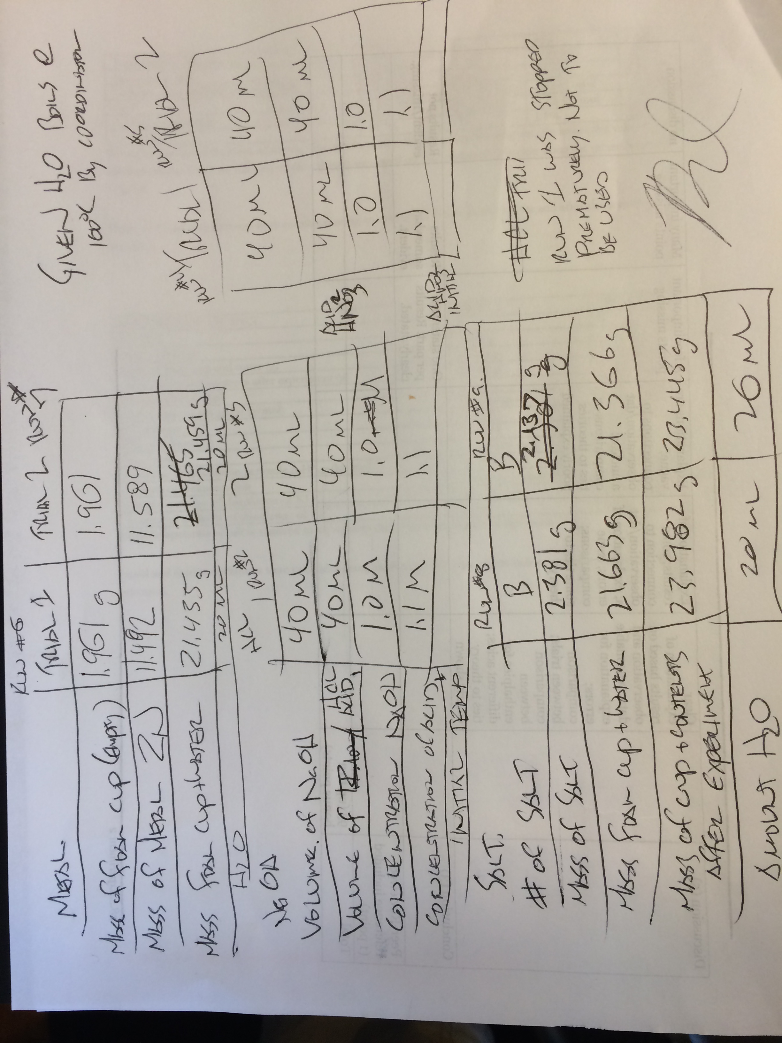

Venkateswaran, R, “ “…BUT A HOT TEMPER LEAPS O’ER A COLD DECREE” ENTHALPY OF VARIOUS REACTIONS”, pp 28,
Petrucci, R; Harwood, W; Herring, F.G; Madura, J, “General Chemistry, Principles & Modern Applications”, 9th edition, pp 284
Venkateswaran, R, “ “…BUT A HOT TEMPER LEAPS O’ER A COLD DECREE” ENTHALPY OF VARIOUS REACTIONS”, pp 29
Petrucci, R; Harwood, W; Herring, F.G; Madura, J, “General Chemistry, Principles & Modern Applications”, 9th edition, pp 229
Venkateswaran, R, “ “…BUT A HOT TEMPER LEAPS O’ER A COLD DECREE” ENTHALPY OF VARIOUS REACTIONS”, pp 31.
Venkateswaran, R, “ “…BUT A HOT TEMPER LEAPS O’ER A COLD DECREE” ENTHALPY OF VARIOUS REACTIONS”, pp 32-36.

