Econ 313 FEB 22 notes

The teacher repeated what he said about Solow’s model, that it didn’t show income disparities, and that the level of income is lower than what the model predicts.
So, we have variable equilibrium, some low, normal, high

Here is a graph that represents this Multiple-Equilibria.
An S-shape function and 45˙line
On the X axis you have the expected decisions (average investment level) by other agents
On the Y axis you have the privately rational decision (individual investment level)
This model assumes that an investment decision depend on the your expectations of what others will do, so you have 3 possible equilibrium (D1,D2,D3)
The 45˙line represents equilibrium, when X = Y.
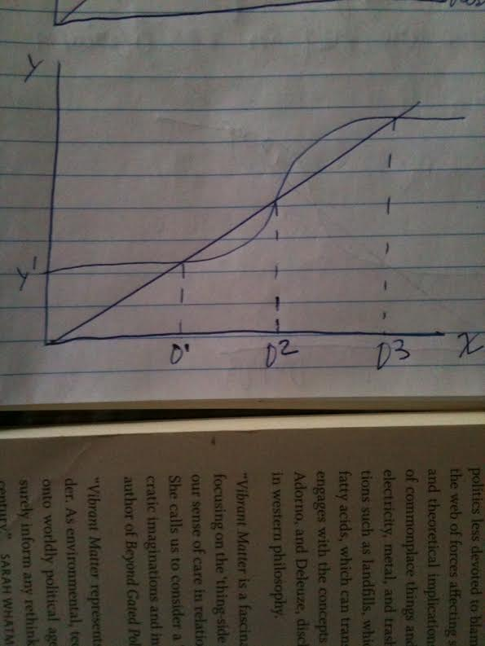

However, there are times where your expectations will differ from equilibrium, but it will be equalizing by the market forces. D4,D5,D6, are not in equilibrium.
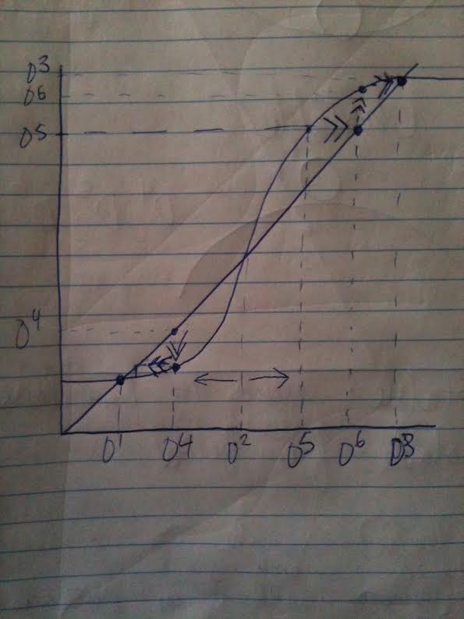
If you invest D4, the other investors will also invest less, bringing the equilibrium to D1.
However, if you invest D5, the other will invest more, which result in the equilibrium at D3.
The equilibrium is stable when the curve crosses over the 45˙line (D1,D2,D3)
The equilibrium is unstable when the curve crosses under the 45˙line (D4,D5,D6)

Second half of the class:

The Big Push: a graphical model with 6 assumptions; because market failures lead to a need for public policy intervention

- One factor of production
- 2 sectors
- Same production function for each sector
- Consumers spend an equal amount on each good
- Closed economy
- Perfect competition with traditional firms operating, limit pricing monopolist with a modern firm operating

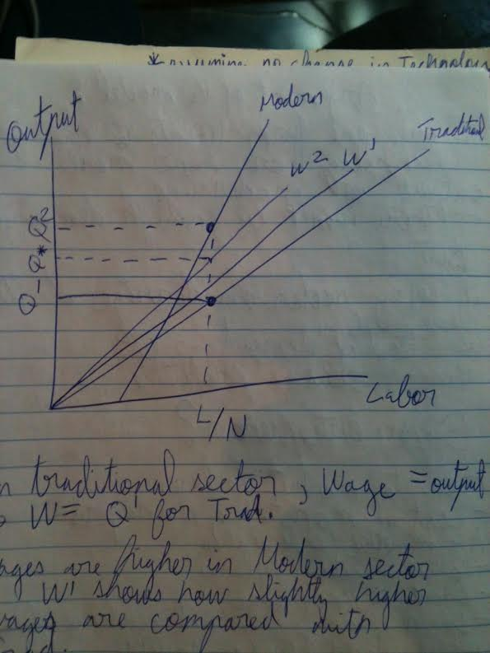
There are two curves, one for the Traditional-sector production function, and one for the Modern-sector production function.
Labor on the X axis and Output on the Y axis.
Wages in the Traditional sector are equal to output, equilibrium is Q1.
However, wages in Modern-sector are different as shown by the two curves W1 and W2. Those two curves show the higher wages because of new technology we need less labor and produce more output. But, this model aims to demonstrate that if one sector changes their technology or modernize, there won’t be enough demand. The demand comes from Labor, and the Labor in the traditional sector still have their wages proportionate to their output.
If every sector modernizes at the same time, and equilibrium is at Q2, then it would be profitable.

A Big Push may also be necessary when there are:
Inter-temporal effects
Urbanization effects
Infrastructure effects
Training effects

But does this model’s argument imply that we need “Super Entrepreneur”, capable of modernizing more than one sector at the time

Here are some counterarguments to the model:

-Capital market failures
-Cost of monitoring managers
-Asymmetric (unequal) information
-Communication failures
-Limits to knowledge
-Lack of any empirical evidence that would suggest this is possible

The India company, an empire, “Tata” is specialized in a large variety of sectors. From cars, to medicine, to housing, to natural resources…

End.
“A room without books is like a body without a soul.”
― Marcus Tullius Cicero

